Extended Data Figures
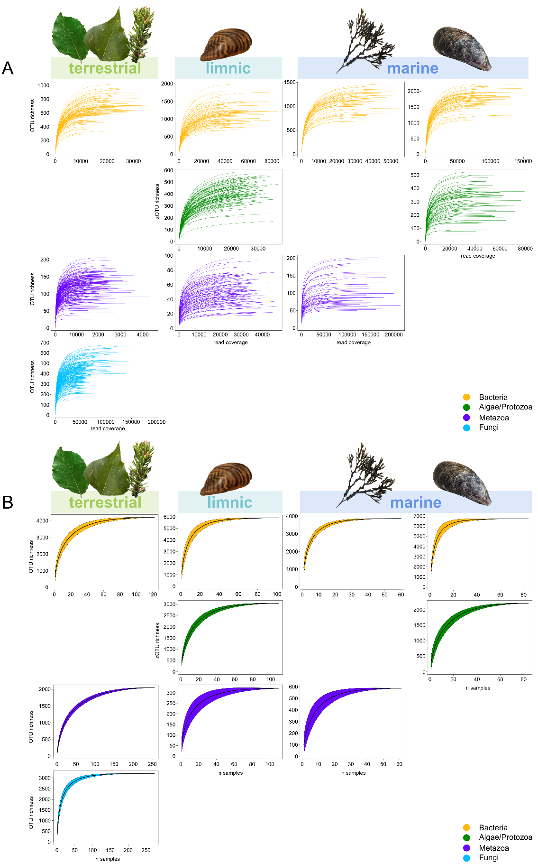
Extended Data Figure 1. Rarefaction and accumulation curves depict the saturation and completeness of OTU (zero-radius operational taxonomic unit) richness for each sampling species. A) Rarefaction curves showing OTU richness against read coverage, with each curve representing an individual sample. B) Accumulation curves illustrate the cumulative increase in OTU richness with each additional sample. Taxonomic groups are represented by different colors. Icons refer to sampled species.

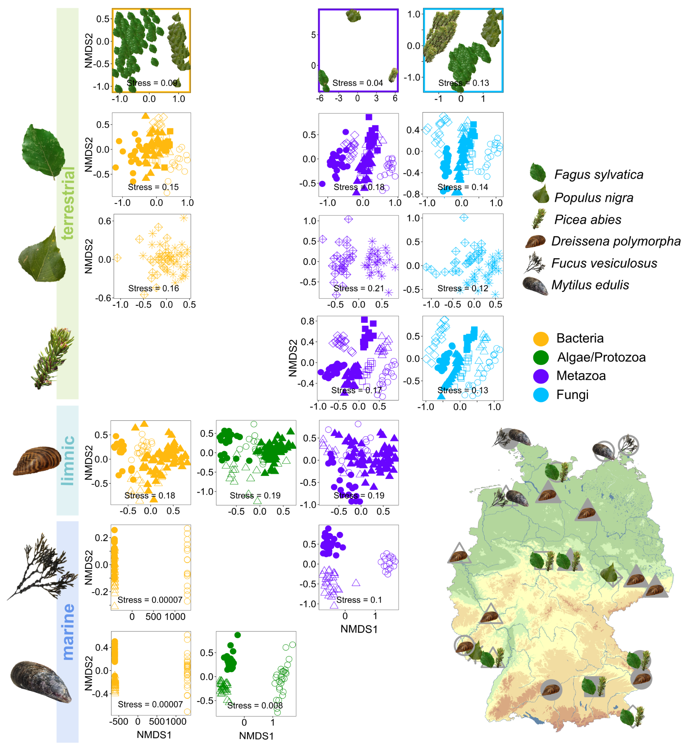
Extended Data Figure 2: Map of sampling sites and non-metric multidimensional scaling (NMDS) plots illustrating distinct bacterial, microeukaryotic plankton, metazoan and fungal communities at different sampling sites within terrestrial, limnic and marine ecosystems. The first row shows NMDS plots of Bacteria, Metazoa and Fungi associated with the leaves of three tree species - European beech, Norway spruce, and Lombardy poplar -, where each tree species is represented by a distinct icon. Rows two through four illustrate the studied leave-associated communities for each tree species separately. Rows five to seven show NMDS plots of Bacteria, Algae/Protozoa and Metazoa associated with limnic zebra mussels, as well as marine bladderwrack and blue mussel. Taxonomic groups are represented by distinct colors. Icons indicate sampled species. Shapes denote the sampling location.

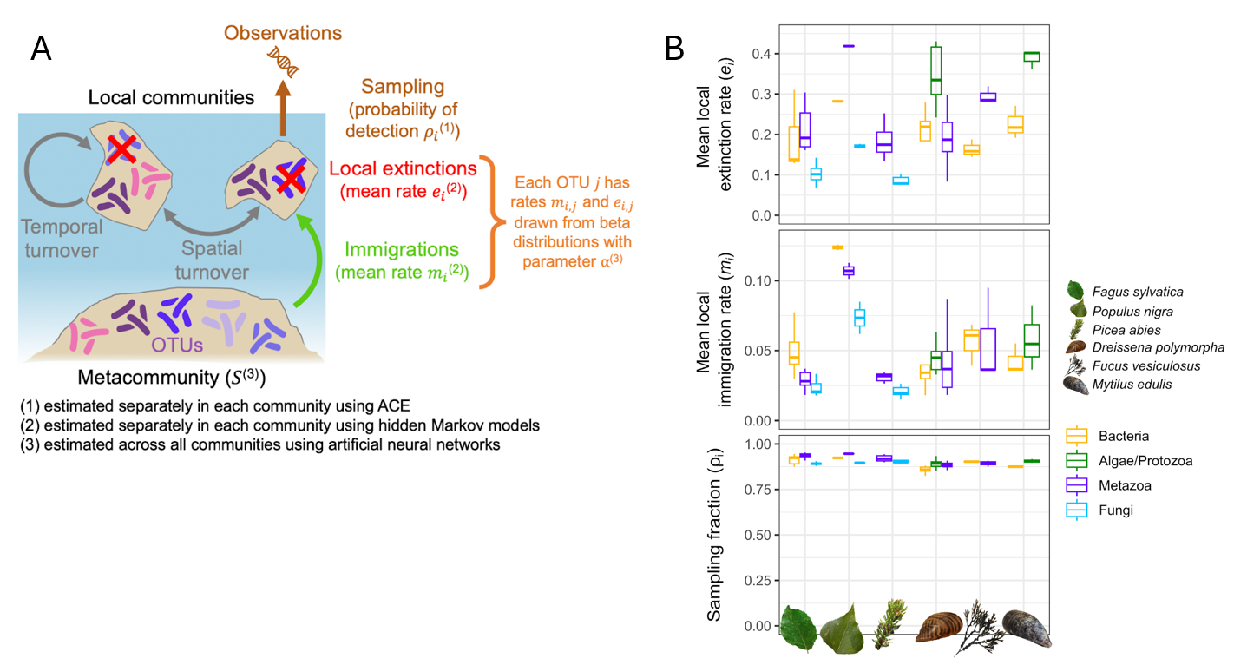
Extended Data Figure 3. A non-neutral dynamic model for community assembly derived from the equilibrium theory of island biogeography¹⁹ (A) and estimated parameters of extinction rate (e_{i}), immigration rate (m_{i}) and detection probability (ρ_{i}) in the different communities (B).
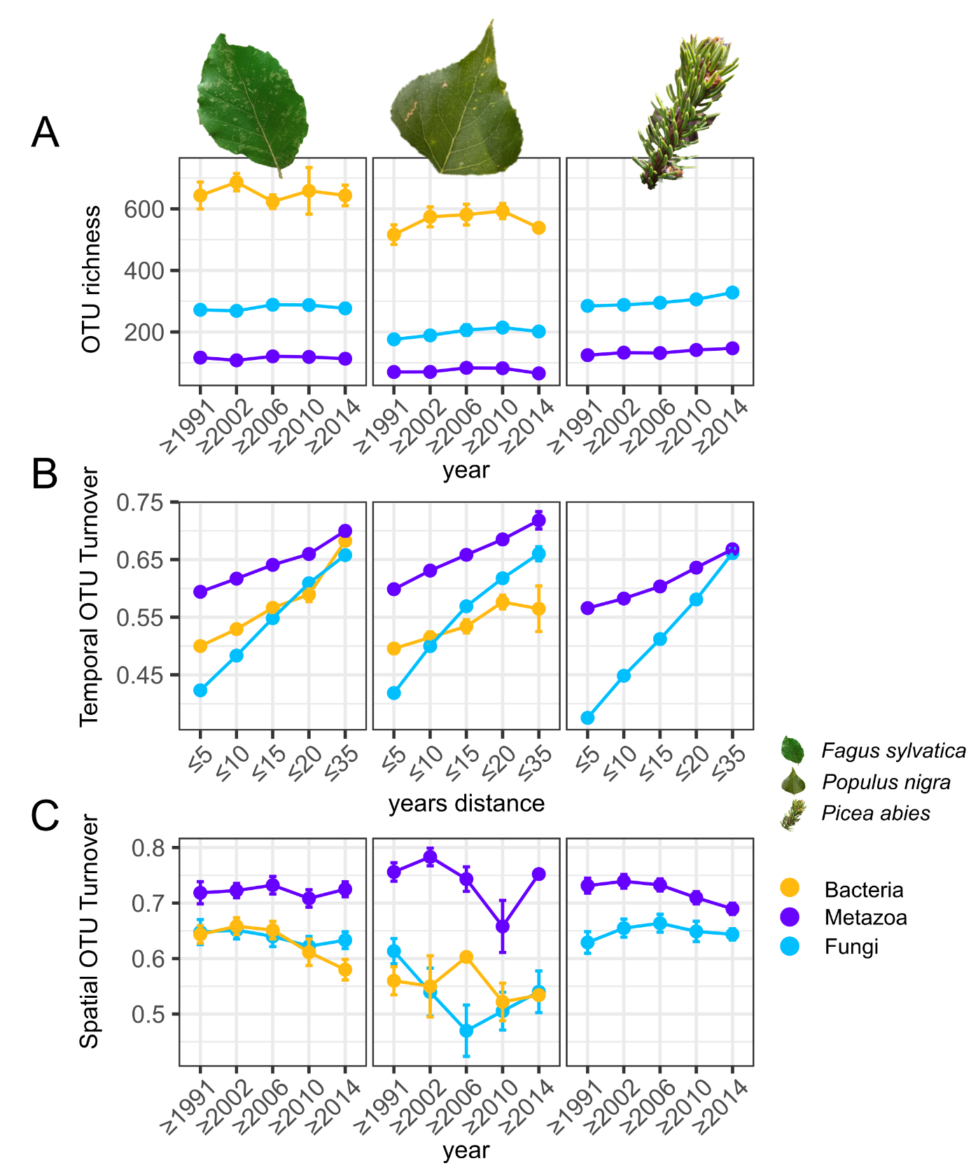
Extended Data Figure 4. Multidecadal trends of α- and 𝛽-diversity in communities across the tree of life associated with tree leaves, with each tree species presented separately. A) Trends in OTU richness of the associated communities between 1991 and 2021. B) Temporal OTU turnover of the associated communities calculated from the turnover component of Jaccard distance is shown as a function of the distance in years between samples from the same sampling site. C) Spatial OTU turnover of the associated communities between 1991 and 2021. Trends describe the degree of dissimilarity in community composition between different sampling locations over time. OTU richness and turnover values were summarized as mean with standard error bars across sampling locations and time windows. Taxonomic groups are represented by different colors. Icons refer to sampled species.
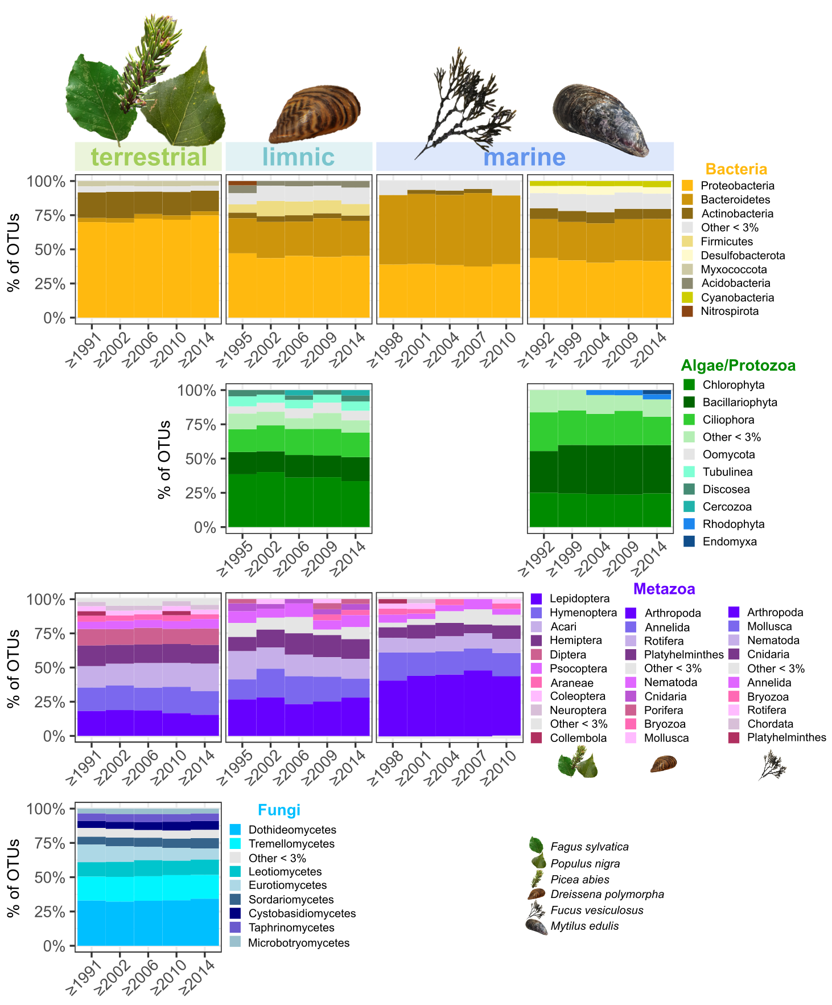
Extended Data Figure 5. Taxonomic composition of bacteria, microeukaryotic plankton, metazoa, and fungi detected in ESB samples from the 1980s to today. Taxonomic composition is based on relative OTU abundance and is shown for five time periods, each spanning several consecutive years per sampling type. Community composition is shown on phylum level for bacteria, microeukaryotic plankton, and aquatic metazoans. Terrestrial metazoans are shown on order level and fungi on class level. Taxonomic groups are represented by different color palettes. Icons refer to sampled species.

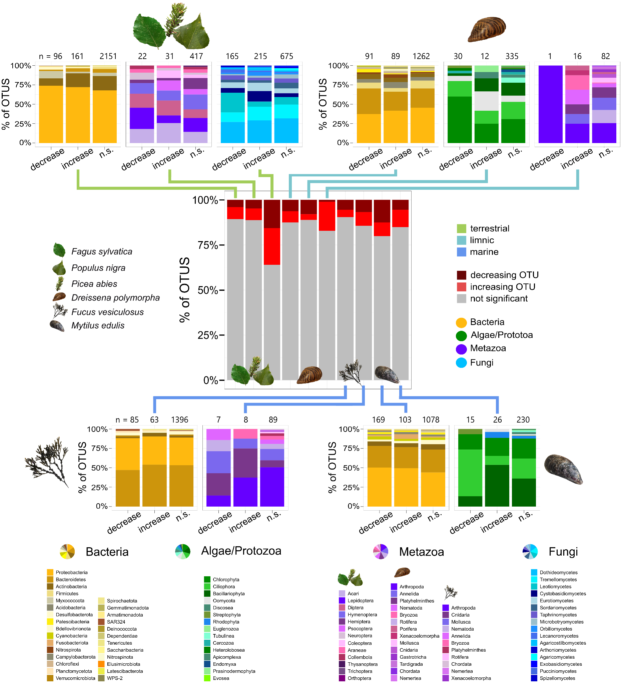
Extended Data Figure 6. Proportion of OTUs showing a significant increase, decrease, or no significant trend in occurrence over time and the respective taxonomic composition of each category (increase, decrease, n.s.) for each sampling type and taxonomic group (Bacteria, Algae/Protozoa, Metazoa, Fungi). The central chart represents the proportion of OTUs increasing, decreasing or showing no significant trend per taxonomic group and sample type. From each bar of the central chart a line (indicating the ecosystem type by its color) leads to one of the surrounding bar charts, which illustrate the taxonomic composition of each trend category (increase, decrease, n.s.). Community composition is shown on phylum level for bacteria, microeukaryotic plankton, and aquatic metazoans. Terrestrial metazoans are shown on order level and fungi on class level. Taxonomic groups are represented by different color palettes. Icons refer to sampled species.

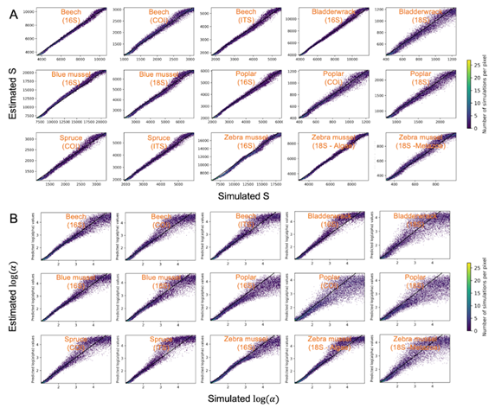
Extended Data Figure 7. Validation of parameter estimations using the artificial neural networks for the dynamic model of community assembly. A) Estimated values of the total number of OTU in the metacommunity (S) as a function of the simulated one. B) Estimated values of parameter of the beta distribution (log()) as a function of the simulated ones. The black lines y=x represent perfect estimations.

