Supplementary material
FIGO stage
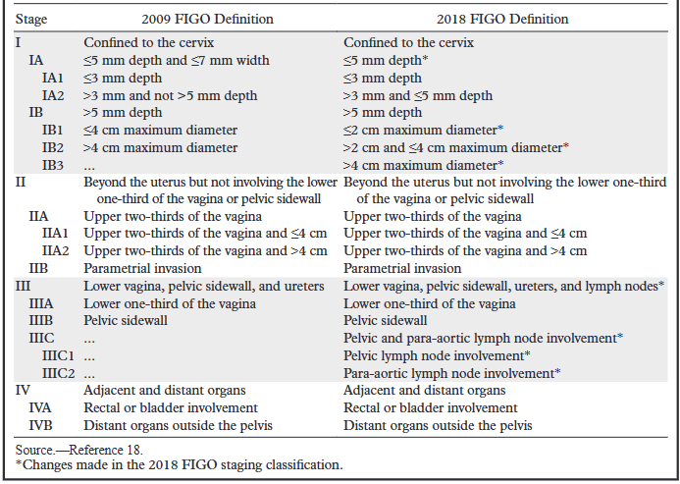
Come from Salib MY, Russell JHB, Stewart VR, Sudderuddin SA, Barwick TD, Rockall AG, Bharwani N. 2018 FIGO Staging Classification for Cervical Cancer: Added Benefits of Imaging. Radiographics. 2020 Oct;40(6):1807-1822. doi: 10.1148/rg.2020200013. Epub 2020 Sep 18. PMID: 32946322.

