Supporting Information for
Ultra-lightweight carbon nanocomposites as microwave absorber with high absorbing performance derived from flour

Yiming Zhong,^{1, #} Yunchen Long,^{2, #} Yinuo Sun,¹ Jiachen Qin,¹ Yongxin Li,^{1,} * Gemeng Liang,³ Jinshuo Zou,³ Peitao Xie ^{1,} *

¹ College of Materials Science and Engineering, Qingdao University, Qingdao 266071, China
² School of Chemistry and Chemical Engineering, Southeast University, Nanjing 211189, China
³ School of Chemical Engineering & Advanced Materials, The University of Adelaide, Adelaide, Australia

# Yiming Zhong and Yunchen Long contributed equally for this work.

*Corresponding author, E-mail:
liyx@qdu.edu.cn (Y. Li); xiepeitao1991@qdu.edu.cn (P. Xie).

Figure. S1. The O 1s spectra of the Co/C nanocomposites.
By observing the peak of O 1S, it can be divided into THREE peaks: H₂O, Co-O and C=O, indicating that the existence of O may be due to the oxidation of Co, the oxygen-containing groups in the amorphous carbon and the adoption of H₂O, and these oxygen-containing groups contribute to the final microwave absorption performance.

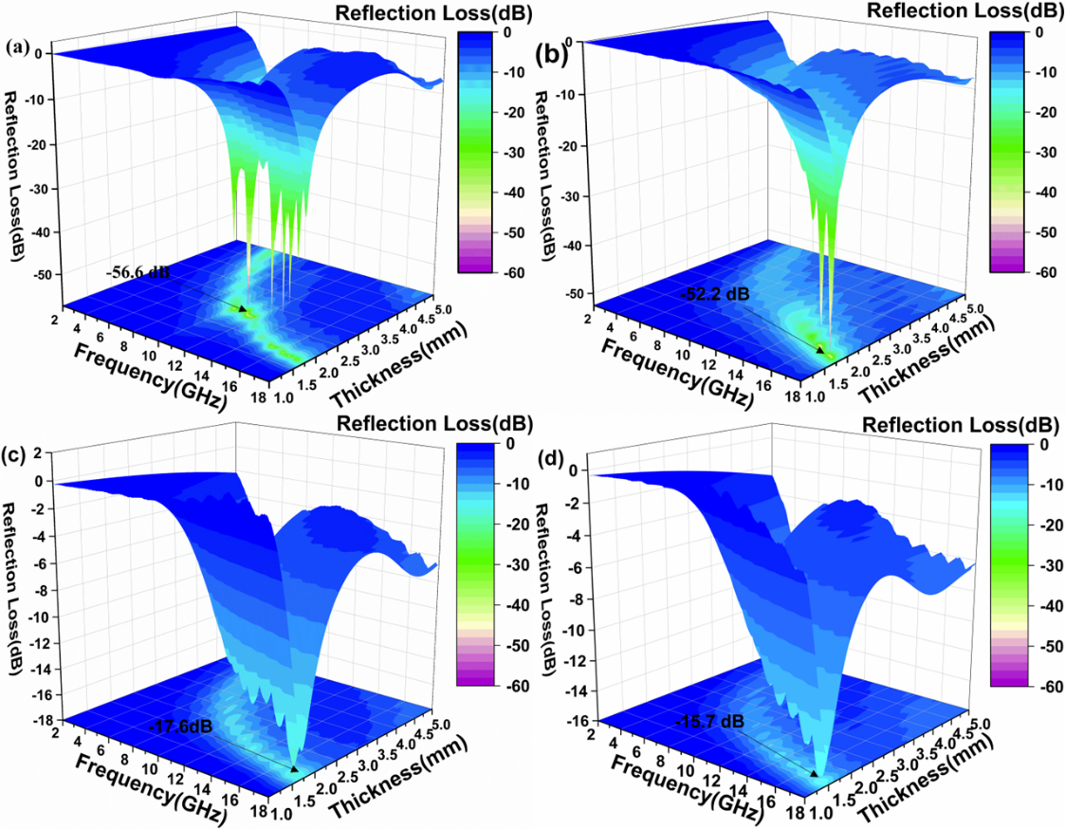
Figure. S2. 3D reflection loss curve of composites at 0.08 mol/L
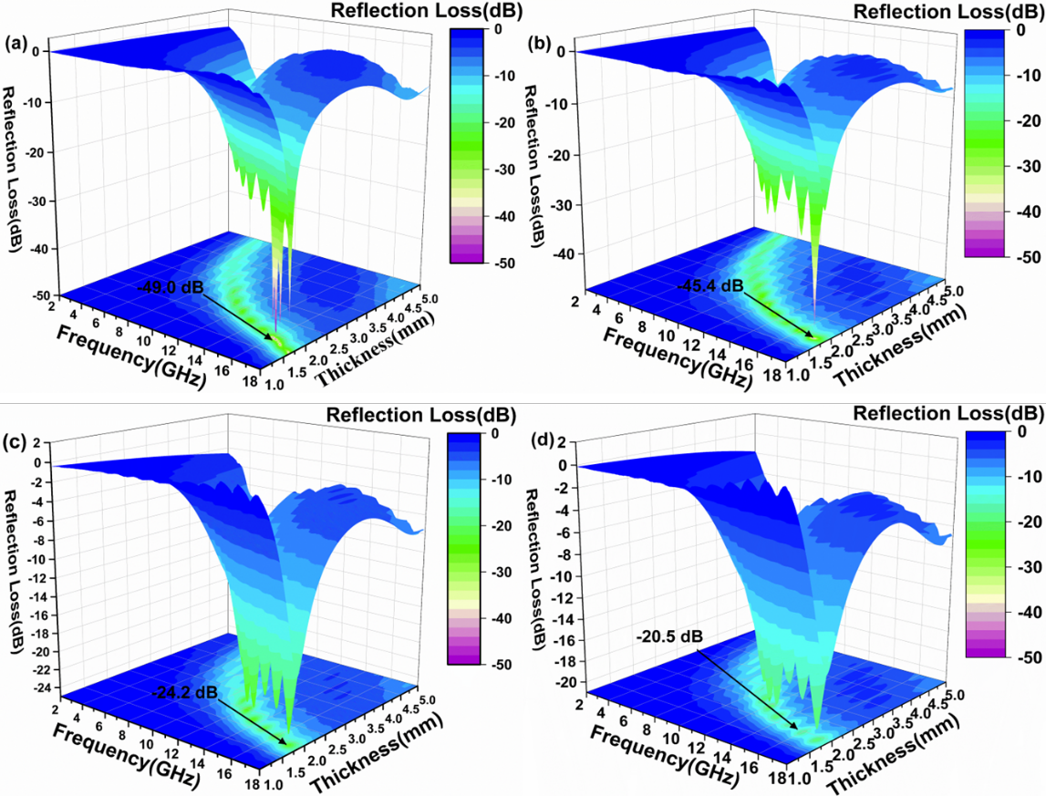
Figure. S3. 3D reflection loss curve of composites at 0.2 mol/L
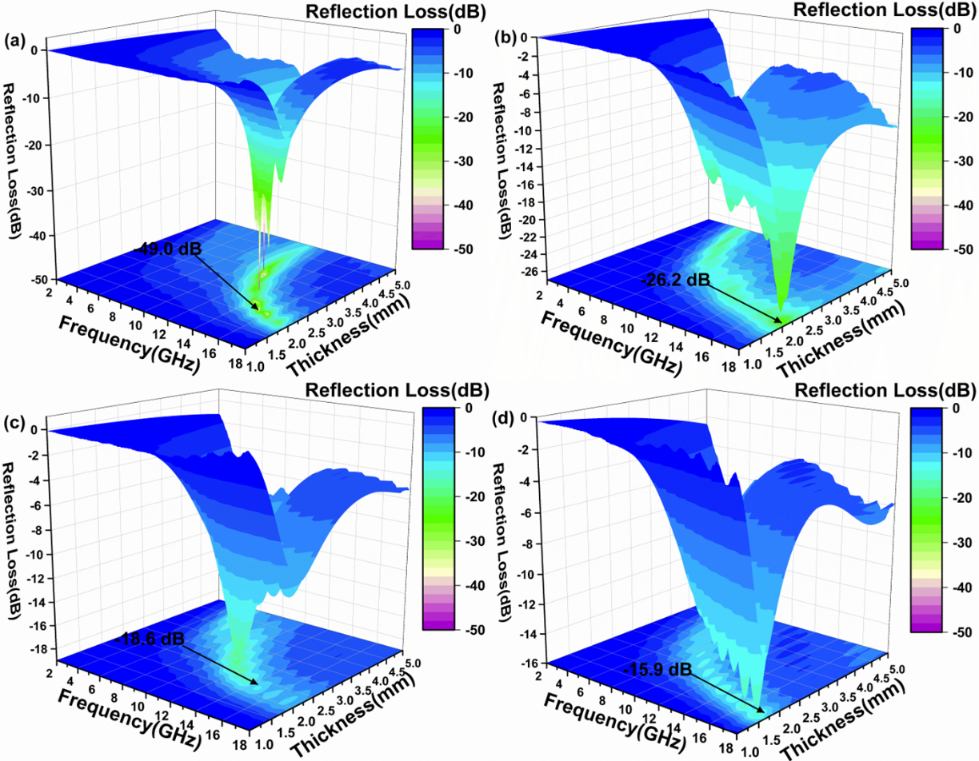
Figure. S4. Three - dimensional reflection loss curve of blank carbon material

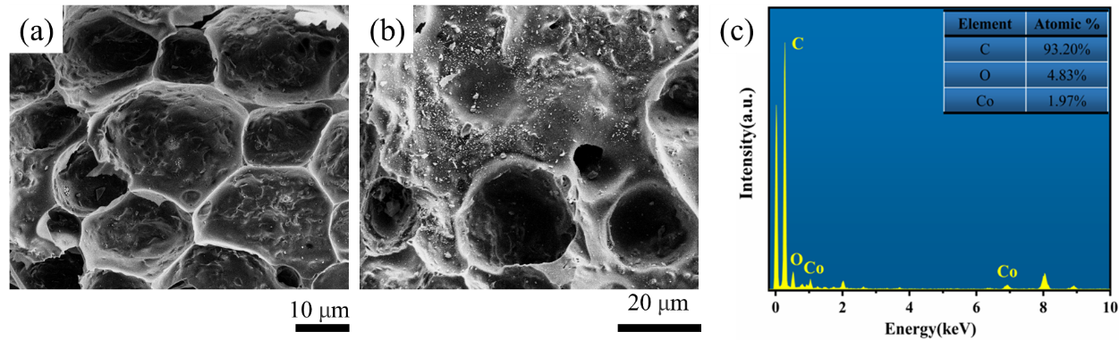
Figure. S5. (a) SEM images of Co/C nanocomposites after fermentation, (b) unfermented and (c) EDS of Co/C nanocomposites
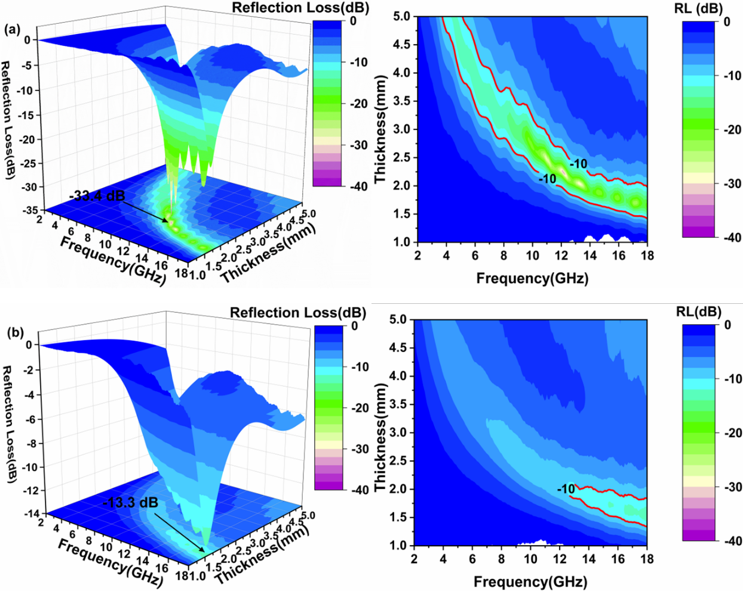
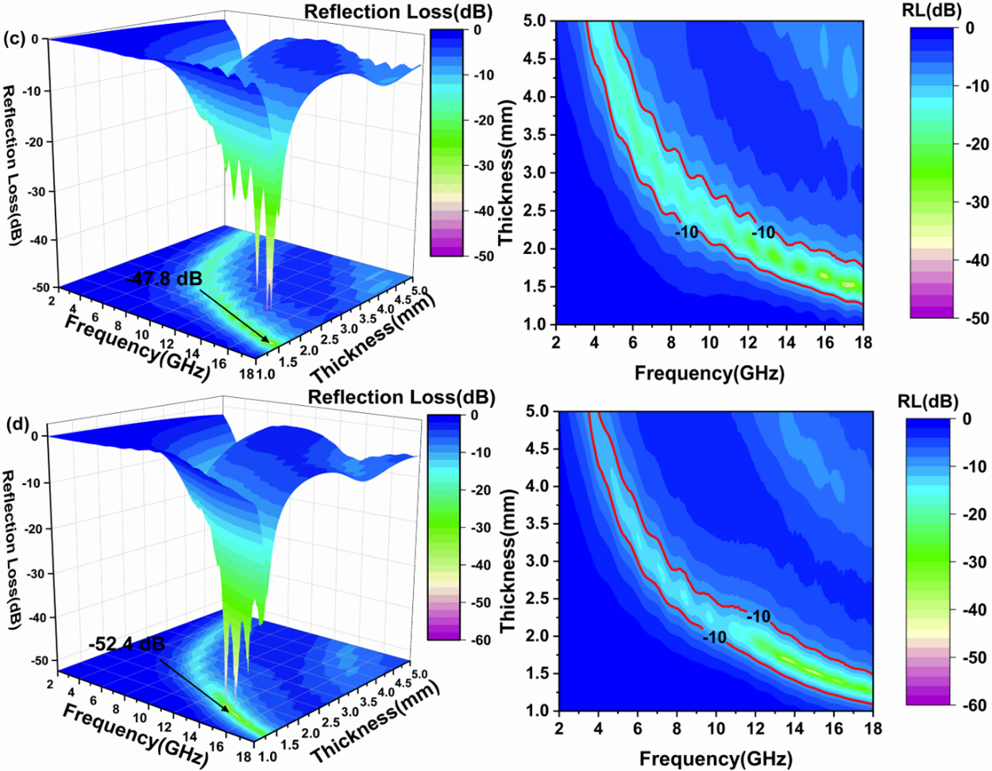
Figure. S6. Three-dimensional reflection loss curve and corresponding projection diagram of unfermented Co/C nanocomposites
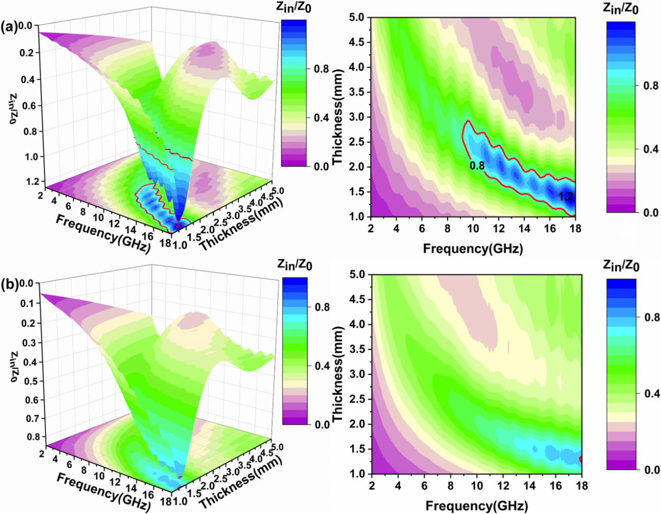
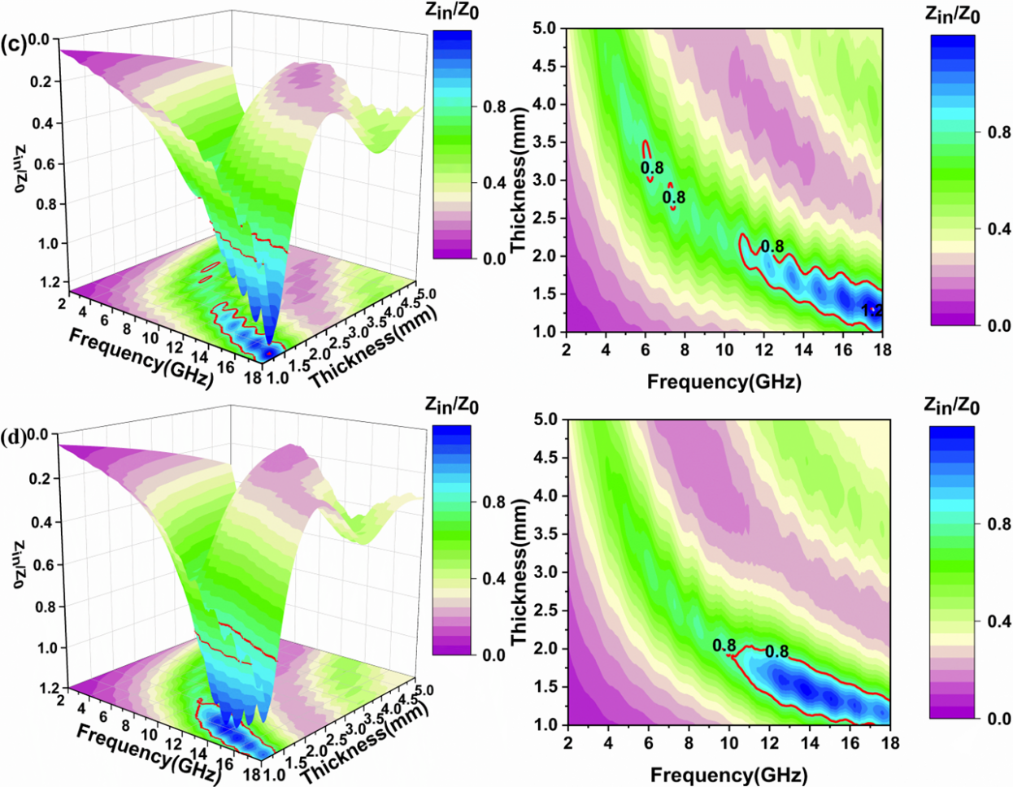
Figure. S7. Three-dimensional impedance ratio of Co/C nanomaterials with different contents in unfermented samples and projection of impedance ratio and frequency
Figure. S8. Attenuation coefficient of 600℃ carbonized samples with the same Co/C content as samples Co-0, Co-1, Co-2, and Co-3
The analysis of the attenuation factor in Figure. S8 reveals that, despite the identical Co/C ratio content in the Co-0, Co-1, Co-2, and Co-3 samples depicted in Figure 9, the attenuation factor of the samples carbonized at 600°C is significantly lower than that of those carbonized at 800°C. This observation aligns with the previous analysis of reflection loss (RL). The lower carbonization temperature of 600°C leads to incomplete carbonization, resulting in inadequate formation of crystalline carbon, poor impedance matching, and insufficient catalysis of crystalline carbon for the reduction of magnetic cobalt metal. Consequently, this hinders the reduction of a considerable amount of magnetic cobalt metal, thus limiting the involvement of Co metal in electromagnetic wave absorption and consequently impacting the material's microwave absorption performance.
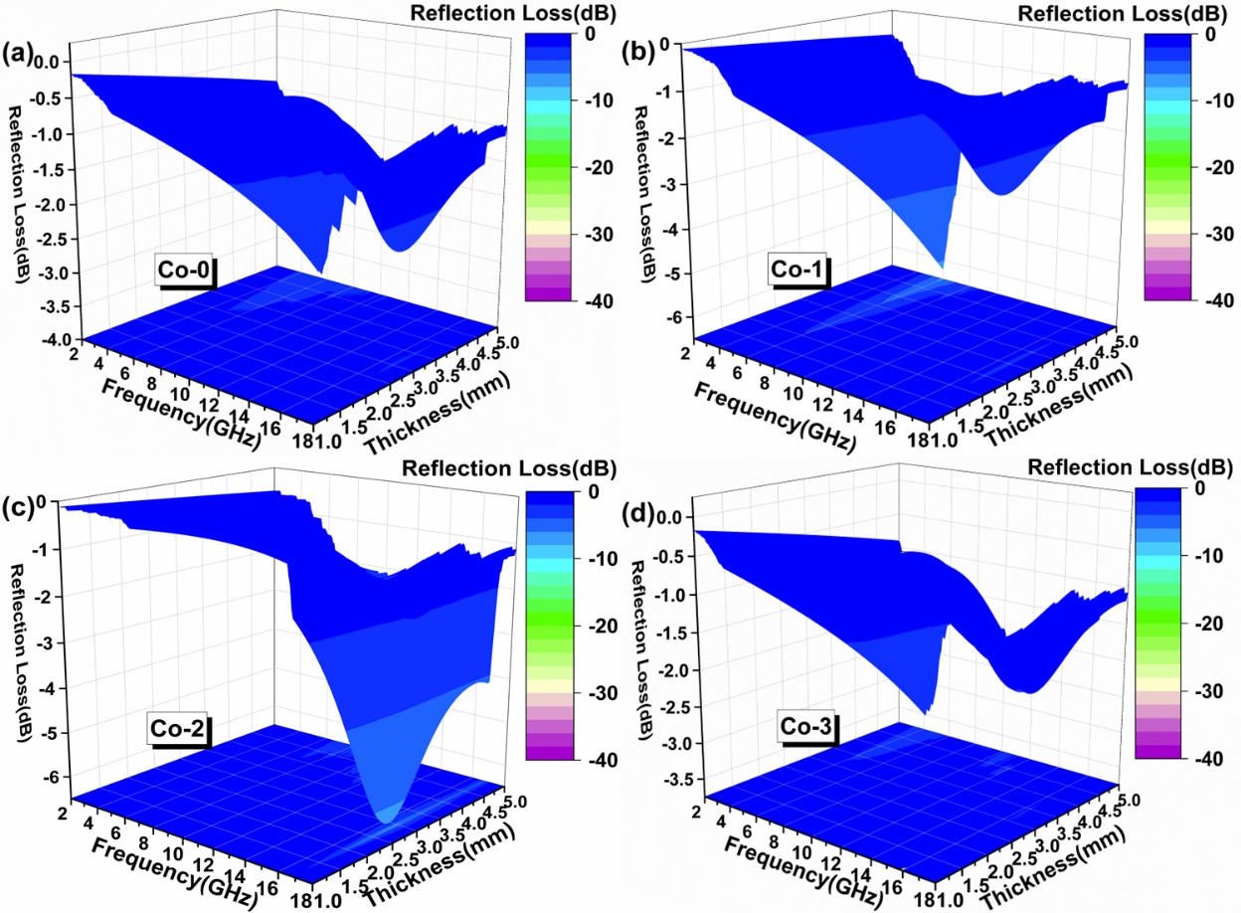
Figure. S9. Reflection loss of 600℃ carbonized samples with the same Co/C content as Co-0, Co-1, Co-2 and Co-3
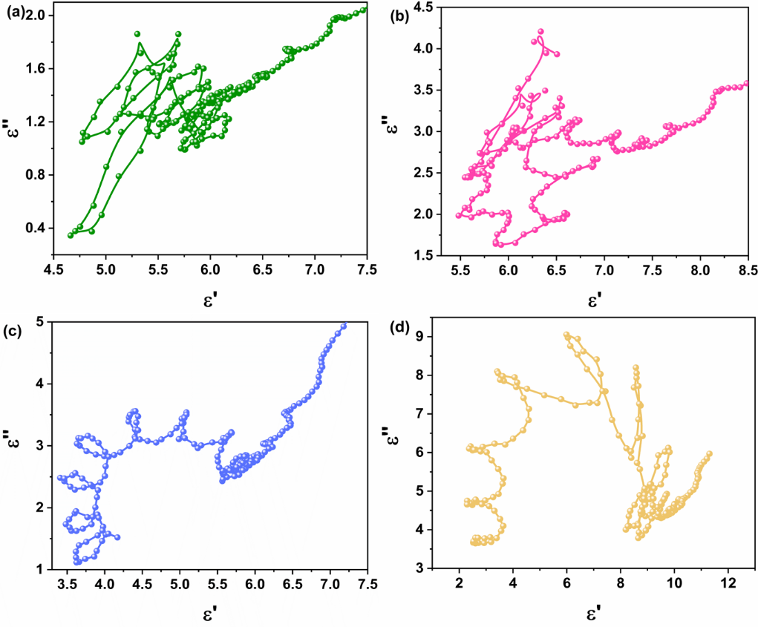
Figure. S10. Cole-Cole semicircles (ε' vs. ε'') of samples of different amounts of Co-2

Numerous semicircles observed in the Cole-Cole curve of the sample suggest the presence of multiple polarization relaxation processes. The linear segment in the Cole-Cole diagram signifies conduction losses, with the length of the line correlating with the level of conductivity. Notably, the linear length in Figure S10 (c) of the Cole-Cole plot is extended, indicating enhanced conductivity. It exemplifies that variations in the Co/C ratio can modify conductivity and escalate conduction losses.

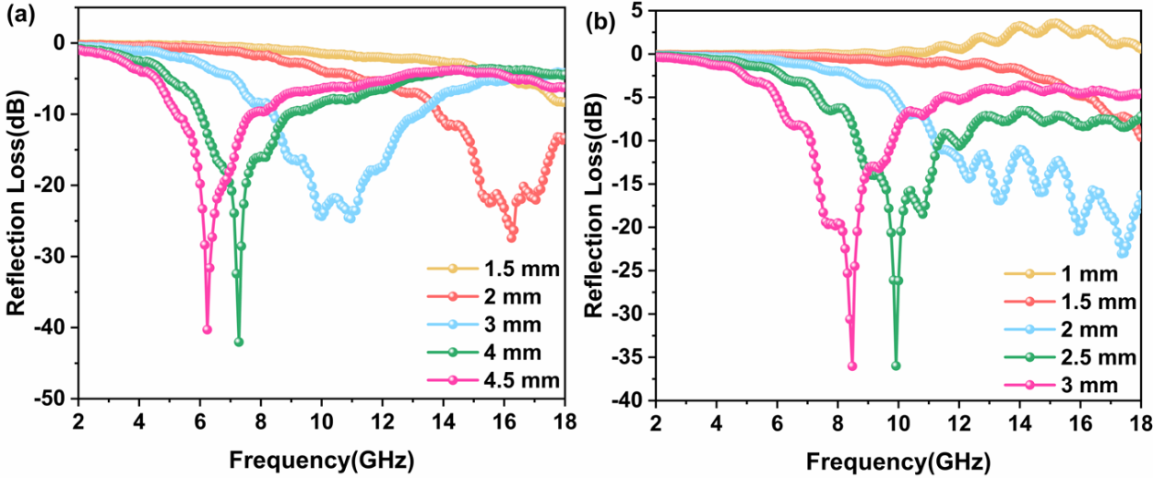
Figure. S11. Frequency dependence of RL values at different thicknesses: (a) blank carbon, (b)Co-2

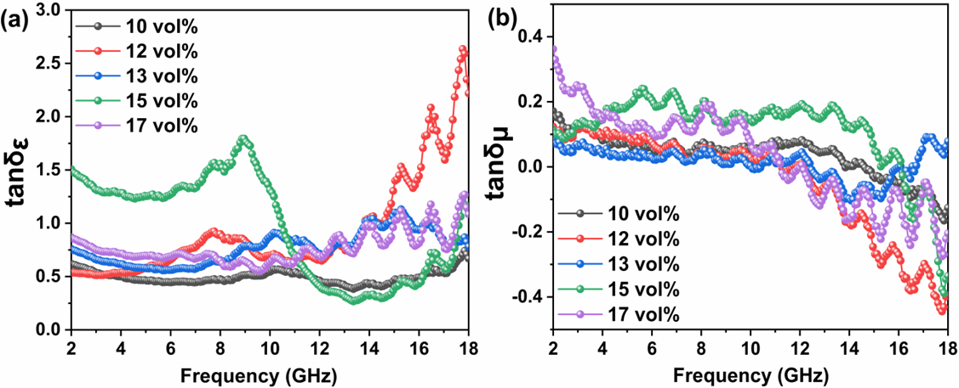
Figure. S12. Dielectric loss tangent (a) and magnetic loss tangent (b) images of a blank carbon sample
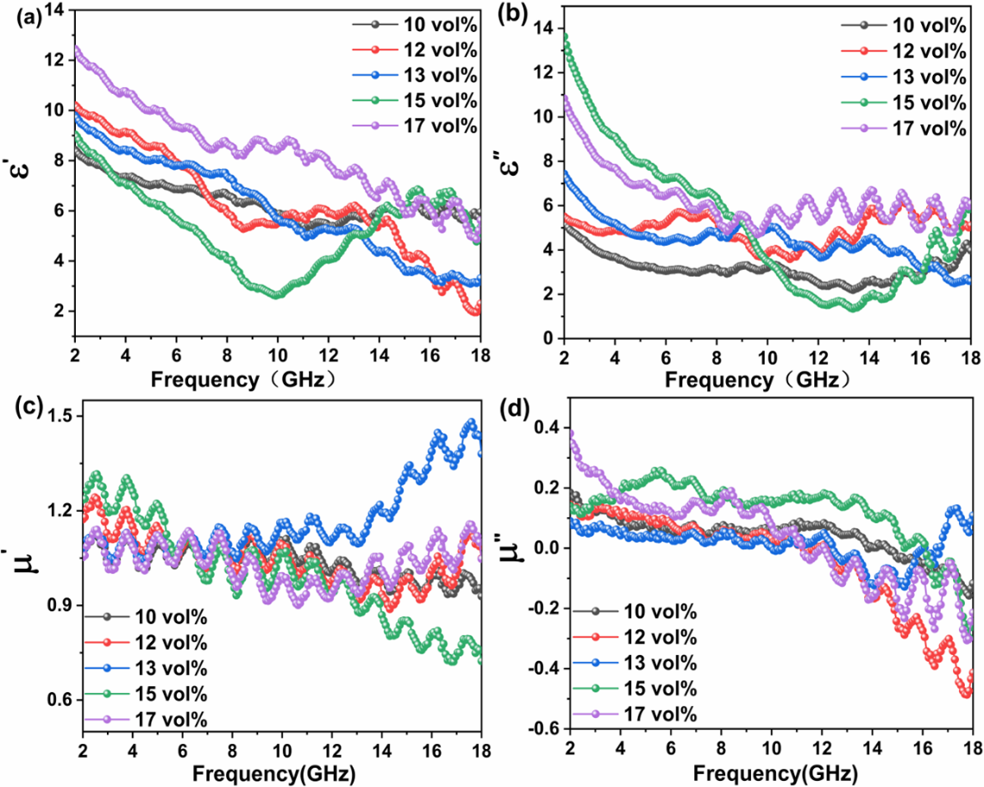
Figure. S13. The permittivity (a, b) and permeability (c, d) of the blank carbon sample are frequency dependent on the real and imaginary parts

Table S1 EDS analyzes the specific data of Co, C and O elements
Element | Line Type | k factor | Absorption Correction | Wt% | Wt% Sigma
C | K series | 2.47155 | 1.00 | 93.20 | 0.49
O | K series | 1.84933 | 1.00 | 4.83 | 0.44
Co | K series | 1.28955 | 1.00 | 1.97 | 0.23
Total: |  |  |  | 100.00

