Continuous measurement of pulse wave velocity under general anesthesia by carotid and femoral Doppler

Supplementary Material

Théophile Harlé^{1,2*}, Jona Joachim^{1,2}, Pierre Boutouyrie³, Joaquim Mateo^{1,2}, Jade Perdereau^{1,2}, Alexandre Mebazaa^{1,2}, Jérome Cartailler^{1,2} and Fabrice Vallée^{1,2**}

¹Université Paris Cité, Inserm UMRS 942 Mascot, F-75006, Paris, France. ²Department of Anesthesia and Critical Care, Lariboisière Hospital, APHP, F-75010, Paris, France. ³Pharmacology, Inserm PARCC U970, Georges-Pompidou European Hospital, Paris-Cité University, Assistance publique-Hôpitaux de Paris, Paris, France.
* Corresponding author email: theophile.harle@aphp.fr
** This author was equally involved in the realization of this work and should be considered as senior author.

Short running title: Arterial stiffness under general anaesthesia and cardiovascular risk

Supplementary Material 1. Description of anesthesia protocol.
Protocol steps:
- Anaesthesia consultation: 2-30 days before
- Perioperative monitoring: electrocardiogram, heart rate (HR), pulsed oxygen saturation, non-invasive blood pressure measured by cuff oscillometry and depth of anaesthesia was monitored using the bispectral index (BIS)
- General anaesthesia induced and maintained by the intravenous route with a BIS objective between 40 and 60.
Drugs used for anesthesia:
  - Propofol (75-150 μg / kg / min)
  - Remifentanil (0.2-0.5 μg / kg / min)
  - Atracurium Besilate (0.5mg/kg) was used for intubation
- Norepinephrine diluted at 5 µg/mL administered continuously via an electric syringe to restore optimal MAP ( > 15% of pre-induction MAP) after induction anesthesia
- Mechanical ventilation: volume 6ml / kg and a EtCO2 objective at［35-38］mmHg

Supplementary Material 2. Description of the study protocol. A: WAKIe R3 2TC® monitor connected directly to IntelliVue MX850® monitor for centralized monitoring of carotid and femoral Doppler signals. B: IntelliVue MX850 ® monitor screen recording all intraoperative signals (carotid and femoral Doppler signals are framed in red).
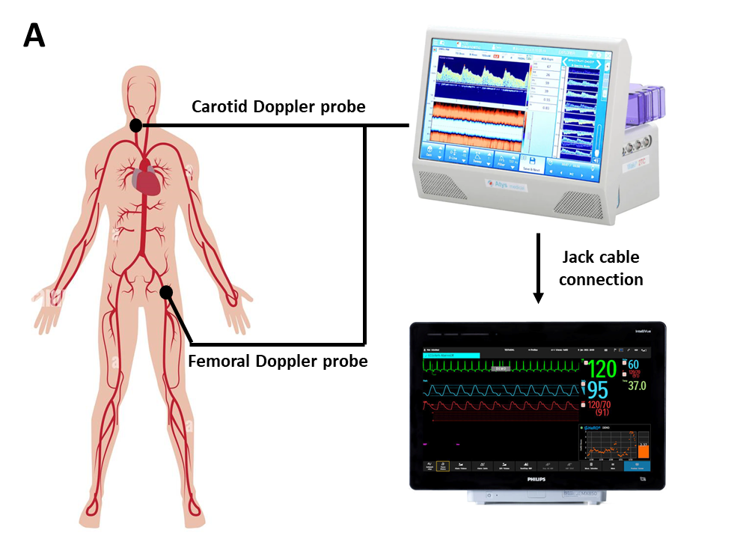
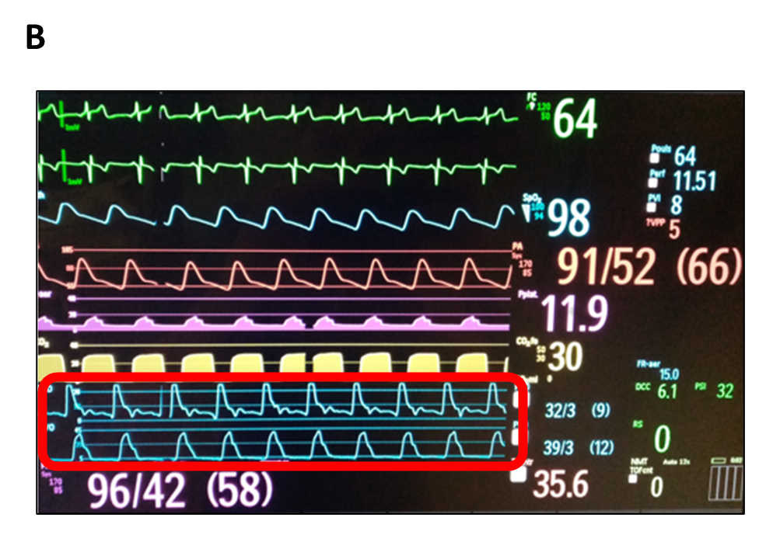
Supplementary Material 3. Measurement of TTcf and PWV using Graphysio software. A: TTcf measurement using the "foot-by-foot" method (the maximum second derivative function of each signal is used to determine the wave foot). B: Graphysio software representation of carotid and femoral Doppler signals, MAP, TTcf and PWV (in cm.s⁻¹) over time
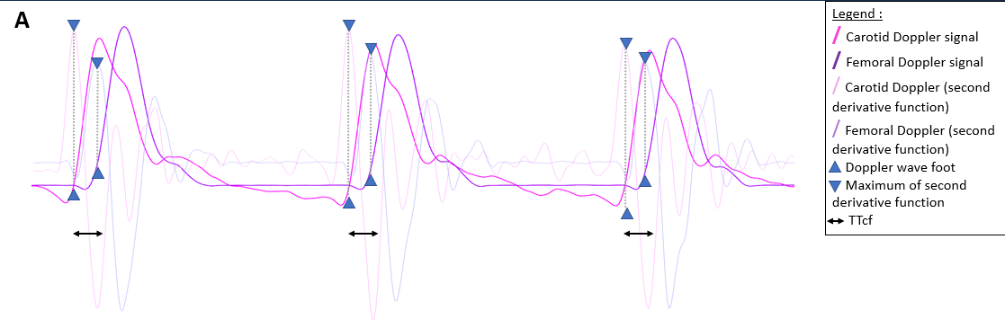
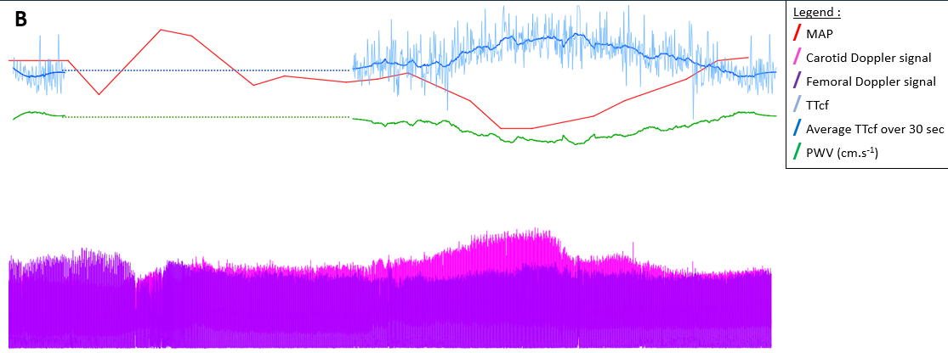
Supplementary material 4. Flow chart of the study. 43 patients were included in the study. 2 patients were excluded due to insufficient Doppler signal quality. Of the 41 analyzed patients, 32 received both PWV_{AW} and PWV_{GA} evaluation and 38 patients received at least one continuous dynamic PWV_{GA} evaluation with a total of 54 episodes of MAP changes (24 MAP increases and 30 MAP decreases).

Analysed patients
n = 41
Included patients
n=43
PWV_{AW} and PWV_{GA} assessment
32 patients
Excluded patients
n=2
(poor signal quality)
Dynamic PWV_{GA} assessment
38 patients
54 dynamic PWV_{GA} measurements
24 MAP increases
30 MAP decreseases
Supplementary Material 5. PWV_{AW} (A) and PWV_{GA} (B) according to cardiovascular risk status. ***p<0.001, ****p<0.0001 and NS=not significant.
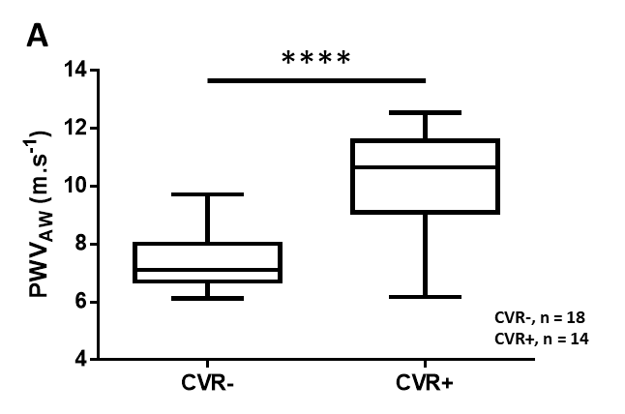
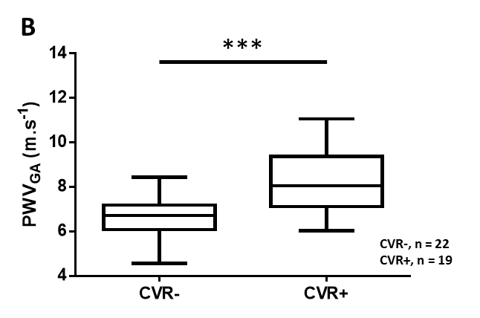
Supplementary Material 6. Variations in PWV_{GA}, MAP and HR during MAP increases (A) and decreases (B). ₀: start of MAP variation. ₁: end of MAP variation. ****p<0.0001 and NS=not significant.

