Supplementary Figures and Tables
Supplementary Figure 1. Clustering output plots.
(A) 2D multidimensional scaling representation of the similarity matrix. Dots represent subjects, whose distance reflects the similarity between them with respect to their cortical and subcortical patterns. (B) Hierarchical clustering tree result. The horizontal axis represents the distance in random forest similarity between the subjects, while the vertical axis shows the hierarchical grouping based on similarities. Colors represent different subtypes as indicated in the legend. (C) Gini index indicating the top 10 brain regions driving the Random Forest clustering.
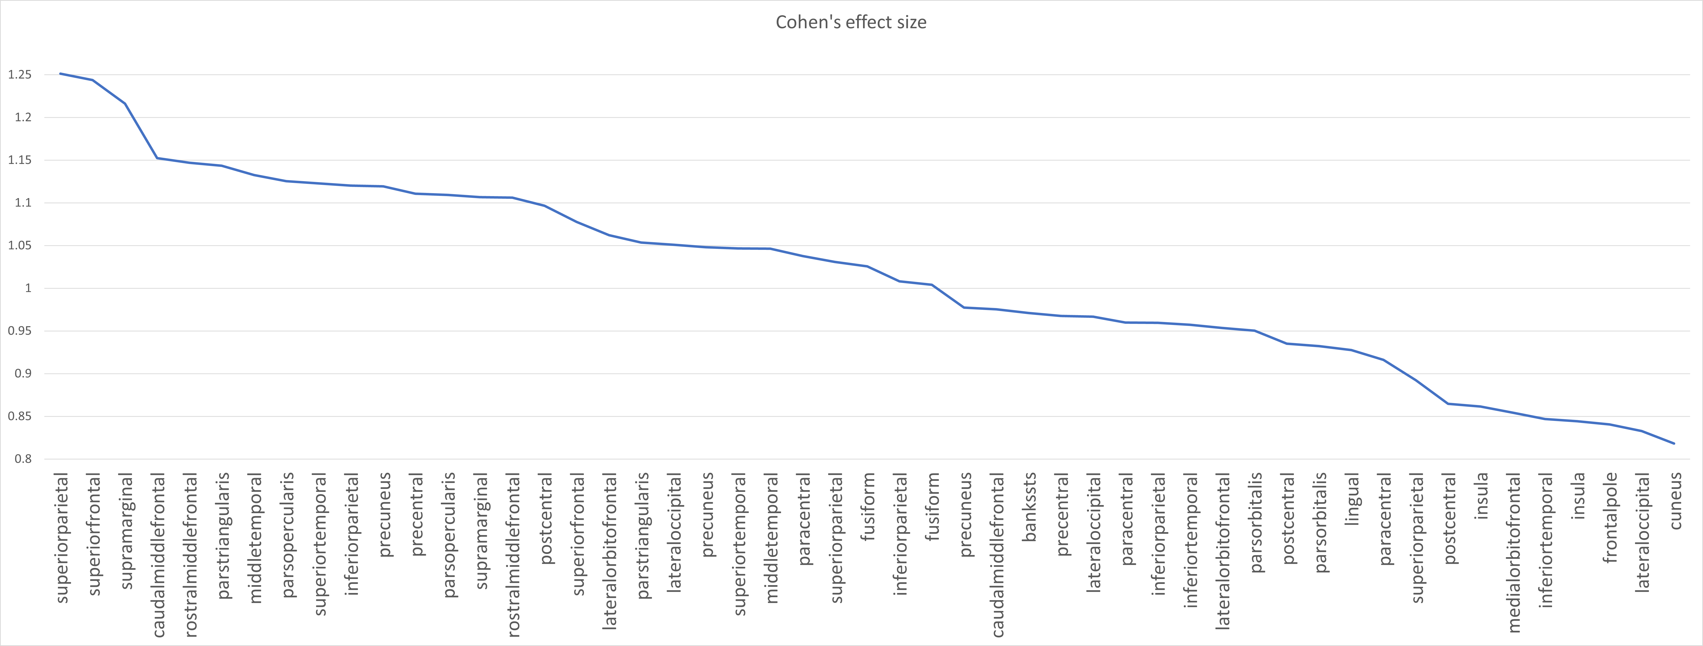
Supplementary Figure 2. Cohen’s effect size of large magnitude per ROI.

Supplementary Figure 3. Region-specific brain values per cluster.
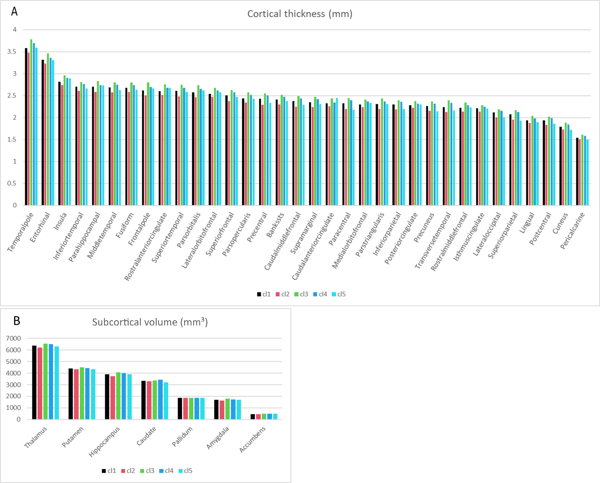(A) Cortical thickness values (mm) for all cortical regions across clusters. (B) Subcortical volume values (mm³) for all subcortical regions across clusters.

Supplementary Table 1. Characteristics of 746 dementia-free participants from the Gothenburg H70– Birth Cohort 1944 comparing CSF subsample (n=286) vs. no-CSF subsample (n=460).

 | CSF subsample (N=286) | no-CSF subsample (N=460) | Total (N=746) | p *
Sex |  |  |  | 0.231
Men | 147 (51.4) | 206 (44.8) | 353 (47.3)
Women | 139 (48.6) | 254 (55.2) | 393 (52.7)
Education, years |  |  |  | 0.189
Primary school | 33 (11.5) | 49 (10.7) | 82 (11.0)
Secondary school | 159 (55.6) | 209 (45.5) | 368 (49.4)
Higher education | 94 (32.9) | 201 (43.8) | 295 (39.6)
APOE ε4 (one/two) | 102 (36.2) | 138 (30.8) | 240 (32.9) | 0.307
MMSE score | 28.98 ± 1.23 | 29.16 ± 1.11 | 29.09 ± 1.16 | 0.047
Vascular risk factors
Current/former smoking | 177 (62.1) | 279 (60.9) | 456 (61.4) | 0.811
Alcohol risk consumption | 83 (29.1) | 152 (33.1) | 235 (31.6) | 0.490
Physical inactivity | 8 (2.8) | 17 (3.8) | 25 (3.4) | 0.626
Overweight/obese (BMI ≥25 kg/m²) | 143 (52.0) | 257 (59.6) | 400 (56.7) | 0.192
Elevated triglycerides | 94 (32.9) | 179 (39.2) | 273 (36.7) | 0.231
Reduced HDL cholesterol | 27 (9.4) | 59 (12.9) | 86 (11.6) | 0.307
LDL cholesterol |  |  |  | 0.857
T1 (≤3) | 95 (33.2) | 160 (35.1) | 255 (34.4)
T2 (3.1-3.9) | 99 (34.6) | 156 (34.2) | 255 (34.4)
T3 (≥4) | 92 (32.2) | 140 (30.7) | 232 (31.3)
Medical comorbidities
Hypertension (≥140/90 mmHg) | 210 (73.4) | 309 (67.3) | 519 (69.7) | 0.231
Heart disease | 40 (14.0) | 92 (20.0) | 132 (17.7) | 0.189
Stroke/TIA | 14 (4.9) | 43 (9.3) | 57 (7.6) | 0.189
Diabetes |  |  |  | 0.626
Normoglycemia | 124 (43.4) | 189 (41.2) | 313 (42.0)
Prediabetes | 126 (44.1) | 197 (42.9) | 323 (43.4)
Diabetes | 36 (12.6) | 73 (15.9) | 109 (14.6)
Depression (major/minor) | 26 (9.1) | 33 (7.2) | 59 (7.9) | 0.571
Traumatic brain injuries | 99 (34.6) | 143 (31.1) | 242 (32.4) | 0.566
Blood measurements
Homocysteine > 13 µmol/L | 104 (36.6) | 167 (37.4) | 271 (37.1) | 0.856
C-reactive protein ≥ 8 mg/L | 20 (7.1) | 36 (8.1) | 56 (7.7) | 0.745
Data are presented as Mean ± Standard deviations for continuous variables or number (proportion %) for categorical variables.
Abbreviations: APOE-ɛ4, apolipoprotein E gene-ɛ4 allele; MMSE, Mini-Mental State Examination; BMI, body mass index; HDL, High-density lipoprotein; LDL, Low-density lipoprotein; TIA, transient ischemic attack.
Missing data: Education (n=1), APOE-ɛ4 (n=16), MMSE (n=4), Smoking (n=3), Alcohol consumption (n=2), Physical activity (n=15), BMI (n=2), Elevated triglycerides (n=3), Reduced HDL cholesterol (n=4), LDL cholesterol (n=4), Hypertension (n=1), Heart disease (n=1), Prediabetes/diabetes (n=1), Depression (n=2), FA (n=36), Homocysteine (n=16), C-reactive protein (n=16).

Supplementary Table 2. Neuroimaging characteristics of 746 dementia-free participants from the Gothenburg H70– Birth Cohort 1944 comparing CSF subsample (n=286) vs. no-CSF subsample (n=460).

 | CSF subsample (N=286) | no-CSF subsample (N=460) | Total (N=746) | p *
GM measures
Mean cortical thickness (mm) | 2.35 ± 0.08 | 2.35 ± 0.08 | 2.35 ± 0.08 | 0.269
AD signature (mm) | 2.72 ± 0.09 | 2.73 ± 0.10 | 2.72 ± 0.09 | 0.400
Resilience signature (mm) | 2.67 ± 0.11 | 2.68 ± 0.11 | 2.68 ± 0.11 | 0.158
Small vessel disease
DTI’s Average FA |  |  |  | 0.626
T1 (<0.3) | 85 (31.4) | 152 (34.6) | 237 (33.4)
T2 (0.3 - 0.4) | 89 (32.8) | 148 (33.7) | 237 (33.4)
T3 (>0.4) | 97 (35.8) | 139 (31.7) | 236 (33.2)
WMHV, mm³ |  |  |  | 0.626
T1 (<3.2) | 97 (34.0) | 151 (33.0) | 248 (33.4)
T2 (3.2 - 6.4) | 101 (35.4) | 147 (32.1) | 248 (33.4)
T3 (>6.4) | 87 (30.5) | 160 (34.9) | 247 (33.2)
Cerebral microbleeds (presence) | 25 (8.8) | 56 (12.3) | 81 (10.9) | 0.307
Lacunes 3-15 mm | 27 (9.5) | 25 (5.5) | 52 (7.0) | 0.189
Large infarctions | 5 (1.8) | 10 (2.2) | 15 (2.0) | 0.785
Enlarged PVS
Centrum semiovale |  |  |  | 0.189
0-10 | 63 (22.2) | 133 (29.1) | 196 (26.5)
$≥$11 | 221 (77.8) | 324 (70.9) | 545 (73.5)
Basal ganglia |  |  |  | 0.626
0-10 | 219 (77.1) | 364 (79.6) | 583 (78.7)
$≥$11 | 65 (22.9) | 93 (20.4) | 158 (21.3)

Data are presented as number (proportion %) for categorical variables.
Abbreviations: MRI, Magnetic Resonance Imaging; AD, Alzheimer’s Disease; DTI, diffusion tensor imaging; FA, fractional anisotropy; WMHV, white matter hyperintensities volume; PVS, perivascular spaces.
Missing data: WMHV (n=3), Cerebral microbleeds (n=6), Lacunes (n=3), Large infarctions (n=4), Enlarged PVS Centrum semiovale (n=5), Enlarged PVS Basal ganglia (n=5).
* P value <0.05.

Supplementary Table 3. Odds ratios (ORs) and 95% confidence intervals (CIs) of a panel of the four multinomial regression models (health and sociodemographic, cerebrovascular, inflammation, and CSF) between clusters. Cluster 1 is set as reference for outcome measures. CSF analyses were conducted in a subset of 286 participants. Asterisks (*) and red color indicate statistical significance.

 | Cluster 2 |  |  |  | Cluster 3 |  |  |  | Cluster4 |  |  |  | Cluster 5
 | OR |  | 95% CI |  | OR |  | 95% CI |  | OR |  | 95% CI |  | OR |  | 95% CI
Health and sociodemographic
Sex
Men | Reference |  |  |  | Reference |  |  |  | Reference |  |  |  | Reference
Women | 1.13 | 0.70 |  | 1.83 | 1.16 | 0.71 |  | 1.88 | 1.20 | 0.76 |  | 1.90 | 1.50 | 0.74 |  | 3.03
Education, years
Primary school | Reference |  |  |  | Reference |  |  |  | Reference |  |  |  | Reference
Secondary school | 1.27 | 0.64 |  | 2.54 | 2.06 | 0.84 |  | 5.04 | 2.14 | 0.94 |  | 4.86 | 0.63 | 0.23 |  | 1.73
Higher education | 0.93 | 0.44 |  | 1.99 | 2.13 | 0.84 |  | 5.38 | 2.52* | 1.08 |  | 5.87 | 1.09 | 0.39 |  | 3.02
APOE ε
No ε allele | Reference |  |  |  | Reference |  |  |  | Reference |  |  |  | Reference
One/two ε allele | 1.19 | 0.74 |  | 1.92 | 0.95 | 0.57 |  | 1.57 | 1.16 | 0.73 |  | 1.84 | 1.19 | 0.59 |  | 2.40
Current/former smoking | 1.08 | 0.67 |  | 1.74 | 0.86 | 0.54 |  | 1.38 | 0.62* | 0.40 |  | 0.95 | 0.79 | 0.40 |  | 1.56
Alcohol risk consumption | 1.83* | 1.13 |  | 2.97 | 1.12 | 0.67 |  | 1.86 | 0.93 | 0.57 |  | 1.53 | 2.09* | 1.05 |  | 4.16
Physical inactivity | 0.62 | 0.20 |  | 1.99 | 0.55 | 0.11 |  | 2.66 | 0.48 | 0.10 |  | 2.35 | 1.82 | 0.43 |  | 7.63
Overweight/obese (BMI ≥25 kg/m2) | 1.09 | 0.67 |  | 1.79 | 0.57* | 0.35 |  | 0.94 | 1.04 | 0.65 |  | 1.66 | 0.89 | 0.43 |  | 1.83
Elevated triglycerides | 1.06 | 0.63 |  | 1.79 | 0.91 | 0.52 |  | 1.57 | 0.55* | 0.32 |  | 0.95 | 0.46 | 0.20 |  | 1.06
Reduced HDL cholesterol | 0.90 | 0.44 |  | 1.83 | 0.82 | 0.36 |  | 1.89 | 1.20 | 0.59 |  | 2.43 | 0.97 | 0.32 |  | 2.91
LDL cholesterol
T1 (≤3) | Reference |  |  |  | Reference |  |  |  | Reference |  |  |  | Reference
T2 (3.1-3.9) | 0.89 | 0.50 |  | 1.56 | 0.71 | 0.39 |  | 1.29 | 1.19 | 0.68 |  | 2.08 | 1.05 | 0.43 |  | 2.59
T3 (≥4) | 0.73 | 0.40 |  | 1.31 | 0.83 | 0.46 |  | 1.49 | 0.99 | 0.55 |  | 1.76 | 1.80 | 0.75 |  | 4.30
Hypertension (≥140/90 mmHg) | 1.10 | 0.65 |  | 1.89 | 1.02 | 0.61 |  | 1.70 | 1.00 | 0.62 |  | 1.62 | 1.04 | 0.49 |  | 2.18
Heart disease | 0.77 | 0.40 |  | 1.49 | 1.27 | 0.65 |  | 2.48 | 1.70 | 0.92 |  | 3.15 | 3.44* | 1.48 |  | 8.01
Stroke/TIA | 1.18 | 0.53 |  | 2.62 | 0.94 | 0.36 |  | 2.46 | 0.93 | 0.38 |  | 2.24 | 1.20 | 0.35 |  | 4.09
Diabetes
Normoglycemia | Reference |  |  |  | Reference |  |  |  | Reference |  |  |  | Reference
Prediabetes | 1.00 | 0.59 |  | 1.68 | 1.13 | 0.68 |  | 1.88 | 0.91 | 0.56 |  | 1.47 | 1.25 | 0.60 |  | 2.63
Diabetes | 2.54* | 1.27 |  | 5.06 | 0.85 | 0.36 |  | 2.02 | 1.06 | 0.49 |  | 2.28 | 1.50 | 0.48 |  | 4.72
Depression (major/minor) | 0.67 | 0.31 |  | 1.45 | 0.77 | 0.35 |  | 1.69 | 0.17* | 0.05 |  | 0.56 | 0.93 | 0.32 |  | 2.66
Traumatic brain injuries | 1.27 | 0.79 |  | 2.04 | 1.04 | 0.63 |  | 1.71 | 1.34 | 0.85 |  | 2.13 | 0.86 | 0.41 |  | 1.78
Cerebrovascular
DTI’s Average FA
T1 (<0.3) | Reference |  |  |  | Reference |  |  |  | Reference |  |  |  | Reference
T2 (0.3 - 0.4) | 0.61 | 0.36 |  | 1.04 | 1.20 | 0.65 |  | 2.24 | 1.61 | 0.93 |  | 2.76 | 0.95 | 0.44 |  | 2.06
T3 (>0.4) | 0.43* | 0.24 |  | 0.78 | 1.59 | 0.87 |  | 2.91 | 1.38 | 0.79 |  | 2.41 | 0.50 | 0.21 |  | 1.22
WMHV, mm3
T1 (<3.2) | Reference |  |  |  | Reference |  |  |  | Reference |  |  |  | Reference
T2 (3.2 - 6.4) | 0.86 | 0.48 |  | 1.53 | 0.45* | 0.26 |  | 0.77 | 0.54* | 0.33 |  | 0.88 | 0.72 | 0.35 |  | 1.47
T3 (>6.4) | 1.30 | 0.72 |  | 2.36 | 0.50* | 0.27 |  | 0.91 | 0.65 | 0.38 |  | 1.12 | 0.23* | 0.08 |  | 0.64
Cerebral microbleeds (presence) | 0.73 | 0.38 |  | 1.42 | 0.96 | 0.47 |  | 1.96 | 0.73 | 0.36 |  | 1.47 | 0.16 | 0.02 |  | 1.22
Lacunes 3-15 mm | 0.46 | 0.20 |  | 1.05 | 0.53 | 0.20 |  | 1.36 | 0.18* | 0.05 |  | 0.62 | 0.65 | 0.18 |  | 2.41
Large infarctions | 3.01 | 0.73 |  | 12.39 | 1.31 | 0.13 |  | 13.38 | 0.92 | 0.09 |  | 9.40 | 10.80* | 1.42 |  | 82.23
Enlarged PVS in centrum semiovale
0-10 | Reference |  |  |  | Reference |  |  |  | Reference |  |  |  | Reference
≥11 | 1.15 | 0.68 |  | 1.94 | 1.36 | 0.80 |  | 2.32 | 1.12 | 0.70 |  | 1.81 | 1.94 | 0.86 |  | 4.37
Enlarged PVS in basal ganglia
0-10 | Reference |  |  |  | Reference |  |  |  | Reference |  |  |  | Reference
≥11 | 1.41 | 0.83 |  | 2.42 | 1.01 | 0.54 |  | 1.89 | 1.37 | 0.79 |  | 2.38 | 1.36 | 0.59 |  | 3.13
Inflammation
Homocysteine > 13 µmol/L | 1.01 | 0.66 |  | 1.52 | 0.76 | 0.48 |  | 1.19 | 0.82 | 0.55 |  | 1.24 | 0.40* | 0.19 |  | 0.84
C-reactive protein ≥ 8 mg/L | 1.69 | 0.83 |  | 3.47 | 1.32 | 0.59 |  | 2.95 | 0.68 | 0.28 |  | 1.66 | 2.02 | 0.76 |  | 5.37
CSF
Amyloid-β 1-42 ≥ 530 pg/mL | 0.76 | 0.39 |  | 1.45 | 0.69 | 0.34 |  | 1.41 | 1.01 | 0.53 |  | 1.91 | 1.16 | 0.43 |  | 3.08
Total tau ≥ 350 pg/mL | 0.76 | 0.36 |  | 1.58 | 1.10 | 0.51 |  | 2.35 | 1.41 | 0.72 |  | 2.77 | 3.35* | 1.22 |  | 9.14
Phosphorylated tau ≥ 80 pg/mL | 0.57 | 0.11 |  | 2.91 | 0.37 | 0.04 |  | 3.14 | 1.47 | 0.43 |  | 5.04 | 1.90 | 0.35 |  | 10.22

Supplementary Table 4. β (beta estimates) of a panel of the six Generalized Linear Models (GLM) (global cognition, episodic memory, attention and perceptual speed, executive function, verbal fluency, visuospatial abilities) between clusters. Cluster 1 is set as reference for prediction measures. Asterisks (*) and red color indicate statistical significance. Points (.) indicate marginal significance.
 | β (Estimate) | SE | t value | p-value
Global cognition
Cluster 2 | -0.122 | 0.063 | -1.943 | 0.052 .
Cluster 3 | 0.079 | 0.067 | 1.177 | 0.239
Cluster 4 | 0.158 | 0.061 | 2.575 | 0.010 *
Cluster 5 | -0.036 | 0.096 | -0.373 | 0.709
Episodic memory
Cluster 2 | -0.190 | 0.077 | -2.472 | 0.014 *
Cluster 3 | 0.070 | 0.083 | 0.851 | 0.395
Cluster 4 | 0.155 | 0.075 | 2.059 | 0.040 *
Cluster 5 | -0.011 | 0.118 | -0.096 | 0.924
Attention and perceptual speed
Cluster 2 | -0.119 | 0.081 | -1.476 | 0.140
Cluster 3 | 0.078 | 0.087 | 0.902 | 0.367
Cluster 4 | 0.076 | 0.079 | 0.973 | 0.331
Cluster 5 | -0.070 | 0.123 | -0.565 | 0.572
Executive function
Cluster 2 | -0.157 | 0.082 | -1.910 | 0.057 .
Cluster 3 | 0.005 | 0.088 | 0.055 | 0.956
Cluster 4 | 0.068 | 0.080 | 0.846 | 0.398
Cluster 5 | -0.122 | 0.125 | -0.976 | 0.329
Verbal fluency
Cluster 2 | 0.017 | 0.088 | 0.190 | 0.849
Cluster 3 | 0.161 | 0.094 | 1.714 | 0.087 .
Cluster 4 | 0.237 | 0.086 | 2.771 | 0.006 **
Cluster 5 | 0.096 | 0.134 | 0.716 | 0.474
Visuospatial abilities
Cluster 2 | -0.209 | 0.103 | -2.022 | 0.044 *
Cluster 3 | 0.053 | 0.110 | 0.481 | 0.631
Cluster 4 | 0.222 | 0.099 | 2.229 | 0.026 *
Cluster 5 | -0.070 | 0.159 | -0.436 | 0.663

