Supplementary material
Geographic Information System based multi-criteria decision-making for onshore wind farm site selection in Brazil
Lucas Garbellinia,1, Shangjun Keb,1, Srinivasa Raghavendra Bhuvan Gummidib, Di Dong c, Morten Birkvedb, Gang Liuc, d, ∗
ª Sustainability Graduate Program, University of Sao Paulo, R. Arlindo Bettio 100, São Paulo, 03828-000, Brazil
b SDU Life Cycle Engineering, Department of Green Technology, University of Southern Denmark, Odense, 5230, Denmark
^{c} College of Urban and Environmental Sciences, Peking University, Beijing, 100871, China
^{d} Institute of Carbon Neutrality, Peking University, Beijing, 100871, China

*Corresponding author: Gang Liu (gangliu@pku.edu.cn)
1. Lucas Garbellini and Shangjun Ke contribute equally as co-first authors.

Section 1: Case country and data details
Non-RE sources contributed 52.6% to Brazil's total energy supply in 2022, predominantly in the transportation sector (EPE, 2023). RE sources fulfilled 45% of Brazil's primary energy demand in 2023 (Brasil, 2021a). Hydropower and wind power became the major contributors to Brazil's electricity generation in 2022, providing 62% and 11.8% respectively (ABEEólica, n.d.).
Based on projections of population growth, GDP growth, and cultural and social trends, Brazil anticipates its electricity consumption to triple by 2050 (compared to 2015), reaching 214 GW (Brasil, 2020). The estimated gross capacity for onshore wind energy potential, considering sites with mean wind speed exceeding 7 m/s, reaches 315 GW (Brasil, 2020). Brazil's wind farms usually achieve a capacity factor of 60%, more than double the global average of 24.7%(Li et al., 2020). Brazil’s National Energy Plan 2050 suggests that the country could have a cumulative wind energy demand ranging from 109 GW to 246 GW by 2050, according to the most expansive wind energy scenarios (Brasil, 2020).
Brazil would benefit from electrifying its economic growth by expanding its RE sources, especially for transportation and industrial sectors, as it could contribute to the reduction of greenhouse gas emissions. The Brazilian government is deliberating a subsidy program to incentivize the adoption of clean RE sources to achieve this goal in 2022 (Brasil, 2023a).

Table S1. Brazil country profile.
Parameter | 1990 | 2000 | 2010 | 2020 | Source
Land area (km²) | 8,515,770 |  |  |  | (IBGE, 2018)
Renewable energy generation, excluding hydropower (% of total electricity generation) | 1.73 | 2.25 | 6.53 | 10.46 | (EPE, 2022)
Renewable electricity output (% of total electricity output) | 94.50 | 89.49 | 84.72 | 84.2 | (EPE, 2022)
Electricity consumption (kWh per capita) | 1460.76 | 1897.35 | 2374.12 | 2254.6 | (EPE, n.d.)

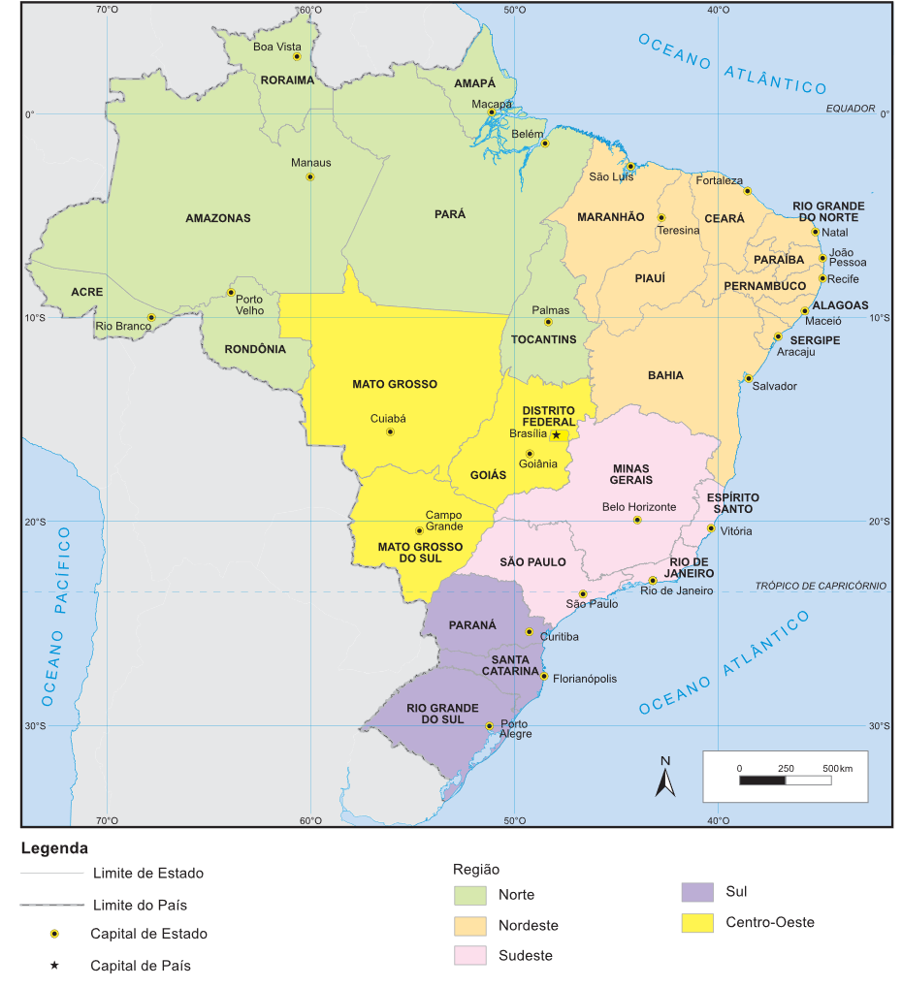 | 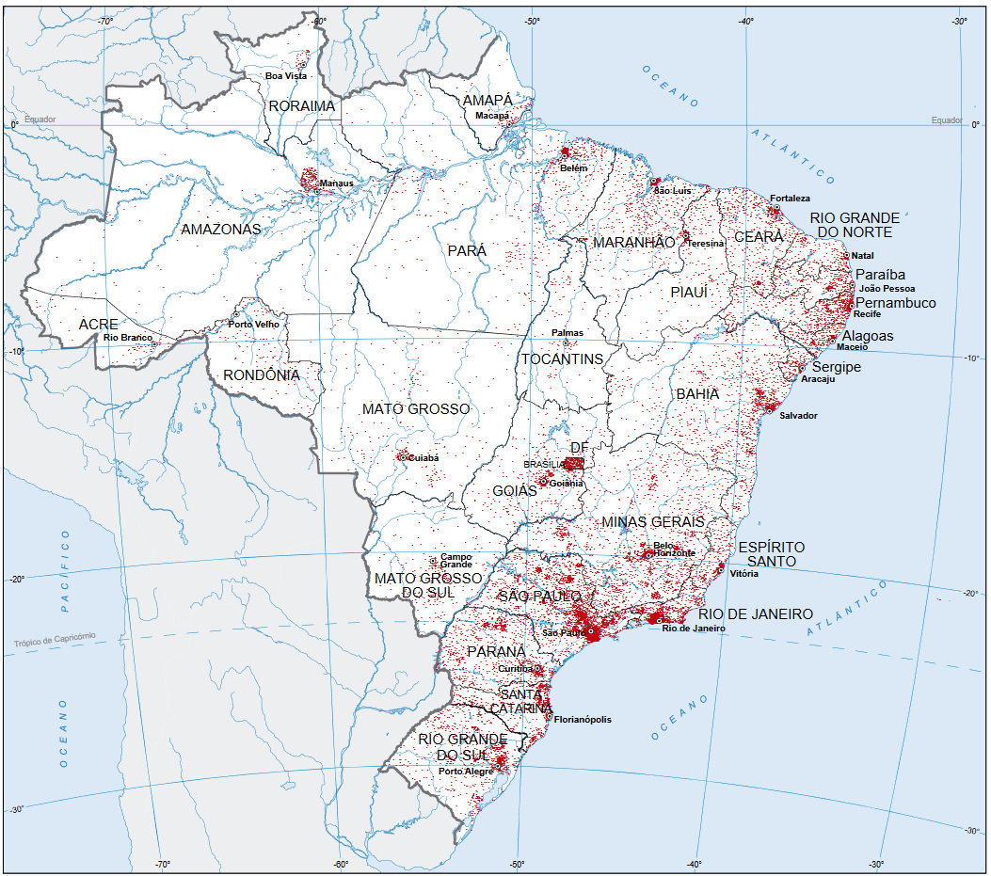

Figure S1. Brazil's regional and states division (a), and population distribution (b) (Brasil, 2022a)

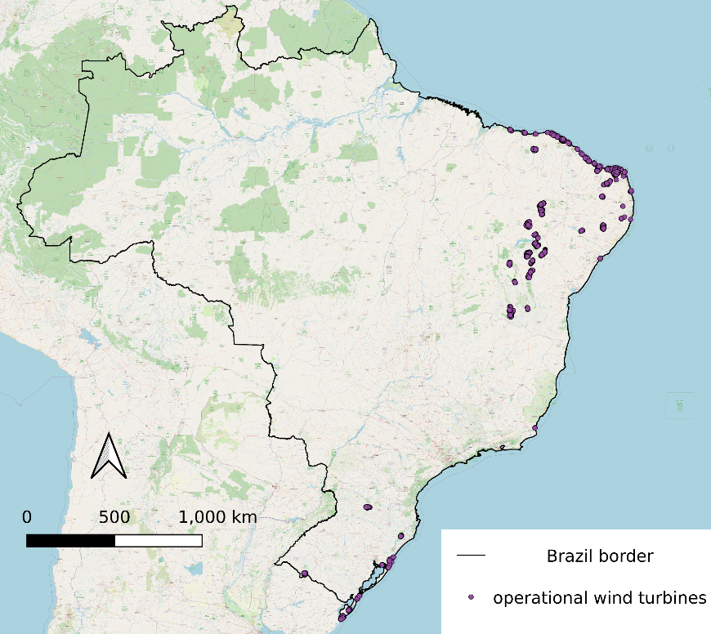

Figure S2. Brazil onshore territory and geographical distribution of existing wind turbines (Brasil, 2021a)

The median values in Table S2 indicates that existing wind farms were installed in safe enough distance from the constraint factors (excluding wind speed), but minimum values show exceptions, such as for distance to Indigenous territory, urbanized areas. This is even more problematic for IBAs, which the statistical analysis was not possible to be conducted due to the existence of wind turbines inside these areas. This assessment further supported the definition of each minimum distance considered in this study, which are presented and explained in Table S2. Not all the most conservative values found in literature were adopted for this study, as we understand that environmental licensing is the legitimate mechanism for determining the conditions and implementation of individual projects.

Table S2. Statistical analysis of distance from existing wind turbines to constraint factors within Brazil and comparison with literature-derived values for other nations.
Type |  | Brazil onshore territory |  |  | Iran | Ecuador | Nigeria | Ethiopia | France | Saudi Arabia | Review on wind farm site selection
Factor | Unit | Statistical analysis of existing wind turbines |  |  | (Moradi et al., 2020) | (Villacreses et al., 2017) | (Ayodele et al., 2018) | (Yegizaw & Mengistu, 2023) | (Ifkirne et al., 2022) | (Baseer et al., 2017) | (Rediske et al., 2021)*
Factor | Unit | Min | Max | Median
Wind speed | m/s | 4.49 | 15.1 | 8.76 | >5.6 | >5 | >4.4 | >5.6 | >5 | >5 | 7> x>25
Existing wind turbines | m | - | - | - | - | - | - | - | - | - | -
Distance to power grid | km | 0.016 | 172.78 | 42.62 | >0.25 | - | >0.25 | <0,25;  >20 | >1.5^{c} | <10 | Not specified
Distance to Environmental Protection Areas | km | 0.49 | 188.47 | 80.36 | >2 | >0.25 | >0.5 | - | >2 | - | >1^{d}, >0.5e
Water bodies and streams | km | 0.06 | 32.80 | 3.44 | >1ª, >0.5^{b} | >4 | >0.2 | >1ª, >0.2^{b} | >2 | - | >0.4
Distance to IBAs | km | - | - | - | - | - | >0.3 | - | - | >0.3 | Not specified
Distance to Indigenous territory | km | 0.07 | 320.74 | 173.5 | - | - | - | - | - | - | -
Distance to urban settlements | km | 0.18 | 282.65 | 76.62 | >2.5 | >3 | >2 | >3.5 | >2 | >0.5 | >1; >0.5 ^{f}
Distance to roads | km | 0.28 | 72.92 | 19.33 | >0.50 | - | >0.50, <10 | <0.5, >10 | >2 | - | >0.5
Distance to airports | km | 3.15 | 108.85 | 31.92 | >2.5 | >2.5 | >5 | >4 | - | >2.5 | 2.5
Distance to ports | km | 2.54 | 399.88 | 131.9 | - | - | - | - | - | - | -
Distance to railways | km | 0.01 | 234.05 | 33.66 | >0.30 | - | - | - | >2 | - | Not specified
Altitude | m | 0 | 1439.0 | 321 | <2000 | - | - | - | <1500 | - | -
Slope | %, | 0 | 19.91 | - | <30 | <15 | <15 | <40 | <15 | - | <25
Legend: a- minimum distance to lakes; b- minimum distance to rivers; c- maximum distance from power stations; d- cultural landscapes; e- nature reserves, f- rural areas. *- the least restricted values from this study are listed.
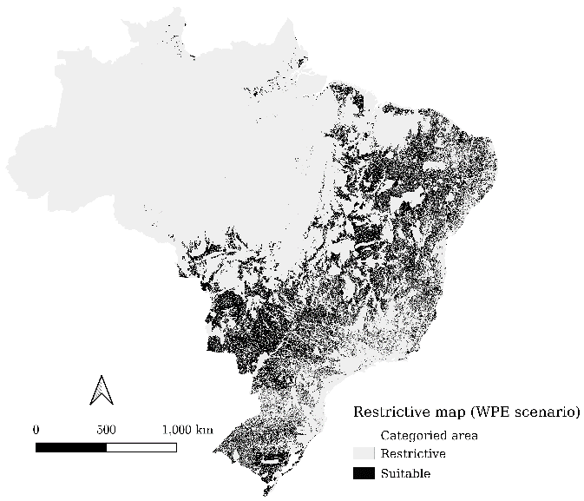  a). | b)
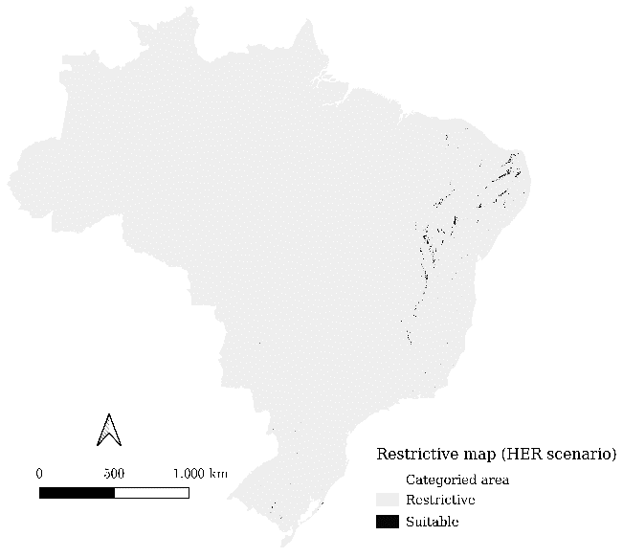

Figure S3. The integrated restrictive maps for the WPE (a) and HER (b) scenarios in Brazil.
In this supplementary file, we compile the responses provided by experts into a structured table. For each question, we eliminate the highest and lowest values to mitigate any outlier effects. Subsequently, we compute the mean of the remaining values. To refine our analysis further, we calculate the average between this mean and the responses provided by two experts from Denmark. The result serves as the final input value for our study.

Table S3. Evaluation criteria for this research.
Evaluation criteria | Category
Wind speed | Technical/ Economic
Distance to roads | Economic/Technical
Distance to existing wind farms | Technical / Economic
Distance to the power grid | Technical / Economic
Distance to urban settlements | Social/Economic
Distance to ports and railways | Technical / Economic
Mean wind speed of a site is a crucial factor for determining the economic viability of a wind farm project. In this study we considered that the higher a mean wind speed of a site, the best its suitability score is. Existing proximity to roads can benefit a wind farm project by reducing costs with transportation of wind farm components and personnel. Only the federal pavemented roads were considered as a criterion of interest, as they are more likely to have the necessary structure to support the transportation of large-sized and heavy wind farm equipment. The proximity to existing wind turbines is defined as a technical/economic criterion that could benefit newly installed wind farms by utilizing established infrastructures nearby. Additionally, proximity to the power line can reduce the costs of installing transmission lines. Furthermore, shorter distances from future wind farm projects to urban settlements can minimize electricity loss from long-distance transmission. Only urbanized areas with a population higher than 200,000 inhabitants were considered as an evaluation criterion in this study.
Lastly, in Brazil, regions rich in waterways such as the north and northeast, maritime and river transport are more prevalent. and the railway network is relatively underdeveloped and unevenly distributed across the country but is commonly used where it is available. Thus, the proximity to ports and railways could also essentially facilitate the transportation of wind turbine components and ease regular maintenance. Airports were not encompassed in this criterion. Even though airplane transportation could facilitate of workers to future wind farms, this is not a sustainable way of transportation to be counted with.

Table S4. The scale of relative importance (Saaty, 2001)
Level | Importance preference | Interpretation
1 | Equal importance | Two sub-objectives contribute equally to the objective
3 | Weak importance of one over the other | Experience and judgment slightly favor one sub-objective over another
5 | Moderate importance | Experience and judgment moderately favor one sub-objective over another
7 | Strong importance | A sub-objective is strongly favored, and its dominance demonstrated in practice
9 | Very strong importance | The evidence favoring one sub-objective over another is of the highest possible order of affirmation
2, 4, 6, 8 | Intermediate values | A compromise is needed due to the difficulty of c distinguishing between the sub-objectives’' importance levels.

Table S5. Results of survey for Brazilian experts
Expert No | 1 | 2 | 3 | 4 | 5 | 6 | 7 | 8 | 9
State | São Paulo | São Paulo | Rio de Janeiro | São Paulo | São Paulo | São Paulo | Odense | Odense | Rio de Janeiro
/City
Area | Technical / Economic (e.g., energy engineers, entrepreneurs) |  |  |  |  | Environmental (e.g., inspectors and/or researchers)
of Expertise
Wind Speed vs Roads | 7 | 8 | 7 | 7 | 5 | 5 | 2 | 1 | 4
Wind Speed vs Op. Wind Farms | 7 | 6 | 4 | 9 | 5 | 9 | 3 | 3 | 4
Wind Speed vs Power Grid | 9 | 8 | 6 | 5 | 7 | 5 | 5 | 4 | 4
Wind Speed vs Urban settlements | 3 | 5 | 8 | 9 | 9 | 5 | 6 | 7 | 4
Wind Speed vs Railways/Ports | 3 | 6 | 6 | 8 | 4 | 9 | 8 | 8 | 1
Roads vs Op. Wind Farms | 5 | 5 | 3 | 9 | 5 | 9 | 1 | 1 | 1
Roads vs Power Grid | 9 | 5 | 4 | 3 | 4 | 5 | 2 | 3 | 1
Roads vs Urban settlements | 3 | 5 | 2 | 9 | 4 | 5 | 4 | 4 | 1
Roads vs Railways/Ports | 3 | 6 | 7 | 6 | 4 | 9 | 5 | 5 | 1
Op. Wind Farms vs Power Grid | 9 | 4 | 3 | 3 | 2 | 5 | 3 | 3 | 1
Op. Wind Farms vs Urban settlements | 3 | 6 | 8 | 3 | 2 | 4 | 4 | 4 | 1
Op. Wind Farms vs Railways/Ports | 3 | 3 | 6 | 3 | 4 | 9 | 5 | 6 | 1
Power Grid vs Urban settlements | 3 | 9 | 9 | 9 | 5 | 4 | 1 | 1 | 5
Power Grid vs Railways/Ports | 3 | 7 | 7 | 9 | 5 | 5 | 2 | 2 | 1
Urban settlements vs Railways/Ports | 1 | 8 | 3 | 3 | 3 | 7 | 1 | 1 | 1

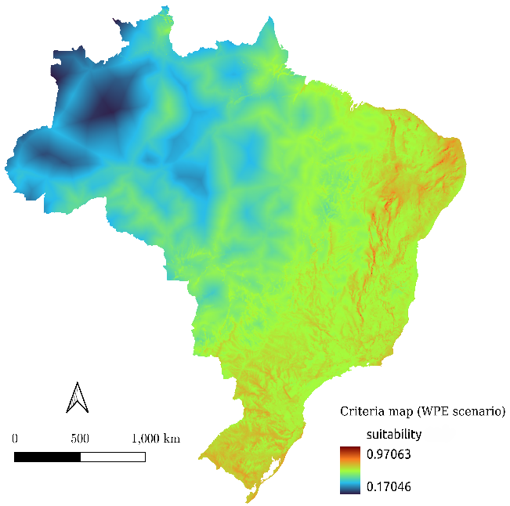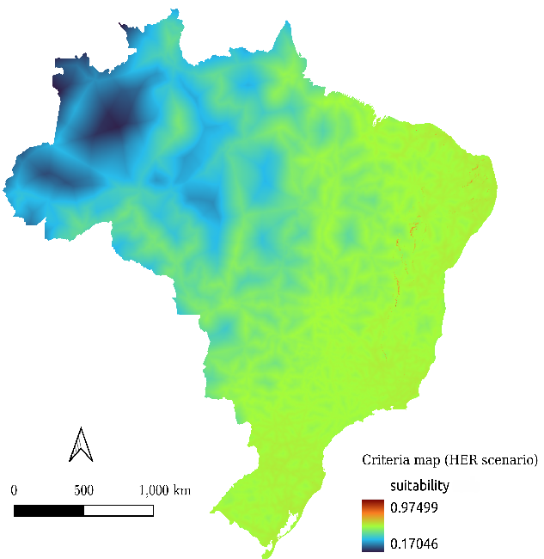

Figure S4. The aggregated weighted criteria maps under the WPE (a) and HER (b) scenarios.

Table S6. Data source and its format
No. | Data | Data format | Source
1 | Wind speed | Raster | Global Wind Atlas (DTU Wind Energy & World Bank Group, 2018)
2 | Existing wind turbines | Shapefile | National Agency of Electric Energy - ANEEL (Brasil, 2021b)
3 | Power grid | Shapefile | Electricity System National Operator - ONS (ONS, 2016)
4 | Environmental protection Areas | Raster | National Water Agency – ANA (Brasil, 2019)
5 | Water bodies and streams | Shapefile | National Water Agency – ANA (Brasil, 2012)
6 | IBAs | Shapefile | Birdlife International and SAVE Brasil (De Luca et al., 2009)
7 | Indigenous territory | Shapefile | National Indian Foundation – FUNAI (Brasil, 2021c)
8 | Urban settlements | Shapefile | IBGE (Brasil, 2022b)
9 | Roads | Shapefile | Ministry of Infrastructure – MINFRA (Brasil, 2023b)
10 | Airports | Shapefile | Ministry of Infrastructure – MINFRA (Brasil, 2023b)
11 | Ports | Shapefile | Ministry of Infrastructure – MINFRA (Brasil, 2023b)
12 | Railways | Raster | Ministry of Infrastructure – MINFRA (Brasil, 2023b)
13 | Altitude | Shapefile | DIVA-GIS (Hijmans, 2016)
14 | Land slope | Shapefile | DIVA-GIS (Hijmans, 2016)

Section 2: Additional results

Table S7. Brazilian States with suitable areas for onshore wind farms in the HER scenario
Brazilian State | Area (km²) | Share of Total  Suitable Area (%)
Bahia | 6946.74 | 50.24
Paraiba | 1905.97 | 13.78
Rio Grande do Norte | 1789.07 | 12.94
Minas Gerais | 1094.19 | 7.91
Piaui | 657.44 | 4.75
Pernambuco | 574.58 | 4.16
Ceará | 492.09 | 3.56
Rio Grande do Sul | 222.71 | 1.61
Alagoas | 48.19 | 0.35
Paraná | 35.35 | 0.26
Sergipe | 15.44 | 0.11
Gioias | 13.69 | 0.1
Santa Catarina | 6.53 | 0.047
Rio de Janeiro | 6.50 | 0.047

Table S8. Suitable area for Brazil Stats and municipalities under HER scenario.
State | Municipality | Municipality Area (km²) | State Area (km²) | Municipality Percentage (%) | State Percentage (%)
Total |  | 13,331.91
BA | Gentio do Ouro | 871.55 | 6881.819685 | 6.54% | 51.62%
BA | Campo Formoso | 691.61 | 6881.819685 | 5.19% | 51.62%
BA | Morro do Chapéu | 293.69 | 6881.819685 | 2.20% | 51.62%
BA | Xique-Xique | 290.27 | 6881.819685 | 2.18% | 51.62%
BA | Brotas de Macaúbas | 283.48 | 6881.819685 | 2.13% | 51.62%
BA | Ibitiara | 256.18 | 6881.819685 | 1.92% | 51.62%
BA | Rodelas | 230.99 | 6881.819685 | 1.73% | 51.62%
BA | Casa Nova | 192.32 | 6881.819685 | 1.44% | 51.62%
BA | Caetité | 190.22 | 6881.819685 | 1.43% | 51.62%
BA | Piatã | 177.67 | 6881.819685 | 1.33% | 51.62%
BA | Jussara | 175.99 | 6881.819685 | 1.32% | 51.62%
BA | Riacho de Santana | 167.27 | 6881.819685 | 1.25% | 51.62%
BA | Urandi | 153.58 | 6881.819685 | 1.15% | 51.62%
BA | Juazeiro | 149.12 | 6881.819685 | 1.12% | 51.62%
BA | Jacobina | 128.83 | 6881.819685 | 0.97% | 51.62%
BA | Seabra | 126.11 | 6881.819685 | 0.95% | 51.62%
BA | Pindaí | 122.76 | 6881.819685 | 0.92% | 51.62%
BA | Mirangaba | 113.68 | 6881.819685 | 0.85% | 51.62%
BA | Igaporã | 113.66 | 6881.819685 | 0.85% | 51.62%
BA | Paratinga | 113.17 | 6881.819685 | 0.85% | 51.62%
BA | Novo Horizonte | 109.20 | 6881.819685 | 0.82% | 51.62%
BA | Macururé | 107.36 | 6881.819685 | 0.81% | 51.62%
BA | Guanambi | 95.57 | 6881.819685 | 0.72% | 51.62%
BA | Ipupiara | 94.37 | 6881.819685 | 0.71% | 51.62%
BA | Cafarnaum | 90.26 | 6881.819685 | 0.68% | 51.62%
BA | Várzea Nova | 88.48 | 6881.819685 | 0.66% | 51.62%
BA | Glória | 87.47 | 6881.819685 | 0.66% | 51.62%
BA | Oliveira dos Brejinhos | 76.52 | 6881.819685 | 0.57% | 51.62%
BA | Jaguarari | 75.47 | 6881.819685 | 0.57% | 51.62%
BA | Érico Cardoso | 72.56 | 6881.819685 | 0.54% | 51.62%
BA | Ibotirama | 71.37 | 6881.819685 | 0.54% | 51.62%
BA | Ituaçu | 66.21 | 6881.819685 | 0.50% | 51.62%
BA | Barra do Mendes | 65.80 | 6881.819685 | 0.49% | 51.62%
BA | Matina | 47.70 | 6881.819685 | 0.36% | 51.62%
BA | Brumado | 47.49 | 6881.819685 | 0.36% | 51.62%
BA | Manoel Vitorino | 46.06 | 6881.819685 | 0.35% | 51.62%
BA | Boquira | 45.39 | 6881.819685 | 0.34% | 51.62%
BA | Canudos | 43.41 | 6881.819685 | 0.33% | 51.62%
BA | Dom Basílio | 39.81 | 6881.819685 | 0.30% | 51.62%
BA | Mulungu do Morro | 38.89 | 6881.819685 | 0.29% | 51.62%
BA | Rio do Pires | 34.48 | 6881.819685 | 0.26% | 51.62%
BA | Itaguaçu da Bahia | 33.80 | 6881.819685 | 0.25% | 51.62%
BA | Jacaraci | 31.89 | 6881.819685 | 0.24% | 51.62%
BA | Buritirama | 29.19 | 6881.819685 | 0.22% | 51.62%
BA | Ibipeba | 29.00 | 6881.819685 | 0.22% | 51.62%
BA | Sobradinho | 26.85 | 6881.819685 | 0.20% | 51.62%
BA | Jussiape | 26.12 | 6881.819685 | 0.20% | 51.62%
BA | São Gabriel | 25.62 | 6881.819685 | 0.19% | 51.62%
BA | Licínio de Almeida | 23.59 | 6881.819685 | 0.18% | 51.62%
BA | Boninal | 23.37 | 6881.819685 | 0.18% | 51.62%
BA | Curaçá | 23.07 | 6881.819685 | 0.17% | 51.62%
BA | Uibaí | 22.88 | 6881.819685 | 0.17% | 51.62%
BA | Sento Sé | 22.17 | 6881.819685 | 0.17% | 51.62%
BA | Ibipitanga | 21.14 | 6881.819685 | 0.16% | 51.62%
BA | Macaúbas | 20.67 | 6881.819685 | 0.16% | 51.62%
BA | Jequié | 19.19 | 6881.819685 | 0.14% | 51.62%
BA | Bom Jesus da Lapa | 18.14 | 6881.819685 | 0.14% | 51.62%
BA | Ibicoara | 17.67 | 6881.819685 | 0.13% | 51.62%
BA | Mucugê | 14.89 | 6881.819685 | 0.11% | 51.62%
BA | Antônio Gonçalves | 14.12 | 6881.819685 | 0.11% | 51.62%
BA | Euclides da Cunha | 13.15 | 6881.819685 | 0.10% | 51.62%
BA | Souto Soares | 11.51 | 6881.819685 | 0.09% | 51.62%
BA | Livramento de Nossa Senhora | 11.42 | 6881.819685 | 0.09% | 51.62%
BA | Ourolândia | 9.49 | 6881.819685 | 0.07% | 51.62%
BA | Barra da Estiva | 9.29 | 6881.819685 | 0.07% | 51.62%
BA | Pindobaçu | 9.12 | 6881.819685 | 0.07% | 51.62%
BA | Andorinha | 8.89 | 6881.819685 | 0.07% | 51.62%
BA | Itatim | 8.39 | 6881.819685 | 0.06% | 51.62%
BA | Remanso | 8.21 | 6881.819685 | 0.06% | 51.62%
BA | Morpará | 7.59 | 6881.819685 | 0.06% | 51.62%
BA | Umburanas | 6.80 | 6881.819685 | 0.05% | 51.62%
BA | Bom Jesus da Serra | 6.58 | 6881.819685 | 0.05% | 51.62%
BA | Vitória da Conquista | 6.53 | 6881.819685 | 0.05% | 51.62%
BA | Saúde | 6.51 | 6881.819685 | 0.05% | 51.62%
BA | Iaçu | 6.14 | 6881.819685 | 0.05% | 51.62%
BA | Uauá | 6.13 | 6881.819685 | 0.05% | 51.62%
BA | Monte Santo | 5.93 | 6881.819685 | 0.04% | 51.62%
BA | Rio de Contas | 5.71 | 6881.819685 | 0.04% | 51.62%
BA | Mirante | 5.08 | 6881.819685 | 0.04% | 51.62%
PB | São João do Tigre | 203.80 | 1849.296904 | 1.53% | 13.87%
PB | Picuí | 135.87 | 1849.296904 | 1.02% | 13.87%
PB | Santa Luzia | 133.15 | 1849.296904 | 1.00% | 13.87%
PB | Nova Palmeira | 123.16 | 1849.296904 | 0.92% | 13.87%
PB | São Mamede | 98.10 | 1849.296904 | 0.74% | 13.87%
PB | Imaculada | 84.76 | 1849.296904 | 0.64% | 13.87%
PB | Remígio | 79.33 | 1849.296904 | 0.60% | 13.87%
PB | São José do Sabugi | 68.14 | 1849.296904 | 0.51% | 13.87%
PB | Cacimba de Areia | 55.82 | 1849.296904 | 0.42% | 13.87%
PB | Mãe d'Água | 51.56 | 1849.296904 | 0.39% | 13.87%
PB | Pedra Lavrada | 47.95 | 1849.296904 | 0.36% | 13.87%
PB | Solânea | 45.49 | 1849.296904 | 0.34% | 13.87%
PB | Quixaba | 40.49 | 1849.296904 | 0.30% | 13.87%
PB | Cuité | 38.40 | 1849.296904 | 0.29% | 13.87%
PB | Esperança | 36.29 | 1849.296904 | 0.27% | 13.87%
PB | Araruna | 35.83 | 1849.296904 | 0.27% | 13.87%
PB | Pocinhos | 34.39 | 1849.296904 | 0.26% | 13.87%
PB | Bananeiras | 31.74 | 1849.296904 | 0.24% | 13.87%
PB | Areia de Baraúnas | 31.32 | 1849.296904 | 0.23% | 13.87%
PB | Catingueira | 28.71 | 1849.296904 | 0.22% | 13.87%
PB | Passagem | 28.06 | 1849.296904 | 0.21% | 13.87%
PB | Junco do Seridó | 27.56 | 1849.296904 | 0.21% | 13.87%
PB | Taperoá | 23.51 | 1849.296904 | 0.18% | 13.87%
PB | São Vicente do Seridó | 23.02 | 1849.296904 | 0.17% | 13.87%
PB | Teixeira | 22.49 | 1849.296904 | 0.17% | 13.87%
PB | Areia | 22.15 | 1849.296904 | 0.17% | 13.87%
PB | Arara | 20.82 | 1849.296904 | 0.16% | 13.87%
PB | Frei Martinho | 19.67 | 1849.296904 | 0.15% | 13.87%
PB | Casserengue | 19.14 | 1849.296904 | 0.14% | 13.87%
PB | Cacimbas | 17.23 | 1849.296904 | 0.13% | 13.87%
PB | Olho d'Água | 16.71 | 1849.296904 | 0.13% | 13.87%
PB | Natuba | 16.38 | 1849.296904 | 0.12% | 13.87%
PB | Algodão de Jandaíra | 16.06 | 1849.296904 | 0.12% | 13.87%
PB | Manaíra | 15.79 | 1849.296904 | 0.12% | 13.87%
PB | Dona Inês | 15.47 | 1849.296904 | 0.12% | 13.87%
PB | São José do Bonfim | 14.83 | 1849.296904 | 0.11% | 13.87%
PB | Damião | 14.18 | 1849.296904 | 0.11% | 13.87%
PB | Água Branca | 13.97 | 1849.296904 | 0.10% | 13.87%
PB | Umbuzeiro | 12.88 | 1849.296904 | 0.10% | 13.87%
PB | Salgado de São Félix | 12.27 | 1849.296904 | 0.09% | 13.87%
PB | Salgadinho | 10.10 | 1849.296904 | 0.08% | 13.87%
PB | São José de Princesa | 8.00 | 1849.296904 | 0.06% | 13.87%
PB | Juru | 7.98 | 1849.296904 | 0.06% | 13.87%
PB | Areial | 7.79 | 1849.296904 | 0.06% | 13.87%
PB | Princesa Isabel | 7.33 | 1849.296904 | 0.05% | 13.87%
PB | Maturéia | 7.02 | 1849.296904 | 0.05% | 13.87%
PB | Santa Cecília | 6.66 | 1849.296904 | 0.05% | 13.87%
PB | São Sebastião do Umbuzeiro | 6.51 | 1849.296904 | 0.05% | 13.87%
PB | Cacimba de Dentro | 6.19 | 1849.296904 | 0.05% | 13.87%
PB | Santa Teresinha | 5.27 | 1849.296904 | 0.04% | 13.87%
RN | Santana do Matos | 225.29 | 1761.627635 | 1.69% | 13.21%
RN | Pedro Avelino | 148.14 | 1761.627635 | 1.11% | 13.21%
RN | Fernando Pedroza | 139.02 | 1761.627635 | 1.04% | 13.21%
RN | Bodó | 93.63 | 1761.627635 | 0.70% | 13.21%
RN | Parelhas | 90.60 | 1761.627635 | 0.68% | 13.21%
RN | Florânia | 88.78 | 1761.627635 | 0.67% | 13.21%
RN | Carnaúba dos Dantas | 72.33 | 1761.627635 | 0.54% | 13.21%
RN | Pedra Preta | 68.94 | 1761.627635 | 0.52% | 13.21%
RN | João Câmara | 66.45 | 1761.627635 | 0.50% | 13.21%
RN | Lajes | 64.08 | 1761.627635 | 0.48% | 13.21%
RN | Caicó | 61.71 | 1761.627635 | 0.46% | 13.21%
RN | Jandaíra | 60.90 | 1761.627635 | 0.46% | 13.21%
RN | São Tomé | 60.39 | 1761.627635 | 0.45% | 13.21%
RN | Equador | 48.82 | 1761.627635 | 0.37% | 13.21%
RN | Touros | 43.39 | 1761.627635 | 0.33% | 13.21%
RN | Acari | 34.93 | 1761.627635 | 0.26% | 13.21%
RN | Angicos | 34.18 | 1761.627635 | 0.26% | 13.21%
RN | Cerro Corá | 32.94 | 1761.627635 | 0.25% | 13.21%
RN | Jucurutu | 30.52 | 1761.627635 | 0.23% | 13.21%
RN | São Miguel do Gostoso | 26.56 | 1761.627635 | 0.20% | 13.21%
RN | Lagoa Nova | 25.65 | 1761.627635 | 0.19% | 13.21%
RN | Santana do Seridó | 25.50 | 1761.627635 | 0.19% | 13.21%
RN | São José do Campestre | 20.34 | 1761.627635 | 0.15% | 13.21%
RN | Coronel Ezequiel | 16.58 | 1761.627635 | 0.12% | 13.21%
RN | Triunfo Potiguar | 16.50 | 1761.627635 | 0.12% | 13.21%
RN | Currais Novos | 15.23 | 1761.627635 | 0.11% | 13.21%
RN | Monte das Gameleiras | 14.93 | 1761.627635 | 0.11% | 13.21%
RN | Jaçanã | 13.39 | 1761.627635 | 0.10% | 13.21%
RN | Japi | 13.35 | 1761.627635 | 0.10% | 13.21%
RN | Parazinho | 12.85 | 1761.627635 | 0.10% | 13.21%
RN | Tenente Laurentino Cruz | 12.61 | 1761.627635 | 0.09% | 13.21%
RN | Campo Grande | 11.35 | 1761.627635 | 0.09% | 13.21%
RN | Campo Redondo | 10.83 | 1761.627635 | 0.08% | 13.21%
RN | São Vicente | 9.42 | 1761.627635 | 0.07% | 13.21%
RN | Bento Fernandes | 8.34 | 1761.627635 | 0.06% | 13.21%
RN | Serra de São Bento | 7.92 | 1761.627635 | 0.06% | 13.21%
RN | Lajes Pintadas | 7.87 | 1761.627635 | 0.06% | 13.21%
RN | Sítio Novo | 7.82 | 1761.627635 | 0.06% | 13.21%
RN | Caiçara do Rio do Vento | 7.54 | 1761.627635 | 0.06% | 13.21%
RN | Cruzeta | 6.27 | 1761.627635 | 0.05% | 13.21%
RN | Ruy Barbosa | 5.74 | 1761.627635 | 0.04% | 13.21%
MG | Curvelo | 130.65 | 977.3943399 | 0.98% | 7.33%
MG | Coração de Jesus | 90.66 | 977.3943399 | 0.68% | 7.33%
MG | Espinosa | 70.29 | 977.3943399 | 0.53% | 7.33%
MG | Felixlândia | 68.34 | 977.3943399 | 0.51% | 7.33%
MG | Mato Verde | 66.09 | 977.3943399 | 0.50% | 7.33%
MG | Corinto | 61.44 | 977.3943399 | 0.46% | 7.33%
MG | Três Marias | 56.46 | 977.3943399 | 0.42% | 7.33%
MG | Francisco Sá | 52.19 | 977.3943399 | 0.39% | 7.33%
MG | Várzea da Palma | 44.03 | 977.3943399 | 0.33% | 7.33%
MG | Porteirinha | 43.90 | 977.3943399 | 0.33% | 7.33%
MG | Claro dos Poções | 37.23 | 977.3943399 | 0.28% | 7.33%
MG | Monte Azul | 34.37 | 977.3943399 | 0.26% | 7.33%
MG | Santo Antônio do Retiro | 27.32 | 977.3943399 | 0.20% | 7.33%
MG | São João da Lagoa | 27.16 | 977.3943399 | 0.20% | 7.33%
MG | Lassance | 24.72 | 977.3943399 | 0.19% | 7.33%
MG | Riacho dos Machados | 21.67 | 977.3943399 | 0.16% | 7.33%
MG | Morro da Garça | 15.78 | 977.3943399 | 0.12% | 7.33%
MG | Gameleiras | 14.55 | 977.3943399 | 0.11% | 7.33%
MG | Coroaci | 14.48 | 977.3943399 | 0.11% | 7.33%
MG | Serranópolis de Minas | 13.53 | 977.3943399 | 0.10% | 7.33%
MG | Grão Mogol | 11.16 | 977.3943399 | 0.08% | 7.33%
MG | Tarumirim | 7.93 | 977.3943399 | 0.06% | 7.33%
MG | Curral de Dentro | 7.61 | 977.3943399 | 0.06% | 7.33%
MG | Buritizeiro | 7.41 | 977.3943399 | 0.06% | 7.33%
MG | Marilac | 6.73 | 977.3943399 | 0.05% | 7.33%
MG | Paraopeba | 5.85 | 977.3943399 | 0.04% | 7.33%
MG | Jequitinhonha | 5.47 | 977.3943399 | 0.04% | 7.33%
MG | Itambacuri | 5.27 | 977.3943399 | 0.04% | 7.33%
MG | Frei Inocêncio | 5.11 | 977.3943399 | 0.04% | 7.33%
PI | Dom Inocêncio | 236.52 | 636.1911885 | 1.77% | 4.77%
PI | Acauã | 101.43 | 636.1911885 | 0.76% | 4.77%
PI | Lagoa do Barro do Piauí | 92.37 | 636.1911885 | 0.69% | 4.77%
PI | Queimada Nova | 61.49 | 636.1911885 | 0.46% | 4.77%
PI | Betânia do Piauí | 43.80 | 636.1911885 | 0.33% | 4.77%
PI | Curral Novo do Piauí | 31.85 | 636.1911885 | 0.24% | 4.77%
PI | Padre Marcos | 19.59 | 636.1911885 | 0.15% | 4.77%
PI | Simões | 18.13 | 636.1911885 | 0.14% | 4.77%
PI | Francisco Macedo | 16.61 | 636.1911885 | 0.12% | 4.77%
PI | Paulistana | 8.21 | 636.1911885 | 0.06% | 4.77%
PI | Campo Alegre do Fidalgo | 6.19 | 636.1911885 | 0.05% | 4.77%
PE | Tupanatinga | 42.38 | 504.9193448 | 0.32% | 3.79%
PE | Bom Conselho | 40.19 | 504.9193448 | 0.30% | 3.79%
PE | Tacaratu | 34.94 | 504.9193448 | 0.26% | 3.79%
PE | Belo Jardim | 34.90 | 504.9193448 | 0.26% | 3.79%
PE | Arcoverde | 32.94 | 504.9193448 | 0.25% | 3.79%
PE | Ibimirim | 30.59 | 504.9193448 | 0.23% | 3.79%
PE | Sertânia | 28.96 | 504.9193448 | 0.22% | 3.79%
PE | Jataúba | 27.54 | 504.9193448 | 0.21% | 3.79%
PE | Saloá | 23.67 | 504.9193448 | 0.18% | 3.79%
PE | Santa Cruz da Baixa Verde | 18.97 | 504.9193448 | 0.14% | 3.79%
PE | Pesqueira | 17.40 | 504.9193448 | 0.13% | 3.79%
PE | Manari | 17.05 | 504.9193448 | 0.13% | 3.79%
PE | Poção | 15.45 | 504.9193448 | 0.12% | 3.79%
PE | Iati | 15.41 | 504.9193448 | 0.12% | 3.79%
PE | Bezerros | 12.26 | 504.9193448 | 0.09% | 3.79%
PE | Caruaru | 11.18 | 504.9193448 | 0.08% | 3.79%
PE | Afrânio | 10.86 | 504.9193448 | 0.08% | 3.79%
PE | Venturosa | 10.50 | 504.9193448 | 0.08% | 3.79%
PE | Brejo da Madre de Deus | 9.72 | 504.9193448 | 0.07% | 3.79%
PE | Carnaubeira da Penha | 8.37 | 504.9193448 | 0.06% | 3.79%
PE | Santa Filomena | 8.37 | 504.9193448 | 0.06% | 3.79%
PE | Petrolândia | 7.22 | 504.9193448 | 0.05% | 3.79%
PE | Belém do São Francisco | 7.21 | 504.9193448 | 0.05% | 3.79%
PE | Sanharó | 7.18 | 504.9193448 | 0.05% | 3.79%
PE | Inajá | 6.91 | 504.9193448 | 0.05% | 3.79%
PE | Caetés | 6.89 | 504.9193448 | 0.05% | 3.79%
PE | Serra Talhada | 6.21 | 504.9193448 | 0.05% | 3.79%
PE | Gravatá | 5.91 | 504.9193448 | 0.04% | 3.79%
PE | São Caitano | 5.73 | 504.9193448 | 0.04% | 3.79%
CE | Carnaubal | 91.64 | 464.8985429 | 0.69% | 3.49%
CE | Guaraciaba do Norte | 39.30 | 464.8985429 | 0.29% | 3.49%
CE | Itapipoca | 38.97 | 464.8985429 | 0.29% | 3.49%
CE | Pereiro | 31.15 | 464.8985429 | 0.23% | 3.49%
CE | São Benedito | 30.39 | 464.8985429 | 0.23% | 3.49%
CE | Icó | 27.73 | 464.8985429 | 0.21% | 3.49%
CE | Itapajé | 25.44 | 464.8985429 | 0.19% | 3.49%
CE | Poranga | 24.99 | 464.8985429 | 0.19% | 3.49%
CE | Ubajara | 19.31 | 464.8985429 | 0.14% | 3.49%
CE | Catunda | 17.99 | 464.8985429 | 0.13% | 3.49%
CE | Irauçuba | 17.86 | 464.8985429 | 0.13% | 3.49%
CE | Santa Quitéria | 16.73 | 464.8985429 | 0.13% | 3.49%
CE | Ipueiras | 11.96 | 464.8985429 | 0.09% | 3.49%
CE | Maranguape | 11.60 | 464.8985429 | 0.09% | 3.49%
CE | Ibiapina | 11.08 | 464.8985429 | 0.08% | 3.49%
CE | Independência | 9.74 | 464.8985429 | 0.07% | 3.49%
CE | Caridade | 9.60 | 464.8985429 | 0.07% | 3.49%
CE | Tamboril | 8.31 | 464.8985429 | 0.06% | 3.49%
CE | Caucaia | 7.67 | 464.8985429 | 0.06% | 3.49%
CE | Palmácia | 7.31 | 464.8985429 | 0.05% | 3.49%
CE | Canindé | 6.11 | 464.8985429 | 0.05% | 3.49%
RS | Dom Pedrito | 40.07 | 194.8059483 | 0.30% | 1.46%
RS | Sant'Ana do Livramento | 28.47 | 194.8059483 | 0.21% | 1.46%
RS | Rosário do Sul | 25.76 | 194.8059483 | 0.19% | 1.46%
RS | Bagé | 23.74 | 194.8059483 | 0.18% | 1.46%
RS | Tapes | 18.86 | 194.8059483 | 0.14% | 1.46%
RS | Arambaré | 15.13 | 194.8059483 | 0.11% | 1.46%
RS | Aceguá | 14.55 | 194.8059483 | 0.11% | 1.46%
RS | Júlio de Castilhos | 10.93 | 194.8059483 | 0.08% | 1.46%
RS | Itaqui | 10.17 | 194.8059483 | 0.08% | 1.46%
RS | Quaraí | 7.12 | 194.8059483 | 0.05% | 1.46%
AL | Mata Grande | 16.12 | 39.10923554 | 0.12% | 0.29%
AL | Poço das Trincheiras | 10.40 | 39.10923554 | 0.08% | 0.29%
AL | Palmeira dos Índios | 6.98 | 39.10923554 | 0.05% | 0.29%
AL | Pariconha | 5.60 | 39.10923554 | 0.04% | 0.29%
PR | Barbosa Ferraz | 7.33 | 13.70276192 | 0.05% | 0.10%
PR | Novo Itacolomi | 6.38 | 13.70276192 | 0.05% | 0.10%
SE | Tobias Barreto | 8.15 | 8.145539064 | 0.06% | 0.06%

Figure S5. The statistical analysis of installed capacity per square kilometers of Brazilian wind farms during 2020 to 2021
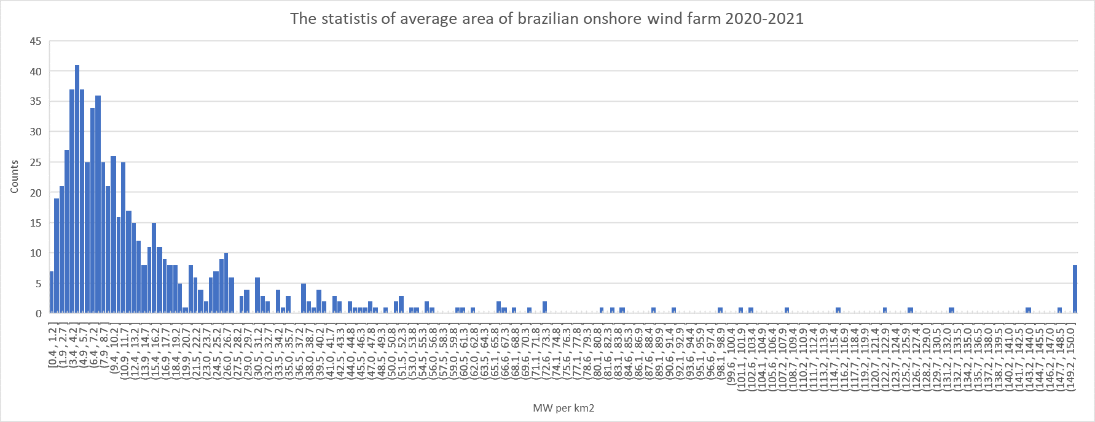

References in the supplementary material
ABEEólica. (n.d.). ABEEólica ASSOCIAÇÃO BRASILEIRA DE ENERGIA EÓLICA E NOVAS TECNOLOGIAS ONSHORE OFFSHORE.
Ayodele, T. R., Ogunjuyigbe, A. S. O., Odigie, O., & Munda, J. L. (2018). A multi-criteria GIS based model for wind farm site selection using interval type-2 fuzzy analytic hierarchy process: The case study of Nigeria. Applied Energy, 228, 1853–1869. https://doi.org/10.1016/J.APENERGY.2018.07.051
Baseer, M. A., Rehman, S., Meyer, J. P., & Alam, Md. M. (2017). GIS-based site suitability analysis for wind farm development in Saudi Arabia. Energy, 141, 1166–1176. https://doi.org/10.1016/j.energy.2017.10.016
Brasil. (2012). Cursos d’Água do Brasil—Base de dados ANA. Catálogo de Metadados Da ANA. https://metadados.snirh.gov.br/geonetwork/srv/api/records/5dd8982f-afe3-4bf0-88d1-73fd53bc196c
Brasil. (2019, August 2). Catálogo de Metadados da ANA - Unidades de Conservação. Catálogo de Metadados Da ANA. https://metadados.snirh.gov.br/geonetwork/srv/api/records/9407d38f-84d2-48ea-97dd-ee152c493043
Brasil. (2020). Plano Nacional de Energia 2050.
Brasil. (2021a). Balanço Energético Nacional 2021: Ano base 2020. In Balanço nacional de energia.
Brasil. (2021b). Sistema de Informações Geográficas do Setor Elétrico—SIGEL. https://sigel.aneel.gov.br/portal/home/
Brasil. (2021c, January 25). Fundação Nacional dos Povos Indígenas—Geoprocessamento e Mapas. Fundação Nacional dos Povos Indígenas. https://www.gov.br/funai/pt-br/atuacao/terras-indigenas/geoprocessamento-e-mapas
Brasil. (2022a). Áreas Urbanizadas | IBGE. https://www.ibge.gov.br/geociencias/cartas-e-mapas/redes-geograficas/15789-areas-urbanizadas.html?=&t=downloads
Brasil. (2022b). Instituto Brasileiro de Geografia e Estatística—Áreas Urbanizadas. https://www.ibge.gov.br/geociencias/cartas-e-mapas/redes-geograficas/15789-areas-urbanizadas.html?=&t=downloads
Brasil. (2023a). Portal da Câmara dos Deputados. https://www.camara.leg.br/proposicoesWeb/fichadetramitacao?idProposicao=2399261
Brasil. (2023b, October 1). Banco de Informações de Transportes—Mapas. Ministério dos Transportes. https://www.gov.br/transportes/pt-br/assuntos/dados-de-transportes/bit/bit-mapas
De Luca, A. C., Develey, P. F., Bencke, G. A., & Goerck, J. M. (2009). Áreas importantes para a conservação das aves no Brasil. Parte II – Amazônia, Cerrado e Pantanal . https://www.savebrasil.org.br/ibas
DTU Wind Energy, & World Bank Group. (2018). Global Wind Atlas. In Global Wind Atlas (p. 28782).
EPE. (n.d.). Investimentos e Custos Operacionais e de Manutenção no Setor de Biocombustíveis. Retrieved June 6, 2024, from https://www.epe.gov.br/pt/publicacoes-dados-abertos/publicacoes/investimentos-e-custos-operacionais-e-de-manutencao-no-setor-de-biocombustiveis
EPE, squisa E. (2022). Balanço Energético Nacional 2021. https://www.epe.gov.br/pt/publicacoes-dados-abertos/publicacoes/balanco-energetico-nacional-2021
EPE, squisa E. (2023). Balanço Energético Nacional / Brazilian Energy Balance 2023 (https://www.epe.gov.br/sites-pt/publicacoes-dados-abertos/publicacoes/PublicacoesArquivos/publicacao-748/topico-681/BEN_S%C3%ADntese_2023_PT.pdf; p. 65) [Relatório 2023 / ano base 2022]. https://www.epe.gov.br/pt/publicacoes-dados-abertos/publicacoes/balanco-energetico-nacional-2023
Hijmans, R. (2016). Free Spatial Data | DIVA-GIS. https://www.diva-gis.org/Data
IBGE. (2018). Projeções da População | IBGE. https://www.ibge.gov.br/estatisticas/sociais/populacao/9109-projecao-da-populacao.html
Ifkirne, M., El Bouhi, H., Acharki, S., Pham, Q. B., Farah, A., & Linh, N. T. T. (2022). Multi-Criteria GIS-Based Analysis for Mapping Suitable Sites for Onshore Wind Farms in Southeast France. Land, 11(10). Scopus. https://doi.org/10.3390/land11101839
Li, M., Xu, Y., Guo, J., Li, Y., & Li, W. (2020). Application of a GIS-Based Fuzzy Multi-Criteria Evaluation Approach for Wind Farm Site Selection in China. Energies 2020, Vol. 13, Page 2426, 13(10), 2426. https://doi.org/10.3390/EN13102426
Moradi, S., Yousefi, H., Noorollahi, Y., & Rosso, D. (2020). Multi-criteria decision support system for wind farm site selection and sensitivity analysis: Case study of Alborz Province, Iran. Energy Strategy Reviews, 29, 100478. https://doi.org/10.1016/j.esr.2020.100478
ONS. (2016). ONS - Operador Nacional do Sistema Elétrico. ONS - Operador Nacional do Sistema Elétrico. http://www.ons.org.br:80/paginas/sobre-o-sin/mapas
Rediske, G., Burin, H. P., Rigo, P. D., Rosa, C. B., Michels, L., & Siluk, J. C. M. (2021). Wind power plant site selection: A systematic review. Renewable and Sustainable Energy Reviews, 148, 111293. https://doi.org/10.1016/J.RSER.2021.111293
Saaty, T. L. (2001). Fundamentals of the Analytic Hierarchy Process. 15–35. https://doi.org/10.1007/978-94-015-9799-9_2
Villacreses, G., Gaona, G., Martínez-Gómez, J., & Jijón, D. J. (2017). Wind farms suitability location using geographical information system (GIS), based on multi-criteria decision making (MCDM) methods: The case of continental Ecuador. Renewable Energy, 109, 275–286. https://doi.org/10.1016/J.RENENE.2017.03.041
Yegizaw, E. S., & Mengistu, D. A. (2023). Multi-criteria decision analysis for wind farm location selection in Bahir Dar City and its surroundings, Northwestern Ethiopia. Environmental Monitoring and Assessment, 195(5), 559. https://doi.org/10.1007/s10661-023-11114-y

