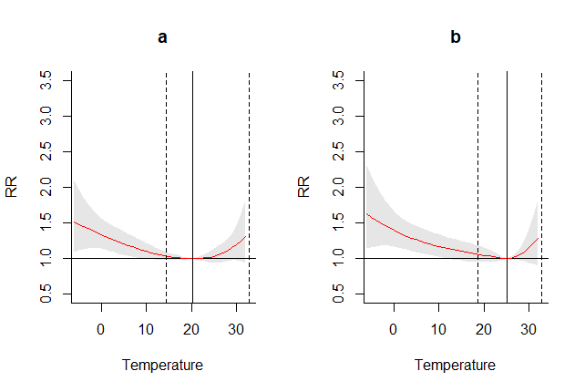
Fig S1 The Optimum Temperature (solid black and vertical line) and its 95 % confidence interval. a represents the OT value when all confounders were considered in the regression model and b represents the value when no confounder was considered.

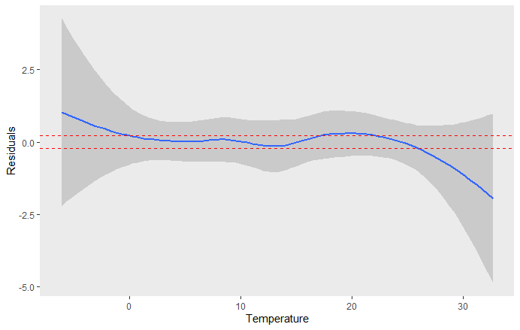
Fig S2 The non-linear effect of temperature on residuals estimated from ARIMA model (the blue line) and its 95% confidence interval (grey shadow). The two dashed red lines represents standard error of the residuals.

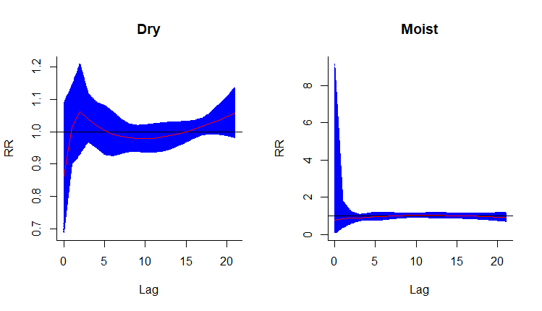
Fig S3 The interaction effect between heat (percentile (99th) and relative humidity. OT was used as reference value of heat to calculate relative risk and optimum values of humidity were used as reference category of humidity to calculate interaction effects.

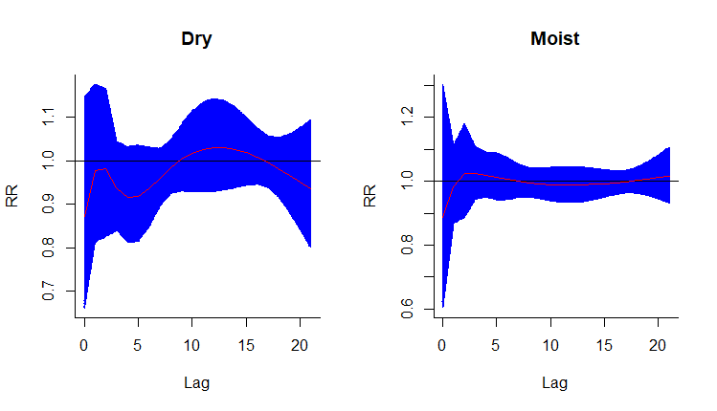
Fig S4 The interaction effect between cold (1th percentile) and relative humidity. OT was used as reference value of cold to calculate relative risk and optimum values of humidity were used as reference category of humidity to calculate interaction effects.

Table S1 Number of HAs attributed to different levels of heat and cold by different age and sex groups
Group | Cold |  |  |  | Heat
 | All values | Medium | High | Extreme | All values | Medium | High | Extreme
Total | 9836 | 8714 | 758 | 364 | 381 | 95 | 182 | 104
Male | 4747 | 4221 | 335 | 191 | 95 | 16 | 49 | 30
Female | 4111 | 3428 | 451 | 232 | 579 | 481 | 98 | 0
Young | 5721 | 5001 | 483 | 237 | 230 | 66 | 112 | 52
Elderly | 4057 | 3665 | 266 | 126 | 138 | 24 | 68 | 46

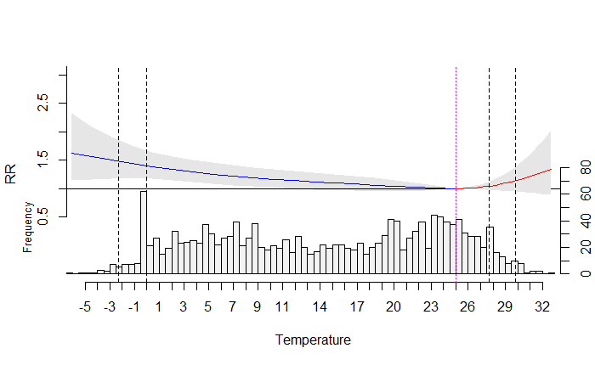
Fig S5 Overall cumulative relative risk and distribution of temperature in the area under study. The dashed pink line is reference value, separating cold value from heat values and used as reference value. The two left vertical dashed lines represent cold and extreme cold value, defining different ranges of cold (i.e. from medium to extreme values). The two right vertical dashed lines represent heat and extreme heat values, defining different ranges of heat (i.e. from medium to extreme values).

