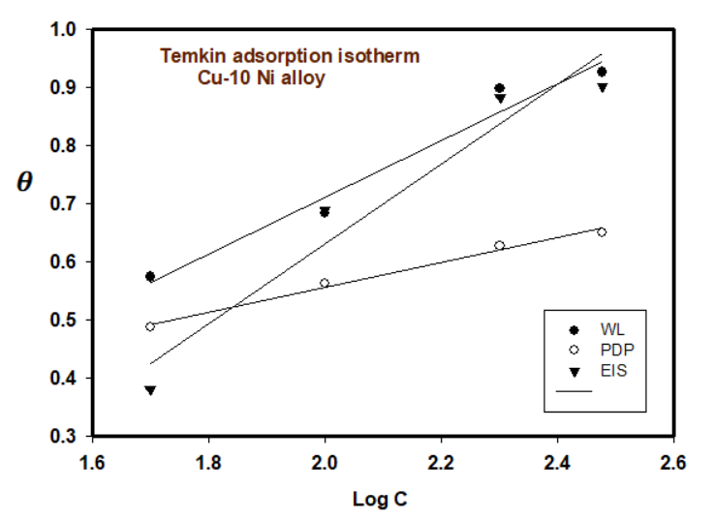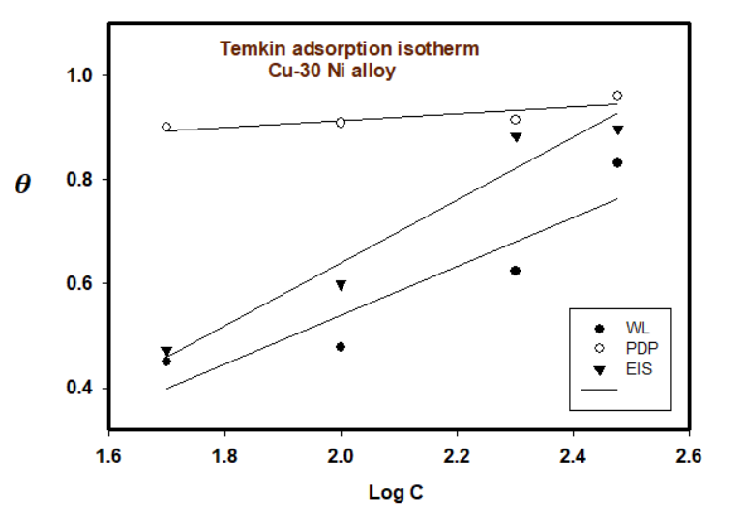
Carob Plant Extract as Naturally Products Corrosion Inhibitor for Copper-Nickel Alloys in Brine Solutions
Abd El Aziz S. Fouda^{1*}, Mona Nageeb², Mohamed F. Atia³, Ghalia A. Gaber^{2*}, Amal S. I. Ahmed², Ahmed A El-Hossiany^{1,4}

¹Chemistry Department, Faculty of Science, Mansoura University, Mansoura -35516, Egypt
Email: asfouda@mans.edu.eg
²Department of Chemistry, Faculty of Science (Girls), Al-Azhar University, P.O. Box: 11754, Yousef Abbas Str., Nasr City, Cairo, Egypt
³Institute of Aviation Engineering and Technology, Cairo, Egypt.
⁴ Delta for Fertilizers and Chemical Industries, Talkha, Egypt.

Fig. S1. Temkin isotherm plot for the corrosion of Cu-Ni alloys in 3.5 % NaCl solution in the absence and presence of different doses of Carob at 25ºC
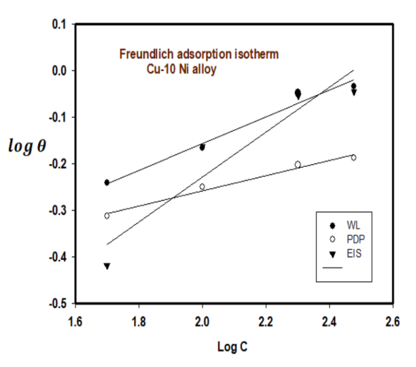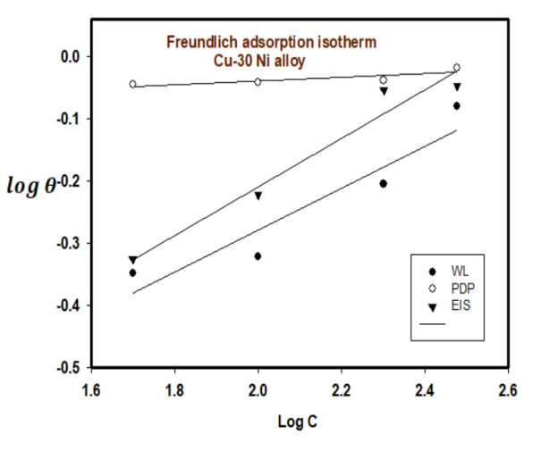
Fig. S2. Freundlich isotherm plot for the corrosion of Cu-Ni alloys in 3.5 % NaCl solution in the absence and presence of different doses of Carob at 25ºC
Temkin adsorption isotherm
The surface coverage (θ) is connected to the inhibitor dose (C) and the adsorption equilibrium constant K_{ads} as shown in Eq. 1 [37].

Exp ^{(−2a θ)} = K_{ads} × C (1)
where a is the attractive parameter and K is the adsorption equilibrium constant. From Fig. S1 linear plots are obtained, which affirms that the adsorption obeys the Temkin adsorption isotherm. Adsorption parameters obtained from this Figure are shown in Table S1.

Freundlich adsorption isotherm
According to the Freundlich isotherm, θ is related to the inhibitor dose C by Eq. 2 [38].

log θ = log K_{ads} + nlog C (2)
where n is the empirical constant, and the other constants have the same meaning. Fig. S2 shows straight lines relation of log θ against log C with slope n and intercept log K_{ads}. The deduced adsorption parameters K_{ads}, n, and ΔG⁰_{ads} are shown in Table S1. The obtained values of the correlation factor are far from unity. The adsorption process was studied using Langmuir, Freundlich, and Temkin isotherms. The adsorption studies clearly indicated that the experimental data satisfied the Langmuir Freundlich, and Temkin adsorption isotherms with good linearity. The chosen criteria of the best-fit isotherm are based on the higher correlation coefficient. The higher value of K_{ads} indicates that the inhibitor is strongly adsorbed on the Cu-Ni surface.
Table S1. Values of parameters of Langmuir adsorption isotherm for two Cu-Ni alloys with the addition of Carob in 3.5 % NaCl solution
Isotherm | Corros Tech. | Cu-10Ni |  |  |  | Cu-30Ni
Isotherm | Corros Tech. | slope | K_{ads} | R² | -∆Gº_{ads} | slope | K_{ads} | R² | -∆Gº_{ads}
Langmuir | WL | 9.209x10⁻⁴ | 21.997 | 0.9953 | 17.608 | 9.754x10⁻⁴ | 10.871 | 0.9221 | 15.86
Langmuir | PDP | 1.432x10⁻³ | 30.713 | 0.9999 | 18.436 | 1.032x10⁻³ | 15.305 | 0.9986 | 16.71
Langmuir | EIS | 8.240x10⁻⁴ | 13.323 | 0.9746 | 16.366 | 8.696x10⁻⁴ | 14.932 | 0.9843 | 16.65
Temkin | WL | 0.488 | 0.267 | 0.9684 | 6.680 | 0.470 | 0.069 | 0.8437 | 3.33
Temkin | PDP | 0.212 | 0.207 | 0.9881 | 6.046 | 0.065 | 1.083 | 0.6943 | 10.15
Temkin | EIS | 0.684 | 0.033 | 0.9412 | 1.445 | 0.603 | 0.029 | 0.9506 | 1.15
Freundlich | WL | 0.286 | 0.138 | 0.9729 | 19.003 | 0.337 | 0.207 | 0.8871 | 6.05

