Supporting Information
Remarkable Enhancement of Thermoelectric Performance of Semicrystalline Polymer Films upon Incorporating A Nucleating Agent Additive
Chen Chen¹, Haibao Ma^{2,7}, Kaiqing Lu^{2,4,6}, Xiaoxuan Zhang^{2,5,6}, Baiqiao Yue^{2,5,6}, Ce Song¹, Pochong Huang³, Haifeng Cheng¹, Yue Lin^{2,3,7,*}
1 Science and Technology on Advanced Ceramic Fibers and Composites Laboratory, College of Aerospace Science and Engineering, National University of Defense Technology, Changsha, 410073, P. R. China
2 CAS Key Laboratory of Design and Assembly of Functional Nanostructures, Fujian Key Laboratory of Nanomaterials, and State Key Laboratory of Structural Chemistry, Fujian Institute of Research on the Structure of Matter, Chinese Academy of Sciences, Fuzhou, Fujian, 350002, P. R. China
3 Fujian Science & Technology Innovation Laboratory for Optoelectronic Information of China, Fuzhou, Fujian 350108, P. R. China
4 College of Chemistry and Materials Science, Fujian Normal University, Fujian, Fuzhou 350007, P. R. China
5 College of Chemistry, Fuzhou University, Fuzhou 350002, China
6 Fujian College, University of Chinese Academy of Sciences, Fujian, Fuzhou 350007, P. R. China
7 University of Chinese Academy of Sciences, Beijing 100049, P. R. China
*Corresponding Author: Yue Lin linyue@fjirsm.ac.cn

Session S1. Grazing incidence wide angle X-ray scattering (GIWAXS) characterization and analysis
GIWAXS (Grazing Incidence Wide Angle X-ray Scattering) serves as a powerful tool for elucidating the crystallinity characteristics of thin films. In our study, we employed GIWAXS characterization to investigate the microstructural transformations that occur in response to variations in PDA additive concentration and doping levels.
Figure S1b and S1c present one-dimensional linecut scattering profiles of the undoped films with varying PDA additive concentrations, and the pertinent crystallographic parameters extracted from these profiles are compiled in Table S1. Figures S2, on the other hand, displays linecut scattering profiles of those films after Ion exchange (IEx) doping at a concentration of 5 mM, with the corresponding extracted crystallographic parameters summarized in Table S2.
As two key factors contributing to crystallite imperfection, the crystallite size and paracrystallinity are commonly employed to assess the structural order within the crystalline domains of conjugated polymers^{1,2}. Among these, the crystallite size is specifically evaluated utilizing the Scherrer equation¹.
$$\begin{aligned}L_{c}=\frac{2πK}{∆q}\#\left(S1\right)\end{aligned}$$
where K is a shape factor (typically close to 0.9) and Δq denotes the full width at half-maximum (FWHM) in q-space for a given diffraction peak. To isolate the impact of paracrystalline disorder specifically on the (h00) laminar peak, the relationship between the and h² is established as a function as a function. From this function, $L_{c}$ is derived as the y-axis intercept, which signifies the point where the impact of disorder is theoretically minimized (mathematically, this intercept corresponds to a zero-order reflection, where the effect of disorder vanishes).
The lattice paracrystallinity, which describes the cumulative structural disorder within the crystalline domains, can calculated as³:
$$\begin{aligned}g=\frac{1}{2π}\sqrt{∆q⋅d}\#\left(S2\right)\end{aligned}$$
where d is the interplanar distance.

S1.1. GIWAXS characterization of undoped films
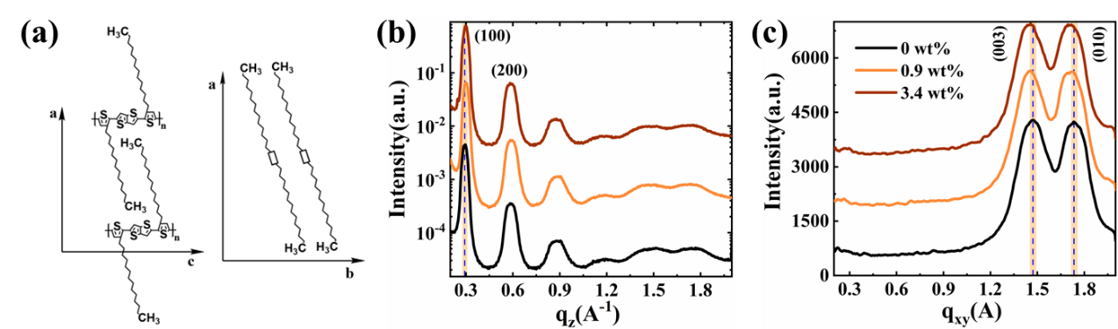
Figure S1. (a) Sketch of molecular Stacking in PBTTT-C14 derived from GIWAXS data analysis; 1D GIWAXS line-cut scattering profiles of undoped films: Out-of-plane (b) and, In-plane (c).
Table S1. The crystallographic parameters extracted from GIWAXS data of undoped films
Crytallographic parameters |  | 0 | 0.9 | 3.4
Lamellar Stacking  (Out-of-plane) | q_{z} (Å⁻¹) | 0.293 | 0.300 | 0.298
Lamellar Stacking  (Out-of-plane) | d-spacing (Å) | 21.437 | 20.937 | 21.051
Lamellar Stacking  (Out-of-plane) | FWHM(Δ_{q}) (Å⁻¹) | 0.026 | 0.027 | 0.030
Lamellar Stacking  (Out-of-plane) | Lc (Å) | 218.141 | 211.239 | 186.694
Lamellar Stacking  (Out-of-plane) | g (%) | 11.864 | 11.915 | 12.708
π-π Stacking  (In-plane) | q_{xy} (Å⁻¹) | 1.745 | 1.723 | 1.720
π-π Stacking  (In-plane) | d-spacing (Å) | 3.601 | 3.646 | 3.654
π-π Stacking  (In-plane) | FWHM(Δ_{q}) (Å⁻¹) | 0.22 | 0.224 | 0.231
π-π Stacking  (In-plane) | Lc (Å) | 25.679 | 25.215 | 24.530
π-π Stacking  (In-plane) | g (%) | 14.172 | 14.392 | 14.607
Backbone | q_{xy} (Å⁻¹) | 1.462 | 1.445 | 1.442
Backbone | d-spacing (Å) | 4.298 | 4.348 | 4.358
Backbone | g (%) | 16.161 | 16.028 | 16.094

S1.2. GIWAXS characterization of doped films
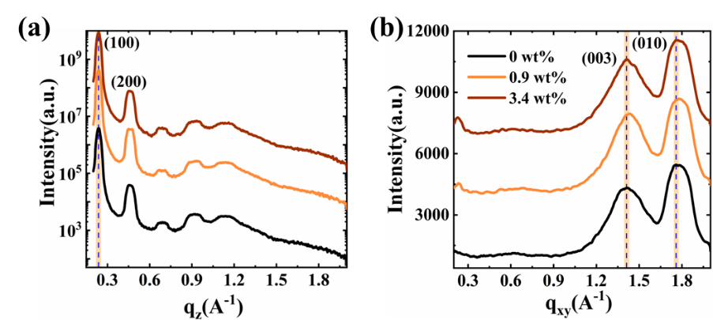
FigureS2. 1D GIWAXS line-cut scattering profiles of doped films: Out-of-plane (a) and In-plane (b)
Table S2. The crystallographic parameters extracted from GIWAXS data of doped films
Crytallographic parameters |  | 0 | 0.9 | 3.4
Lamellar Stacking  (Out-of-plane) | q_{z} (Å⁻¹) | 0.238 | 0.238 | 0.238
Lamellar Stacking  (Out-of-plane) | d-spacing (Å) | 26.417 | 26.449 | 26.444
Lamellar Stacking  (Out-of-plane) | FWHM(Δ_{q}) (Å⁻¹) | 0.023 | 0.023 | 0.022
Lamellar Stacking  (Out-of-plane) | Lc(Å) | 245.058 | 243.78 | 253.383
Lamellar Stacking  (Out-of-plane) | g (%) | 12.426 | 12.466 | 12.227
π-π Stacking  (In-plane) | q_{xy} (Å⁻¹) | 1.781 | 1.787 | 1.783
π-π Stacking  (In-plane) | d-spacing (Å) | 3.526 | 3.516 | 3.524
π-π Stacking  (In-plane) | FWHM(Δ_{q}) (Å⁻¹) | 0.186 | 0.185 | 0.186
π-π Stacking  (In-plane) | Lc (Å) | 30.440 | 30.516 | 30.411
π-π Stacking  (In-plane) | g (%) | 12.881 | 12.846 | 12.884
Backbone | q_{xy} (Å⁻¹) | 1.408 | 1.419 | 1.409
Backbone | d-spacing (Å) | 4.463 | 4.428 | 4.460
Backbone | g (%) | 17.348 | 17.128 | 17.431

Session S2. Atomic force microscopy (AFM) characterization
Atomic force microscopy was employed to monitor the morphological evolution of undoped pristine PBTTT-C14 and PBTTT-C14/PDA blended films across various nucleating agent concentrations (Figure S4). The right-hand panel showcases a magnified sections of the left images, specifically outlined by the blue frames. Additionally, the AFM images are annotated with scale bars, root-mean-square (R_{q}) roughness values, and ribbon widths, facilitating a comprehensive analysis of the surface morphological characteristics.
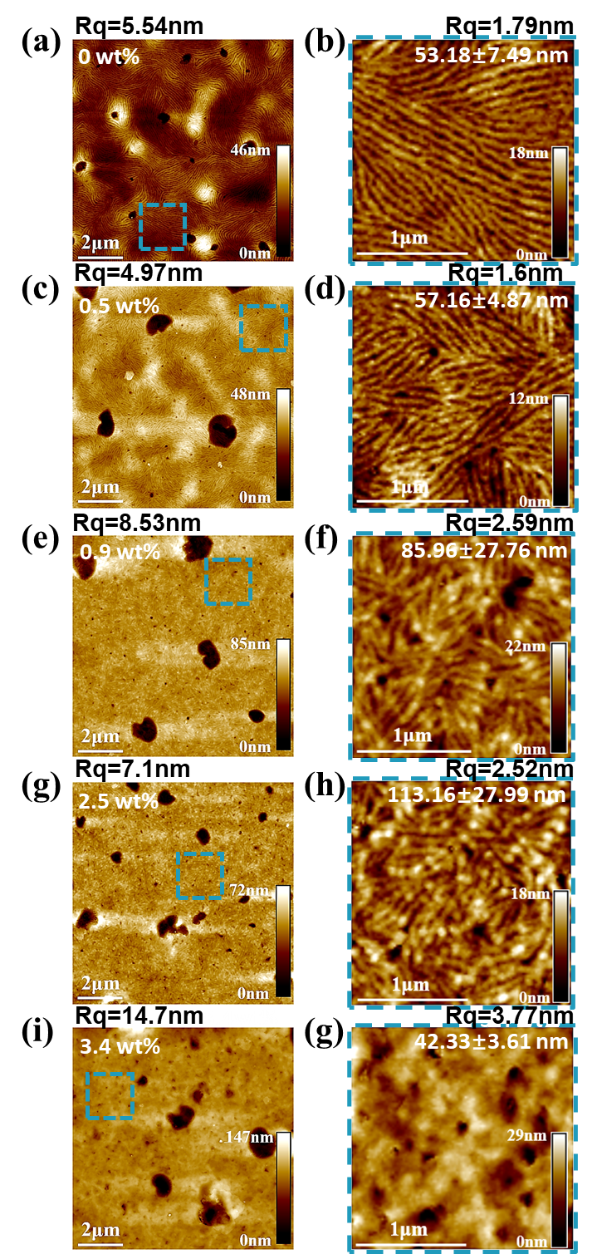
Figure S3. AFM images of PBTTT-C14 Films with varying PDA additive concentrations: 0, 0.5, 0.9, 2.5, 3.4 wt%.
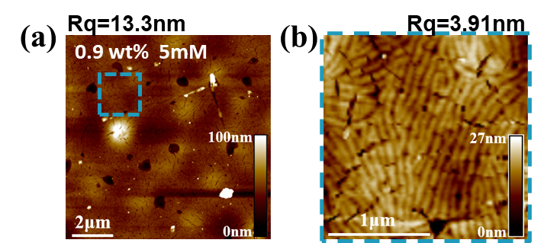
Figure S4. AFM images of doped 0.9 wt% blended films at a doping concentration of 5mM.

Session S3. Ultraviolet-Visible-Near Infrared and Fourier Transform Infrared Spectroscopy (FT-IR) characterization
Figure S5 displays the UV-Vis-NIR absorption spectra of blended PBTTT-C14 films containing PDA additives at concentrations of 0.5, 2.5, and 3.4 wt%, both before and after doping. These spectra exhibit similar trends to those observed in films with PDA concentrations of 0 and 0.9 wt% discussed in Section 2 of the main text. Meanwhile, Figure S6 presents the FTIR spectra of neat films that incorporate varying concentrations of nucleating agents, prior to undergoing IEx doping.
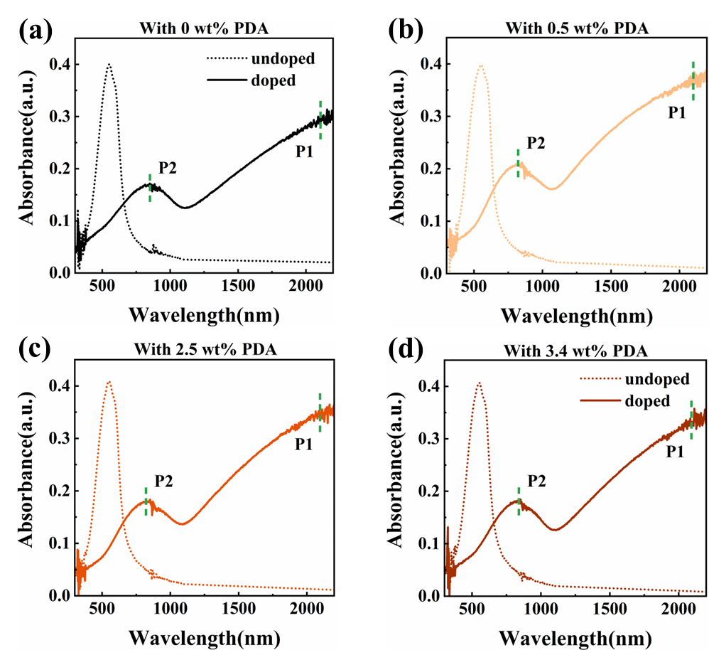
Figure S5. UV-vis NIR absorption spectra of blended PBTTT-C14 films with varying PDA concentrations of (a) 0 wt%, (b) 0.5 wt%, (c) 2.5 wt%, and (d) 3.4 wt%. In all cases, the doping concentration was maintained at a fixed value of 5 mM.
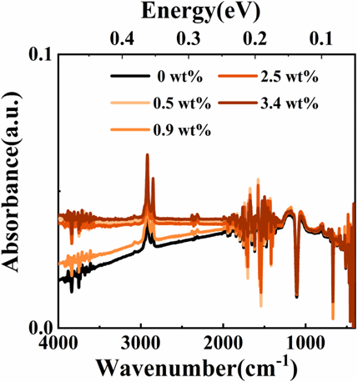
Figure S6. FTIR absorption spectra for blended PBTTT-C14 Films with varying PDA additive concentrations before IEx doping.

Session S4. Hall effect analysis
Hall effect measurements serve as a powerful technique for investigating the delocalized charge transport mechanisms in doped polymers^{4,5}. These measurements enable the extraction of crucial charge transport parameters such as Hall coefficient (R_{H}), Hall concentration (n_{Hall}) and Hall mobility (μ_{Hall}), providing deep insights into the charge transport properties.
At room temperature, we systematically measured the Hall voltages in both pristine and 0.9 wt% blended polymer systems, varying the doping concentrations. The Hall carrier concentration n_{Hall} was precisely calculated using the fundamental relationship R_{H} = 1/(n_{Hall}q), where q represents the elementary charge. The Hall mobility μ_{Hall} was derived from the conductivity (σ) and carrier concentration relationship given by σ = n_{Hall}qμ_{Hall.} The Hall concentration data for the studied samples are presented in Figure S7, while the corresponding Hall mobility data are summarized in Figure 4e of the main text.
Figure S7. Comparison of Hall concentrations in pristine and 0.9 wt% PDA-blended PBTTT-C14 films as a function of doping concentration.
Session S5. Extraction of thermal activation energy E_{a}
The thermal activation energy $E_{a}$ is determined using the Arrhenius equation⁶:
$$\begin{aligned}σ\left(T\right)∝\exp\left(-\frac{E_{a}}{k_{B}T}\right)\#\left(S3\right)\end{aligned}$$
where $E_{a}$ can be extracted by performing a linear regression analysis on the plot of lnσ(T) versus T⁻¹.
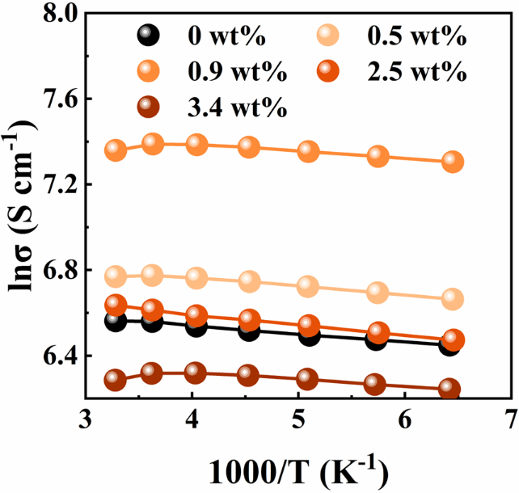
Figure S8. Temperature dependence of conductivity data for PBTTT-C14 films with varying PDA concentrations. The doping concentration was maintained at a fixed value of 5 mM.

Session S6. Transport property analysis utilizing the Kang-Snyder model
Dongmin Kang and G. Jeffrey Snyder⁷ proposed a generalized model that elucidates charge transport mechanisms in organic semiconductors. This model presents an expression for the transport function σ(E), incorporating two fundamental characteristics: the transport parameter s and the transport edge Et.:
$$\begin{aligned}σ_{E}\left(E, T\right)=\left\{\begin{aligned}σ_{E_{0}}\left(T\right)×{\left(\frac{{E-E}_{t}}{k_{B}T}\right)}^{s}, E>E_{t} \\ 0, E<E_{t}\end{aligned}\right.\#\left(S4\right)\end{aligned}$$
where $σ_{E_{0}}$ is a temperature-dependent but energy-independent transport coefficient. The transport edge, E_{t}, acts as an analogue to the mobility edge, marking the demarcation between energy levels occupied by localized and delocalized charge carriers. However, a crucial distinction lies in the fact that states residing above E_{t} are not necessarily fully delocalized. In this framework, charges with energies exceeding E_{t} remain partially localized, necessitating thermal activation for effective transport.
In polymer systems, the transport coefficient $σ_{E_{0}}$ takes the form as
$$\begin{aligned}σ_{E_{0}}∝\exp{{\left(-\frac{W_{γ}}{k_{B}T}\right)}^{γ}}\#\left(S5\right)\end{aligned}$$
Where K_{B} represents the Boltzmann constant, while $W_{γ}$ denotes the activation energy, which is contingent upon the polymer morphology and crystallinity, such as dimensionality or connectivity of domains, and is related to the choice of γ. Conventionally, a γ value of 1/2 is adopted for polymers⁶.
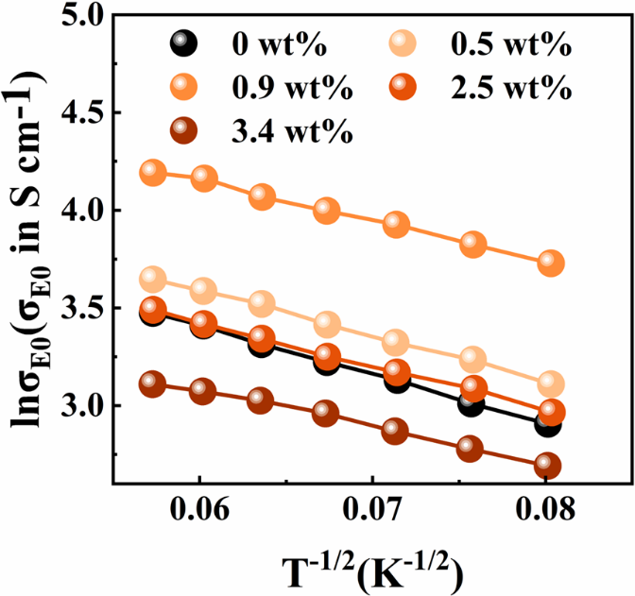
Figure S9. The temperature-dependent transport coefficients of PBTTT-C14 films with varying PDA concentrations. The doping concentration was maintained at a fixed value of 5 mM..

Reference
1 Rivnay, J., Mannsfeld, S. C. B., Miller, C. E., Salleo, A. & Toney, M. F. Quantitative Determination of Organic Semiconductor Microstructure from the Molecular to Device Scale. Chem Rev 112, 5488-5519, doi:10.1021/cr3001109 (2012).
2 Jiao, X. C. et al. Resolving Different Physical Origins toward Crystallite Imperfection in Semiconducting Polymers: Crystallite Size vs Paracrystallinity. J Phys Chem B 124, 10529-10538, doi:10.1021/acs.jpcb.0c06763 (2020).
3 Gregory, S. A. et al. Quantifying Charge Carrier Localization in PBTTT Using Thermoelectric and Spectroscopic Techniques. J Phys Chem C 127, 12206-12217, doi:10.1021/acs.jpcc.3c01152 (2023).
4 Bruevich, V. & Podzorov, V. Reporting Hall effect measurements of charge carrier mobility in emerging materials. Nat Electron 7, 510-512, doi:10.1038/s41928-024-01198-w (2024).
5 Wood, W. A. et al. Revealing contributions to conduction from transport within ordered and disordered regions in highly doped conjugated polymers through analysis of temperature-dependent Hall measurements. Phys Rev Mater 7, 034603, doi:10.1103/PhysRevMaterials.7.034603 (2023).
6 Chen, C. et al. Observation of Weak Counterion Size Dependence of Thermoelectric Transport in Ion Exchange Doped Conducting Polymers Across a Wide Range of Conductivities. Adv Energy Mater 13, 202202797, doi:10.1002/aenm.202202797 (2023).
7 Kang, S. D. & Snyder, G. J. Charge-transport model for conducting polymers. Nat Mater 16, 252-257 (2017).

