Supplementary Figure 1. Comprehensive analysis of gene expression by RNA-seq and gene expression analysis by qPCR. (A) Volcano plot of differentially expressed genes (DEGs) in gastrocnemius (GM) for each group; there were 8, 7 and 1067 upregulated genes in Acvr1b KO, Tgfbr1 KO and dKO mice respectively; 13, 70 and 744 downregulated genes in Acvr1b KO, Tgfbr1 KO and dKO mice respectively. (B) Volcano plot of DEGs in soleus muscles for each group; there were 8, 8 and 85 upregulated genes in Acvr1b KO, Tgfbr1 KO and dKO mice respectively; 13, 46 and 196 downregulated genes in Acvr1b KO, Tgfbr1 KO and dKO mice respectively. Vertical dash lines indicate Log₂ (fold change) when fold change is ± 1.5. Horizontal dash line indicates -Log₁₀ (fdr P value) when fdr P value is 0.05. DEGs: fdr P $<$ 0.05, fold change $>$ 1.5. Gene expression levels of (C) Mgf, (D) Ttn, (E) Obscn, (F) Ankrd2, (G) Sgcd, (H) Adora1 and (I) Cacna1s. (J) Total amount of RNA per microgram muscle tissue was not different between groups in either gastrocnemius or soleus muscles. Two-way ANOVA with Bonferroni post hoc tests were performed to analyse data. Independent t-tests were used to compare qPCR data of gastrocnemius and soleus muscles of control groups. Data are shown as mean ± SEM. #: P $<$ 0.05 compared to GM of control mice.

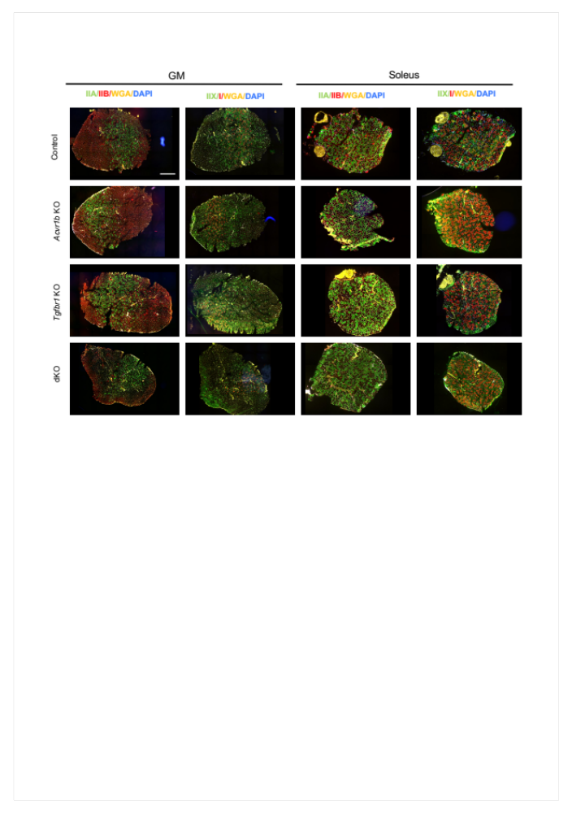
Supplementary Figure 2. Myofibre type distribution in gastrocnemius and soleus muscles. Immunofluorescence staining of type IIB (red), IIA (green), IIX (green), and I (red) myosin heavy chain in gastrocnemius and soleus muscles. Yellow: wheat germ agglutinin (WGA), blue: DAPI for nuclei. Scale bar=1mm

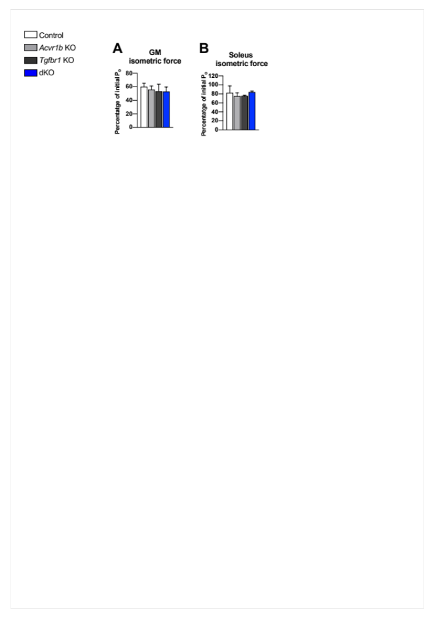
Supplementary Figure 3. Maximal isometric contraction force (P_{o}) after 15 consecutive eccentric contractions. Percentage of P_{o} post 15 consecutive eccentric contractions was reduced compared to P_{o} of pre-contraction. Two-way ANOVA with Bonferroni post hoc tests were performed to analyse data. Data are shown as mean ± SEM.
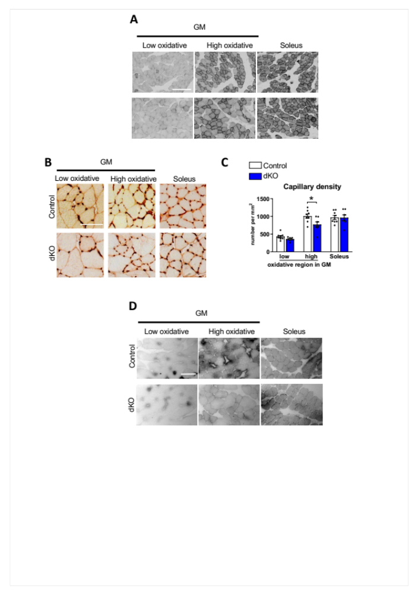
Supplementary Figure 4. Intracellular oxygen supply and capillary distribution were not diminished in both gastrocnemius (GM) and soleus muscles in dKO mice. (A) cytochrome c oxidase, (B) capillary and (D) myoglobin stainings of gastrocnemius and soleus muscles. For capillary and myoglobin staining, length of scale bars are 100μm. For cytochrome c oxidase staining, length of scale bar is 250μm. (C) Capillary density per view was quantified. Independent t-tests were used to compare differences between control and dKO mice. Data are shown as mean ± SEM. *: P$<$ 0.05.

Supplementary Figure 5. Number of Acvr1b and Tgfbr1 mRNA was decreased per myofibre cross-sectional area (FCSA) in both gastrocnemius (GM) and soleus muscles of corresponding gene knockout mice. (A) Acvr1b (green) and Tgfbr1 (red) mRNA was detected by RNA scope assay. White: wheat germ agglutinin (WGA), blue: DAPI for nuclei. Gene expression was found in interstitial cells (dash square). Scale bar=25μm. mRNA number of Acvr1b per myofibre CSA in (B) gastrocnemius and (D) soleus muscles. mRNA number of Tgfbr1 per myofibre CSA in (C) gastrocnemius and (E) soleus muscles (n=3). Kruskal-Wallis analysis was used to perform the multiple comparison. Data are shown as mean ± SEM. *: P$<$ 0.05.

Supplementary Table 1. Mouse body and of muscle mass (g)
 | Control | Acvr1b KO | Tgfbr1 KO | dKO
Body mass | 34.3±1.2 | 34.5±0.6 | 34.0±0.9 | 39.7±1.1 *†
Soleus | 16.6±0.9 | 18.2±0.5 | 19.3±0.9 | 20.6±0.8*
Gastrocnemius medialis | 75.2±3.3 | 78.6±3.1 | 84.8±3.1 | 123.7±4.2*#†
Gastrocnemius lateralis | 116.6±4.2 | 120.8±3.6 | 126.2±3.8 | 186.6±3.7*#†
Plantaris | 25.4±0.4 | 28.1±1.2 | 30.3±1.4 | 40.2±1.4*#†
Tibialis anterior | 61.5±1.4 | 65.8±1.4 | 67.0±3.1 | 132.6±4.3*#†
Extensor digitorum longus | 14.0±0.2 | 15.3±0.4 | 16.7±0.5* | 26.1±1.1*#†
N =7-8. *Significantly different from control, # Significantly different from Acvr1b KO, †Significantly different from Tgfbr1 KO

Supplementary Table 2. Gene ontology enrichment of gastrocnemius.
GM | GO Term | gene number | -Log₁₀ (p-value)
Acvr1b KO | GO:0001525: angiogenesis | 4 | 3.04
Acvr1b KO | GO:0045600: positive regulation of fat cell differentiation | 2 | 1.40
Tgfbr1 KO | GO:0006954: inflammatory response | 5 | 1.92
Tgfbr1 KO | GO:0070374: positive regulation of ERK1 and ERK2 cascade | 6 | 3.91
Tgfbr1 KO | GO:0006954: inflammatory response | 5 | 1.92
Tgfbr1 KO | GO:0035914: skeletal muscle cell differentiation | 3 | 2.05
Tgfbr1 KO | GO:0045926: negative regulation of growth | 2 | 1.51
Tgfbr1 KO | GO:0035994: response to muscle stretch | 2 | 1.36
dKO | GO:0001525~angiogenesis | 41 | 5.88
dKO | GO:0006954~inflammatory response | 52 | 5.66
dKO | GO:0030335~positive regulation of cell migration | 34 | 4.69
dKO | GO:0001666~response to hypoxia | 32 | 4.39
dKO | GO:0003009~skeletal muscle contraction | 10 | 4.15
dKO | GO:0070374~positive regulation of ERK1 and ERK2 cascade | 27 | 2.74
dKO | GO:0006811~ion transport | 69 | 3.72
dKO | GO:0014883~transition between fast and slow fiber | 6 | 3.36
dKO | GO:0032869~cellular response to insulin stimulus | 12 | 1.19
dKO | GO:0006915~apoptotic process | 69 | 4.03
dKO | GO:0030198~extracellular matrix organization | 20 | 3.10
dKO | GO:0007179~transforming growth factor beta receptor signaling pathway | 15 | 2.91
dKO | GO:0048630~skeletal muscle tissue growth | 4 | 2.80
dKO | GO:0030154~cell differentiation | 80 | 2.42
dKO | GO:0001953~negative regulation of cell-matrix adhesion | 6 | 2.29
dKO | GO:0006955~immune response | 33 | 2.12
dKO | GO:0034599~cellular response to oxidative stress | 12 | 2.17
dKO | GO:0007015~actin filament organization | 14 | 2.06
dKO | GO:0007274~neuromuscular synaptic transmission | 7 | 1.88
dKO | GO:0045600~positive regulation of fat cell differentiation | 9 | 1.55
dKO | GO:0045217~cell-cell junction maintenance | 3 | 1.52
dKO | GO:0051450~myoblast proliferation | 3 | 1.32

Supplementary Table 3. Gene ontology enrichment of soleus.
Sol | GO Term | gene number | -Log₁₀(p- value)
Acvr1b KO | GO:0032869~cellular response to insulin stimulus | 2 | 1.37
Acvr1b KO | GO:0051443~positive regulation of ubiquitin-protein transferase activity | 2 | 2.03
Acvr1b KO | GO:0006468~protein phosphorylation | 3 | 1.50
Tgfbr1 KO | GO:0032869~cellular response to insulin stimulus | 4 | 3.22
Tgfbr1 KO | GO:0006915~apoptotic process | 7 | 3.22
dKO | GO:0001525~angiogenesis | 8 | 1.92
dKO | GO:0001666~response to hypoxia | 11 | 4.51
dKO | GO:0032869~cellular response to insulin stimulus | 6 | 2.67
dKO | GO:0006915~apoptotic process | 15 | 2.63
dKO | GO:0050873~brown fat cell differentiation | 4 | 2.30
dKO | GO:0001568~blood vessel development | 5 | 2.21
dKO | GO:0006468~protein phosphorylation | 13 | 1.79

Supplementary Table 4. Physiological properties of gastrocnemius and soleus muscles
 | Control | Acvr1b KO | Tgfbr1 KO | dKO
Gastrocnemius
P_{o} (mN) | 1669.65±105.47 | 1791.03±68.69 | 1743.61±121.34 | 2123.46±142.71
P_{t} (mN) | 268.88±25.29 | 326.71±22.80 | 367.62±39.98 | 363.80±44.23
Twitch/tentanus ratio | 0.16±0.01 | 0.18±0.02 | 0.21±0.02 | 0.17±0.01
TTPT (ms) | 26.18±0.18 | 27.30±0.70 | 27.61±0.55 | 26.47±0.16
½ RT (ms) | 11.68±0.17 | 12.54±0.47 | 12.61±0.36 | 11.97±0.15
dF/dt (mN/ms) | 55.66±3.10 | 53.71±3.11 | 55.13±4.46 | 66.74±5.48
(dF/dt)/P_{o} (ms⁻¹) | 3.36E-02±1.23E-03 | 3.00E-02±1.43E-03 | 3.17E-02±1.41E-03 | 3.12E-02±7.75E-04
Soleus
P_{o} (mN) | 240.96±21.28 | 281.08±13.69 | 297.04±13.76 | 399.02±10.55 *#
P_{t} (mN) | 33.24±4.03 | 37.56±3.85 | 46.64±3.36 | 51.60±3.23 *
Twitch/tentanus ratio | 0.15±0.02 | 0.14±0.01 | 0.16±0.01 | 0.13±0.01
TTPT (ms) | 34.29±4.17 | 33.19±1.34 | 31.36±0.72 | 30.96±0.46
½ RT (ms) | 22.61±5.65 | 22.63±2.95 | 18.97±1.13 | 17.67±0.60
dF/dt (mN/ms) | 4.29±0.49 | 5.23±0.37 | 6.04±0.49 | 7.59±0.35*#
(dF/dt)/P_{o} (ms⁻¹) | 1.83E-02±1.49E-03 | 1.89E-02±1.10E-03 | 2.05E-02±1.18E-03 | 1.96E-02±7.47E-04
N =7-8. P_{o} = maximal tetanic force, P_{t} = maximal twitch force; TTPT = time to peak twitch tension; ½ RT = twitch half-relaxation time; dF/dt = maximum rise in tension; dF/dt/P_{o} = relative maximum rise in tension. *Significantly different from Control, # Significantly different from Acvr1b KO, †Significantly different from Tgfbr1 KO.

Supplementary Table 5. Primers sequences
Gene name | Primers | Sequence
Acvr1b | forward | TGCTGCGCCATGAAAACATC
Acvr1b | reverse | TGCCCACAATCTCCATATGCA
Tgfbr1 | forward | CCTCGAGACAGGCCATTTGT
Tgfbr1 | reverse | AGACGAAGCAGACTGGACCA
Obsl1 | forward | GACCCGAGAAGATGCTGGAG
Obsl1 | reverse | GGACTGTGCTTGACACATTTGA
Sntb1 | forward | AGTGCTGCTGGAAGTGAAGTAT
Sntb1 | reverse | ATCCAATCTCAGACACCGGG
Igf1ea | forward | GTGTTGCTTCCGGAGCTGTG
Igf1ea | reverse | CAATGTACTTCCTTCTGAGTC
Hgf | forward | GATTATTGCCCTATTTCCCGTTGTG
Hgf | reverse | TGGCACAGGATATTACAGGATGG
Trim63 | forward | CGTCCAGAGCGTGTGTCTCACTC
Trim63 | reverse | GGGCTACCTTCCTCTCAAGTGC
Pax7 | forward | TCCATCAAGCCAGGAGACA
Pax7 | reverse | AGGAAGAAGTCCCACACAG
Myod | forward | CATCCAGCCCGCTCCAAC
Myod | reverse | GGGCCGCTGTAATCCATCATGCC
Tgfb1 | forward | GCTGACCCCCACTGATACG
Tgfb1 | reverse | CCTGTATTCCGTCTCCTTGGTT
Adgre | forward | AGTGTCCTTACAGAGTGCAGC
Adgre | reverse | GAGCTCAAACCATGTGGTCG
Sdhb | forward | GTCAGGAGCCAAAATGGCG
Sdhb | reverse | CGACAGGCCTGAACTGC
Mb | forward | GTGCTGAATGTCTGGGGGAA
Mb | reverse | GGGTGAGTCTTAAACAGACCGA
Ttn | forward | GTCAGCTGGATATGACCGGG
Ttn | reverse | TGAGCGGCAGTTCTTTCACT
Obscn | forward | ATGCAGGGGAGGTCAAGTTT
Obscn | reverse | GTCACGGGCAGTTCTTTCAC
Sgcd | forward | AGCTGGCAATATGGAAGCCA
Sgcd | reverse | CGCAGCATCTAACTTAATCTCTCC
Igf1ec | forward | GGAGAAGGAAAGGAAGTACATTTG
Igf1ec | reverse | CCTGCTCCGTGGGAGGCT
Adora1 | forward | TCAAGATCCCTCTCCGGTACA
Adora1 | reverse | GGGAGAGAATCCAGCAGCC
Cacna1s | forward | TGGTATGTCGTCACTTCCTCC
Cacna1s | reverse | CCGACTGGTTGTAATGCTGC
Ppargc1a | forward | ACACAACCGCAGTCGCAACA
Ppargc1a | reverse | GGGAACCCTTGGGGTCATTTGG
Vegfa | forward | CTGTAACGATGAAGCCCTGGAGTG
Vegfa | reverse | GGTGAGGTTTGATCCGCATGATCT
Mybph | forward | CTCCGAGTGAAGATGTCCCC
Mybph | reverse | ACAGTCAAGGAGCTGTGGC
Ankrd2 | forward | CAGGAGGAAGAGACTGAGAAACTT
Ankrd2 | reverse | TTCCTCTAGCACTAGCATGTCC
Mtco2 | forward | AACCGAGTCGTTCTGCCAAT
Mtco2 | reverse | GGACTGCTCATGAGTGGAGG

Supplementary Data. DEGs in gastrocnemius of dKO mice compared to control.
Gene Ensemble | Gene name | -Log₁₀ (p-value) | Fold change | Comparison
ENSMUSG00000055775 | MYH8 | 1.67 | 1.55 | Control ≥ dKO
ENSMUSG00000027470 | MYLK2 | 1.37 | 1.58 | Control ≥ dKO
ENSMUSG00000053093 | MYH7 | 4.91 | 1.93 | Control ≥ dKO
ENSMUSG00000026418 | TNNI1 | 4.11 | 2.07 | Control ≥ dKO
ENSMUSG00000091898 | TNNC1 | 5.39 | 2.09 | Control ≥ dKO
ENSMUSG00000064179 | TNNT1 | 6.40 | 2.17 | Control ≥ dKO
ENSMUSG00000027940 | TPM3 | 7.01 | 1.96 | Control ≥ dKO
ENSMUSG00000044167 | FOXO1 | 6.08 | 2.41 | Control ≥ dKO
ENSMUSG00000042903 | FOXO4 | 8.16 | 1.44 | Control ≥ dKO
ENSMUSG00000018893 | MB | 6.53 | 2.11 | Control ≥ dKO
ENSMUSG00000029167 | PPARGC1A | 6.15 | 2.11 | Control ≥ dKO
ENSMUSG00000029467 | ATP2A2 | 6.79 | 1.86 | Control ≥ dKO
ENSMUSG00000064179 | TNNT1 | 6.40 | 2.17 | Control ≥ dKO
ENSMUSG00000026576 | ATP1B1 | 1.48 | 1.85 | Control ≥ dKO
ENSMUSG00000042045 | SLN | 15.49 | 20.65 | Control < dKO
ENSMUSG00000004105 | ANGPTL2 | 7.79 | 1.79 | Control < dKO
ENSMUSG00000021822 | PLAU | 12.47 | 1.99 | Control < dKO
ENSMUSG00000014773 | DLL1 | 1.38 | 1.98 | Control < dKO
ENSMUSG00000068614 | ACTC1 | 22.85 | 8.72 | Control < dKO
ENSMUSG00000042451 | MYBPH | 19.29 | 7.11 | Control < dKO
ENSMUSG00000026211 | OBSL1 | 5.78 | 2.40 | Control < dKO
ENSMUSG00000055632 | HMCN2 | 3.94 | 2.14 | Control < dKO
ENSMUSG00000027107 | CHRNA1 | 1.53 | 2.71 | Control < dKO
ENSMUSG00000026253 | CHRNG | 1.78 | 7.62 | Control < dKO
ENSMUSG00000026251 | CHRND | 2.90 | 2.39 | Control < dKO

