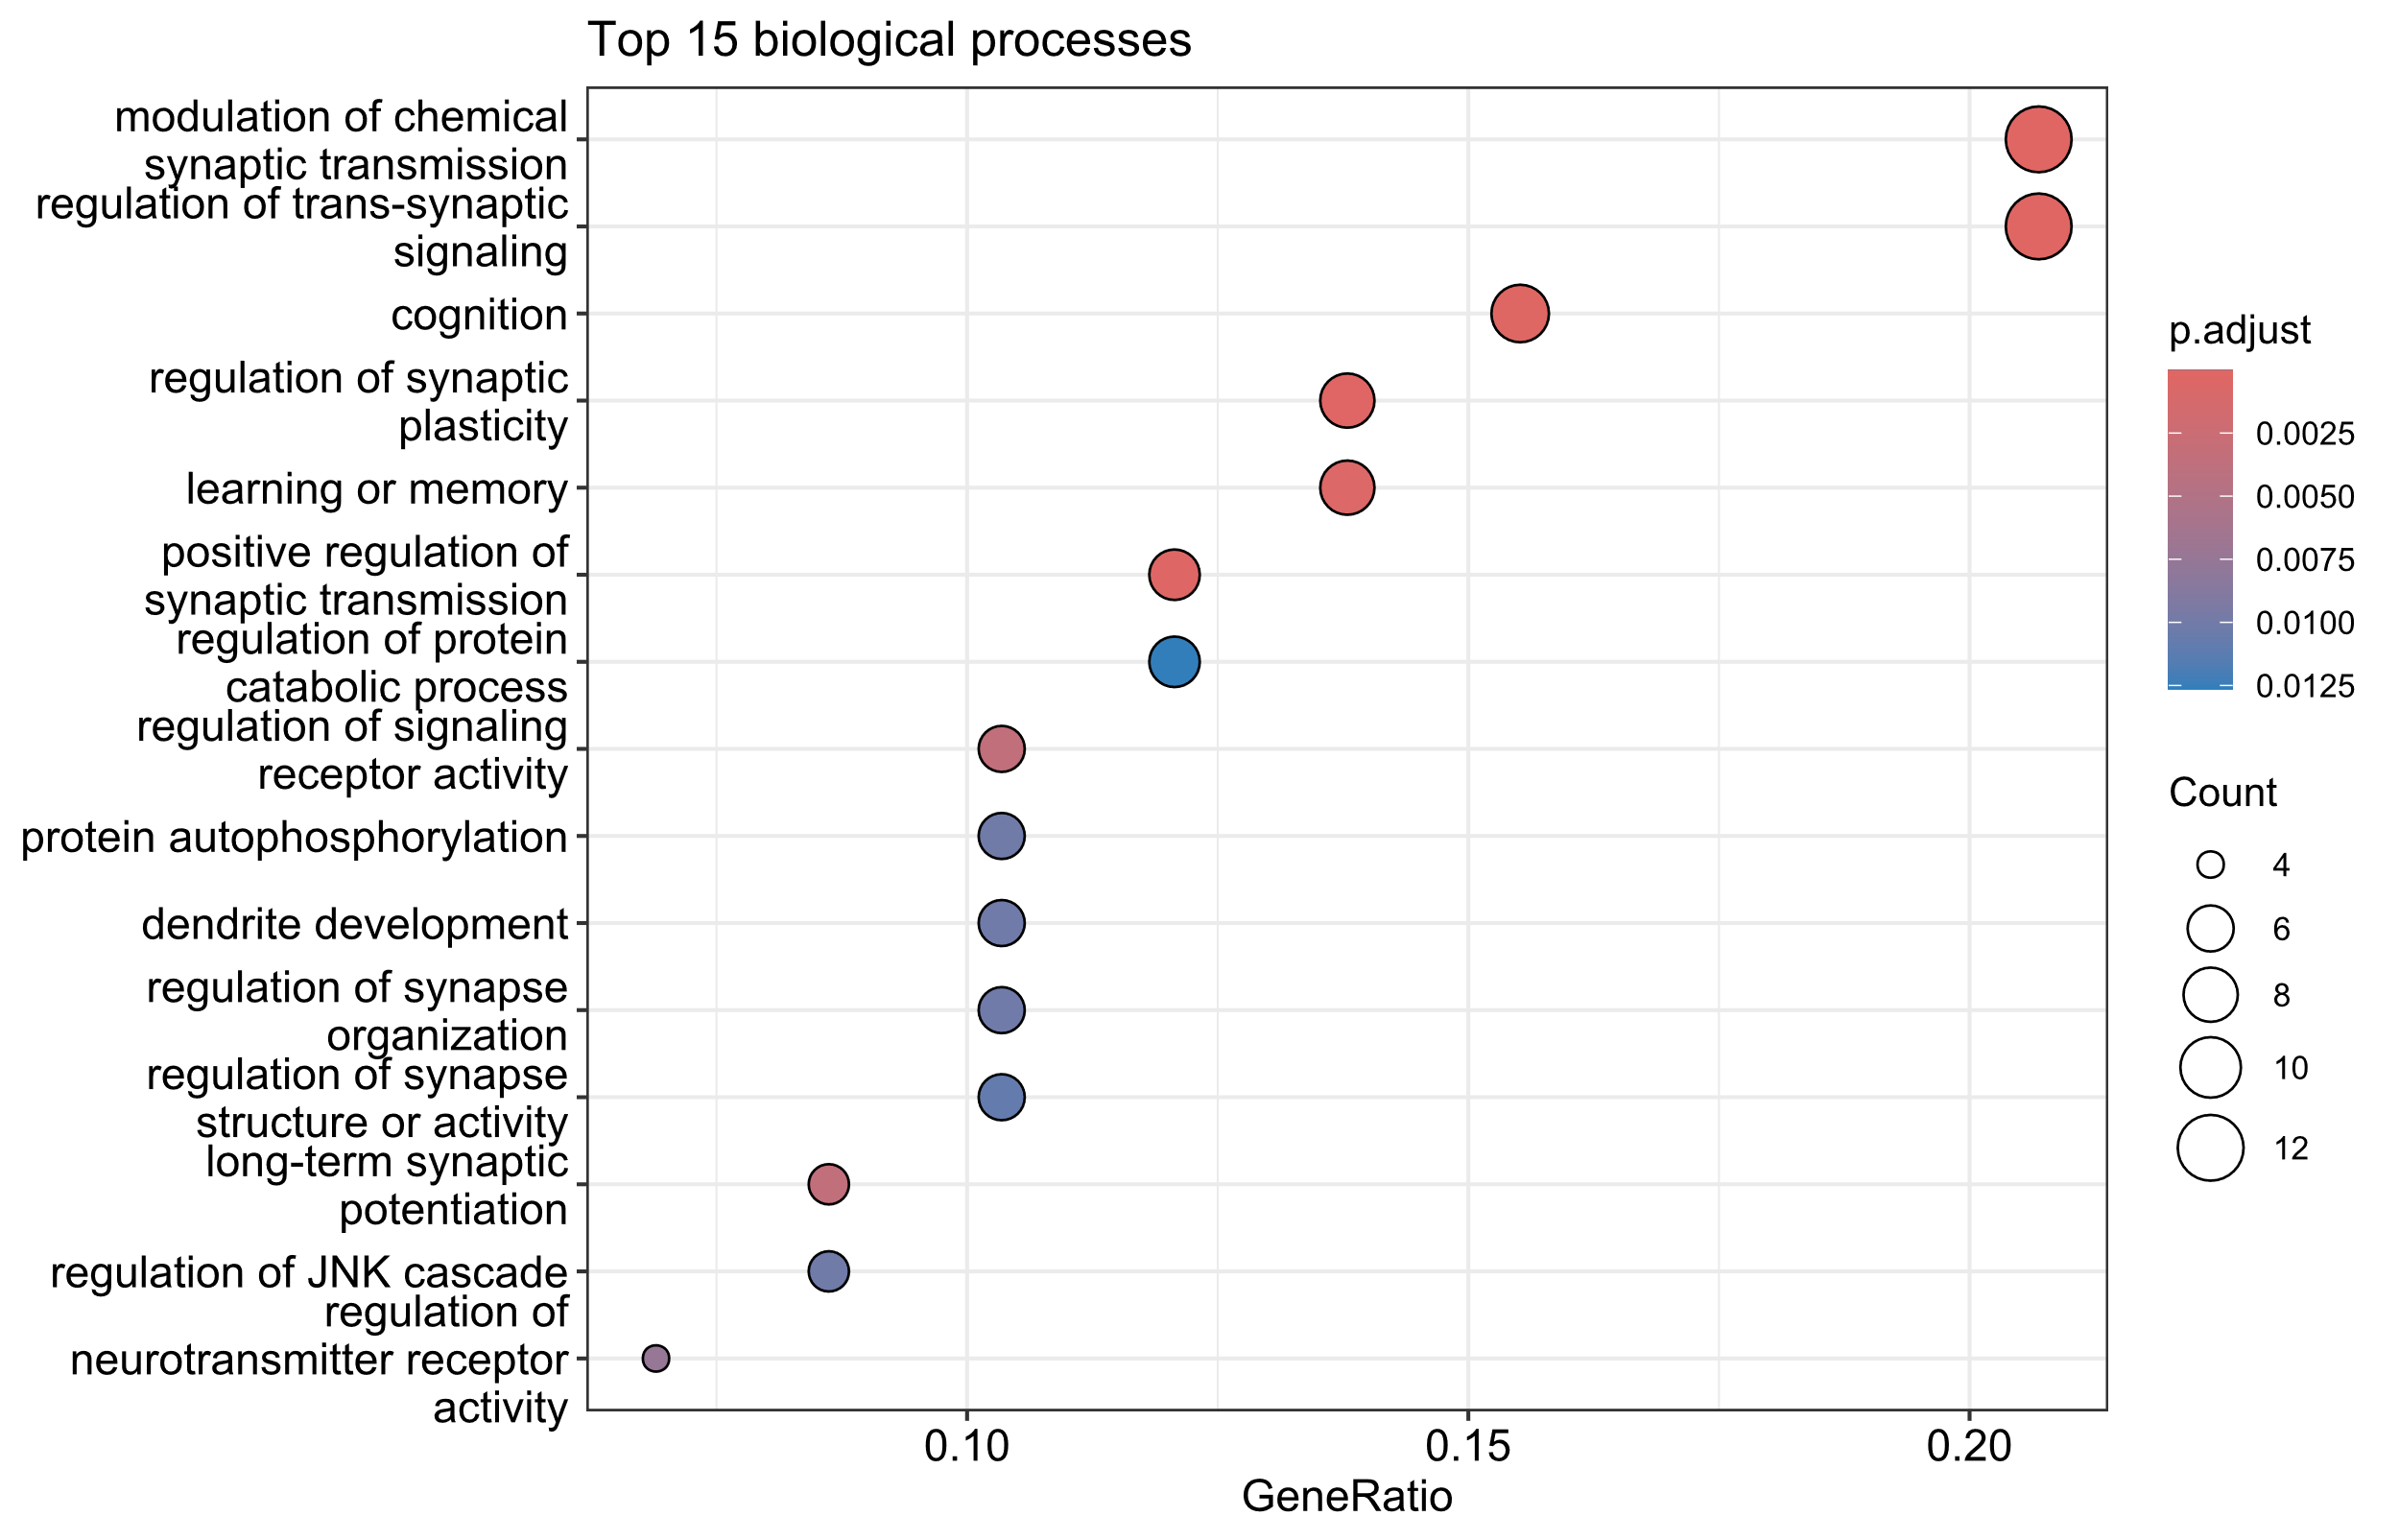
Supplementary Figure 1. Top 15 enriched terms in the GO categories of biological processes for the brain-specific network of functionally-related genes.

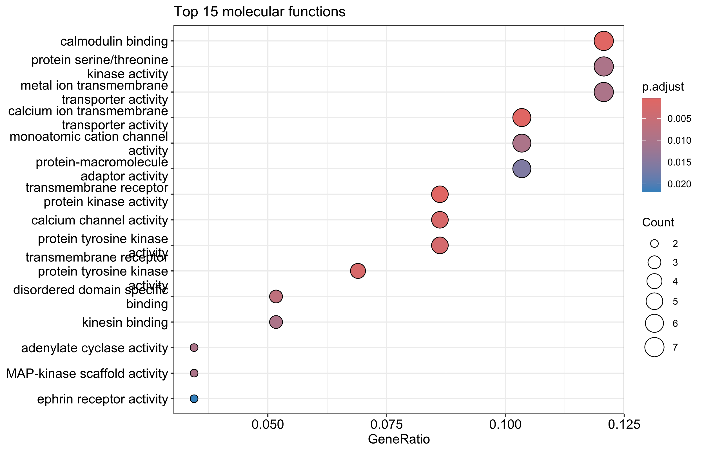
Supplementary Figure 2. Top 15 enriched terms in the GO categories of molecular functions for the brain-specific network of functionally-related genes.

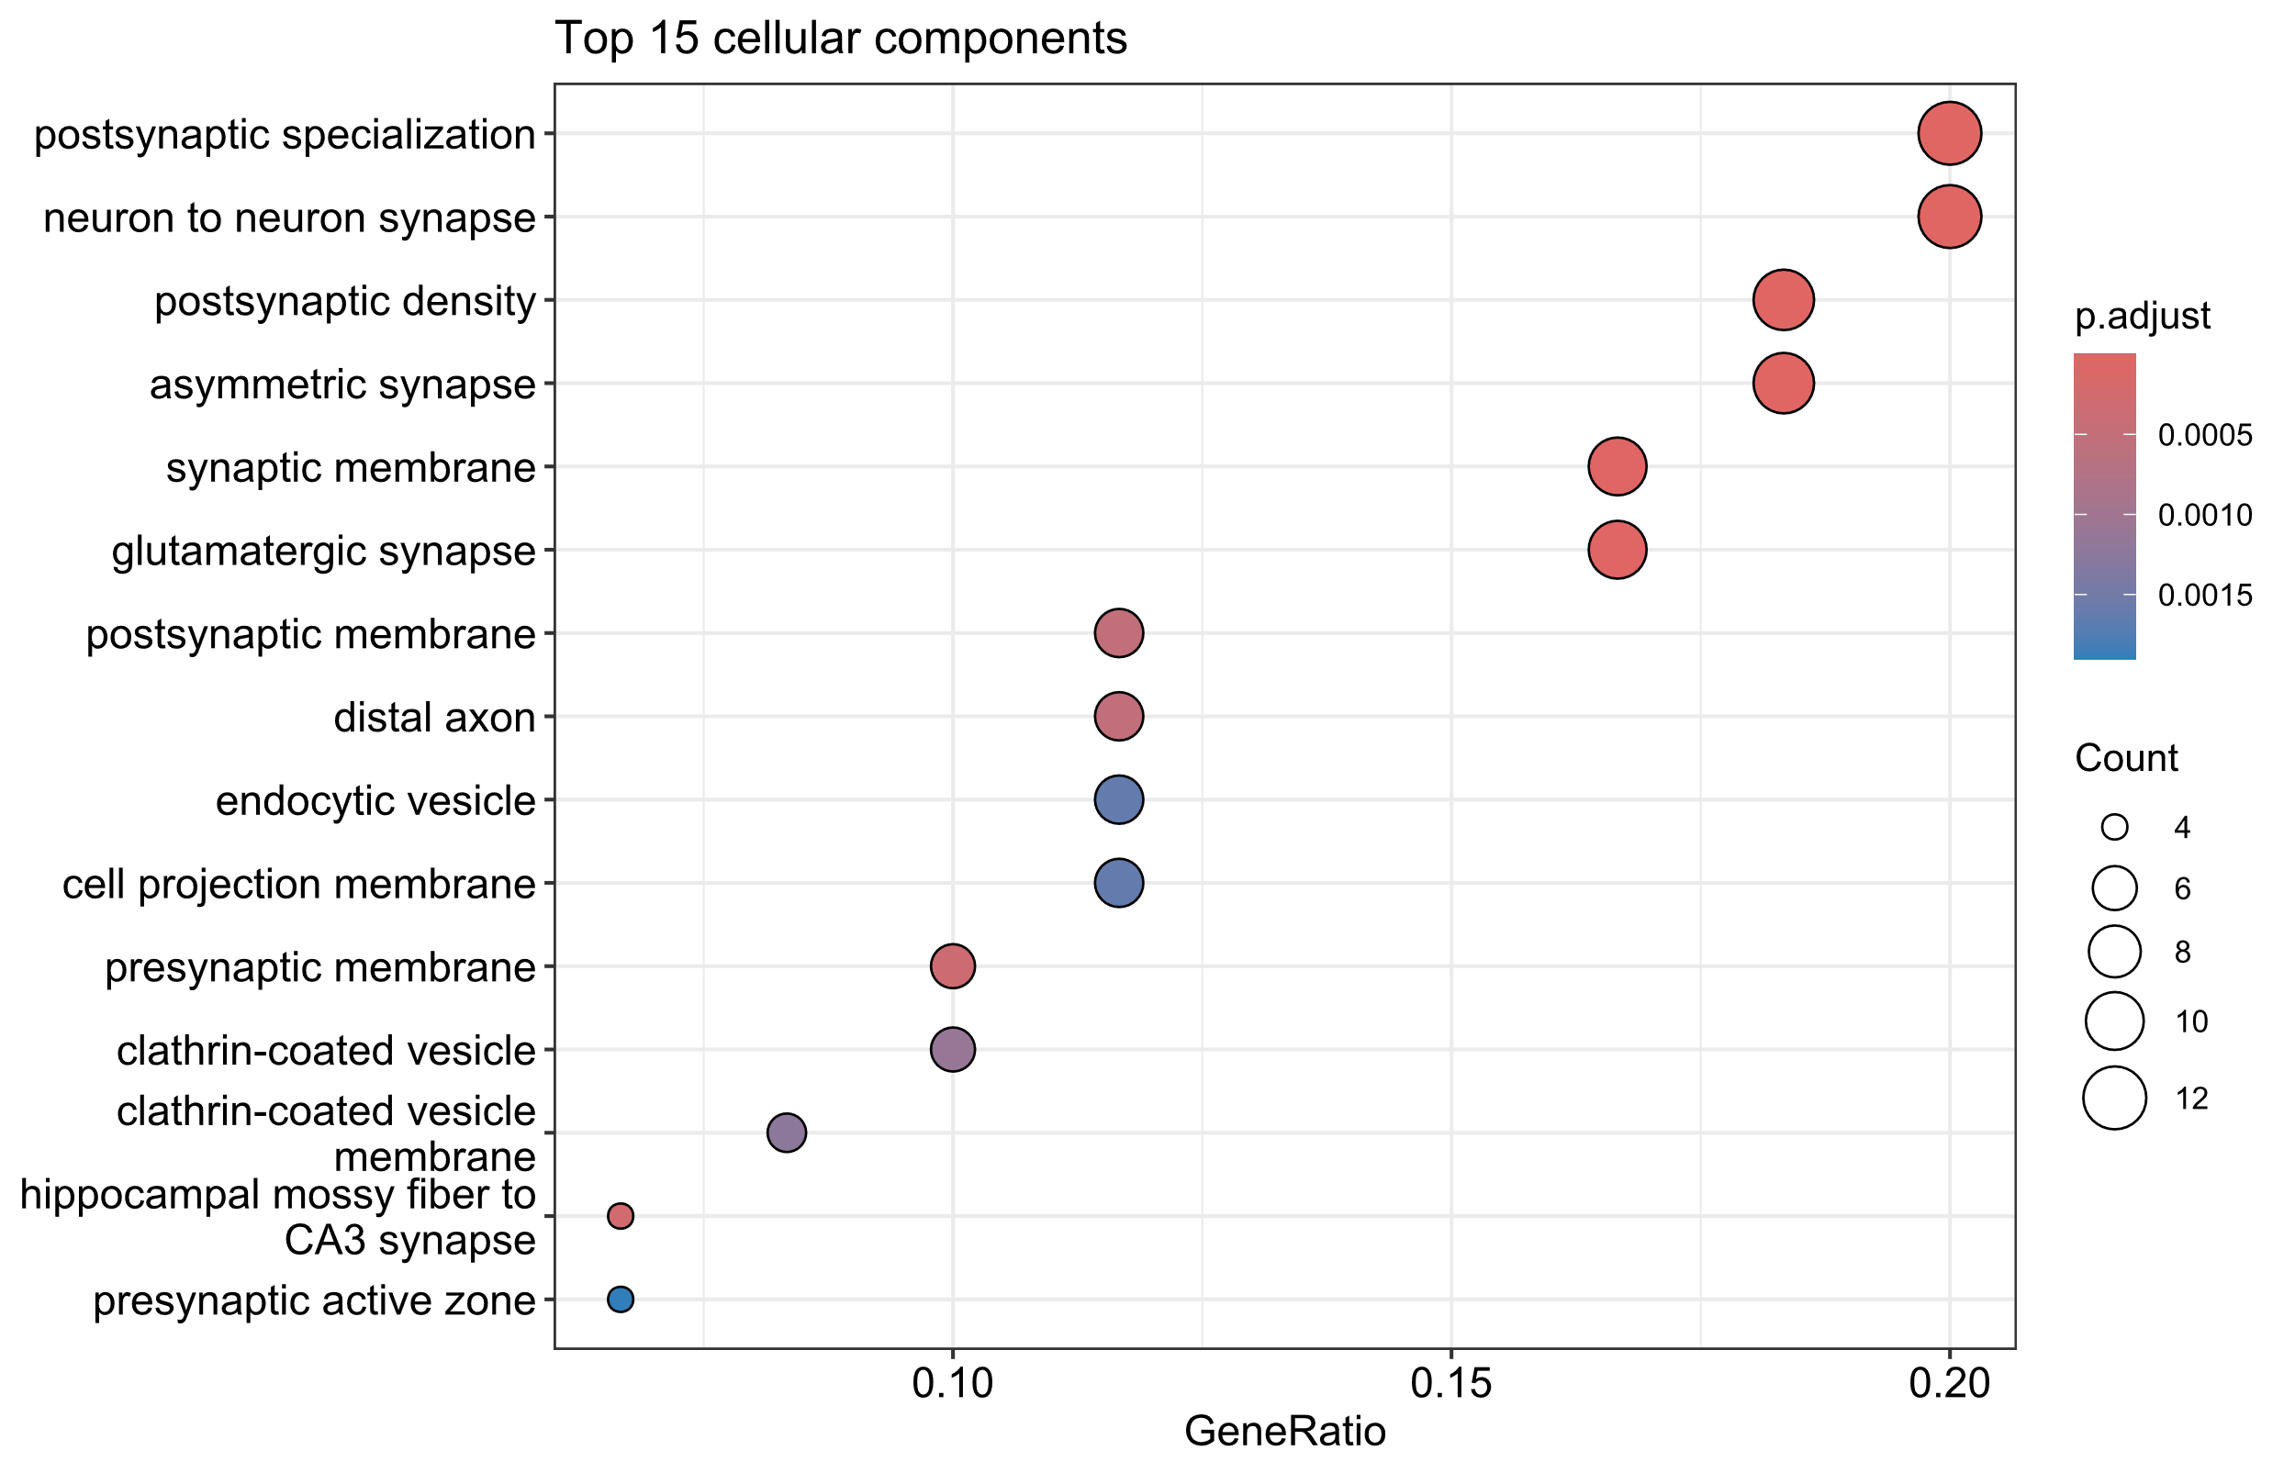
Supplementary Figure 3. Top 15 enriched terms in the GO categories of cellular components for the brain-specific network of functionally-related genes.

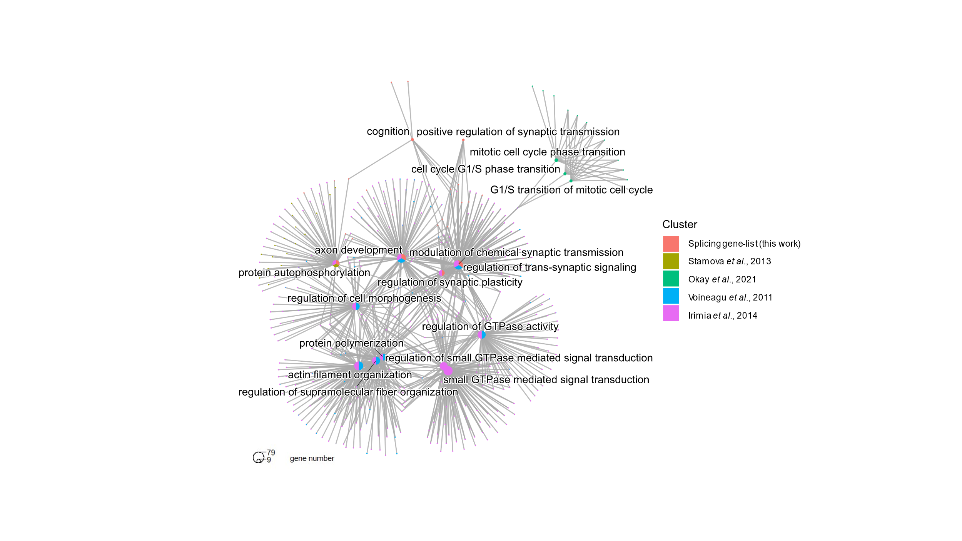
Supplementary Figure 4. Cluster enrichment in the GO categories of biological processes for the datasets with alternative-splicing-genes implicated in ASD.
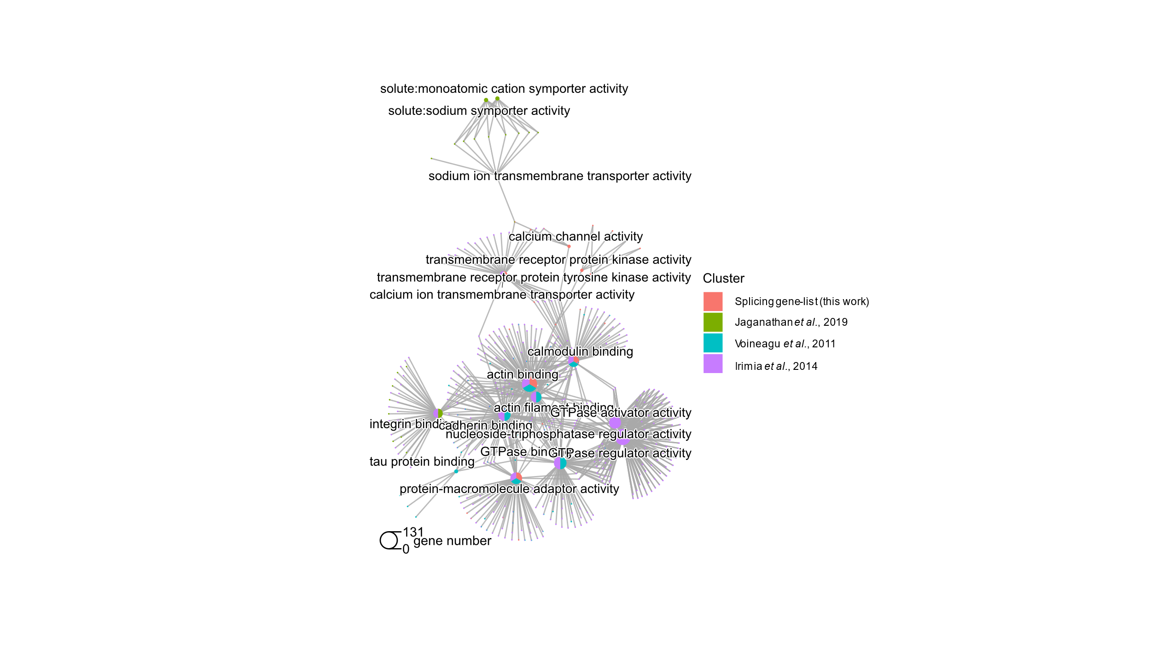
Supplementary Figure 5. Cluster enrichment in the GO categories of molecular functions for the datasets with alternative-splicing-genes implicated in ASD.
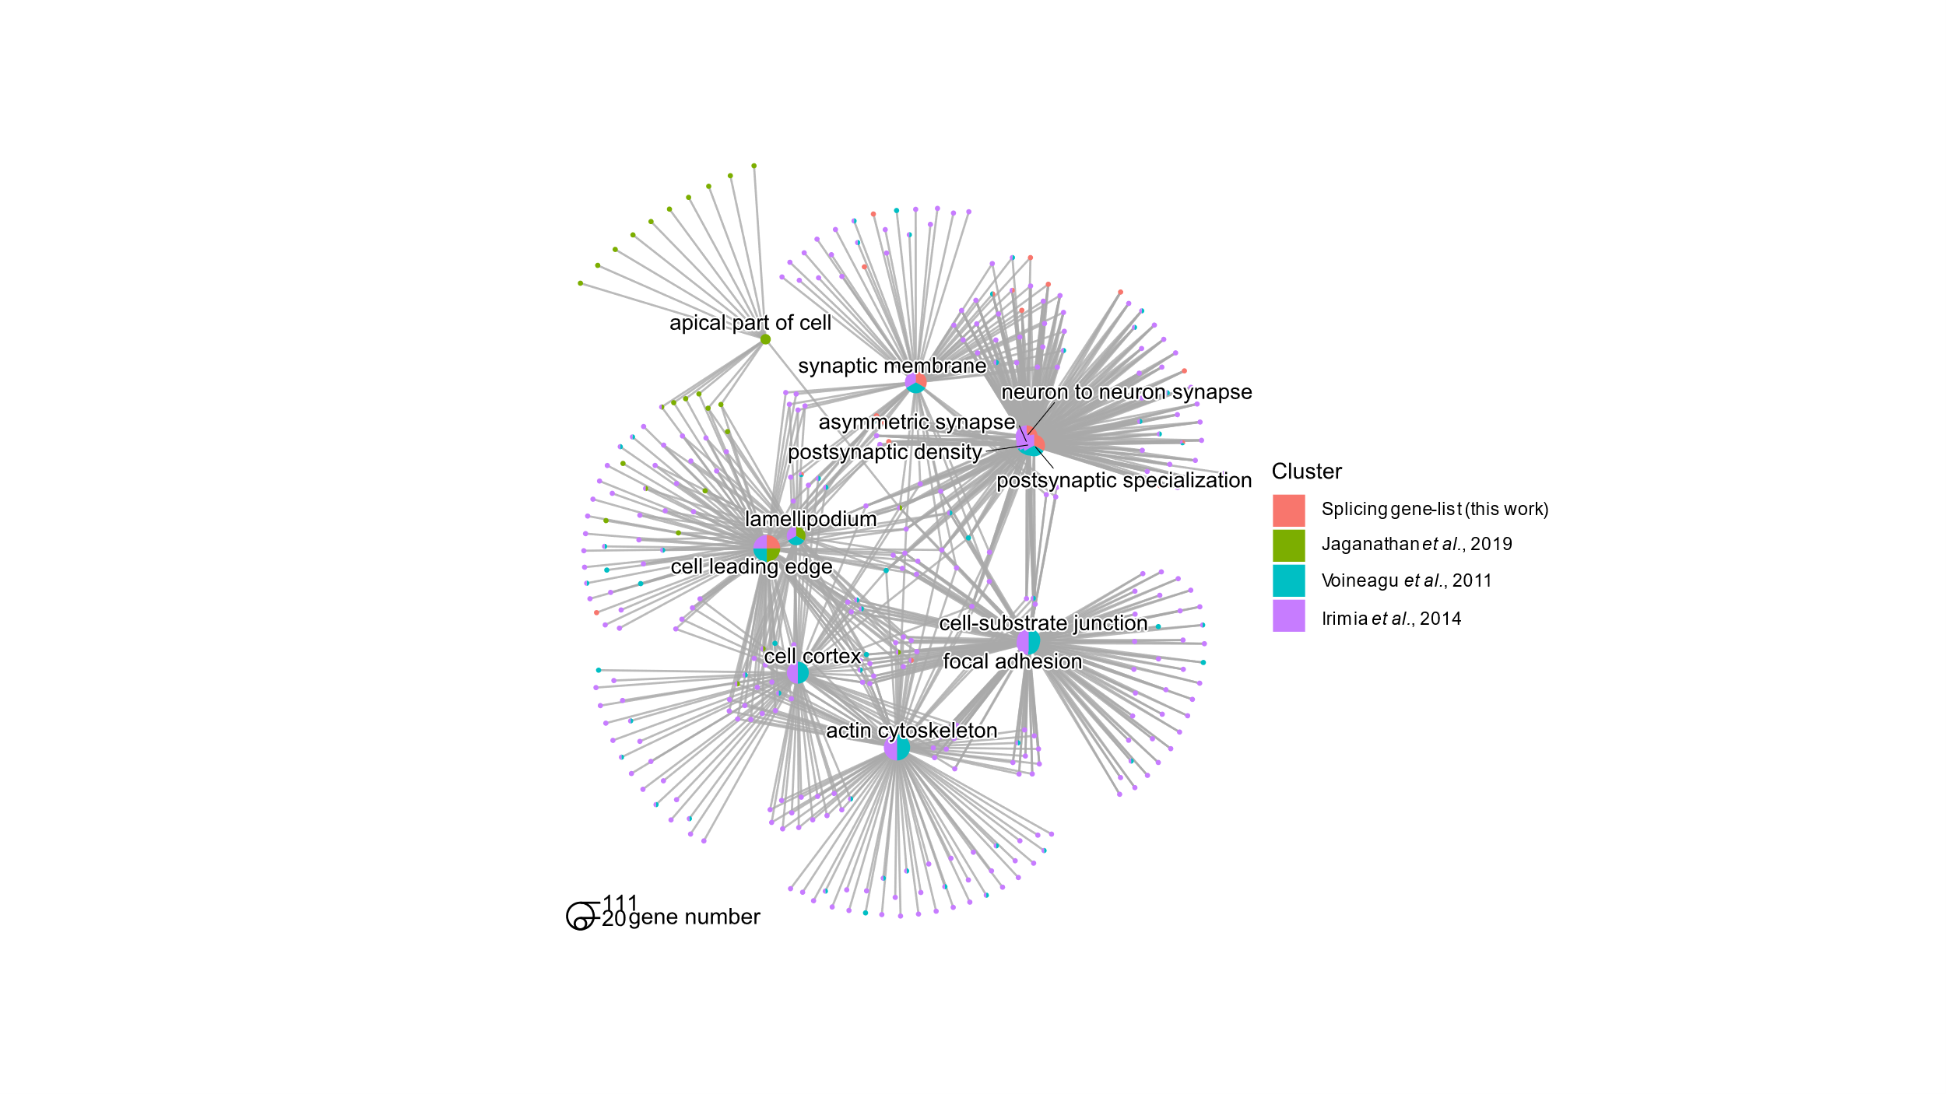Supplementary Figure 6. Cluster enrichment in the GO categories of cellular components for the datasets with alternative-splicing-genes implicated in ASD.

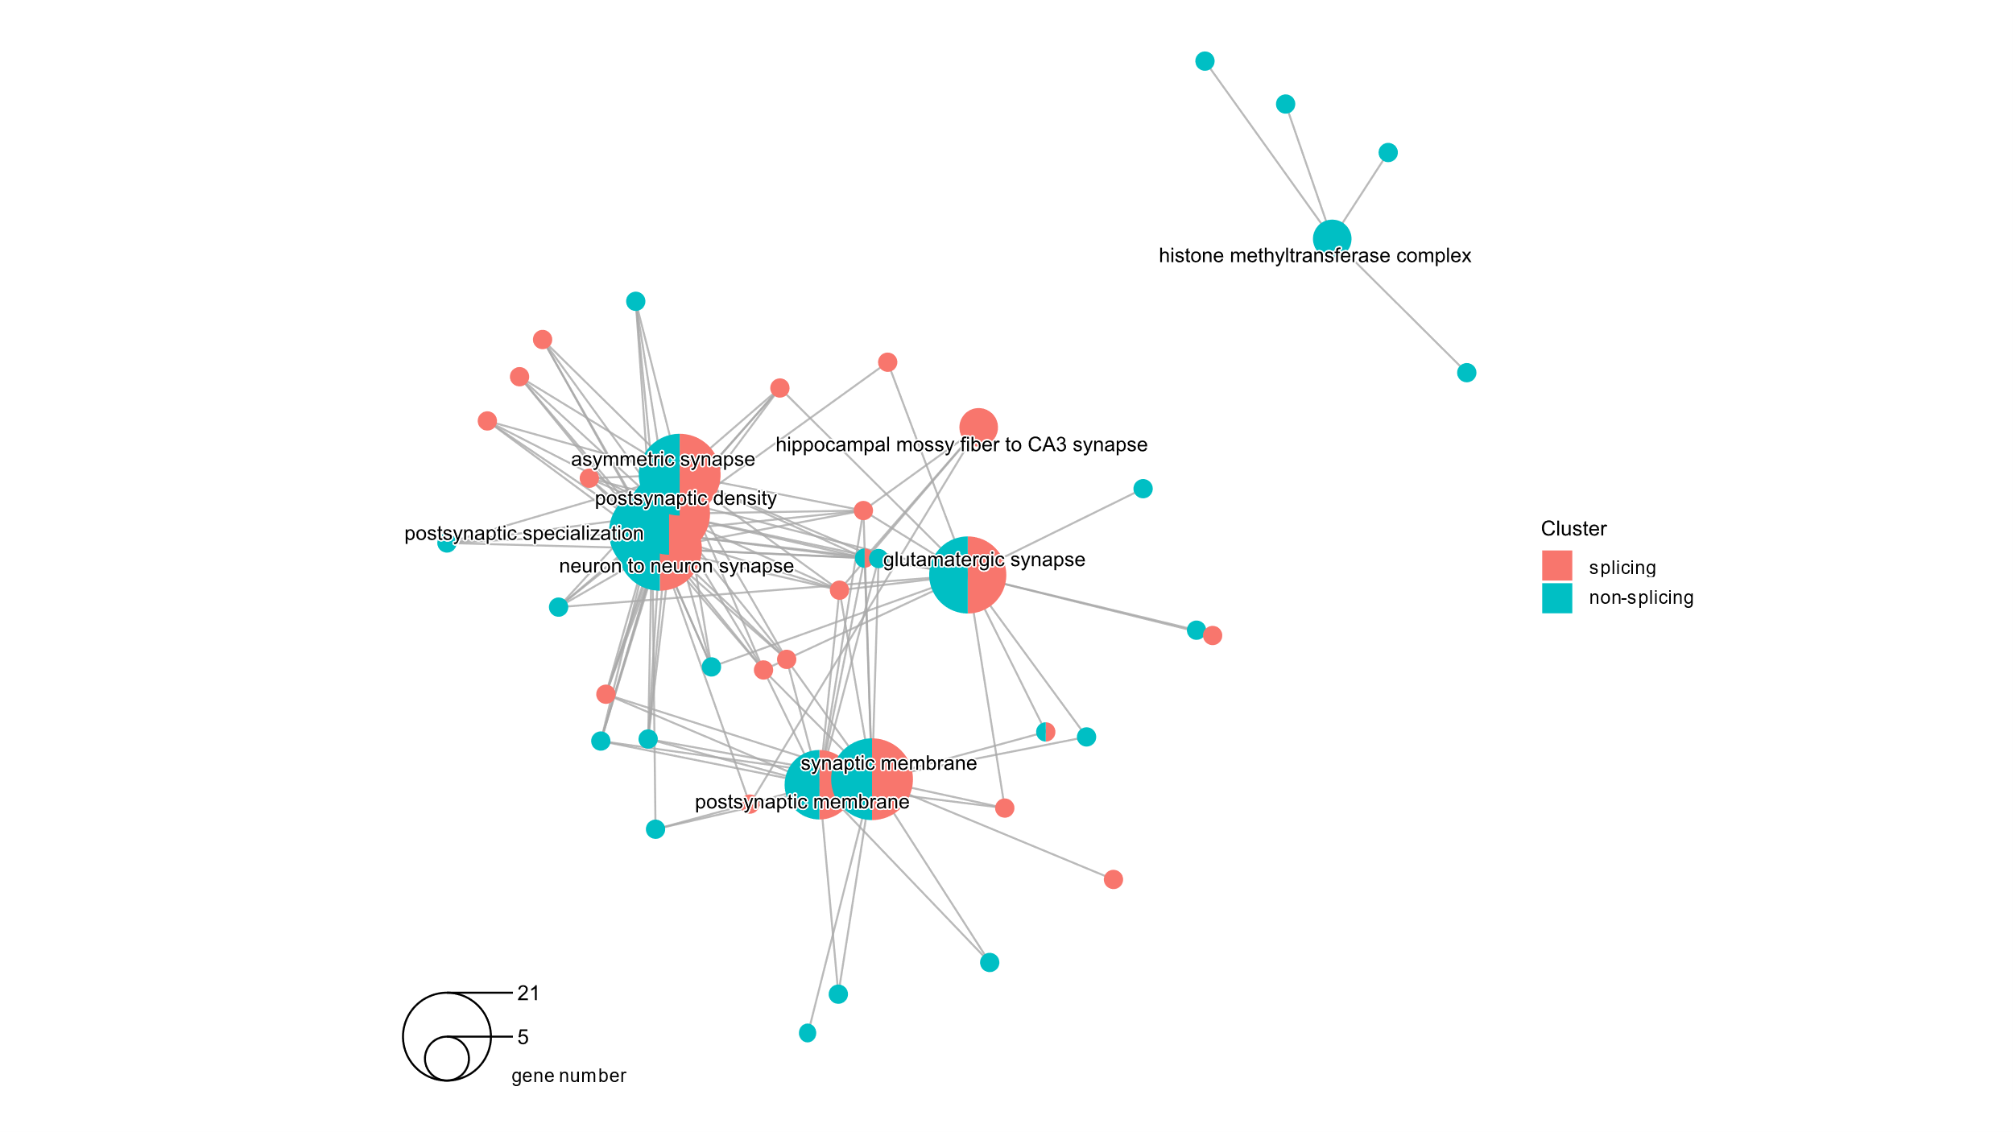
Supplementary Figure 7. Cluster enrichment in the GO categories of cellular components for the splicing gene list and the non-splicing gene list.

