Extended Data Figures
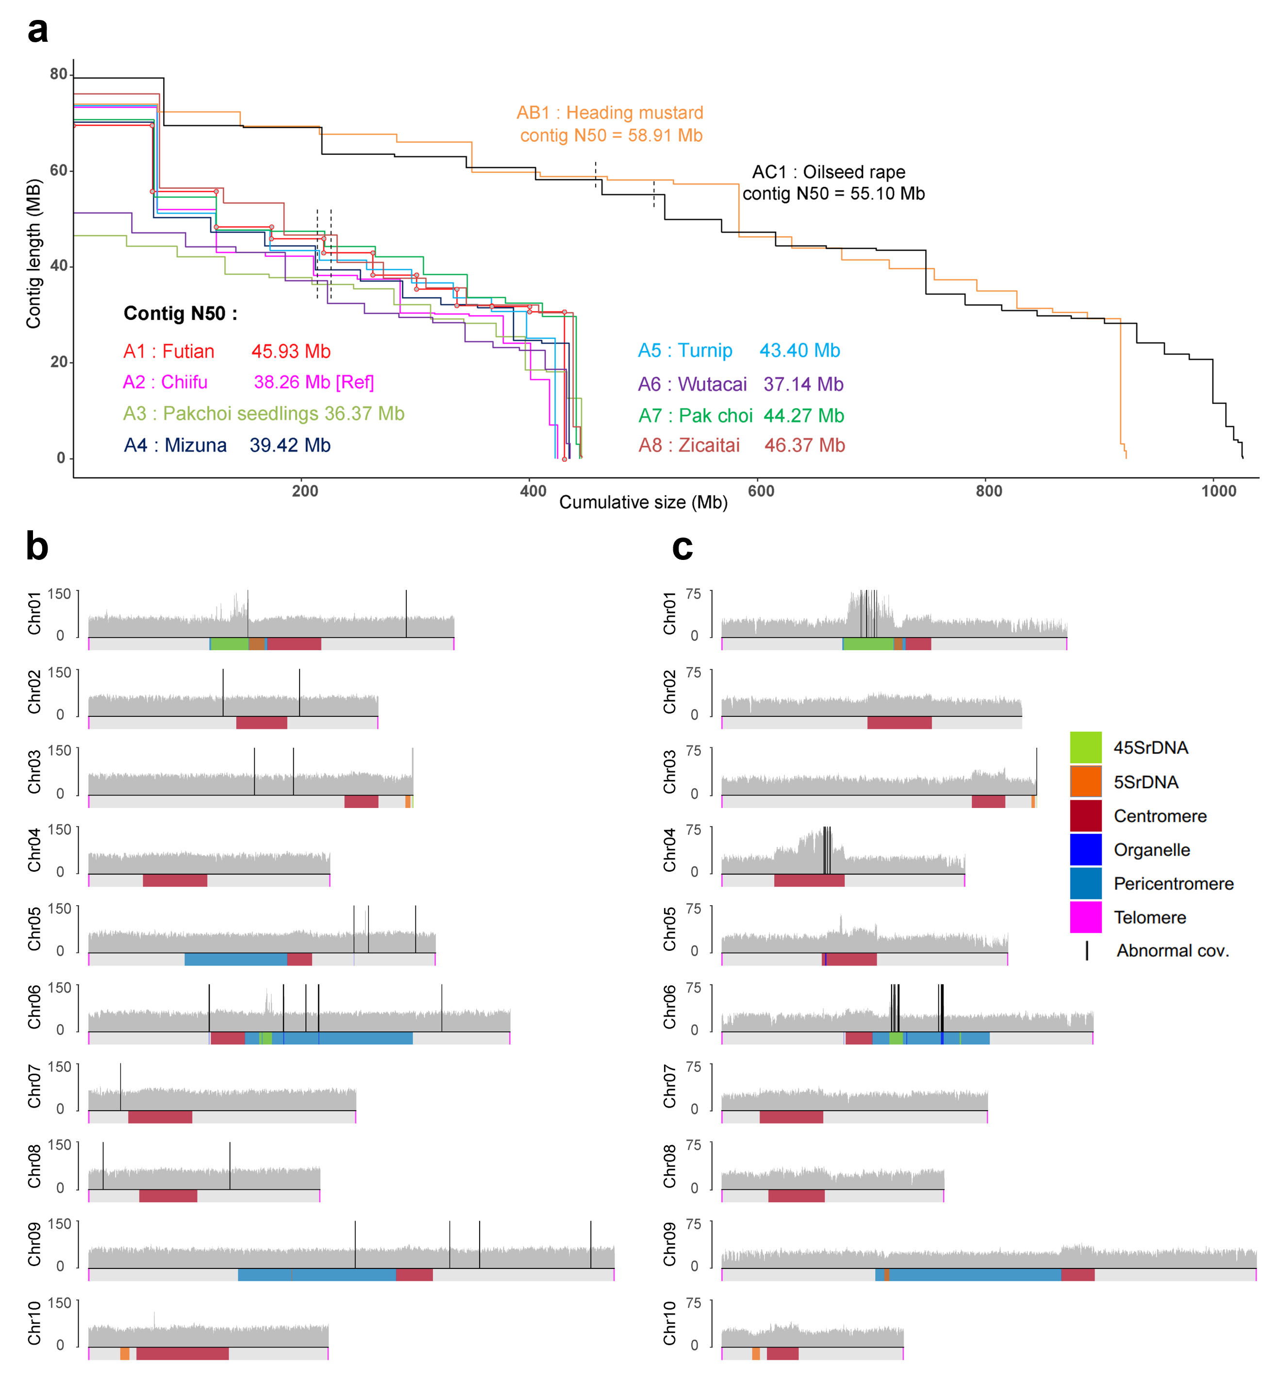
Extended Data Fig. 1 | Genome assembly statistics and validation. a, Assembly statistics of the ten Brassica genome used in this study. The dashed lines represent the contig N50 index. b and c, Whole-genome coverage of HiFi reads across A1 Futian (b) and A5 turnip (c) genome assembly. The regions of telomere, centromere, pericentromere, rDNA arrays and organelle insertions were marked on the bottom track.
Extended Data Fig. 2 | Genome assembly and centromere structure of the allotetraploid B. juncea (AABB). a, Circos plot of the AB genome assembly. Quantitative tracks were calculated in 100-kb bins. Full descriptions for the tracks are also available in the main Figure 1 legend. b, The structure of B03 centromere and statistics of CENH3 log2(ChIP/input), CpG and CHG methylation, Copia density, and Gypsy density. c, StainedGlass heatmap of the pairwise sequence identity (%) between 5-kb bins. A CEN176 satellite relict was identified at the boundary of B08 centromere.
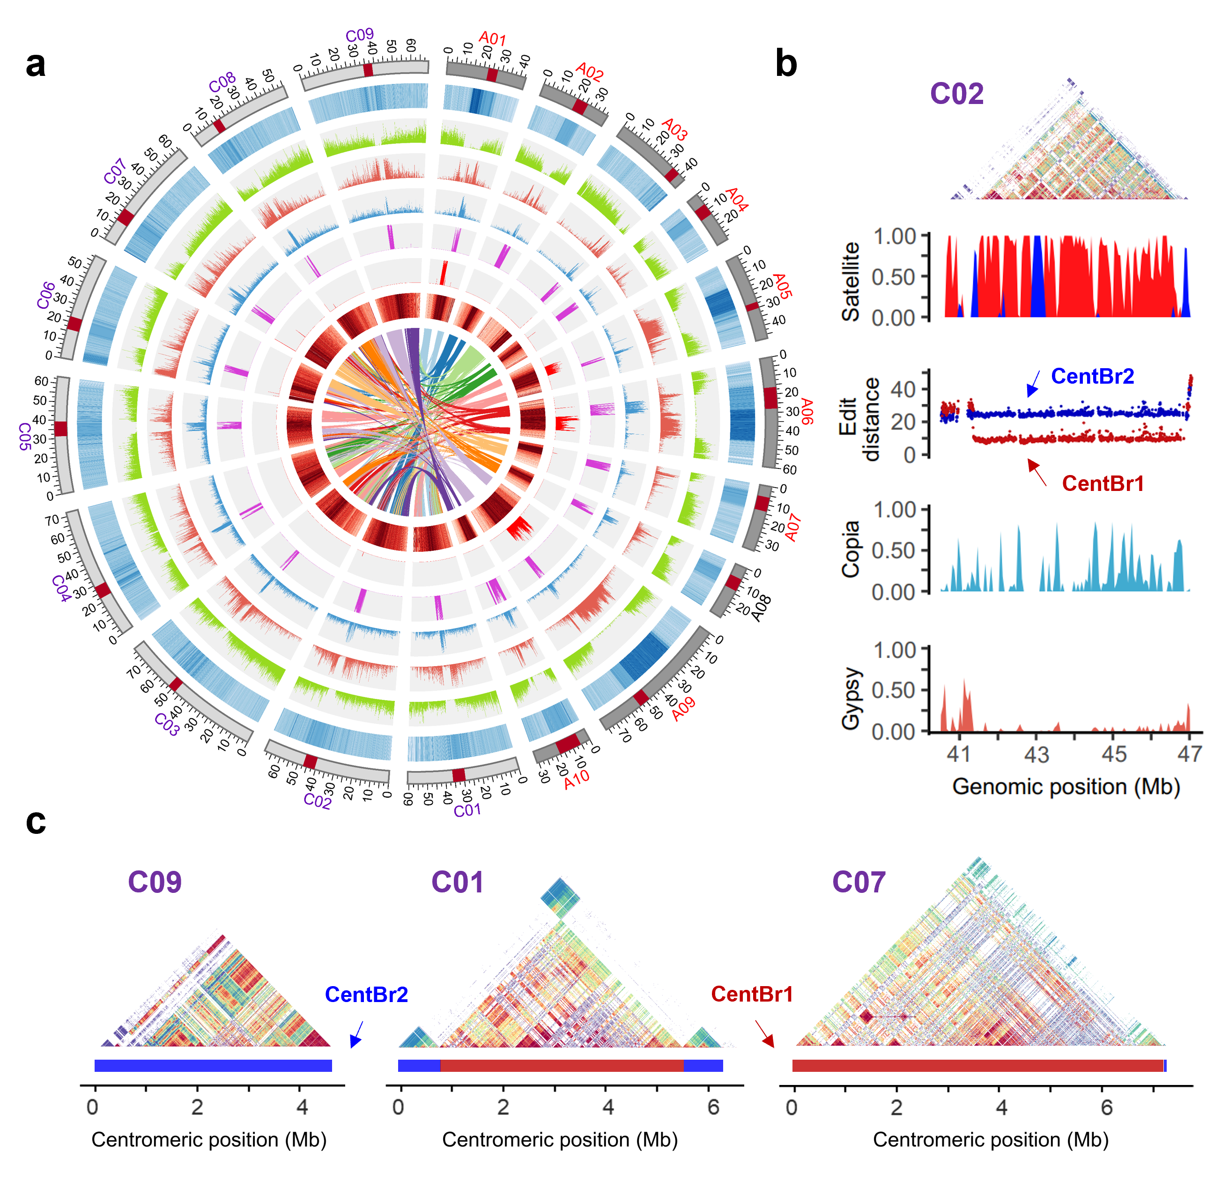
Extended Data Fig. 3 | Genome assembly and centromere structure of the allotetraploid B. napus (AACC). a, Circos plot of the AC genome assembly. Quantitative tracks were calculated in 100-kb bins. Track from outer to inner: chromosomes (red: centromere), GC content, gene density, Gypsy density, Copia density, CEN176 density, rDNA density, CpG methylation level estimated by ONT reads and color ribbons representing syntenic blocks. b, The structure of C02 centromere and statistics of satellite density (red, forward; blue, reverse orientation), satellite edit distance relative to CentBr1 and CentBr2, Copia density, and Gypsy density. c, StainedGlass heatmaps of the pairwise sequence identity (%) between 5-kb bins. Three representative centromeres of C subgenome were exhibited.
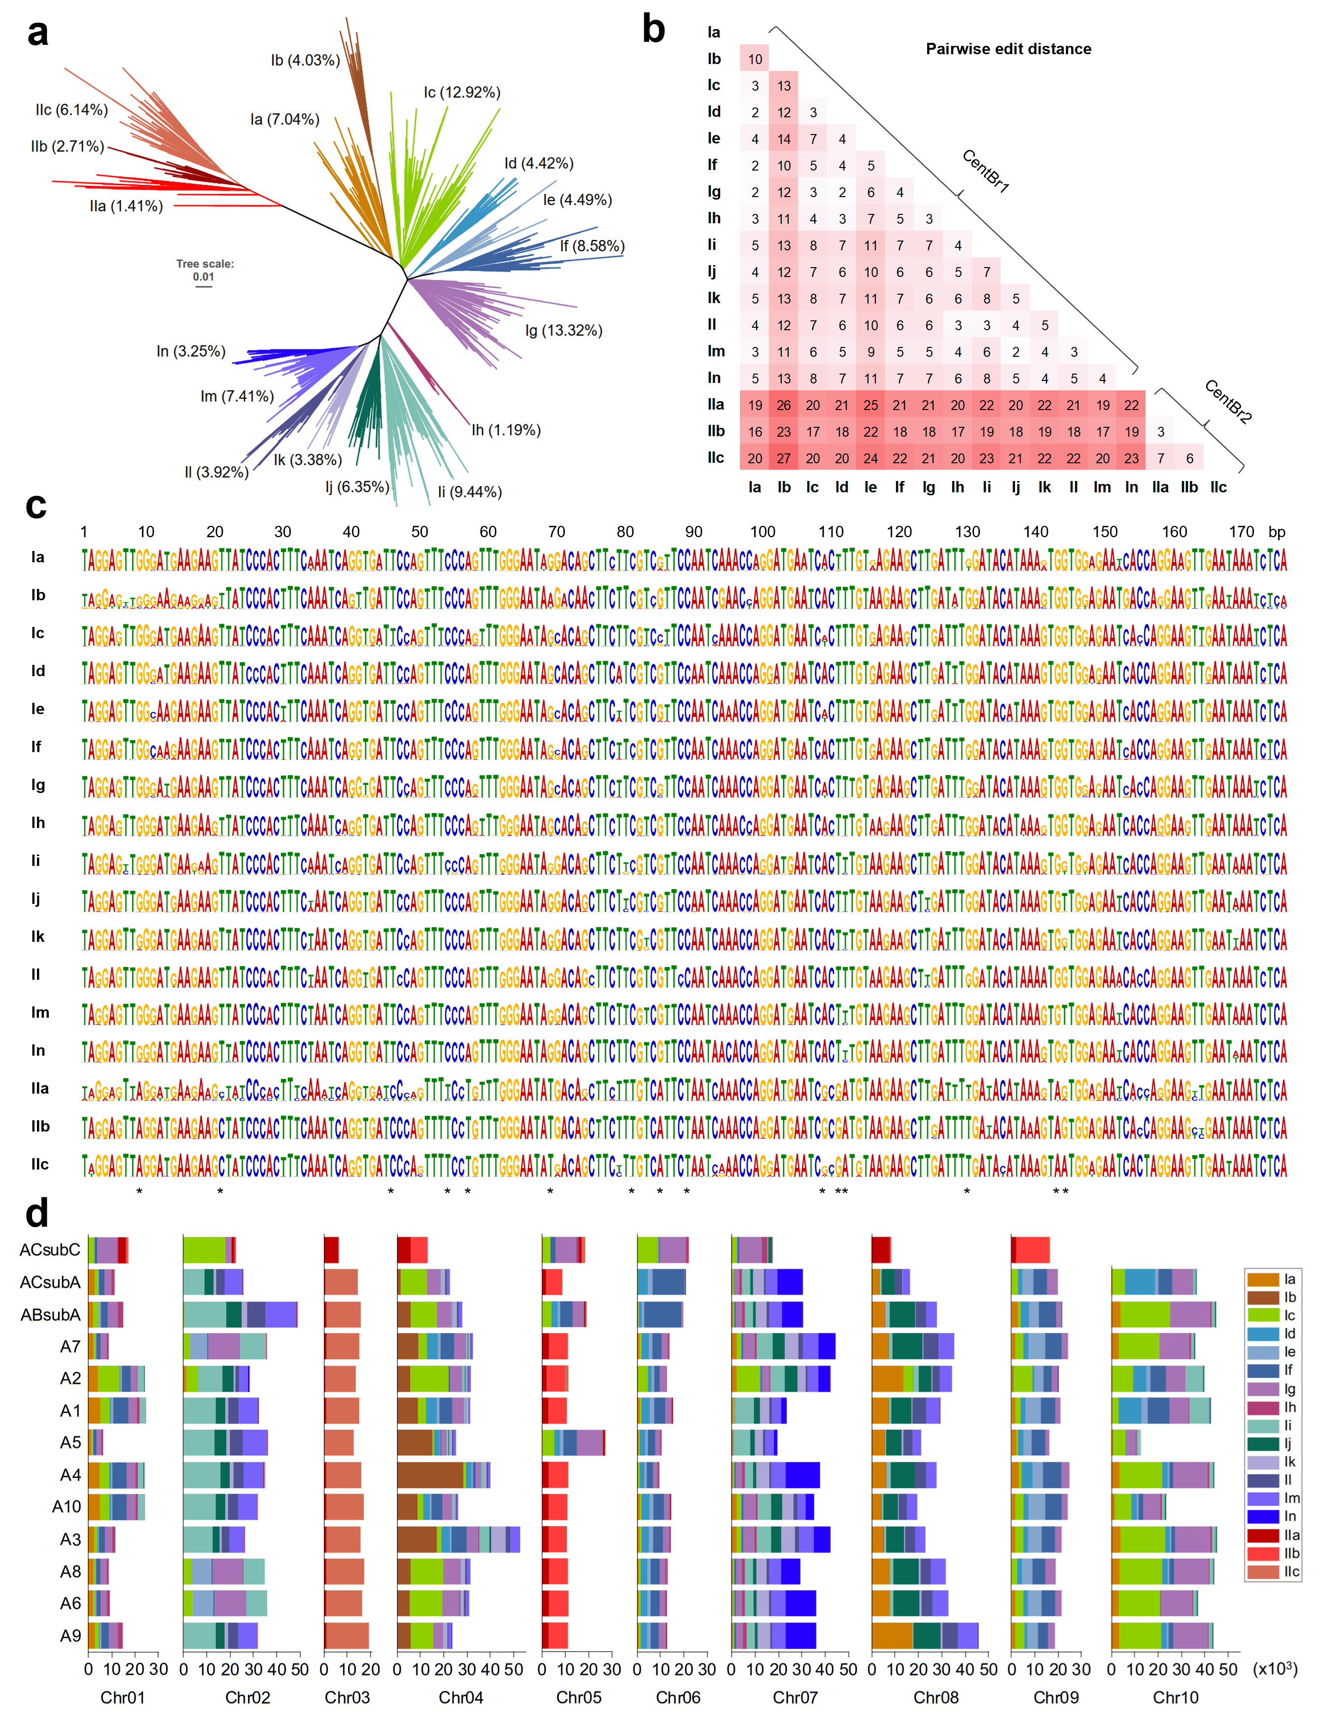
Extended Data Fig. 4 | Dynamics of CEN176 satellites in Brassica crops. a, A maximum-likelihood phylogenetic tree of 6,487 representative (>50 occurrences in the pan-centromere collection) CEN176 satellites. b, Pairwise edit distance of top one (the highest occurrences) CEN176 monomer in each family. c, Consensus sequences of the CEN176 satellites in each family. The asterisk indicates the distinct bases between two major groups (I and II). d, Copy number of the CEN176 satellites across each chromosome and each accession. Seventeen families are colored according to the taxonomic groups.

Extended Data Fig. 5 | Sequence alignment of CENH3 protein and its occupied satellite. a, Sequence alignment of centromeric satellites from A. thaliana, R. sativus, B. rapa and B. oleracea. b, Amino acid alignment of CENH3 proteins from A. thaliana, R. sativus, B. nigra, B. rapa and B. oleracea. The BnCENH3 has a deletion of sequences (red box) corresponding to the fourth and fifth exons of BrCENH3.
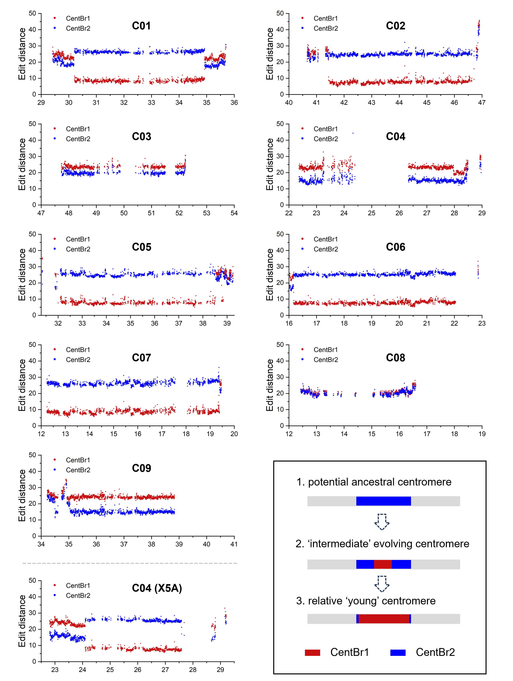
Extended Data Fig. 6 | Edit distance of centromeric satellites relative to CentBr1 and CentBr2. The edit distances of centromeric satellites in C subgenome were calculated. The previous X5A assembly showed similar results except for the C04 centromere. The box in the lower right corner shows the proposed centromere evolution model in C sub/genome.
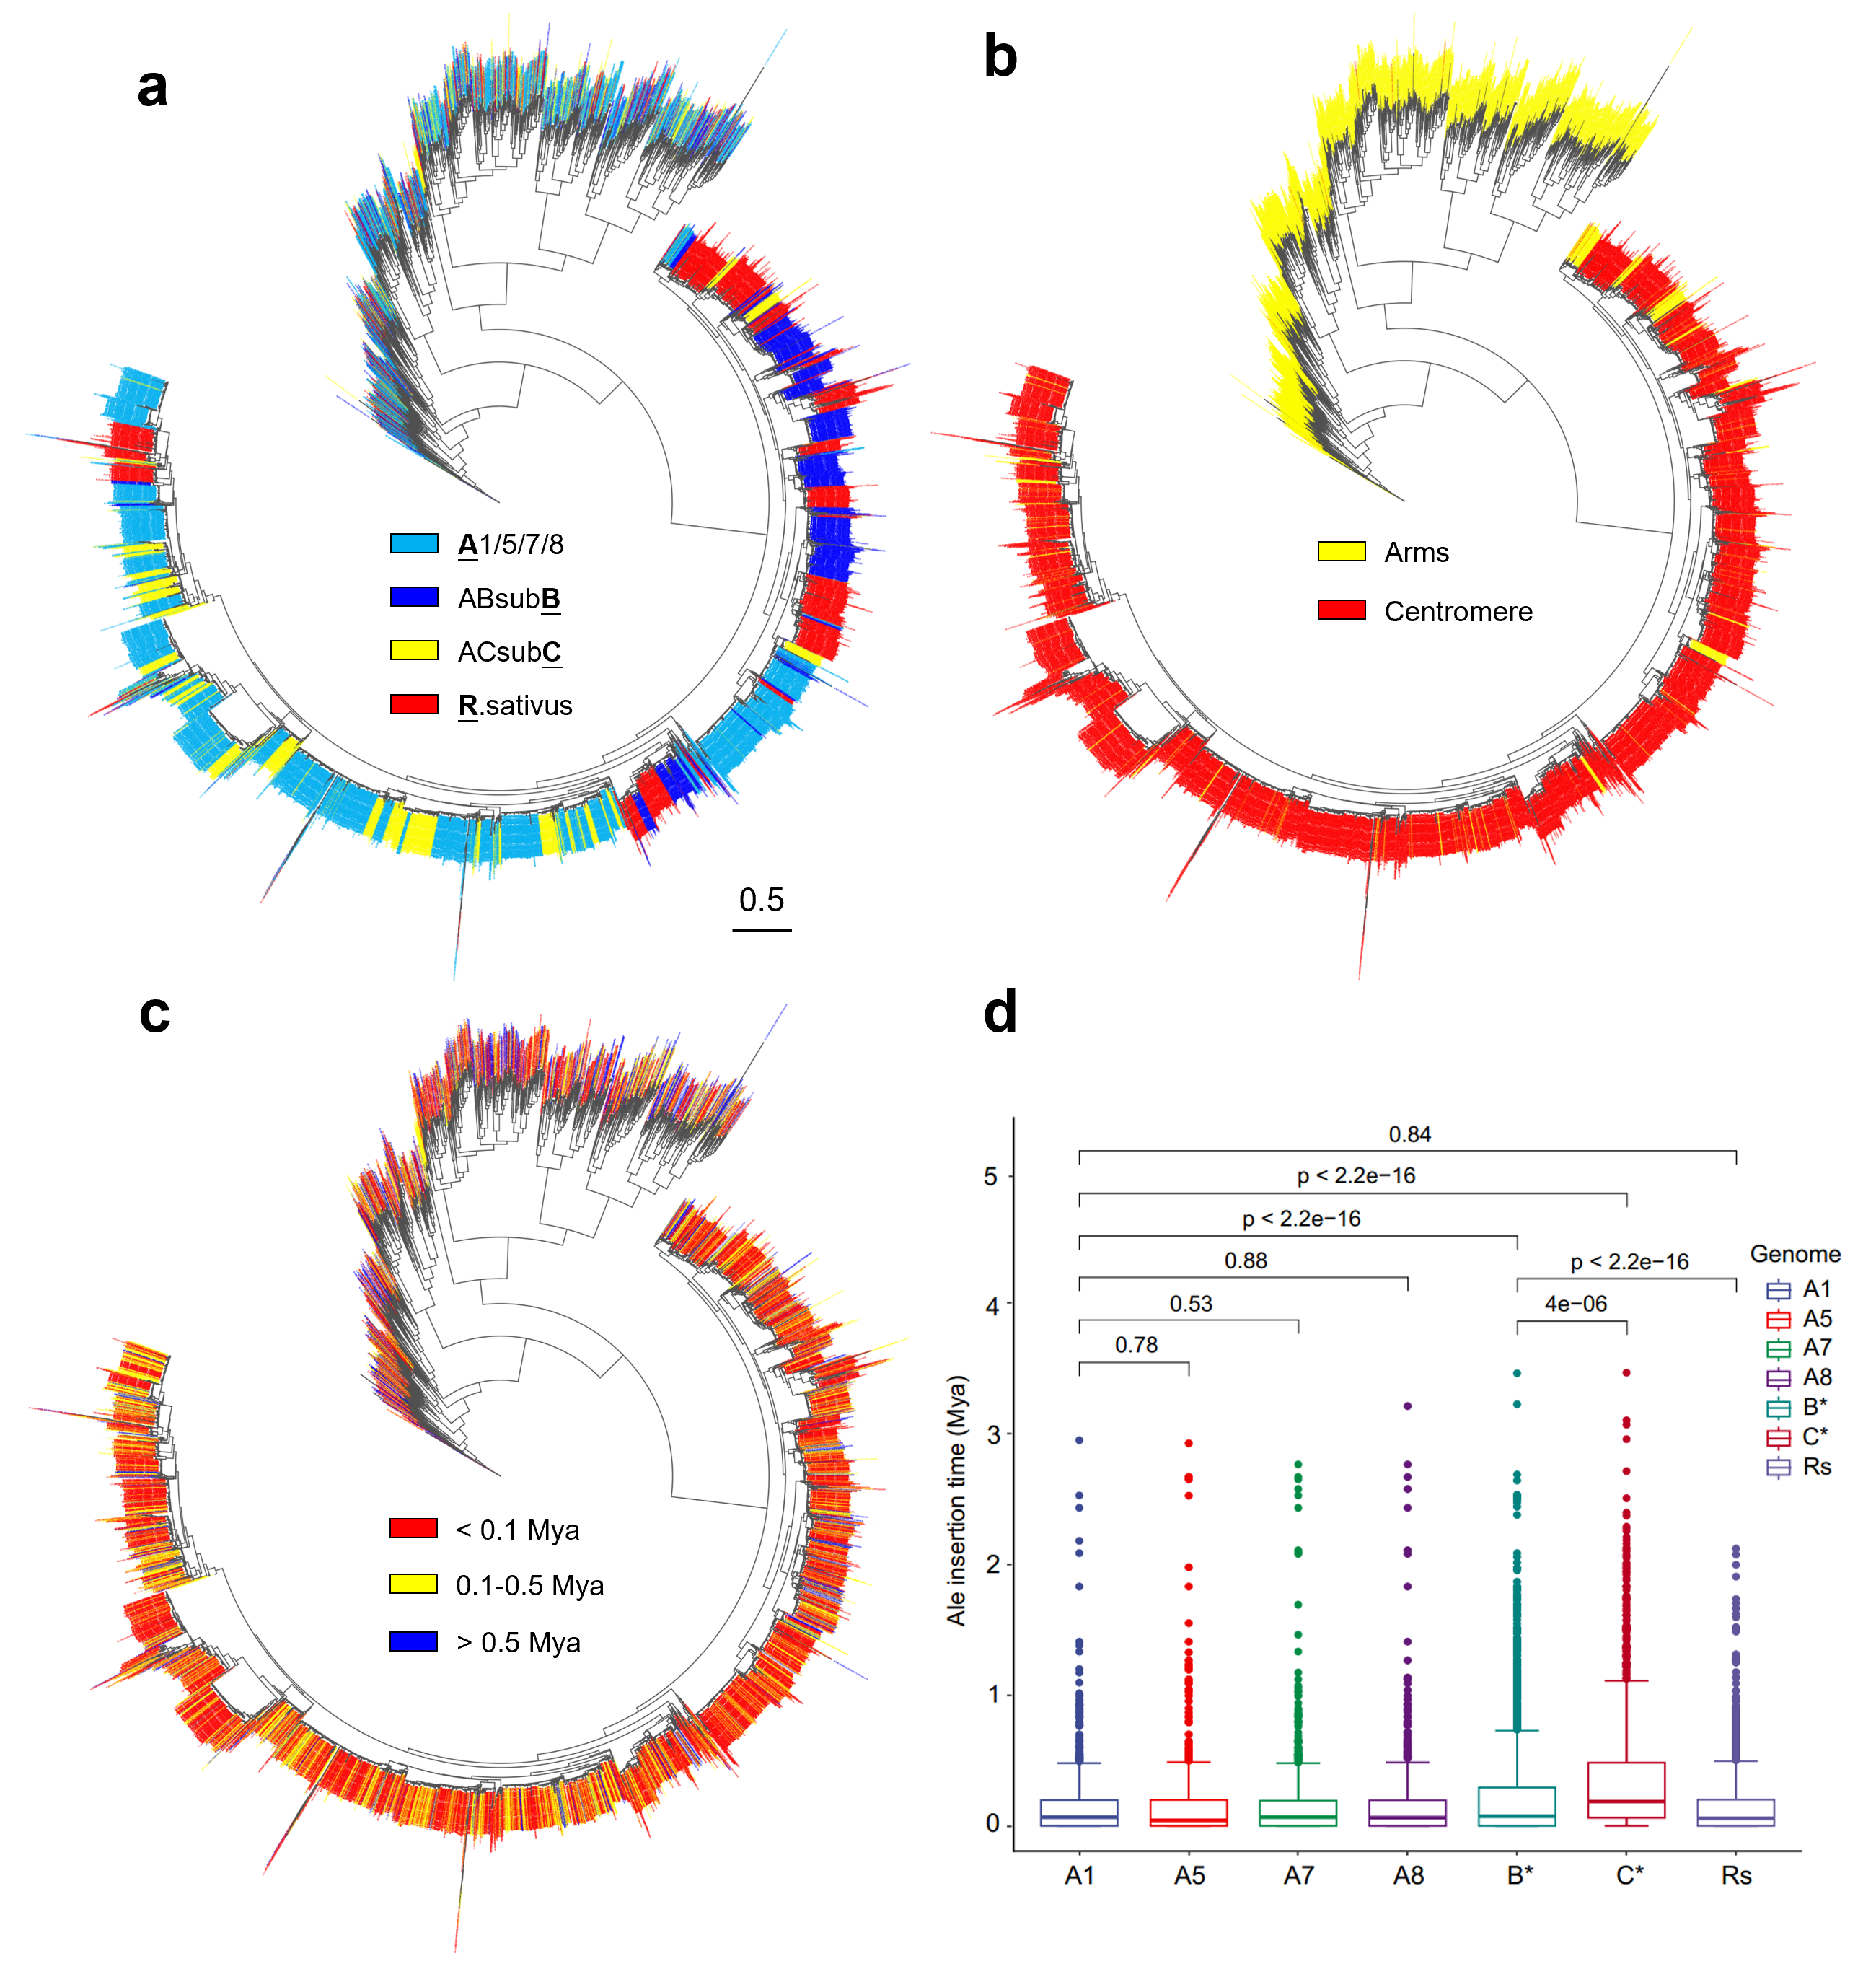
Extended Data Fig. 7 | Phylogenetic analysis of intact Ale retrotransposons in Brassica crops. a-c, Ale phylogeny across Brassica crops and R. sativus. Tree labels are coloured according to sample accession (a), position inside or outside the centromeres (b) and the LTR insertion time (c). Scale bar, 0.5 substitutions per site. d, The insertion time of Ale retrotransposons among different sample accessions. A two-sided Wilcoxon test was used to determine the significant levels.
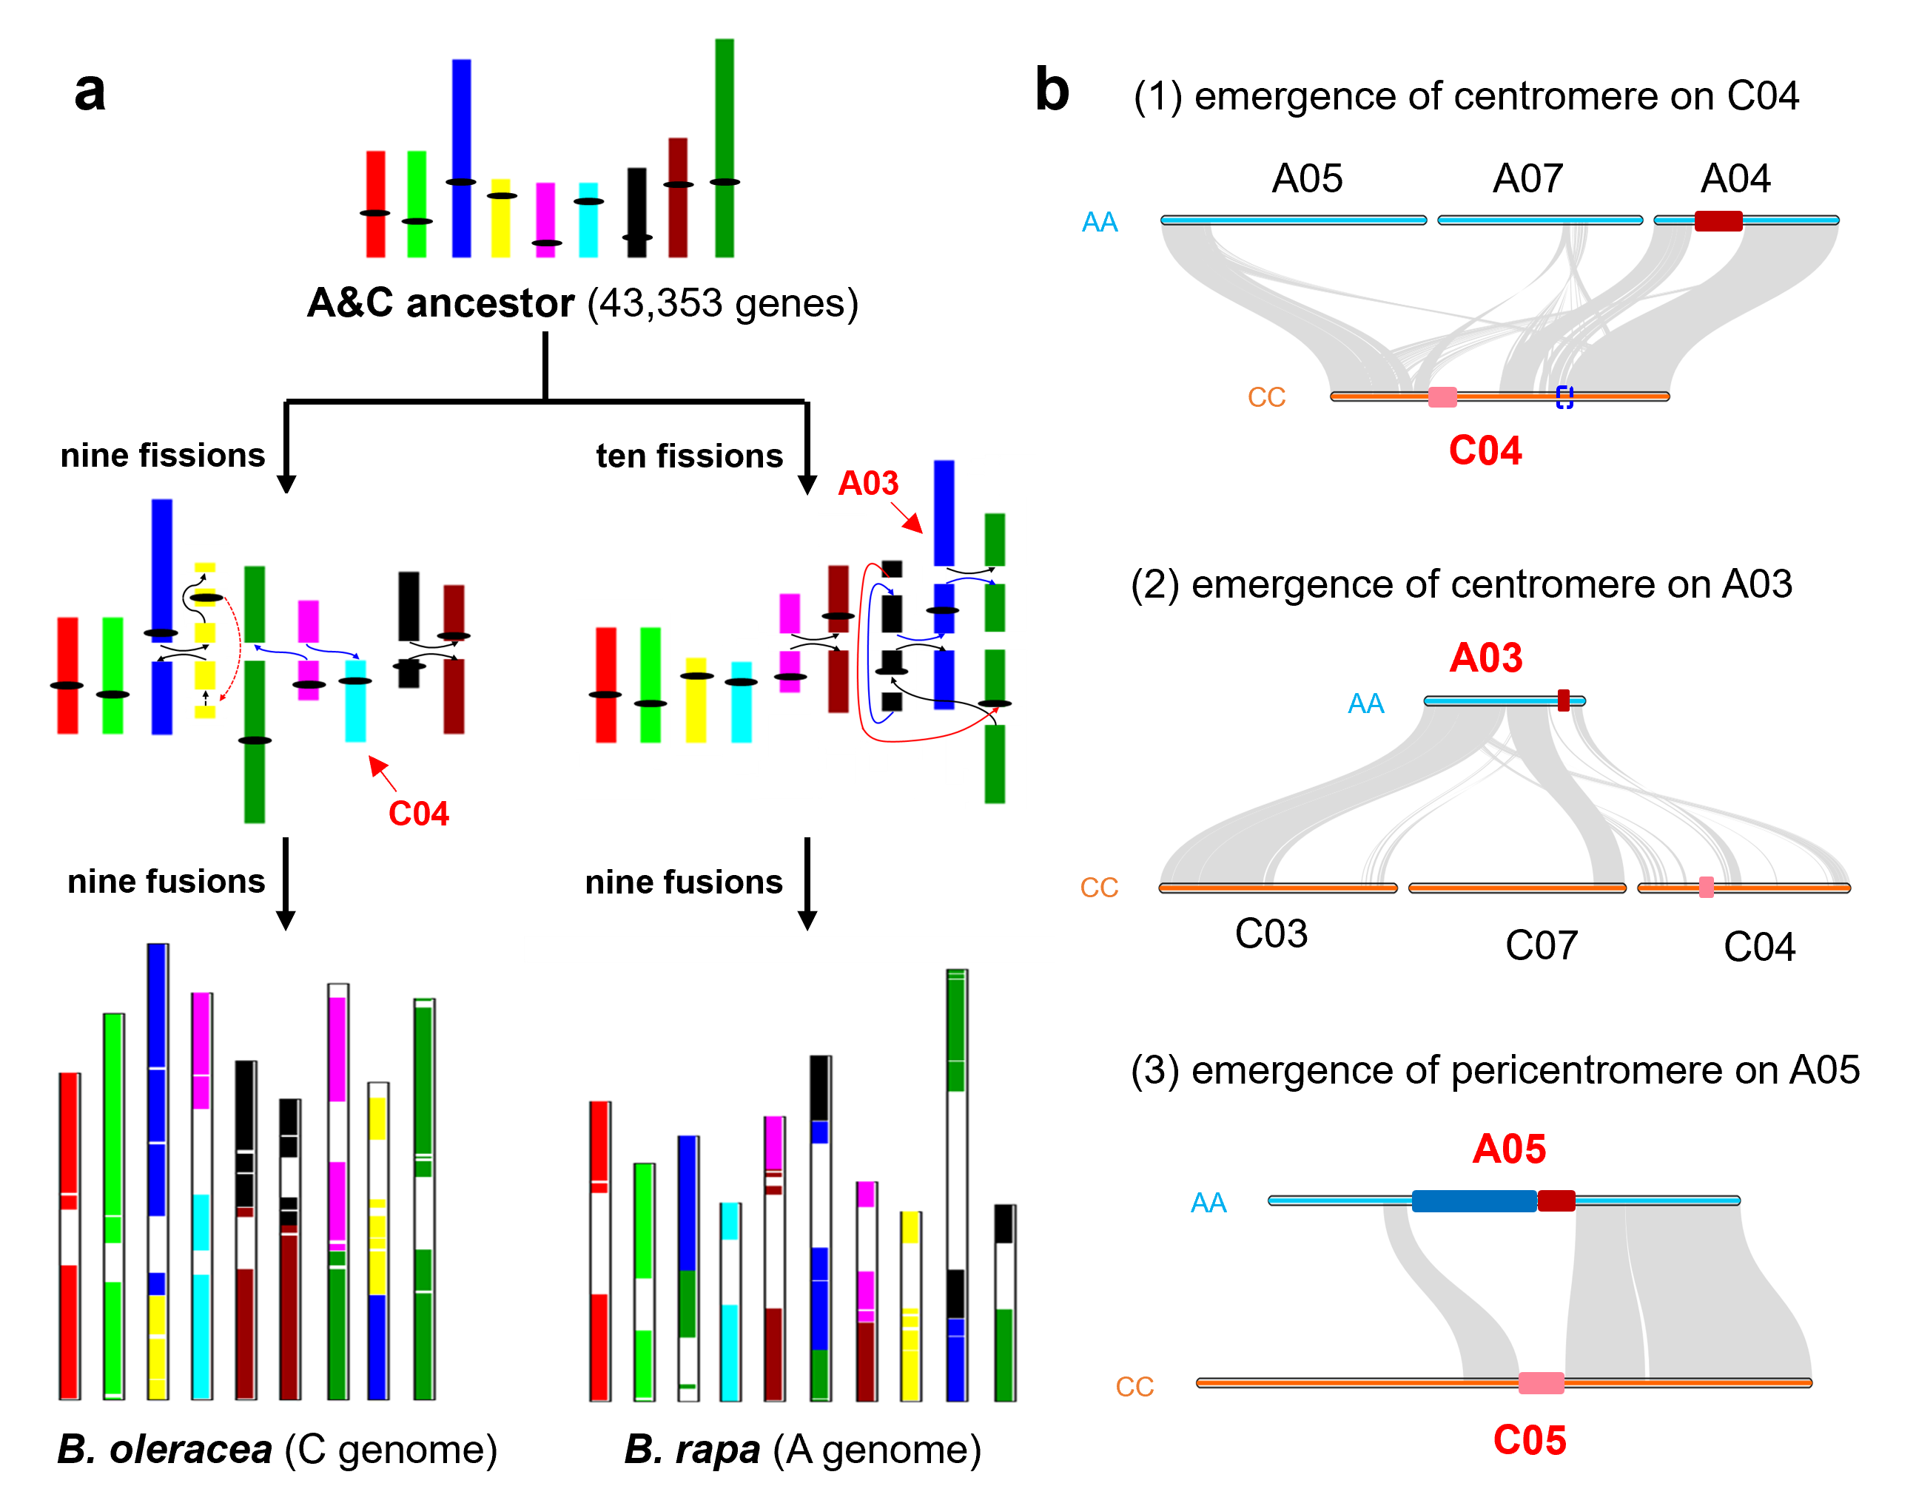
Extended Data Fig. 8 | Genome rearrangements and centromere evolution of B. rapa and B. oleracea. a, Karyotype evolution from previous reported ancestral genome to current B. rapa and B. oleracea genomes. Syntenic blocks are ‘painted’ with colours corresponding to ancestral chromosomes. Black bars represent ancestral centromeric regions. b, Chromosome alignments illustrate the emergence of peri/centromere in A and C sub/genome.

