Pan-centromere landscape and dynamic evolution in Brassica plants

Chen et al.

Supplementary Notes

Supplementary Note 1. Genetic backgrounds of the assembled Brassica accessions
The species Brassica rapa (AA, 2n=20) is mainly cultivated as a vegetable crop worldwide, and has been domesticated into many subspecies with distinctive morphotypes¹⁻⁸. We individually de novo assembled seven representative B. rapa genomes, including Futian Chinese cabbage (A1, ssp. pekinensis), Pak-choi (A3 and A7, ssp. chinensis), Mizuna (A4, ssp. nipposinica), Turnip (A5, ssp. rapa), Wutacai (A6, ssp. narinosa), and Zicaitai (A8, var. purpurea). To construct pan-centromere analysis, we also included three previously reported near-complete assemblies in this study, such as ssp. pekinensis cv. Chiifu (A2)², ssp. chinensis cv. AiJiaoBai (A9, AJ)³, and ssp. purpuraria cv. HongShanCaiTai (A10, HS)³. We examined their genetic relationships through single nucleotide polymorphism (SNP) analysis using Futian genome as a reference. A total of 1,913,458 high-quality SNPs were common and located in non-peri/centromeric regions. The SNP-based phylogenetic tree of 32 B. rapa accessions showed that the ten accessions (A1-A10) used for pan-centromere analysis displayed distinct genetic backgrounds (Supplementary Fig. 1). The wild-type ‘Futian’ Chinese cabbage was grouped with the well-known ‘Chiifu’ Chinese cabbage, which were then clustered with the non-heading Chinese cabbage A7 accession. However, the clustering of A5, A6 and A8 accessions sequenced in this study was not fully consistent with the previous reported turnip (TUE, TUA and ECD04), wutacai (WTC) and zicaitai (ZCT and HS) samples (Supplementary Fig. 1), respectively, illustrating a complex intraspecific diversification even in same morphotypes.
In addition, we also generated two near-T2T assemblies for the allotetraploid B. juncea (AABB, 2n=36) and B. napus (AACC, 2n=38). To infer the ordinal phylogeny of the different Brassica species, we selected 3,870 single-copy nuclear genes from three representative diploids and above two allotetraploids using A. thaliana⁹ and R. sativus¹⁰ as outgroups. The phylogenetic tree showed that the R. sativus/B. nigra diverged from B. rapa/B. oleracea first, and then R. sativus diverged from B. nigra soon after (Supplementary Fig. 2), indicating a closer relationship of R. sativus with B. nigra¹¹ than B. rapa and B. oleracea¹², in agreement with previous report¹³. It’s worth noting that we introduced R. sativus in our Brassica pan-centromere analysis as a outgroup, as we found that the 177-bp centromeric satellites in R. sativus showed high sequence similarity with the 176-bp Brassica centromeric satellites.

Supplementary References
1. Cai, X. et al. Impacts of allopolyploidization and structural variation on intraspecific diversification in Brassica rapa. Genome Biol. 22, 166 (2021).
2. Yang, Z. et al. R gene triplication confers European fodder turnip with improved clubroot resistance. Plant Biotech. J. 20, 1502-1517 (2022).
3. Zhang, L. et al. A near-complete genome assembly of Brassica rapa provides new insights into the evolution of centromeres. Plant Biotech. J. 21, 1022-1032 (2023).
4. Ren, H. et al. Chromosome-level genome assembly and annotation of Zicaitai (Brassica rapa var. purpuraria). Sci. Data 10, 759 (2023).
5. Zhou, Y. et al. The complexity of structural variations in Brassica rapa revealed by assembly of two complete T2T genomes. Sci. Bull. 69, 2346-2351 (2024).
6. Li, P. et al. Assembly of the non-heading pak choi genome and comparison with the genomes of heading Chinese cabbage and the oilseed yellow sarson. Plant Biotech. J. 19, 966-976 (2021).
7. Liu, Z. et al. The high-quality sequencing of the Brassica rapa ‘XiangQingCai’ genome and exploration of genome evolution and genes related to volatile aroma. Hortic. Res. 10, uhad187 (2023).
8. Li, Y. et al. A chromosome-level reference genome of non-heading Chinese cabbage [Brassica campestris (syn. Brassica rapa) ssp. chinensis]. Hortic. Res. 7, 212 (2020).
9. Naish, M. et al. The genetic and epigenetic landscape of the Arabidopsis centromeres. Science 374, eabi7489 (2021).
10. Xu, L. et al. A chromosome-level genome assembly of radish (Raphanus sativus L.) reveals insights into genome adaptation and differential bolting regulation. Plant Biotechnol. J. 21, 990-1004 (2023).
11. Perumal, S. et al. A high-contiguity Brassica nigra genome localizes active centromeres and defines the ancestral Brassica genome. Nat. Plants 6, 929-941 (2020).
12. Li, X. et al. Large-scale gene expression alterations introduced by structural variation drive morphotype diversification in Brassica oleracea. Nat. Genet. 56, 517-529 (2024).
13. Cho, A. et al. An improved Raphanus sativus cv. WK10039 genome localizes centromeres, uncovers variation of DNA methylation and resolves arrangement of the ancestral Brassica genome blocks in radish chromosomes. Theor. Appl. Genet. 135, 1731-1750 (2022).

Supplementary Figures

Supplementary Fig. 1. SNP-based maximum likelihood phylogenetic tree of Brassica rapa accessions. The ten near-complete assemblies (A1-A10) are applied to pan-centromere analysis. Sources of public data are listed in the Supplementary References.

Supplementary Fig. 2. Single-copy orthologs resolve the phylogeny of three Brassica diploids (AA, BB, CC) and two allotetraploids (AABB and AACC, each with two subgenomes) using A. thaliana and R. sativus as outgroups. The draft R. sativus assembly is also used as an outgroup in Brassica pan-centromere analysis. Sources of public data are listed in the Supplementary References.

Supplementary Fig. 3. The validation of T2T genome assembly for B. rapa ssp. pekinensis cultivar Futian. (a) Hi-C interaction matrix of Futian genome (n=10). (b) Chromosome collinearity between Futian T2T and Chiifu v4.

Supplementary Fig. 4. Hi-C interaction matrix of six accessions of B. rapa genomes.

Supplementary Fig. 5. The validation of allotetraploid B. juncea and B. napus genome assemblies. (a) Hi-C interaction matrix of B. napus genome (n=19). (b) Chromosome collinearity analysis against Darmor-bzh v10. (c) Hi-C interaction matrix of B. juncea genome (n=18). (d) Chromosome collinearity analysis against ‘Sichuan Huangzi’ (GCA_018703725.1).

Supplementary Fig. 6. The validation of genome annotation for B. rapa ssp. pekinensis cultivar Futian. (a) Inter-genomic synteny comparison of Futian T2T and Chiifu v4.1 genomes. Syntenic blocks with more than 30 genes were showed. (b) Venn diagram of orthogroups in Futian T2T and Chiifu v4.1 proteomes. (c) The completeness and consistency assessment of Futian T2T and Chiifu v4.1 proteomes.

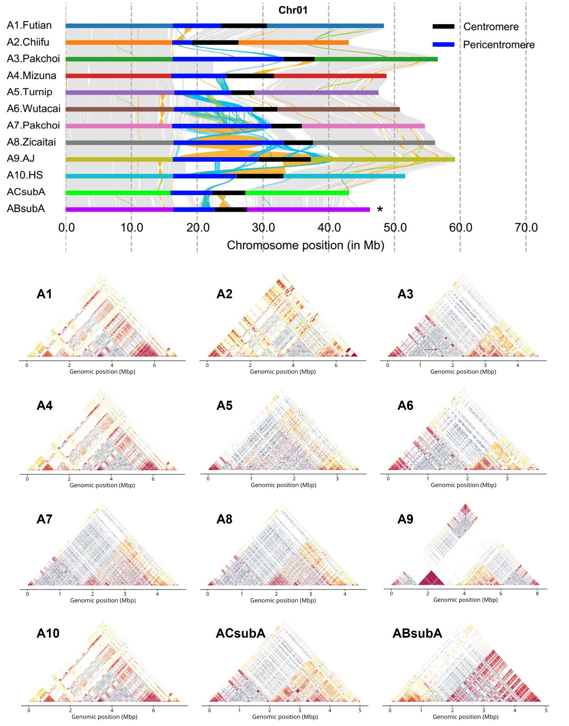

Supplementary Fig. 7. Overview of centromere CEN01 in distinct A genome accessions. Top: Syntenic regions and structural rearrangements in chromosome Chr01. Asterisk marks the inverted chromosome. Bottom: StainedGlass heatmaps showed sequence identity within CEN01.

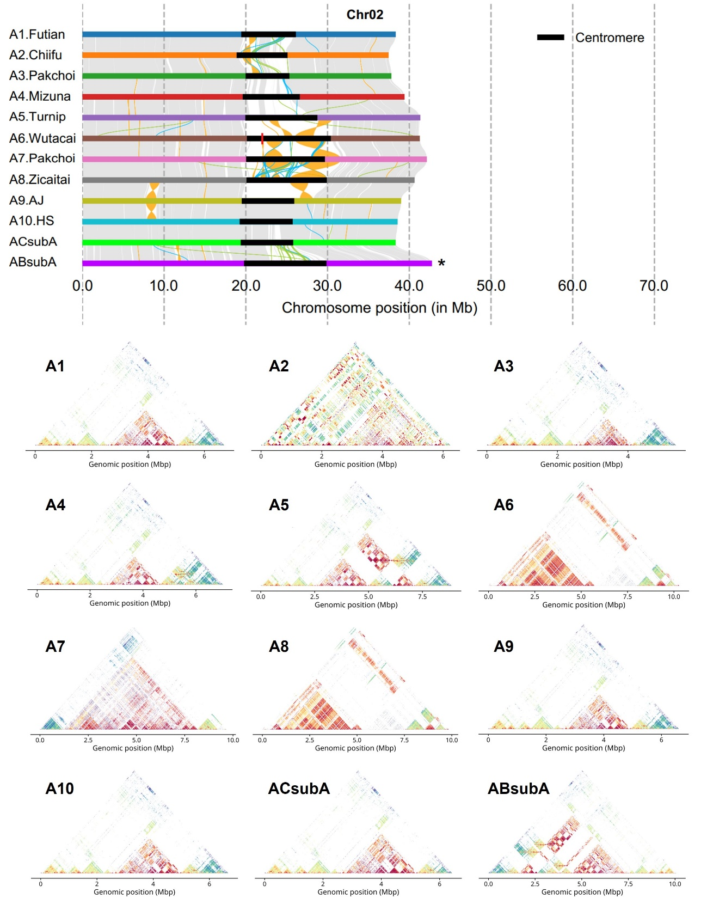

Supplementary Fig. 8. Overview of centromere CEN02 in distinct A-genome accessions. Top: Syntenic regions and structural rearrangements in chromosome Chr02. Asterisk marks the inverted chromosome. Bottom: StainedGlass heatmaps showed sequence identity within CEN02.

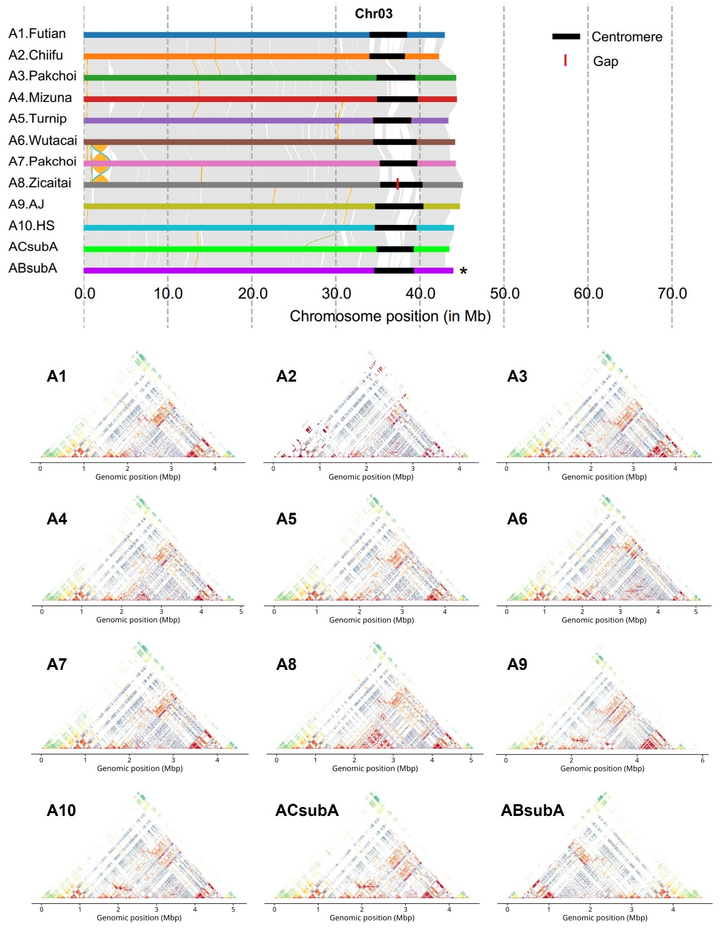

Supplementary Fig. 9. Overview of centromere CEN03 in distinct A-genome accessions. Top: Syntenic regions and structural rearrangements in chromosome Chr03. Asterisk marks the inverted chromosome. Bottom: StainedGlass heatmaps showed sequence identity within CEN03.

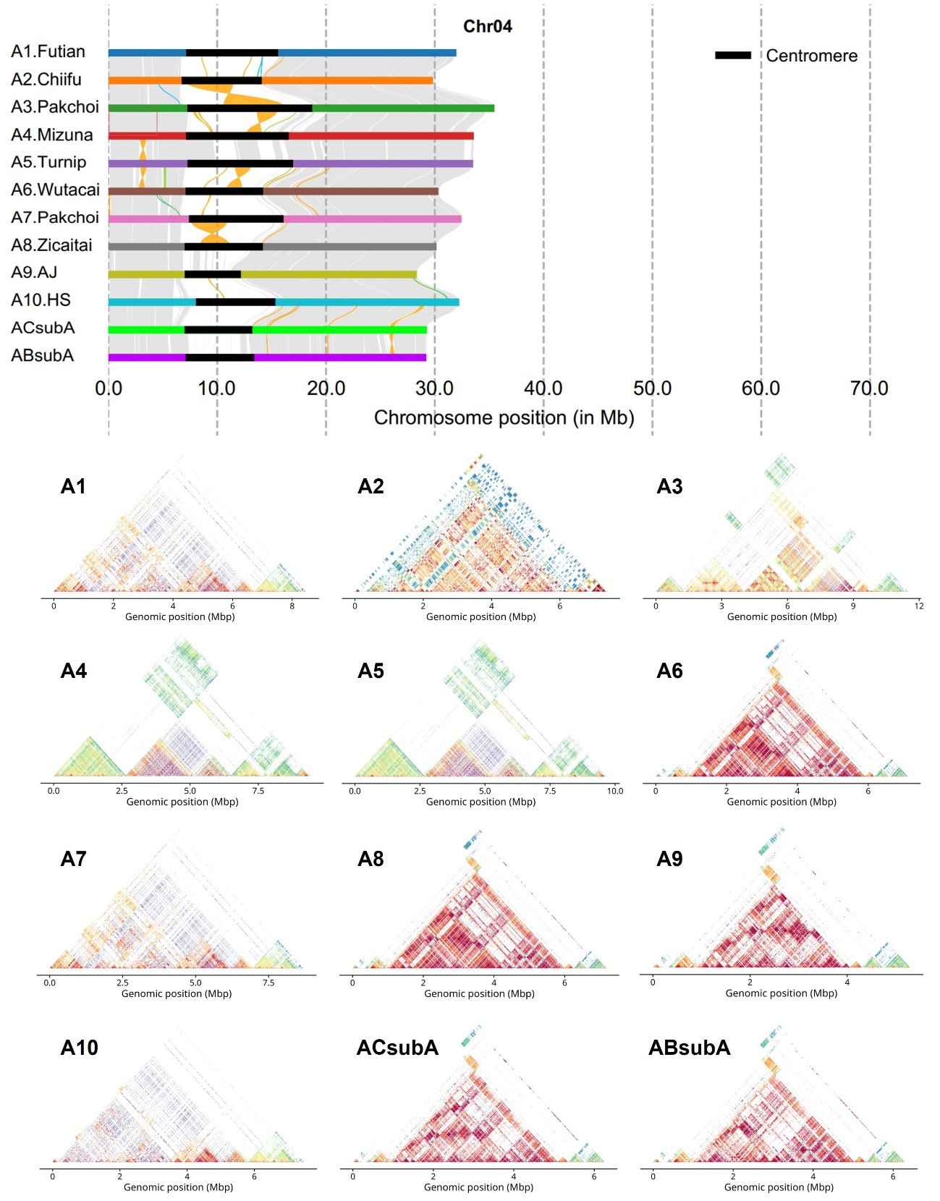

Supplementary Fig. 10. Overview of centromere CEN04 in distinct A-genome accessions. Top: Syntenic regions and structural rearrangements in chromosome Chr04. Bottom: StainedGlass heatmaps showed sequence identity between 5-kb bins within CEN04.

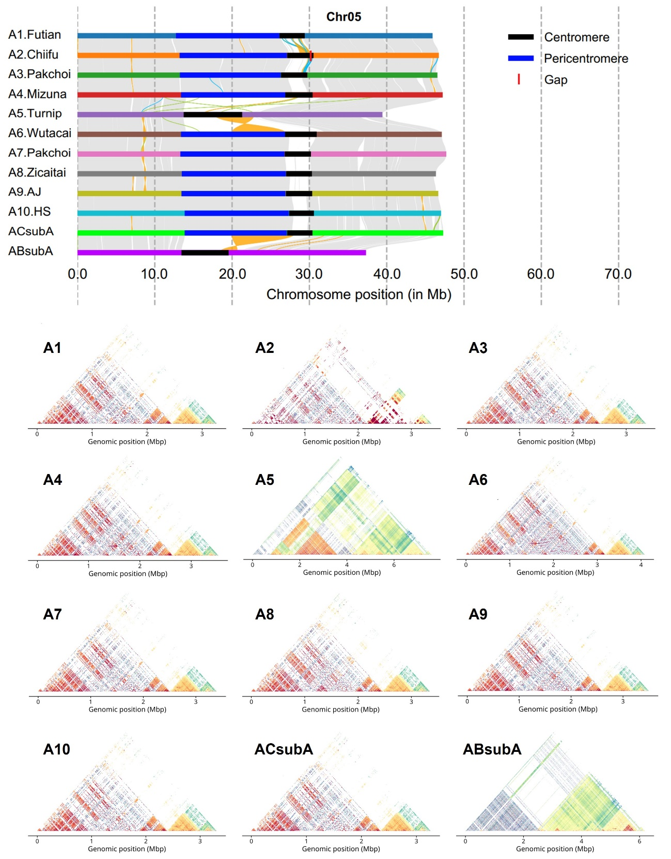

Supplementary Fig. 11. Overview of centromere CEN05 in distinct A-genome accessions. Top: Syntenic regions and structural rearrangements in chromosome Chr05. Bottom: StainedGlass heatmaps showed sequence identity between 5-kb bins within CEN05.

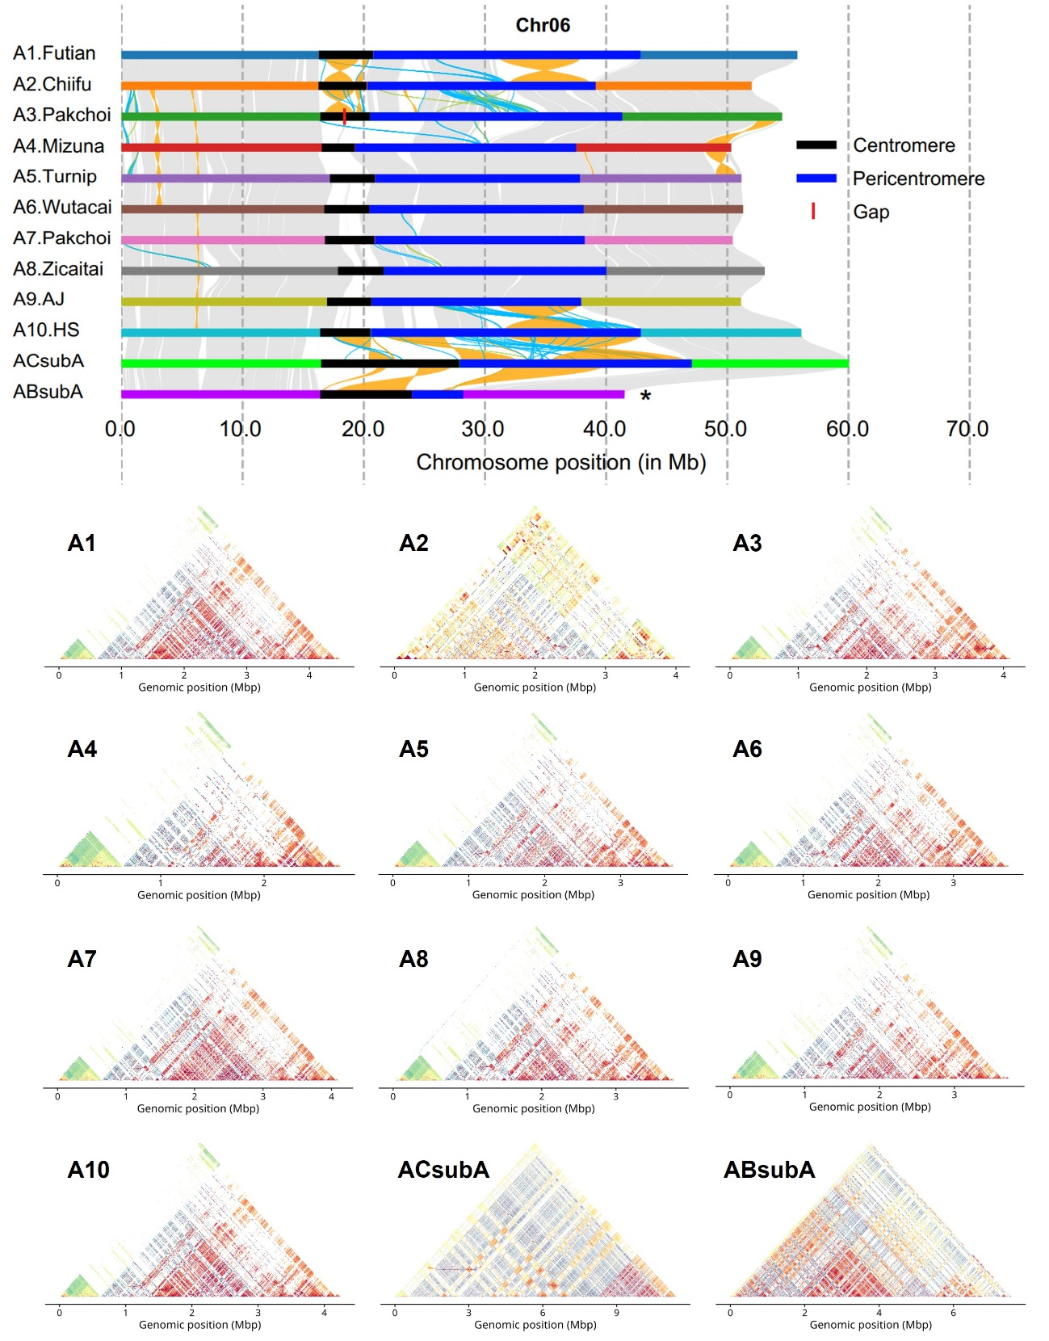

Supplementary Fig. 12. Overview of centromere CEN06 in distinct A-genome accessions. Top: Syntenic regions and structural rearrangements in chromosome Chr06. Asterisk marks the inverted chromosome. Bottom: StainedGlass heatmaps showed sequence identity within CEN06.

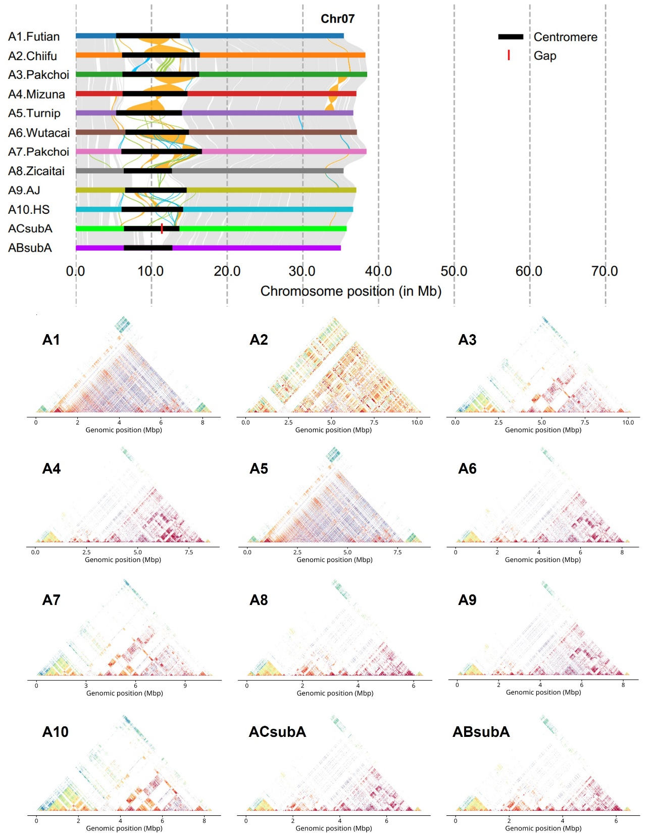

Supplementary Fig. 13. Overview of centromere CEN07 in distinct A-genome accessions. Top: Syntenic regions and structural rearrangements in chromosome Chr07. Bottom: StainedGlass heatmaps showed sequence identity between 5-kb bins within CEN07.

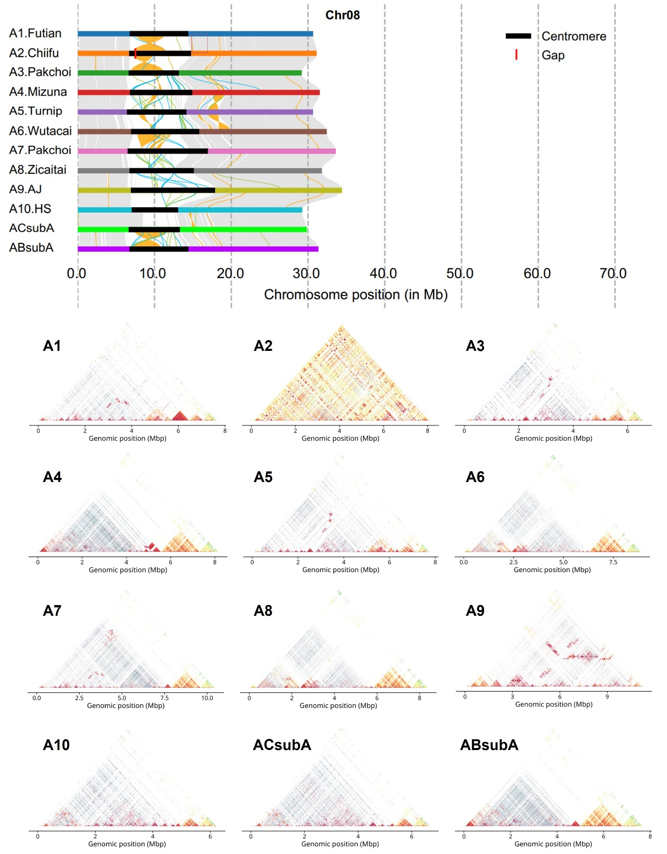

Supplementary Fig. 14. Overview of centromere CEN08 in distinct A-genome accessions. Top: Syntenic regions and structural rearrangements in chromosome Chr08. Bottom: StainedGlass heatmaps showed sequence identity between 5-kb bins within CEN08.

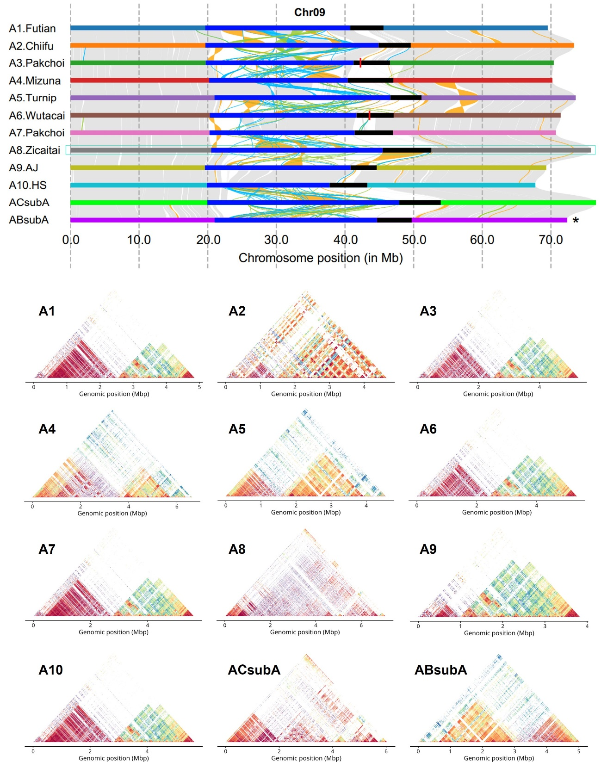

Supplementary Fig. 15. Overview of centromere CEN09 in distinct A-genome accessions. Top: Syntenic regions and structural rearrangements in chromosome Chr09. Asterisk marks the inverted chromosome. Bottom: StainedGlass heatmaps showed sequence identity within CEN09.

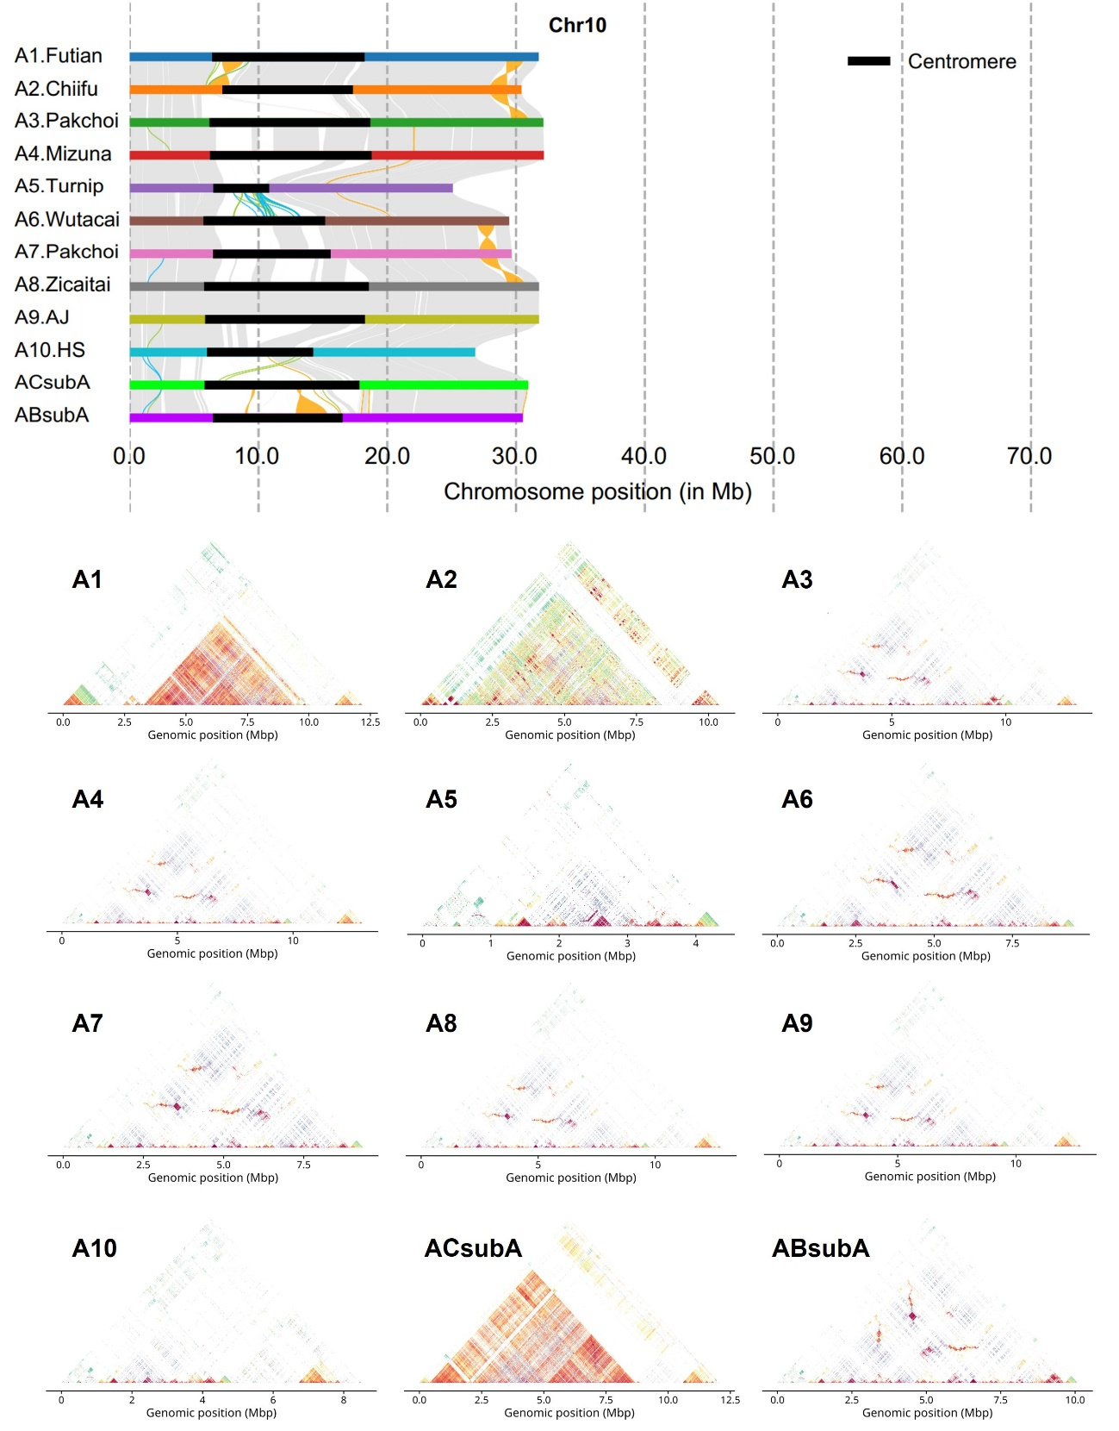

Supplementary Fig. 16. Overview of centromere CEN10 in distinct A-genome accessions. Top: Syntenic regions and structural rearrangements in chromosome Chr10. Bottom: StainedGlass heatmaps showed sequence identity between 5-kb bins within CEN10.

Supplementary Fig. 17. Phylogenetic analysis of intact Ale retrotransposons in four B. rapa accessions. Tree labels are coloured according to sample accession (a) and chromosome (b), respectively. Scale bar, 0.5 substitutions per site.

Supplementary Fig. 18. Metaprofiles of DNA methylation in CG (red), CHG (blue), and CHH (light blue) contexts around CEN176, centromeric or non-centromeric intact Ale and CRM retrotransposons in B. rapa and B. juncea. Dark colors represent A subgenome while the light colors represent C subgenome.

