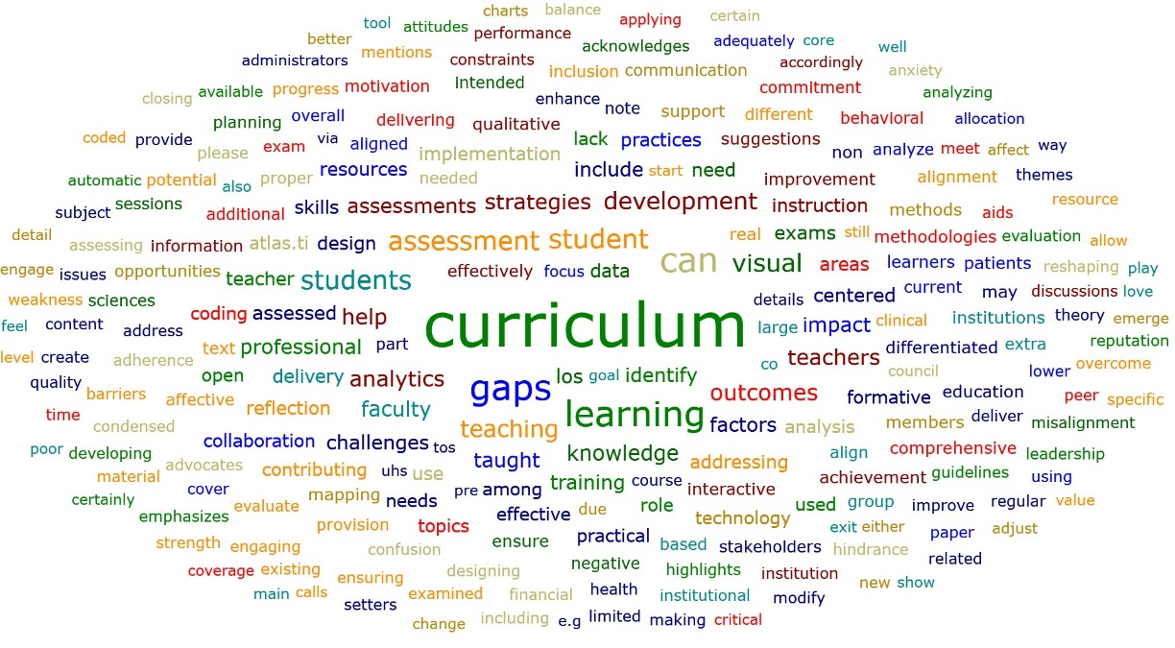
Fig. 7: Atlas.ti_Word Cloud (Top 2000 Word Count Analysis of Interviews)

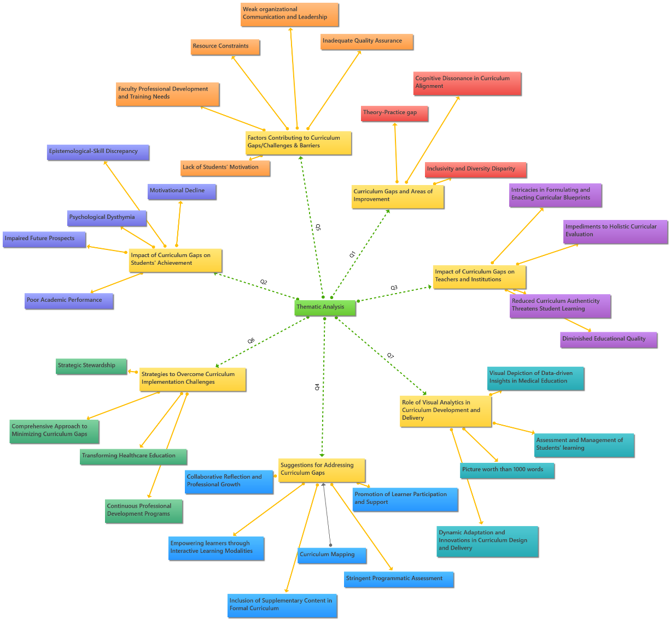
Fig. 8: Atlas.ti_Thematic Analysis of One-to-One Interviews

