Online Supplement

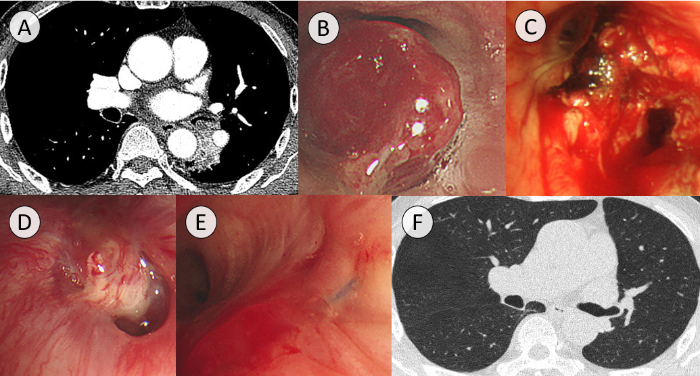
Supplemental Figure 1. Case # 2. (A) A 66-year-old man underwent thoracic computed tomography (CT) due to blood-tinged sputum. A low attenuated mass was seen at the left lower lobe bronchus. (B) Gross bronchoscopic findings were a round mass in the superior segmental bronchus of the left lower lobe causing near total occlusion of the left lower lobe bronchus. (C) After tumor resection using rigid bronchoscope, the tumor base was cauterized using a diode laser. (D) Surveillance bronchoscopy showed tumor recurrence six months after the procedure. (E) Another surveillance bronchoscopic examination performed two months after left lower lobectomy showed no tumor recurrence. (F) A surveillance thoracic CT performed six months after lobectomy demonstrated no tumor recurrence. There was no recurrence during 22.3 months of follow-up.
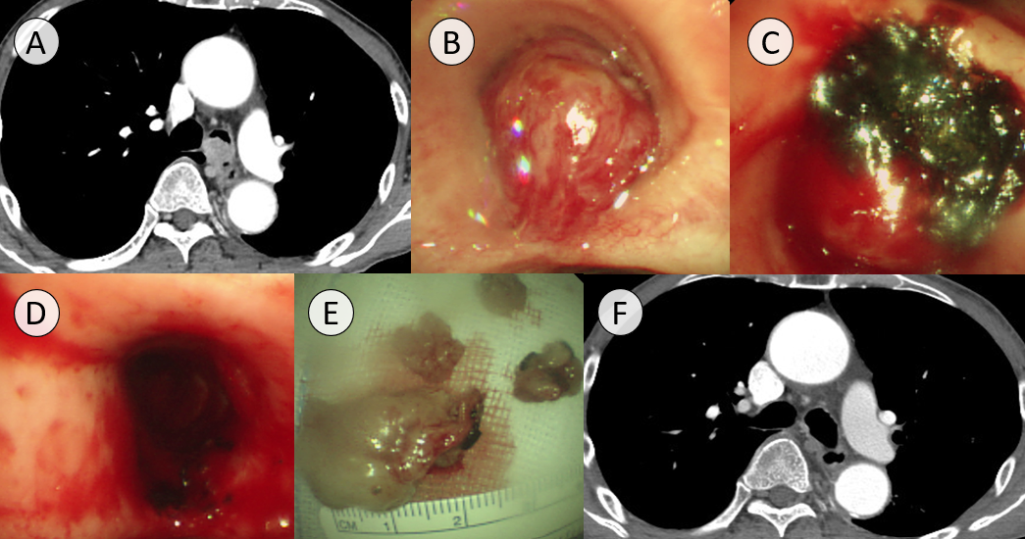
Supplemental Figure 2. Case #3. (A) A 75-year-old man underwent thoracic computed tomography (CT) due to blood-tinged sputum. A contrast-enhancing mass was seen at the proximal left main bronchus without obvious bronchial wall invasion. (B) Gross bronchoscopic findings were a round mass protruding from the left main bronchus causing near total occlusion. (C) The margin between the tumor and the bronchial mucosa was cauterized using a diode laser before resection. (D) After tumor resection using a rigid bronchoscope, the tumor base was cauterized using a diode laser. (E) The tumor mass was resected en bloc. (F) A lesion on surveillance thoracic CT performed three months after the procedure led to suspicions of tumor recurrence or granulation tissue formation. However, no tissue confirmation was performed due to loss to follow-up.
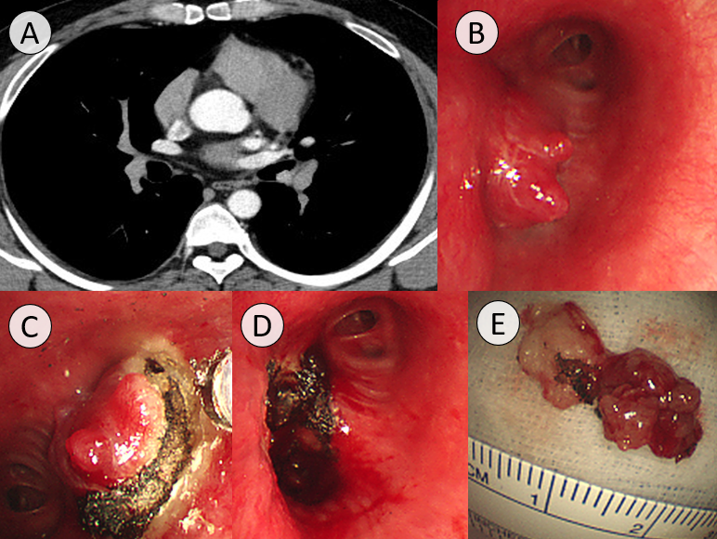
Supplemental Figure 3. Case #4. (A) A 32-year-old man underwent thoracic computed tomography (CT) due to blood-tinged sputum. A contrast-enhancing mass was seen at the distal left main bronchus without obvious bronchial wall invasion. (B) Gross bronchoscopic findings were a protruding lobulated mass near the second carina of the distal left main bronchus. (C) The margin between the tumor and the bronchial mucosa was cauterized using a diode laser before resection. (D) After tumor resection using a rigid bronchoscope, the tumor base was cauterized using a diode laser. (E) The mass was resected en bloc. Surveillance bronchoscopy and CT have not been performed.

