Supplementary material for the manuscript

Tackling deforestation with deep-learning-based cattle counts on satellite images

Leonie Hodel et al., leoniejhodel@gmail.com

This PDF file includes:

Supplementary figures S1-S3

Supplementary tables S4-S9

(Table S1, S2 in separate excel files, S3 in data repository)

Table S4.
Variable | N | Mean | Std. Dev. | Min | Pctl. 25 | Pctl. 75 | Max
Municipality | 56
... Acre | 21 | 38%
... Amazonas | 6 | 11%
... Para | 15 | 27%
... Rondonia | 14 | 25%
PPM pasture area (km2) | 56 | 2110 | 1855 | 78 | 1097 | 2362 | 8564
PPM heads | 56 | 271202 | 216344 | 7737 | 130302 | 349828 | 884331
PPM stocking rate | 56 | 1.3 | 0.58 | 0.3 | 0.88 | 1.8 | 2.4
VHR pasture area (km2) | 56 | 134 | 106 | 10 | 66 | 171 | 573
VHR heads | 56 | 5892 | 7107 | 124 | 2234 | 7343 | 44084
VHR stocking rate | 56 | 0.57 | 0.32 | 0.028 | 0.35 | 0.76 | 1.5
VHR percentage pasture | 56 | 9.7 | 7.4 | 0.63 | 4.8 | 13 | 35
Difference SR(PPM-VHR) | 56 | 0.75 | 0.56 | -0.69 | 0.44 | 1.1 | 1.8

Table S4: Summary statistics for cattle heads, pasture area, and stocking rates across 56 observed municipalities. The data compare official statistics from the census (Pesquisa Pecuária Municipal (PPM, 2019)) with cattle density estimates derived from very high-resolution (VHR) images. Key metrics include the total number of cattle heads, total pasture area, stocking rates from both PPM and VHR sources, the percentage of pasture observed via VHR images relative to total pasture area, and the difference in stocking rates (PPM stocking rate minus VHR stocking rate).

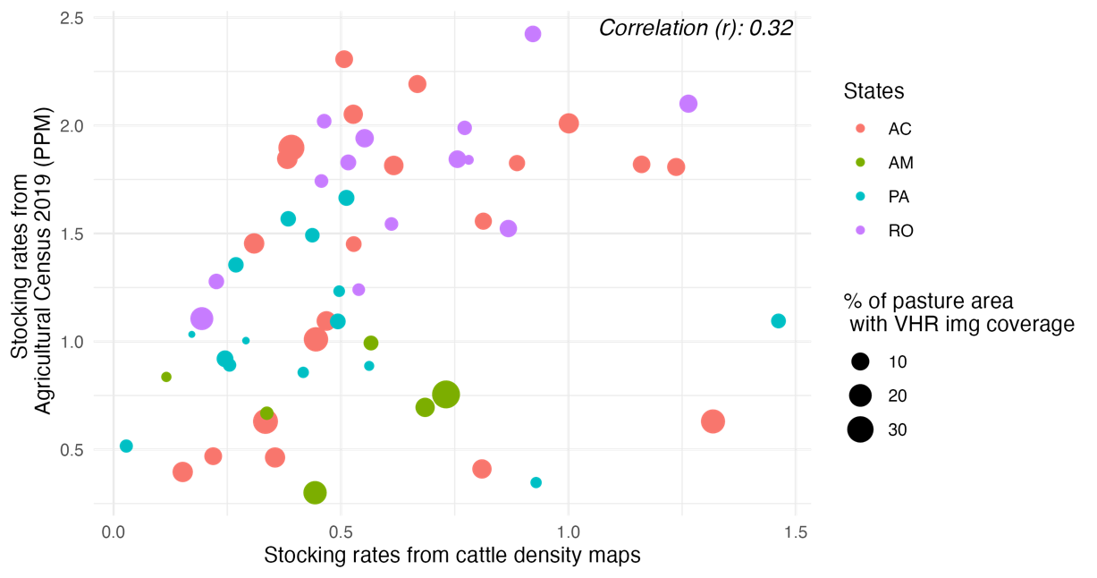
Fig S1.
Figure S1: Correlation between stocking rates from the official census (Pesquisa Pecuária Municipal, PPM, 2019) and cattle density estimates derived from very high-resolution satellite imagery. The Pearson correlation coefficient is 0.32, indicating a moderate positive relationship between official data and satellite-derived stocking rate estimates. Size of dots represent the percentage of image coverage per municipality, Entity of observation is the municipality (n = 56).

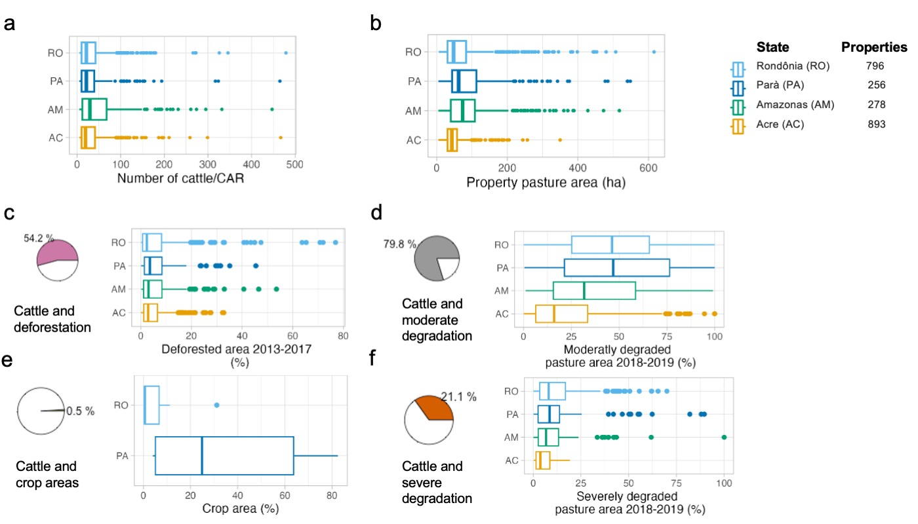
Fig. S2.

Figure S2: Summary statistics for n = 2223 properties in the states of Acre (AC), Amazonas (AM), Parà (PA) and Rondônia (RO), where cattle have been detected on satellite in the years 2018-2019. (a) Number of cattle on properties and (b) Property pasture areas for the four states visualized as a boxplot and a summary table. (d) Land management variables: pie charts show the % of total amount of properties for which the variables are > 0, and boxplots depicting distribution of these variables. Boxplots display the median (center line), upper and lower quartiles (box limits), whiskers extending to 1.5 times the interquartile range, and points indicating outliers.

Fig. S3.

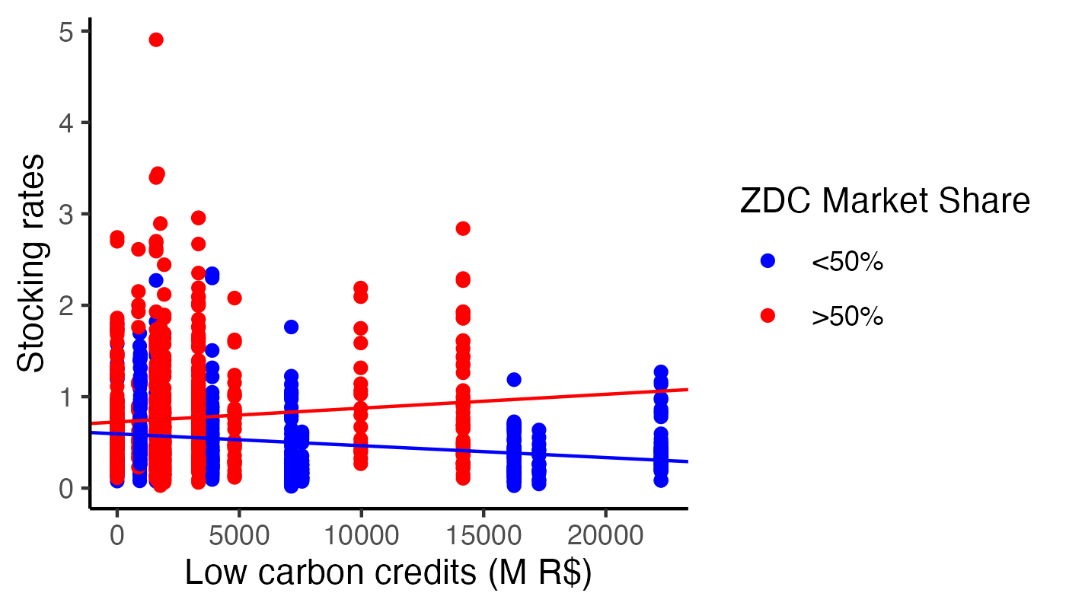
Figure S3: Correlation of stocking rates with the interaction of governmental intensification incentives (in form of subsidized credits) and the binary variable of zero deforestation commitments (ZDC) market share. The ZDC variable is grouped as ‘>50%’, if the market share of a company with a ZDC is higher than 50%. In 11 of 22 municipalities these companies have a lower than 50% market share, for which the ABC credits are negatively correlated with stocking rates. For municipalities with a higher market share, the ABC credits are positively correlated. Lines show linear regression coefficients. Entity of observation is the property (n = 1185).

Table S5.

Variable | Description | Data provider | Unit | Time period
Stocking rate | N_cattle from ensemble CSR predictor / pasture |  | Animal/ha | 2017-2020 (2018-2019 for models I and II)
Pasture | Area of pasture (class 15) | MapBiomas v7 (35) | ha | Mean of 2018-2019
Forest area (buffer) | Area of forest (class 3), buffer around properties of 10km. | MapBiomas v7 | Km2 | 2013
Deforestation | Area of forest changing to pasture (class 315-class 1503), subtracting reforestation | MapBiomas v7 | %ha | Sum of 2013-2017
Deforestation (buffer) | Area of forest changing to pasture (class 315-class 1503), buffer around properties of 10km | MapBiomas v7 | %ha | Sum of 2013-2017
Crop area | Area covered by agricultural area (MapBiomas v7 class ID 39,41) | MapBiomas v7 | ha | Mean of 2018-2019
Pasture  degradation | Area of moderate and severe degradation | MapBiomas v7 | ha | Mean of 2018-2019
Precipitation | Mean bi-annual precipitation/municipality | Nasa's Monthly Global Precipitation Measurement (78) | mm/ municipality | Mean of 2018-2019
Temperature | Mean bi-annual temperature/municipality | Nasa’s Global Change observation mission (79) | °C/municipality | Mean of 2018-2019
Population | Number of inhabitants/municipality | IBGE via Sidrar API for R (82) | In thousands of poeple | 2019
Distance to nearest federal slaughterhouse | Distance from property to the next slaughterhouse | Trase (81) – | km | 2021
ABC Rural credit | Share of the value of ACB+ and FNO-ABC credits | Banco Central do Brasil (83) | $/municipality | Sum of 2013-2017 in 1000 R$
ZDC market share | Market share of slaughterhouses with a G4 zero deforestation commitment. | Levy et al., 2023 (30) | %/ municipality | Mean of 2013-2017
Property boundaries and property area | CAR | SICAR | ha | 2022

Table S5: Data sources for data used in linear regression model including a description, data provider, unit and time period of the selected data.

Table S6.
Variable | N | Mean | Std. Dev. |  |  | Min | Pctl. 25 | Pctl. 75 | Max
State | 2223
... Para | 256 | 12%
... Rondonia | 796 | 36%
... Acre | 893 | 40%
... Amazonas | 278 | 13%
Number of cattle | 2223 | 35 |  | 43 | 5 |  | 10 | 43 | 479
Uncertainty | 2223 | 0.12 |  | 0.07 | 0 |  | 0.064 | 0.17 | 0.3
Pasture area | 2223 | 67 |  | 66 | 4.9 |  | 33 | 74 | 616
%Deforestation 2013-2017 | 2223 | 3.1 |  | 6.7 | -16 |  | 0 | 3.5 | 53
%Deforestation 2013-2017  (buffer) | 2223 | 3.1 |  | 2.7 | 0.24 |  | 1.4 | 4 | 19
Moderate pasture degradation (2018/2019) | 2223 | 29 |  | 47 | 0 |  | 2 | 36 | 448
Severe pasture degradation (2018/2019) | 2223 | 3.1 |  | 12 | 0 |  | 0 | 0 | 236
Crop area (2018/2019) | 2223 | 0.37 |  | 9 | 0 |  | 0 | 0 | 290
 | 2223 | 4245 |  | 4849 | 0 |  | 749 | 6906 | 22259
Forest (buffer, 2013) | 2223 | 143 |  | 71 | 27 |  | 80 | 193 | 396
Precipitation (2018/201919) | 2223 | 0.38 |  | 0.062 | 0.19 |  | 0.33 | 0.43 | 0.5
Temperature (2018/2019) | 2223 | 33 |  | 1.6 | 30 |  | 31 | 34 | 37
Population | 2223 | 29 |  | 23 | 6.5 |  | 16 | 35 | 407
Distance to nearest federal slaughterhouse | 2223 | 85 |  | 71 | 5.9 |  | 38 | 119 | 464
Stocking rate | 2223 | 0.77 |  | 0.66 | 0.02 |  | 0.33 | 0.99 | 6.7

Table S6: Summary statistics of dataset with 2223 CAR properties used for the regression analysis. Bold variables are used in the models I_{δ}, II_{δ}. The variables pasture area, number of cattle and standard deviation of cattle (uncertainty derived from the ensemble predictor) are excluded from the regression model but shown for completeness.

Table S7.

Variable | N | Mean | Std. Dev. | Min | Pctl. 25 | Pctl. 75 | Max
State | 1185
... Para | 389 | 33%
... Rondonia | 796 | 67%
Number of cattle | 1185 | 32 | 42 | 5 | 9 | 38 | 479
Uncertainty | 1185 | 0.13 | 0.071 | 0 | 0.073 | 0.18 | 0.3
Pasture area | 1185 | 74 | 73 | 5 | 34 | 87 | 616
Property Area | 1185 | 97 | 110 | 6 | 45 | 100 | 766
%Deforestation 2013-2017 | 1185 | 3.4 | 7.8 | -14 | 0 | 3.1 | 74
%Deforestation 2013-2017  (buffer) | 1185 | 3.5 | 3.7 | 0.24 | 1 | 4.4 | 19
Moderate pasture degradation (2018/2019) | 1185 | 39 | 49 | 0 | 11 | 48 | 448
Severe pasture degradation (2018/2019) | 1185 | 4.4 | 15 | 0 | 0 | 1.2 | 236
Crop area (2018/2019) | 1185 | 0.69 | 12 | 0 | 0 | 0 | 290
ABC rural credit | 1185 | 4759 | 5797 | 0 | 1593 | 4804 | 22259
ZDC market share | 1185 | 0.55 | 0.27 | 0 | 0.29 | 0.69 | 0.97
Forest (buffer, 2013) | 1185 | 116 | 57 | 8.6 | 66 | 153 | 344
Precipitation (2018/201919) | 1185 | 0.33 | 0.074 | 0.19 | 0.29 | 0.37 | 0.5
Temperature (2018/2019) | 1185 | 34 | 1.2 | 31 | 33 | 35 | 37
Population | 1185 | 31 | 23 | 6.5 | 13 | 51 | 115
Distance to nearest federal slaughterhouse | 1185 | 87 | 65 | 5.9 | 44 | 130 | 250
 | 1185 | 0.59 | 0.49 | 0 | 0 | 1 | 1
Stocking rate | 1185 | 0.66 | 0.54 | 0.02 | 0.28 | 0.87 | 4.9

Table S7: Summary statistics of 1185 CAR properties showing the regressors. Bold variables are used in the models III_{δ}, IV_{δ} and V_{δ.}

Table S8.
 | I_{δ} | II_{δ} | III_{δ} | IV_{δ} | V_{δ}
... Para | 2.46966 (.40841)*** | 2.35250 (.40625)*** | 3.26885 (.46136)*** | 3.16611 (.46681)*** | 3.51646 (.48962)***
... Rondonia | 2.80130 (.42111)*** | 2.67712 (.41892)*** | 3.67592 (.46755)*** | 3.65921 (.49522)*** | 3.90454 (.52403)***
... Acre | 2.82981 (.39854)*** | 2.71070 (.39649)***
... Amazonas | 2.82338 (.40475)*** | 2.71131 (.40291)***
Property area | -.00063 (.00020)** | -.00057 (.00020)** | -.00038 (.00020) | -.00034 (.00020) | -.00038 (.00020)
Precipitation (2018/201919) | -.04610 (.01269)*** | -.04236 (.01262)*** | -.07455 (.01363)*** | -.07132 (.01356)*** | -.07980 (.01416)***
Temperature (2018/2019) | -.79294 (.33055)* | -.79254 (.33092)* | -.64564 (.28028)* | -.85457 (.27068)** | -.42676 (.32250)
Distance to nearest federal slaughterhouse | -.00138 (.00021)*** | -.00127 (.00022)*** | -.00143 (.00029)*** | -.00126 (.00032)*** | -.00124 (.00030)***
Forest (buffer, 2013) | -.00011 (.00026) | -.00009 (.00027) | -.00007 (.00034) | -.00006 (.00035) | -.00043 (.00036)
Population | .00074 (.00062) | .00085 (.00062) | .00301 (.00084)*** | .00337 (.00081)*** | .00205 (.00097)*
%Deforestation 2013-2017 | -.00722 (.00209)*** |  | -.00165 (.00214) | -.00155 (.00214) | -.00148 (.00214)
Moderate pasture degradation (2018/2019) | .00003 (.00041) | .00003 (.00041) | -.00002 (.00043) | -.00021 (.00042) | .00020 (.00045)
Severe pasture degradation (2018/2019) | -.00014 (.00122) | .00004 (.00122) | -.00025 (.00109) | -.00069 (.00109) | -.00058 (.00110)
Crop area (2018/2019) | -.00050 (.00156) | -.00053 (.00156) | -.00038 (.00126) | -.00052 (.00126) | .00008 (.00127)
%Deforestation 2013-2017 (buffer) |  | -.01520 (.00564)** | -.00898 (.00521) | -.00895 (.00522) | -.00953 (.00531)
ABC rural credit |  |  | -.00001 (.00000) |  | -.00001 (.00000)**
ZDC market share |  |  |  | -.08391 (.09686)
ZDC (binary) |  |  |  |  | -.12623 (.07008)
ABC rural credit: ZDC (binary) |  |  |  |  | .00002 (.00001)*
R² | .60818 | .60735 | .65075 | .65008 | .65304
Adj. R² | .60570 | .60486 | .64657 | .64590 | .64829
Num. obs. | 2223 | 2223 | 1185 | 1185 | 1185

***p < 0.001; **p < 0.01; *p < 0.05
Table S8: Full state fixed effects regression model with stocking rates as dependent variable for Model I - V. Standard deviations in parentheses.

Table S9.
Standardized Model | I_{δ} | II_{δ} | III_{δ} | IV_{δ} | V_{δ}
... Para | -.468 (.077)*** | -.393 (.084)*** | -.450 (.084)*** | -.557 (.093)*** | -.347 (.096)***
... Rondonia | .036 (.043) | .101 (.051)* | .306 (.053)*** | .358 (.056)*** | .373 (.139)**
... Acre | .080 (.039)* | .152 (.046)***
... Amazonas | .070 (.073) | .153 (.077)*
Property area | -.092 (.030)** | -.084 (.029)** | -.077 (.040) | -.070 (.040) | -.077 (.040)
Precipitation (2018/201919) | -.110 (.030)*** | -.101 (.030)*** | -.172 (.031)*** | -.164 (.031)*** | -.184 (.033)***
Temperature (2018/2019) | -.075 (.031)* | -.075 (.031)* | -.089 (.039)* | -.118 (.037)** | -.059 (.044)
Distance to nearest federal slaughterhouse | -.149 (.023)*** | -.137 (.024)*** | -.173 (.035)*** | -.152 (.038)*** | -.150 (.036)***
Forest (buffer, 2013) | -.012 (.028) | -.010 (.029) | -.008 (.036) | -.006 (.037) | -.046 (.039)
Population | .026 (.022) | .030 (.022) | .128 (.036)*** | .144 (.035)*** | .087 (.041)*
%Deforestation 2013-2017 | -.074 (.021)*** |  | -.024 (.031) | -.022 (.031) | -.021 (.031)
Moderate pasture degradation (2018/2019) | .002 (.030) | .002 (.030) | -.002 (.039) | -.019 (.038) | .018 (.040)
Severe pasture degradation (2018/2019) | -.003 (.023) | .001 (.023) | -.007 (.031) | -.020 (.031) | -.017 (.031)
Crop area (2018/2019) | -.007 (.021) | -.007 (.021) | -.009 (.029) | -.012 (.029) | .002 (.029)
%Deforestation 2013-2017 (buffer) |  | -.023 (.009)** | -.017 (.010) | -.017 (.010) | -.018 (.010)
ABC rural credit |  |  | -.065 (.038) |  | -.156 (.052)**
ZDC market share |  |  |  | -.042 (.048)
ZDC (binary) |  |  |  |  | -.064 (.129)
ABC rural credit: ZDC (binary) |  |  |  |  | .207 (.082)*
R2 | .074 | .072 | .131 | .129 | .136
Adj. R2 | .068 | .066 | .120 | .118 | .124
Num. obs. | 2223 | 2223 | 1185 | 1185 | 1185
***p < 0.001; **p < 0.01; *p < 0.05
Table S9: Full standardized state fixed effects regression model with stocking rates as dependent variable for Model I - V. Predictor variables are standardized using the standard score. Standard deviations in parentheses.

