Supplemental Materials

Online Resource 1. Summary of 4D flow hemodynamic parameters quantified
Parameter | Definitions and Quantification | Reported value | ROI
V_{max} (m/s) | Maximum velocity magnitude in a voxel at peak systole | Mean average of values for voxels in each ROI (mean V_{max}) | - Aorta: entire volume, AAo, arch, and DAo  - Pulmonary arteries
V_{mean} (m/s) | Velocity magnitudes measured in a voxel during systole, averaged over time | Mean average of values for voxels in each ROI (mean V_{mean}) | - Aorta: entire volume, AAo, arch, and DAo  - Pulmonary arteries
Stasis (%) | Percentage of time frames for which velocity <0.10 m/s in a voxel | Mean average of values for voxels in each ROI (mean stasis) | - Aorta  - Pulmonary arteries
KE_{max} | Maximum kinetic energy (energy of blood flow due to motion) calculated at peak systole for a voxel | Mean average of values for voxels in each ROI (mean KE_{max}) | - Aorta  - Pulmonary arteries
KE_{mean} (J) | Systolic kinetic energy (energy of blood flow due to motion) values calculated for a voxel, averaged over time, used as an indicator of cardiovascular efficiency [22] | Mean average of values for voxels in each ROI (mean KE_{mean}) | - Aorta  - Pulmonary arteries
EL (J) | Systolic energy loss (kinetic energy lost as thermal energy due to friction from blood viscosity) calculated for a voxel, averaged over time, used as indicator of cardiovascular efficiency [22] | Mean average of values for voxels in each ROI (mean EL_{mean}) | - Aorta  - Pulmonary arteries
PWV (m/s) | Measure of arterial stiffness [21], calculated through cross-correlation analysis of through-plane flow curves | Value reported for entire ROI | - Aorta
Maximum WSS (N/m²) | Maximum wall shear stress (shear force exerted on the vessel wall by blood flow) at a point along the vessel wall, used as an indicator of the effect of hemodynamic alterations on endothelial cell function and risk for vascular remodeling [21] | Mean average of values for each point in the ROI | - Aorta: anterior AAo, posterior AAo, superior arch, inferior arch, anterior DAo, posterior DAo  - Pulmonary arteries
Mean WSS (N/m²) | Wall shear stress (shear force exerted on the vessel wall by blood flow) values measured at a point along the vessel wall, averaged over time, used as an indicator of the effect of hemodynamic alterations on endothelial cell function and risk for vascular remodeling [21] | Mean average of values for each point in the ROI | - Aorta: anterior AAo, posterior AAo, superior arch, inferior arch, anterior DAo, posterior DAo  - Pulmonary arteries
ROI = region of interest, V_{max} = maximum velocity, V_{mean} = mean velocity, KE_{max} = maximum kinetic energy, KE_{mean} = mean kinetic energy, EL = energy loss, PWV = pulse wave velocity, WSS = wall shear stress, AAo = ascending aorta (aortic annulus to the brachiocephalic trunk), DAo = descending aorta (left subclavian artery through distal thoracic aorta)
Online Resource 2. Regions of interest in the aorta for wall shear stress, velocity, and diameter quantification.
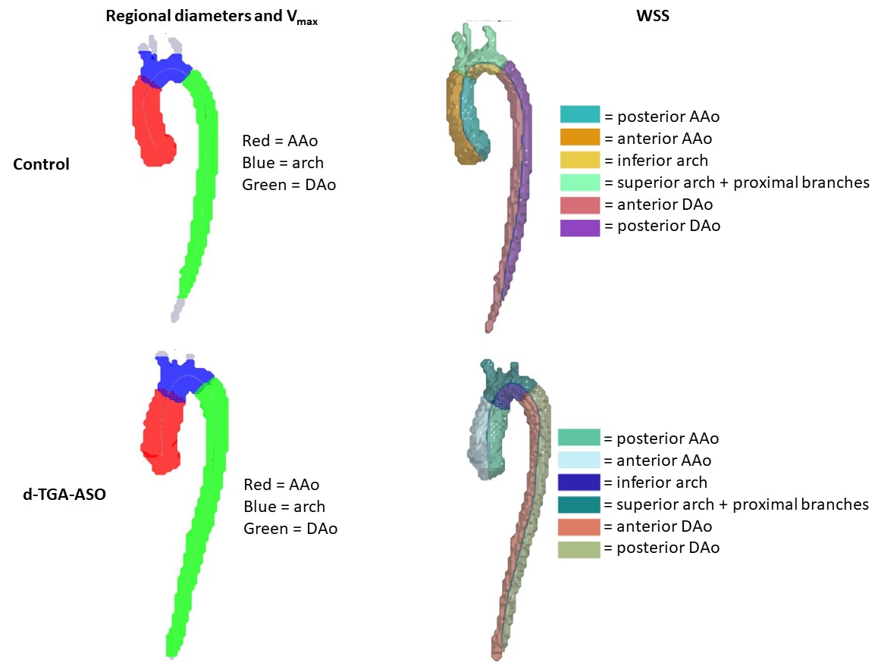
A centerline was automatically calculated in the aorta and two-dimensional analysis planes were manually placed to divide the aorta into three regions of interest: ascending aorta (AAo) from the aortic valve to the brachiocephalic trunk, aortic arch (arch) including proximal branch vessels, and descending (DAo) aorta from the left subclavian artery through the distal thoracic aorta. For wall shear stress (WSS) analyses, these regions were further divided on either side of the centerline in the sagittal plane. Depicted segmentations are from a patient with dextro-transposition of the great arteries (d-TGA) after the arterial switch operation (ASO) and an age-matched control. V_{max} = maximum velocity, WSS = wall shear stress, d-TGA-ASO = dextro-transposition of the great arteries after arterial switch operation.

Online Resource 3. Number of patients included in each analysis
 | d-TGA-ASO |  | Control
Analysis | Age Matched  No. of Patients | Whole Cohort  No. of Patients |  | Age-Matched  No. of Patients | Whole Cohort  No. of Patients
Pulmonary arteries:
V_{max} | 25 | 44 | 25 |  | 25
V_{mean} | 25 | 44 | 25 |  | 25
KE_{max} | 25 | 44 | 25 |  | 25
KE_{mean} | 25 | 44 | 25 |  | 25
EL | 25 | 44 | 25 |  | 25
Max WSS | 25 | 44 | 25 |  | 25
Mean WSS | 25 | 44 | 25 |  | 25
Aorta:
V_{max}  Whole aorta  AAo  Arch  DAo | 25  24  24  24 | 44  42  42  42 | 25  24  24  24 |  | 25  24  24  24
V_{mean} | 25 | 44 | 25 |  | 25
KE_{max} | 25 | 44 | 25 |  | 25
KE_{mean} | 25 | 44 | 25 |  | 25
EL | 25 | 44 | 25 |  | 25
Max WSS | 22 | 44 | 22 |  | 22
Mean WSS | 22 | 44 | 22 |  | 22
PWV | 23 | 42 | 23 |  | 25
Patients from both the dextro-transposition of the great arteries after arterial switch operation (d-TGA-ASO) and control cohorts had to be excluded from aortic analyses due to unresolvable errirs in MATLAB that prevented quantification. When these patients were part of an age-matched pair, the entire pair was excluded. V_{max} = maximum velocity, AAo = ascending aorta, DAo = descending aorta, V_{mean} = mean velocity, KE_{max} = maximum kinetic energy, KE_{mean} = mean kinetic energy, EL = energy loss, PWV = pulse wave velocity, WSS = wall shear stress.

Online Resource 4. Comparison of baseline characteristics for age-matched pairs
Pair No. | Absolute value of age difference (y) | BSA difference (m²) | Sex matched?
1 | 0.4 | 0.04 | Yes
2 | 0.1 | 0.43 | No
3 | 0.3 | 0.24 | No
4 | 0.1 | 0.14 | Yes
5 | 0.7 | 0.26 | No
6 | 0.0 | 0.09 | No
7 | 0.5 | 0.17 | Yes
8 | 0.5 | 0.42 | Yes
9 | 0.8 | 0.12 | No
10 | 0.4 | 0.34 | No
11 | 0.1 | 0.05 | Yes
12 | 0.1 | 0.3 | Yes
13 | 0.5 | 0.65 | No
14 | 0.5 | 0.15 | Yes
15 | 0.2 | 0.3 | Yes
16 | 0.6 | 0.1 | No
17 | 0.9 | 0.13 | Yes
18 | 0.2 | 0.46 | Yes
19 | 0.4 | 0.13 | No
20 | 0.4 | 0.05 | Yes
21 | 0.2 | 0.8 | No
22 | 0.3 | 0.4 | Yes
23 | 0.3 | 0.37 | Yes
24 | 0.7 | 0.13 | Yes
25 | 0.6 | 0.1 | No
Control patients and patients with dextro-transposition of the great arteries after arterial switch operation (d-TGA-ASO) were matched by age, with a cut-off of 1 year maximum age difference. The absolute value of the difference in age between control and d-TGA-ASO patient in each pair is shown in years. BSA = body surface area (Mosteller formula).

Online Resource 5. patients with dextro-transposition of the great arteries after arterial switch operation who underwent reintervention
Patient No. | Age at 4D Flow Exam  (Y) | Age at Reintervention (Y) | Reintervention Type | Procedure(s) | Indication(s)
1 | 15.7 | 17.7 | Surgical | Pulmonary valve replacement, RVOT patch, and pericardial membrane placement | Pulmonary regurgitation
2 | 14.8 | 16.8 | Catheter-based | Pulmonary valve replacement | Pulmonary regurgitation
3 | 15.2 | 16.7 | Surgical | Neoaortic valve replacement and RPA interposition grafting | Neo-aortic valve insufficiency with aortic root dilatation
4 | 15.8 | 15.9 | Surgical | Neoaortic annuloplasty, neoaortic root remodeling, and RPA interposition grafting | Neo-aortic valve insufficiency with aortic root dilatation
4 |  | 16.1 | Surgical | Neoaortic valve replacement | Neo-aortic valve insufficiency with aortic root dilatation
 |  | 16.3 | Surgical | Orthotopic heart transplant | Heart failure
Four patients in our cohort of patients with dextro-transposition of the great arteries (d-TGA) after the arterial switch operation (ASO) underwent reintervention after 4D flow cardiac MRI. All four patients were included in the sub-group of d-TGA-ASO patients who were age-matched with controls. RVOT = right ventricular outflow tract, RPA = right pulmonary artery.

Online Resource 6. Z-Scores for diameters of the aortic root and main and branch pulmonary arteries in patients with dextro-transposition of the great arteries after arterial switch operation
ROI | No. of patients | Z-Score Average | Z-Score Range
Aortic root | 44 | 3.61 ± 1.64 | 0.400 to 7.20
MPA | 40 | -2.02 [-2.44-(-1.15)] | -3.72 to 1.38
RPA | 42 | -1.13 [-2.14-(-0.358)] | -2.89 to 3.92
LPA | 42 | -1.18 [-1.91-(-0.605)] | -4.77 to 1.21
Z-scores were determined for patients with d-transposition of the great arteries (d-TGA) after the arterial switch operation (ASO) using the Boston Children’s Hospital Z-Score Calculator. The largest aortic root diameter and smallest diameter for the main pulmonary artery (MPA), right pulmonary artery (RPA), and left pulmonary artery (LPA) were used for Z-score determination. Z-scores less than -2 and greater than +2 are considered abnormal.

