Supplementary Figures
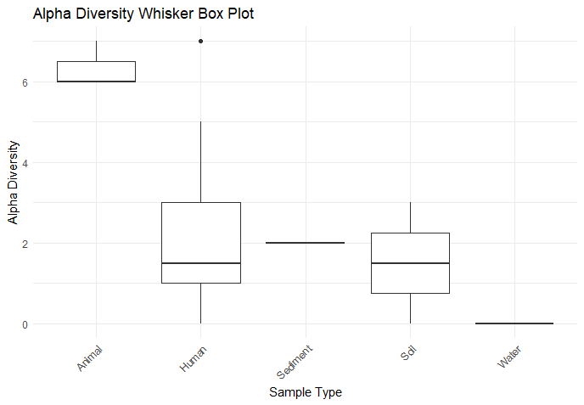
Supplementary Figure 1 Shanon alpha diversity of phage distribution in Animal, Human, Sediment, Soil and Water samples with Apha diversity index on Y-axis and Sample Type on X-axis.
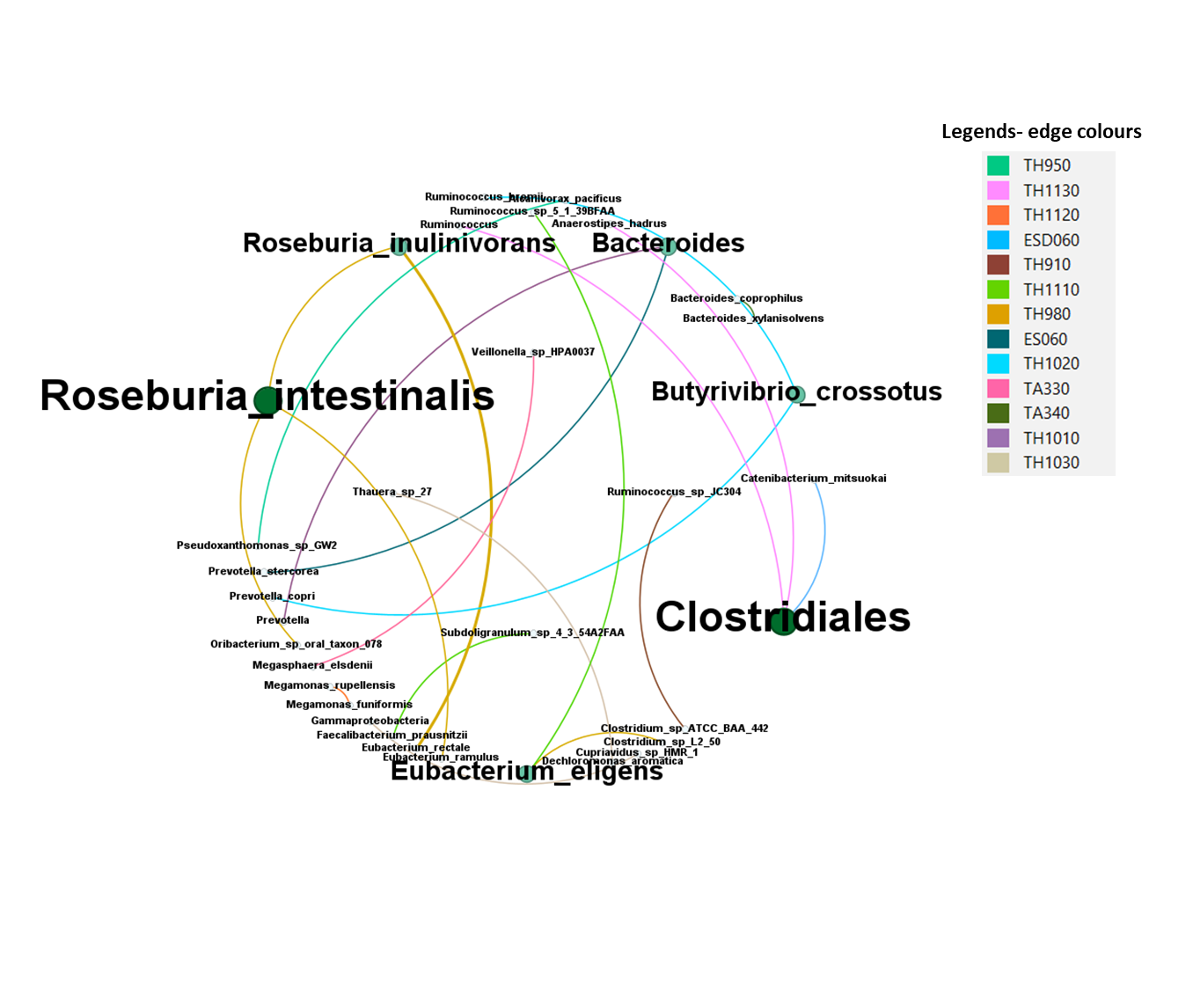
Supplementary Figure 2 Horizontal gene transfer events detected by WAFFLE represented as network using Gephi v0,10. The Nodes are represented by bacterial taxa with green dots- size of which correlates with the number of events detected. Every nodes are connected with each other with edge colour of which corresponds to the sample in which it was detected as in the legends. The node font size and dot size are proportional to the number of events.

