Figure S1: (A‒C) Molecular structures of (DOPA)₄-PEG₅-DBCO, P1 (N₃-K15-PVGLIG-K23), and P2 (N₃-Y5-PVGLIG-K23). (D) Synthesis of (DOPA)₄-PEG₅-DBCO.

Figure S2: (A‒B) Synthesis of P1 (N₃-K15-PVGLIG-K23) and P2 (N₃-Y5-PVGLIG-K23).

Figure S3: (A) Representative images of ALP staining and corresponding (D) quantitative analysis after mixing P1 and P2 at different ratios. (B) Representative images of ARS staining and corresponding (E) quantitative analysis after mixing P1 and P2 at different ratios. (C) Representative images of the tube formation assay and the corresponding (F‒G) quantitative analysis after mixing P1 and P2 at different ratios. The data are presented as the mean ± standard deviation (SD) (n=3 per group). Statistical analysis was performed via one-way ANOVA (*P < 0.05, **P < 0.01 vs. P1: P2 = 4: 0 group; #P < 0.05, ##P < 0.01 vs. P1: P2 = 3: 1 group; ^P < 0.05, ^^P < 0.01 vs. P1: P2 = 2: 2 group; &P < 0.05, &&P < 0.01 vs. P1: P2 = 1: 3 group; $P < 0.05, $$P < 0.01 vs. P1: P2 = 0: 4 group). P < 0.05 indicates statistical significance.

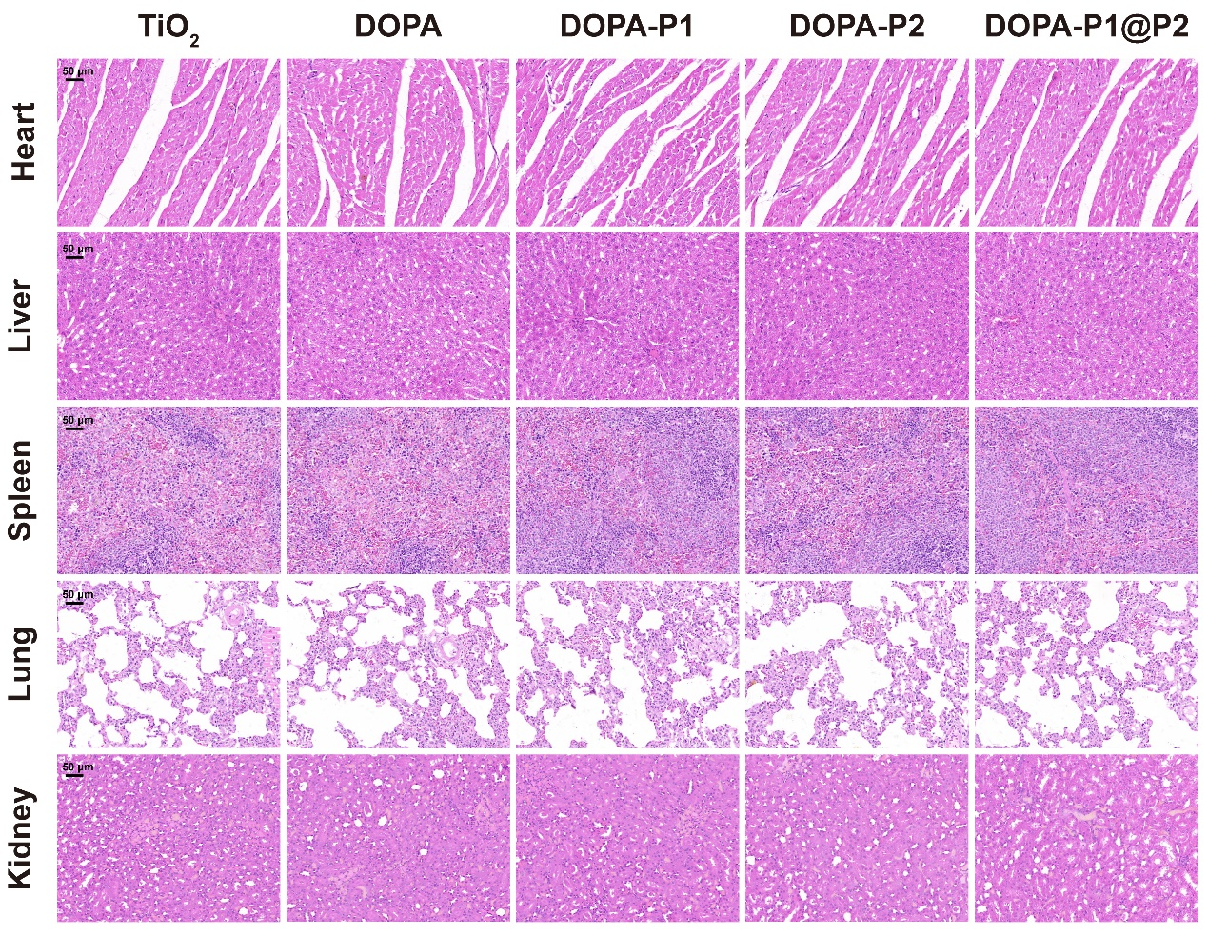

Figure S4: H&E staining of the rat heart, liver, spleen, lung, and kidney at two months post-implantation.

Figure S5: (A) Immunofluorescence staining was used to evaluate the indirect osteogenic effects of the modified surfaces, with the cytoskeleton in green (F-actin), osteogenesis-related proteins in red (OPN), and nuclei in blue. (B) Quantitative results of immunofluorescence analysis. (C‒F) RT-qPCR was used to assess the expression of osteogenic (Colla1 and Opn) and angiogenic (VEGF and FGF2) genes to evaluate the indirect osteogenic effects of the modified surfaces. The data are presented as the mean ± standard deviation (SD); n = 3 or 5 per group. Statistical analysis was performed via one-way ANOVA, and *P < 0.05 and **P < 0.01 indicate statistical significance.

Figure S6: (A) Immunofluorescence staining was used to evaluate the direct osteogenic effects of the modified surfaces, with the cytoskeleton in green (F-actin), osteogenesis-related proteins in red (COL-I), and nuclei in blue. (B) Quantitative results of immunofluorescence analysis. (C‒F) RT-qPCR was used to assess the expression of osteogenic (Colla1 and Opn) and angiogenic (VEGF and FGF2) genes to evaluate the direct osteogenic effects of the modified surfaces. The data are presented as the mean ± standard deviation (SD) (n=3 or 5 per group). Statistical analysis was performed via one-way ANOVA (∗P < 0.05 and ∗∗P < 0.01 vs. the TiO₂ group or comparisons between the combined groups indicated in the figure; #P < 0.05 and ##P < 0.01 vs. the DOPA group; $P < 0.05 and $$P < 0.01 vs. the DOPA-P1 group; and ^P < 0.05 and ^^P < 0.01 vs. the DOPA-P2 group). P < 0.05 indicates statistical significance.

Figure S7: (A, E) Box plot of gene expression levels. (B, F) Area distribution map of gene expression levels. (C, G) Heatmap of correlation coefficients between samples. (D, H) Results of sample-to-sample cluster analysis.

Figure S8: (A, D) Differentially expressed gene radar chart. (B, E) Circle plot of Gene Ontology (GO) enrichment analysis of differentially expressed genes. (C, F) Circle plot of Encyclopedia of Genes and Genomes (KEGG) enrichment analysis of differentially expressed genes.

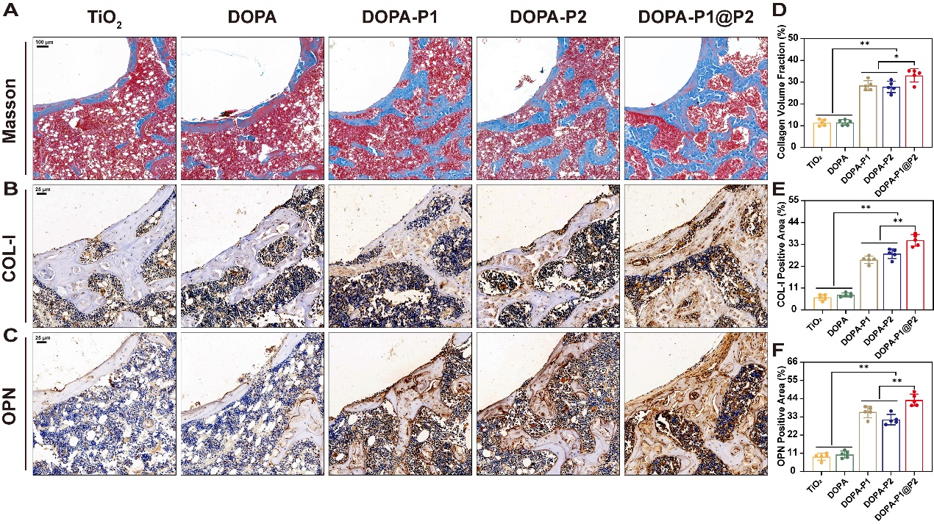

Figure S9: (A, D) Masson's trichrome staining and corresponding quantitative analysis. (B‒C) Immunohistochemical staining was used to assess the expression of osteogenic proteins (COL-I and OPN), and a quantitative analysis (E‒F) was performed.

Figure S10: (A) Exposure of the femur condyles. (B) Drilling of the femur condyles. (C) Completion of the drilling process. (D‒E) Implantation of the titanium rod. (F) Completion of the implantation process.

Table S1. Primer sequences used in RT-PCR analysis.
Genes | Primes (F-Forward, R-Reverse, 5‘-3’)
Mouse-Ccr7 | F: GGTGGCTCTCCTTGTCATTTTC
Mouse-Ccr7 | R: AGGTTGAGCAGGTAGGTATCCG
Mouse-Cd206 | F: TACTTGGACGGATAGATGGAGG
Mouse-Cd206 | R: CATAGAAAGGAATCCACGCAGT
Mouse-Actb | F: GTGACGTTGACATCCGTAAAGA
Mouse-Actb | R: GTAACAGTCCGCCTAGAAGCAC
Rat-Col1a1 | F: AGCTCGATACACAATGGCCT
Rat-Col1a1 | R: CCTATGACTTCTGCGTCTGG
Rat-Opn | F: GAACATGAAATGCTTCTTTCTCAG
Rat-Opn | R: TCCATGAAGCCACAAACTAAACTA
Rat-Actb | F: CCTCTATGACAACACAGT
Rat-Actb | R: AGCCACCAATCCACACAG
Human-VEGF | F: TATGCGGATCAAACCTCACCA
Human-VEGF | R: CACAGGGATTTTTCTTGTCTTGCT
Human-FGF-2 | F: AAGAGCGACCCTCACATCAA
Human-FGF-2 | R: GCCAGGTAACGGTTAGCACA
Human-GADPH | F: CATCATCCCTGCCTCTACTGG
Human-GADPH | R: GTGGGTGTCGCTGTTGAAGTC

