Supplementary Material

Oxygen vacancy-induced strengthening and toughening in (K,Na)NbO₃-based piezoceramics revealed via nanoindentation
Zhidong Zhang ^{a, #}, Bin Yang ^{a, #}, Longyu Chen ª, Zaoli Zhang ^{b,} *, Jinming Guo ^{a,} *
ª Ministry-of-Education Key Laboratory of Green Preparation and Application for Functional Materials, School of Materials Science and Engineering, Hubei University, 430062 Wuhan, China
^{b} Erich Schmid Institute of Materials Science, Austrian Academy of Sciences, A-8700 Leoben, Austria
*Corresponding authors: Jinming Guo (guojinming@hubu.edu.cn; guojinming0123@126.com); Zaoli Zhang (zaoli.zhang@oeaw.ac.at)
#These two authors contribute equally to this work

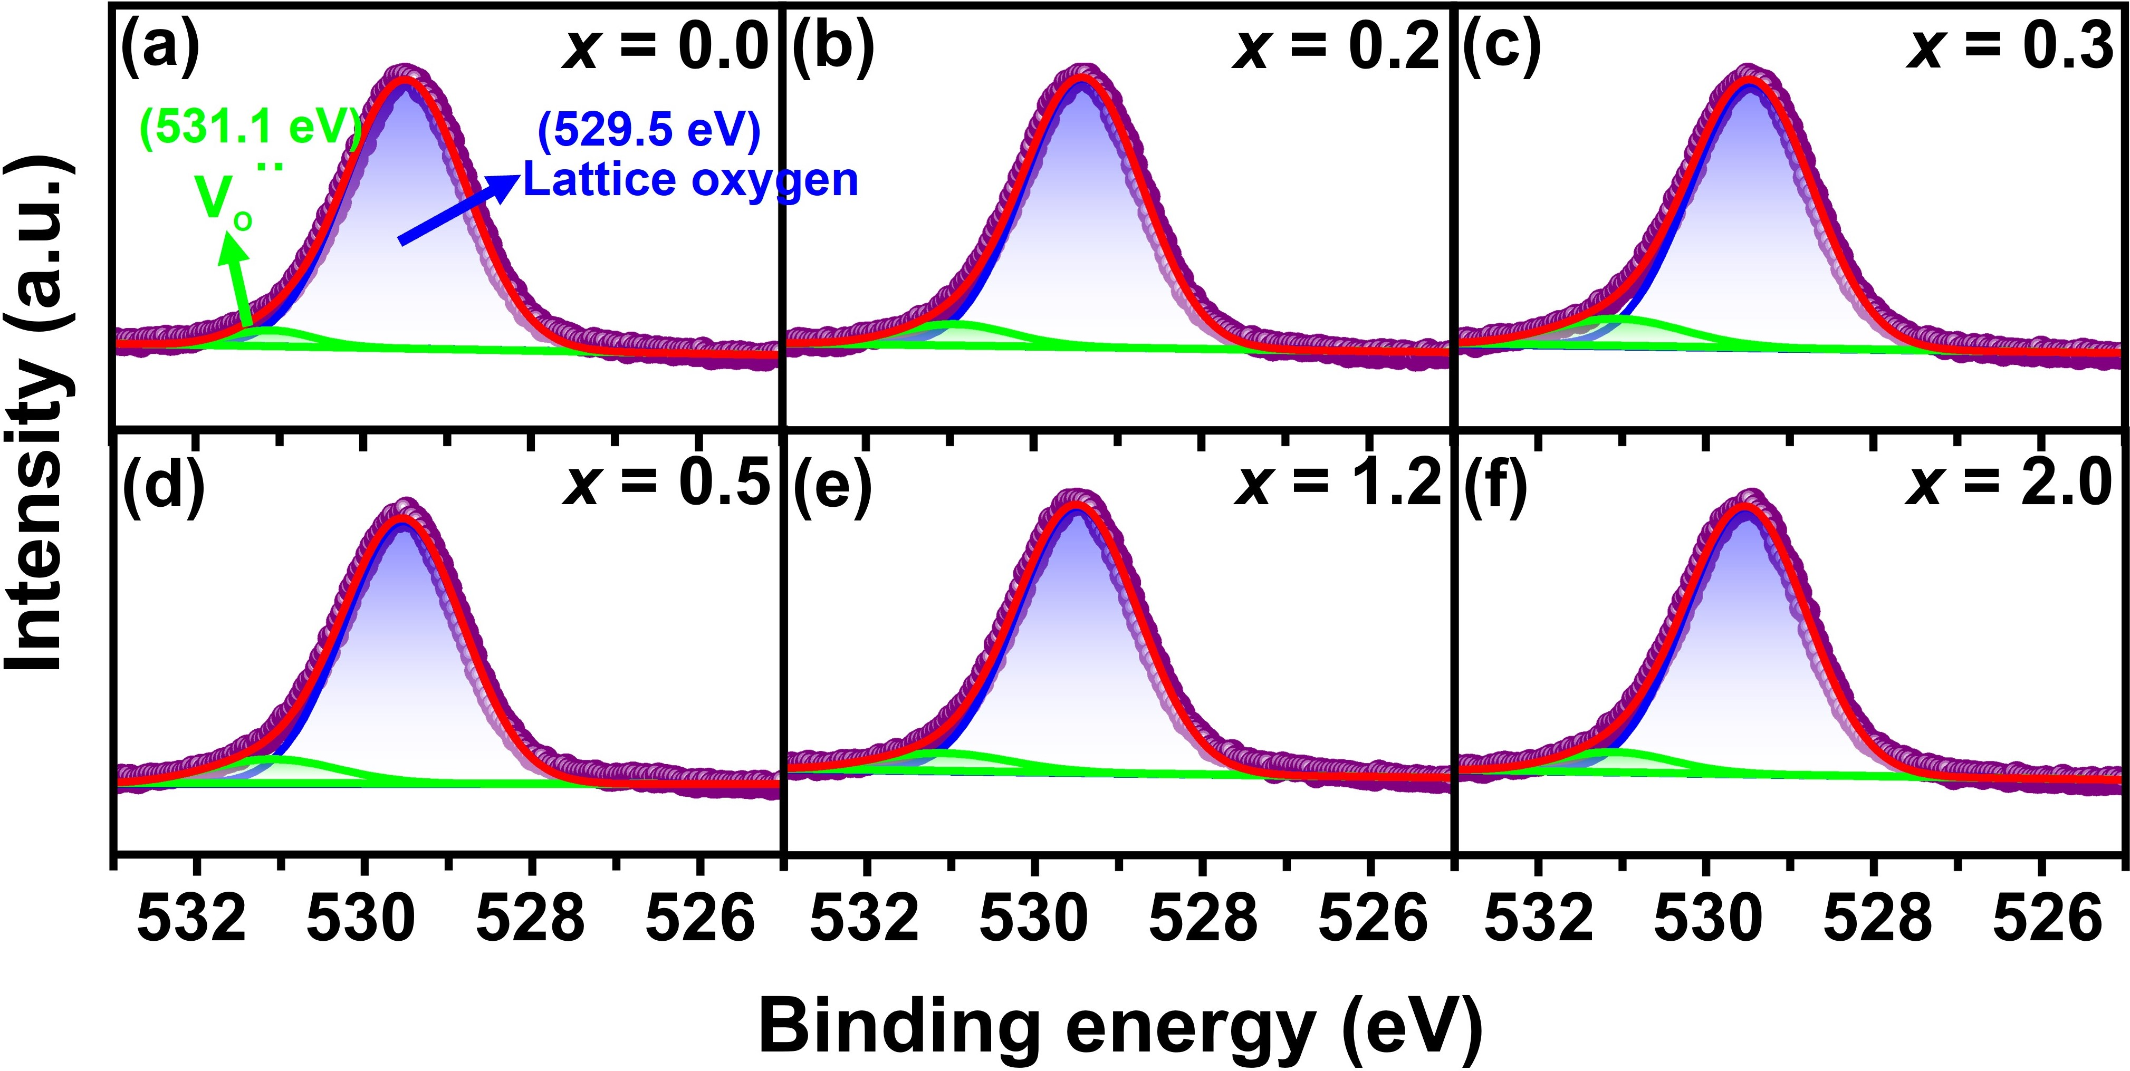
Supplementary Fig. S1 (a-f) XPS deconvolution of the O 1s peaks for KNLNST-xCuO.
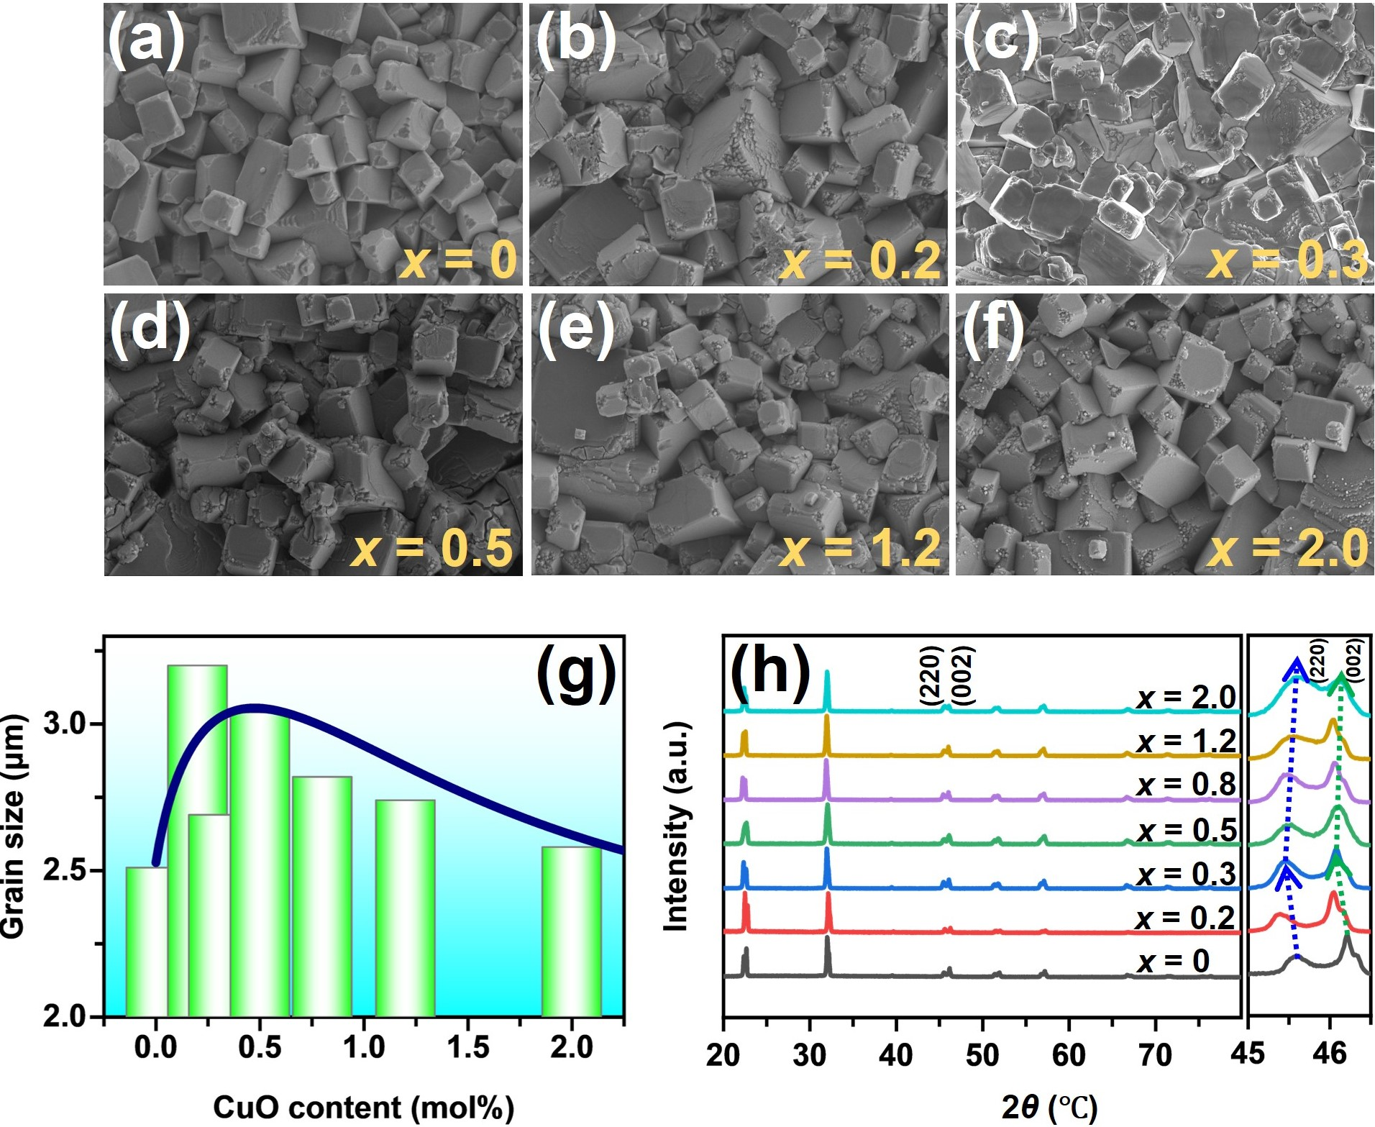
Supplementary Fig. S2 (a-f) SEM images, (g) grain size statistics, and (h) XRD spectrum of KNLNST-xCuO ceramics.
Supplementary Fig. S2a-f depict SEM images of KNLNST ceramics doped with varying amounts of CuO. The grain size statistics of KNLNST-xCuO are shown in Supplementary Fig. S2g. It is observed that upon initial doping with CuO, there is an increase in the size of the ceramic grains, including the occurrence of some abnormally expanded grains. As the addition of CuO continues, a slight reduction in grain size is noted. As demonstrated in Fig. S2h, when the doping level of CuO is comparatively small (x < 0.3 mol%), the characteristic diffraction peak shifts towards smaller angles, manifesting the increase of interplanar spacing d. As the CuO doping level increases further, the characteristic diffraction peak shifts towards larger angles, manifesting the decrease of interplanar spacing d. This corroborates the findings of the preceding SEM analysis. It is thus inferred that when x < 0.3 mol%, larger-radius Cu²⁺ ions substitute for smaller-radius B-site ions, leading to the expansion of grain size and interplanar spacing d. Inversely, when x > 0.3 mol%, smaller-radius Cu²⁺ ions substitute for larger-radius A-site ions, leading to the shrinkage of grain size and interplanar spacing d. Consequently, the oxygen vacancy concentration increases when x < 0.3 mol% due to acceptor doping. The oxygen vacancy concentration decreases when x > 0.3 mol% due to donor doping.

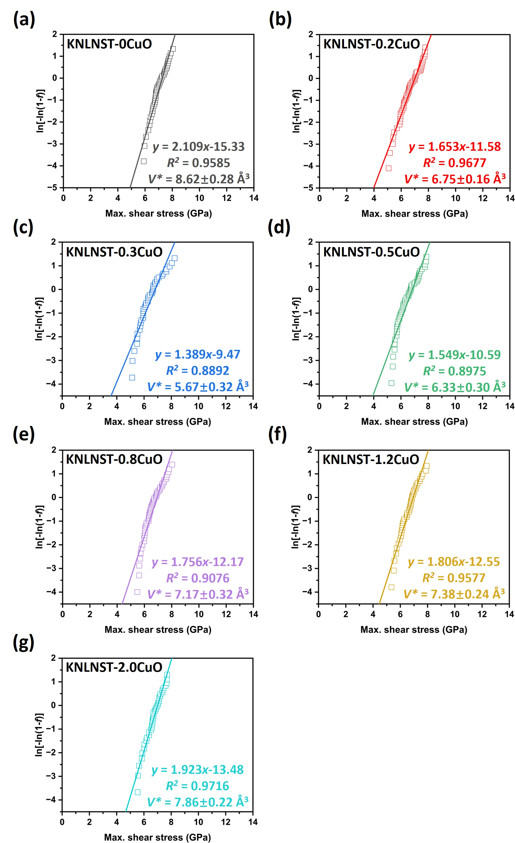
Supplementary Fig. S3 (a-g) The relationship plots between the term ln[-ln(1-f)] and the maximum shear stress τ_{max} in order to deduce the activation volume of KNLNST-xCuO by the linear least-squares fitting procedure.
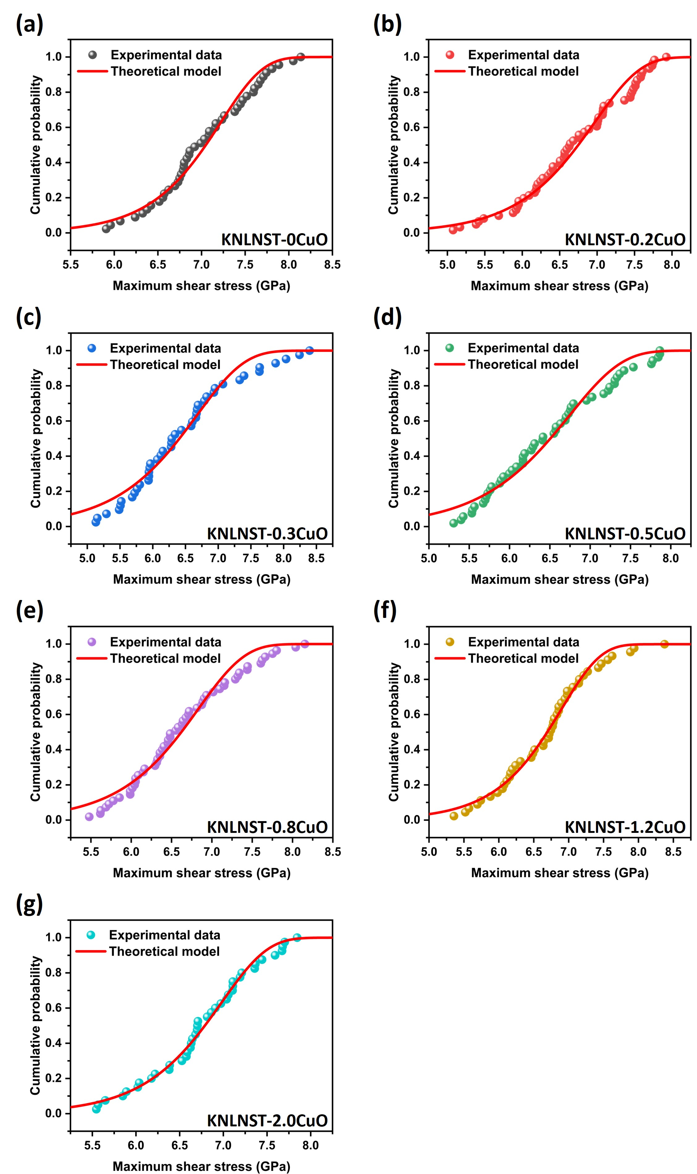
Supplementary Fig. S4 (a-g) The statistics of incipient plasticity in KNLNST-xCuO ceramics illustrate the cumulative distribution of maximum shear stress τ_{max} associated with the first pop-in event. The red lines represent the expectation of the theoretical model in Eq. 14.
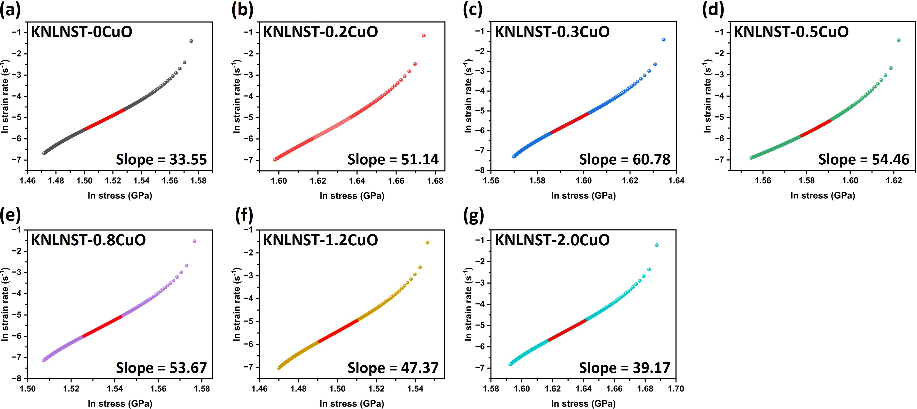
Supplementary Fig. S5 (a-g) Representative ln (stress) versus ln (strain rate) curves of KNLNST-xCuO.
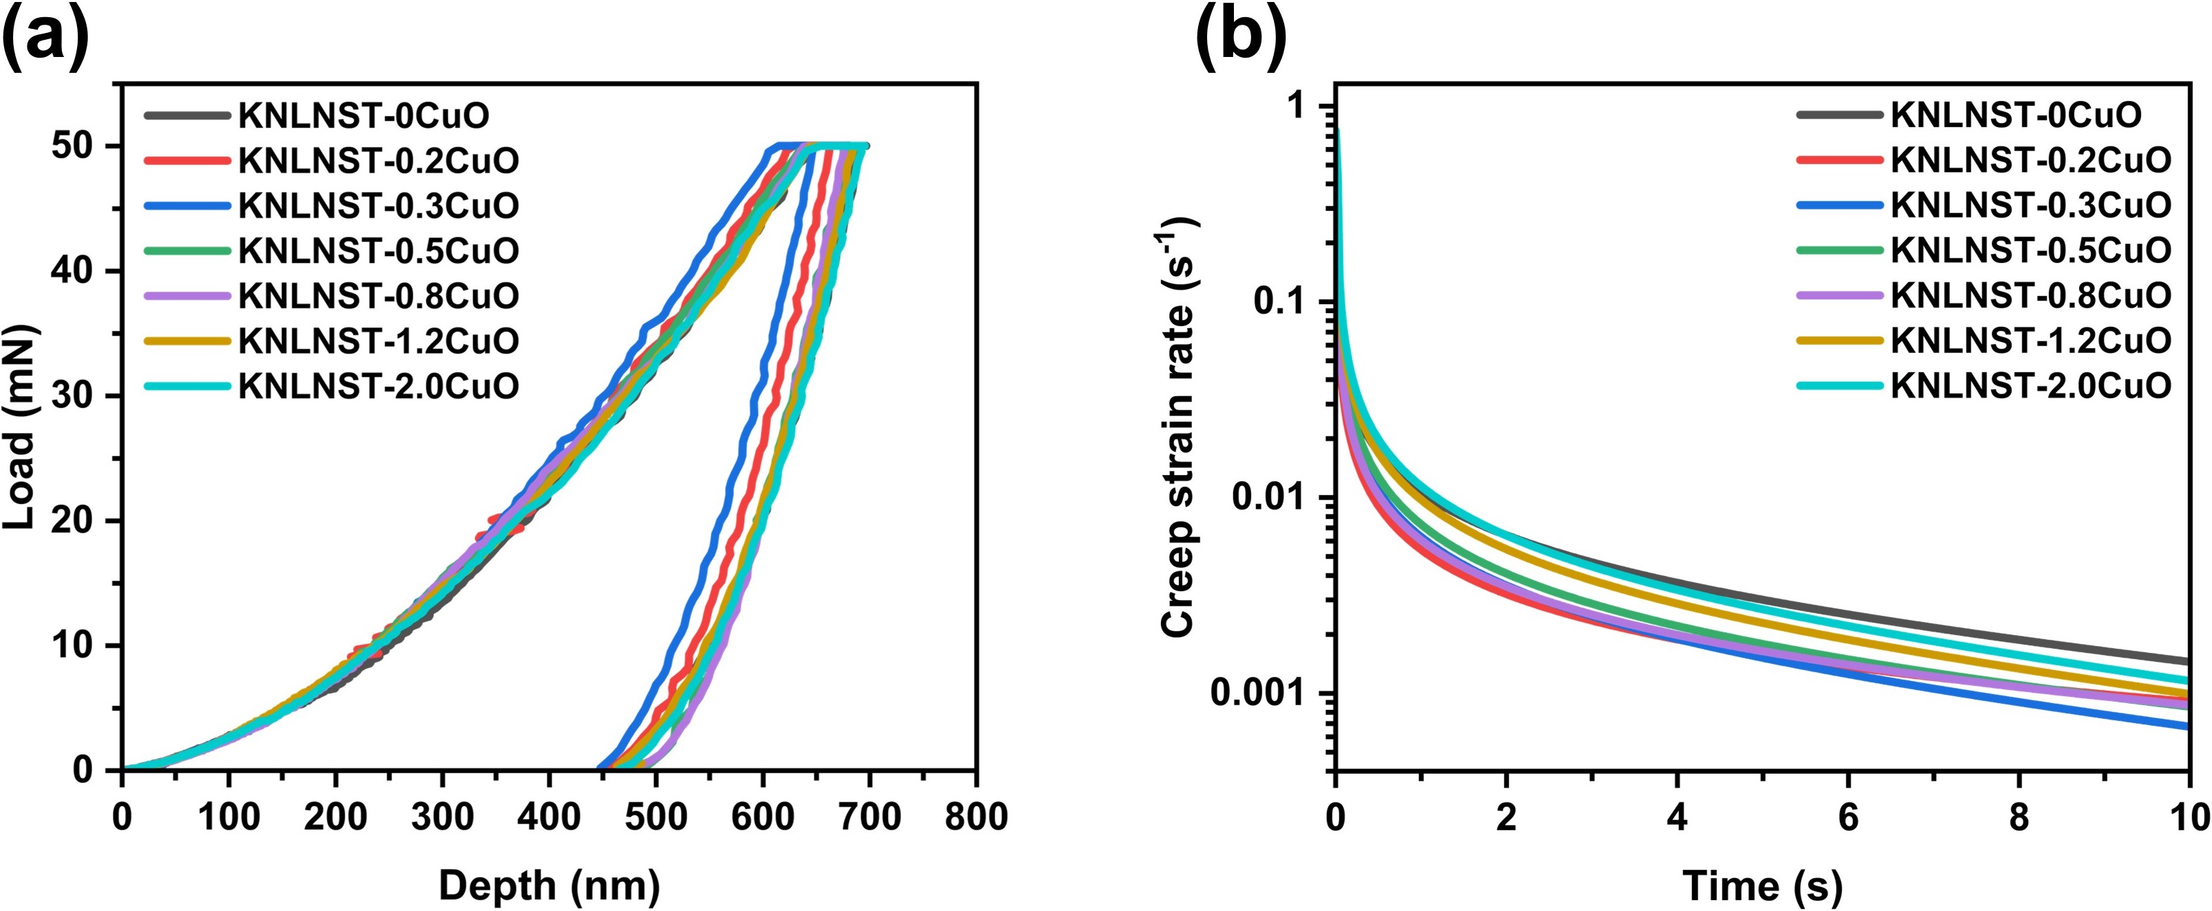
Supplementary Fig. S6 (a) Representative load-depth curves of KNLNST-xCuO during creep experiments. (b) The creep strain rate versus time curve during the creep stage of KNLNST-xCuO.

