Identification and functional analysis of bacteria in sclerotia of Cordyceps militaris
Li Luo^{1,2}, Jia-Xi Zhou^{1,2}, Zhong-Shun Xu^{1,2}, Ying-Ming Gao^{1,2}, Xiao Zou^{1,2}
¹Institute of Fungus Resources, Guizhou University, Guiyang, Guizhou, China
²Department of Ecology, College of Life Science, Guizhou University, Guiyang, Guizhou, China
*Correspondence: xzou@gzu.edu.cn

Li Luo：269587315@qq.com
Jia-Xi Zhou：1552047449@qq.com
Zhong-Shun Xu：1744955579@qq.com
Ying-Ming Gao：1397509719@qq.com
Xiao Zou：xzou@gzu.edu.cn

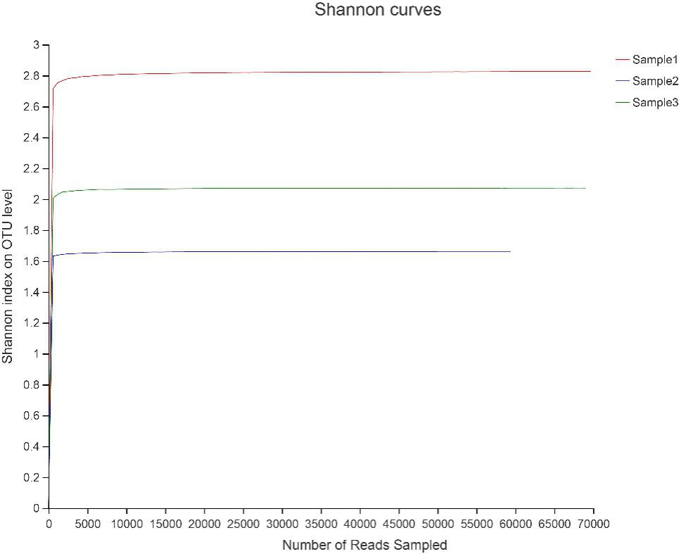
Fig. S1 Shannon rarefaction curves for bacterial communities.

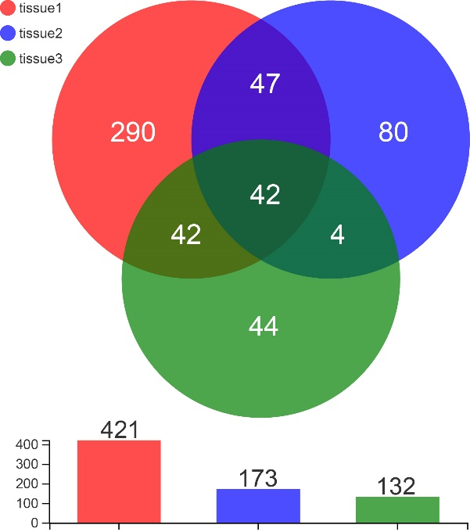
Fig. S2 Venn diagram of OTU overlap in the three samples.

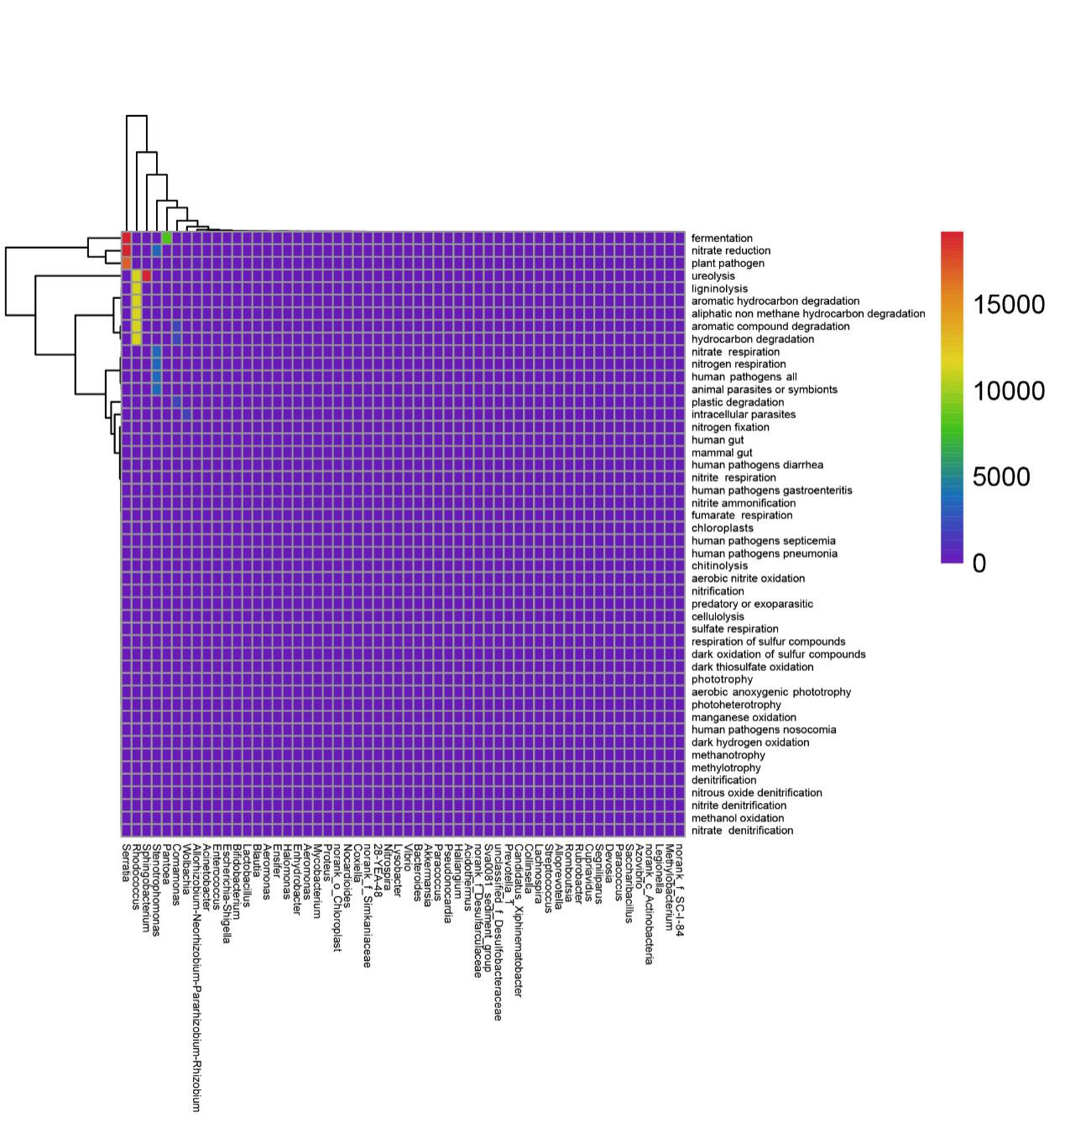
Fig. S3 Ecological function prediction of bacteria in the sclerotia of C. militaris.

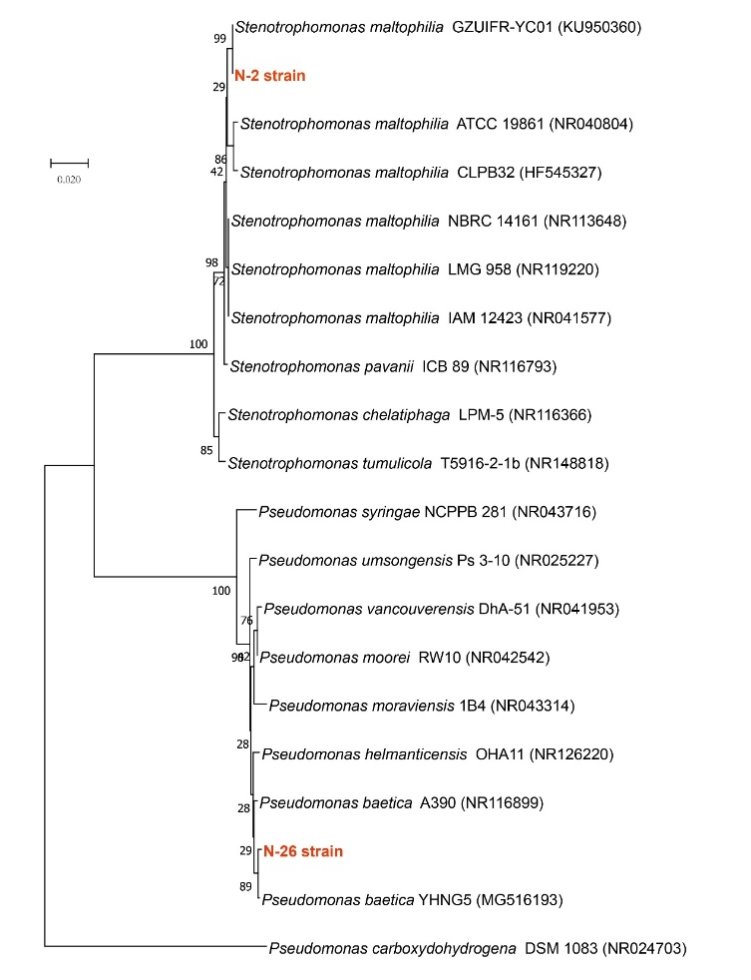
Fig. S4. Phylogenetic analysis of the bacterial strains isolated in this study.
Note: The number at each branch point is the bootstrap percentage (1000 resamplings). Numbers in parentheses are GenBank accession codes. Bar: 2% sequence divergence.

Table S1. Classification, functional prediction and abundance of OTUs in sclerotia of C. militaris.
OTU ID | Taxonomy | Function of prediction | Abundance
OTU1940 | Allorhizobium-Neorhizobium-Pararhizobium-Rhizobium | None |  | 29
OTU1261 | Devosia | None |  | 47
OTU1448 | Pseudomonas | aerobic chemoheterotrophy；chemoheterotrophy |  | 537
OTU2324 | Comamonas | None |  | 713
OTU1490 | Stenotrophomonas | human pathogens；animal parasites or symbionts；nitrate respiration；nitrate reduction；nitrogen respiration；aerobic chemoheterotrophy；chemoheterotrophy； |  | 3593
OTU1229 | norank_f__Ilumatobacteraceae | None |  | 6
OTU2330 | Pseudomonas | aerobic chemoheterotrophy；chemoheterotrophy |  | 32281
OTU1071 | Pedomicrobium | aerobic chemoheterotrophy；chemoheterotrophy |  | 33
OTU1534 | Pedobacter | aerobic chemoheterotrophy；chemoheterotrophy |  | 20951
OTU1539 | Rhodococcus | ligninolysis |  | 11404
OTU2342 | Sphingobacterium | ureolysis |  | 11404
OTU2028 | norank_c__KD4-96 | None |  | 18
OTU1507 | unclassified_f__Micromonosporaceae | None |  | 15
OTU2350 | Sphingopyxis | aerobic chemoheterotrophy；chemoheterotrophy |  | 109
OTU1732 | Gaiella | None |  | 11
OTU2338 | Bosea | None |  | 199
OTU1633 | Ochrobactrum | None |  | 2009
OTU1632 | Variovorax | None |  | 6207
OTU1243 | Labrys | aerobic chemoheterotrophy；chemoheterotrophy |  | 2121
OTU1854 | norank_f__Methyloligellaceae | None |  | 22
OTU1479 | Sphingobacterium | None |  | 3105
OTU4 | Ralstonia | None |  | 11
OTU1179 | Microlunatus | aerobic chemoheterotrophy；chemoheterotrophy |  | 24
OTU1047 | Ensifer | nitrate reduction；aerobic chemoheterotrophy；chemoheterotrophy； |  | 96
OTU1477 | Luteibacter | None |  | 7692
OTU1313 | Phyllobacterium | None |  | 3343
OTU1629 | Achromobacter | None |  | 12357
OTU2313 | Delftia | None |  | 864
OTU1579 | Serratia | fermentation |  | 1556
OTU1423 | Rhodococcus | aromatic compound degradation；aliphatic non methane hydrocarbon degradation；hydrocarbon degradation；chemoheterotrophy； |  | 16
OTU6 | unclassified_f__Enterobacteriaceae | None |  | 26773
OTU2234 | Candidatus_Xiphinematobacter | animal parasites or symbionts |  | 7
OTU1387 | Mycobacterium | aerobic chemoheterotrophy；chemoheterotrophy |  | 61
OTU2314 | Pseudomonas | aerobic chemoheterotrophy；chemoheterotrophy |  | 75
OTU2356 | Rhodopseudomonas | None |  | 124
OTU1845 | Allorhizobium-Neorhizobium-Pararhizobium-Rhizobium | nitrogen fixation |  | 385
OTU1334 | norank_f__norank_o__IMCC26256 | None |  | 15
OTU1529 | Arthrobacter | None |  | 24
OTU212 | Ellin6055 | aerobic chemoheterotrophy；chemoheterotrophy |  | 20
OTU1060 | Mesorhizobium | None |  | 89
OTU2348 | Curtobacterium | aerobic chemoheterotrophy；chemoheterotrophy |  | 2312

Table S2. Physiological and biochemical characteristics of strains N-2 and N-26.
Indicators | Strain |  | Indicators | Strain
Indicators | N-2 | N-26 | Indicators | N-2 | N-26
Semi-solid Agar | + | + | Mannitol | - | -
Gelatin | - | - | Inositol | - | -
Ornithine decarboxylase | + | + | Sorbitol | - | -
Lysine decarboxylase | + | + | Melibiose | - | -
Amino acid decarboxylase | + | + | Adonitol | - | -
Simmons citrate | - | - | Raffinose | - | -
Hydrogen sulfide | - | - | Xylose | - | -
Urease | - | - | Maltose | - | -
Peptone hydrolysis | - | - | Lipase | - | -
MR test | - | - | D-mannitol | - | -
VP test | + | + | Salicin | - | -
Phenylalanine | - | - | Aescinoside hydrolyzed | + | -
Note: “+” means positive, “−” means negative.

