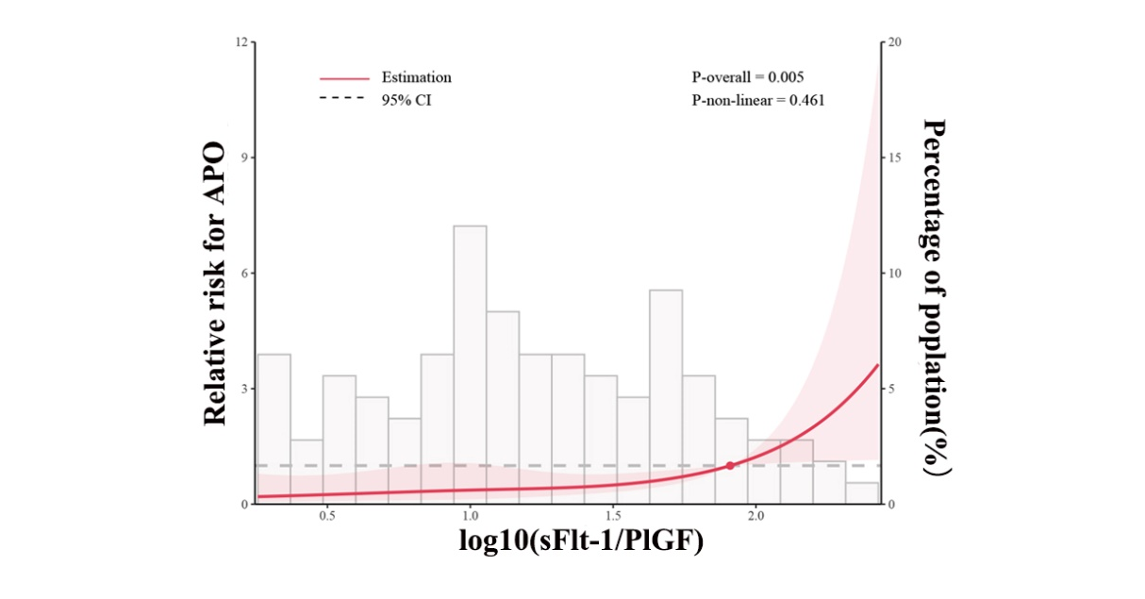 Supplementary Figure 1. Association of sFlt-1/PlGF ratio with relative risk for adverse prenatal outcome (APO) using a restricted cubic spline regression model. Lines represent the relative risk and 95% confidence interval (CI) based on restricted cubic splines for the log10-transformed sFlt-1/PlGF ratio.

