Supplementary Figure S1. Diagram of selection procedure for candidate genes. OS, osteosarcoma; COL1A2, Collagen Type I Alpha 2 Chain; GJA1, Gap Junction Protein Alpha 1; PLS3, Plastin-3; COL5A2, Collagen Type V Alpha 2 Chain; COL3A1, Collagen Type III Alpha 1 Chain; CDR1, Cerebellar degeneration-related protein 1; COL2A1, Collagen Type II Alpha 1 Chain; EGR1 Early Growth Response Protein 1; ACTB, Actin Beta.
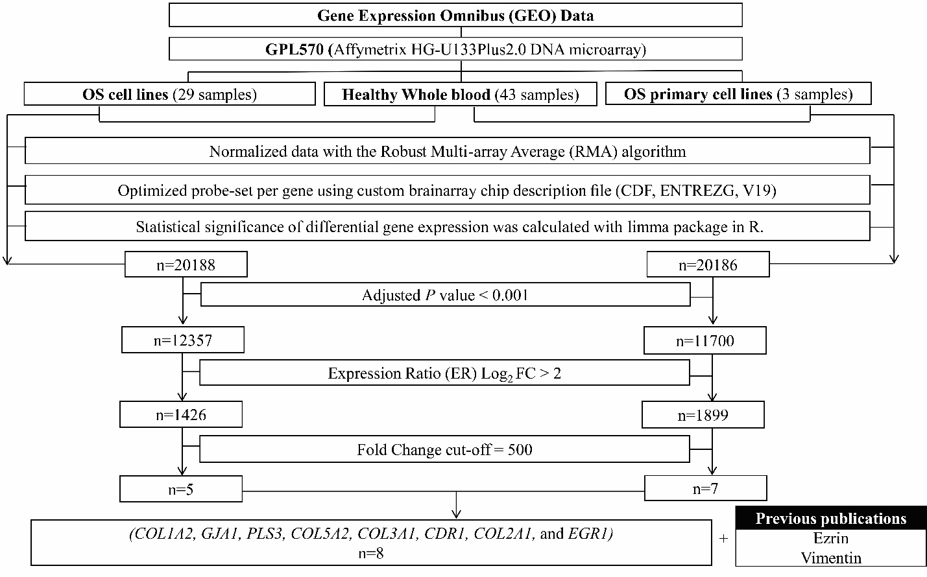

Supplementary Figure S2-6. The relative quantitative curve patterns. Each curve shows the corresponding relationship between the number of OS cells and the C(t) value of each candidate gene (Y-axis) and the corresponding relationship between the number of PBMCs and the C(t) value of CD45 (X-axis). There were three type of curve pattern labelled as C, P and N (Completely separated pattern, Partially separated pattern and Non-separated pattern, respectively).

Supplementary Figure S2.
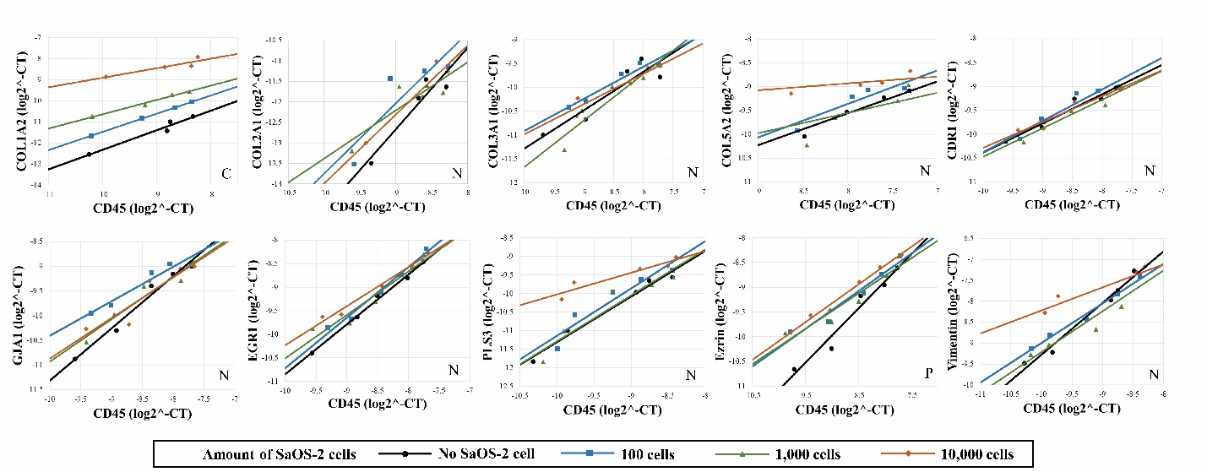
Supplementary Figure S3.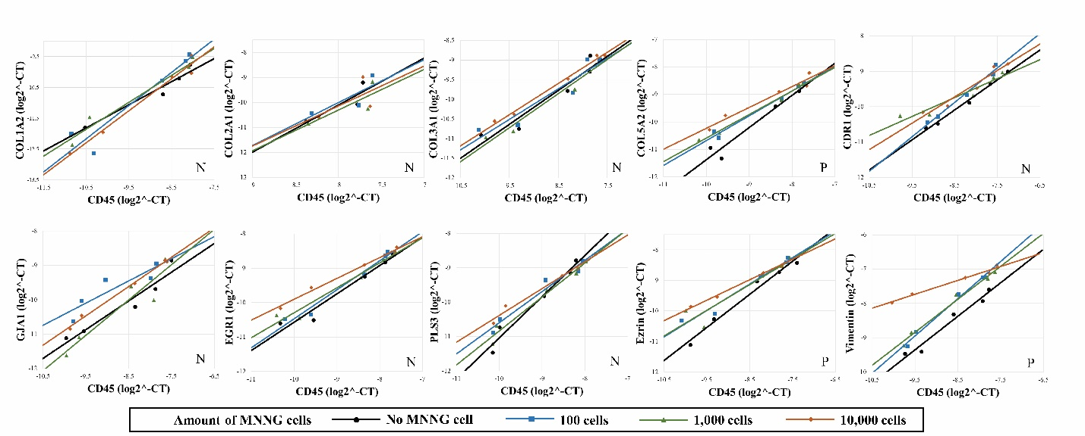
Supplementary Figure S4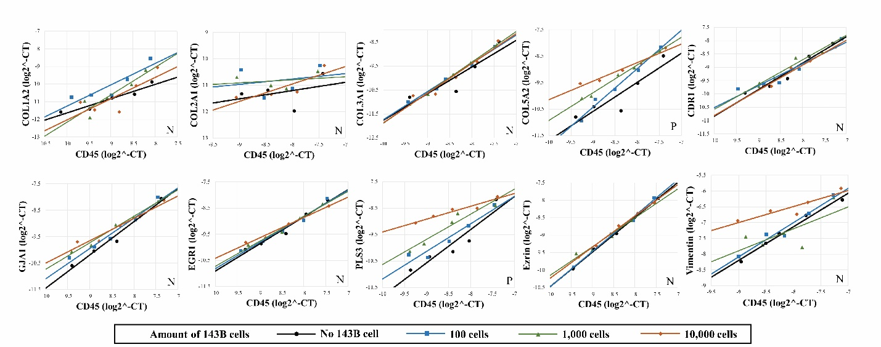

Supplementary Figure S5.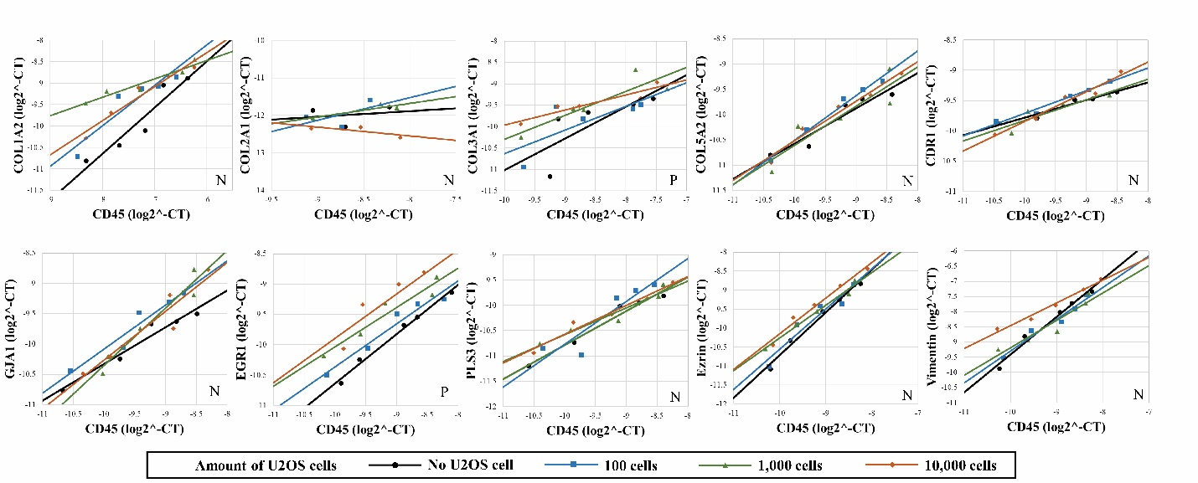

Supplementary Figure S6.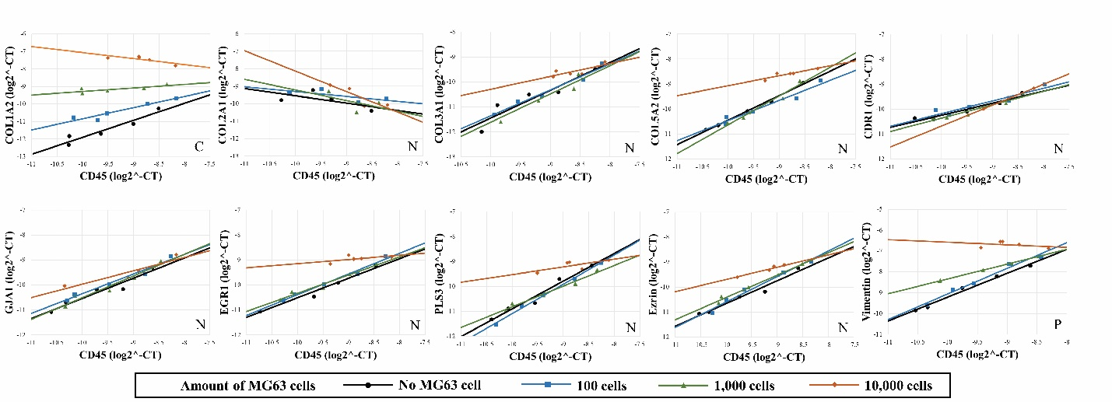
Supplementary Figure S7. Locally-weighted scatter plot smoothing (LOWESS) and fractional polynomial assessment of linear association between relative gene expression and log odds of osteosarcoma (fracplot of PLS3 was truncated maximal value for visualization).
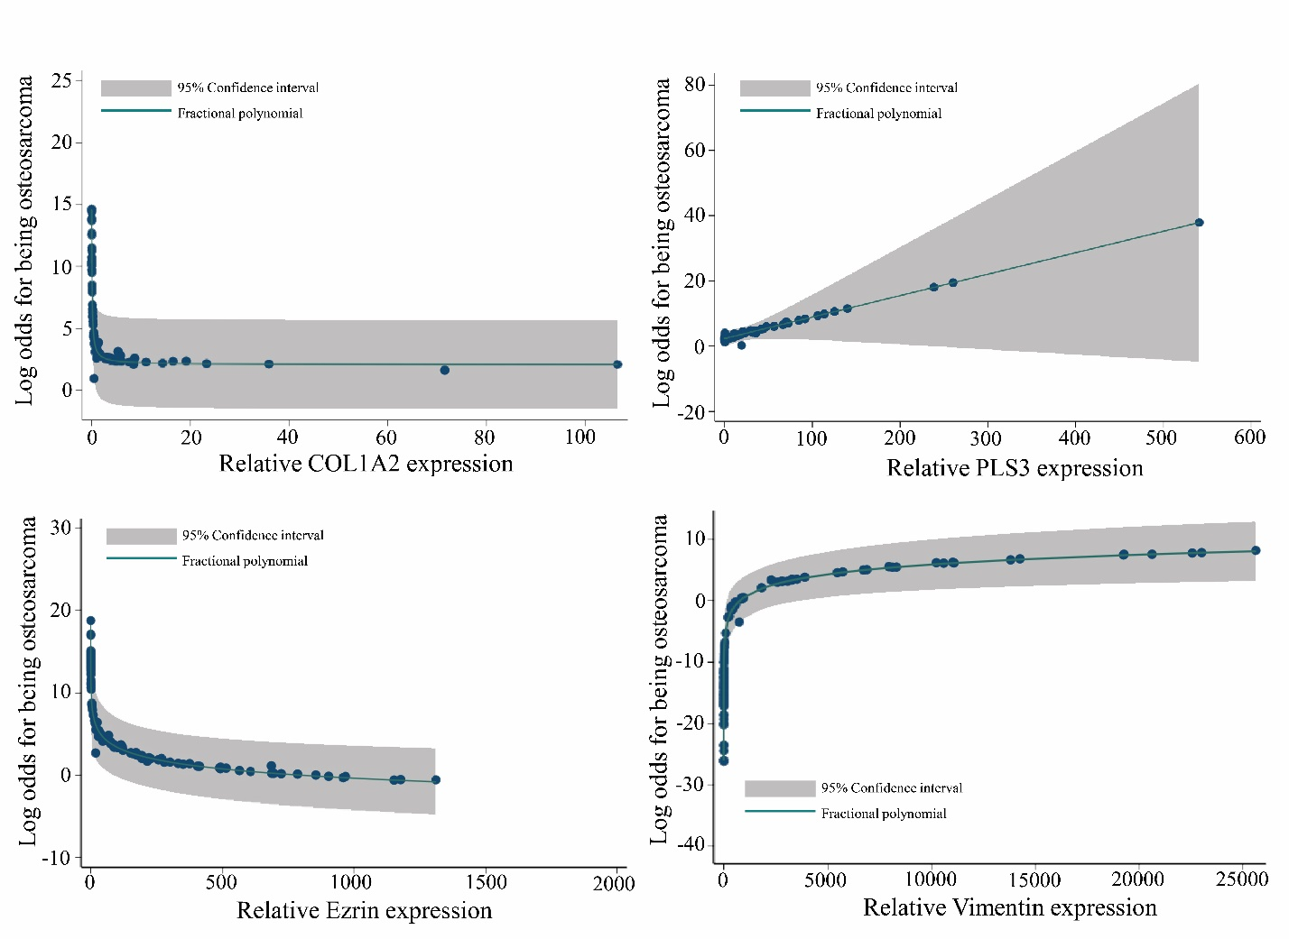

Supplementary Figure S8. Comparison of the expression of four osteosarcoma (OS)-specific candidate genes by qRT-PCR technique. Data are shown as scatter plots of the relative expression of COL1A2 (A), PLS3 (B), Ezrin (C) and VIM (D) by qRT-PCR. Expression of seven candidate genes in 24 OS primary cells and 3 normal PBMCs was quantified using qRT-PCR. Expression data was normalized on B-actin RNA level by the 2^{-∆Ct} method. Each sample was analyzed in triplicate. Data are displayed as vertical scatter plots with bars representing mean ± SD. The Mann-Whitney U-Test test was used to determine P-values: *, p <0.05; **, p <0.01; ***, p <0.001.

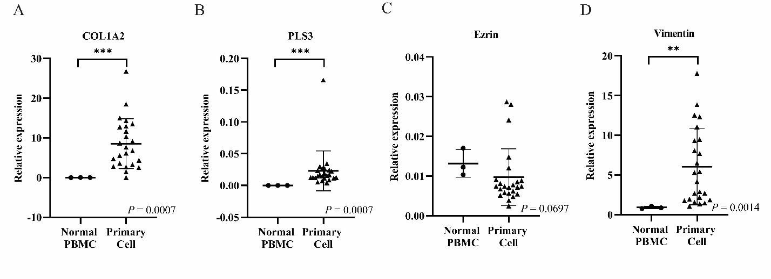

Supplementary Table S1. Real-Time PCR primers sequences
Gene group | Name | Sequence (5’-3’):  Forward (F); Reverse (R) | Accession Number
Comparative expression analysis | COL1A2 | F: AGGGCAACAGCAGGTTCACTTA  R: TCAGCACCACCGATGTCCAA | NM_000089.4
Comparative expression analysis | GJA1 | F: GGACTGTTTCCTCTCTCGCC  R: CGCTCTTTCCCTTAACCCGA | NM_000165.5
Comparative expression analysis | PLS3 | F: TTGTCCAGCGAAGGAACACA  R: ACAGGTCATCGGTGTTAGGG | NM_001172335.3
Comparative expression analysis | COL5A2 | F: CGCTTTTGTCATGTCAGTGGTT  R: GTGTCATGTTGCCTTTGTGGG | NM_000393.5
Comparative expression analysis | COL3A1 | F: CGCCCTCCTAATGGTCAAGG  R: TTCTGAGGACCAGTAGGGCA | NM_000090.4
Comparative expression analysis | CDR1 | F: GGAAGACCTGGAGGCCATTG  R: AGTCTTCCGGATAATTTGGGTCT | NM_004065.2
Comparative expression analysis | COL2A1 | F: CATGAGGGCGCGGTAGAGA  R: CCGGCTTCCACACATCCTTAT | NM_001844.5
Comparative expression analysis | EGR1 | F: TCCCATTTACTCAGCGGCAC  R: TGGAAACAGGTAGTCGGGGA | NM_001964.3
Previous study source | Ezrin | F: AAGGGTTCTGCTCTGACTCCA  R: TGGTTTCGGCATTTTCGGTT | NM_003379.5
Previous study source | VIM | F: TCTCTGAGGCTGCCAACCG  R: CGAAGGTGACGAGCCATTTCC | NM_003380.5
Housekeeping gene | ACTB | F: GTAAAGACCTCTATGCCAACA  R: GGACTCATCGTACTCCTGCT | NM_031144.3
Other | CD45 | F: ACAGCCAGCACCTTTCCTAC  R: GTGCAGGTAAGGCAGCAGA | NM_002838.5

Abbreviations: COL1A2, Collagen Type I Alpha 2 Chain; GJA1, Gap Junction Protein Alpha 1; PLS3, Plastin-3; COL5A2, Collagen Type V Alpha 2 Chain; COL3A1, Collagen Type III Alpha 1 Chain; CDR1, Cerebellar degeneration-related protein 1; COL2A1, Collagen Type II Alpha 1 Chain; EGR1, Early Growth Response Protein 1; VIM, Vimentin; ACTB, Actin Beta.
Supplementary Table S2. Summary of relative quantitative curve patterns
Genes | Osteosarcoma Cell Lines
Genes | SaOS-2 | MNNG | 143B | U2OS | MG63
COL1A2 | C | N | N | P | C
COL2A1 | N | N | N | N | N
COL3A1 | N | N | P | N | N
COL5A2 | P | P | P | N | N
CDR1 | N | N | N | N | N
GJA1 | N | N | N | N | N
EGR1 | N | N | N | P | N
PLS3 | N | N | P | N | N
Ezrin | P | P | N | N | N
VIM | N | P | N | N | P
COL1A2, Collagen Type I Alpha 2 Chain; GJA1, Gap Junction Protein Alpha 1; PLS3, Plastin-3; COL5A2, Collagen Type V Alpha 2 Chain; COL3A1, Collagen Type III Alpha 1 Chain; CDR1, Cerebellar degeneration-related protein 1; COL2A1, Collagen Type II Alpha 1 Chain; EGR1 Early Growth Response Protein 1; VIM, Vimentin; C, Completely separated pattern; P, Partially separated pattern; N, Non-separated pattern, respectively.

Supplementary Table S3. The microarray expression data sets used in this study are publicly available (continued).
Entity | GEOAccession codes |  | Title of Samples
Entity | Series | Sample | Title of Samples
OS cell line  (n=29) | GSE70414 | GSM1727193  GSM1727194  GSM1727195  GSM1727196  GSM1727197 | - MG63 [mRNA]  - Saos [mRNA]  - HOS [mRNA]  - NY [mRNA]  - Hu09 [mRNA]
OS cell line  (n=29) | GSE30807 | GSM764200 | - osteosarcoma U2OS cells
OS cell line  (n=29) | GSE37552 | GSM921514  GSM921515  GSM921516  GSM921517 | - Human_Osteosarcoma_Non-Metastatic_SaOS-2_Parental Line  - Human_Osteosarcoma_ Metastatic_LM7_Subline of SaOS-2  - Human_Osteosarcoma_Non-Metastatic_HOS_Parental Line  - Human_Osteosarcoma_ Metastatic_143B_Subline of HOS
OS cell line  (n=29) | GSE18947 | GSM469260  GSM469261  GSM469264 | - low metastatic potential cell subline of Sosp-9607, biological rep1  - low metastatic potential cell subline of Sosp-9607, biological rep2  - low metastatic potential cell subline of Saos-2
OS cell line  (n=29) | GSE16089 | GSM402655  GSM402656  GSM402657 | - Saos-2 parental cells replicate 1  - Saos-2 parental cells replicate 2  - Saos-2 parental cells replicate 3
OS cell line  (n=29) | GSE7454 | GSM180459 | - U-2OS (no-treatment) expression profile (AffyChip U133 Plus 2.0 platform)
OS cell line  (n=29) | GSE41828 | GSM1025090  GSM1025091  GSM1025092  GSM1025093  GSM1025094 | - U2OS, Untreated 24 hours rep1  - U2OS, Untreated 24 hours rep2  - U2OS, Untreated 24 hours rep3  - U2OS, Untreated 24 hours rep4  - U2OS, Untreated 24 hours rep5
OS cell line  (n=29) | GSE46493 | GSM1131226  GSM1131227  GSM1131228 | - U2OS No Treatment, Replicate 1  - U2OS No Treatment, Replicate 2  - U2OS No Treatment, Replicate 3

Supplementary Table S3. The microarray expression data sets used in this study are publicly available (continued).
Entity | GEOAccession codes |  | Title of Samples
Entity | Series | Sample | Title of Samples
OS cell line  (n=29) | GSE41445 | GSM1017514  GSM1017515  GSM1017516 | - U2OS_21a  - U2OS_21b  - U2OS_21c
OS cell line  (n=29) | GSE55957 | GSM1349294 | - ZOS osteosaracoma cell line
Primay OS cells  (n=3) | GSE85537 | GSM2276632  GSM2276633  GSM2276634 | - Bone1, biological rep1  - Bone2, biological rep2  - Bone3, biological rep3
Healthy whole blood  (n=43) | GSE93272 | GSM2449608  GSM2449609  GSM2449610  GSM2449611  GSM2449612  GSM2449613  GSM2449614  GSM2449615  GSM2449616  GSM2449617  GSM2449618  GSM2449619  GSM2449620  GSM2449621  GSM2449622  GSM2449623  GSM2449624  GSM2449625  GSM2449626  GSM2449627  GSM2449628 | - Whole blood from healthy control(HC003_1)  - Whole blood from healthy control(HC004_1)  - Whole blood from healthy control(HC005_1)  - Whole blood from healthy control(HC006_1)  - Whole blood from healthy control(HC007_1)  - Whole blood from healthy control(HC008_1)  - Whole blood from healthy control(HC009_1)  - Whole blood from healthy control(HC010_1)  - Whole blood from healthy control(HC011_1)  - Whole blood from healthy control(HC012_1)  - Whole blood from healthy control(HC013_1)  - Whole blood from healthy control(HC015_1)  - Whole blood from healthy control(HC016_1)  - Whole blood from healthy control(HC017_1)  - Whole blood from healthy control(HC018_1)  - Whole blood from healthy control(HC019_1)  - Whole blood from healthy control(HC020_1)  - Whole blood from healthy control(HC021_1)  - Whole blood from healthy control(HC022_1)  - Whole blood from healthy control(HC023_1)  - Whole blood from healthy control(HC024_1
Supplementary Table S3. The microarray expression data sets used in this study are publicly available.
Entity | GEOAccession codes |  | Title of Samples
Entity | Series | Sample | Title of Samples
Healthy whole blood  (n=43) | GSE93272 | GM2449629  GSM2449630  GSM2449631  GSM2449632  GSM2449633  GSM2449634  GSM2449635  GSM2449636  GSM2449637  GSM2449668  GSM2449669  GSM2449670  GSM2449671  GSM2449672  GSM2449673  GSM2449674  GSM2449675  GSM2449676  GSM2449677  GSM2449678  GSM2449679  GSM2449680 | - Whole blood from healthy control(HC025_1)  - Whole blood from healthy control(HC026_1)  - Whole blood from healthy control(HC027_1)  - Whole blood from healthy control(HC028_1)  - Whole blood from healthy control(HC030_1)  - Whole blood from healthy control(HC031_1)  - Whole blood from healthy control(HC034_1)  - Whole blood from healthy control(HC035_1)  - Whole blood from healthy control(HC036_1)  - Whole blood from healthy control(AU_2)  - Whole blood from healthy control(AW_2)  - Whole blood from healthy control(AY_2)  - Whole blood from healthy control(BA_2)  - Whole blood from healthy control(BB_2)  - Whole blood from healthy control(HC003_2)  - Whole blood from healthy control(HC005_2)  - Whole blood from healthy control(HC008_2)  - Whole blood from healthy control(HC023_2)  - Whole blood from healthy control(HC025_2)  - Whole blood from healthy control(HC026_2)  - Whole blood from healthy control(HC034_2)  - Whole blood from healthy control(HC036_2)

