Supplementary Appendix
SQL code used to select variables from HMDA data for 2019
DROP TABLE IF EXISTS public.il2019F1;
CREATE TABLE il2019F1 AS (SELECT
lar_2019.activity_year,
lar_2019.derived_msa_md,
lar_2019.state_code,
lar_2019.county_code,
lar_2019.census_tract,
lar_2019.debt_to_income_ratio,
lar_2019.combined_loan_to_value_ratio,
lar_2019.income,
lar_2019.property_value,
lar_2019.loan_amount,
lar_2019.interest_rate,
lar_2019.applicant_ethnicity_1,
lar_2019.applicant_race_1,
lar_2019.denial_reason_1,
lar_2019.tract_minority_population_percent,
lar_2019.tract_to_msa_income_percentage,
lar_2019.tract_population,
lar_2019.tract_owner_occupied_units,
lar_2019.tract_median_age_of_housing_units,
lar_2019.rate_spread,
lar_2019.hoepa_status,
lar_2019.lien_status
FROM
public.lar_2019
WHERE lar_2019.loan_purpose = '1' and
lar_2019.action_taken = '1' and
lar_2019.loan_type = '1' and
lar_2019.derived_dwelling_category = 'Single Family (1-4 Units):Site-Built' and
lar_2019.occupancy_type = '1' and
lar_2019.state_code = 'IL' and
lar_2019.county_code = '17031' and
(lar_2019.property_value) != 'NA' and (lar_2019.property_value) != 'Exempt' and
(lar_2019.income) != 'NA' and
(lar_2019.loan_amount) != 'NA' and lar_2019.income != '9999' AND lar_2019.loan_amount != '99999'
);

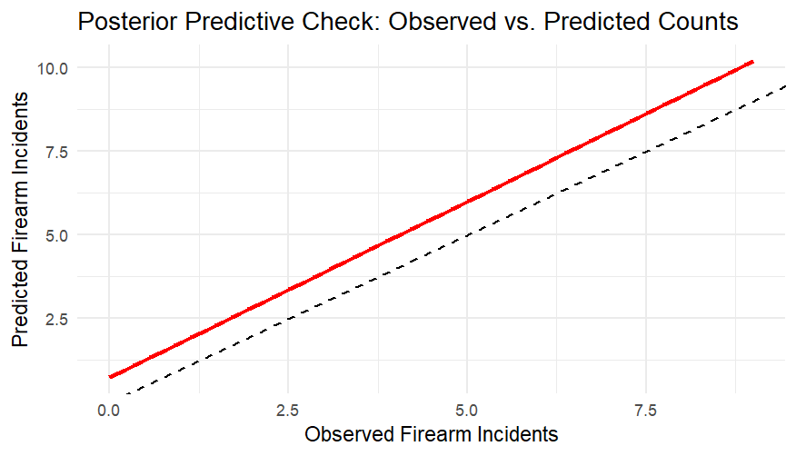
Supplementary Figure 1: Posterior Predictive Check for Firearm-Related Homicides. The plot compares observed and predicted firearm-related homicide counts at the census tract level. The black dashed line represents the ideal 1:1 fit, indicating perfect agreement between predictions and observations, while the red line shows the actual trend from the model. The strong alignment between observed and predicted values suggests that the Poisson BYM model provides reasonable estimates of firearm-related violence risk across census tracts.

