Supplementary information to:

Nanomechanical subsurface characterisation of cellulosic fibres

Julia Auernhammer¹, Markus Langhans², Jan-Lukas Schäfer², Tom Keil³, Tobias Meckel², Markus Biesalski² and Robert W. Stark^{1*}
¹ Institute of Materials Science, Physics of Surfaces, Technische Universität Darmstadt, Alarich-Weiss-Str. 16, 64287 Darmstadt, Germany
²Department of Chemistry, Macromolecular Chemistry and Paper Chemistry, Technische Universität Darmstadt, Alarich-Weiss-Str. 8, 64287 Darmstadt, Germany
³ Institute of Materials Science, Physical Metallurgy, Technical University of Darmstadt, Alarich-Weiss-Str. 2, 64287 Darmstadt, Germany

*corresponding author
stark@pos.tu-darmstadt.de

ORCIDs:
Julia Auernhammer 0000-0002-9896-7353
Markus Langhans 0000-0002-1117-5645
Jan-Lukas Schäfer 0000-0002-4335-9342
Tom Keil 0000-0002-9145-4731
Markus Biesalski 0000-0001-6662-0673
Robert W. Stark 0000-0001-8678-8449

Figure S1: Extracted force-distance curve from the measurements.

In figure S1 an example for a force-distance curve of the measurements is displayed. It is visible, that directly after the contact point the curve possesses the highest slope which is fading out until the setpoint is reached. Thus, the hard layer on top with the decreasing E_{lok}(z) towards the fibre interior is resulting.

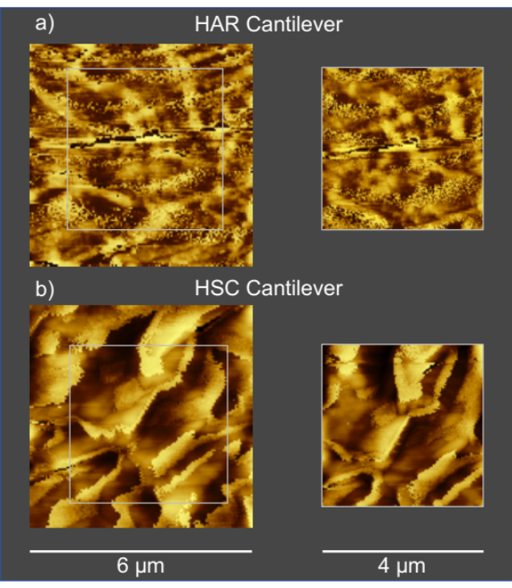
Figure S2: AFM topography maps. a) Maps with a HAR cantilever in dry state. b) Maps with a HSC cantilever in wet state.

As seen in figure S2 the applied force-volume mapping is not destroying the fibres surface as no imprint of the 4x4 µm scan shape is visible in the 6x6 µm scan. This applies also in wet state.

