SUPPLEMENTARY MATERIALS

MATERIALS & METHODS
2.3.2 Characterization of the Decellularization Efficiency: DNA Content
Residual DNA quantification and base pair length were used as indirect measures of decellularization efficiency. For quantitative analysis of DNA levels, we used native and decellularized brain samples (i.e., 1 mg lyophilized tissue) that were resuspended in buffer containing 1% SDS, 100 mM NaCl, 10 mM Tris, 25 mM EDTA and 0.1 mg/ml proteinase K and incubated at 37 °C for 60 hours. Later, the samples were treated with phenol:chloroform:isoamyl alcohol and centrifuged to remove proteins; the aqueous layer was collected and placed in a new tube with ice-cold 3.0 M sodium acetate (0.1 volumes) and 100% ethanol (2.5 volumes). The DNA pellet was washed with 70% ethanol, centrifuged and dried. DNA dried pellet was resuspended with nuclease free water and stored at -20°C until analysis. Double-stranded DNA was quantified using PicoGreen Assay (Invitrogen Corp.) per kit instructions [44, 79]. For analysis of base pair length of residual DNA in brain samples, DNA extracts of brain decellularized ECM scaffolds were analyzed by gel electrophoresis on 1.0% agarose gel with ethidium bromide (2h at 60V) followed by imaging with ultraviolet transillumination [6, 49].

2.3.3 Characterization of the Decellularization Efficiency: Western Blot
Tissue lysates of lyophilized native and decellularized samples (30 µg) were separated in SDS-polyacrylamide gel (PAGE) (12 %) in reducing conditions and transferred to a PVDF membrane for 2 h. Membranes were then blocked with Tris-buffered saline solution with 0.05 % Tween-20 (TBS-T) and 5 % fat free milk and incubated overnight with mouse monoclonal α-tubulin (1:3000, T8203, Sigma Aldrich) and mouse monoclonal Neu-N (1:1000, MAB377, Sigma Aldrich). The membranes were washed in TBS-T and incubated for 2 h with horseradish peroxidase-conjugated anti-mouse (1:10000, HAF018, R&D System). Detection of bands was accomplished by chemiluminescence using Western Blotting Luminol Reagent (Santa Cruz Biotechnology, Inc. Santa Cruz, CA) [80].

2.3.4 Structural Characterization: Histological Analysis
Fresh, recently dissected native tissue and non-lyophilized brain decellularized ECM samples were sectioned into 2x2 mm² pieces and fixed in 10% neutral buffered formalin for 24 hours, followed by dehydration with a series of baths in an ethanol gradient (i.e., 70%, 95% and 100%) twice in each concentration for 1h. Dehydrated samples were put in xylene twice for 1 h prior to paraffin embedding (Paraplast catalog # 39601006, Leica Biosystems, Heidelberger, Germany) and blocking twice for 2 h. Samples were sectioned in a HMT-2260 manual rotary microtome (Ted Pella, Redding, CA, USA) set to 5 µm-thick slices. The slices were deparaffinized and stained with Hematoxylin & Eosin (H&E), Coomassie Blue and DAPI (4',6-diamidino-2-phenylindole) following standard protocols for structural analysis, as previously described [44, 81]. The images were acquired using standard bright field techniques on an IM70 inverted phase-contrast DIC microscope (Olympus, Tokyo, Japan) for H&E and Coomassie Blue stains, and a BX-60 fluorescent microscope (Olympus) for DAPI.

2.3.5 Morphological Characterization: Scanning Electron Microscopy
Samples were prepared for morphological/topographical analysis with scanning electron microscope (SEM) by fixing in glutaraldehyde for 2 h, followed by dehydration in a 7-step series of ethanol rinses (30-100%) for 30 min in each concentration. Dehydrated samples in 100% ethanol were critical point dried (EMS, Hatfield, PA, USA) and coated with an ultrathin layer of gold-palladium with a low-vacuum sputter coater (EMS). The samples were observed with an Evo 40 variable-pressure SEM (Carl Zeiss, Oberkochen, Germany) [44, 82].

2.4.2 Cytotoxicity of Region-Specific Brain Decellularized ECM
Undifferentiated PC12 cells (P5-8) were passaged at 80–90% confluence on flasks in complete RPMI medium. Expanded PC12 cells were plated onto PLL–coated, sterile, 12-mm glass coverslips (catalog # GG-12-1.5-IHC, Neuvitro Corporation, Camas, WA, USA) at 70,000 cells per well in 12-well tissue culture plates. After 24 hours, we added 10 μg/ml decellularized ECM from each of the region-specific sections (i.e., cortex, cerebellum, and remaining areas) or PBS (negative control) to the growth medium, for 2 h [44]. Cell viability and cell death were examined using a commercially available live/dead cell assay (R&D Systems). To distinguish between viable and dead cells, PC12 cells were stained with calcein AM (4 μM) and propidium iodide (4 μM). Calcein-AM is a non-fluorescent vital dye that passively crosses the cell membrane of viable cells and is converted by cytosolic esterases into green-fluorescent calcein (live cells); while propidium iodide stains DNA in cells with damaged membranes with a bright red fluorescence (dead cells). The number of viable cells (Calcein⁺) versus dead cells (Propidium iodide⁺) in the same field was determined under epifluorescent illumination in an inverted microscope. The software ImageJ (NIH, Bethesda, VA, USA) was used to analyze and quantify all images [44, 83].

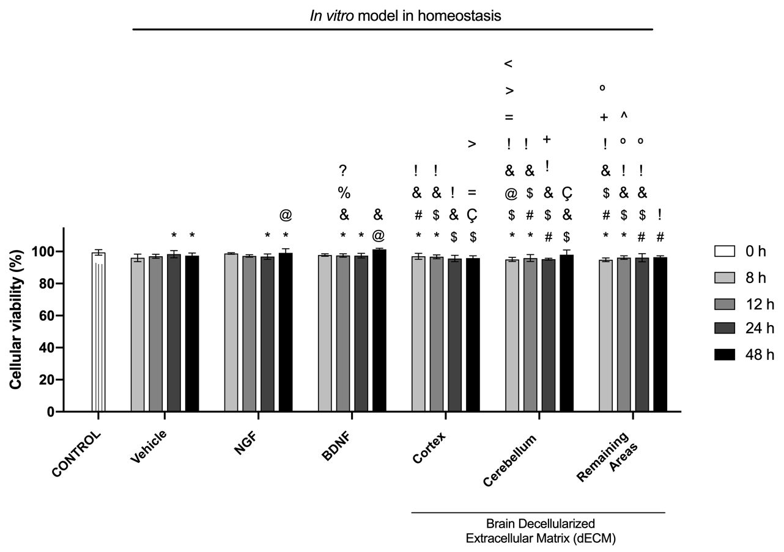

Supplementary Figure 1. Viability test for normoxia conditions after 6 hours of insult (OGD). Percentage of cell viability before (Control) and after 6 h of hypoxic conditions (OGD, 0h), as well as with the recovery treatments (i.e., Vehicle, NGF, BDNF, and decellularized ECM from Cortex, Cerebellum and Remaining Areas) monitored at 0, 8, 12, 24 and 48 hours. Results were expressed as Mean $±$ SD (n=9). * refers to a statistically p-value below 0.05 versus vehicle (24- 48 h), NGF (24-48 h), BDNF (8-12 h), and Cortex, Cerebellum, Remaining Area during 0-8 h. @ refers to a statistically p-value below 0.05 versus NGF (48 h), BDNF (48 h), and Cerebellum ( 0 h). ); # refers to a statistically significant p-value below 0.05 versus cortex ( 0 h), Cerebellum ( 8-12 h) and Remaining areas ( 24-48 h). $ refers to a statistically significant p-value below 0.05 versus Cortex, Cerebellum, Remaining Area (12-48 h); & refers to a statistically significant p-value below 0.05 versus BDNF ( 12,48 h) , Cortex, Cerebellum, Remaining Area (0-48 h); % refers to a statistically significant p-value below 0.05 versus BDNF (8h); ? refers to a statistically significant p-value below 0.05 versus BDNF (48h); ! refers to a statistically significant p-value below 0.05 versus cortex ECM (8h); Ç refers to a statistically significant p-value below 0.05 versus cortex ECM (12h); + refers to a statistically significant p-value below 0.05 versus, Cerebellum and Remaining Areas ECM (0-24h); = refers to a statistically significant p-value below 0.05 versus cortex ECM (48h); > refers to a statistically significant p-value below 0.05 versus cerebellum ECM (12h); < refers to a statistically significant p-value below 0.05 versus cerebellum ECM (24h); > refers to a statistically significant p-value below 0.05 versus cortex ECM (24h); º refers to a statistically significant p-value below 0.05 versus cerebellum ECM (0-12h) and ^ refers to a statistically significant p-value below 0.05 versus remaining areas ECM (8h).

