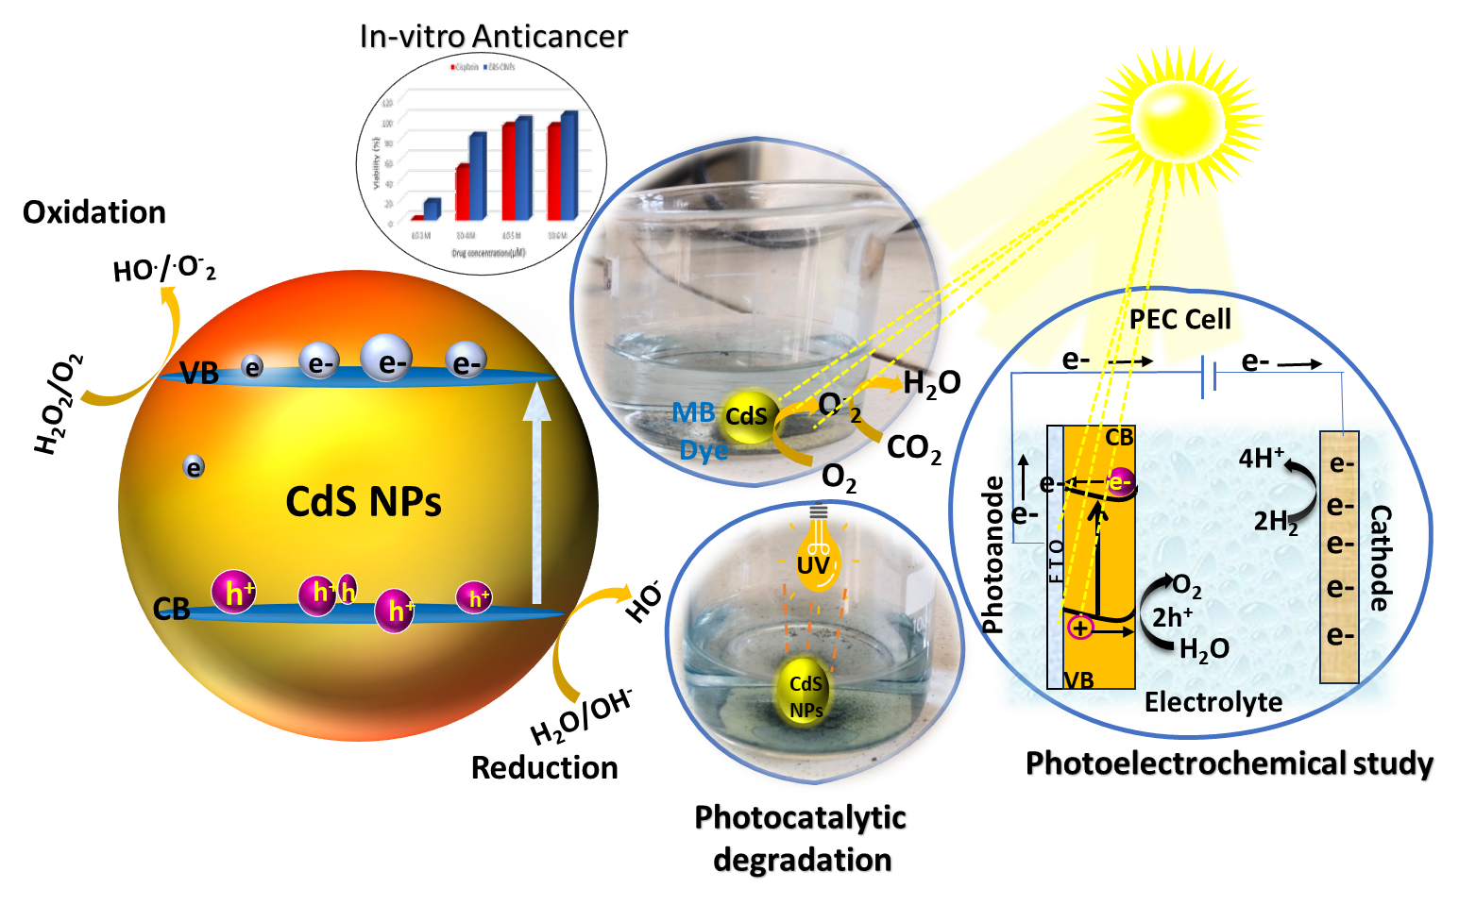
Graphical abstract of green synthesis of CdS Nanoparticle for multifunctional photocatalyst for photoelectrochemical and biomedical applications

