Supplementary Information

Interplay of In-O bond activation and stabilization for CO₂ hydrogenation to methanol
Fengwang Zhao^{a,}＃, Ting Zeng^{b,＃}, Xiaoli Yang^{a,*}, Qi Wang^{b}, Yang Zhao^{c}, Jing Zhou^{d}, Xiaofeng Yang^{c}, Chunfu Linª, Haoxi Benª, Nianxue Zhaiª, Youzhu Yuan^{e}, Xingyun Li^{a,*}, Xiang-Kui Gu^{b,*}, Yanqiang Huang^{c,*}, Xiu Song Zhaoª

ªInstitute of Materials for Energy and Environment, State Key Laboratory of BioFibers and Eco-textiles, College of Materials Science and Engineering, Qingdao University, Qingdao 266071, China
^{b}School of Power and Mechanical Engineering, Wuhan University, Wuhan 430000, China
^{c}State Key Laboratory of Catalysis, Dalian Institute of Chemical Physics, Chinese Academy of Sciences, Dalian 116023, China
^{d}Zhejiang Institute of Photoelectronics & Zhejiang Institute for Advanced Light Source, Zhejiang Normal University, Jinhua 321004, China
^{e}State Key Laboratory of Physical Chemistry of Solid Surfaces, National Engineering Laboratory for Green Chemical Production of Alcohols-Ethers-Esters, Collaborative Innovation Center of Chemistry for Energy Materials (iChEM), College of Chemistry and Chemical Engineering, Xiamen University, Xiamen 361000, China.
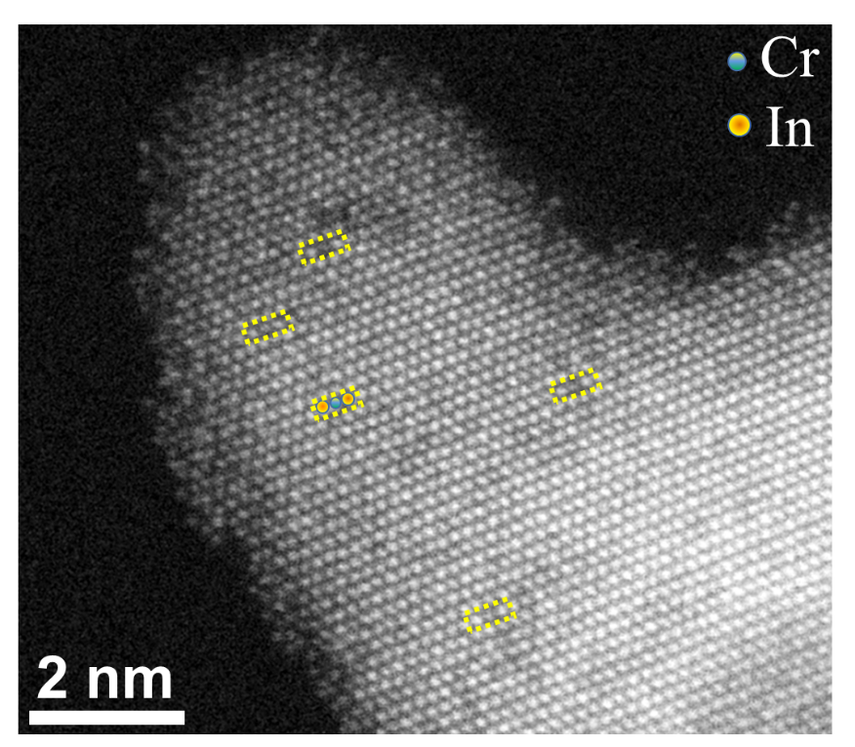
Supplementary Figure 1. HAADF-STEM image of 2% Cr-In₂O₃.

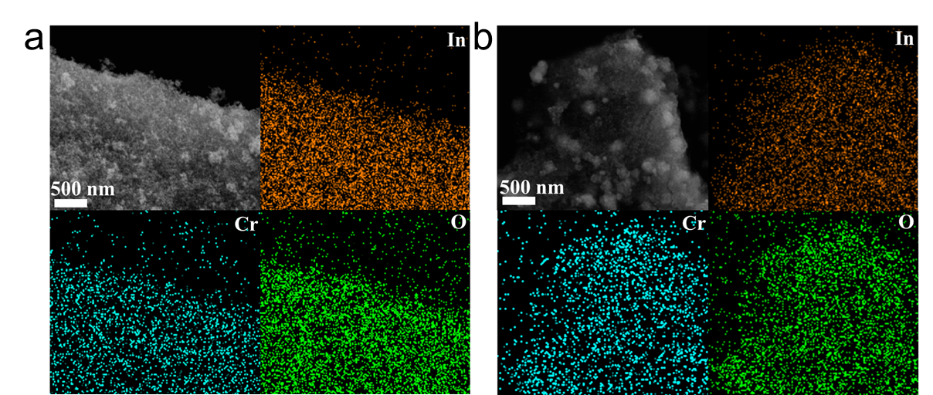
Supplementary Figure 2. SEM and EDS elemental mapping of (a) 1% Cr-In₂O₃ and (b) 5% Cr-In₂O₃.

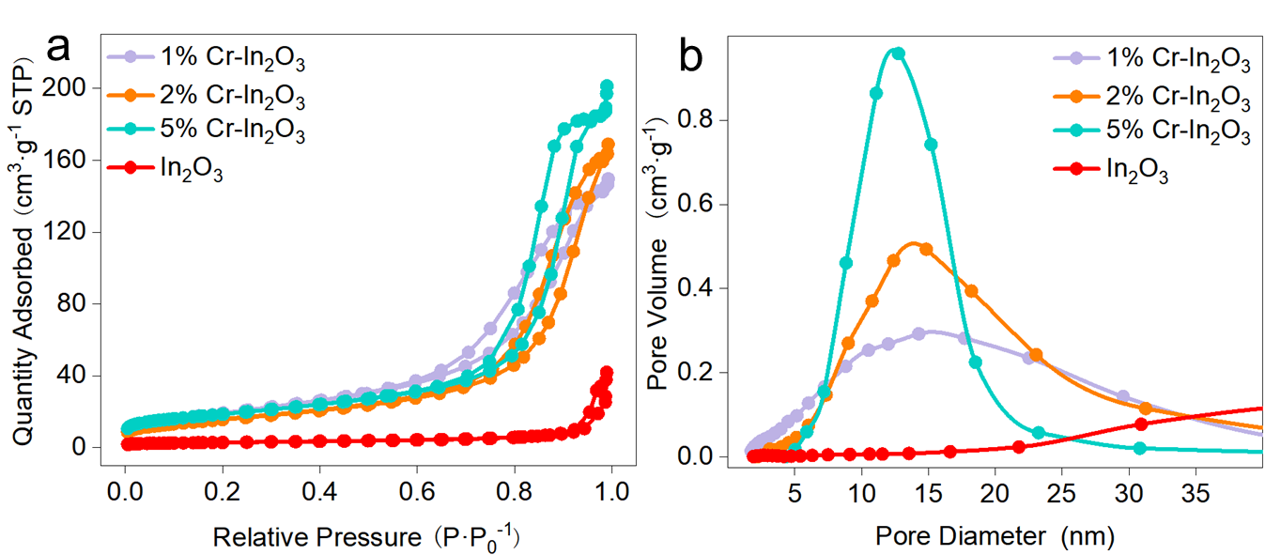
Supplementary Figure 3. (a) N₂ adsorption-desorption isotherms and (b) BJH pore size distribution curves of In₂O₃ and Cr-In₂O₃ samples with different Cr contents.

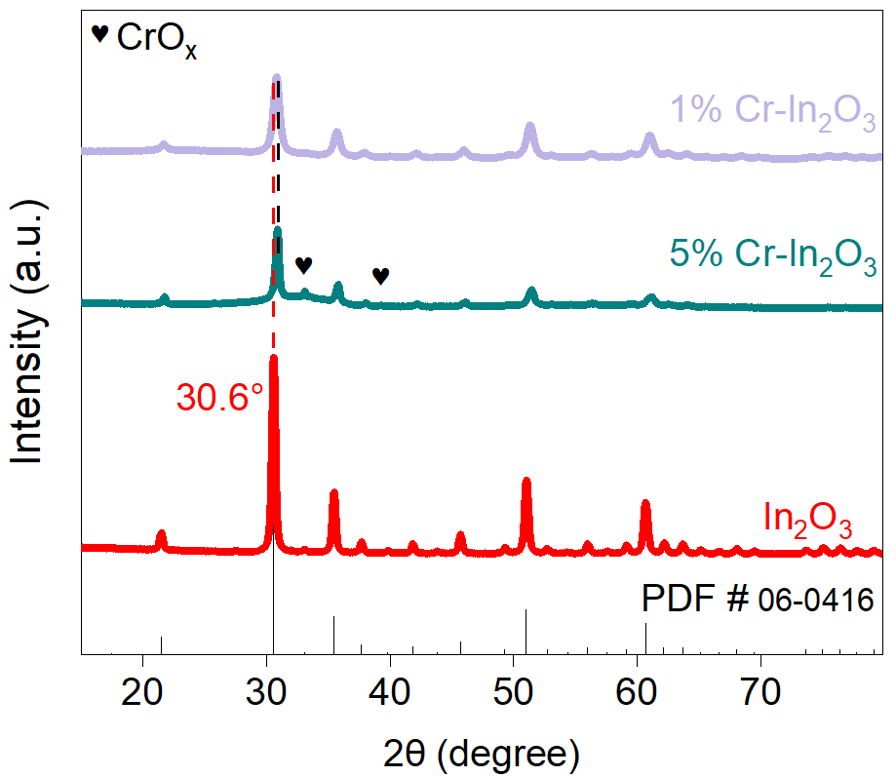
Supplementary Figure 4. XRD patterns for the 1% Cr-In₂O₃, 5% Cr-In₂O₃ and In₂O₃.
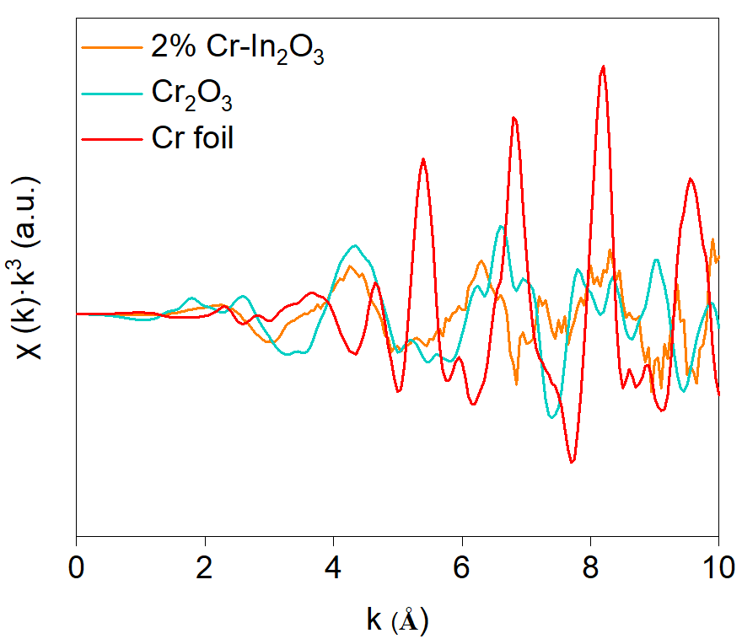
Supplementary Figure 5. Cr K-edge EXAFS spectra in K space for Cr-doped samples.

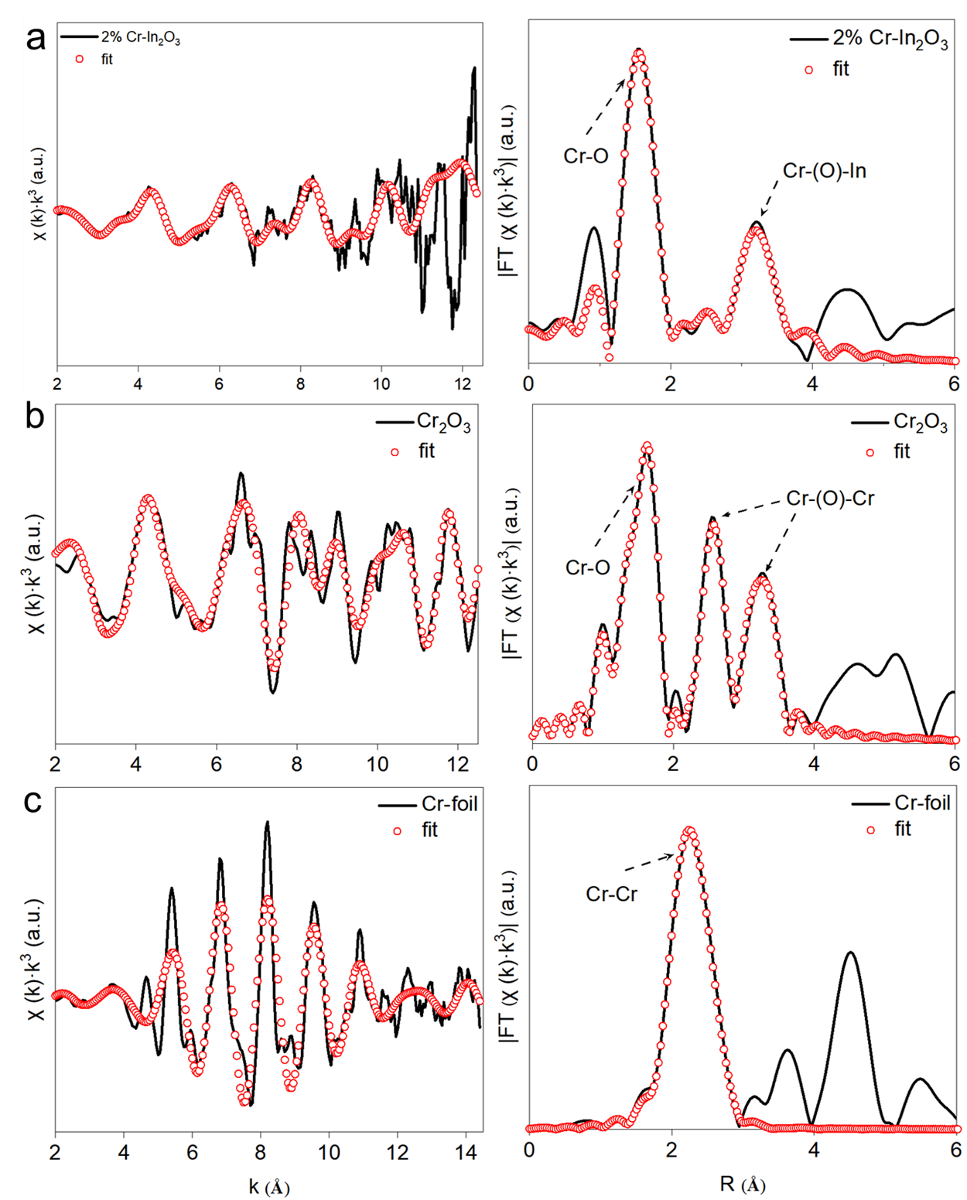
Supplementary Figure 6. Comparison of Cr K edge EXAFS spectral data and fitting data of (a) 2% Cr- In₂O₃, (b) Cr₂O₃, (c) Cr foil in K space and R space, respectively.
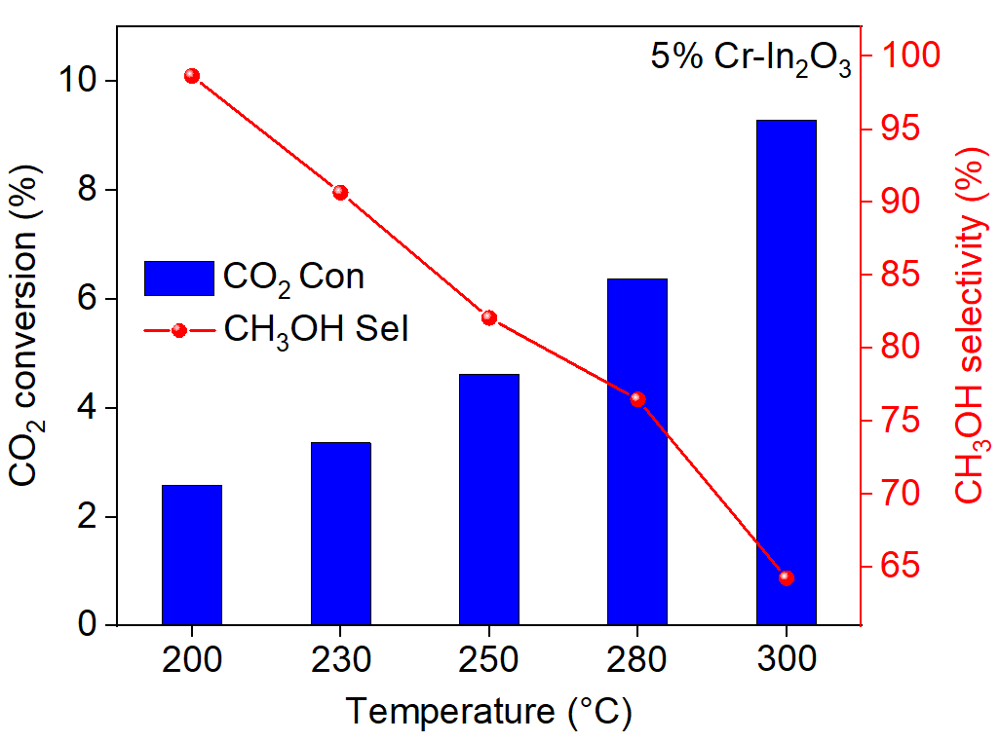
Supplementary Figure 7. Catalytic performance of 5% Cr-In₂O₃, P = 5 MPa, CO₂/H₂ = 1/3, and WHSV = 3000 mL·g_{cat}⁻¹·h⁻¹.
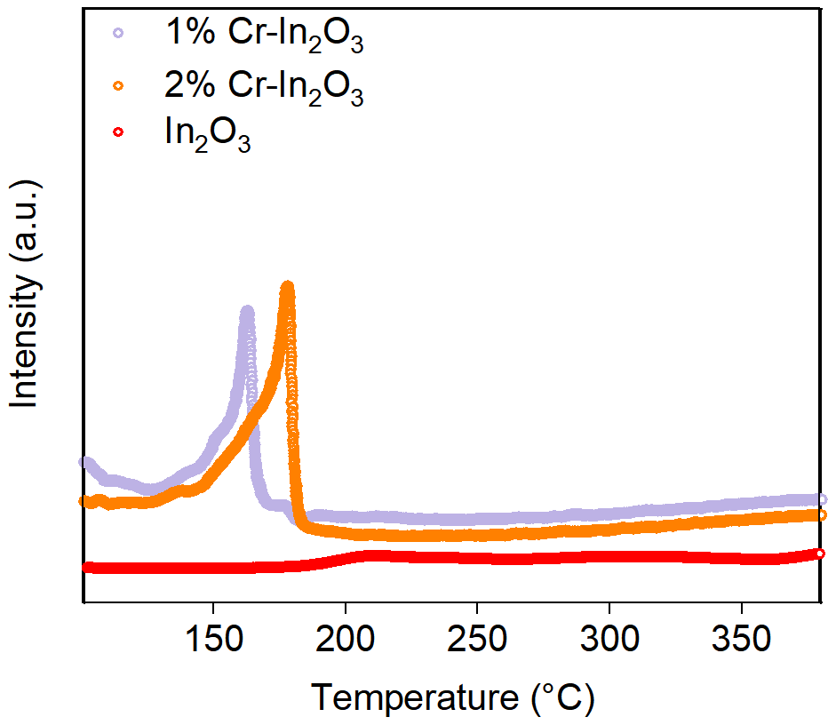
Supplementary Figure 8. H₂-TPR profiles of In₂O₃ and Cr-In₂O₃ samples.

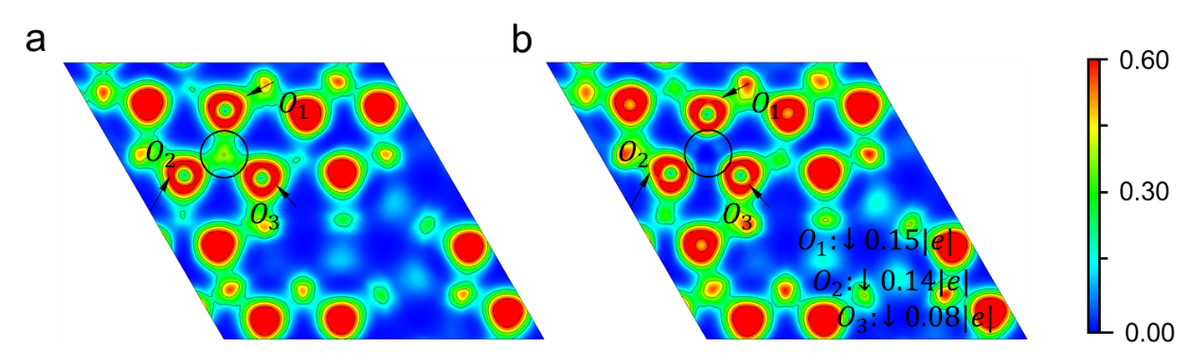
Supplementary Figure 9. The Electron Localization Function (ELF) contours and bader charge analysis for oxygen atoms in region I of Initial-In₂O₃ (111) (a) and Initial-Cr-In₂O₃ (111) (b). The number in the color bar represents the degree of electron localization in atomic units (a.u.).
Note: After Cr doping, the green area in the circle becomes more delocalized, specifically, around the In atom for Initial-In₂O₃ (111) and the Cr atom for Initial-Cr-In₂O₃ (111). This delocalization corresponds to a decrease in the charge of these oxygen atoms.

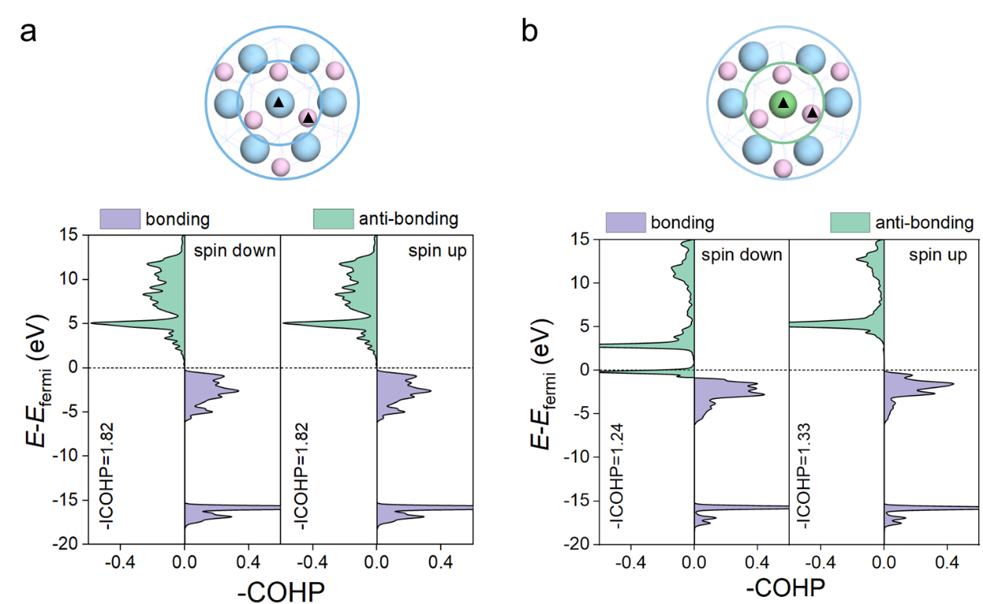
Supplementary Figure 10. The Crystal Orbital Hamilton population (COHP) and the Integrated values (-ICOHP) of the O-In bond for Initial-In₂O₃ (111) (a), and O-Cr bond for Initial-Cr-In₂O₃ (111) (b) in region I, respectively. Considering that the three oxygen atoms in region I are equivalent, for simplicity in explanation, we selected only one of the oxygen atoms as a representative, indicated by the triangles in local structures for the COHP analysis.

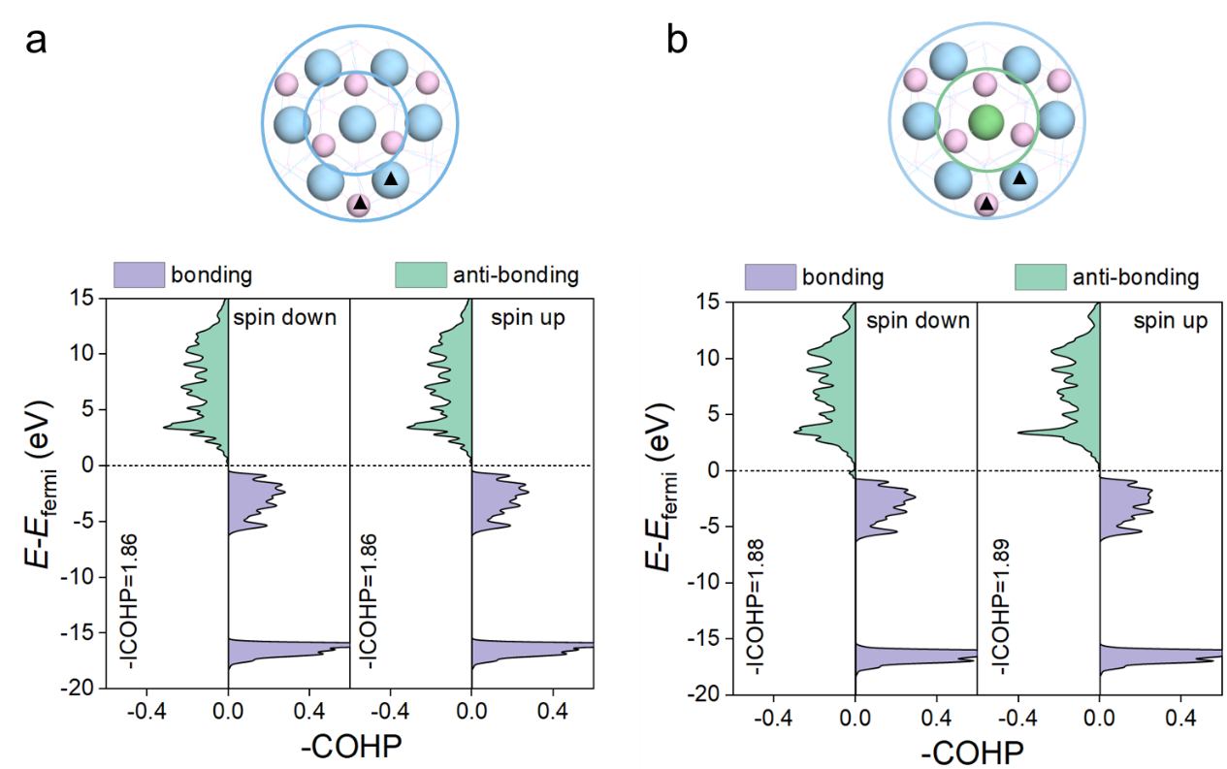
Supplementary Figure 11. The COHP analysis and -ICOHP of O-In bond for (a) Initial-In₂O₃ (111), and O-Cr bond for (b) Initial-Cr-In₂O₃ (111) in region II, respectively. Considering that the three oxygen atoms in region II are equivalent, for simplicity in explanation, we selected only one of the oxygen atoms as a representative, indicated by the triangles in local structures for the COHP analysis.

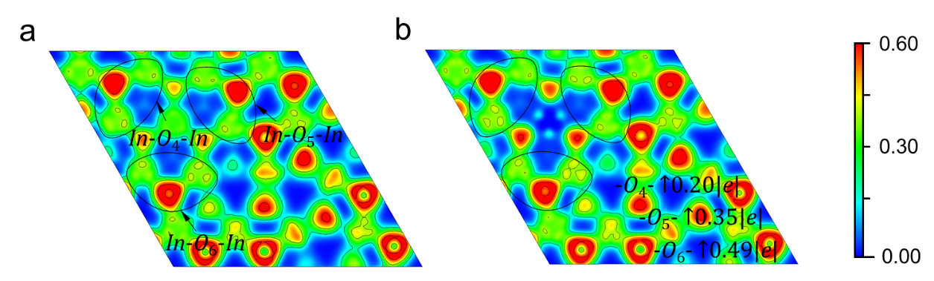
Supplementary Figure 12. The ELF contours and bader charge analysis for oxygen atoms in region II for (a) Initial-In₂O₃ (111) and (b) Initial-Cr-In₂O₃ (111), respectively. The number beside the color bar represents the degree of electron localization in atomic units (a.u.).
Note: As shown by contours in region II, after Cr doping, the electron localization degree of In atoms was enhanced and the electron density of the In-O-In pair was also increased, which shows stronger electron donating capability of In atoms during the bonding process with oxygen atoms. This is consistent with the conclusion of the COHP analysis in Supplementary Figure 11 that the In-O-In bonds are strengthened.

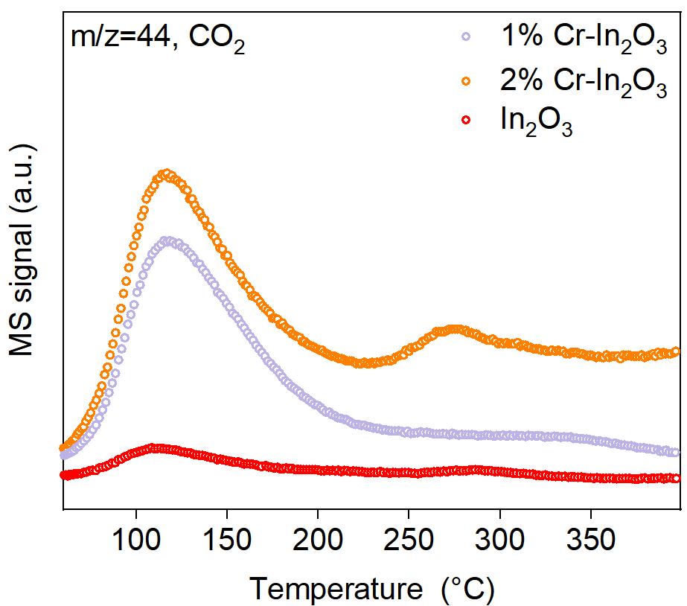
Supplementary Figure 13. CO₂-TPD profiles of In₂O₃ and Cr-In₂O₃ samples.

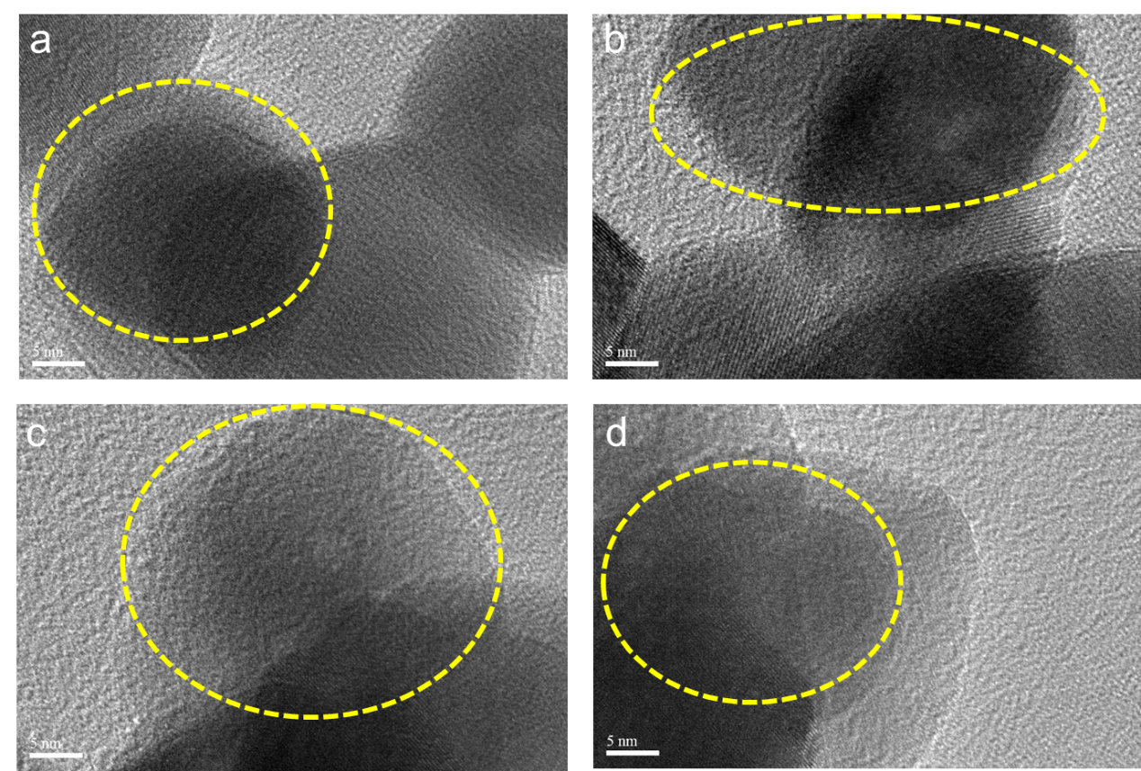
Supplementary Figure 14. TEM image of In₂O₃ after 300 h stability test.
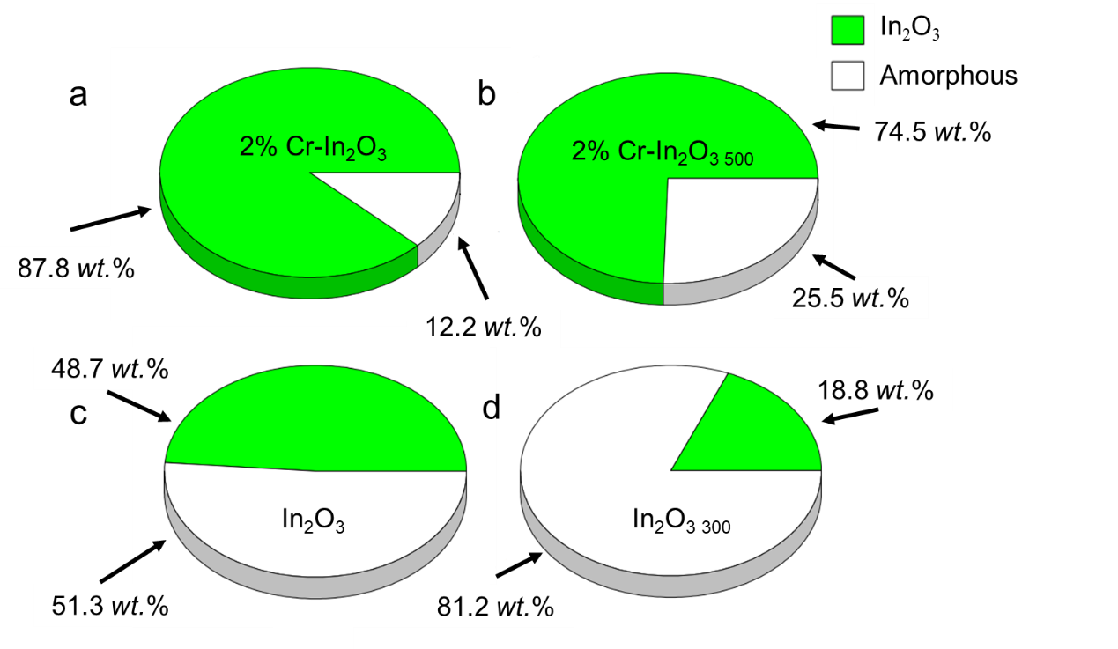
Supplementary Figure 15. The crystallinity of the sample calculated by the XRD Rietveld method.

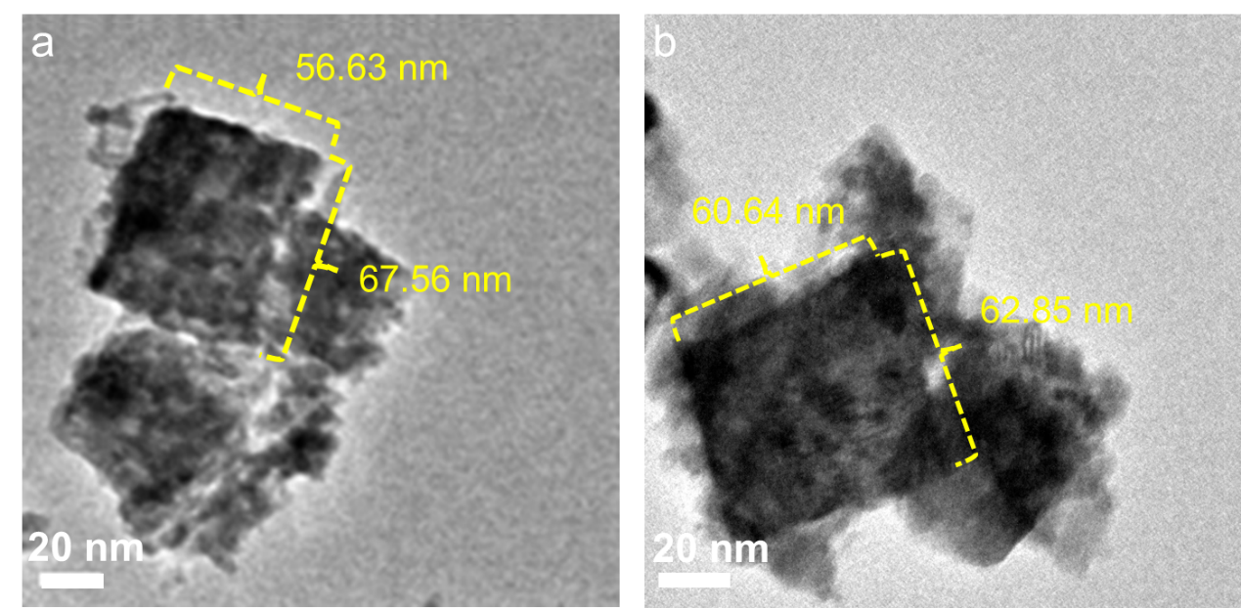
Supplementary Figure 16. TEM image of (a) fresh 2% Cr-In₂O_{3,} (b) 2% Cr-In₂O₃ after 500 h stability test.
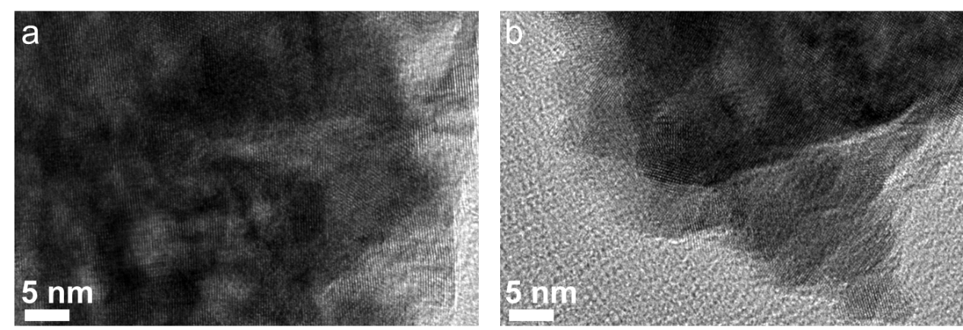
Supplementary Figure 17. HRTEM image of (a) fresh 2% Cr-In₂O_{3,} (b) 2% Cr-In₂O₃ after 500 h stability test.

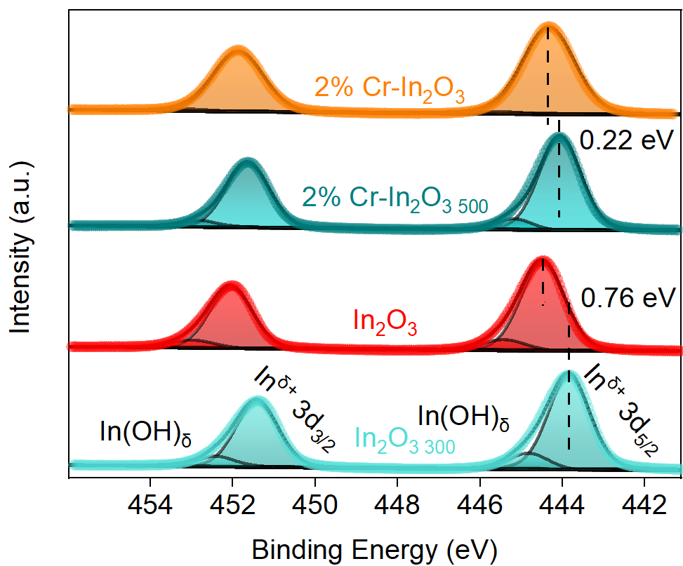
Supplementary Figure 18. In 3d XPS spectra of the fresh 2% Cr-In₂O₃, In₂O₃ and catalysts after stability test.

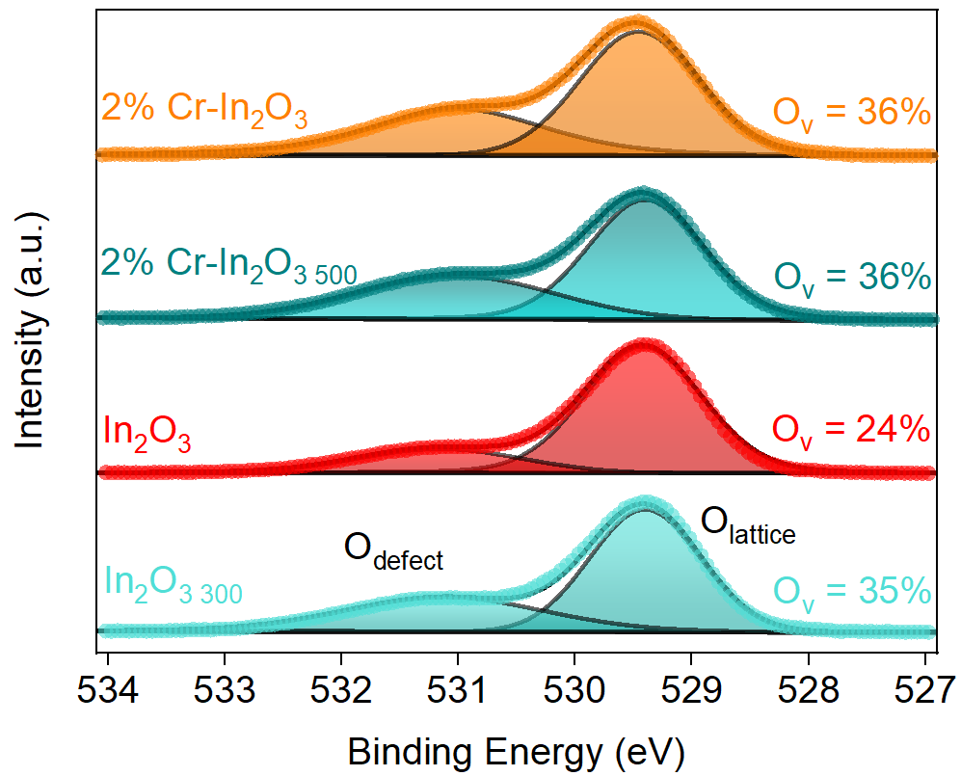
Supplementary Figure 19. O 1s XPS spectra of the fresh 2% Cr-In₂O₃, In₂O₃ and catalysts after stability test.

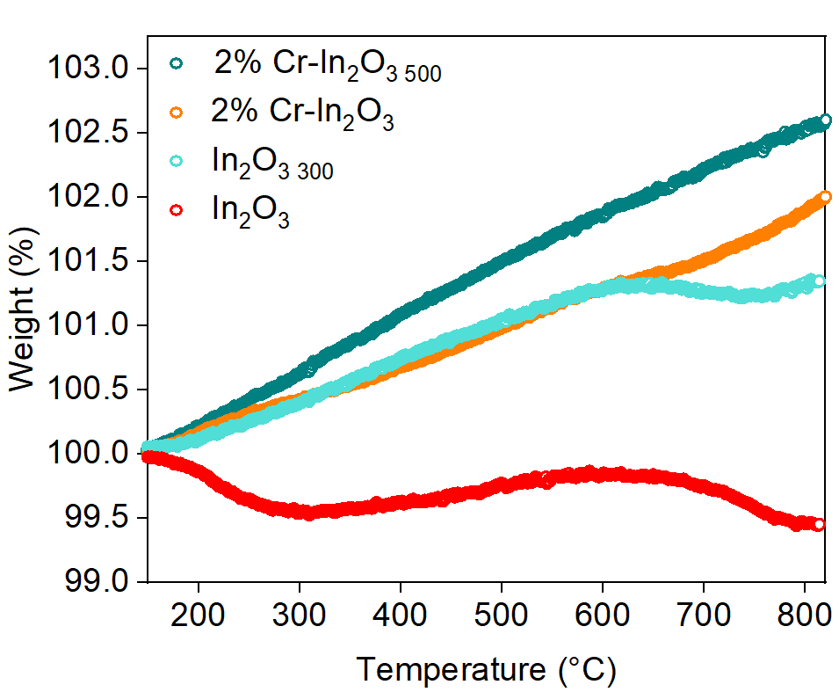
Supplementary Figure 20. TG of fresh and stability-tested 2% Cr-In₂O₃ and In₂O₃.

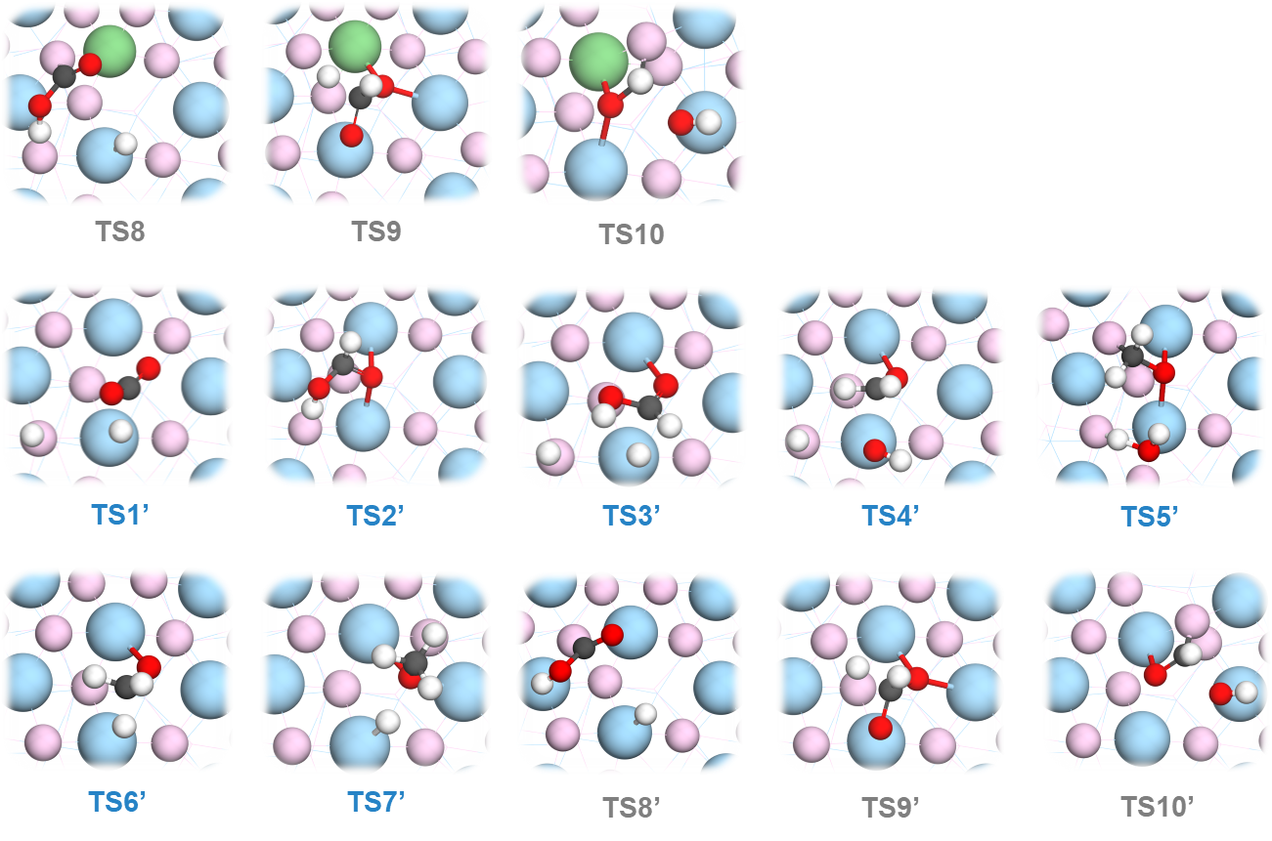

Supplementary Figure 21. Optimized transient states of the elementary steps involved in CO₂ hydrogenation to methanol on Cr-In₂O₃ (111) and In₂O₃ (111) surface. Chromium (green), Oxygen (red and pink), Indium (blue), Carbon (black) and Hydrogen (white).

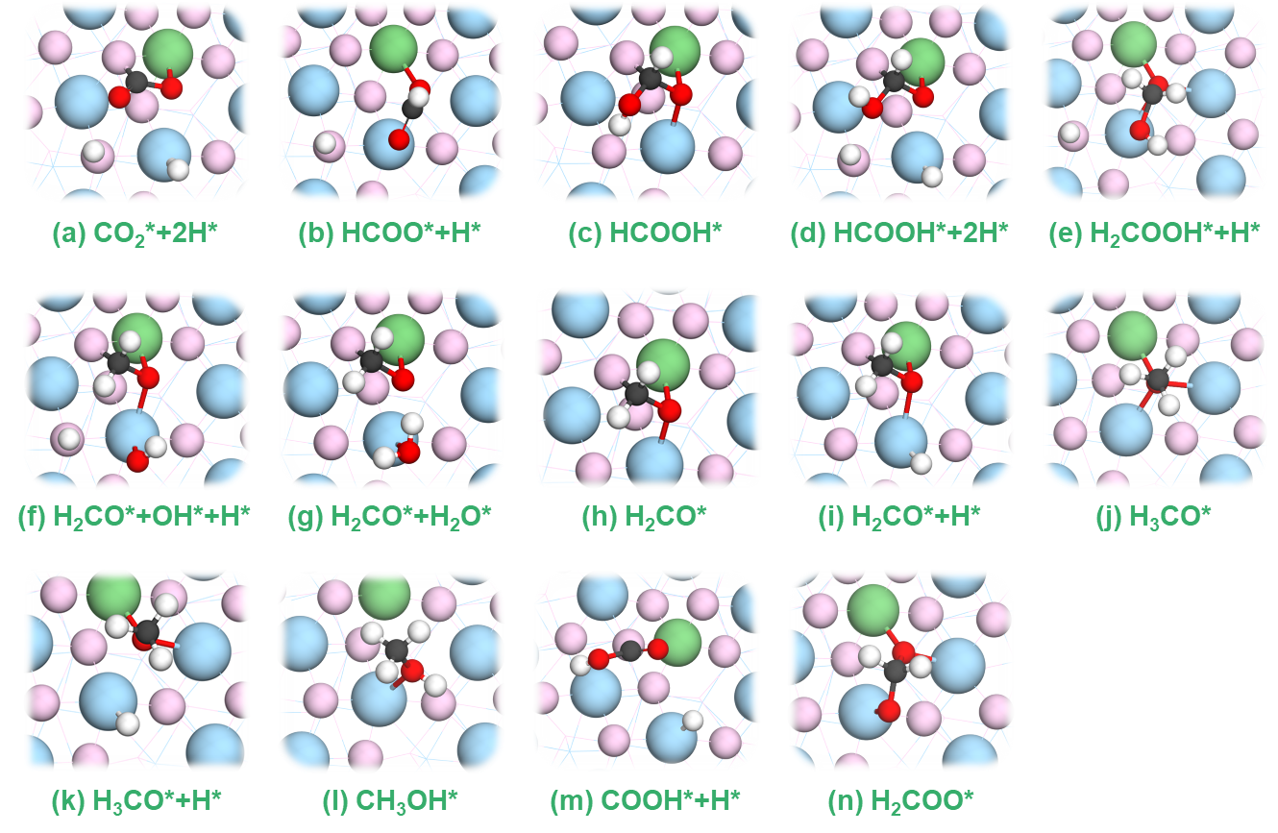
Supplementary Figure 22. Optimized intermediate structures involved in CO₂ hydrogenation to methanol on Cr-In₂O₃ (111) surface. Chromium (green), Oxygen (red and pink), Indium (blue), Carbon (black) and Hydrogen (white).

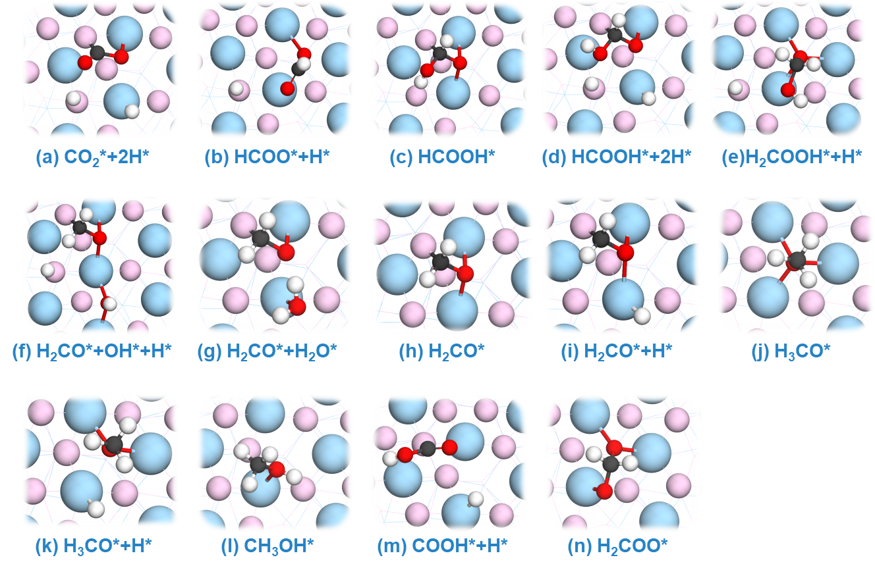
Supplementary Figure 23. Optimized intermediates structures involved in CO₂ hydrogenation to methanol on In₂O₃ (111) surface. Oxygen (red and pink), Indium (blue), Carbon (black) and Hydrogen (white).

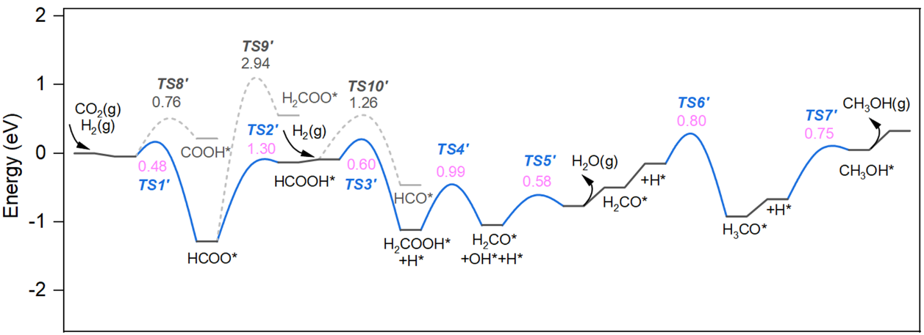
Supplementary Figure 24. Free energy diagram of the hydrogenation of CO₂ to methanol on In₂O₃ (111) at 523 K and 5 MPa.

Supplementary Table 1. Cr content, specific surface area and total pore volume of Cr-In₂O₃ samples
Catalysts | Cr content  (wt.%)ª | S_{BET} (m²·g⁻¹)^{b} | V_{pore} (10⁻² cm³·g⁻¹)^{c}
1% Cr-In₂O₃ | 1.23 | 69.9 | 22.6
2% Cr-In₂O₃ | 2.04 | 56.2 | 25.2
5% Cr-In₂O₃ | 4.76 | 65.9 | 29.2
In₂O₃ | - | 10.1 | 4.42
ªCr content determined by ICP-AES.
^{b}Specific surface area calculated by the BET method.
^{c}Total pore volume determined at P/P₀ = 0.99.

Supplementary Table 2. EXAFS fitting parameters at the Cr K-edge for various samples. (Ѕ₀²=0.724)
Sample | Shell | CNª | R (Å)^{b} | σ² (Å²)^{c} | ΔE₀ (eV)^{d} | R factor
Cr foil | Cr-Cr | 8* | 2.495±0.007 | 0.0055±0.0009 | 5.2±1.2 | 0.0020
Cr foil | Cr-Cr | 6* | 2.876±0.006 | 0.0048±0.0012 | 5.2±1.2 | 0.0020
Cr₂O₃ | Cr-O | 6.0±0.7 | 1.995±0.009 | 0.0049±0.0010 | 3.4±1.7 | 0.0191
Cr₂O₃ | Cr-O-Cr | 4.1±0.4 | 2.897±0.012 | 0.0116±0.0010 | -2.6±3.1 | 0.0191
Cr₂O₃ | Cr-O-Cr | 3.2±0.3 | 3.472±0.034 | 0.0116±0.0010 | 1.0±2.3 | 0.0191
2% Cr-In₂O₃ | Cr-O | 3.7±0.3 | 1.983±0.004 | 0.0018±0.0008 | 2.1±0.9 | 0.0067
2% Cr-In₂O₃ | Cr-O-In | 5.9±0.4 | 3.603±0.011 | 0.0071±0.0021 | -10.1±1.4 | 0.0067
ªCN: coordination number.
^{b}R: the distance to the neighboring atom.
^{c}σ²: the Mean Square Relative Displacement (MSRD).
^{d}ΔE₀: inner potential correction, R factor indicates the goodness of the fit. S₀² was fixed to 0.724, according to the experimental EXAFS fit of Cr foil by fixing CN as the known crystallographic value.
*This value was fixed during EXAFS fitting, based on the known structure of Cr. Fitting range: 3.0 ≤ k (Å) ≤ 12.5 and 1.0 ≤ R (Å) ≤ 3.0 (Cr foil), 2.0 ≤ k (Å) ≤ 10.5 and 1.0 ≤ R (Å) ≤ 4.0 (2% Cr-In₂O₃). A reasonable range of EXAFS fitting parameters: 0.700 < Ѕ₀²< 1.000, CN > 0; σ² > 0 Å2, |ΔE₀| < 10 eV, R factor < 0.02.

Catalysts | P  [MPa] | T  [℃] | WHSV  [mL·g_{cat}⁻¹·h⁻¹] | X_{CO2}ª  [%] | S_{MeOH}^{b}  [%] | H₂/CO₂ | Ref.
ZnZrO_{x} | 5 | 250 | 24000 | 0.8 | 88.2 | 4 | 1
NiO-In₂O₃ | 3 | 250 | 60000 | 2.8 | 53.1 | 3 | 2
Ni/In₂O₃ | 5 | 250 | 21000 | 5.4 | 85.0 | 4 | 3
Ni/In₂O₃ | 5 | 280 | 24000 | 8.1 | 71.9 | 4 | 4
Ir-In₂O₃ | 5 | 250 | 21000 | 6.2 | 89.3 | 4 | 5
In₂O₃ | 5 | 250 | 21000 | 2.2 | 83.6 | 4 | 5
Au-In₂O₃ | 5 | 250 | 21000 | 3.9 | 83.8 | 4 | 6
Ag-In₂O₃ | 5 | 250 | 21000 | 2.9 | 73.9 | 4 | 7
Pt-In₂O₃ | 5 | 250 | 21000 | 6.8 | 83.0 | 4 | 8
In₂O₃/m-ZrO₂ | 5 | 280 | 24000 | 4.8 | 84 | 4 | 9
In₂O₃/t-ZrO₂ | 5 | 280 | 24000 | 0.5 | 83 | 4 | 9
Cu/m-ZrO₂ | 5 | 250 | 7200 | 3.5 | 50 | 4 | 10
ZnO-ZrO₂ | 5 | 250 | 24000 | 1.6 | 98.22 | 4 | 11
CuO/ZnO | 5 | 250 | - | 11.7 | 36.1 | 3 | 12
Co₃O₄-In₂O₃ | 5 | 250 | 7500 | 6.2 | 92 | 3 | 13
Co₃O₄-In₂O₃ | 5 | 250 | 7500 | 4.2 | 90 | 3 | 13
Pd_{0.1}Zn₁/CNTs | 5 | 250 | 1800 | 6.22 | 95.2 | 3 | 14
PdZn/ZnO/SiO₂ | 5 | 260 | 30000 | 3.6 | 49.8 | 3 | 15
2Pd-ZnO | 5 | 260 | 120000 | 2.8 | 66.5 | 3 | 15
N-In₂O₃ | 5 | 250 | 21000 | 1.1 | 80.6 | 4 | 16
Cr-In₂O₃ | 5 | 250 | 3000 | 9.4 | 92 | 3 | This work
In₂O₃ | 5 | 250 | 3000 | 2.2 | 56 | 3 | This work

Supplementary Table 3. Comparison of catalytic performance.
ªX_{CO2}: CO₂ conversion.
^{b}S_{MeOH}: methanol selectivity.

Supplementary Table 4. Structural information obtained from XRD Rietveld refinement of the fresh and used samples.
Samples | 2% Cr-In₂O₃ | 2% Cr-In₂O₃ ₅₀₀ | In₂O₃ | In₂O₃ ₃₀₀
Space group | I a -3 | I a -3 | I a -3 | I a -3
a(=b=c) (Å) | 10.08 (192) | 10.06 (214) | 10.08 (192) | 10.12 (162)
α(=β=γ) (°) | 90 | 90 | 90 | 90
Rwp | 4.59% | 5.42% | 7.17% | 4.05%
Rp | 3.37% | 3.38% | 4.97% | 2.77%
V(Å³) | 1028.33(5) | 1018.82(6) | 1026.44(5) | 1037.16(2)
Microstrain (%) | 0.238 | 0.221 | -0.097 | -0.027

Supplementary Table 5. The catalytic performance of CO hydrogenation for samples with different Cr contents.
Catalysts | Products | Conv. CO (%)ª
1% Cr-In₂O₃ | CO₂, CH₄ | 0.65
2% Cr-In₂O₃ | CO₂, CH₄ | 0.52
5% Cr-In₂O₃ | CO₂, CH₄ | 0.76
In₂O₃ | CO₂, CH₄ | 0.99
ªConv.CO represents the conversion of CO.
Reaction conditions: CO/H₂=1/1, T=250 ºC, P = 5 MPa, WHSV = 3000 mL·g_{cat}⁻¹·h⁻¹.

Supplementary Table 6. The coordinated-oxygen vacancy formation energy (eV) on experimentally observed surfaces.
In₂O₃ facets | Without Cr doping | With Cr doping
(111) | 2.17 | 2.03 (↓)
(211) | 2.10 | 2.34 (↑)
(100) | 3.20 | 3.79 (↑)

References
1 Lee, K. Y. H. et al. Atomic Pd-promoted ZnZrO_{x} solid solution catalyst for CO₂ hydrogenation to methanol. Applied Catalysis B: Environmental 304, 12 (2022).
2 Zhu, J. D. et al. Ni-In Synergy in CO₂ Hydrogenation to Methanol. ACS Catalysis 11, 11371-11384 (2021).
3 Jia, X. Y., Sun, K. H., Wang, J., Shen, C. Y. & Liu, C. J. Selective hydrogenation of CO₂ to methanol over Ni/In₂O₃ catalyst. Journal of Energy Chemistry 50, 409-415 (2020).
4 Frei, M. S. et al. Nanostructure of nickel-promoted indium oxide catalysts drives selectivity in CO₂ hydrogenation. Nature Communications 12, 9 (2021).
5 Shen, C. Y. et al. Highly Active Ir/In₂O₃ Catalysts for Selective Hydrogenation of CO₂ to Methanol: Experimental and Theoretical Studiese. ACS Catalysis 11, 4036-4046 (2021).
6 Rui, N. et al. Hydrogenation of CO₂ to Methanol on a Au^{δ+}-In₂O_{3-x} Catalyst. ACS Catalysis 10, 11307-11317 (2020).
7 Sun, K. H., Zhang, Z. T., Shen, C. Y., Rui, N. & Liu, C. J. The feasibility study of the indium oxide supported silver catalyst for selective hydrogenation of CO₂ to methanol. Green Energy Environ. 7, 807-817 (2022).
8 Sun, K. et al. A highly active Pt/In₂O₃ catalyst for CO₂ hydrogenation to methanol with enhanced stability. Green Chemistry 22, 5059-5066 (2020).
9 Frei, M. S. et al. Role of Zirconia in Indium Oxide-Catalyzed CO₂ Hydrogenation to Methanol. ACS Catalysis 10, 1133-1145 (2020).
10 Witoon, T., Chalorngtham, J., Dumrongbunditkul, P., Chareonpanich, M. & Limtrakul, J. CO₂ hydrogenation to methanol over Cu/ZrO₂ catalysts: Effects of zirconia phases. ‌Chemical Engineering Journal 293, 327-336 (2016).
11 Wang, J. J. et al. A highly selective and stable ZnO-ZrO₂ solid solution catalyst for CO₂ hydrogenation to methanol. Science Advances 3, 10 (2017).
12 Fujitani, T. et al. Development of an active Ga₂O₃ supported palladium catalyst for the synthesis of methanol from carbon dioxide and hydrogen. Applied Catalysis A: General 125, 199-202 (1995).
13 Zhang, H., Mao, D. L., Zhang, J. X. & Wu, D. F. Regulating the crystal structure of layered double hydroxide-derived Co-In catalysts for highly selective CO₂ hydrogenation to methanol. ‌Chemical Engineering Journal 452, 11 (2023).
14 Liang, X. L., Xie, J. R. & Liu, Z. M. A Novel Pd-decorated Carbon Nanotubes-promoted Pd-ZnO Catalyst for CO₂ Hydrogenation to Methanol. Catalysis Letters 145, 1138-1147 (2015).
15 Zabilskiy, M. et al. Mechanistic Study of Carbon Dioxide Hydrogenation over Pd/ZnO-Based Catalysts: The Role of Palladium-Zinc Alloy in Selective Methanol Synthesis. Angewandte Chemie International Edition 60, 17053-17059 (2021).
16 Yang, Y., Shen, C., Sun, K., Mei, D. & Liu, C.-j. Enhanced Surface Charge Localization Over Nitrogen-Doped In₂O₃ for CO₂ Hydrogenation to Methanol with Improved Stability. ACS Catalysis 13, 6154-6168 (2023).

＃These authors contribute equally to this manuscript. *Corresponding authors: xlyang@qdu.edu.cn (X. Yang), xingyun_2008@sina.cn (X. Li), xiangkuigu@whu.edu.cn (X. Gu), yqhuang@dicp.ac.cn (Y. Huang)

