All original, full-length gel and blot images
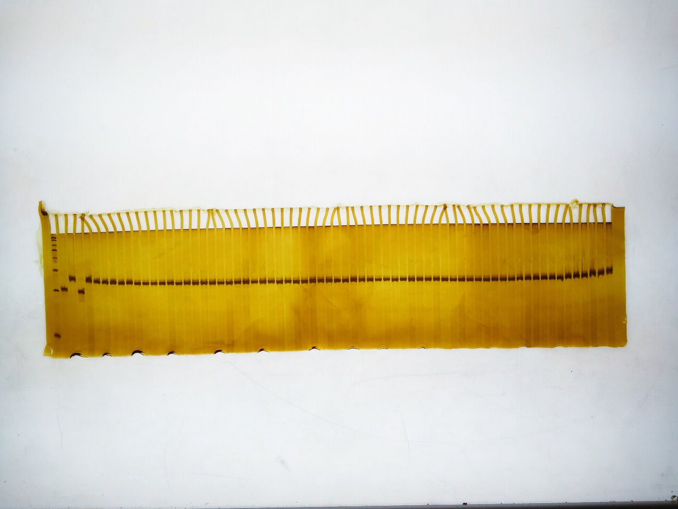
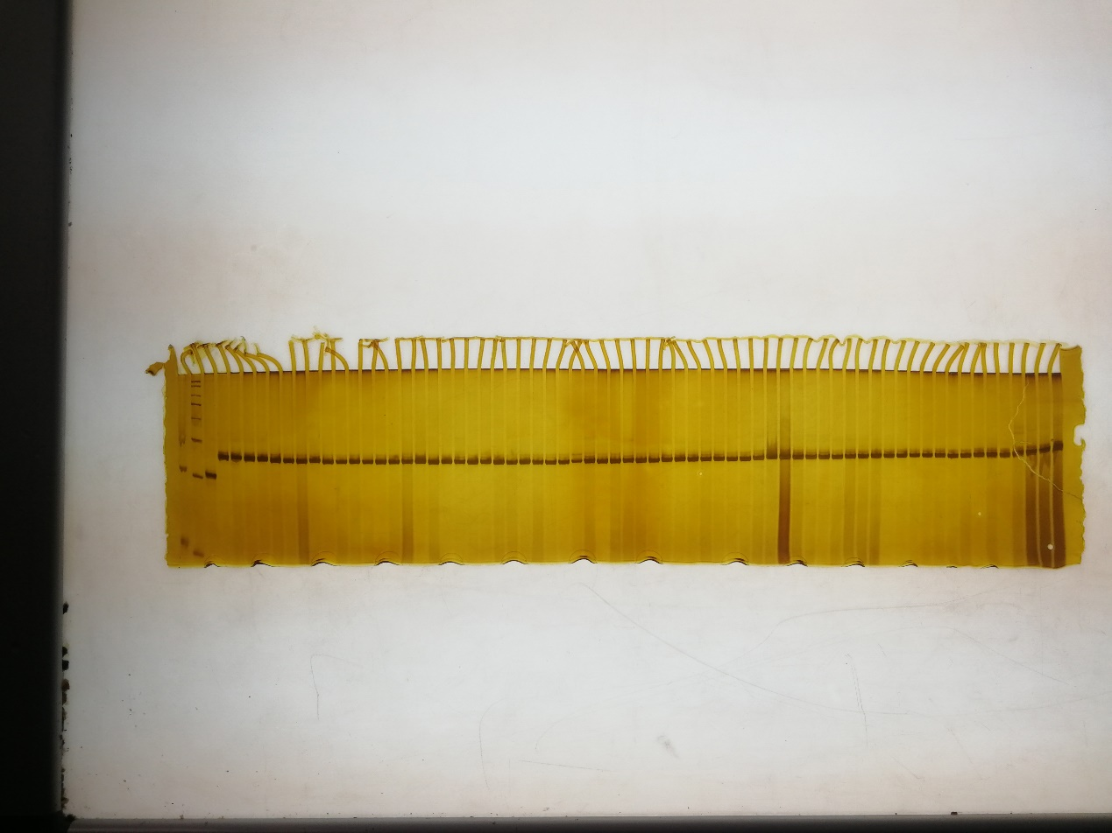
Fig. 6 Amplicons of the co-dominant marker CMLMI1 in parents and 118 different cabbage inbred lines and ornamental kale inbred lines 2523.

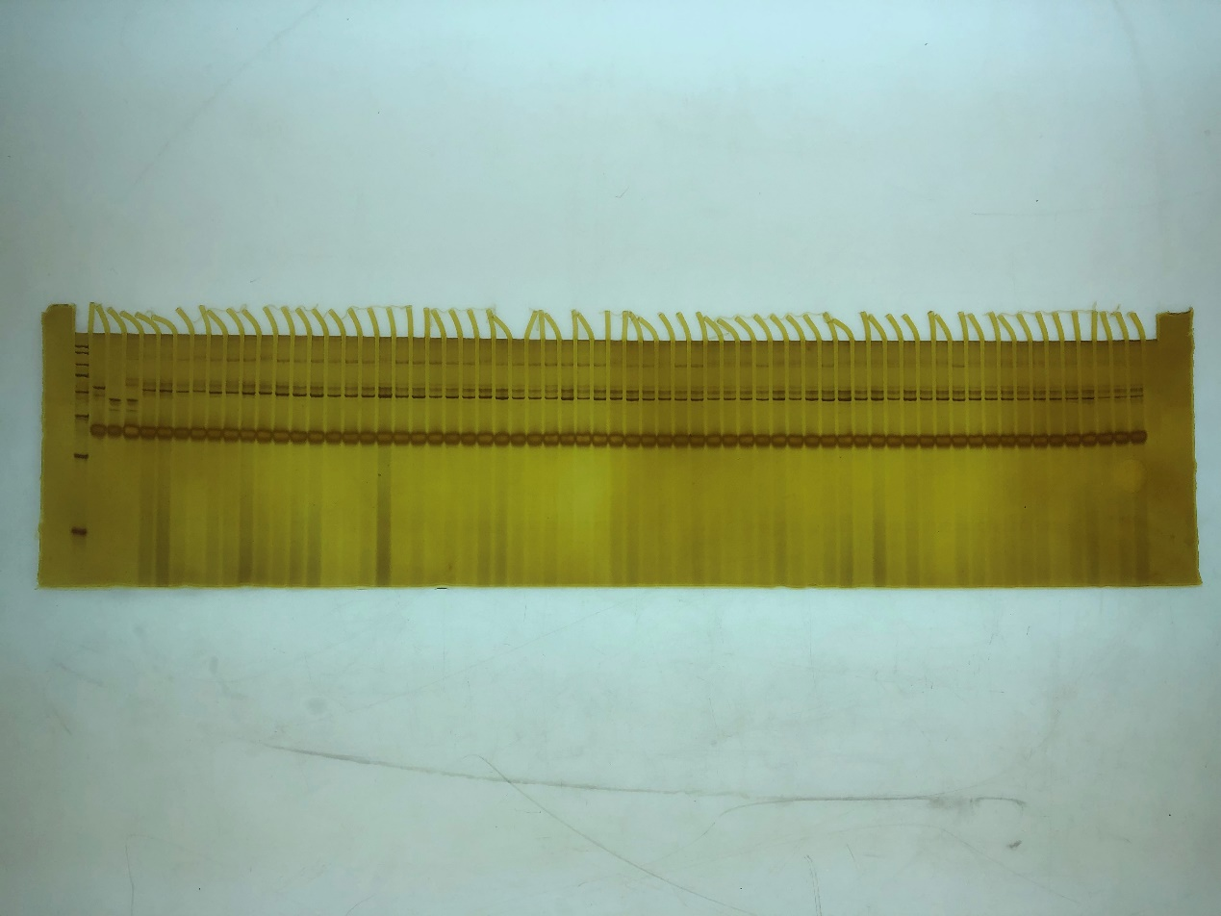
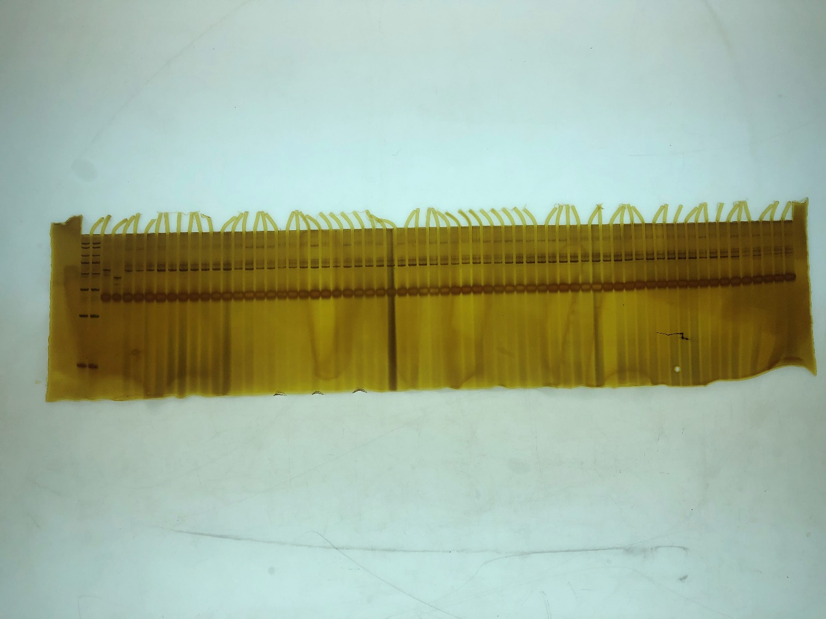
Figure S1. Amplicons of the dCAPS marker DMLMI1 in parents and 118 different cabbage inbred lines and ornamental kale inbred lines 2523.

