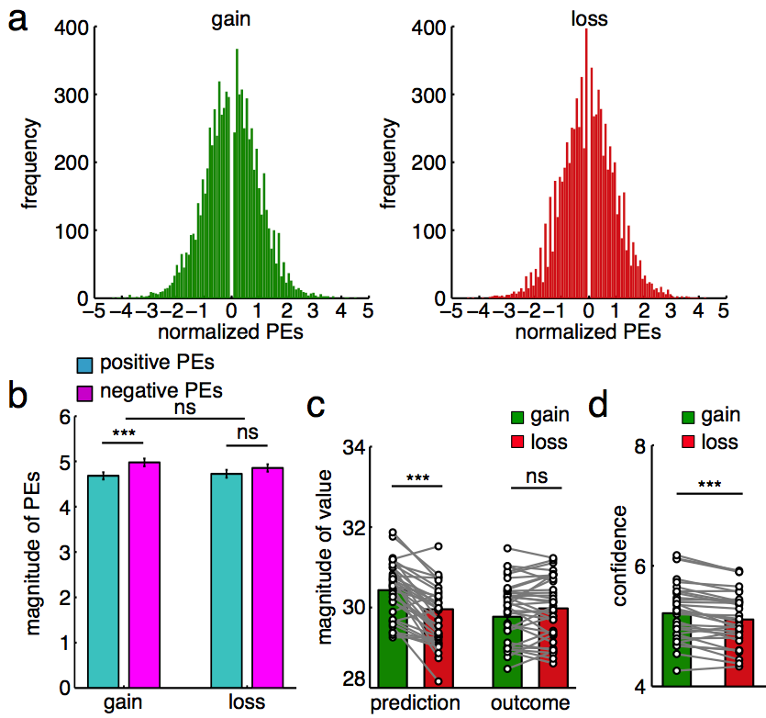

Supplementary Figure 1. Valence-related predictions.

- The distributions of PEs in the gain and loss conditions, respectively. To show the symmetry between the positive and negative PEs, the PE values equal to zero was omitted.
- The magnitudes of the negative PEs were larger than those of the positive PEs in the gain condition, but not in the loss condition. There were also no significant differences between the two conditions.
- The magnitudes of predictions in the gain condition were larger than those in the loss condition, whereas no outcome differences between the two conditions.
- The reported confidence was reliably larger in the gain condition than in the loss condition.
ns, no significance, ***P < 0.001. Error bars indicate s.e.m. across participants.
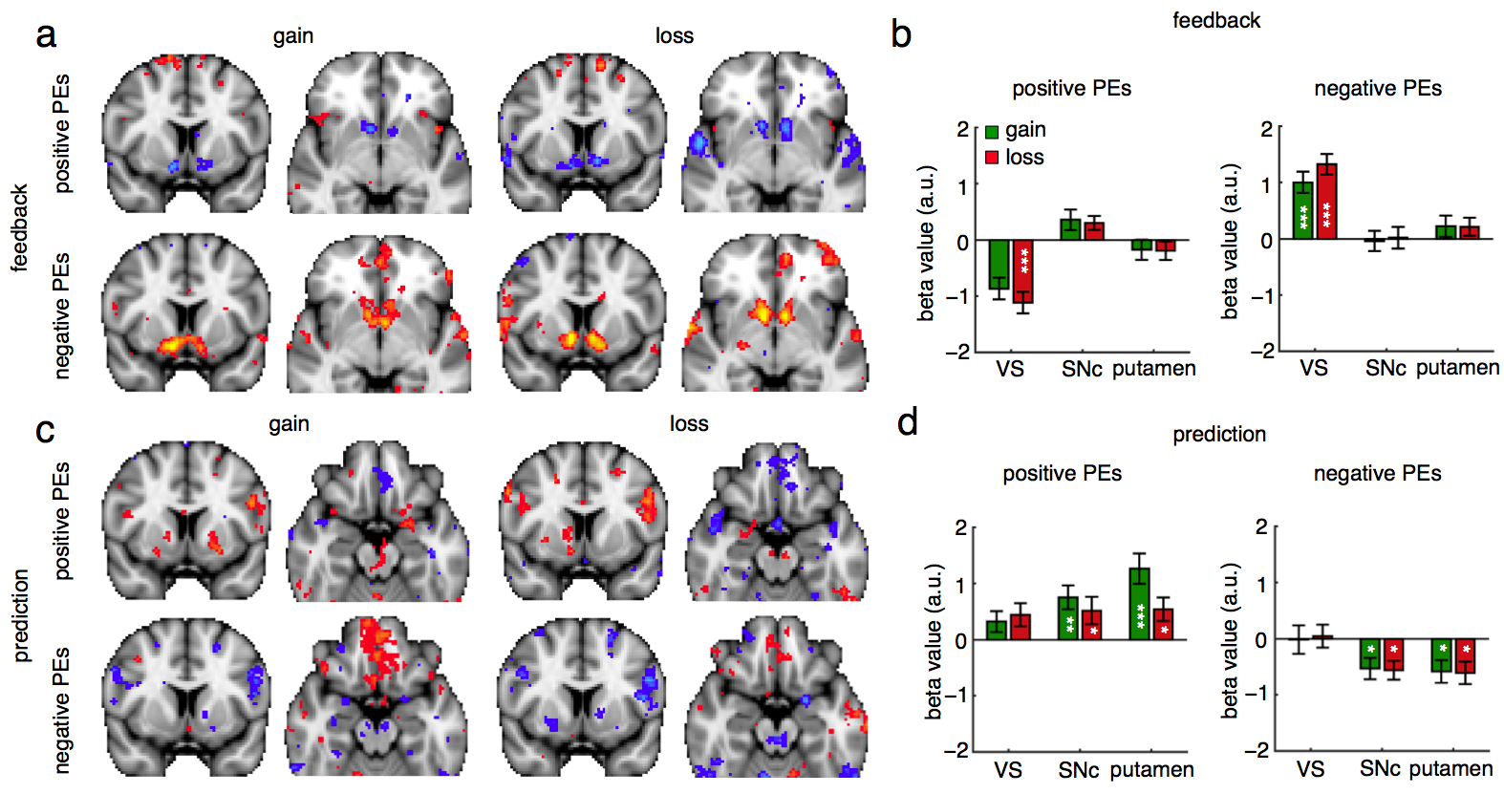

Supplementary Figure 2. Robust neural correlates of the UPEs, but not the SPEs, in the human dopaminergic reward system.

- Activation maps showing significant correlations with the positive and negative PEs during the feedback phase of the gain and loss conditions, respectively (z > 2.6, P < 0.005, uncorrected). Regardless of the gain or loss conditions, the VS activities were negatively correlated with the positive PEs but positively correlated with the negative PEs during the feedback phase.
- The beta values of regression of the fMRI activities with the positive and negative PEs during the feedback phase of the gain and loss conditions in the ROIs, respectively.
- Activation maps showing significant correlations with the positive and negative PEs during the prediction phase of the gain and loss conditions, respectively (z > 2.6, P < 0.005, uncorrected). Regardless of the gain or loss conditions, the putamen and putative SN activities were positively correlated with the positive PEs but negatively correlated with the negative PEs during the prediction phase.
- The beta values of regression of the fMRI activities with with the positive and negative PEs during the prediction phase of the gain and loss conditions in the ROIs, respectively.
*P < 0.05, **P < 0.01, ***P < 0.001. Error bars indicate s.e.m. across participants.

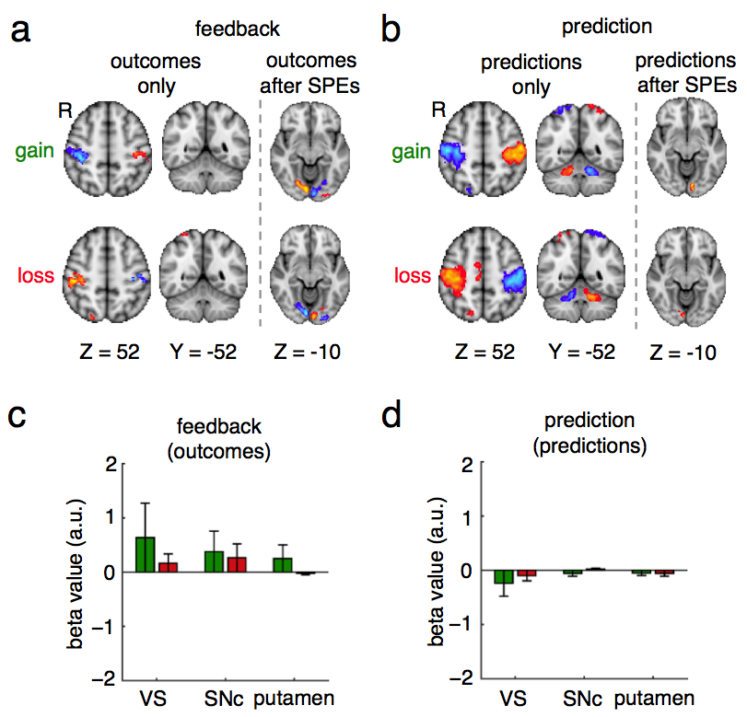

Supplementary Figure 3. Dissociation of CS-associated valences in the dopaminergic reward system.

- Activation maps showing significant correlations with the outcomes only or the outcomes after orthogonalization with the SPEs during the feedback phase of the gain and loss conditions, respectively (z > 3.1, P < 0.05 after FWE correction). Although the outcomes were also significantly correlated with fMRI activities in the bilateral PMC (left), this correlation was explained away by the SPEs (right). Only the fMRI activities in the primary visual cortex remained robust representations of the outcomes.
- Activation maps showing significant correlations with the predictions only or the predictions after orthogonalization with the SPEs during the prediction phase of the gain and loss conditions, respectively (z > 3.1, P < 0.05 after FWE correction). Although the predictions were also significantly correlated with fMRI activities in the bilateral PMC (left), this correlation was explained away by the SPEs (right). Only the fMRI activities in the primary visual cortex remained robust representations of the predictions.
- The fMRI activities in the regions of the dopaminergic reward system were not correlated with the outcomes in either the gain or loss condition during the feedback phase.
- The fMRI activities in the regions of the dopaminergic reward system were not correlated with the predications in either the gain or the loss condition during the prediction phase.
Error bars indicate s.e.m. across participants.

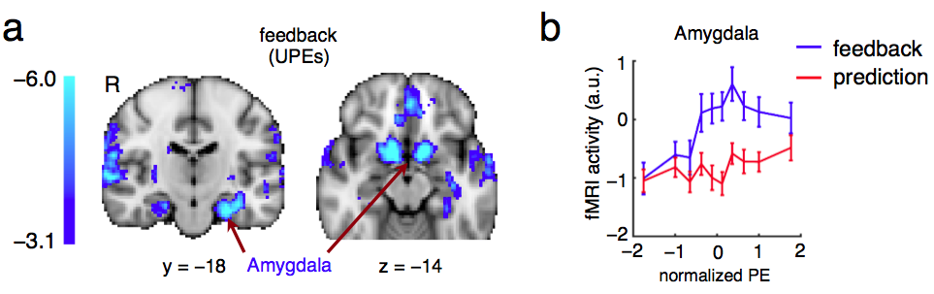

Supplementary Figure 4. The amygdala activations during the feedback phase.

- Similar to the VS, the neural activities in the bilateral amygdala were also negatively correlated with the UPEs during the feedback phase (z > 3.1, P < 0.05 after FWE correction).
- The fMRI activities as a function of PEs in the amygdala.

