Appendix

Explanation of interactions using margins function:

1) Interaction of BUSF with GFC and GHC:

BUSF x GFC=0: -0.047** significantly negative effect of BUSF during normal periods
BUSF x GFC=1: -0.003 – no effect during the global financial crisis

BUSF x GHC=0: -0.048** significantly negative effect of BUSF during normal periods
BUSF x GHC=1: 0.032 – no effect during the global health crisis

2) Interaction of BUSF with TRAD
a) Impact of TRAD on FDI at different levels of BUSF
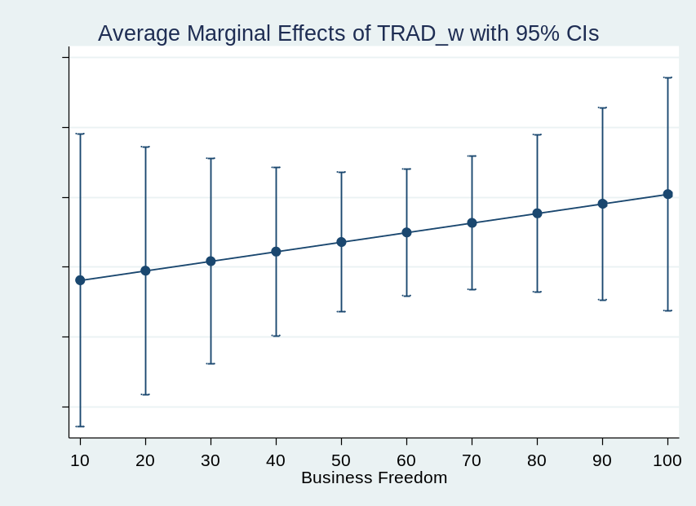
b) Impact of BUSF on FDI at different levels of TRAD

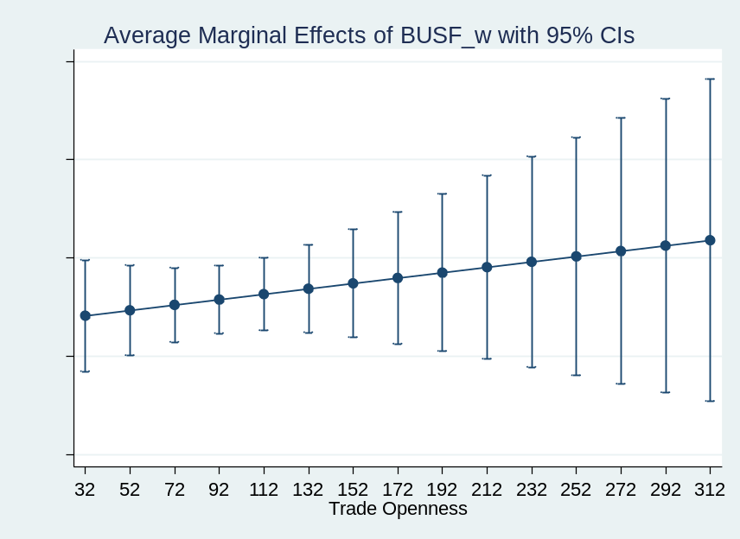

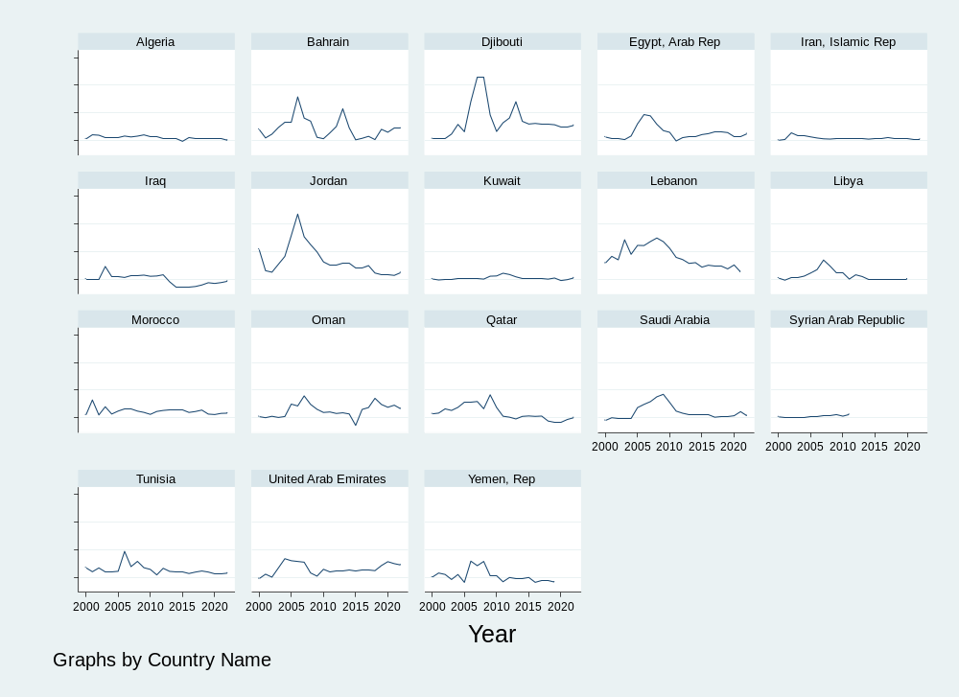

Visual test for heterogeneity
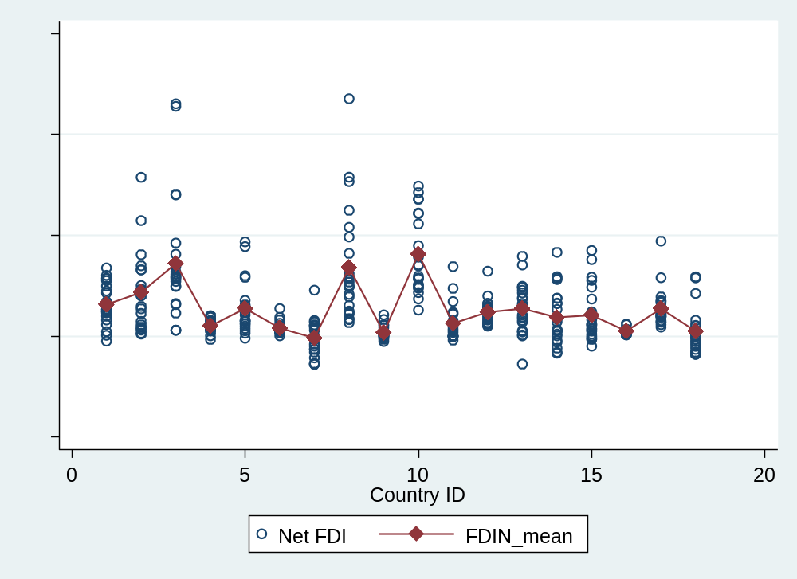

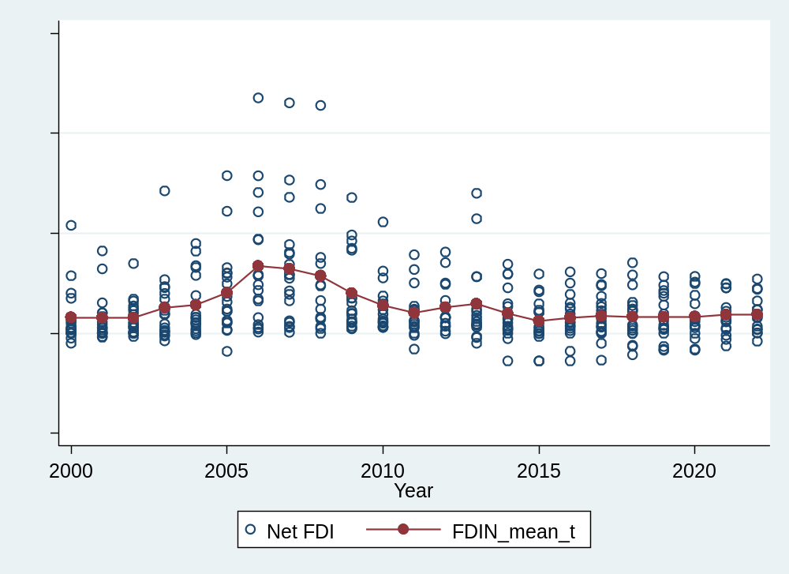

Scatter Plot: FDI vs Business Freedom
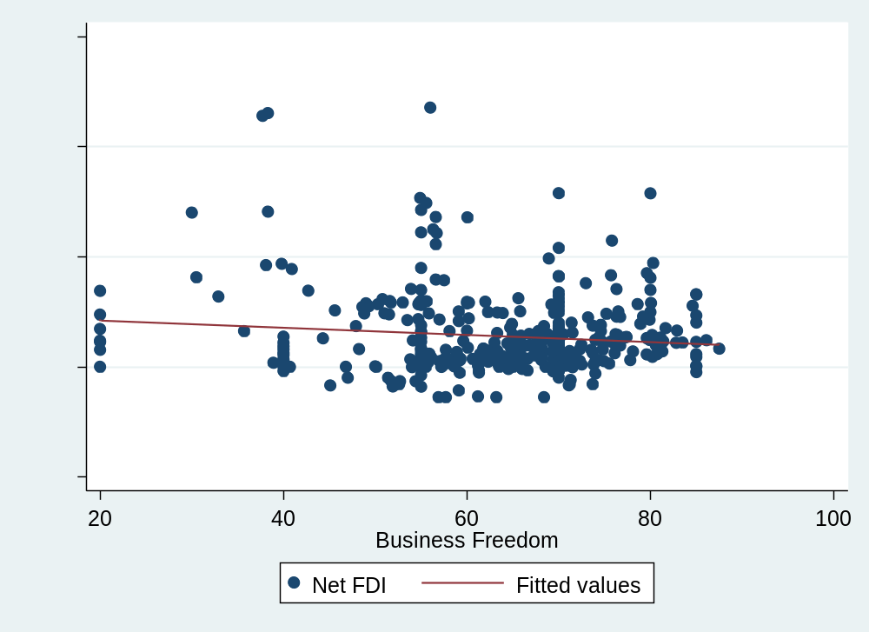
Scatter Plot: FDI vs Trade Openness
