Supplementary Information for
Edge-guided inverse design of digital metamaterials for ultra-high-capacity on-chip multi-dimensional interconnect
Aolong Sun^{1,2,3,4}, Sizhe Xing^{1,2,4}, Xuyu Deng^{1,2,3}, Ruoyu Shen^{1,3}, An Yan^{1,2}, Fangchen Hu³, Yuqin Yuan^{1,2}, Boyu Dong^{1,2}, Junhao Zhao^{1,2}, Ouhan Huang^{1,2}, Ziwei Li^{1,2}, Jianyang Shi^{1,2}, Yingjun Zhou^{1,2}, Chao Shen^{1,2}, Yiheng Zhao³, Bingzhou Hong³, Wei Chu^{3,*}, Junwen Zhang^{1,2,*} Haiwen Cai³ &Nan Chi^{1,2,*}
¹School of Information Science and Technology, Fudan University, Shanghai, China
²Key Laboratory for Information Science of Electromagnetic Waves (MoE), Fudan University, Shanghai, China
³Zhangjiang Laboratory, Shanghai, China
⁴These authors contributed equally to this work.
*Corresponding authors: junwenzhang@fudan.edu.cn, chuwei@zjlab.ac.cn ,nanchi@fudan.edu.cn

Contents
Supplementary Note 1: An overview of the EG-ADO 1
A. Topology optimization based on the adjoint method 1
B. Index mapping based on edge information 3
C. Digital optimization based on the direct binary search method 4
Supplementary Note 2: Calculation of mode effective index 5
Supplementary Note 3: Supplementary simulation results for mode MUXs 6
A. Five-mode MUX 6
B. Two-mode MUX 7
C. Four-mode MUX 9
D. Fabrication tolerance of the five-mode MUX 10
Supplementary Note 4: Conversion process of index patterns during the optimization 12
Supplementary Note 5: Discussions on the conversion rate 14
Supplementary Note 6: Supplementary information for the on-chip interconnect experiments 15
A. Chip packaging 15
B. System frequency response 16
C. Detailed experiment set-up and DSP flow 17
D. Operation methods for generating the WDM signal 18
E. Principle of PS-PAM signal generation 19
F. NGMI performance of the multi-dimensional experiment 21
G. Potential performance estimation of the ultra-high-capacity interconnect 22
Supplementary Note 7: Scalability validation 24
Supplementary Note 8: Equipment models 26
References 27

Supplementary Note 1: An overview of the EG-ADO
As inverse design continues to evolve within the field of photonics, numerous methodologies have been developed and widely adopted. These inverse-designed devices based on metamaterials can generally be categorized into analog and digital metamaterials. Analog metamaterials can be optimized using gradient-based topology optimization algorithms, with the adjoint method being the most prevalent¹. This method calculates the optimization sensitivity of design parameters in the focused region through two electromagnetic simulations, allowing efficient inverse design by updating these parameters with a suitable optimizer. The two simulations include a forward simulation using the incident source as excitation and an adjoint simulation using reciprocal displacement current as excitation source². However, gradient-based optimization often requires fine electromagnetic computation grids and results in devices with irregular and extremely small features, posing significant challenges for reliable fabrication tolerance. In contrast, digital metamaterials^{3,4}, with their larger minimum feature sizes (>100 nm) and more regular geometries, offer enhanced fabrication stability, making them well-suited for large-scale production through commercial foundries. Nonetheless, traditional optimization methods for digital metamaterials are inefficient and time-intensive⁵.
The edge-guided analog-and-digital optimization (EG-ADO) method proposed in this paper combines the efficiency of topology optimization with the fabrication robustness of digital designs. It extracts edge information from analog patterns using image edge detection techniques and uses this information to guide the transformation from analog to digital patterns, achieving efficient and low-loss conversion. The EG-ADO method consists of three main stages, detailed step-by-step in this section. For a detailed illustration of the pattern conversion process during optimization, please refer to Supplementary Note 4.

Topology optimization based on the adjoint method
The first stage in the EG-ADO process involves using the adjoint method for gradient-based optimization of the permittivity distribution within the design region. The adjoint method utilizes one forward and one backward electromagnetic simulation to calculate the gradient of the objective function F, namely the figure of merit (FOM), with respect to the design parameters. In this context, the design parameters are the relative permittivity values $ε_{r}\left(x\right)$ at position $x$. In this study, we treat the design as a linear electromagnetic system, where the state of the entire system during the forward electromagnetic simulation is described by Maxwell's equations with free currents:
$∇×∇×E\left(x\right)-\frac{ω_{0}^{2}}{c^{2}}ε_{r}\left(x\right)E\left(x\right)=-iω_{0}μ_{0}J\left(x\right)$ (S1)
In this model, $E\left(x\right)$ represents the electric field distribution within the design region, $ω_{0}$ is the angular frequency of light, 𝑐 denotes the speed of light in vacuum, $μ_{0}$ is the magnetic permeability in vacuum, and $J\left(x\right)$ is the current source. We can further express this model as:
$A\left(ε_{r}\right)e=b\left(ε_{r}\right)$ (S2)
In this equation, $A$ is a linear operator that characterizes the Maxwell equations and the distribution of relative permittivity, $b$ is a vector representing the light source, while $ε_{r}$ and $e$ are vectors that describe the distribution of relative permittivity and the electric field within the design region, respectively. The derivative of this equation with respect to $ε_{r}$ yields:
$A\left(ε_{r}\right)\frac{∂e}{∂ε_{r}}=\frac{∂b\left(ε_{r}\right)}{∂ε_{r}}-\frac{∂A}{∂ε_{r}}e$ (S3)
In the backward electromagnetic simulation, also known as the adjoint simulation, the light source is placed at the location of the objective-function monitor from the forward simulation. This repositioning allows for another round of electromagnetic computation, where the resulting electric field distribution (the adjoint field) $e_{adj}$ satisfies:
$A^{T}\left(ε_{r}\right)e_{adj}=-{\left(\frac{∂F}{∂e}\right)}^{T}$ (S4)
Taking the transpose of both sides of the equation yields:
$\frac{∂F}{∂e}=-{e_{adj}}^{T}A\left(ε_{r}\right)$ (S5)
To calculate the gradient of the objective function $F$ with respect to the design parameters, we seek to determine:
$\frac{∂F}{∂ε_{r}}=\frac{∂F}{∂e}⋅\frac{∂e}{∂ε_{r}}$ (S6)
Substituting (S5) and (S3) into (S6) we can obtain:
$\frac{∂F}{∂ε_{r}}=-{e_{adj}}^{T}A\left(ε_{r}\right)⋅\frac{∂e}{∂ε_{r}}$ (S7)$=-{e_{adj}}^{T}\left(\frac{∂b\left(ε_{r}\right)}{∂ε_{r}}-\frac{∂A}{∂ε_{r}}e\right)$ (S8)
We employ the commercial electromagnetic simulation software, ANSYS Lumerical FDTD, to obtain the field distributions for both forward and adjoint simulations. This allows us to calculate the gradient based on (S8), which is then optimized using the L-BFGS optimizer to finalize the design of the analog metamaterial. The simulation employs a mesh size of 20×20×44 nm³ (x, y, z), with the x-y plane mesh refined sufficiently to ensure accurate gradient information. We adopt a universal topology optimization workflow that includes two key phases: grayscale optimization and binarization. In the first phase, the permittivity values of pixels are allowed to vary continuously between $ε_{Si}$ and $ε_{SiO_{2}}$. In the second phase, to avoid sharp angles and isolated holes with small feature sizes that could hinder subsequent digital optimization, a circular Heaviside filter with a radius twice the pixel side length of the digital metamaterial is convolved with the permittivity pattern after each iteration in the binarization phase. The Heaviside filter can be expressed as:
$ε_{i}=\frac{ε_{Si}+ε_{SiO_{2}}}{2}+\frac{\tanh\left(β\left(\frac{ε_{i}}{Δε}-\frac{ε_{Si}+ε_{SiO_{2}}}{2Δε}\right)\right)}{2\tanh\left(\frac{β}{2}\right)}Δε$ (S9)
where $ε_{i}$ represents the pixel permittivity, $Δε$ is the difference between $ε_{Si}$ and $ε_{SiO_{2}}$, and β is a hyperparameter that can be modified to increase the discreteness of the analog pattern. We incrementally increase β to push the permittivity values toward their boundaries, in order to obtain the final binary distribution. The evolution process of the permittivity profiles for the two-mode multiplexer (MUX) during the topology optimization is shown in Fig. S1(a). Discussions regarding the filter model and filter radius can be found in Reference⁶.

Index mapping based on edge information
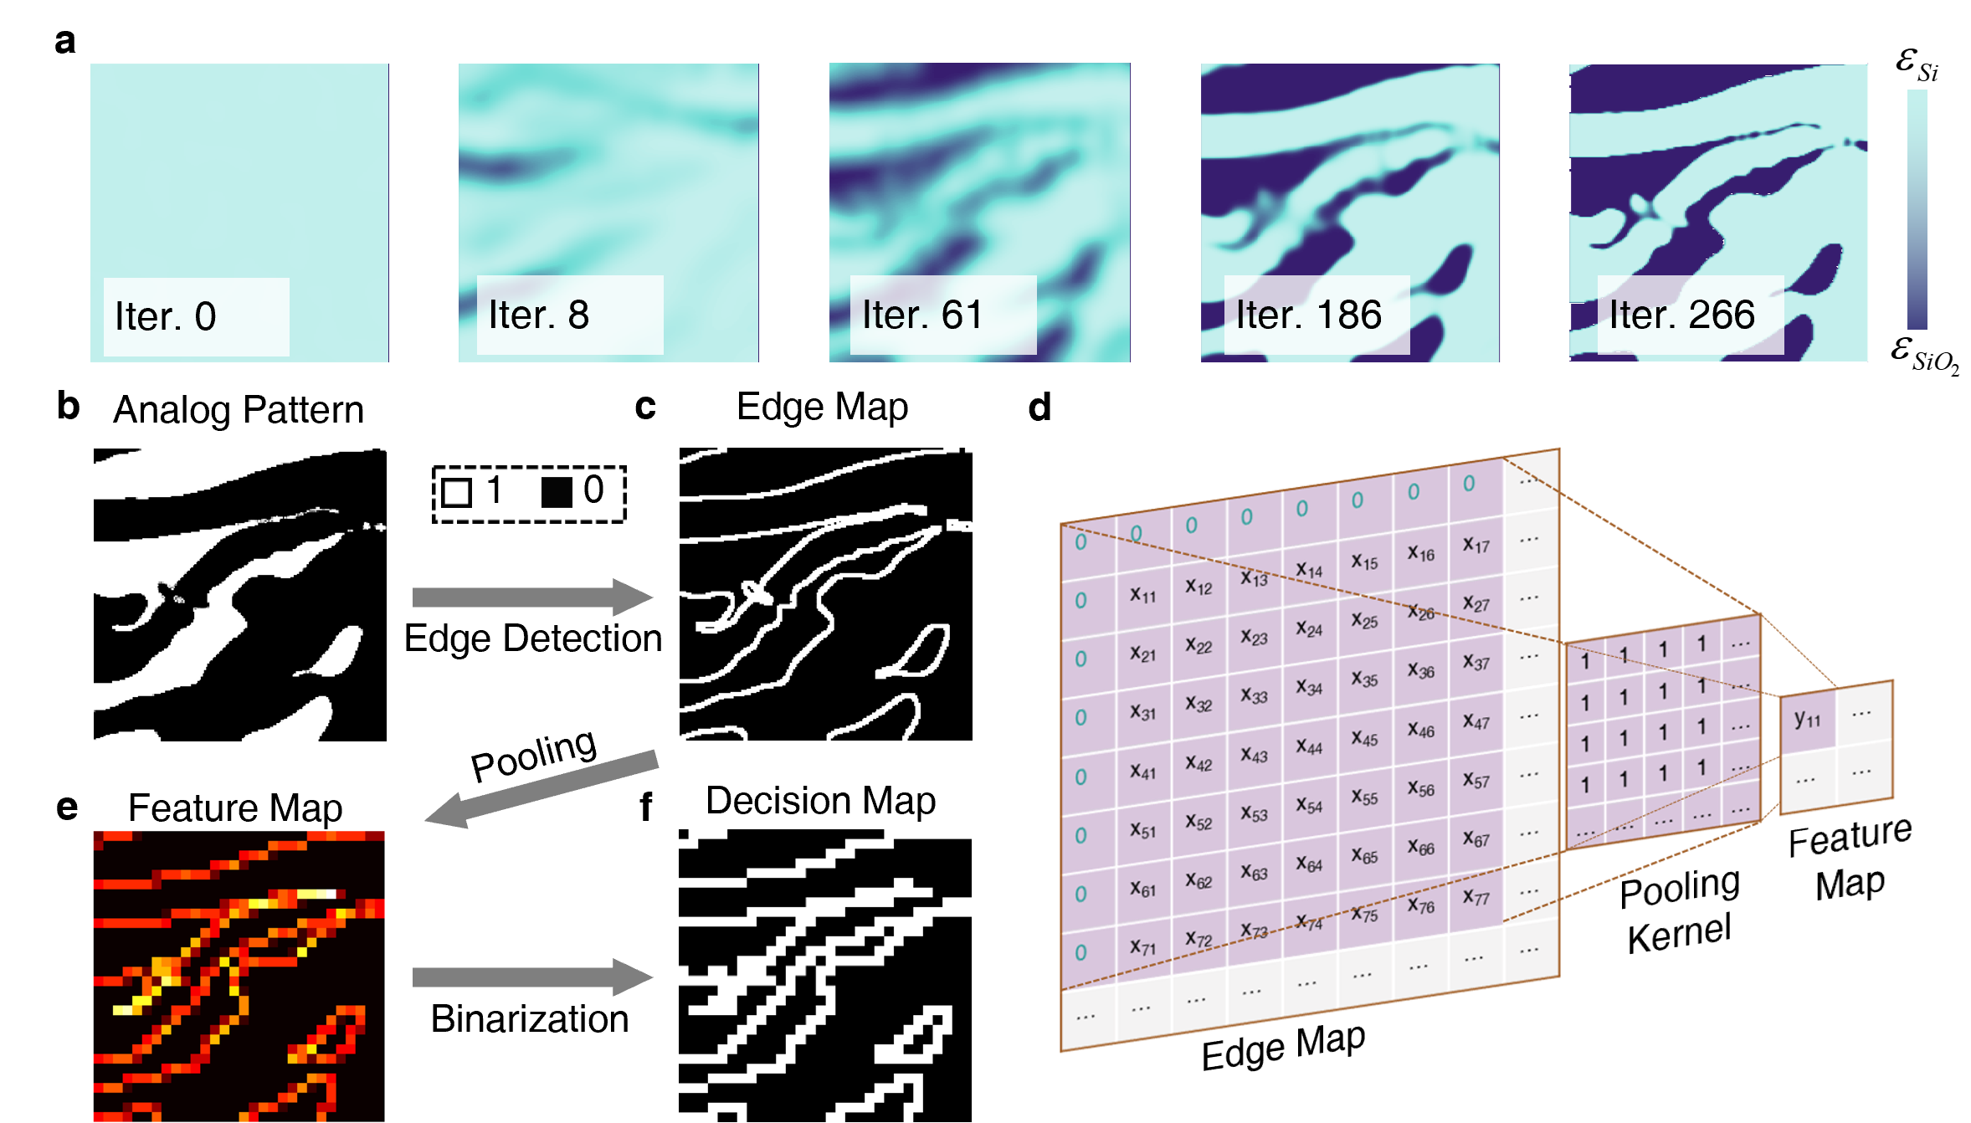
Fig. S1 (a) Evolution of the permittivity distribution for the two-mode MUX during the topology optimization stage. (b) Normalized permittivity distribution of a two-mode MUX after topology optimization. (c) Obtained edge map after edge detection using the Canny algorithm. (d) Concept schematic of the max-pooling operation with D = 2. (e) Obtained feature map and (f) decision map of the two-mode MUX.
Following the optimization of analog metamaterials using the adjoint method, the permittivity distribution within the design region, termed the analog pattern, is extracted and processed using the Canny edge detection algorithm⁷. Given that the analog pattern can be regarded as a single-channel grayscale image, the workflow for Canny edge detection in this work includes smoothing with a Gaussian filter, directional gradient calculation using the Sobel operator, non-maximum suppression, double thresholding, and finally edge tracking by hysteresis. Fig. S1(b) displays the normalized permittivity distribution of a two-mode MUX after topology optimization, and Fig. S1(c) shows the edge map obtained using the Canny edge detector, where white pixels (value of 1) indicate edges and black pixels (value of 0) indicate non-edge areas.
Due to the small pixel size of the analog pattern (20 nm×20 nm in this design) relative to the significantly larger pixel size required for the target digital pattern (120 nm×120 nm in this design), a pooling operation is required to adjust the pixel dimensions, as depicted in Fig. S1(d). Max pooling is employed, where the pooling kernel is an all-one matrix. The scaling factor of pooling can be expressed as S_{AD} = P_{A}/P_{D}, where P_{A} and P_{D} are the pixel side length of the analog and digital patterns, respectively. This process convolves the final edge map with the pooling kernel to generate a feature map (Fig. S1(e)). Subsequently, this feature map undergoes binarization to form a decision matrix (Fig. S1(f)), with all non-zero elements assigned a value of 1. According to Fig. S1(d), the value of pixel y₁₁ in the feature map is set to 0 only if every pixel in the corresponding area (x₁₁-x₇₇) in the edge map is non-edge. The index mapping is then conducted based on the decision matrix. Direct mapping of the index is only performed if the corresponding region in the analog pattern consists entirely of non-edge pixels; otherwise, the pixel state is labeled as TBD (i.e., “to be determined”).
Additionally, to discuss the relationship between conversion efficiency and optimization performance, we introduce a dilation coefficient D which determines the size of the pooling kernel as S_{AD}+D. Increasing D raises the proportion of TBD pixels and can be visually understood as thickening the boundaries (see Supplementary Note 4). When D is greater than 0, as illustrated in Fig. S1(d), the edge map is surrounded by padding of width D/2. The stride of the pooling operation, set to the scaling factor S_{AD}, facilitates the conversion of the pixel size of the analog pattern to that required for the digital pattern.

Digital optimization based on the direct binary search method
Following the index mapping based on the decision map, we obtain the converted pattern of the device, which includes pixels directly mapped to Si and SiO₂, as well as pixels where the material remains to be determined. Subsequently, we employ the direct binary search (DBS) method to specifically determine the materials for TBD pixels. For each TBD pixel, its index is alternately set to $n_{Si}=3.48$ and $n_{SiO_{2}}=1.44$ , and one 3D FDTD simulation is conducted for each setting to calculate the FOM. The material that yields the better FOM is then selected for that pixel. After a complete round of iteration through all TBD pixels, the optimization concludes. The pixel traversal during this optimization is conducted in a column-wise direction. The detailed workflow of the DBS method can be found in Reference⁸.

Supplementary Note 2: Calculation of mode effective index
To determine the appropriate widths for the input and output waveguides of the mode MUXs, we use the FDE solver of ANSYS Lumerical MODE (Fig. S2(a)) to calculate the effective index of various orthogonal modes. We conduct two-dimensional simulations, assuming the waveguide is infinitely long in the direction of light propagation, and set the boundary conditions on all four sides to perfectly matched layers (PMLs). The background index is set to 1.44. For the waveguide core, we set the height to 220 nm and the material to silicon, and sweep the width from 300 nm to 3000 nm to determine the effective indices of different modes at various widths. Around the waveguide, we use a small mesh size of 5×11 nm². The two-dimensional set-up exhibits a fast computational speed, facilitating the implementation of a very fine mesh to obtain accurate indices. Fig. S2(b) shows the evolution in the effective indices of the first six TE modes at the wavelength of 1550 nm. As the width increases, high-order modes gradually appear. We set the width of the single-mode waveguide at 500 nm, and the widths for the multimode waveguides in two-mode, four-mode, five-mode, and six-mode MUXs are sequentially set to 900 nm, 1800 nm, 2500 nm, and 3000 nm, respectively, to accommodate the corresponding modes. Fig. S2(c) depicts the mode profiles for TE₀ to TE₅ modes at a waveguide width of 3000 nm as the wavelength is set to 1550 nm.
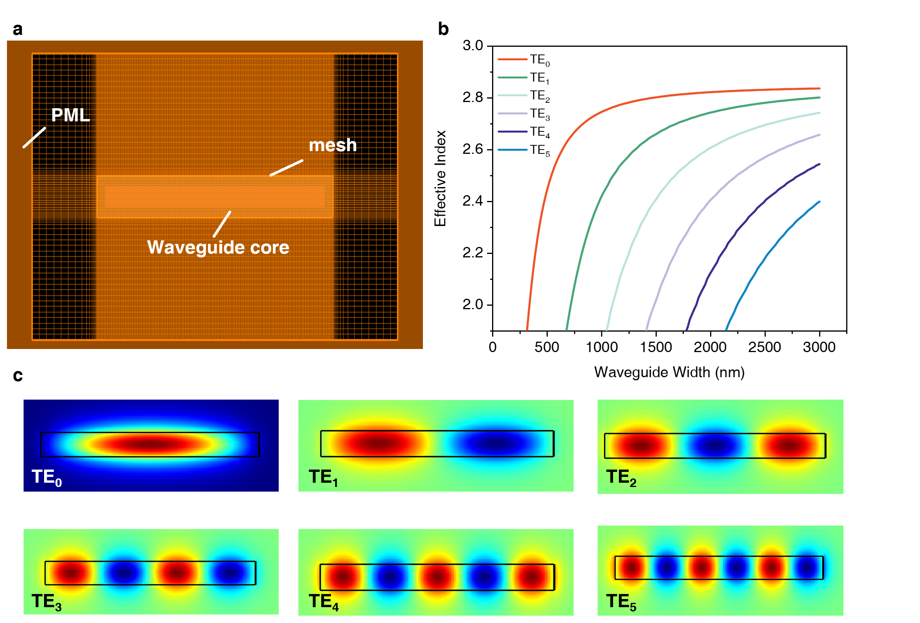
Fig. S2 Mode effective index simulation. (a) Schematic of the simulation region in FDE solver. (b) Calculated effective index for TE₀-TE₅ modes at different waveguide width at the wavelength of 1550 nm. (c) Simulated mode profiles for TE₀-TE₅ modes at a waveguide width of 3000 nm.

Supplementary Note 3: Supplementary simulation results for mode MUXs

Five-mode MUX
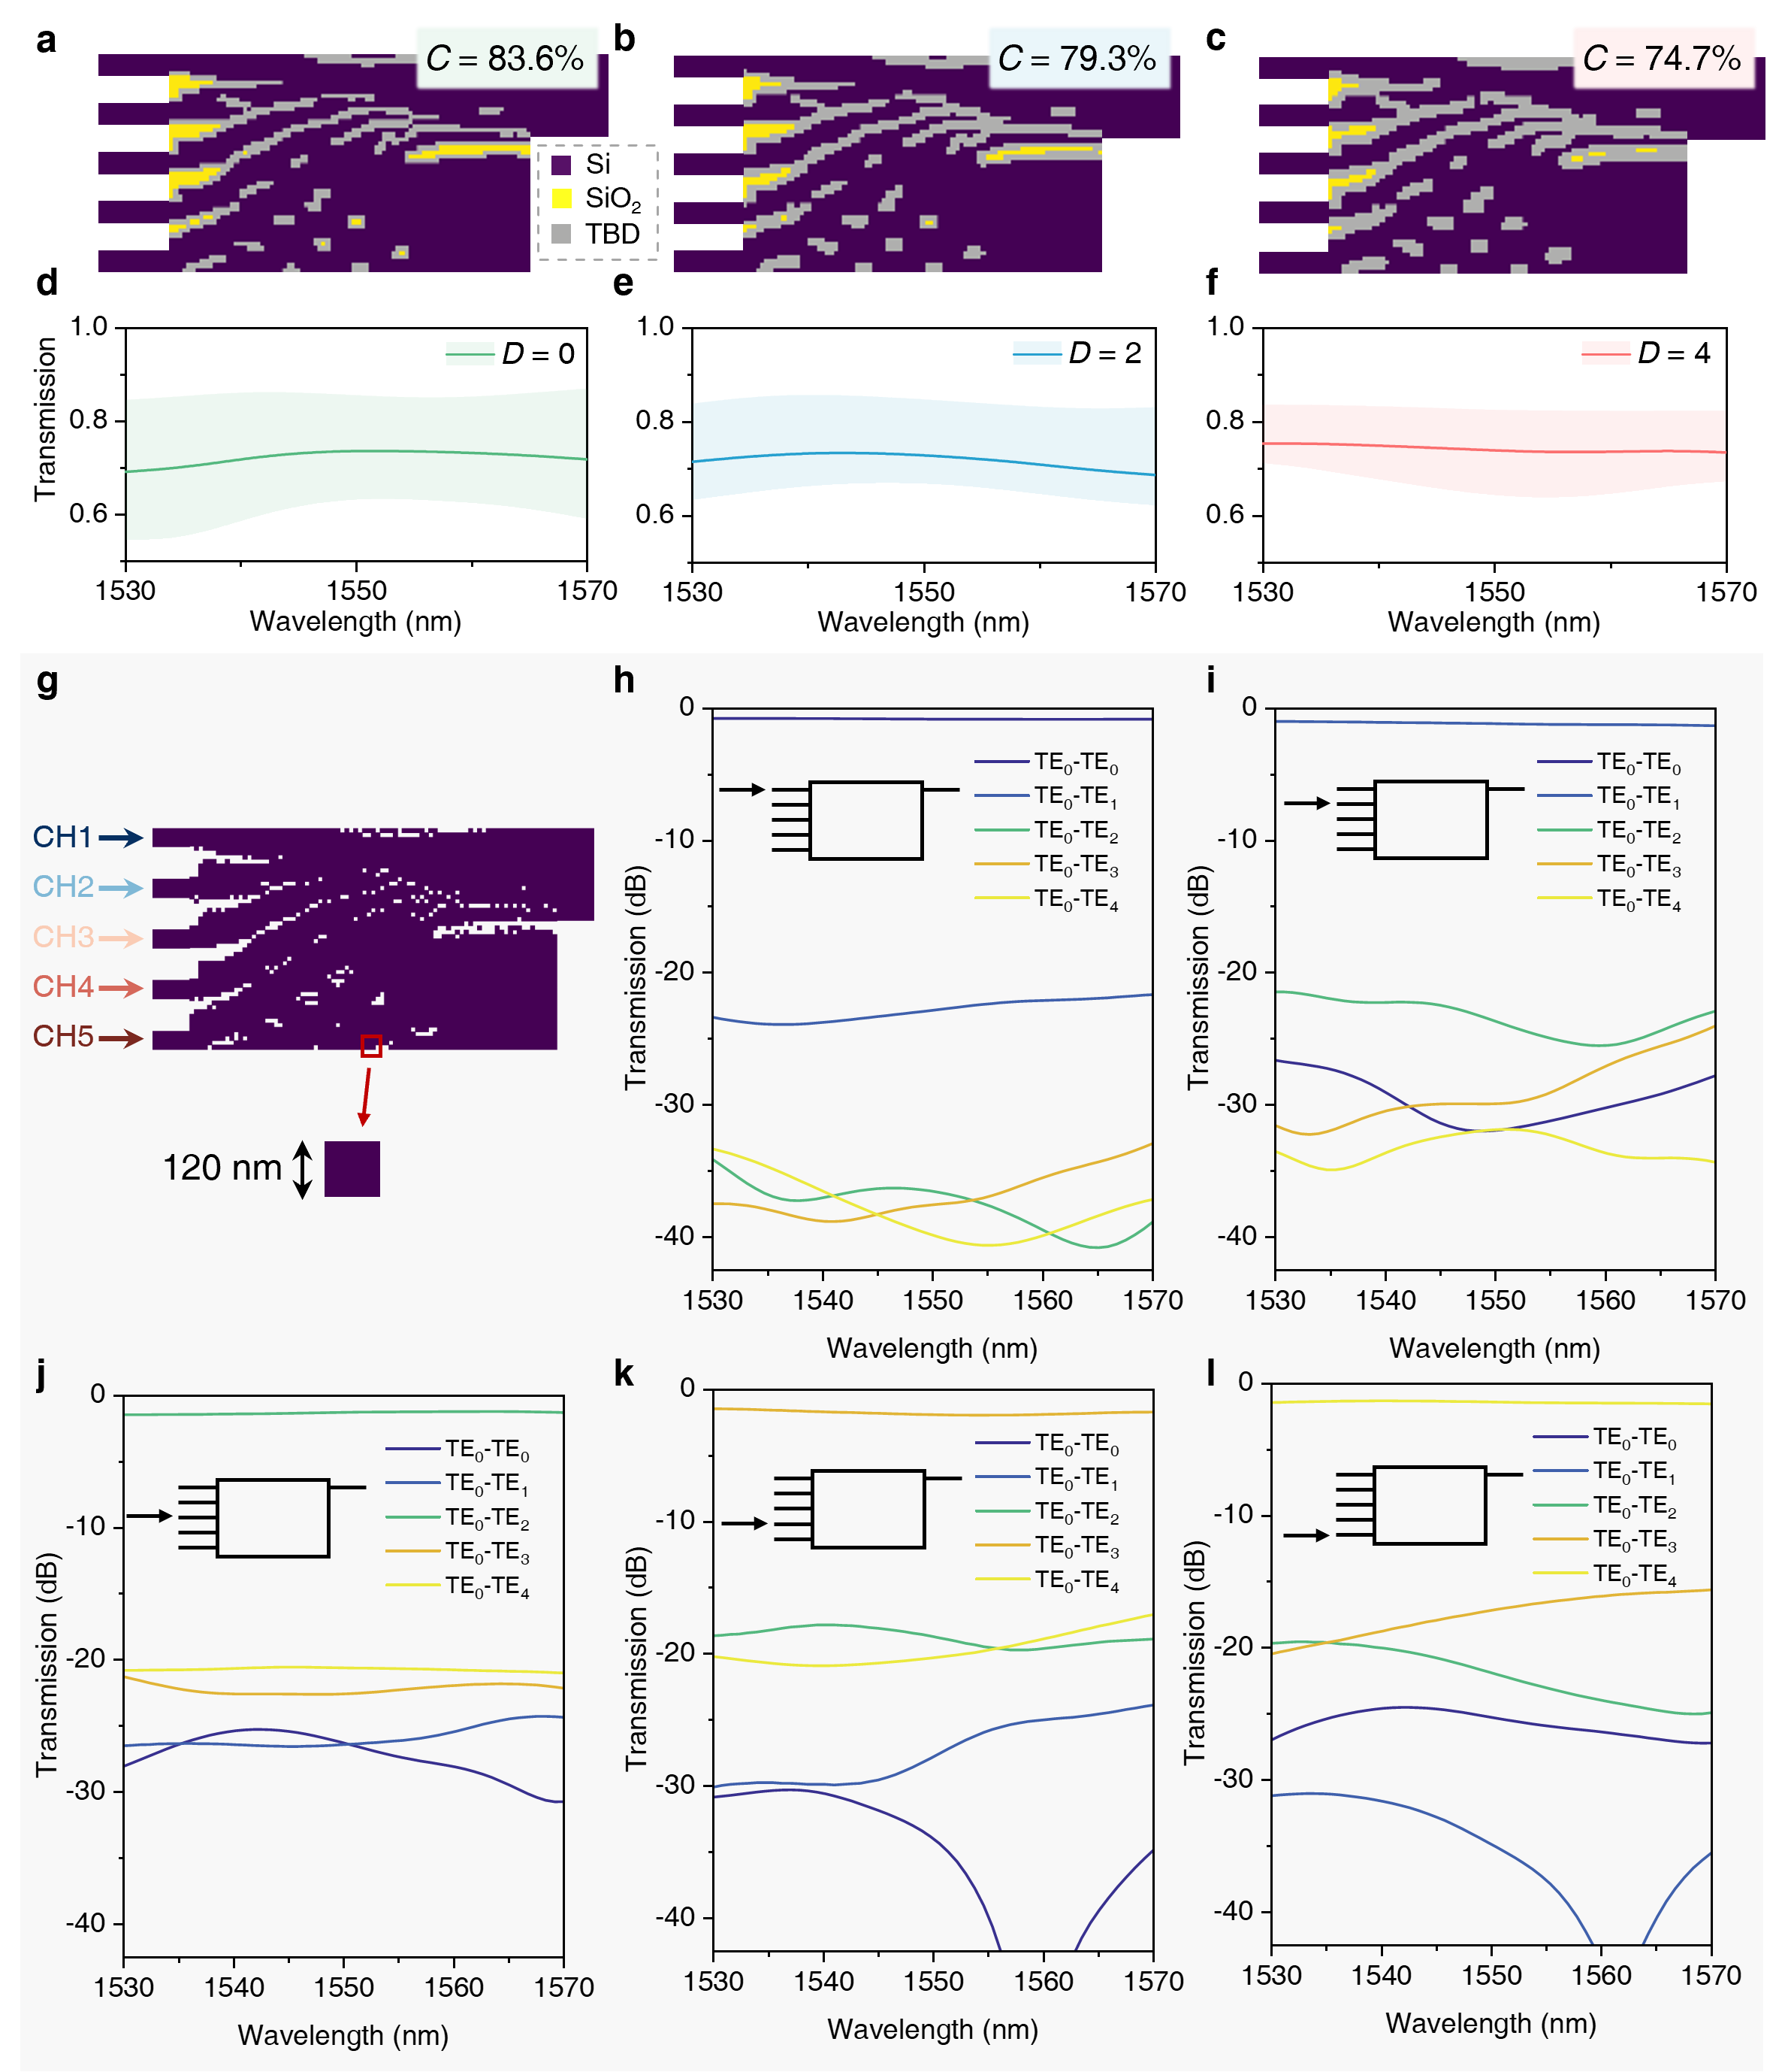
Fig. S3 Supplementary simulation results for the five-mode MUX. a-c Obtained converted patterns of the five-mode MUX optimized with (a) D = 0, (b) D = 2, and (c) D = 4, respectively. d-f Calculated conversion efficiency of the five-mode MUX optimized with (d) D = 0, (e) D = 2, and (f) D = 4, respectively. Shaded areas indicate minimum and maximum values across all input channels, and solid lines indicate the average values. g Schematic diagram of the five-mode MUX optimized with D = 4. h-l Simulated transmission spectra of the selected MUX when the TE₀ mode is incident from CH1 to CH5 at the wavelength range of 1530 to 1570 nm. Insets include the annotations of the input port.
The detailed design process and simulation results of the five-mode MUX are given in this section. Three different dilation coefficients (D = 0, 2, 4) are applied to conduct edge extraction and pooling convolution on the same analog pattern of a five-mode MUX, resulting in the converted patterns displayed in Fig. S3(a)-(c). The pixel conversion rate (C) during index mapping, defined as the ratio of pixels undergoing direct index mapping to the total number of pixels, decreases linearly from 83.6% to 74.7% as D increases. It can be observed that the grey region along the material boundaries dilates with the increase of D. The variation in conversion efficiency introduced by the change of D is illustrated through the transmission spectra shown in Fig. S3(d)-(f). The results reveal that expanding the number of TBD pixels does not obtain significant performance improvement. For data transmission purposes, we select the MUX optimized at D = 4 as the final structure due to its superior channel uniformity. Fig. S3(h)-(l) displays the simulated transmission spectra for each mode when TE₀ mode is input from CH1 to CH5, across the wavelength range of 1530-1570 nm. The insertion losses at 1550 nm for the five channels are 0.81 dB, 1.19 dB, 1.29 dB, 1.93 dB, and 1.43 dB, respectively. The crosstalk values are −22.67 dB, −23.83 dB, −20.61 dB, −18.79 dB, and −17.10 dB for the five channels, respectively, at the wavelength of 1550 nm.

Two-mode MUX
Using the EG-ADO method, we numerically design an extra two-mode MUX as a proof of concept. The schematic of this two-mode MUX is depicted in Fig. S4. It features two single-mode input waveguides with a width of 500 nm and a spacing of 1.3 μm, a square design area of 3.6×3.6 μm², and a multimode output waveguide with a width of 900 nm. The final optimized digital pattern with a dilation coefficient 𝐷 = 2 is shown in Fig. S4(b). We also examine how the performance of the two-mode MUX changes with different values of the dilation coefficient D. The same analog pattern is digitized using three dilation coefficients (D = 0, 2, 4), and the transmission spectra within the wavelength range of 1500-1600 nm for the resulting devices are shown in Fig. S5(a)-(c). The performance of these devices is remarkably similar, with the D = 2 configuration showing slightly lower insertion loss than the other two cases. Fig. S5(d) and (e) display the transmission spectra for the TE₀ mode injecting from the upper and lower ports, respectively. For both channels, the insertion loss at 1550 nm is less than 0.6 dB, and crosstalk remains below -22 dB across the entire 100 nm wavelength range.
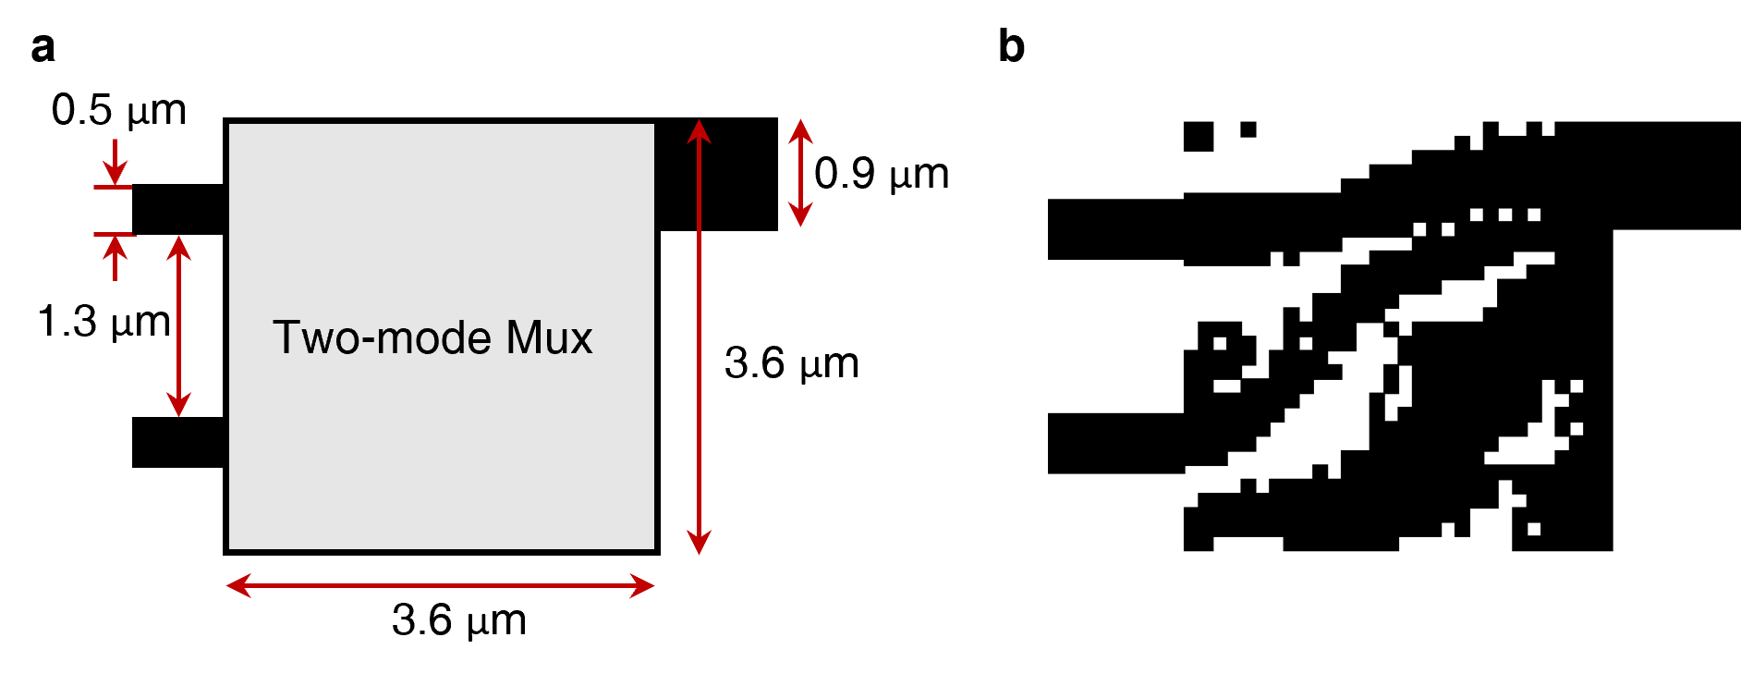
Fig. S4 (a) Schematic of the two-mode MUX. (b) The final structure of the digital-metamaterial-based two-mode MUX. The pixel size is 120×120 nm².
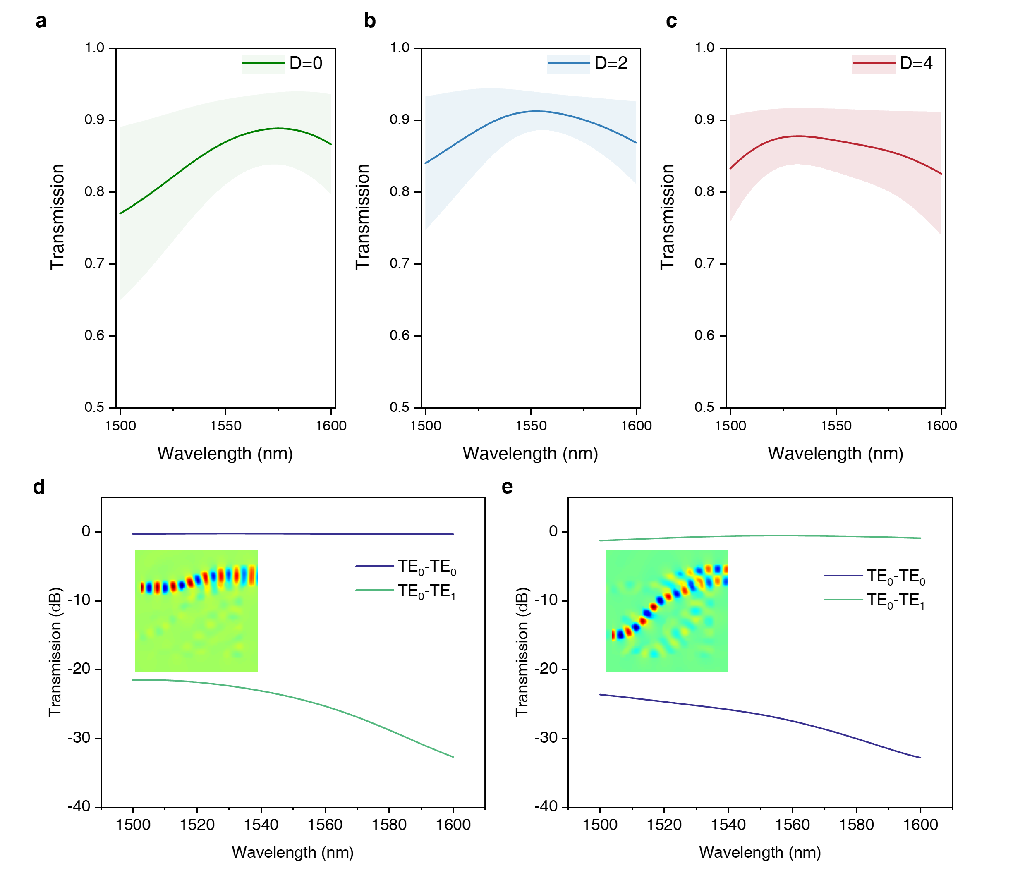
Fig. S5 Device performance of the two-mode MUX. (a)-(c) Conversion efficiency of the two-mode MUXs optimized with D = 0, D = 2, and D = 4. The solid line depicts the average value of both modes, while the shadow represents the lowest and highest ranges. (d)-(e) Simulated transmission spectra of the two-mode MUX.

Four-mode MUX
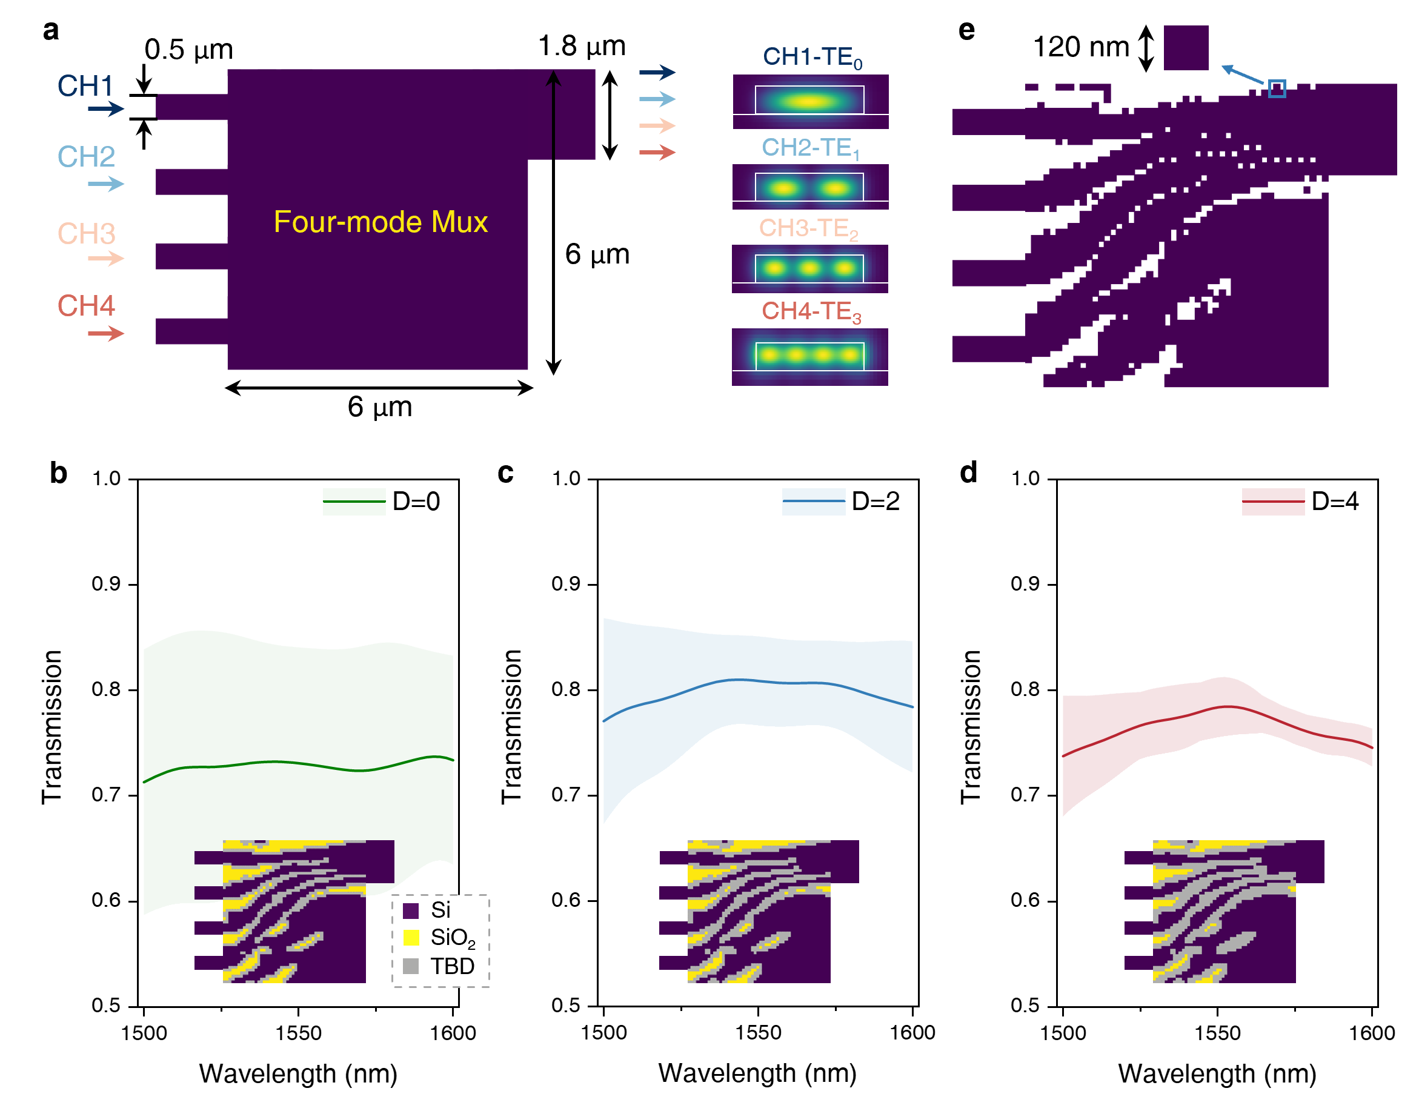
Fig. S6 (a) Initial structure of the four-mode MUX. Insets depict the ideal mode profiles for TE₀-TE₃ in the output multimode waveguide. (b)-(c) Simulated conversion efficiency of the four-mode MUXs optimized with D = 0, D = 2, and D = 4. The solid line depicts the average value of both modes, while the shadow represents the lowest and highest ranges. Insets represent the converted pattern of each configuration. (e) The final structure of the four-mode MUX optimized with D = 2.
In the main manuscript, we have presented experimental results for the four-mode MUX, and here we display the corresponding numerical simulation results in Fig. S6 and S7. Fig. S6(a) illustrates the initial structure of the four-mode MUX, with each pixel of the initial pattern composed of Si. The device includes four single-mode input waveguides, each 500 nm wide with a 1 μm spacing, and a 1.8 μm wide multimode output waveguide. The design area of the device spans 6×6 μm². We also explore the performance of devices optimized with various dilation coefficients, as depicted in Fig. S6(b)-(d), identifying the configuration with D = 2 as offering the best average performance. Fig. S6(e) showcases the final digital pattern of this optimal four-mode MUX. Fig. S7 provides the transmission spectra for the four channels, with the specific input channels marked in each figure. At 1550 nm, this four-mode MUX achieves an insertion loss below 1 dB for all modes, with crosstalk maintained under -17 dB across the entire 100 nm wavelength range.
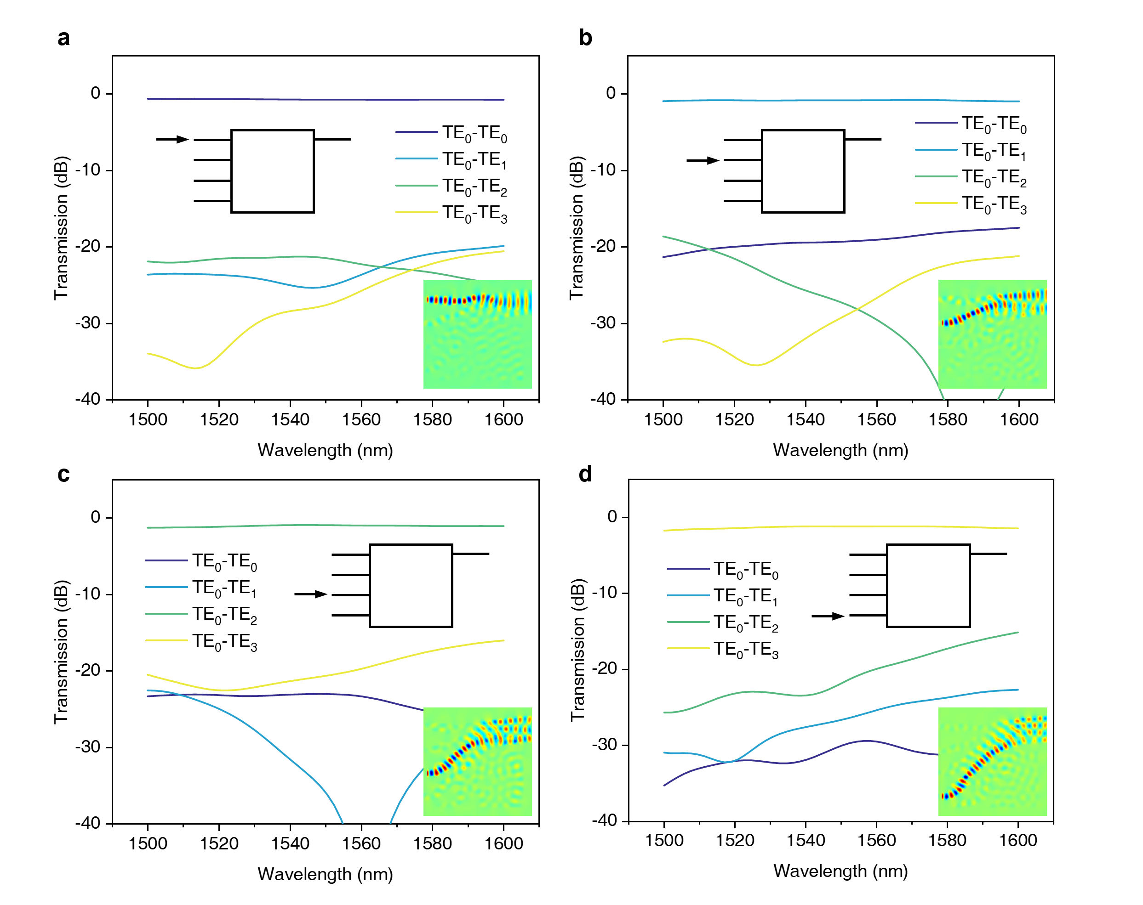
Fig. S7 (a)-(d) Simulated transmission spectra of the selected four-mode MUX. Insets include the annotations of the input port and schematics of the light propagation for each mode channel.

D. Fabrication tolerance of the five-mode MUX
We explore the performance variability of the designed five-mode MUX under fabrication errors through numerical simulations. Specifically, we examine changes in insertion loss and crosstalk when the side lengths of etched square holes fluctuate within a ±20 nm range, as depicted in Fig. S8. It is observed that the insertion losses for each mode remain relatively stable with pixel size variations from -20 nm to +10 nm. The loss fluctuations remain within 1 dB for all five modes at 1550 nm, aligning with findings from Reference⁴. The crosstalk of the five-mode MUX is more sensitive to changes in pixel size because mismatches in the effective index significantly alter the profiles of converted modes in the multimode output waveguide. Within a ±10 nm variation, crosstalks for the five modes at 1550 nm still remain below -16 dB, -18 dB, -15 dB, -15 dB, and -16 dB, respectively. Even under substantial deviations of ±20 nm, the worst crosstalk across the entire C band for this device still stays below -12 dB. According to batch testing data from different wafers provided by a mainstream commercial foundry⁹, the average waveguide width variation is approximately ±6.4 nm. Given this, the fabrication tolerance of the designed five-mode MUX falls within acceptable limits for robust mass production.
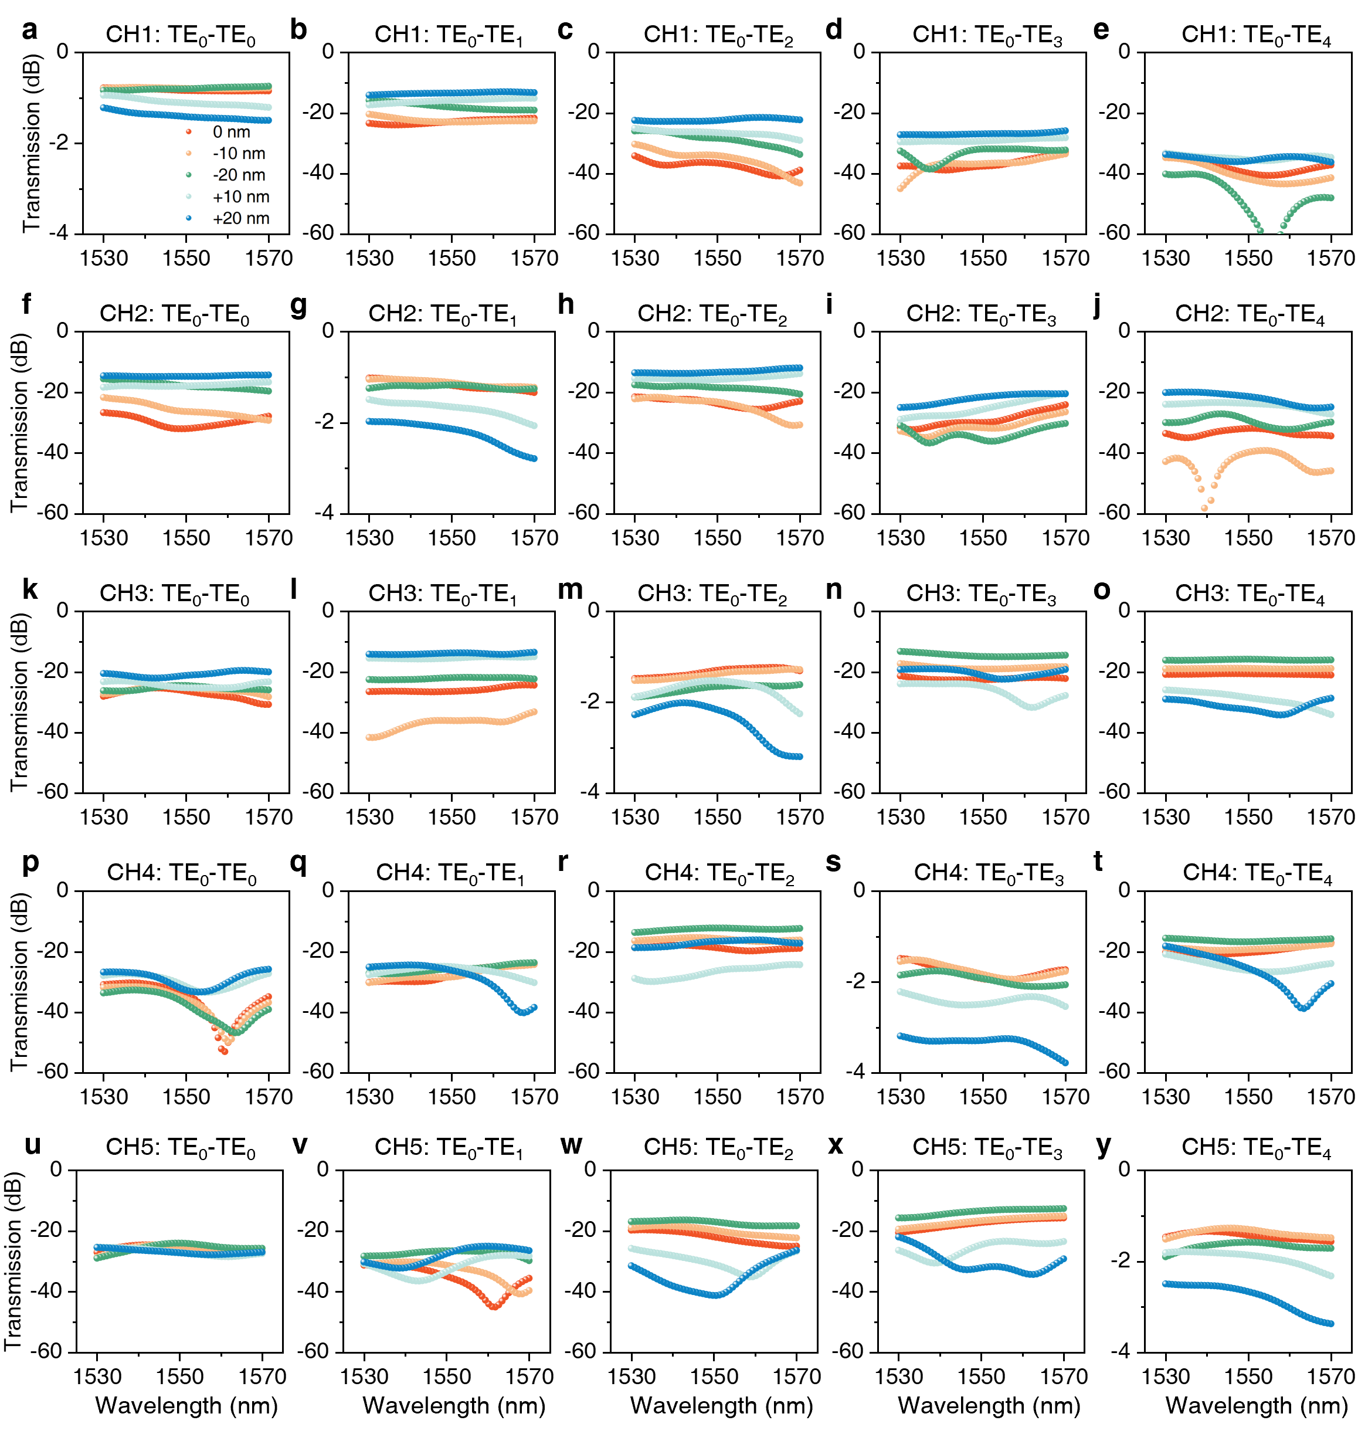
Fig. S8 The simulated transmission spectra of the five-mode MUX under ±20 nm pixel size variations. (a) Simulated insertion losses and (b)-(e) simulated mode-convert crosstalks for CH1 input. (g) Simulated insertion losses and (f), (h)-(j) simulated mode-convert crosstalks for CH2 input. (m) Simulated insertion losses and (k)-(l), (n)-(o) simulated mode-convert crosstalks for CH3 input. (s) Simulated insertion losses and (p)-(r), (t) simulated mode-convert crosstalks for CH4 input. (y) Simulated insertion losses and (u)-(x) simulated mode-convert crosstalks for CH5 input.

Supplementary Note 4: Conversion process of index patterns during the optimization
In this section, we present the evolution of index patterns during the EG-ADO optimization process for two-mode (Fig. S9), four-mode (Fig. S10), and five-mode MUXs (Fig. S11). We display the analog pattern, edge map, decision map, and final converted pattern for each MUX. As the dilation coefficient D increases, the white areas in the decision map (representing edge pixels) expand, and correspondingly, the number of TBD pixels in the converted pattern increases. This indicates that as D increases, pixels more distant from the original boundaries between Si and SiO₂ in the analog pattern are less likely to convert directly and are instead designated as TBD. These pixels require further confirmation through the DBS method in the third stage of EG-ADO.
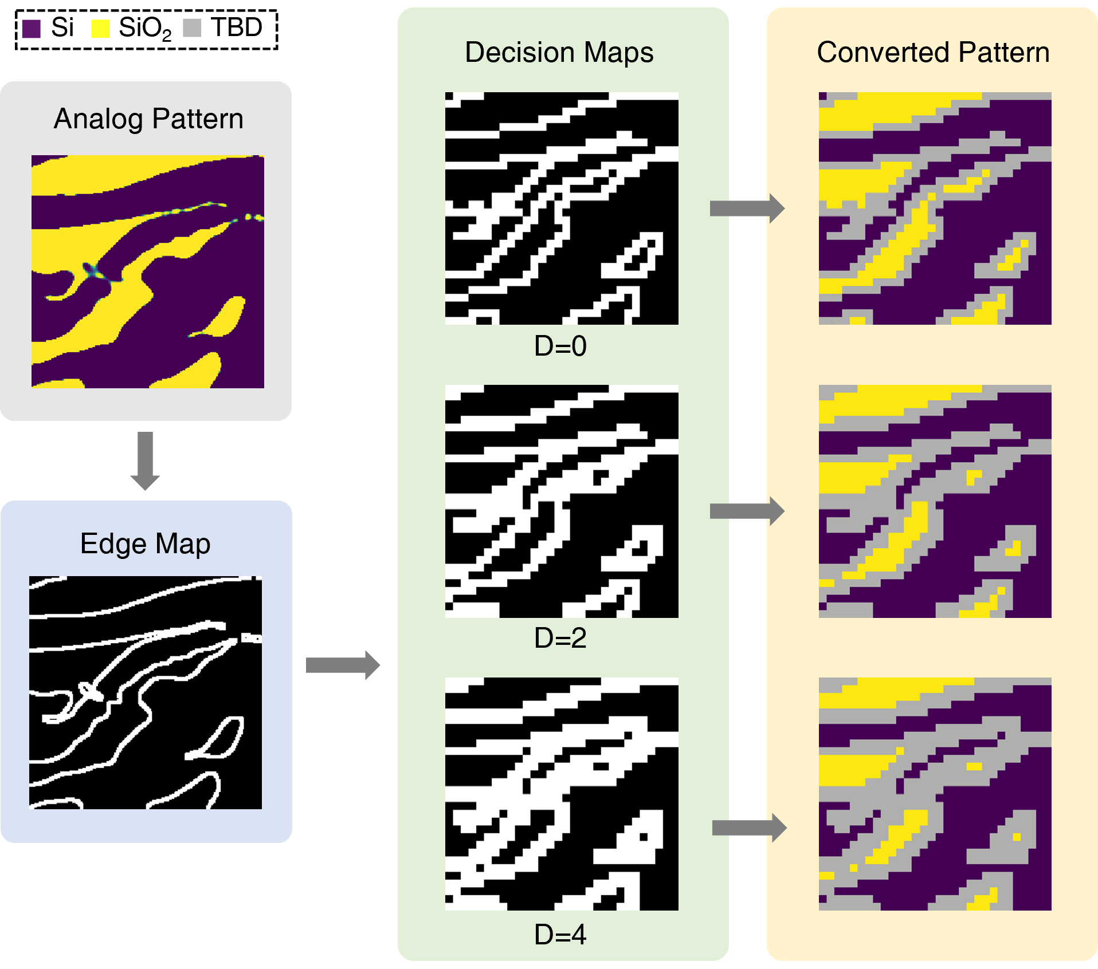
Fig. S9 The evolution of index patterns for the two-mode MUXs.
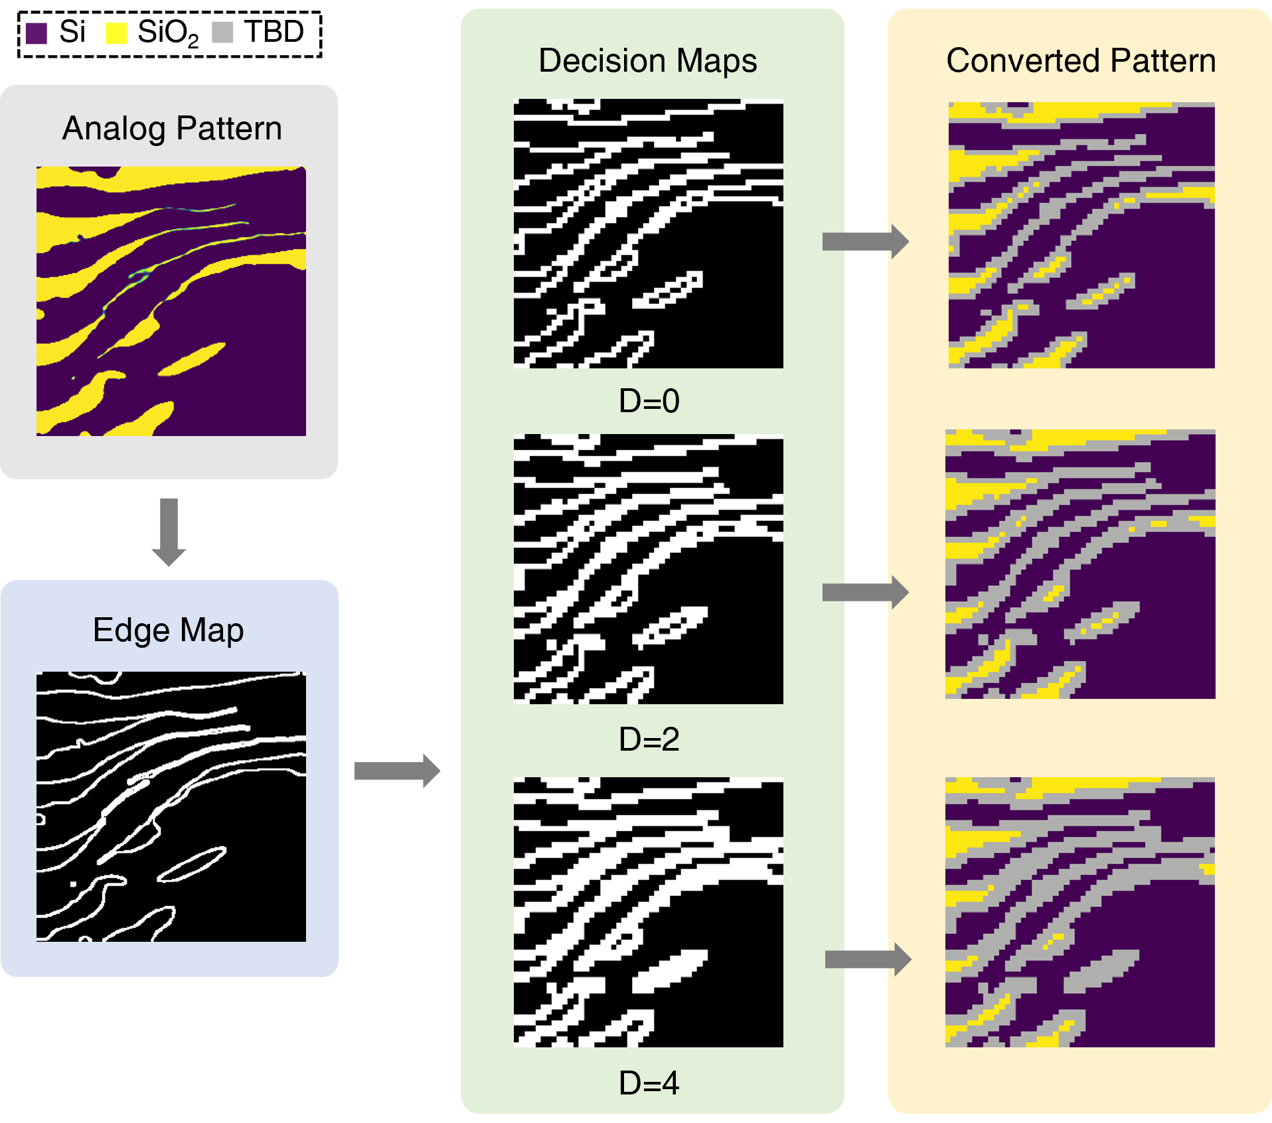
Fig. S10 The evolution of index patterns for the four-mode MUXs.
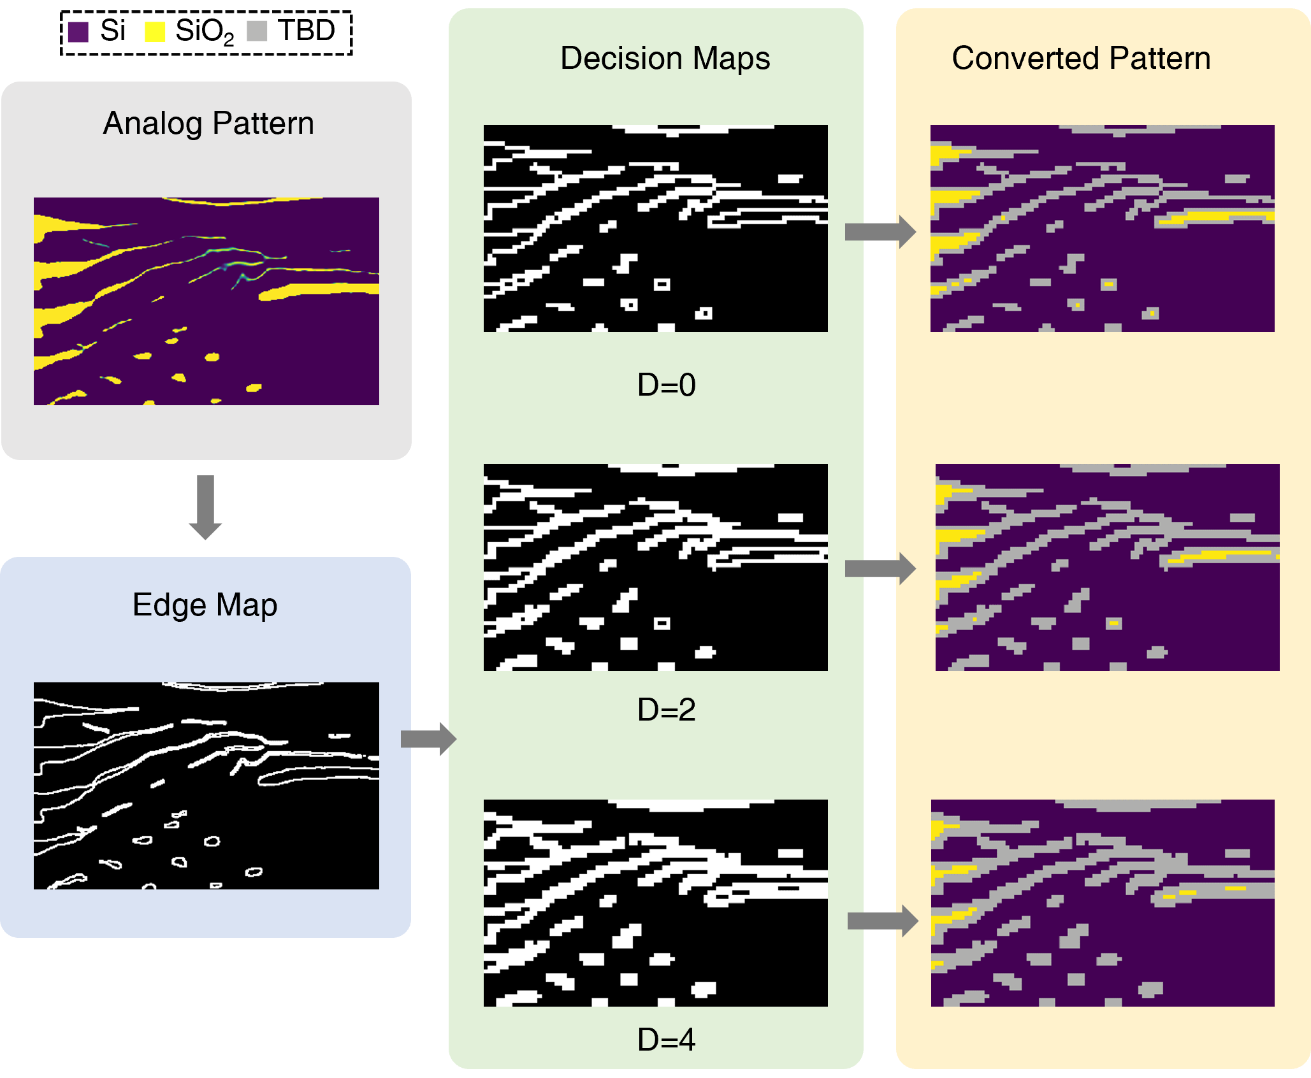
Fig. S11 The evolution of index patterns for the five-mode MUXs.

Supplementary Note 5: Discussions on the conversion rate
As detailed in Supplementary Note 4, the proportion of TBD pixels increases with the dilation coefficient D. Fig. S12 explores the conversion rates of two-mode, four-mode, and five-mode MUXs as D changes, where the conversion rate is defined as the proportion of pixels that directly undergo index mapping relative to the total pixel count. For each MUX, the analog pattern remains the same, only the dilation coefficient D is varied. At D = 0, the direct conversion rates for the two-mode, four-mode, and five-mode MUXs are notably high at 71.22%, 76.52%, and 83.64% respectively, requiring only a few DBS iterations for digital optimization. The conversion rates for all three MUXs show a linear decrease as D increases. MUXs that support more modes demonstrate higher conversion rates under identical dilation coefficients, as evidenced across the configurations examined. The increased efficiency is attributed to a larger device footprint, which inherently contains regions where optical power transmission is minimal (as illustrated in Fig. S7 insets). In these regions, reduced sensitivity of optimization parameters leads to minimal modifications in the local index, resulting in extensive areas comprised of non-edge pixels. Consequently, our EG-ADO method is particularly advantageous for devices supporting high-order modes and proves effective for designs with large footprints. This advantage is highlighted in Fig. 2(e) in the main manuscript, where EG-ADO outperforms traditional digital optimization methods, showing a significant reduction in computational complexity with an increasing number of modes.
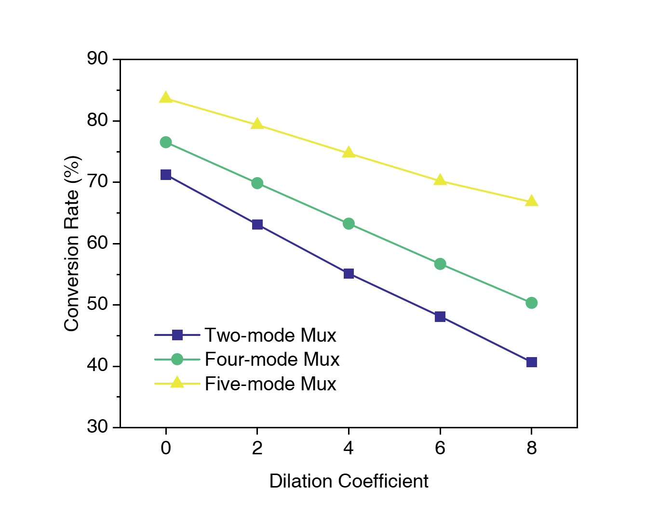
Fig. S12 The conversion rate at different dilation coefficients for two-mode, four-mode, and five-mode MUXs

Supplementary Note 6: Supplementary information for the on-chip interconnect experiments

Chip packaging
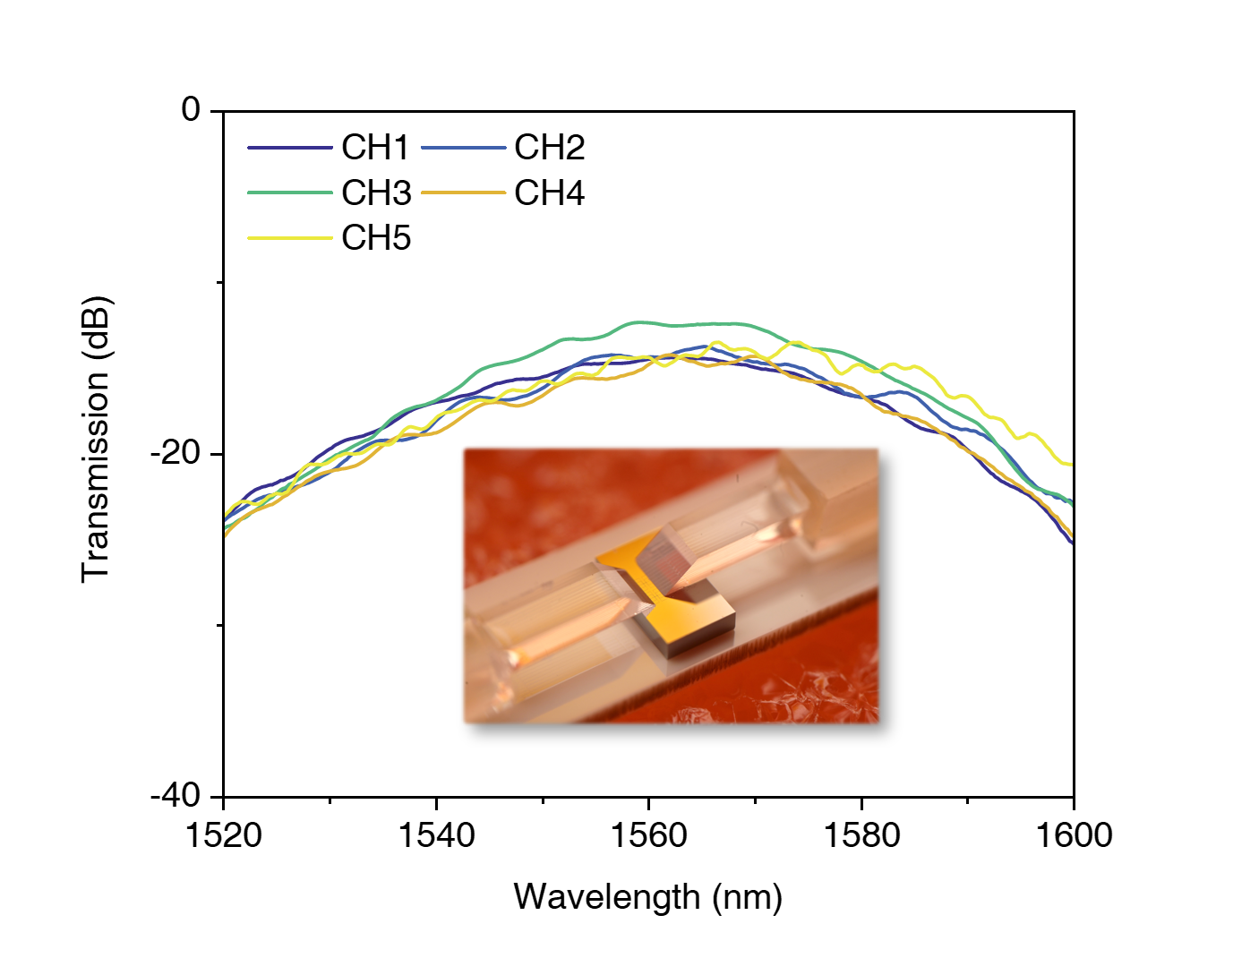
Fig. S13 Measured transmission spectra of the packaged five-mode MDM chip. The inset presents the macroscopic image of the packaged chip.
To enhance stability of signal transmission experiments, we package the five-mode MUX chip using two pairs of 8-channel vertical coupling fiber arrays, utilizing five channels per array. The fiber arrays are aligned at an 8-degree angle, while the optimal incident angle for the grating couplers is approximately 10.5 degrees. The angle mismatch results in a red-shift of the center wavelength of the back-to-back MUX link from the designed 1550 nm. Fig. S13 illustrates the transmission spectra for each mode after packaging, where the total loss per channel includes contributions from two grating couplers, two MUXs, and a multimode bus waveguide. It can be observed that the peak wavelength shifts by approximately 15 nm. The total loss at the center wavelength for all channels remains below 15 dB, indicating that the packaging does not introduce additional loss. Notably, the coupling loss introduced by the input and output grating couplers is approximately 11 dB, accounting for a significant portion of the total loss. Reducing the loss from the grating couplers^{10–12} or adopting edge couplers^{13–15} could significantly enhance the performance of high-speed signal transmission by increasing the signal-to-noise ratio (SNR). The inset in Fig. S13 shows a macroscopic image of the packaged chip.

System frequency response
During the single-λ transmission experiments, we measure the end-to-end frequency response of the system, which includes components such as the digital-to-analog convertor (DAC), Mach Zehnder modulator (MZM), photodiode (PD), analog-to-digital convertor (ADC), and high-speed cables. The system frequency response is measured using Keysight IQtools by transmitting multi-tone signals across the 0-64 GHz range, distributed evenly across 200 frequency points¹⁶. The normalized end-to-end channel response is shown in Fig. S14. This system has an approximate 10-dB bandwidth of 57 GHz.
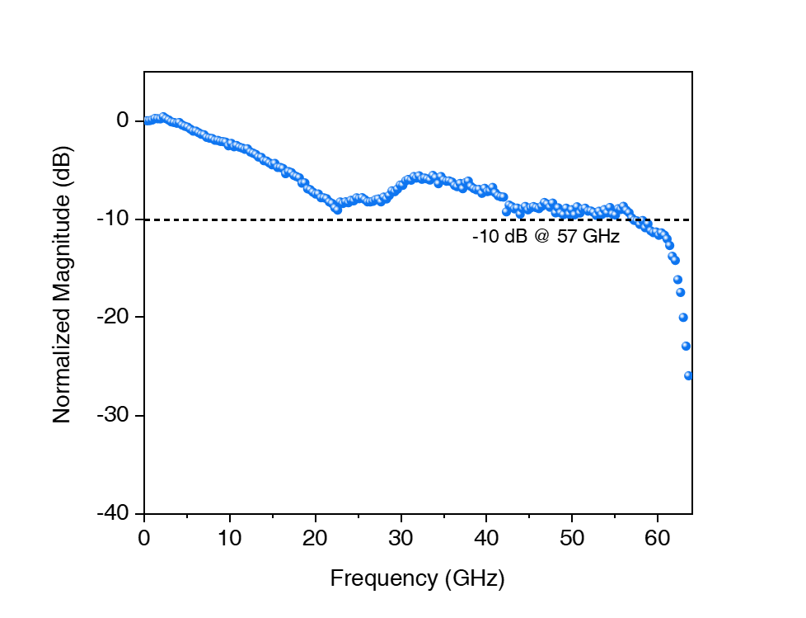
Fig. S14 Measured end-to-end system frequency response for the single-λ experiment.

Detailed experiment set-up and DSP flow
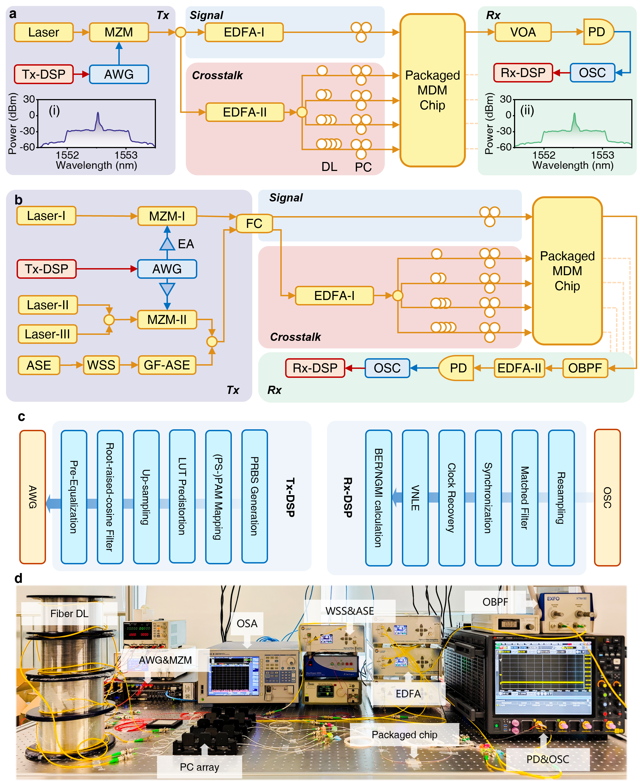
Fig. S15 Detailed experiment set-up and DSP flow. a Experimental setup for the single-λ MDM transmission experiment of the packaged five-mode chip. The insets (i) and (ii) display the measured optical spectra of the optical signal after the MZM and before the PD, respectively. MZM, Mach-Zehnder modulator; AWG, arbitrary waveform generator; EDFA, erbium-doped fiber amplifier; DL, delay line; PC, polarization controller; VOA, variable optical attenuator; PD, photodiode; OSC, oscilloscope; DSP, digital signal processing. b Schematic of the experimental set-up for the multi-dimensional transmission experiments. EA, electrical amplifier; ASE, amplified spontaneous emission source; GF-ASE, gain-flattening ASE source; WSS, wavelength selective switch; FC, fiber coupler; OBPF, optical band-pass filter. c DSP flow at the transmitter and receiver sides for both the single-λ and multi-dimensional interconnect experiments. d Picture of the system set-up.
The detailed experimental set-up schematics for single-λ and multi-dimensional interconnect are presented in Fig. S15(a)-(b). Both experiments share the same digital signal processing (DSP) workflow, as illustrated in Fig. S15(c). At the transmitter side, a pseudo-random binary sequence (PRBS) is first generated, which is then mapped into pulse amplitude modulation (PAM) symbols for the single-λ experiment and probability-shaping PAM (PS-PAM) symbols for the multi-dimensional experiment. A single-tap lookup table (LUT) is employed to pre-compensate for nonlinear distortions. These symbols are then resampled and pulse-shaped using a root-raised cosine (RRC) filter with a roll-off factor of 0.1. Linear pre-equalization is then performed to partially compensate for bandwidth limitations before the signal is finally sent to the arbitrary waveform generator (AWG).
At the receiver, signals captured by the oscilloscope are first resampled and passed through a matched filter. Clock synchronization is conducted to ensure accurate data acquisition and to recover the clock signal from the received signals. To compensate for nonlinear effects in the signal, a third-order Volterra non-linear equalization (VNLE) is employed. In the single-wavelength experiment, the VNLE uses tap counts of 151, 7, and 7 for the three orders. For the multi-dimensional experiment, the tap counts are adjusted to 201, 1, and 1, respectively, to tailor the response for each scenario. Finally, the bit error rate (BER) and normalized generalized mutual information (NGMI) are calculated to assess the quality of the received signal.
Additionally, the picture of the system setup is provided in Fig. S15(d).

Operation methods for generating the WDM signal
In the multi-dimensional experiment for WDM signal transmission, we generate a composite signal encompassing all 88 channels, comprising the modulated optical signals from three lasers and an ASE noise that fills the C-band. Fig. S16 illustrates the process of generating the ASE channels. Initially, we obtain the optical spectrum (Fig. S16(a)) generated by the two cascaded EDFAs. To ensure uniform power across all WDM channels, we extract the relevant spectral range (1531-1565.8 nm) from the initial spectrum. We then adjust the attenuation spectrum on the wavelength selective switch (WSS) to achieve spectral flattening based on the power information. The attenuation at the three signal channels is maximized (60 dB) to create spectral slots. For the remaining ASE channels, we periodically adjust the attenuation to form a comb-like spectrum with 50 GHz frequency intervals. Fig. S16(c)-(e) displays the attenuation spectra sent to the WSS when the central channel index of the excavated slots is set to 1, 44, and 88, respectively.
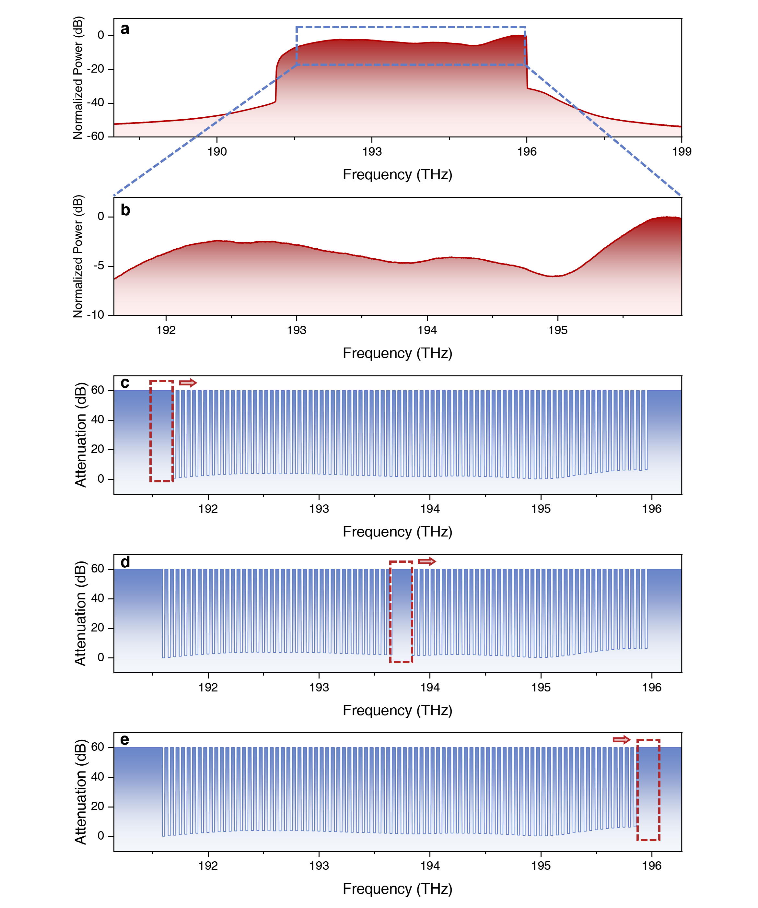
Fig. S16 Operation methods for creating the ASE channels. a-b The initial optical spectrum generated by the cascaded EDFAs in the range of (a) 188 to 199 THz and (b) 191.55 to 191.6 THz. c-e The attenuation spectra sent to the WSS when the central channel index is (c) 1, (d) 44, and (e) 88, respectively.

Principle of PS-PAM signal generation
PS technique has proven to be an efficient way to control source entropy^{17,18}. By changing the constellation distribution towards a Maxwell-Boltzmann distribution, it can flexibly adjust the entropy of the constellation to an arbitrary value. The probability distribution of the generated PS-PAM-M symbols can be expressed as¹⁹:
$p_{i}=\frac{\exp{(}-v⋅{y_{i}}^{2})}{\sum_{j=1}^{M}{\exp{(}-v⋅{y_{j}}^{2})}}$ (S10)
where y_{i} is the modulation value of the i-th symbol, and v is the weight of PS. In PAM, the squared amplitude of each modulation symbol y_{i} represents the concept of "energy," and this energy is influenced by the parameter v. This results in a probability distribution where the likelihood of selecting each signal level is exponentially inversely related to its energy. When v > 0, signals with lower energy (i.e., lower squared amplitudes) have a higher probability of occurrence, whereas higher energy signals are less likely, and vice versa. This type of distribution is advantageous in communication systems that require power control or need to adapt to channel conditions such as attenuation or noise levels. By adjusting v, the average energy of the signal can be optimized, thus enhancing overall system performance by reducing power consumption or improving reliability.
To demonstrate the impact of PS on PAM signals, we generate 1000 PS-PAM-8 symbols under various values of v. The histograms, as shown in Fig. S17, indicate a uniform distribution of symbols at v = 0, which shifts towards more frequent occurrences of lower energy symbols as v increases. Fig. S18 plots the relationship between the entropy of the PS-PAM-8 signals and v, illustrating how adjusting v can flexibly control the entropy and, consequently, the efficiency of signal transmission. As v increases further, the modulated signal progressively approximates the PAM-2 format.
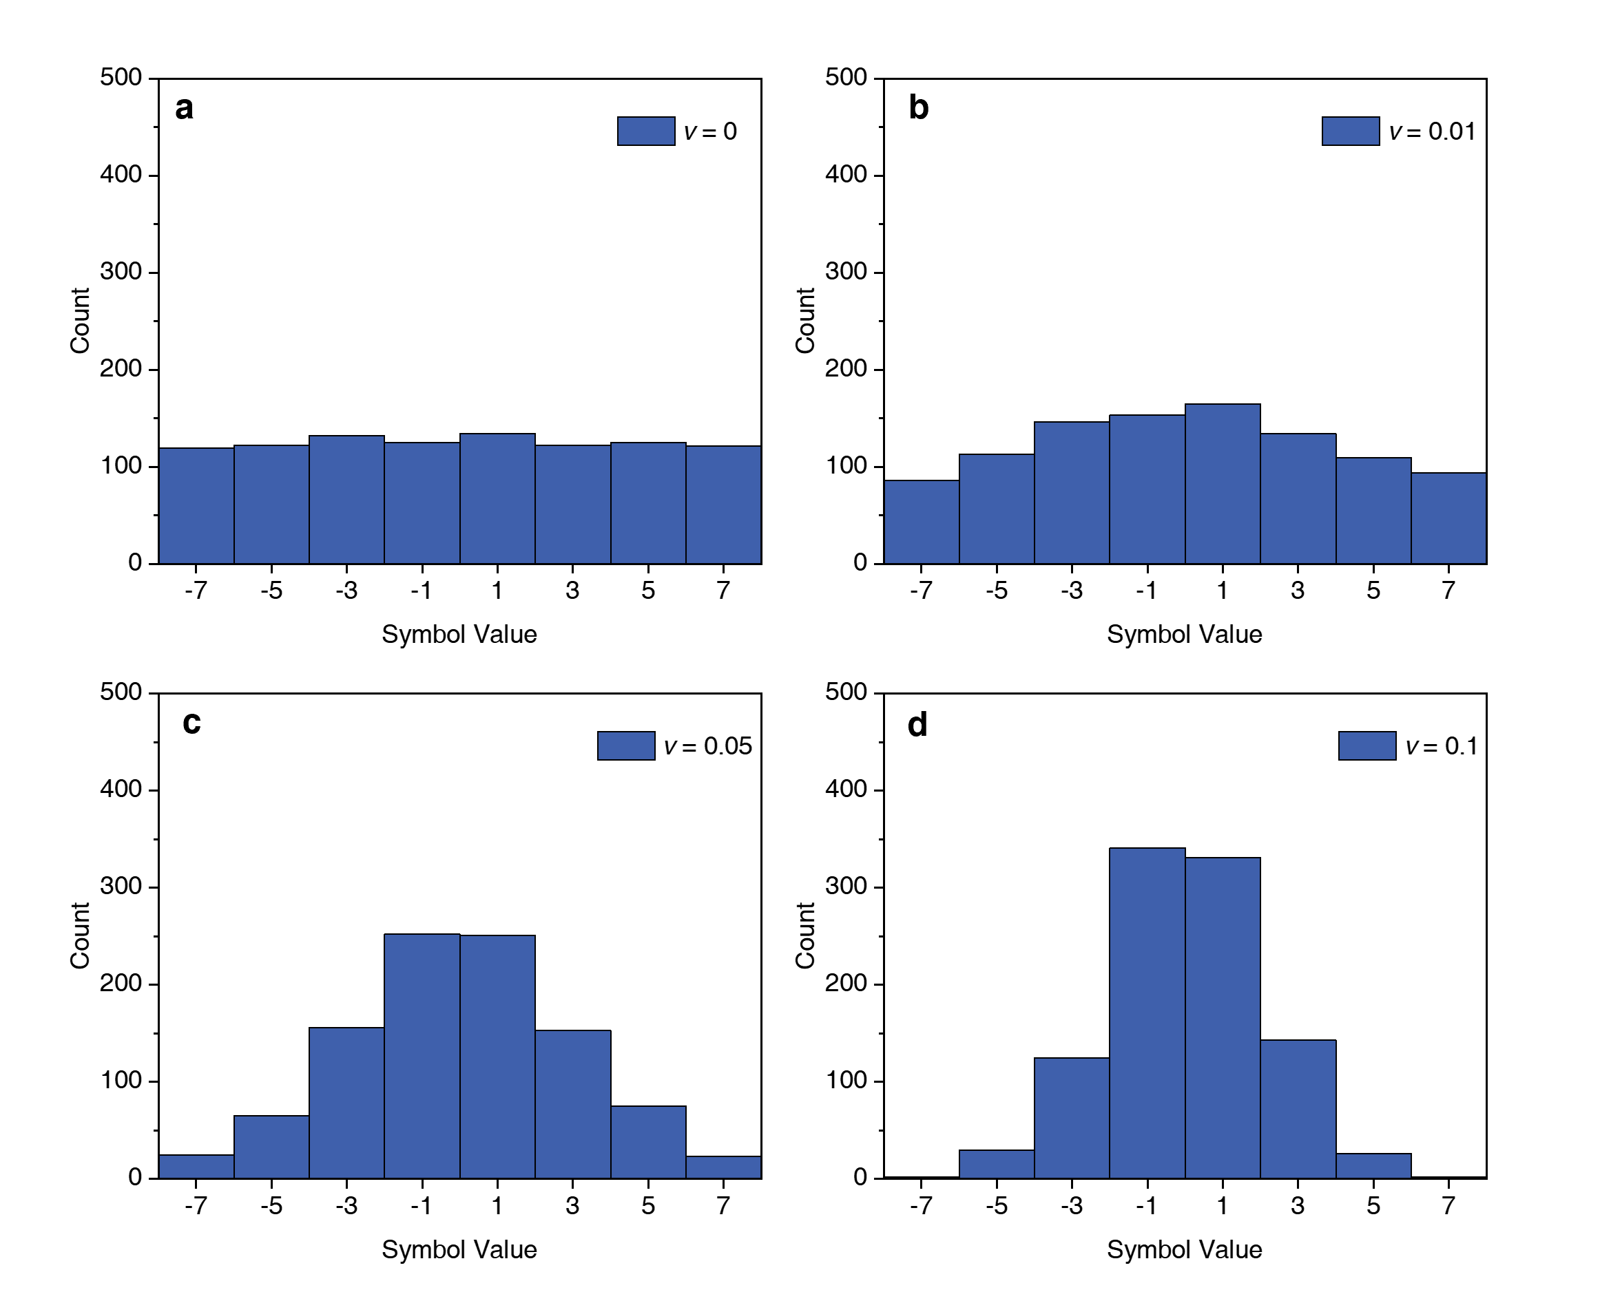
Fig. S17 Histograms for 1000 PS-PAM-8 symbols generated with (a) v = 0, (b) v = 0.01, (c) v = 0.05, and (d) v = 0.1, respectively.
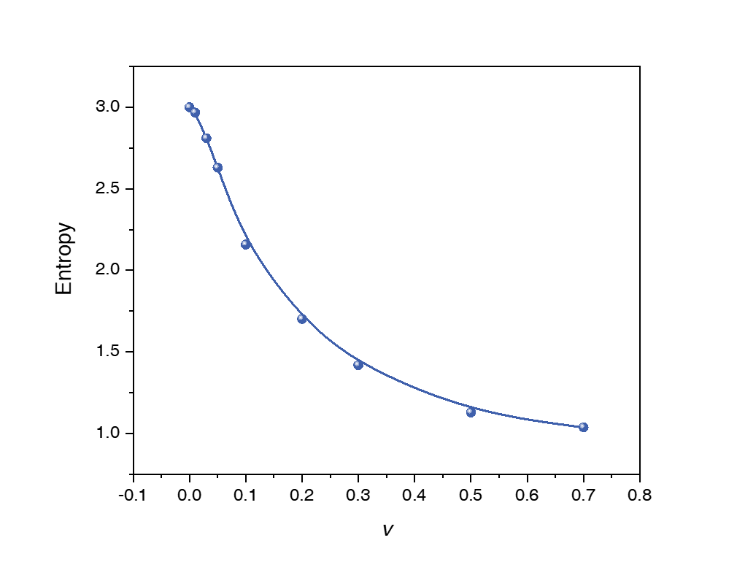
Fig. S18 Entropies of the transmitted PS-PAM-8 signal under different v.

NGMI performance of the multi-dimensional experiment
Here we provide the NGMI performance of the entire 440 channels in the multi-dimensional experiment, as shown in Fig. S19. All channels achieve an NGMI above the 0.8116 threshold, with 432 channels maintaining NGMI values exceeding 0.89. The 0.8116 NGMI threshold corresponds to an overall code rate of 0.7519 using the SD+HD concatenated FEC code, as suggested in Reference²⁰.
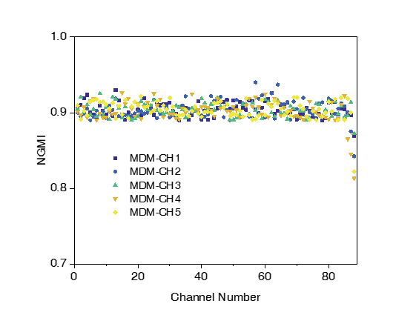
Fig. S19 NGMI performance of the multi-dimensional experiment across all 88 wavelength channels for five modes. The evident fall of NGMI values at the last few channels is due to the high coupling loss introduced by the grating couplers.

Potential performance estimation of the ultra-high-capacity interconnect
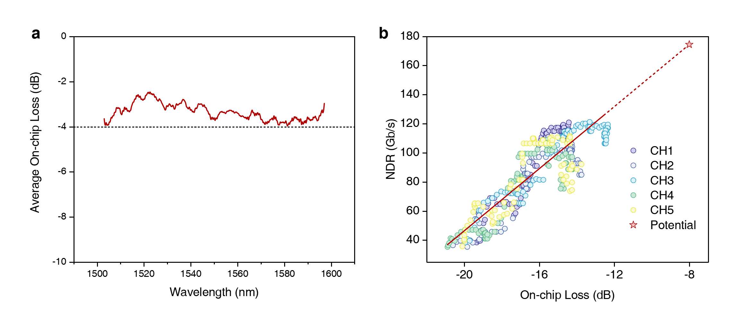
Fig. S20 Potential performance estimation. (a) Average on-chip loss of all five modes for the five-mode MDM chip. (b) Relationship between the measured NDR and the on-chip loss. The red line indicates the linear fit of the scatter plot.
In the MDM chip, grating couplers are employed to connect waveguides and fibers. However, their wavelength sensitivity has obscured the performance of our designed broadband five-mode MUX. During the experiment, we observed that the data rate of each signal channel correlates positively with the device loss at its corresponding wavelength. The measured net data rates (NDR) for all channels are plotted as a function of post-packaging on-chip loss in Fig. S20(b). According to Shannon's theorem, the system capacity C in relation to the SNR is expressed as:
$C=B⋅\log_{2}\left(1+SNR\right)$ (S11)
where B is the system bandwidth. When the SNR is given in decibels (SNR_{dB}), (S11) is rewritten as:
$C=B⋅\log_{2}\left(1+10^{\frac{SNR_{dB}}{10}}\right)$ (S12)
In this experiment, the SNR is much greater than 1, which leads to:
$C≈B⋅\log_{2}\left(10^{\frac{SNR_{dB}}{10}}\right)$ (S13)$=\frac{B}{\log_{2}{1}0}⋅SNR_{dB}$ (S14)
Given the relatively small nonlinear coefficients of silicon, we can adopt the linear relationship between the system capacity and SNR_{dB}. Therefore, we perform a linear regression of the measured net data rates (NDR) against losses, represented by the red line in Fig. S20(d).
There are two primary approaches to augment system capacity:
- Reducing insertion loss: Utilizing edge couplers with lower loss and broader bandwidth for chip-to-fiber connection can significantly improve performance. As shown in Supplementary Table 1, state-of-the-art broadband edge couplers on the SOI platform feature losses below 2 dB and offer substantial bandwidth advantages.
- Expanding spectral resources: Leveraging the flat transmission response of our designed five-mode MUX, we propose expanding the spectral resources to include the S+C+L bands (1500-1600 nm), covering a total bandwidth of 12.5 THz across 250 DWDM channels.
Fig. S20(a) displays the average losses for all five modes across this bandwidth, all under 4 dB. This allows on-chip total loss to be reduced to below 8 dB with the implementation of edge couplers, yielding an estimated rate of 174.4 Gb/s per channel according to the linear fit. Consequently, the supported capacity for on-chip optical interconnects could reach 250 (wavelength channels) × 5 (mode channels) × 174 Gb/s = 0.218 Pb/s, paving the way for next-generation optical on-chip data-center interconnect (DCI)²¹ and the cutting-edge optical compute interconnect (OCI)²².
Supplementary Table 1 List of state-of-the-art broadband edge couplers on the SOI platform
Year ^{Reference} | Loss (dB) | Bandwidth (nm)
2021¹³ | 1.81 | 120
2020¹⁴ | 1.59 | 92

Supplementary Note 7: Scalability validation
The EG-ADO method introduced in this study is not limited to the inverse design of the experimentally validated five-mode MUX. We have extended its application by designing an ultra-compact six-mode MUX through 3D-FDTD simulations to verify the scalability of the algorithm. This six-mode MUX requires only 1.57 times the number of simulations needed for the inverse-design of the five-mode MUX. Fig. S21(a) and (b) illustrate the schematic of the device, with a design region of 10×8 µm² and a 3 µm wide multimode output waveguide to support the first six TE modes. The spacing between input waveguides is set at 1 µm. The MFS of 120 nm ensures compatibility with commercial foundry processes. The transmission spectra of the six-mode MUX, shown in Fig. S21(c)-(h), indicate insertion losses of 0.88 dB, 1.24 dB, 1.75 dB, 1.81 dB, 1.73 dB, and 1.79 dB for the six mode channels at 1550 nm, with crosstalks of -19.6 dB, -19.16 dB, -20.46 dB, -17.26 dB, -17.52 dB, and -21.48 dB, respectively. Broadband optimization ensures that the worst crosstalk across the entire C-band remains below -15 dB, with notably flat transmission spectra for all channels. This outcome highlights the potential of the EG-ADO method in advancing complex, large-area, and high-performance photonic devices.
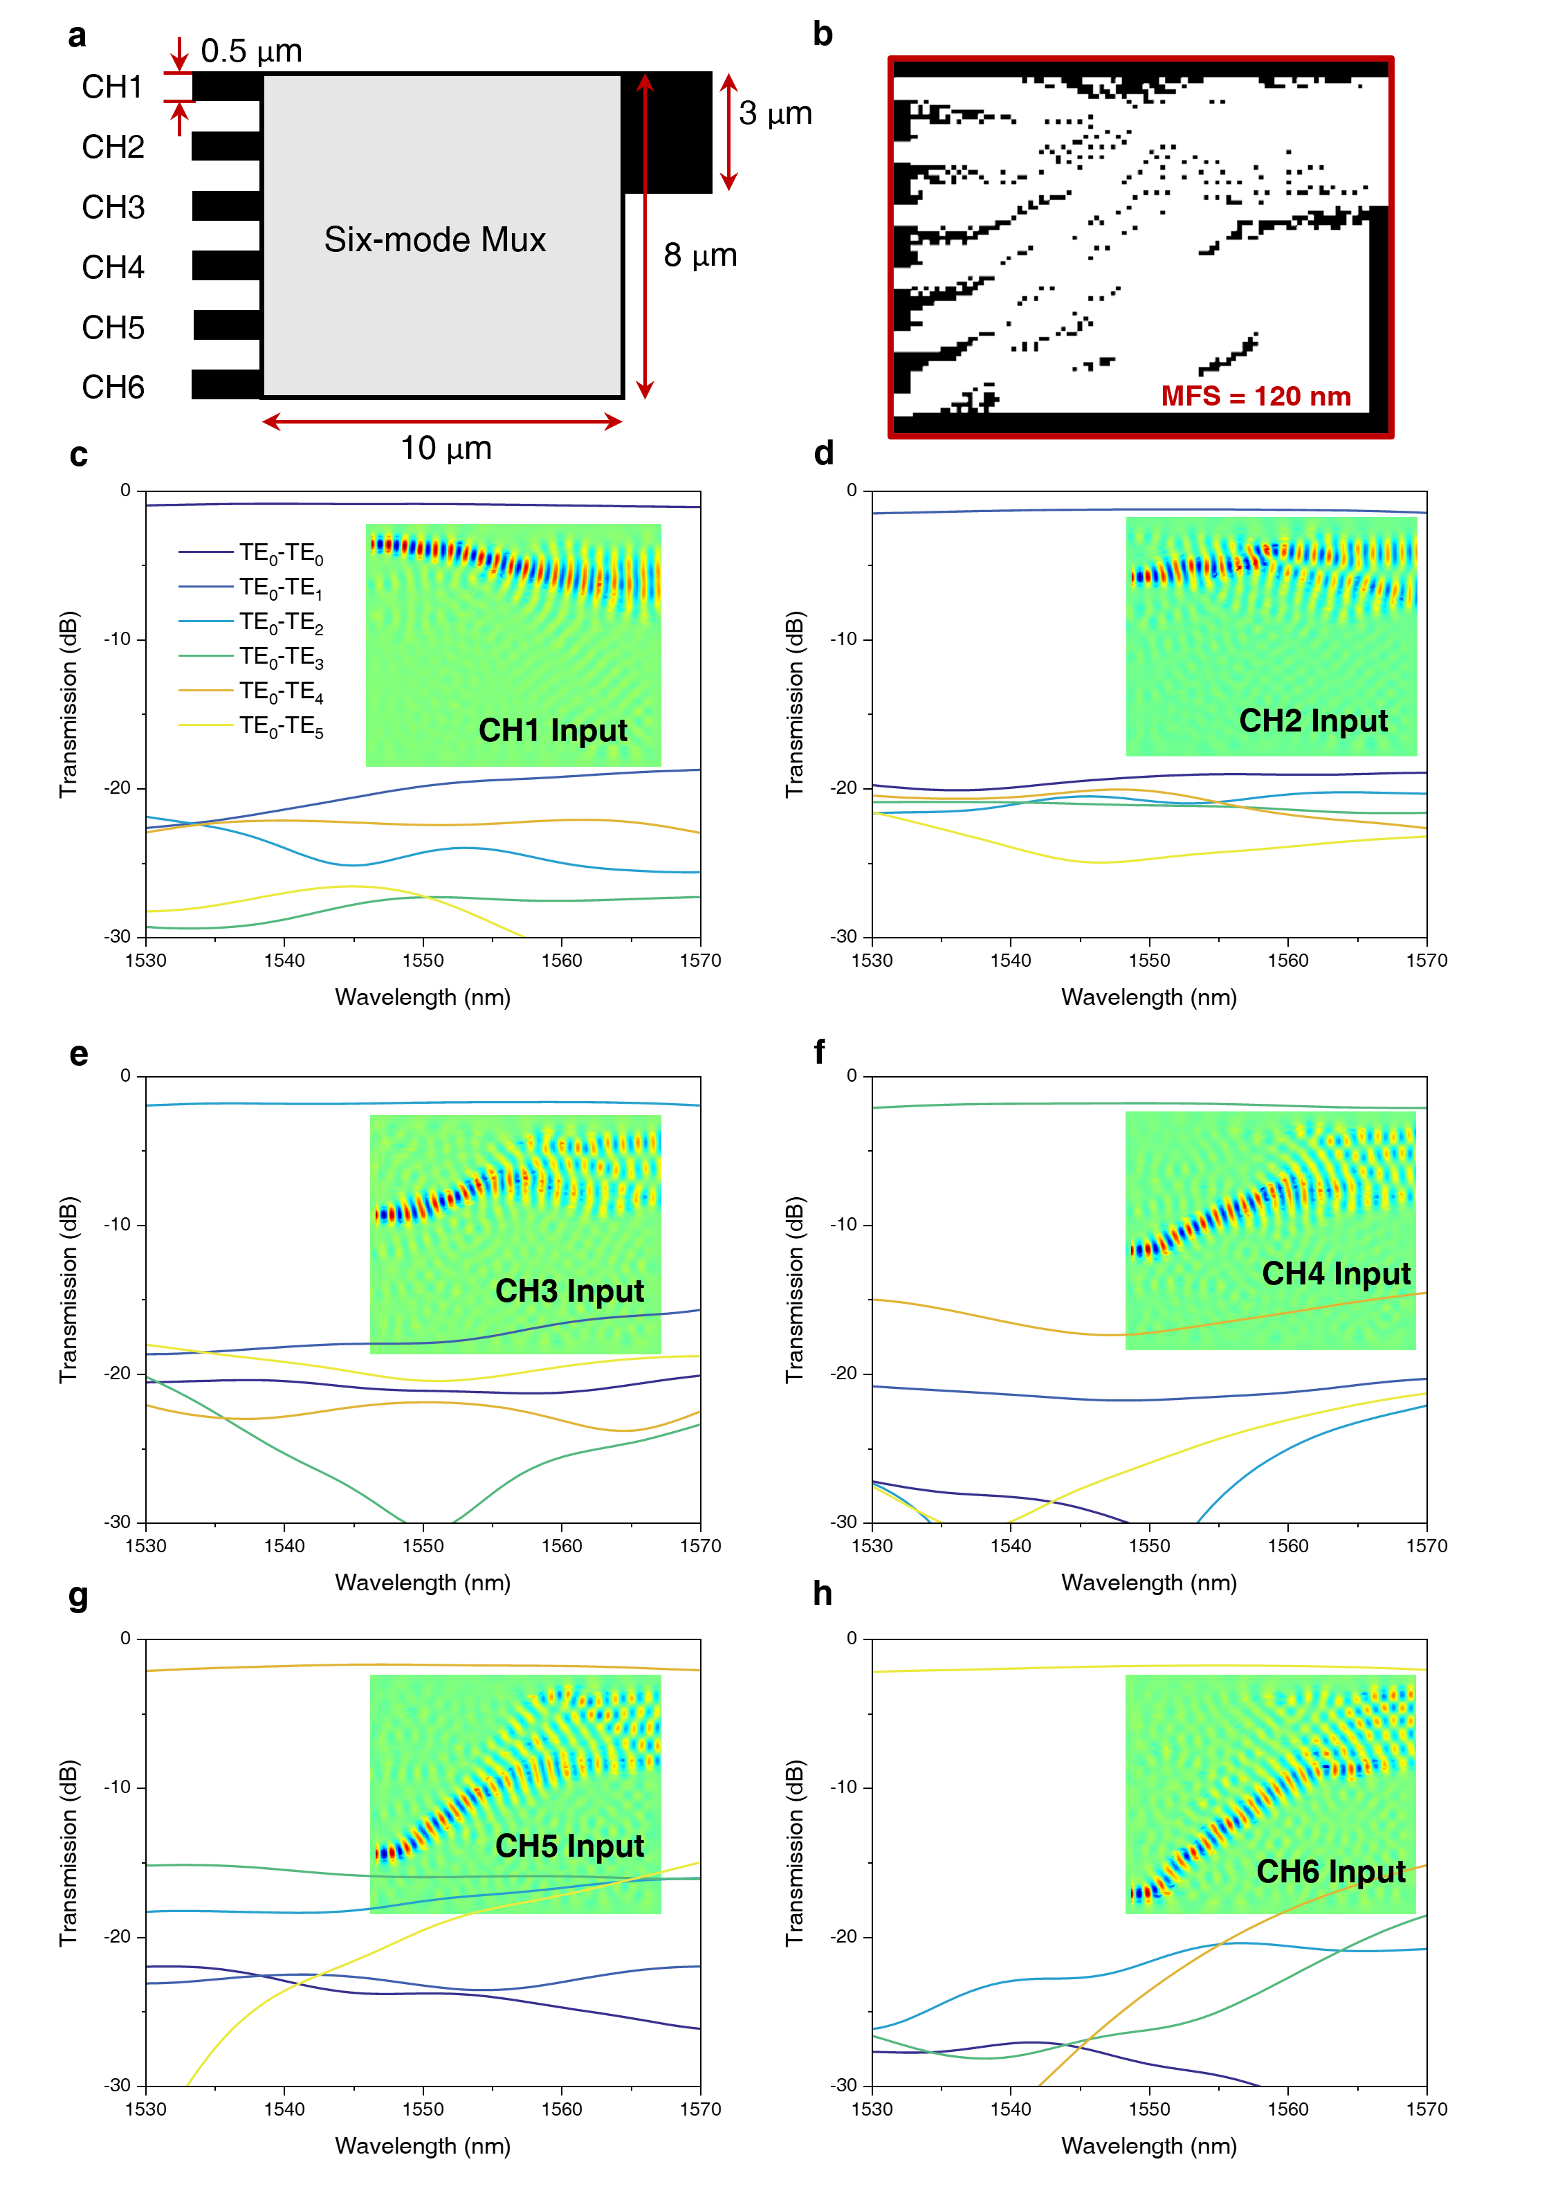
Fig. S21 Structure and performance of the six-mode MUX. (a) Schematic and channel annotations of the six-mode MUX. (b) Final digital pattern of the six-mode MUX. (c)-(h) Simulated transmission spectra of the optimized six-mode MUX. Insets depict the light propagation process for each mode channel.

Supplementary Note 8: Equipment models
The main equipment used in this paper along with their model types are listed in Supplementary Table 2.
Supplementary Table 2 List of instruments and components used in the measurement and characterization setups
Equipment | Model
Arbitrary Waveform Generator | Keysight M8199B  Keysight M8194A
Oscilloscope | Keysight UXR0134A
Optical Spectrum Analyzer | Yokogawa AQ6370D
Photodiode | Finisar XPDV4121R
Mach-Zehnder Modulator | NOEIC MZ135-LN60  Sumicem T.MXH 1.5-20PD-ADC-LV
Tunable Laser | Keysight N7714A
Passive Optical Component Testing Platform | EXFO CTP10
Frequency Sweep Laser | EXFO T100S
Polarization Scrambler | EPS1000
Erbium-Doped Fiber Amplifier | OVLINK EDFA-C-BA-GF-26-PM-B  OVLINK EYDFA-C-HP-BA-30-PM-B  Amonics AEDFA-23-B-FA
Wavelength Selective Switch | Finisar Waveshaper 4000S
Optical Band-Pass Filter | EXFO XTM-50-SCL-U
Variable Optical Attenuator | OVLINK SVOA-1000

References
1. Lalau-Keraly, C. M., Bhargava, S., Miller, O. D. & Yablonovitch, E. Adjoint shape optimization applied to electromagnetic design. Opt. Express, OE 21, 21693–21701 (2013).
2. Meng, Y. et al. Optical meta-waveguides for integrated photonics and beyond. Light Sci Appl 10, 235 (2021).
3. Zhou, H. et al. Dielectric Metasurfaces Enabled Ultradensely Integrated Multidimensional Optical System. Laser & Photonics Reviews 16, 2100521 (2022).
4. Liu, Y. et al. Arbitrarily routed mode-division multiplexed photonic circuits for dense integration. Nat Commun 10, 3263 (2019).
5. Sun, A. et al. Inverse design of an ultra-compact dual-band wavelength demultiplexing power splitter with detailed analysis of hyperparameters. Opt. Express, OE 31, 25415–25437 (2023).
6. Bourdin, B. Filters in topology optimization. International Journal for Numerical Methods in Engineering 50, 2143–2158 (2001).
7. Canny, J. A Computational Approach to Edge Detection. IEEE Transactions on Pattern Analysis and Machine Intelligence PAMI-8, 679–698 (1986).
8. Shen, R. et al. Recent progress on inverse design for integrated photonic devices: methodology and applications. JNP 18, 010901 (2024).
9. Siew, S. Y. et al. Review of Silicon Photonics Technology and Platform Development. J. Lightwave Technol. 39, 4374–4389 (2021).
10. Benedikovic, D. et al. High‐efficiency single etch step apodized surface grating coupler using subwavelength structure. Laser & Photonics Reviews 8, (2014).
11. Marchetti, R. et al. High-efficiency grating-couplers: demonstration of a new design strategy. Sci Rep 7, 16670 (2017).
12. Yang, M. et al. High-performance grating couplers on 220-nm thick silicon by inverse design for perfectly vertical coupling. Sci Rep 13, 18112 (2023).
13. He, A., Guo, X., Wang, T. & Su, Y. Ultracompact Fiber-to-Chip Metamaterial Edge Coupler. ACS Photonics 8, 3226–3233 (2021).
14. He, A., Guo, X., Wang, K., Zhang, Y. & Su, Y. Low Loss, Large Bandwidth Fiber-Chip Edge Couplers Based on Silicon-on-Insulator Platform. J. Lightwave Technol., JLT 38, 4780–4786 (2020).
15. Mu, X., Wu, S., Cheng, L. & Fu, H. Y. Edge Couplers in Silicon Photonic Integrated Circuits: A Review. Applied Sciences 10, 1538 (2020).
16. Keysight. Keysight IQtools. Keysight https://www.keysight.com/us/en/lib/software-detail/computer-software/keysight-iqtools.html.
17. Xing, S. et al. Demonstration of flexible access in a rate-adaptive visible light communication system with constellation probabilistic shaping. Opt. Express 29, 34441 (2021).
18. Xing, S. et al. Demonstration of PS-QAM Based Flexible Coherent PON in Burst-Mode With 300G Peak Rate and Ultra-Wide Dynamic Range. Journal of Lightwave Technology 41, 1230–1239 (2023).
19. Yan, A. et al. Net-432-Gb/s/λ PS-PAM transmission based on advanced DSP and single DAC for 400 G/λ IM/DD links. Opt. Lett. 49, 1656 (2024).
20. Hu, Q. et al. Ultrahigh-Net-Bitrate 363 Gbit/s PAM-8 and 279 Gbit/s Polybinary Optical Transmission Using Plasmonic Mach-Zehnder Modulator. Journal of Lightwave Technology 40, 3338–3346 (2022).
21. Spyropoulou, M. et al. The future of multi-terabit datacenter interconnects based on tight co-integration of photonics and electronics technologies. in Optical Fiber Communication Conference (OFC) 2023 (2023), paper Tu3I.3 Tu3I.3 (Optica Publishing Group, 2023). doi:10.1364/OFC.2023.Tu3I.3.
22. Intel Demonstrates First Fully Integrated Optical I/O Chiplet. Intel https://www.intel.com/content/www/us/en/newsroom/news/intel-unveils-first-integrated-optical-io-chiplet.html.

