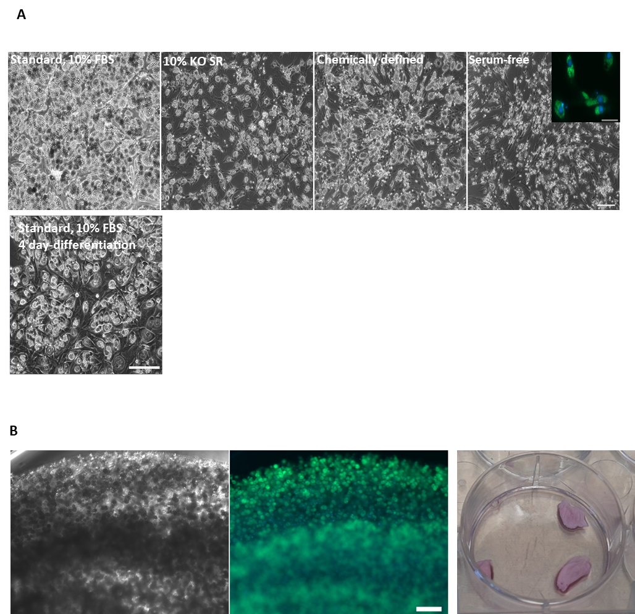
Supplementary Figure 1. Efficient differentiation of FaTTy cells under a variety of conditions. (A) (Top row) Representative brightfield images of adipocytes obtained after differentiation of FaTTy cells for 11 days using standard serum-containing media or media where serum had been removed or replaced with KO serum replacement or chemically defined media, as detailed in Methods (scale bar = 100 µm). Inset shows adipocytes stained with BODIPY (green) and Hoescht 33452 (blue, scale bar = 20 µm). (Bottom row) Image of adipocytes obtained after differentiation of FaTTy cells for four days using standard serum-containing media. Scale bar = 50 µm. (B) Representative brightfield (left) and fluorescence (middle) images denoting a high degree of adipocyte accumulation after differentiation of FaTTy cells in an alginate hydrogel. Scale bar = 100 µm. 3D ‘steaks’ of fat produced after differentiation in hydrogels are also shown (right).
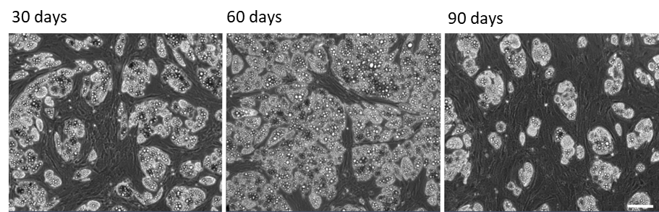
Supplementary Figure 2. Further attempts to re-derive FaTTy-like cells from MSC5 progenitors did not yield cells with sustained proliferative and differentiation capacity. Representative brightfield images showing a reduction in the ability of MSC5 cells to form adipocytes upon continuous expansion for about 30, 60 or 90 days. In each case Images were taken after an 11-day differentiation (scale bar = 100 µm).

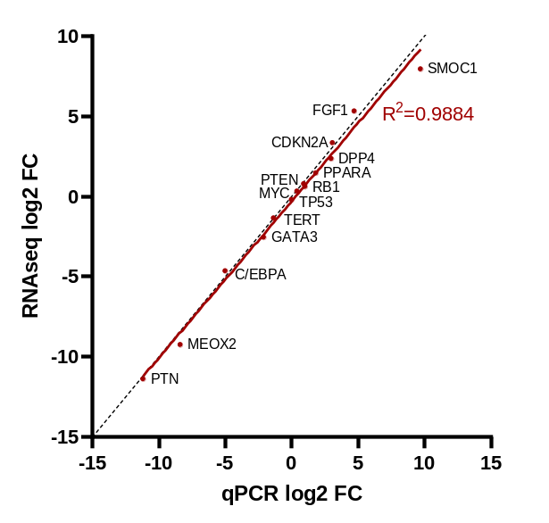
Supplementary Figure 3. Correlation between RNA-seq and RT-qPCR data. Comparison of the log2 fold changes in selected transcript abundance between FaTTy and its parental cell line as measured by bulk RNA-sequencing and RT-qPCR. R squared value was calculated by simple linear regression. Dotted line denotes y=x.
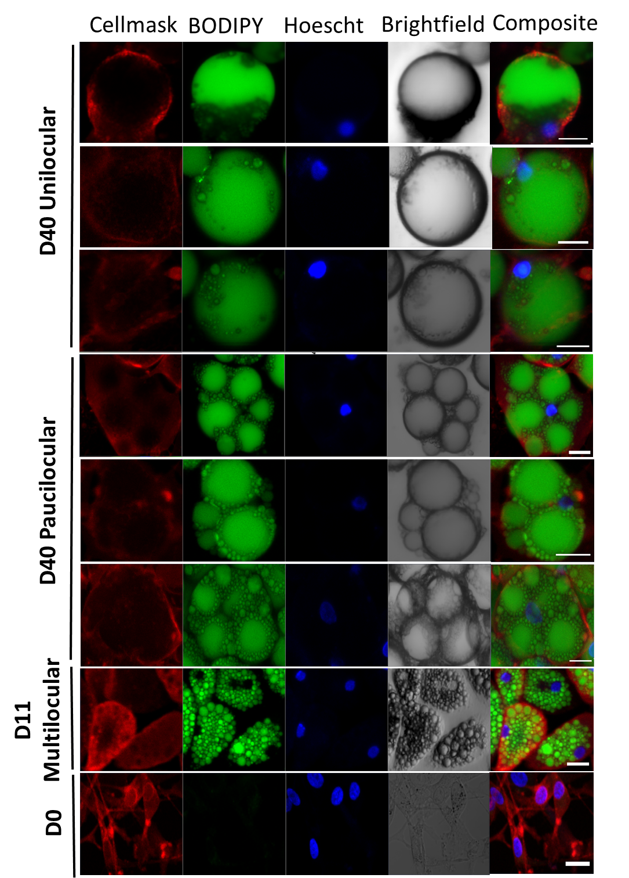
Supplementary Figure 4. Morphology of FaTTy-derived adipocytes. Representative images of individual adipocytes obtained after differentiation of FaTTy cells for 11 or 40 days, illustrating multilocular, paucilocular and unilocular phenotypes. Undifferentiated FaTTy cells (D0) are also shown. CellMask (red), Hoescht 33452 (blue) and BODIPY (green) stain cell membranes, nuclei and lipids, respectively. Scale bar = 20µm
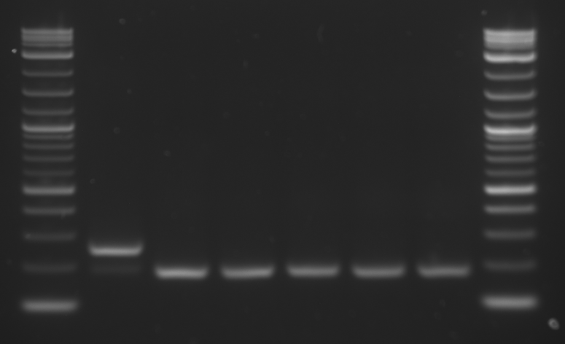
1
2
3
4
5
6
Supplementary Figure 5. Mycoplasma screen. Representative mycoplasma screen, visualised by agarose gel. Lanes from left to right, 1 kb DNA ladder, 1: positive control reaction, 2: negative control reaction, 3, 4: FaTTy PD150 (duplicate expansion), 5: MSC1, 6: FaTTy PD 110.

