SUPPLEMENTARY TABLES
Table S1 MRI protocols of T1w, T2w, FLAIR and contrast-enhanced T1w
Protocols | Sequence | FA (degree) | TR (ms) | TE (ms) | Acquisition voxel size (mm³) | In-plane acquisition matrix | Slice number | Acquisition time
T1w | 3D TFE | 8 | 6.6 | 3 | 1×1×1 | 256×256 | 196 | 2min20s
T2w | 2D TSE | 90 | 2800 | 135 | 1×1×5 (gap 0.5mm) | 240×240 | 24 | 1min
T1C | 3D TFE | 8 | 6.6 | 3 | 1×1×1 | 256×256 | 196 | 2min20s
Note: FA = flip angle; TR = repetition time; TE = echo time; IR = inversion recovery; TFE = turbo field echo; TSE = turbo spin echo; T1w = T1-weighted; T2w = T2-weighted; T1C = contrast-enhanced T1-weighted
Table S2 Univariate logistic regression analysis for clinical and imaging parameters to differentiate H3K27-altered DMGs from non-DMGs patients

 | Univariate Analysis
 | OR (95% CI) | p
Location |  | <0.001*
Pons | ref
Medulla | 0.59(0.11,4.23) | 0.522
Midbrain | No events | 0.989
Age | 0.97(0.94;1.00) | 0.040*
Sex
male | ref
female | 0.93(0.34;2.40) | 0.877
Enhancement
no | ref
yes | 1.04(0.38;2.71) | 0.932
Necrosis
no | ref
yes | 0.78(0.30;2.00) | 0.605
Hydrocephalus
no | ref
yes | 0.89(0.34;2.52) | 0.826
KPS | 0.94(0.89;0.99) | 0.025*
Volume | 1.06(1.01;1.12) | 0.010*
APTw | 2.69(1.42;5.10) | 0.002*
rCBF | 26.2(2.29;300) | 0.009*
AD | 0.15(0.04;0.56) | 0.005*
FA | 3.04(1.20;7.70) | 0.019*
MD | 0.13(0.03;0.51) | 0.003*
RD | 0.12(0.03;0.49) | 0.003*
AK | 4.94(0.05;481) | 0.494
MK | 1.00(0.02;39.8) | 0.998
RK | 0.48(0.02;9.45) | 0.630
KPS = Karnofsky Performance Scale; WT = whole tumor; PE = peritumoral edema; TC = tumor core; APTw = amide proton transfer-weighted; rCBF = relative cerebral blood flow; FA = fractional anisotropy; MD = mean diffusivity; RD = radial diffusivity; AD = axial diffusivity; AK = axial kurtosis; MK = mean kurtosis; RK = radial kurtosis; ref = reference

Table S3 Univariate ROC analysis for clinical and imaging parameters to differentiate H3K27-altered DMGs from non-DMGs patients
Univariate ROC analysis
 | AUC | Cutoff
Location | 0.337 | NA
Age | 0.585 | 14.0
Sex | 0.490 | NA
Enhancement | 0.504 | 0.5
Necrosis | 0.531 | 0.5
Hydrocephalus | 0.488 | NA
KPS | 0.349 | NA
Volume | 0.683 | 18.265
APTw | 0.734 | 2.225
rCBF | 0.707 | -0.311
AD | 0.710 | 1.590
FA | 0.666 | 0.199
MD | 0.717 | 1.238
RD | 0.722 | 1.150
AK | 0.550 | 0.485
MK | 0.514 | 0.531
RK | 0.505 | 0.775
KPS = Karnofsky Performance Scale; APTw = amide proton transfer-weighted; rCBF = relative cerebral blood flow; FA = fractional anisotropy; MD = mean diffusivity; RD = radial diffusivity; AD = axial diffusivity; AK = axial kurtosis; MK = mean kurtosis; RK = radial kurtosis; NA = Not Available

Table S4 Performance of five models for Predicting H3K27-altered DMGs
Model | AUC | Accuracy | Sensitivity | Specificity
Model 1  (Clinical variable + conventional MRI) | 0.831 | 0.821 | 0.417 | 0.958
Model 2  (Model 1+APTw) | 0.901 | 0.842 | 0.583 | 0.930
Model 3  (Model 1+rCBF) | 0.881 | 0.853 | 0.667 | 0.915
Model 4  (Model 1+DKI) | 0.904 | 0.852 | 0.583 | 0.944
Model 5  (Model1+APTw  +rCBF+DKI) | 0.944 | 0.916 | 0.833 | 0.943
AUC = area under the curve; MRI = Magnetic resonance imaging; APTw = amide proton transfer-weighted; rCBF = relative cerebral blood flow; DKI = diffusion kurtosis imaging

Table S5 Performance of each imaging modality alone for Predicting H3K27-altered DMGs
Imaging Technique | AUC | Accuracy | Sensitivity | Specificity
APTw | 0.734 | 0.758 | 0.250 | 0.929
rCBF | 0.707 | 0.779 | 0.208 | 0.972
DKI (FA+MD) | 0.717 | 0.726 | 0.375 | 0.845
AUC = area under the curve; APTw = amide proton transfer-weighted; rCBF = relative cerebral blood flow; DKI = diffusion kurtosis imaging; FA = fractional anisotropy; MD = mean diffusivity

Table S6 Evaluation indicators for the five Cox models
Index | Model1 | Model2 | Model3 | Model4 | Model5
C-index | 0.723 | 0.714 | 0.745 | 0.729 | 0.742

Table S7 Univariate Cox analysis of clinical and imaging features and OS

 | Univariate cox
 | HR (95% CI) | p
Location
Pons | ref
Medulla | 0.73(0.26;2.03) | 0.540
Age | 0.99(0.97;1.01) | 0.189
Sex
male | ref
female | 1.42(0.78;2.59) | 0.249
Enhancement
no | ref
yes | 1.34(0.75;2.41) | 0.323
Necrosis
no | ref
yes | 2.95(1.64;5.32) | <0.001
Hydrocephalus
no | ref
yes | 1.33(0.73;2.42) | 0.353
EOR
Biopsy | ref
GTR | 0.43(0.19;0.98) | 0.045
STR | 0.66(0.23;1.93) | 0.449
PR | 0.82(0.42;1.60) | 0.570
KPS | 0.99(0.97;1.00) | 0.061
Volume | 1.03(1.01;1.05) | 0.011
APTw | 2.06(1.46;2.91) | <0.001
rCBF | 2.24(1.24;4.08) | 0.008
FA | 0.03(0.00;3.54) | 0.154
AD | 1.57(0.92;2.68) | 0.100
MD | 1.57(0.89;2.78) | 0.121
RD | 1.57(0.87;2.82) | 0.135
AK | 0.09(0.01;1.29) | 0.075
MK | 0.16(0.02;1.56) | 0.114
RK | 0.26(0.04;1.67) | 0.155
EOR = extent of resection ; GTR = gross-total resection; STR = subtotal resection, PR = partial resection ; KPS = Karnofsky Performance Scale ; WT = whole tumor; PE = peritumoral edema; TC = tumor core; APTw = amide proton transfer-weighted; rCBF = relative cerebral blood flow; FA = fractional anisotropy; MD = mean diffusivity; RD = radial diffusivity; AD = axial diffusivity; AK = axial kurtosis; MK = mean kurtosis; RK = radial kurtosis; HR = Hazard ratio; CI = confidence interval; ref = reference

Table S8 Age information for all patients
ID | sex | location | age | DMG
1 | male | pons | 10 | yes
2 | female | pons | 5 | yes
3 | female | pons | 11 | yes
4 | female | pons | 57 | yes
5 | male | pons | 5 | yes
6 | male | pons | 10 | yes
7 | female | pons | 9 | yes
8 | male | pons | 28 | yes
9 | male | pons | 4 | yes
10 | male | pons | 13 | yes
11 | female | pons | 32 | yes
12 | female | medulla | 8 | yes
13 | female | pons | 9 | yes
14 | female | pons | 7 | yes
15 | female | pons | 24 | yes
16 | female | pons | 5 | yes
17 | female | pons | 6 | yes
18 | male | pons | 7 | yes
19 | male | pons | 13 | yes
20 | female | pons | 37 | yes
21 | female | pons | 39 | yes
22 | male | pons | 18 | yes
23 | male | pons | 48 | yes
24 | female | pons | 5 | yes
25 | female | pons | 2 | yes
26 | female | pons | 8 | yes
27 | female | pons | 4 | yes
28 | female | pons | 10 | yes
29 | female | pons | 5 | yes
30 | female | pons | 4 | yes
31 | female | pons | 30 | yes
32 | female | pons | 10 | yes
33 | male | pons | 8 | yes
34 | female | pons | 9 | yes
35 | male | pons | 7 | yes
36 | female | pons | 9 | yes
37 | male | pons | 4 | yes
38 | female | pons | 8 | yes
39 | female | pons | 18 | yes
40 | male | pons | 8 | yes
41 | female | pons | 13 | yes
42 | male | pons | 5 | yes
43 | female | pons | 9 | yes
44 | male | pons | 12 | yes
45 | male | pons | 29 | yes
46 | female | pons | 8 | yes
47 | female | pons | 6 | yes
48 | female | pons | 9 | yes
49 | female | pons | 10 | yes
50 | female | medulla | 56 | yes
51 | male | medulla | 17 | yes
52 | male | pons | 8 | yes
53 | female | pons | 13 | yes
54 | female | medulla | 17 | yes
55 | male | pons | 15 | yes
56 | female | pons | 12 | yes
57 | male | pons | 20 | yes
58 | male | medulla | 52 | yes
59 | female | pons | 34 | yes
60 | female | pons | 6 | yes
61 | male | pons | 12 | yes
62 | male | pons | 41 | yes
63 | female | pons | 9 | yes
64 | female | pons | 12 | yes
65 | male | pons | 8 | yes
66 | female | pons | 9 | yes
67 | male | pons | 10 | yes
68 | female | pons | 10 | yes
69 | male | pons | 13 | yes
70 | female | pons | 41 | yes
71 | male | pons | 4 | yes
72 | female | pons | 52 | no
73 | male | pons | 30 | no
74 | male | pons | 8 | no
75 | female | pons | 24 | no
76 | female | pons | 3 | no
77 | male | pons | 5 | no
78 | female | pons | 27 | no
79 | female | midbrain | 51 | no
80 | female | pons | 50 | no
81 | female | pons | 48 | no
82 | female | pons | 15 | no
83 | male | pons | 8 | no
84 | female | pons | 3 | no
85 | female | midbrain | 5 | no
86 | male | midbrain | 5 | no
87 | male | midbrain | 42 | no
88 | female | pons | 3 | no
89 | male | pons | 6 | no
90 | female | midbrain | 12 | no
91 | male | medulla | 34 | no
92 | male | pons | 19 | no
93 | female | medulla | 32 | no
94 | female | midbrain | 42 | no
95 | female | midbrain | 15 | no
DMG = H3K27-altered diffuse midline glioma

Table S9 Molecular information for all patients
ID | DMG | Ki-67 | H3K27M | H3K27me3 | GFAP | Olig-2 | IDH | P53 | ATRX | BRAFV600E | MGMT
1 | yes | 60 | + | - | + | + | - | + | +
2 | yes | 60 | + |  |  |  |  | + | +
3 | yes | 10 | + |  |  | + |  | + | -
4 | yes | 30 | + | - | + | + | - | + | +
5 | yes | 40 | + |  | + | + | -
6 | yes | 30 | + |  | + | + | - |  |  |  | -
7 | yes | 40 | + |  |  |  | - | + | + |  | -
8 | yes | 30 | + | + | + | + | - | + | +
9 | yes | 30 | + |  | + | + | -
10 | yes | 20 | + |  | + | + | - | + | +
11 | yes | 40 | + |  |  |  | - | + | + |  | -
12 | yes | 30 | + |  | + | + | - |  |  | + | +
13 | yes | 15 | + | + | + | + | - | + | + | -
14 | yes | 20 | +
15 | yes | 30 | + |  | + | + | -
16 | yes | 50 | + |  |  | + | - | + | +
17 | yes | 60 | + |  | + | + |  | + | +
18 | yes | 40 | + | - | + | + | - | + | +
19 | yes | 10 | + | - | + | + |  |  | - | -
20 | yes | 40 | + |  | + | + | - |  |  |  | -
21 | yes | 30 | + |  |  |  | - | + | + |  | -
22 | yes | 60 | + | - | + | + | - | + | - |  | +
23 | yes | 20 | + |  |  |  | - | + | +
24 | yes | 70 | + | - | + | +
25 | yes | 60 | + |  |  |  | - | + | + |  | +
26 | yes | 30 | + |  | + | + |  | + | -
27 | yes | 5 | + |  | - | + | -
28 | yes | 50 | + |  | + | +
29 | yes | 50 | + |  |  |  | - | + | + | + | -
30 | yes | 10 | + |  |  | +
31 | yes | 40 | + | - | + | + | - | + | +
32 | yes | 50 | + | - | + | + | - | +
33 | yes | 60 | + | - | + | + | - | + | +
34 | yes | 50 | + | - | + | + | - | + | +
35 | yes | 30 | + |  | + | + |  | + | +
36 | yes | 60 | + |  |  |  | - | + | +
37 | yes | 40 | + |  | + | + | - |  |  |  | +
38 | yes | 60 | + |  | + | +
39 | yes | 20 | + |  | + | + | -
40 | yes | 40 | + |  | + | + |  | - | -
41 | yes | 50 | + |  |  |  | - | - | + |  | -
42 | yes | 60 | + |  | + | + |  | +
43 | yes | 30 | + | - | + | + | - | + | + |  | +
44 | yes | 50 | + |  |  |  |  | + | -
45 | yes | 30 | + | + | + | + | - | + | + |  | +
46 | yes | 20 | + |  | + | + | - |  | - |  | -
47 | yes | 50 | + | - | + | +
48 | yes | 25 | + |  |  |  | - | + | +
49 | yes | 15 | + | - | + | + | - | + | +
50 | yes | 30 | + |  | + | + | -
51 | yes | 20 | + |  | + |  | -
52 | yes | 50 | + | - |  |  | - | + | +
53 | yes | 40 | + | - | + | + | - | + | +
54 | yes | 40 | + | - | + | + | - | + | +
55 | yes | 25 | + | - | + | + | - | + | +
56 | yes | 15 | + | - | + | + | - | + | +
57 | yes | 30 | + | - | + | + | - | + | -
58 | yes | 10 | + | - | + | + | -
59 | yes | 25 | + |  | + | + | -
60 | yes | 50 | + |  | + | +
61 | yes | 20 | + |  | + | + |  | +
62 | yes | 40 | + | + | + | + | - | + | + |  | +
63 | yes | 60 | + |  | + | + | - | + | +
64 | yes | 12 | + | + | + | + | - | + | -
65 | yes | 20 | + |  |  |  | -
66 | yes | 50 | + |  | + | + | -
67 | yes | 5 | + | + | + | + | - | +
68 | yes | 70 | + | - | + | + | - | + | +
69 | yes | 30 | + |  | + | + | -
70 | yes | 10 | + | - | + | + | - | - | +
71 | yes | 8 | + |  |  | +
72 | no | 1 | - |  | + | + | + |  |  | -
73 | no | 30 | - |  |  |  | - | + | + |  | -
74 | no | 40 | - | + | + | + | +
75 | no | 80 | - |  | + | - | -
76 | no | 3 | - | + | + | + | + | +
77 | no | 3 | - | + | + | + | -
78 | no | 15 | - | + | + | + | + | + | -
79 | no | 5 | - |  | + | + | +
80 | no | 10 | - |  | + | + | + | + | + |  | +
81 | no | 10 | - |  | + | + | +
82 | no | 2 | - |  | + | + | - | - | + | -
83 | no | 5 | - | + | + | + | -
84 | no | 5 | - | + | + |  |  | + | +
85 | no | 6 | - | + | + |  | - |  |  | -
86 | no | 5 | - | + | + |  | - | - | + | -
87 | no | 30 | - |  | + |  | + |  |  |  | -
88 | no | 7 | - | + | + | + | - | + | + | -
89 | no | 3 | - | + | + |  | - | + | +
90 | no | 3 | - | + | + | + | - | - | +
91 | no | 10 | - |  | + | + | +
92 | no | 5 | - | + | + | + | + | - | +
93 | no | 1 | - |  | + | + | - |  |  | -
94 | no | 1 | - |  | + | + | - | - |  | +
95 | no | 1 | - | + | + | + |  | - |  | +
DMG = H3K27-altered diffuse midline glioma

SUPPLEMENTARY FIGURES
Fig. S1 the flowchart of this study

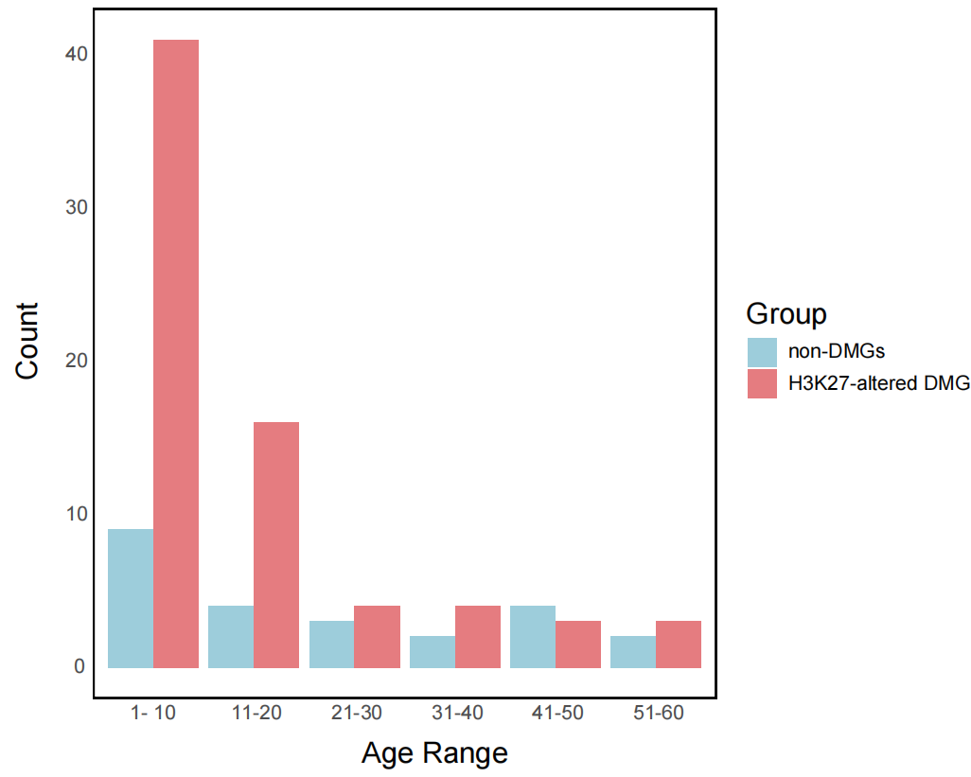
Fig. S2 Patient Age Distribution Chart

Fig. S3 The Delong test of the five multivariable models. * indicate P < 0.05
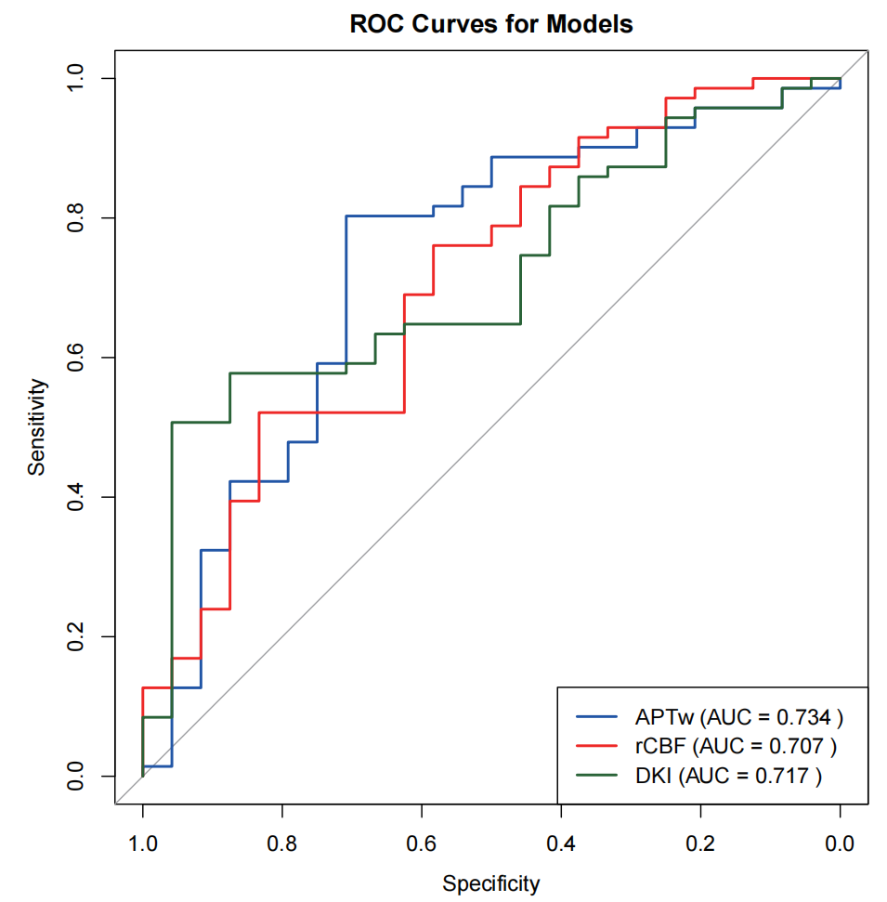
Fig. S4 The ROC curves for each imaging modality alone

Fig. S5 The scatter diagram between Ki-67 and APTw. APTw = amide proton transfer-weighted

