Supplementary Information

Large size of the Australian Indigenous population prior to its massive decline following European invasion

Appendix I: Abundance timeline on linear scale

Figure S1. Timeline of putative population estimates of Indigenous (Aboriginal) Australians from just prior to colonial invasion in 1788 (jittered on x axis for clarity; y axis on linear; see main text Fig. 1 for graph with log₁₀-scale y axis) up to the last full census in 2021. Three major smallpox outbreaks are indicated in pink. Pre-colonial estimates include (1) average modelled carrying capacity (Bradshaw et al.^{1,2}), (2) archaeological radiocarbon date reconstruction³, genetic effective population sizes (N_{e}) from (3) Malaspinas et al.⁴ and (4) Tobler et al.⁵, and various historical estimates (5. Smith⁶; 6. Butlin⁷; 7. Mulvaney & Kamminga⁸; 8. Smith⁹, 9. Radcliffe Brown¹⁰). Grey dots and ranges for 1861 and 1901 (indicated as ‘8’) are derived from Smith⁹ (his Fig. 8.6.3, p. 308). Grey dots from 1898–1970 and associated ranges are from the compilation of state and territory estimates by Smith⁹, and black dots from 1971–2021 are census data from the Australian Bureau of Statistics (abs.gov.au/census). The blue dots and blue error bars indicate the bootstrapped 75% confidence interval for the (a) modelled estimates (i.e., carrying-capacity^{1,2}, radiocarbon³, and N_{e}^{4,5} models) and (b) without the Malaspinas et al.⁴ N_{e} (given extremely wide confidence intervals). Also shown is the estimated total number of frontier massacre victims by decade from the 1790s to the 1920s (red line; right y axis) from the Colonial Frontier Massacres in Australia 1788–1930 database¹¹.

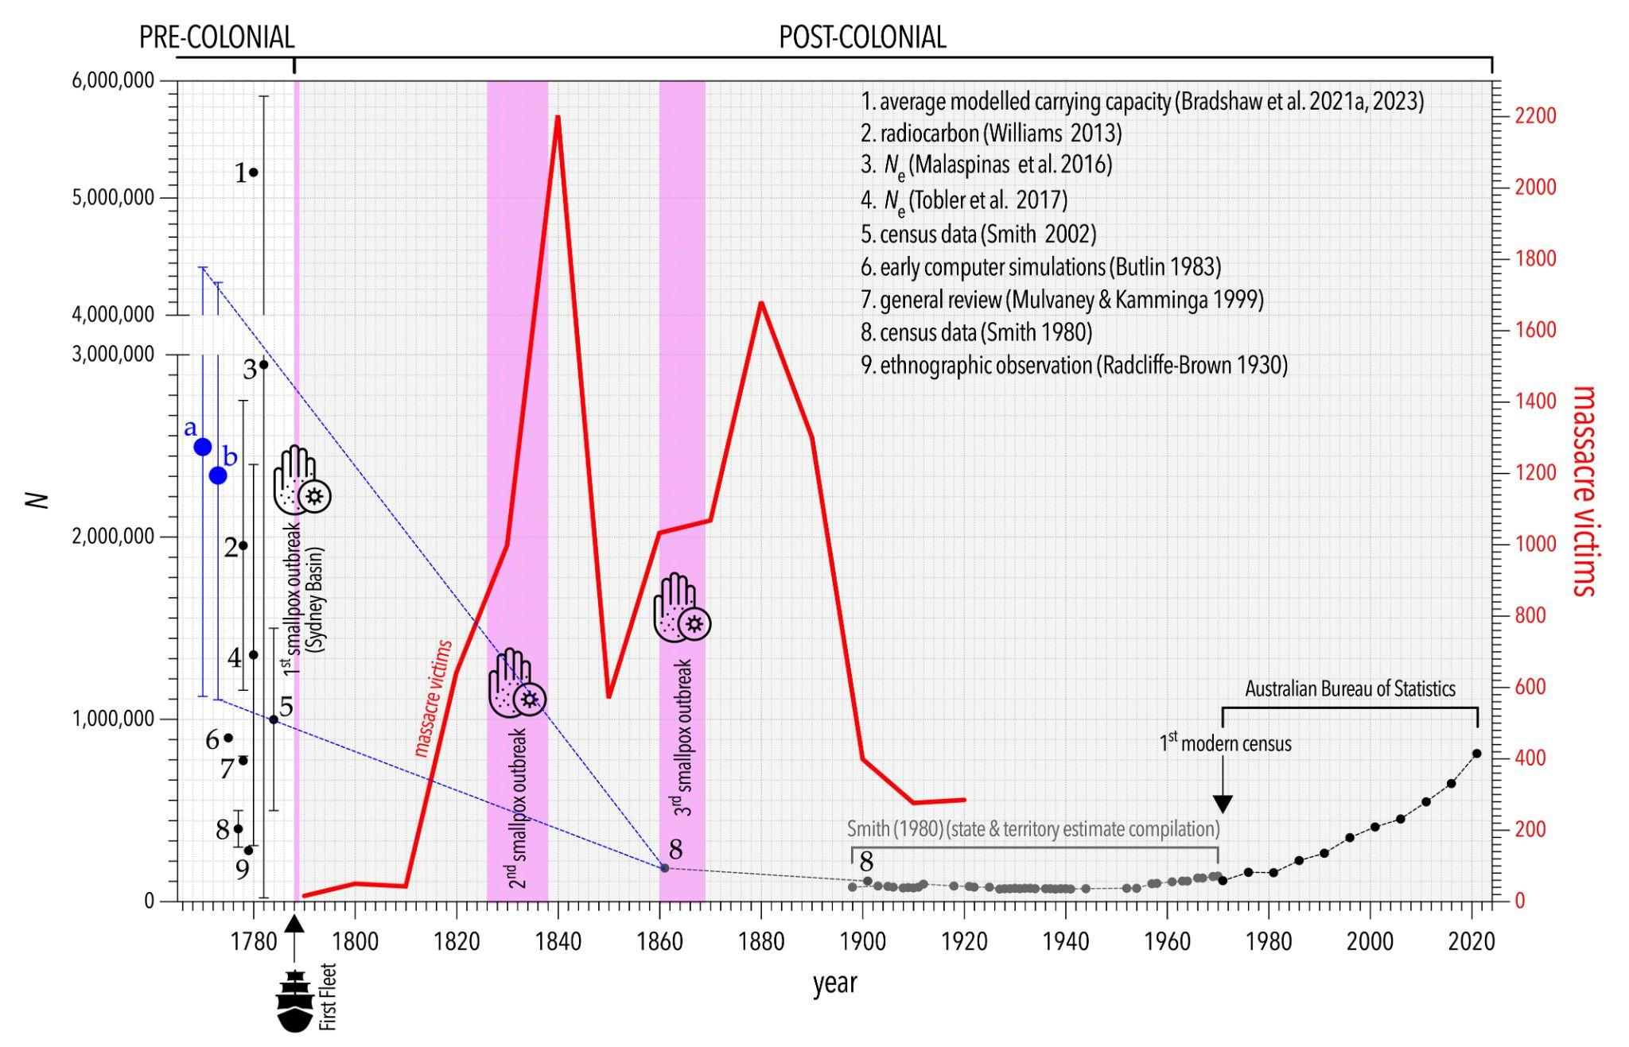

Appendix II. Model estimates compared to historical accounts

We also compared the carrying-capacity estimates to pre- or early invasion historical accounts of population size (likely bias notwithstanding) for several remote areas in Australia that were considered less-impacted by colonialism relative to most other areas at the time of census (Table S1; Fig. S2, S3). We did this to determine whether the model would be able to predict the reported number of people.
Because these early encounters were often brief and/or in passing, we have only referenced observations of small, constrained areas, typically islands, where larger populations are less likely to have been missed or hiding from these early colonists. This results in only a few recordings, primarily by Captain James Cook, Joseph Banks, and/or Captain Matthew Flinders (Table S1) who noted encounters, and that are typically considered to pre-date any impact of disease or other colonial disturbances. A detailed review of family trees and ancestry of the islands of Bentinck Island in the early 20th Century by Tindale¹² where oral history extended to first colonial visitation is an important datum for comparison.

Table S1. Comparison data for historically reported and modelled population sizes for eight locations (mostly islands) considered to pre-date colonial disturbance. ID = abbreviation (see map in Fig. S2); SITE: site name; lon = longitude (decimal degrees); lat = latitude (decimal degrees); area km² = area to which historically reported N applies; repN = historically reported N; predN = carrying capacity-predicted N; %Δ = % difference between repN and predN; ref = source reference.
ID | SITE | lon | lat | area  km² | repN | predN | %Δ | ref
BB | Botany Bay | 151.170 | -33.993 | 416 | 366 | 478 | 30.6 | a
BBKMP | Botany Bay Kurnell Meeting Place | 151.221 | -34.003 | 24.11 | 40 | 28 | -30.0 | b
BI | Bentinck Island | 139.497 | -17.067 | 150 | 123 | 170 | 38.2 | c
DBI | Dorre & Bernier Islands | 113.121 | -24.992 | 100 | 40 | 43 | 7.5 | d
EI | Erub (Darling) Island | 143.760 | -9.590 | 5.7 | 85 | 7 | -91.8 | e
PI | Possession Island | 142.400 | -10.720 | 5 | 10 | 6 | -40.0 | b
RI | Robbins Island | 144.944 | -40.692 | 99 | 45 | 50 | 11.1 | e
SC | Sydney Cove | 151.220 | -33.869 | 489 | 1500 | 562 | -62.5 | f
IM | Ocean Beach, Isla Maria | 148.032 | -42.658 | 13 | 25 | 12 | -52.0 | g

References (ref) cited in Table S1: a: New South Wales Parliament¹³; b: Beaglehole¹⁴; c: Tindale¹²; d: Dampier¹⁵; e: Flinders¹⁶; f: Phillip¹⁷; g: Peron¹⁸

Fig. S2. Distribution of compared sites (blue stars) from Table S1 overlaid on the HadCM3¹⁹ net primary production-derived estimates of human carrying capacities (greyscale expressed in people km⁻²). Darker grey indicates relatively higher densities.
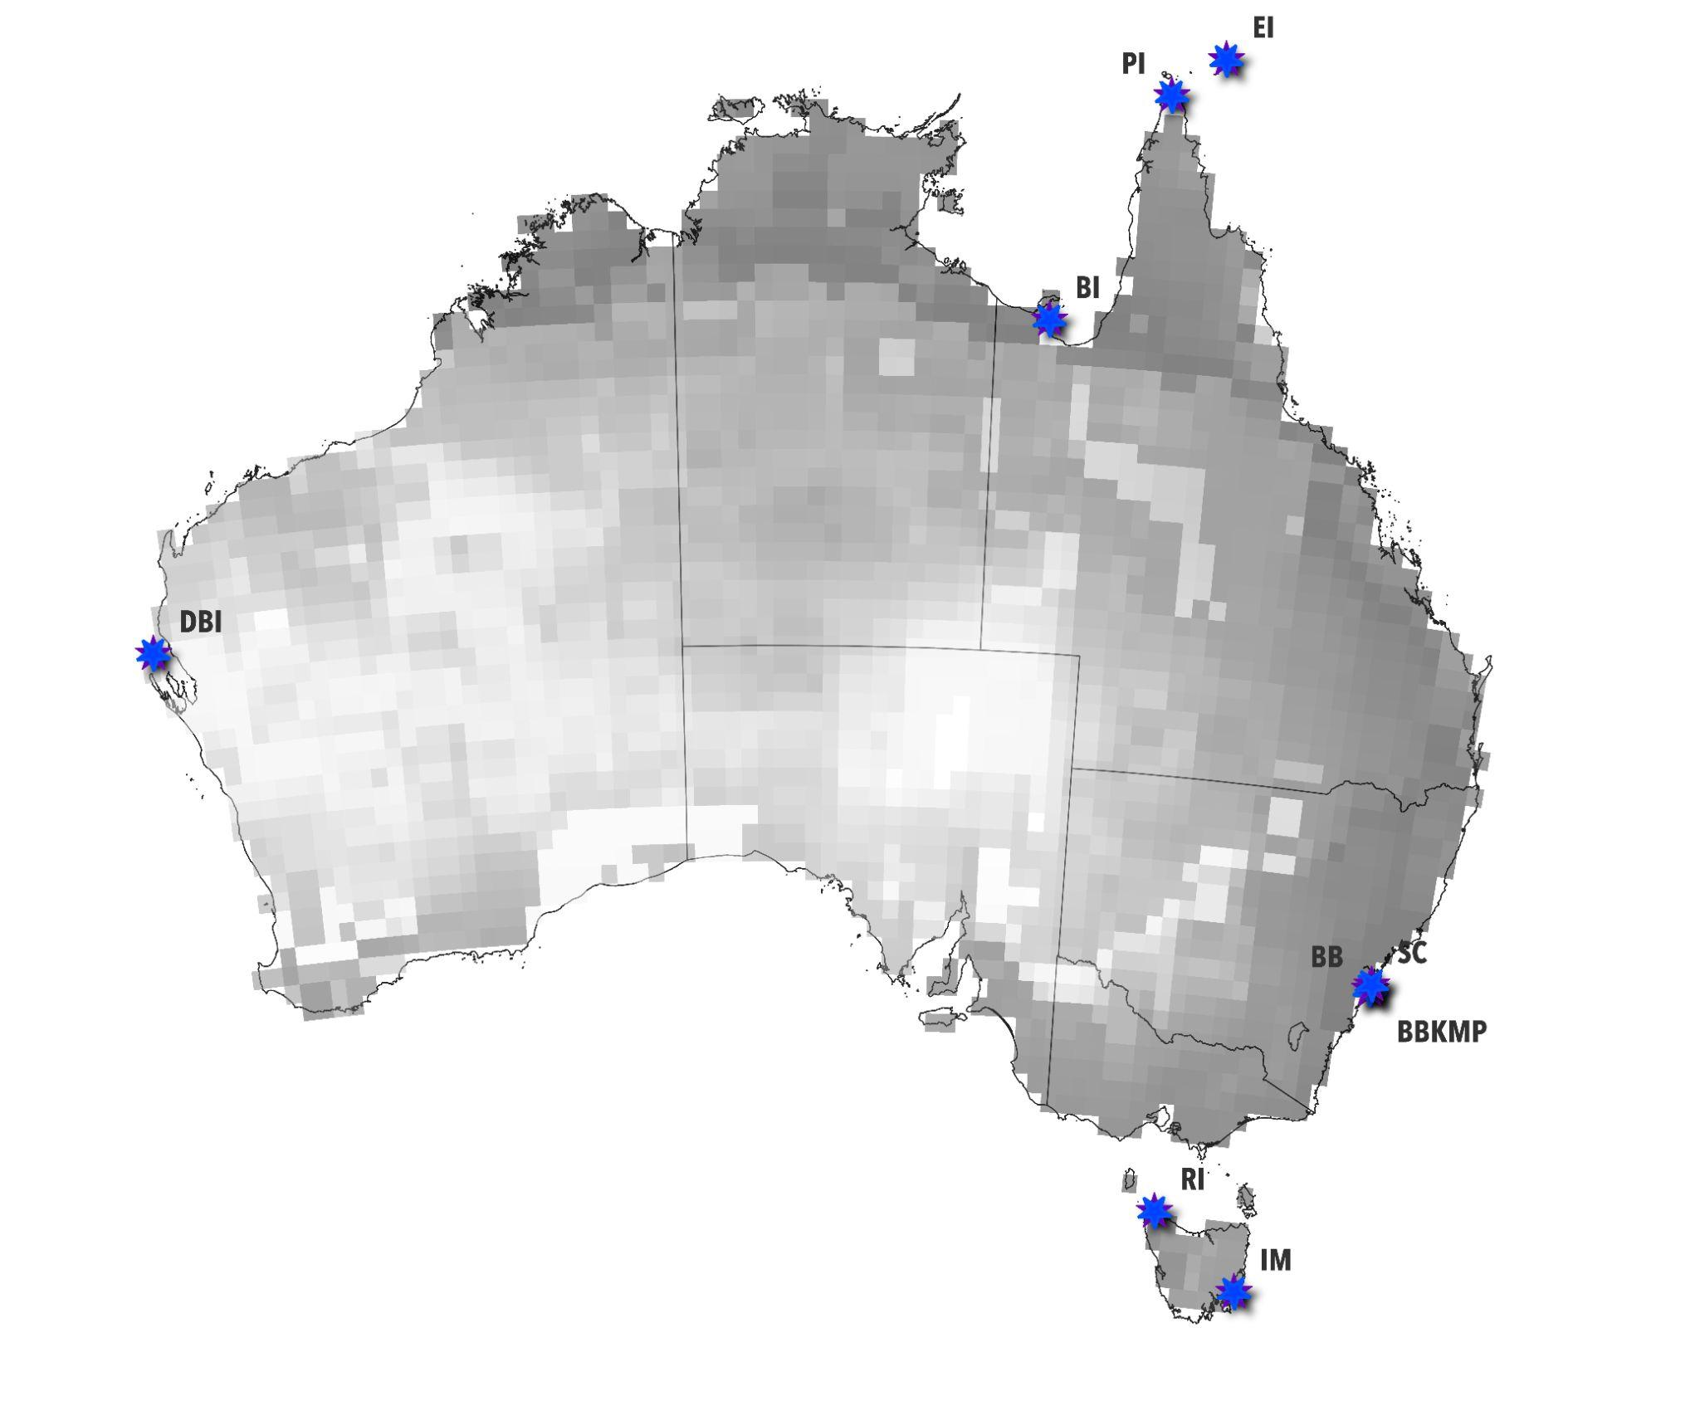
Fig. S3. Power-law relationship between HadCM3¹⁹ net primary production-derived estimates of human carrying capacity N and historically reported N. Red dashed line is the least-squares line of best fit (ŷ = 0.2221x + 0.4415; R² = 0.73); red-shaded area = 95% prediction intervals for line of best fit; black dashed line = 1:1 relationship.
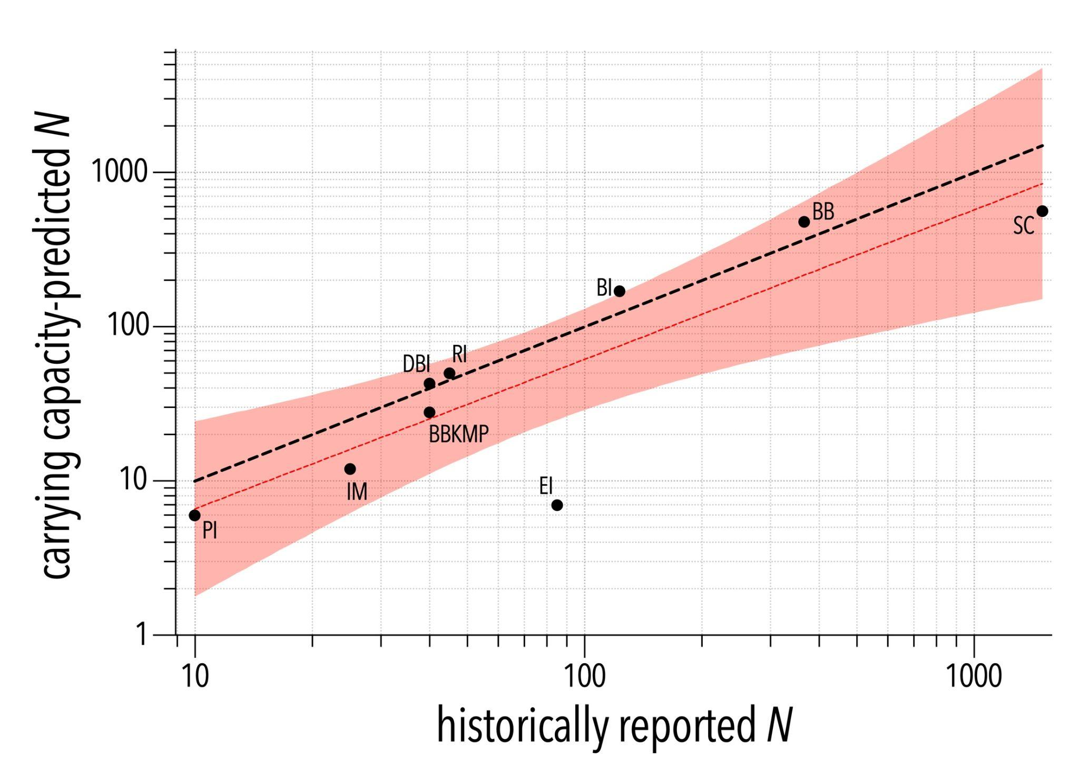
Appendix III. Estimating excess deaths projected to 1901

Figure S4. Excess deaths required to change a pre-colonial Indigenous population from sizes ranging between 5.0 million and 1.0 million to 0.092–0.134 million from 1788 to 1901 based on a stochastic demographic model. (a) For different initial population sizes (x axis), the left y axis shows the average annual excess deaths that would have to occur for the population to decline to the indicated target, expressed as an average annual instantaneous exponential rate of population decline (r) on the right y axis. Grey shaded area indicates the 95% confidence intervals for the annual excess death estimate. Background peach colour indicates the 75% confidence interval of the resampled initial population sizes derived from the modelled sources (i.e., carrying-capacity, radiocarbon, and N_{e} models; Fig. 1), and the black vertical dashed line indicates the central tendency of those estimates (bootstrapped model mean) and the black horizontal dashed indicates the annual excess deaths at that central tendency. (b) For different initial population sizes (x axis), the left y axis shows the sum of the excess deaths from 1788–1861 required to achieve a population of 0.092–0.134 million, expressed as a proportion of the initial population size on the right y axis. Grey and red shaded areas indicate the 95% confidence interval for each measure, and the vertical and horizontal black dashed lines are as in panel a.
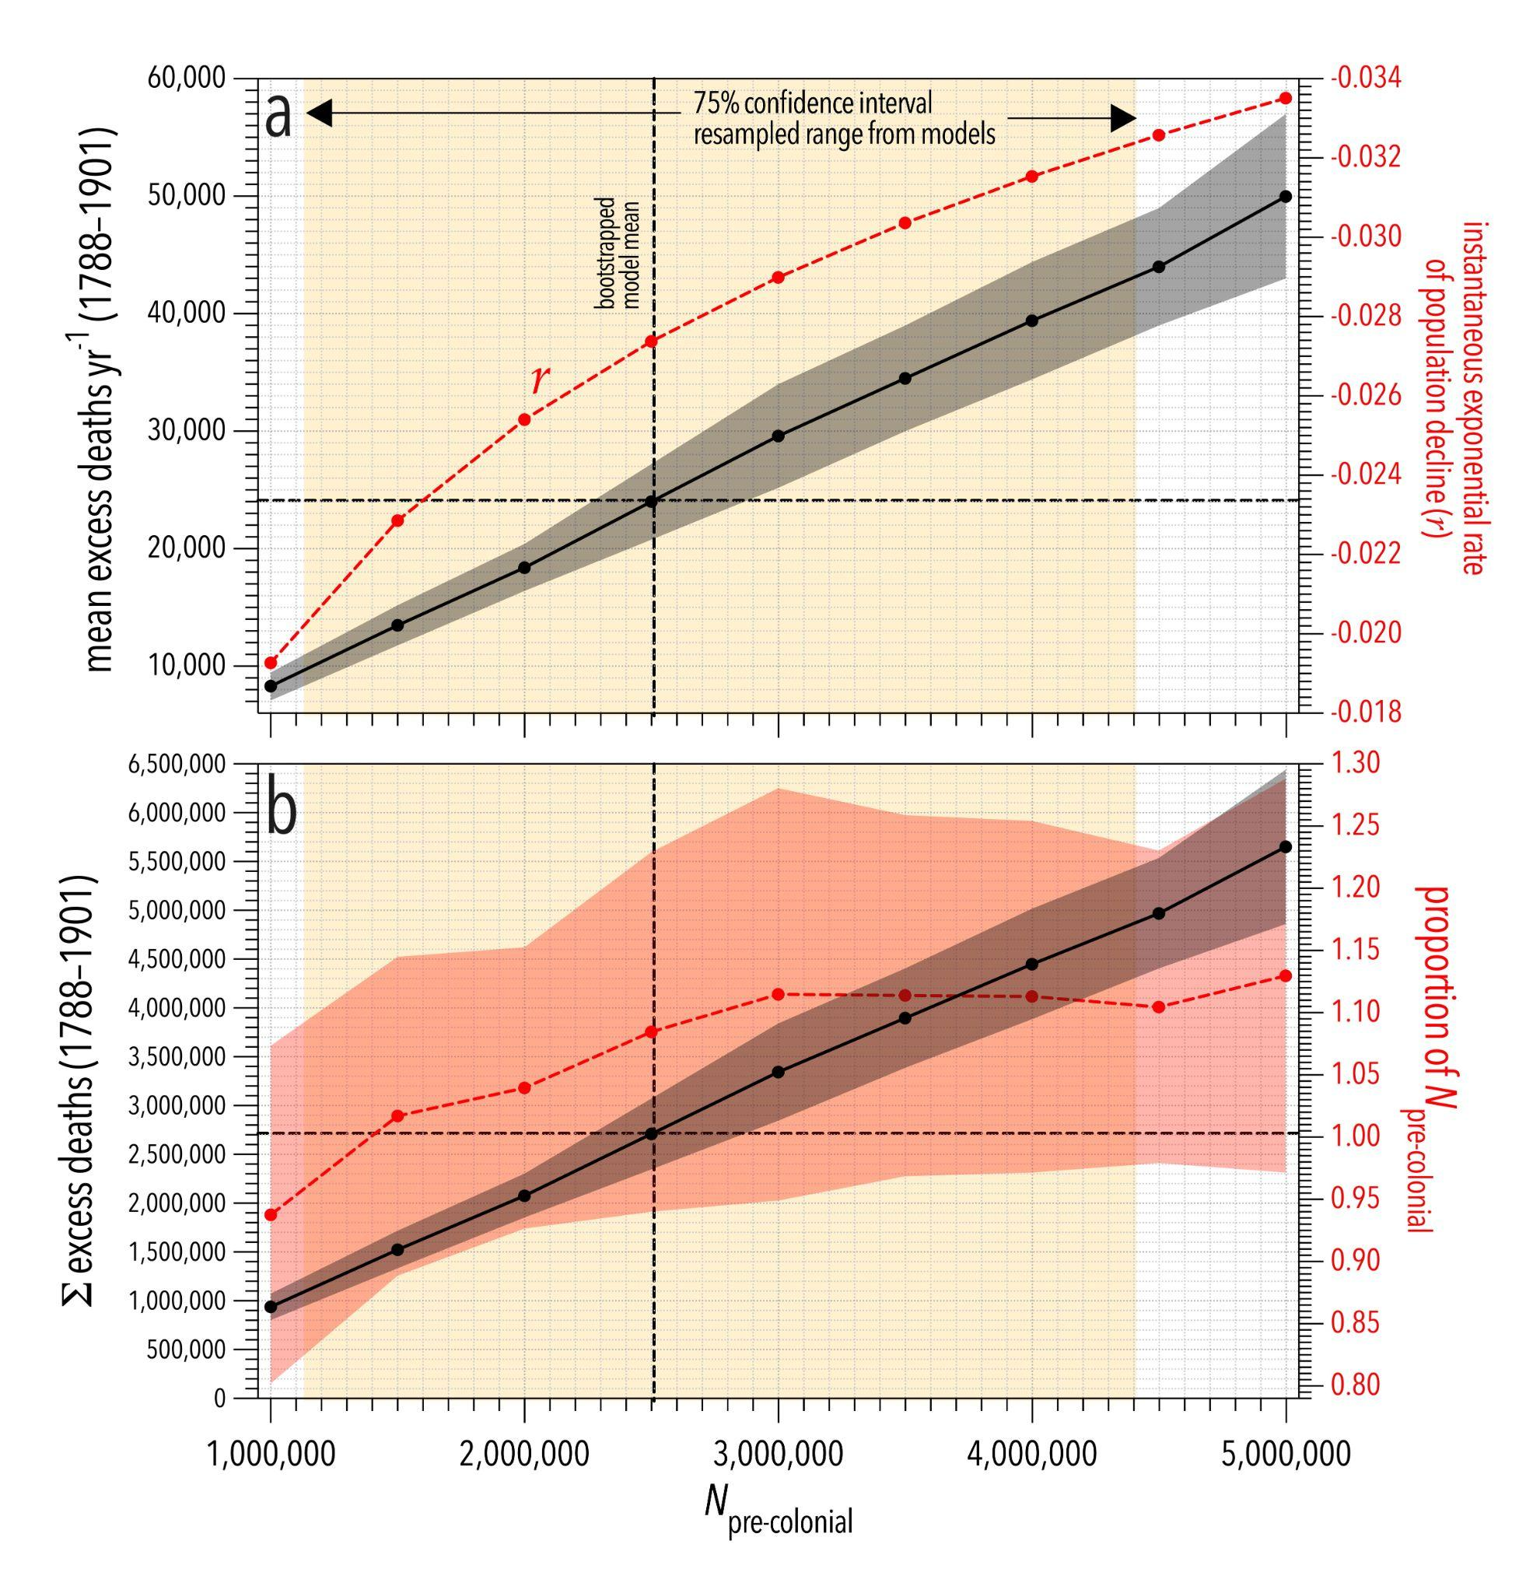
Appendix IV. Trajectory of Indigenous and non-Indigenous populations from 1788 to the present

Figure S5. Trajectory of the Indigenous population (median bootstrapped range a from Fig. 2) from pre-1788 to 2021 compared to that for the non-Indigenous population (in red; source: Australian Bureau of Statistics abs.gov.au/census). For the latter, we subtracted the Indigenous component from the total census values from 1971 onward. Australia’s total population (N_{tot} = N_{Ind} + N_{non-Ind}) shown as a dashed black line. Also shown are the three smallpox outbreaks in pink. The size of the non-Indigenous population first exceeded that of the Indigenous population around 1847 on average (N_{non-Ind} > N_{Ind}). Around 1836 was the year when the total population size (N_{tot} = N_{Ind} + N_{non-Ind}) of Australia was at its lowest (min N_{tot} ≈ 570,000) during the period 1788–2021, and possibly during the last 50,000+ years as well^{1,2,20}.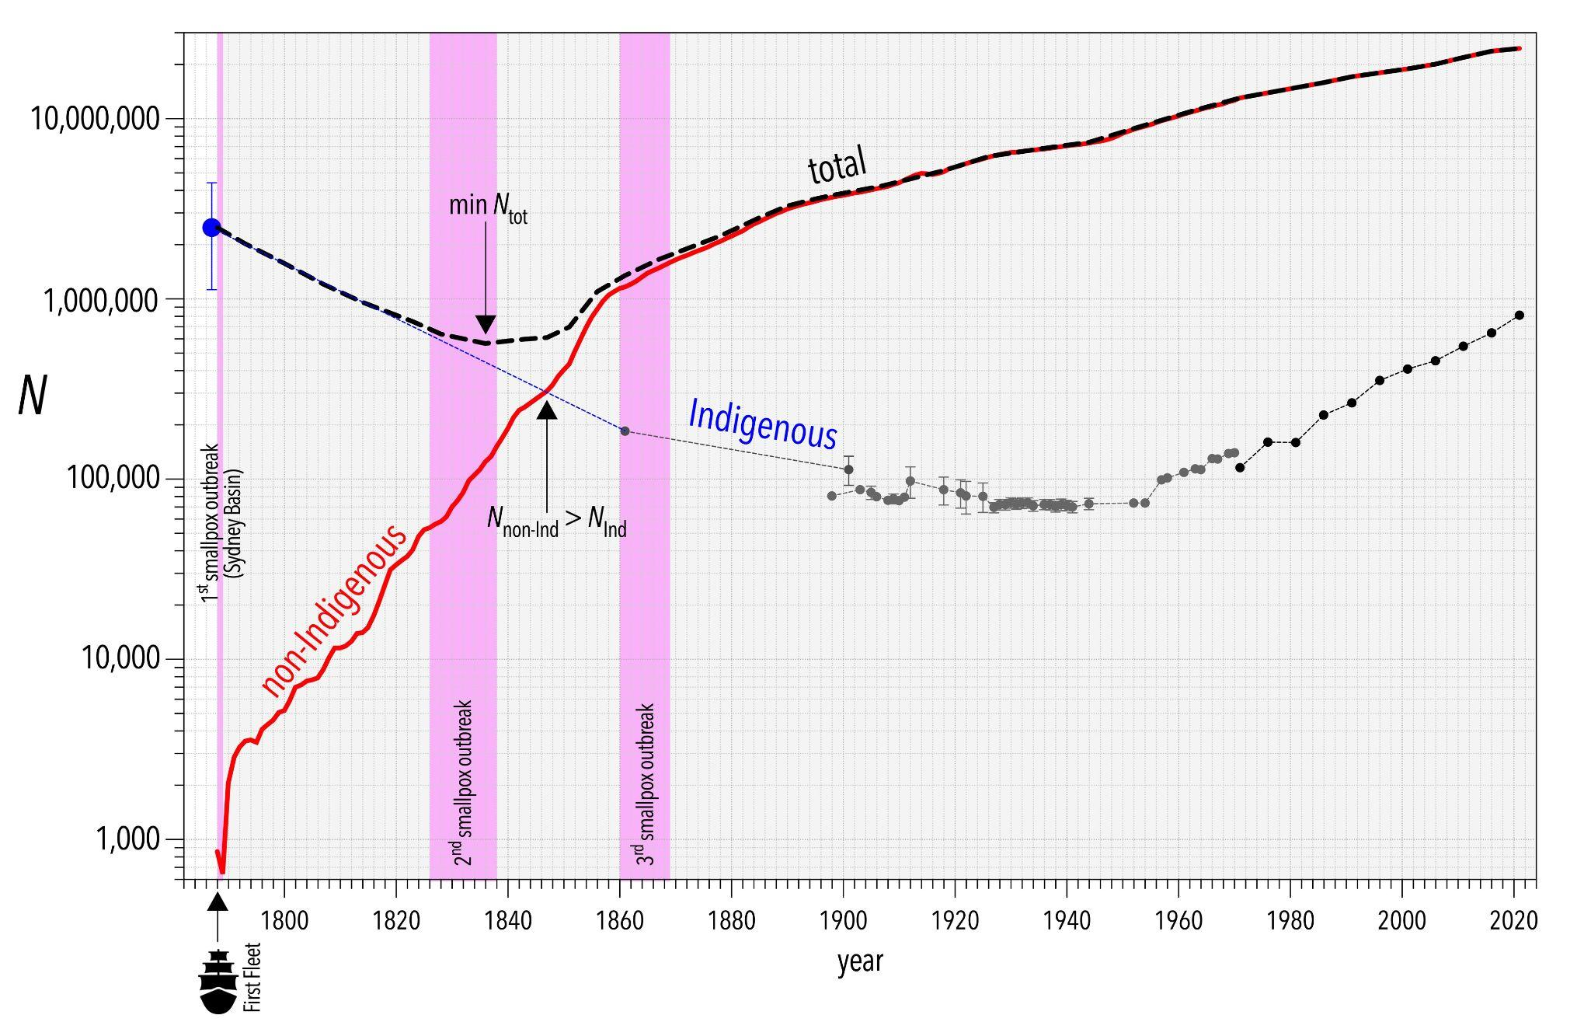
References cited in the Supplementary Information
1. Bradshaw, C. J. A. et al. Stochastic models support rapid peopling of Late Pleistocene Sahul. Nature Communications 12, 2440, doi:10.1038/s41467-021-21551-3 (2021).
2. Bradshaw, C. J. A. et al. Directionally supervised cellular automaton for the initial peopling of Sahul. Quaternary Science Reviews 303, 107971, doi:10.1016/j.quascirev.2023.107971 (2023).
3. Williams, A. N. A new population curve for prehistoric Australia. Proceedings of the Royal Society B: Biological Sciences 280, 20130486 (2013).
4. Malaspinas, A.-S. et al. A genomic history of Aboriginal Australia. Nature 538, 207-214, doi:10.1038/nature18299 (2016).
5. Tobler, R. et al. Aboriginal mitogenomes reveal 50,000 years of regionalism in Australia. Nature 544, 180-184, doi:10.1038/nature21416 (2017).
6. Smith, L. R. How many people had lived in Australia before it was annexed by the English in 1788? in The Aboriginal Population Revisited: 70,000 years to the present (eds G. Briscoe & L. R. Smith) 9-15 (Aboriginal History Incorporated, 2002).
7. Butlin, N. G. Our Original Aggression: Aboriginal Populations of Southeastern Australia 1788–1850. (George Allen & Unwin, 1983).
8. Mulvaney, J. & Kamminga, J. Prehistory of Australia. (Allen & Unwin, 1999).
9. Smith, L. R. The Aboriginal Population of Australia. (Australian National University Press, 1980).
10. Radcliffe-Brown, A. Former numbers and distribution of the Australian Aborigines. Australian Yearbook 23, 687-696 (1930).
11. Ryan, L. et al. Colonial Frontier Massacres in Australia 1788-1930 (University of Newcastle, 2022). hdl.handle.net/1959.13/1340762.
12. Tindale, N. Some population changes among the Kaiadilt people of Bentinck Island. Records of the South Australian Museum 14, 297-336 (1962).
13. New South Wales Parliament Select Committee on the Condition of Aborigines. Report from the Select Committee on the Condition of the Aborigines, with Appendix, Minutes of Evidence and Replies to a Circular Letter. (W.W. Davies, Government Printer, Sydney, 1845). <https://trove.nla.gov.au/work/170133957>.
14. Beaglehole, J. C. The Endeavour Journal of Sir Joseph Banks, 1768-1771. (Angus and Roberston, Sydney, 1962).
15. Dampier, W. A New Voyage Round The World. With an introduction by Albert Gray; and with a new introduction by Percy G. Adams. (Dover Publications Inc., 1968).
16. Flinders, M. A Voyage to Terra Australis: Undertaken for the purpose of completing the discovery of that vast country and prosecuted in the years 1801, 1802 and 1803, in His Majesty's ship the Investigator, and subsequently in the Armed vessel Porpoise and Cumberland schooner with an account of the shipwreck of the Porpoise, arrival of the Cumberland at Mauritius, and imprisonment of the commander during six years and a half in that island. (G. and W. Nicol, 1814).
17. Phillip, A. Governor’s Despatches To and From England in Historical Records of Australia, Volume 1, 1788-1796 (ed F. Watson) 1-402 (The Library Committee of the Commonwealth Parliament, 1914).
18. Peron, M. F. A Voyage of Discovery to the Southern Hemisphere, performed by order of the Emperor Napoleon, during the years 1801, 1802, 1803, and 1804. (Richard Phillips, 1809).
19. Krapp, M., Beyer, R. M., Edmundson, S. L., Valdes, P. J. & Manica, A. A statistics-based reconstruction of high-resolution global terrestrial climate for the last 800,000 years. Scientific Data 8, 228, doi:10.1038/s41597-021-01009-3 (2021).
20. Cadd, H. et al. Last Glacial Maximum cooling induced positive moisture balance and maintained stable human populations in Australia. Communications Earth & Environment 5, 52, doi:10.1038/s43247-024-01204-1 (2024).

