Supplementary Materials for

Inhibition of Malignant Pleural Effusion by a Physiological Intrapleural Pressure-controlled Piezo-catalytic Nanozyme System

Zihan Xu et al.

* Hubing Shi. Email: shihb@scu.edu.cn. Jing Jing. Email:(jingjing@wchscu.cn

Fig. S1. Thermogravimetric analysis curves of UIO-66 and Yb-UIO-66 NPs.

Fig. S2. 3D topography and PFM images over UIO-66. (a) Topography. (b) Amplitude. (c) Phase.

Fig. S3. 3D topography and PFM images over Yb-UIO-66. (a) Topography. (b) Amplitude. (c) Phase.

Fig. S4. a. Images of O₃P@LPYU NPs dispersed in various solutions for 0-7 days. b. DLS measurements of O₃P@LPYU NPs immersed in PBS, DMEM and FBS for 0, 1, 3, 5, 7 days, respectively.

Fig. S5. a. Degradation of RhB in the presence of UIO-66, Yb-UIO-66 (b), and O₃P@LPYU NPs (c).

Fig. S6. Degradation of RhB in the presence of O₃P@LPYU at different treatment time (1, 2, 3, 4, 5, 6, 7, 8, 9, and 10 min).

Fig. S7. Degradation of RhB in the presence of O₃P@LPYU at different pressure level (1, 2, 4, 6, 8, and 10 kPa).

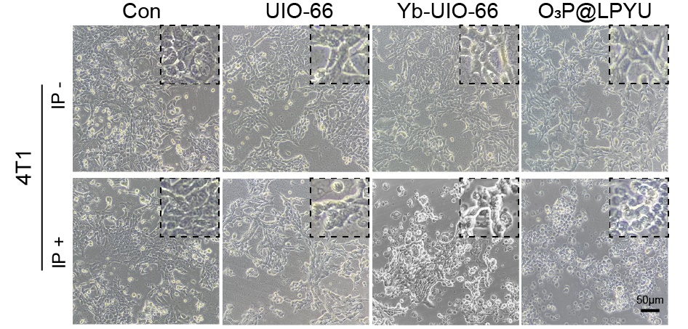
Fig. S8. Bright-field microscopy images show the morphology, growth ability, and cell viability of different treating groups in 4T1 cells. Scale bar = 50 μm.

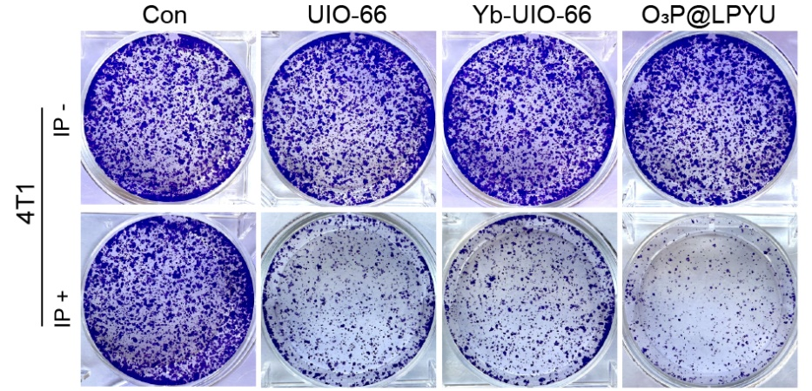
Fig. S9. Long-term cytotoxic effect of pressure-responsive UIO-66/Yb-UIO-66/O₃P@LPYU on 4T1 cells, evaluated by colony formation assay.

Fig. S10. Calcein AM/PI staining of 4T1 cells after different treatments.

Fig. S11. a. DCFH-DA stains of 4T1 cells after indicated treatments to PBS, UIO-66, Yb-UIO-66, and O₃P@LPYU, with or without IP treating. Scale bar = 30 μm. b. Levels of ROS in 4T1 cells were detected by using DCFH-DA probe and flow cytometry.

Fig. S12. Flow cytometry analysis of the 4T1 cells apoptosis by PI and Annexin V staining.

Fig. S13. CRT relocation on the membrane of 4T1, shotted by confocal laser scanning microscopy, Scale bar = 20 μm.

Fig. S14. a. HMGB1 released level in supernatants of 4T1 cells after treatment. b. ATP secretion level in supernatants of 4T1 cells in different treated groups. Data is represented as mean ± SD (n = 5).

Fig. S15. a. Blood cell analysis of different regimen treatments. Data is represented as mean ± SD (n = 5). b. Blood biochemical analysis of different regimen treatments. Data is represented as mean ± SD (n = 5).

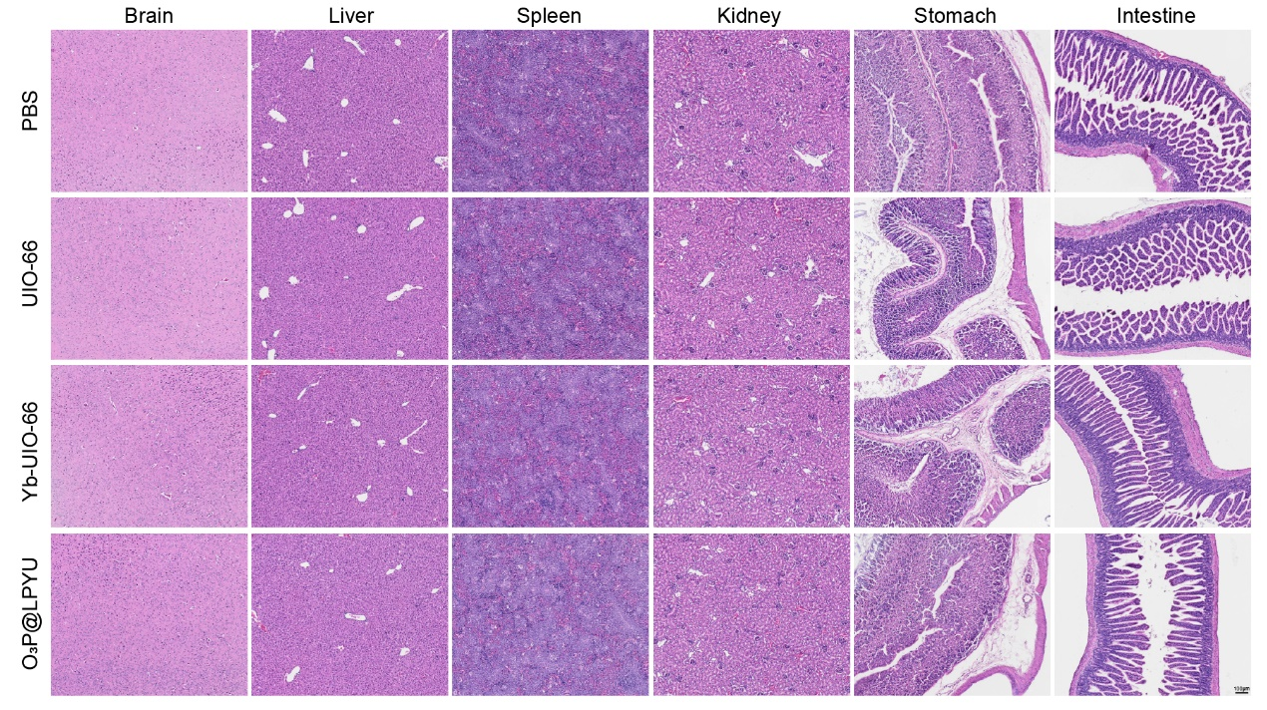
Fig. S16. H&E staining of brain, liver, spleen, kidney, stomach, and intestine after treatment with different regimens.

Fig. S17. Representative contour plots and summary of frequencies of CD45+ cells in LLC- and 4T1-MPE model.

Fig. S18. Representative contour plots and summary of frequencies of M2-type macrophage cells in LLC- and 4T1-MPE model.

Movie S1. Working principle of the reciprocating syringe pump simulating intrapleural pressure to treat piezoelectric materials.
Movie S2. Working principle of a reciprocating syringe pump simulating intrathoracic pressure to process the piezoelectric material's degradation of MB.
Movie S3. Working principle of a reciprocating syringe pump simulating intrathoracic pressure to process the piezoelectric material's degradation of RhB.

