Supporting Information
Green-emitting AIEgen for fluorescent switch-off detection of multi-cations and applications

Dhvani A. Patelª, Thangaraj Anand^{c}, Bigyan R. Jali^{b}, and Suban K. Sahooª*
ª Department of Chemistry, Sardar Vallabhbhai National Institute Technology, Surat-395007, Gujarat, India.
^{b} Department of Chemistry, Veer Surendra Sai University of Technology, Burla, Sambalpur-768018, Odisha, India.
^{c} Department of Chemistry, Sathyabama Institute of Science and Technology, Chennai-600119, India.
*E-mail: sks@chem.svnit.ac.in.
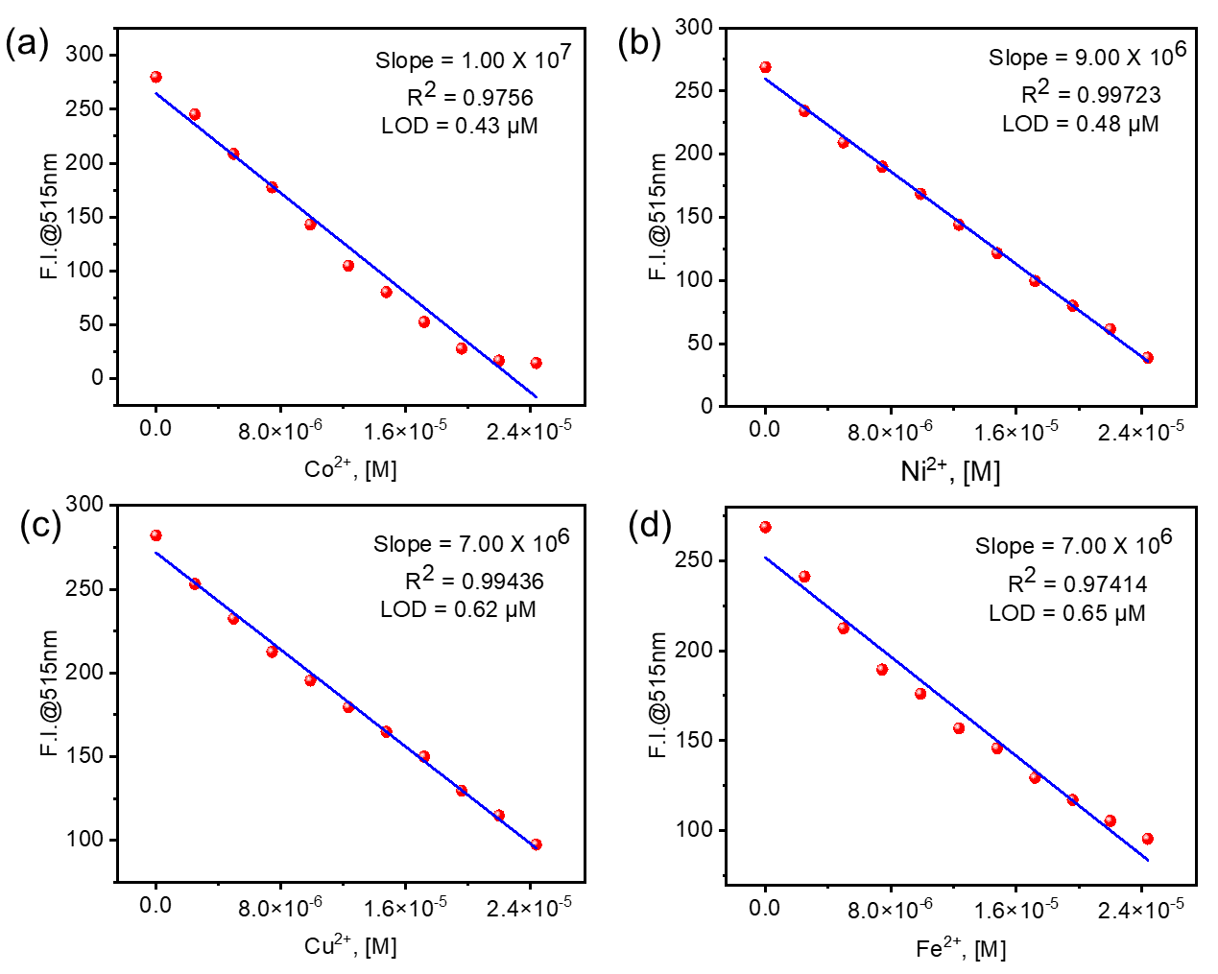Fig. S1. Calibration curve to obtain the LOD for (a) Co²⁺, (b) Ni²⁺, (c) Cu²⁺ and (d) Fe²⁺.
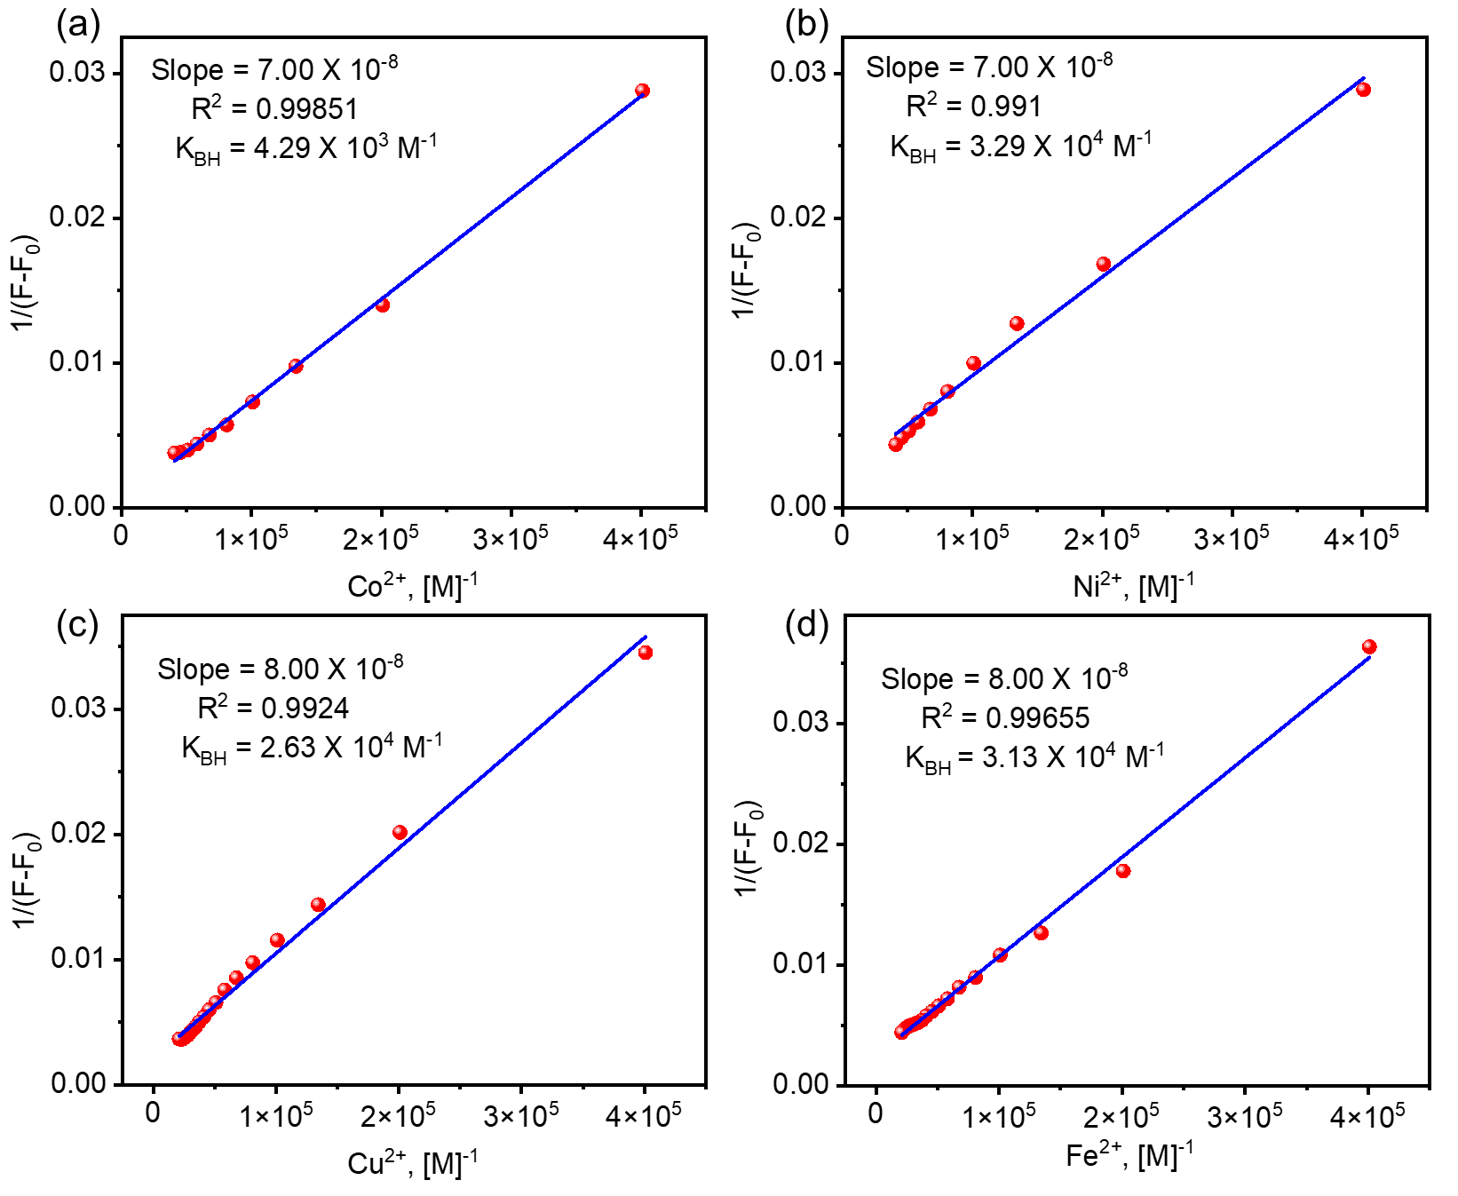
Fig. S2. BH plot of AIEgen HNSA with detected analytes (a) Co²⁺, (b) Ni²⁺, (c) Cu²⁺, and (d) Fe²⁺ ions.

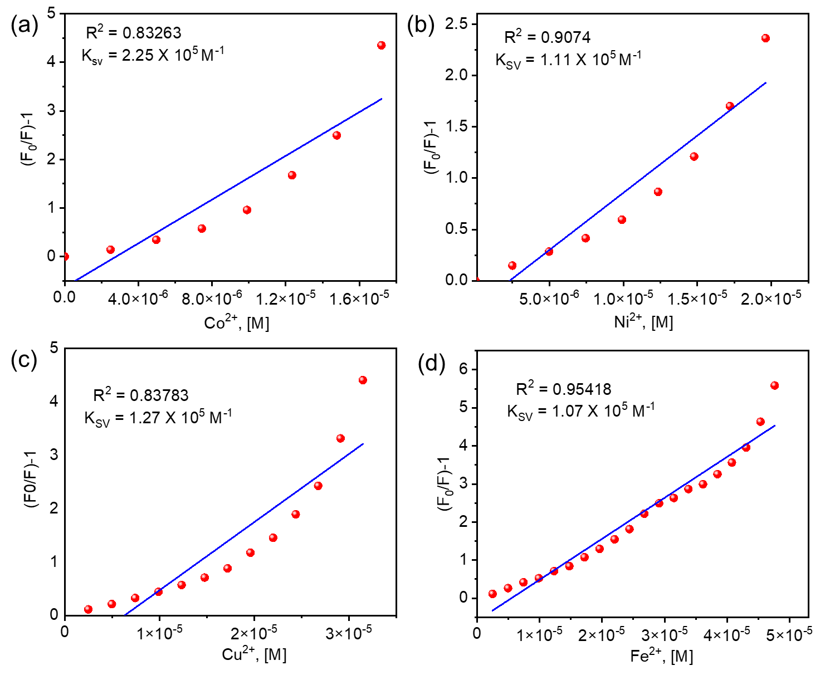
Fig. S3. Stern-Volmer plot of AIEgen HNSA with detected analytes (a) Co²⁺, (b) Ni²⁺, (c) Cu²⁺, and (d) Fe²⁺ ions.
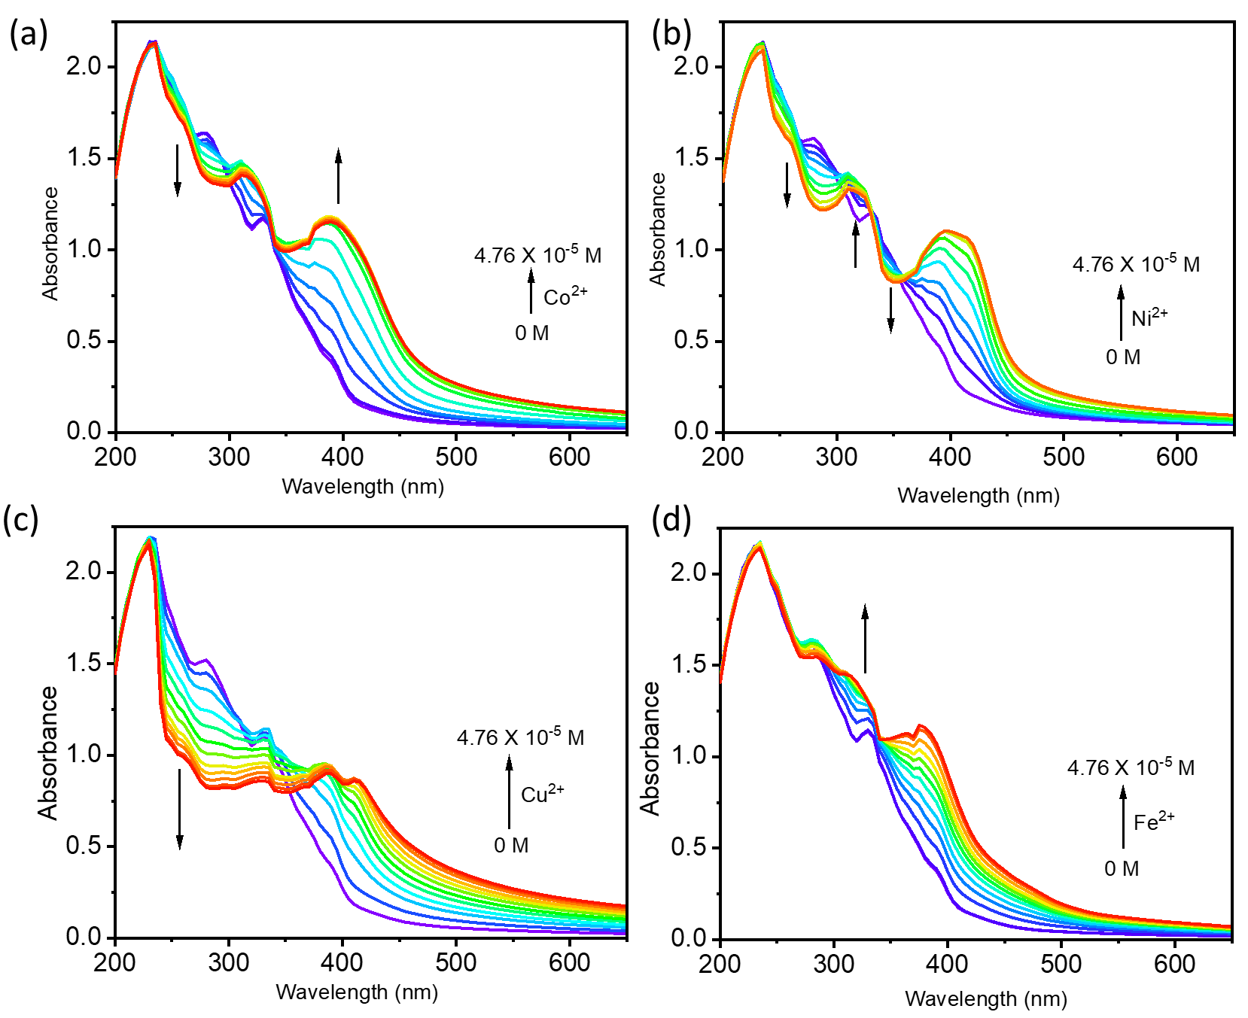
Fig. S4. UV-Vis spectral changes of AIEgen HNSA (5×10⁻⁵ M) upon gradual incremental addition of (a) Co²⁺, (b) Ni²⁺, (c) Cu²⁺ and (d) Fe²⁺.

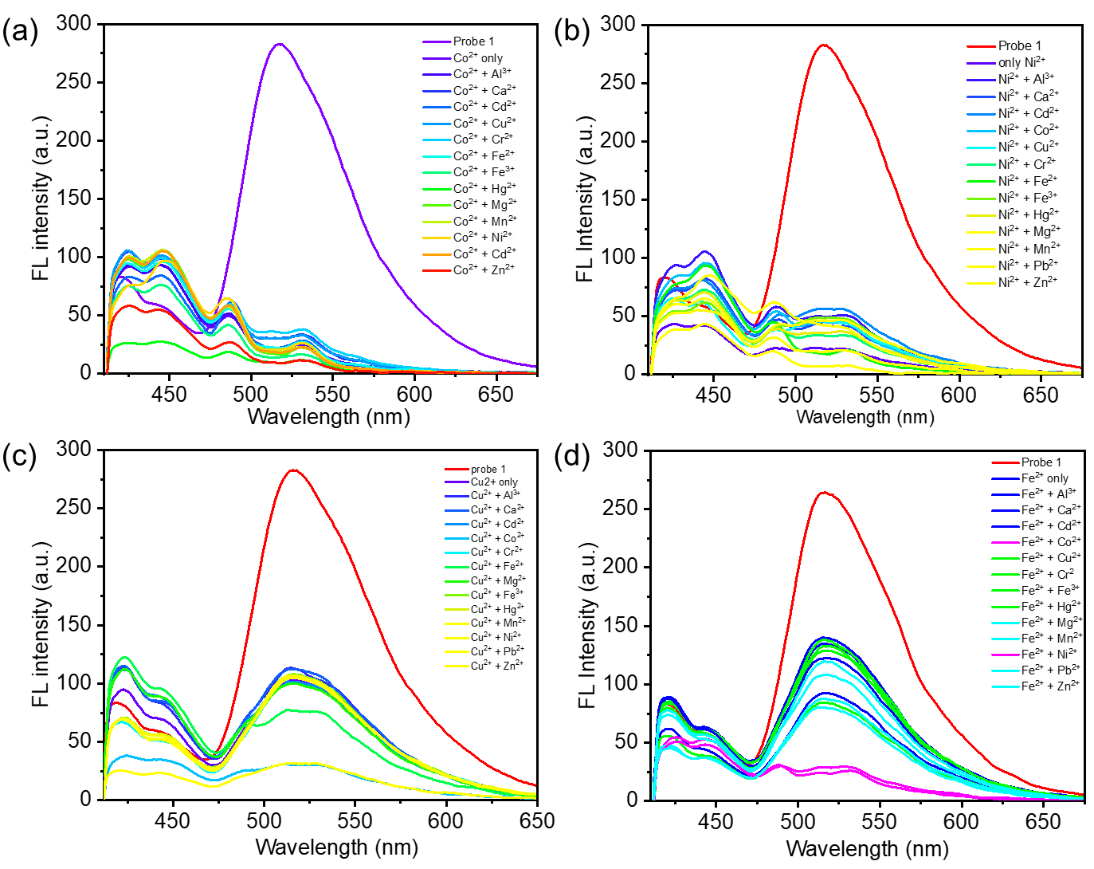
Fig. S5. Fluorescence interference studies of AIEgen HNSA with (a) Co²⁺, (b) Ni²⁺, (c) Cu²⁺, and (d) Fe²⁺ ions.

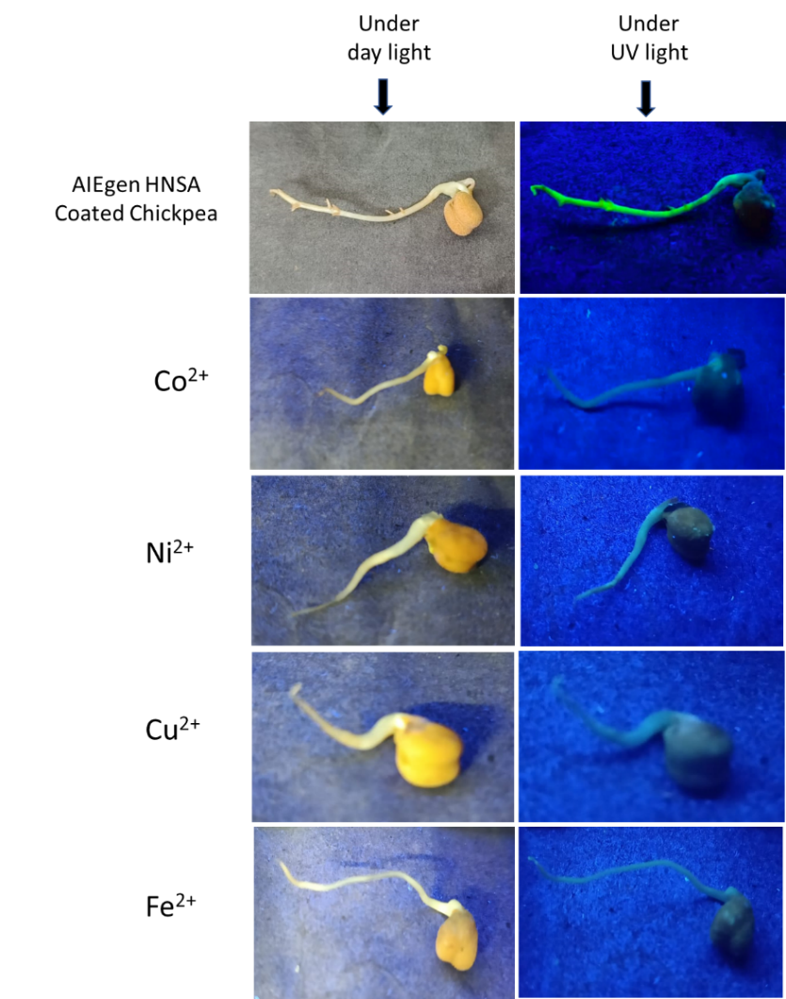
Fig. S6. Detection of Co²⁺, Ni²⁺, Cu²⁺, and Fe²⁺ ions in chickpea sprouts using AIEgen HNSA.

Table S1. Fluorescence lifetime decay parameters of AIEgen HNSA in the absence and presence of Co²⁺ and Cu²⁺.
Compounds | T1 (ns) | T2 (ns) | T3 (ns) | Average time (ns)
HNSA | 0.023 | 1.65 | 6.88 | 2.85
Co²⁺ | 0.98 | 5.45 | 0.08 | 2.18
Cu²⁺ | 0.54 | 3.18 | 2.06 | 1.93

Table S2. The recoveries of Co²⁺, Ni²⁺, Cu²⁺ and Fe²⁺ ions in real water samples using AIEgen HNSA.
Samples | Co²⁺
Samples | Added, M | Found, M | Recovery, %
Tap water | 2.49 × 10⁻⁶ | 2.40 × 10⁻⁶ | 96.38
Tap water | 4.97 × 10⁻⁶ | 4.91 × 10⁻⁶ | 98.79
Drinking water | 1.23 × 10⁻⁵ | 1.22 × 10⁻⁵ | 99.18
Drinking water | 1.47 × 10⁻⁵ | 1.49 × 10⁻⁵ | 101.36
Samples | Ni²⁺
Samples | Added, M | Found, M | Recovery, %
Tap water | 1.96 × 10⁻⁵ | 1.93 × 10⁻⁵ | 98.46
Tap water | 2.20 × 10⁻⁵ | 2.18 × 10⁻⁵ | 99.09
Drinking water | 2.43 × 10⁻⁵ | 2.42 × 10⁻⁵ | 99.58
Drinking water | 2.67 × 10⁻⁵ | 2.70 × 10⁻⁵ | 100.74
Samples | Cu²⁺
Samples | Added, M | Found, M | Recovery, %
Tap water | 3.14 × 10⁻⁵ | 2.91 × 10⁻⁵ | 92.67
Tap water | 3.38 × 10⁻⁵ | 3.09 × 10⁻⁵ | 91.42
Drinking water | 3.61 × 10⁻⁵ | 3.29 × 10⁻⁵ | 91.13
Drinking water | 3.84 × 10⁻⁵ | 3.48 × 10⁻⁵ | 90.62
Samples | Fe²⁺
Samples | Added, M | Found, M | Recovery, %
Tap water | 1.47 × 10⁻⁵ | 1.39 × 10⁻⁵ | 94.56
Tap water | 1.71 × 10⁻⁵ | 1.65 × 10⁻⁵ | 96.49
Drinking water | 1.96 × 10⁻⁵ | 2.00 × 10⁻⁵ | 102.04
Drinking water | 2.20 × 10⁻⁵ | 2.28 × 10⁻⁵ | 103.63

********

