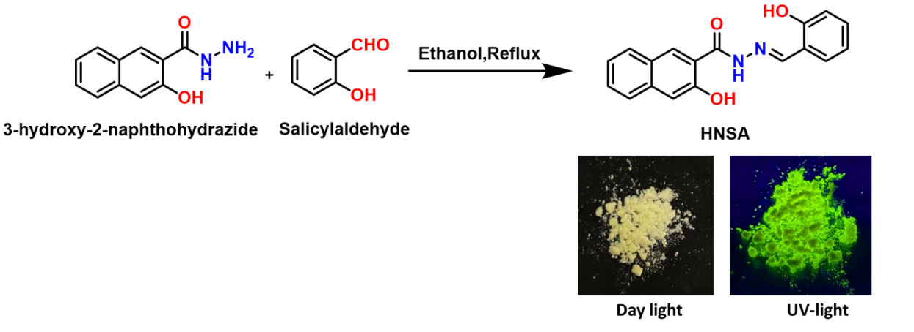
Scheme 1. Synthetic route of the Schiff base HNSA. The colour of the solid HNSA under day and UV light.

