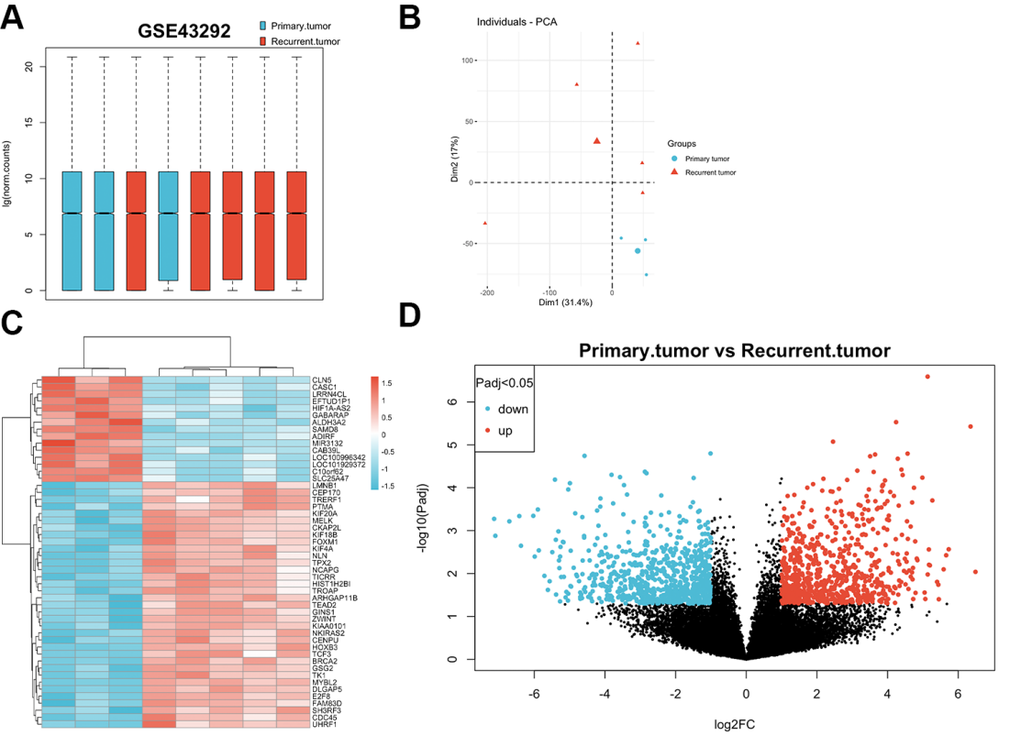
The quality control and differential expression analysis of the dataset GSE173825. A. The boxplot demonstrates that the quality control results of dataset GSE173825 are satisfactory. B-C. Significant differences are observed between the two groups of primary and recurrent meningiomas. D. The volcano plot displays the differentially expressed results of dataset GSE173825.

