Table S1. Statistical Analyses for Radius of Confinement
Comparison | Marker | Test | P value | Significance
WT vs. WT + CK-666 | Ddc2-GFP | t test | 0.0102 | *
SPB, WT vs. WT + CK-666 | Ddc2-GFP | t test | 0.9164 | ns
WT vs. sla2∆ | Ddc2-GFP | t test | 0.4443 | ns
0 h vs. 0 h + CK-666 | LacI-GFP/lacO | one-way Anova | 0.3606 | ns
0 h vs. 3 h | LacI-GFP/lacO | one-way Anova | <0.0001 | ****
0 h vs. 3 h pre-CK-666 | LacI-GFP/lacO | one-way Anova | 0.7636 | ns
0 h vs. 3 h post-CK-666 | LacI-GFP/lacO | one-way Anova | 0.9859 | ns
Las17-AID vs. WT | Ddc2-GFP | one-way Anova | 0.2175 | ns
Las17-AID vs. Las17-AID + IAA | Ddc2-GFP | one-way Anova | 0.006 | **
WT vs. las17-WH-CAΔ | Ddc2-GFP | one-way Anova | 0.0051 | **
WT vs. las17-CAΔ | Ddc2-GFP | one-way Anova | 0.9984 | ns
WT vs. myo5Δ | Ddc2-GFP | one-way Anova | 0.0456 | *
WT vs. myo3Δ | Ddc2-GFP | one-way Anova | 0.0384 | *
WT vs. myo3Δ, second copy of Myo5 | Ddc2-GFP | one-way Anova | 0.993 | ns
WT vs. myo5Δ | Ddc2-GFP | one-way Anova | 0.2269 | ns
WT vs. myo5-motorΔ | Ddc2-GFP | one-way Anova | 0.9998 | ns
WT vs. myo5-TH1Δ | Ddc2-GFP | one-way Anova | 0.9983 | ns
WT vs. myo5-TH2Δ | Ddc2-GFP | one-way Anova | 0.9478 | ns
WT vs. myo5-SH3Δ | Ddc2-GFP | one-way Anova | 0.0462 | *
WT vs. Myo5-AID | Ddc2-GFP | one-way Anova | 0.2036 | ns
WT vs. Myo5-AID + IAA | Ddc2-GFP | one-way Anova | 0.0066 | **
WT vs. myo3Δ, Myo5-AID | Ddc2-GFP | one-way Anova | 0.0304 | *
myo3Δ, Myo5-AID vs. myo3Δ, Myo5-AID + IAA | Ddc2-GFP | one-way Anova | 0.0373 | *
WT vs. myo3Δ, Myo5-AID + IAA | Ddc2-GFP | one-way Anova | 0.9998 | ns
WT vs. myo3Δ, Myo5-AID, las17-WH2-CAΔ | Ddc2-GFP | one-way Anova | 0.0044 | **
WT vs. myo3Δ, Myo5-AID, las17-WH2-CAΔ + IAA | Ddc2-GFP | one-way Anova | 0.0124 | *
WT vs. fun30Δ | Ddc2-GFP | t test | 0.0006 | ***
WT vs. exo1Δ DNA2-AID | Ddc2-GFP | one-way Anova | 0.999 | ns
WT vs. exo1Δ DNA2-AID + IAA | Ddc2-GFP | one-way Anova | 0.0029 | **
exo1Δ DNA2-AID vs. exo1Δ DNA2-AID + IAA | Ddc2-GFP | one-way Anova | 0.0308 | *
WT vs. WT + CK-666 | Ddc2-GFP | one-way Anova | 0.0074 | **
WT vs. pGal::EXO1 | Ddc2-GFP | one-way Anova | 0.1099 | ns
WT vs. pGal::EXO1 + CK666 | Ddc2-GFP | one-way Anova | 0.1078 | ns
pGal::EXO1 vs. pGal::EXO1 + CK-666 | Ddc2-GFP | one-way Anova | 0.1411 | ns

p<0.05 *
p<0.01 **
p<0.001 ***
Wildtype (WT) comparisons were made with data collected the same day.
Dunnett test used for one-way Anova.
Table S2. Radius of Confinement
Strain | Condition | Rc
FZ015 | WT | 0.92
FZ015 | WT + CK-666 | 0.69
FZ015 | WT | 0.93
FZ015 | WT + CK-666 | 0.92
FZ015 | WT | 1.0
FZ077 | sla2∆ | 0.88
FZ152 | 0 h | 0.63
FZ152 | 0 h + CK-666 | 0.46
FZ152 | 3 h | 1.1
FZ152 | 3 h, CK-666 before Gal-HO | 0.55
FZ152 | 3 h, CK-666 after Gal-HO | 0.66
FZ015 | WT | 0.73
FZ075 | Las17-AID | 0.61
FZ075 | Las17-AID + IAA | 0.39
FZ015 | WT | 0.91
FZ099 | las17-CA∆ | 0.9
FZ100 | las17-WH2-CA∆ | 0.53
FZ015 | WT | 0.83
FZ033 | myo3∆ | 0.6
FZ034 | myo5∆ | 0.58
FZ047 | myo3∆, second copy of Myo5 | 0.8
FZ015 | WT | 0.89
FZ034 | myo5∆ | 0.71
FZ048 | myo5-motor∆ | 0.86
FZ054 | myo5-TH1∆ | 0.85
FZ055 | myo5-TH2∆ | 0.96
FZ056 | myo5-SH3∆ | 0.62
FZ015 | WT | 0.91
FZ065 | Myo5-AID | 0.75
FZ065 | Myo5-AID + IAA | 0.56
FZ015 | WT | 0.81
FZ074 | myo3Δ, Myo5-AID | 0.59
FZ074 | myo3Δ, Myo5-AID | 0.81
FZ015 | WT | 0.88
FZ105 | myo3Δ Myo5-AID las17-WH2-CAΔ | 0.57
FZ105 | myo3Δ Myo5-AID las17-WH2-CAΔ + IAA | 0.58
FZ015 | WT | 0.84
FZ151 | fun30∆ | 0.52
FZ015 | WT | 0.79
FZ164 | DNA2-AID exo1∆ | 0.81
FZ164 | DNA2-AID exo1∆ + IAA | 0.47
FZ015 | WT | 0.89
FZ015 | WT + CK-666 | 0.55
FZ201 | pGal::EXO1 | 0.69
FZ201 | pGal::EXO1 + IAA | 0.89

Table S3. List of strains
Strain | Genotype | Parent | Reference
JKM179 | MATα ade1 leu2-3 lys5 trp1::hisG ura3-52 hoΔ hmlΔ::ADE1 MATα hmrΔ::ADE1 GAL-HO::ade3 |  | [15]
FZ015 | MATα Ddc2-GGSGGSRIPGLIN-eGFP::TRP1 Spc42-mCherry::NAT | JKM179 | This study
FZ077 | MATα Ddc2-GGSGGSRIPGLIN-eGFP::TRP1 Spc42-mCherry::NAT TIR1::Leu2 sla2∆::KAN | JKM179 | This study
FZ152 | CFP-Nup49, GFP-LacI::Leu2, MAT-lacO-Trp1 Spc42-mCherry::NAT | GA8862 | This study
FZ066 | MET10::LacO repeats GFP-LacI-URA3 Spc42-mCherry::NAT | GA-10706 | This study
FZ075 | MATα Ddc2-GGSGGSRIPGLIN-eGFP::TRP1 Spc42-mCherry::NAT TIR1::LEU2 Las17-AID::HPH | JKM179 | This study
FZ099 | MATα Ddc2-GGSGGSRIPGLIN-eGFP::TRP1 Spc42-mCherry::NAT las17-WH2-CA∆ | JKM179 | This study
FZ100 | MATα Ddc2-GGSGGSRIPGLIN-eGFP::TRP1 Spc42-mCherry::NAT las17-CA∆ | JKM179 | This study
FZ033 | MATα Ddc2-GGSGGSRIPGLIN-eGFP::TRP1 Spc42-mCherry::NAT myo3∆::KAN | JKM179 | This study
FZ034 | MATα Ddc2-GGSGGSRIPGLIN-eGFP::TRP1 Spc42-mCherry::NAT myo5∆::KAN | JKM179 | This study
FZ047 | MATα Ddc2-GGSGGSRIPGLIN-eGFP::TRP1 Spc42-mCherry::NAT myo3∆::KAN Myo5::URA3 | JKM179 | This study
FZ048 | MATα Ddc2-GGSGGSRIPGLIN-eGFP::TRP1 Spc42-mCherry::NAT myo5∆::KAN myo5-motor∆::URA3 | JKM179 | This study
FZ054 | MATα Ddc2-GGSGGSRIPGLIN-eGFP::TRP1 Spc42-mCherry::NAT myo5∆::KAN myo5-TH1∆::URA3 | JKM179 | This study
FZ055 | MATα Ddc2-GGSGGSRIPGLIN-eGFP::TRP1 Spc42-mCherry::NAT myo5∆::KAN myo5-TH2∆::URA3 | JKM179 | This study
FZ056 | MATα Ddc2-GGSGGSRIPGLIN-eGFP::TRP1 Spc42-mCherry::NAT myo5∆::KAN myo5-SH3∆::URA3 | JKM179 | This study
FZ065 | MATα Ddc2-GGSGGSRIPGLIN-eGFP::TRP1 Spc42-mCherry::NAT TIR1::LEU2 Myo5-AID::KAN | JKM179 | This study
FZ074 | MATα Ddc2-GGSGGSRIPGLIN-eGFP::TRP1 Spc42-mCherry::NAT TIR1::LEU2 Myo5-AID::KAN myo3del::HPH | JKM179 | This study
FZ105 | MATα Ddc2-GGSGGSRIPGLIN-eGFP::TRP1 Spc42-mCherry::NAT TIR1::LEU2 Myo5-AID::KAN myo3del::HPH las17-WH2-CA∆ | JKM179 | This study
FZ076 | MATα Ddc2-GGSGGSRIPGLIN-eGFP::TRP1 Spc42-mCherry::NAT TIR1::LEU2 vrp1∆::KAN | JKM179 | This study
FZ012 | MATα Rad51-GGSGGSRIPGLIN-eGFP::TRP1 | JKM179 | This study
FZ151 | MATα Ddc2-GGSGGSRIPGLIN-eGFP::TRP1 Spc42-mCherry::NAT fun30∆::KAN | JKM179 | This study
FZ164 | MATα Ddc2-GGSGGSRIPGLIN-eGFP::TRP1 Spc42-mCherry::NAT TIR1::LEU2 DNA2-AID::HPH exo1∆::KAN | JKM179 | This study
FZ201 | MATα Ddc2-GGSGGSRIPGLIN-eGFP::TRP1 Spc42-mCherry::NAT pGal::EXO1::LEU2 | JKM179 | This study
YSL056 | MATα tel1∆::TRP1 | JKM179 | [48]
FZ192 | MATα Ddc2-GGSGGSRIPGLIN-eGFP::TRP1 Spc42-mCherry::NAT TIR1::LEU2 Las17-AID::HPH mre11∆::KAN | JKM179 | This study
FZ019 | MATα Ddc2-GGSGGSRIPGLIN-eGFP::TRP1 Spc42-mCherry::NAT mre11∆::KAN | JKM179 | This study
YJK17 | HPH::MATa-inc Ddc2-GGSGGSRIPGLIN-eGFP::TRP1 |  | This study
FZ040 | HPH::MATa-inc Ddc2-GGSGGSRIPGLIN-eGFP::TRP1 myo5del::KAN | YJK17 | This study
FZ063 | HPH::MATa-inc Ddc2-GGSGGSRIPGLIN-eGFP::TRP1 myo3del::KAN | YJK17 | This study
FZ177 | HPH::MATa-inc Ddc2-GGSGGSRIPGLIN-eGFP::TRP1 Las17-AID::NAT TIR1::LEU2 | YJK17 | This study
FZ193 | HPH::MATa-inc Ddc2-GGSGGSRIPGLIN-eGFP::TRP1 Las17-AID::NAT TIR1::LEU2 mre11∆::KAN | YJK17 | This study
FZ172 | HPH::MATa-inc Ddc2-GGSGGSRIPGLIN-eGFP::TRP1 TIR1::Leu2 mre11∆::KAN | YJK17 | This study
FZ028 | MATα Ddc2-GGSGGSRIPGLIN-eGFP::TRP1 Spc42-mCherry::NAT ku70∆::KAN | JKM179 | This study
YSJ278 | ho hmlΔ::ADE1 mataΔ::hisG hmrΔ::ADE1 leu2::KAN ade3::GAL::HO ade1 lys5 ura3-52 trp1 Chr3. 41.4kb::HYG can1::leu2::HOcs | JKM179 | [49]
YCSL254 | Chr11. 443kb::LEU2 | YSJ278 | [49]
YSCL483 | Chr6. 36kb::LEU2 | YSJ278 | [49]
YSCL152 | Chr11. 635kb::LEU2 | YSJ278 | [49]
YCSL064 | Chr1. 29kb::LEU2 | YSJ278 | [49]
FZ109 | myo5∆::KAN | YCSL254 | This study
FZ114 | myo5∆::KAN | YSCL483 | This study
FZ125 | myo5∆::KAN | YSCL152 | This study
FZ128 | myo5∆::KAN | YCSL064 | This study
FZ195 | Las17-AID::NAT TIR1::TRP2 | YCSL064 | This study
FZ196 | Las17-AID::NAT TIR1::TRP2 | YSCL152 | This study
YMV2 | MATaΔ::hisG hoΔ hmlΔ::ADE1 hmrΔ::ADE1 his4::URA3-leu2(XhoI to KpnI fragment)-pBR322 leu2::HOcs ade1-100 lys5 ura3-52 ade3::GAL-HO | JKM179 | [50]
YMA62 | MATaΔ::hisG hoΔ hmlΔ::ADE1 hmrΔ::ADE1 his4::URA3-leu2(XhoI to KpnI fragment)-pBR322 leu2::HOcs ade1-100 lys5 ura3-52 ade3::GAL-HO TIR1::LEU2 | YMV2 | This study
YMA63 | MATaΔ::hisG hoΔ hmlΔ::ADE1 hmrΔ::ADE1 his4::URA3-leu2(XhoI to KpnI fragment)-pBR322 leu2::HOcs ade1-100 lys5 ura3-52 ade3::GAL-HO TIR1::LEU2 Las17-AID::KAN | YMA62 | This study
YMA65 | MATaΔ::hisG hoΔ hmlΔ::ADE1 hmrΔ::ADE1 his4::URA3-leu2(XhoI to KpnI fragment)-pBR322 leu2::HOcs ade1-100 lys5 ura3-52 ade3::GAL-HO TIR1::LEU2 rad51Δ::HYG | YMA62 | This study
YMA66 | MATaΔ::hisG hoΔ hmlΔ::ADE1 hmrΔ::ADE1 his4::URA3-leu2(XhoI to KpnI fragment)-pBR322 leu2::HOcs ade1-100 lys5 ura3-52 ade3::GAL-HO TIR1::LEU2 Las17-AID::KAN rad51Δ::HYG | YMA62 | This study

Table S4. List of primers
Oligo | Sequence | Use
FZ100 Spc42-mCherry 1F | CTGAAAATAATATGTCAGAAACATTCGCAACTCCCACTCCCAATAATCGAcggatccccgggttaatta | C-terminal mCherry tag to SPC42 (forward)
FZ101 Spc42-mCherry 1R | CGTTTACGCCATTCCATTGGAACCGCAGATTGCTAGTACTATATCGTCAAgaattcgagctcgtttaaac | C-terminal mCherry tag to SPC42 (reverse)
FZ068 Myo3 1F | CCGAAAAAGGAAACCGTTTGCTG | Genomic deletion MYO3 (forward)
FZ069 Myo3 1R | CACTTTTGGTATGTTAAGAGGCATGCAC | Genomic deletion MYO3 (reverse)
FZ072 Myo5 1F | GTGTTTTAACTCGTCGGACACG | Genomic deletion MYO5 (forward)
FZ073 Myo5 1R | GTATAAGTAACCTTTCGTTTAAAAATTTCATATGGGC | Genomic deletion MYO5 (reverse)
FZ088 Myo5-AID 1F | GACGAGGAGGCTAACGAAGATGAAGAGGAAGATGATTGGCCTAAAGATCCAGCCAAACCTCC | C-terminal AID tag for MYO5 (forward)
FZ089 Myo5-AID 1R | GCTCGTATAGAGTATATACTCGCTAAATACATTTTGAGATATCATCGATGAATTCGAGCTCG | C-terminal AID tag for MYO5 (reverse)
FZ108 Las17-AID 1F | AAAAACTAAAGTGGGAGCTCATGACGATATGGACAATGGTGATGATTGG CGTACGCTGCAGGTCGAC | C-terminal AID tag for LAS17 (forward)
FZ109 Las17-AID 1R | AGTGAGTACATAAAATTACATATTTTCTATAACAGTAGTTTCATCTTT ATCGATGAATTCGAGCTCG | C-terminal AID tag for Las17 (reverse)
FZ112 Vrp1 1F | GGGGCCTTAAGAATAATCCGCAC | Genomic deletion VRP1 (forward)
FZ113 Vrp1 1R | GCGAAAAGGACGGGAAGC | Genomic deletion VRP1 (reverse)
FZ116 Sla2 1F | GCGTTTTGTACGACGACGC | Genomic deletion SLA2 (forward)
FZ117 Sla2 1R | GCGATTATTTCCATTCGCCGC | Genomic deletion SLA2 (reverse)
FZ128 Las17 gRNA 1F | AGGCACACCTGGTGGACCTCGTTTT | Cas9 gRNA for LAS17
FZ129 Las17 gRNA 1R | GAGGTCCACCAGGTGTGCCTGATCA | Cas9 gRNA for LAS17
FZ130 Las17 template 1 | ATCAACATCCGGAGGCGGTTCATTCGCTGAAACTACTGGATAATGGAATGCAAACAAAGATGAAACTACTGTTATAGAAA | Template to delete WH2-C-A domains of LAS17
FZ131 Las17 template 2 | GCCCTCAGTTTTACTGCAGGAAGCACGTGGAGAATCTGCTTAATGGAATGCAAACAAAGATGAAACTACTGTTATAGAAA | Template to delete C-A domains of LAS17
FZ161 Arc15_pFA6A_F | CACACCTATCGTTCATTATATATCGGATAGAAGAACTGTAGGTGACGGTGCTGGTTTA | C-terminal 3xmNEON tag for ARC15 (forward)
FZ162 Arc15_pFA6A_R | TATGTATATTTCTTTATACTAAGTTTTACTGGGCAGAGTAATCGATGAATTCGAGCTCG | C-terminal 3xmNEON tag for ARC15 (reverse)
MA43ADH1fwd | GTTAAGGGCTGGAAGATCGG | ADH1 forward primer
MA44ADH1rev | TTGTTGGAAAGAACCGTCGT | ADH1 reverse primer
MA29MATaStylqpcrP1 | CTTGGGTGCCTCCACAGTAGA | 0.7 kb from HO cut site forward primer for qPCR
MA30MATaStylqpcrP2 | ACCTGTTCTTAGCTTGTACCAGAG | 0.7 kb from HO cut site reverse primer for qPCR
MA31MATaStylqpcrP1 | GATCGTAAACGTGACCCCTT | 5.0 kb from HO cut site forward primer for qPCR
MA32MATaStylqpcrP2 | GCGCTCTTAACGTACTTTGGC | 5.0 kb from HO cut site reverse primer for qPCR
MA40_10kbdownstreamofHOcsfw | CTTTGCCTCCCTTCAAGCGC | 10 kb from HO cut site forward primer for qPCR
MA41_10kbdownstreamofHOcsrev | GGGGAGGAGCAGGTGAATTTGG | 10 kb from HO cut site reverse primer for qPCR
MATYalphaP2-100bp | GGAGCCAAACTGTGAGTAATATGC | Lies in MAT-Yα 88 bp from HOcs, pointing away from HOcs (MAT-Z).
MATYalphaP1-200bp | CTCAGTTTCGACAGTTCAATAAGACA | Lies in MAT-Yα 186 bp from HOcs, pointing towards HOcs (MAT-Z).
FP82_Rad51MXFWD | GTTTGTTTACAGTACGCGTGGTGGGACCATGCTTGCCTTGTCCCCGCCGG | RAD51 primer with MX homology to any cassette to delete gene, 1.5 kb WT, FWD
FP83_Rad51MXREV | GTTAAGACCGCAGTAGGGTTGCGAGGTATAGACACTGGATGGCGGCGTTA | RAD51 primer with MX homology to any cassette to delete gene, 1.5 kb WT, REV

Bold part is homology to the plasmid
Table S5. List of plasmids
Name | Plasmids | Backbone | Reference
pFZ010 | pFA6A-mCherry::NAT | pFA6a
pKan-AID-9xMyc | pJH2892 | pSM409 | [22]
pNAT-AID-9xMyc | pJH2899 | pSM409 | [22]
pJH2956 | TIR1::TRP1 |  | [22]
pDD2453 | MYO5::URA3 |  | [25]
pDD2455 | myo5-motorΔ::URA3 |  | [25]
pDD2456 | Myo5-TH1Δ::URA3 |  | [25]
pDD2457 | Myo5-TH2Δ::URA3 |  | [25]
pDD2458 | Myo5-SH3Δ::URA3 |  | [25]
pJH1772 | pGal::EXO1 |  | [36]

Table S6. Key Resources
Reagent or Resource | Source | Identifier
Antibodies
Mouse monoclonal anti-Rad53 | AbCam | Cat # ab166859; RRID:AB_2801547
Mouse monoclonal anti-myc | AbCam | Cat# ab16918; RRID:AB_30256
Mouse monoclonal anti-Pgk1 | AbCam | Cat# ab32, RRID:AB_30359
Chemicals, Peptides, and Enzymes
Indole-3-acetic acid | Sigma-Aldrich | I3750-25G-A
CK-666 | Sigma-Aldrich | SML0006
Sty1-HF | New England Biolabs | R3500S
Kits and Reaction Mixes
Masterpure Yeast DNA Purification Kit | Sigma-Aldrich | MPY80200
2× QuantiNova SYBR Green PCR Master Mix | Qiagen | 1076717
Prometheus Protein Biology Products 20-313 OneBlock™ Western-CL Blocking Buffer, For Chemiluminescent Blots | Genesee Scientific | Cat #: 20-313
ECL™ Prime Western Blotting System | Millipore Sigma | GERPN2232
Experimental Models: Organisms/Strains
S. cerevisiae: Strain background S228c. Strains are listed in Table S3 | This paper | N/A
Oligonucleotides
Oligonucleotides tagging proteins with an AID tag and deleting genes are listed in Table S4 | This paper | N/A
Recombinant DNA
Plasmids used in this study are listed in Table S5. | This paper | N/A
Software and Algorithms
Prism 7.00 | GraphPad Software, Inc. | N/A
Image Lab | Bio-Rad | N/A
MATLAB | Mathworks | N/A
FiJi |  | N/A

Supplemental Figures
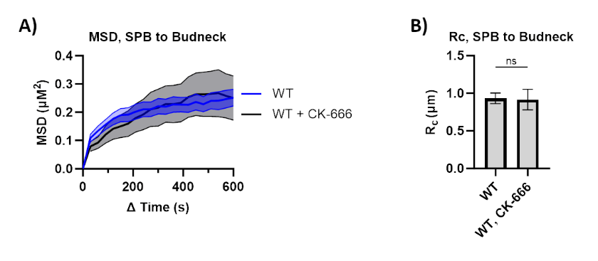
Figure S1. Mobility of spindle pole bodies relative to the bud neck in response to CK-666
- MSD analysis (∆t = 30s) of both SPBs relative to the bud neck in FZ015 (WT) (n=36) 3 h after Gal-HO induction. CK-666 (10 µm) (n=12) was added 20 min before imaging. Imaging and analysis done as described in (1A). Mean ± SEM is shown.
- Boxplot of the Rc from MSD measurements in (A). Statistical analysis as in 1B. See Tables S1 and S2 for significance and R_{C} values. Mean ± SEM is shown.

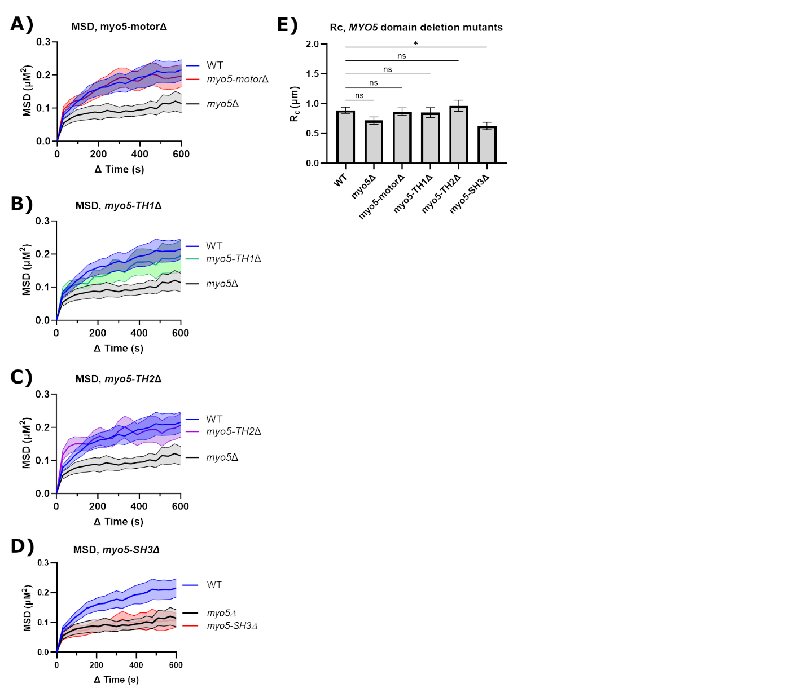
Figure S2. MSD of a DSB in MYO5 domain deletion mutants
- MSD analysis (∆t=30s) of a DSB in FZ015 (WT) (n=20), FZ034 (myo5∆) (n=15), and FZ048 (myo5-motor∆) (n=13) 3 h after Gal-HO induction. Imaging and analysis done as described in (1A). Mean ± SEM is shown.
- MSD analysis (∆t=30s) of a DSB in FZ054 (myo5-TH1∆) (n=11). Imaging and analysis done as described in (1A). Mean ± SEM is shown.
- MSD analysis (∆t=30s) of a DSB in FZ055 (myo5-TH2∆) (n=11). Imaging and analysis done as described in (1A). Mean ± SEM is shown.
- MSD analysis (∆t=30s) of a DSB in FZ056 (myo5-SH3∆) (n=11). Imaging and analysis done as described in (1A). Mean ± SEM is shown.
- Boxplot of the Rc from MSD measurements in (A-D). Statistical analysis as in 1B. See Tables S1 and S2 for significance and R_{C} values. Mean ± SEM is shown.
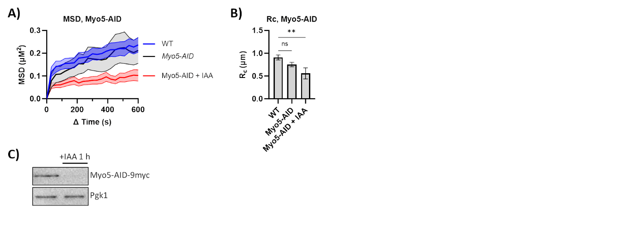
Figure S3. MSD of a DSB in a Myo5-AID mutant
- MSD analysis (∆t = 30s) of DSB relative to the SPB in FZ015 (n=21), FZ065 (Myo5-AID) (n=10), and FZ065 with IAA (Myo5-AID + IAA) (n=10) 3 h after Gal-HO induction. IAA (1 mM) was added 1 h before image collection. Imaging and analysis done as described in (1A). Mean ± SEM is shown.
- Boxplot of the R_{C} from MSD measurements in (A). Statistical analysis as in 1B. See Tables S1 and S2 for significance and R_{C} values. Mean ± SD is shown.
- Western blot analysis of Myo5-AID ± auxin (IAA) (1 mM). IAA or an equivalent amount of 200 proof ethanol was added 2 h after adding galactose. Mouse α-Myc probed for Myo5-AID. Rabbit α-Rad53 probed for Rad53 phosphorylation. Mouse α-Pgk1 was probed as a loading control.

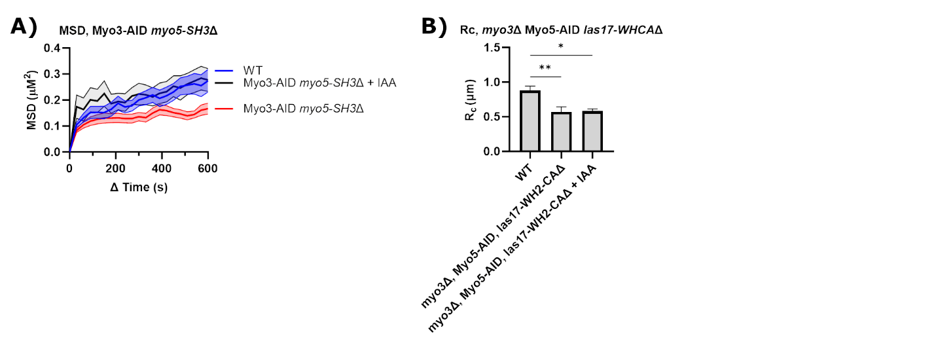
Figure S4 MSD of a DSB in a myo3Δ Myo5-AID las17-WH2-CAΔ mutant
- MSD analysis (∆t = 30s) of DSB relative to the SPB in FZ15 (n=13), FZ105 (myo3∆ Myo5-AID las17-WH2-CA∆) (n=12), and FZ105 with IAA (myo3∆ Myo5-AID las17-WH2-CA∆) (n=15) 3 h after Gal-HO induction. IAA (1 mM) was added 1 h before image collection. Imaging and analysis done as described in (1A). Mean ± SEM is shown.
- Boxplot of the R_{C} from MSD measurements in (A). Statistical analysis as in 1B. See Tables S1 and S2 for significance and R_{C} values. Mean ± SD is shown.

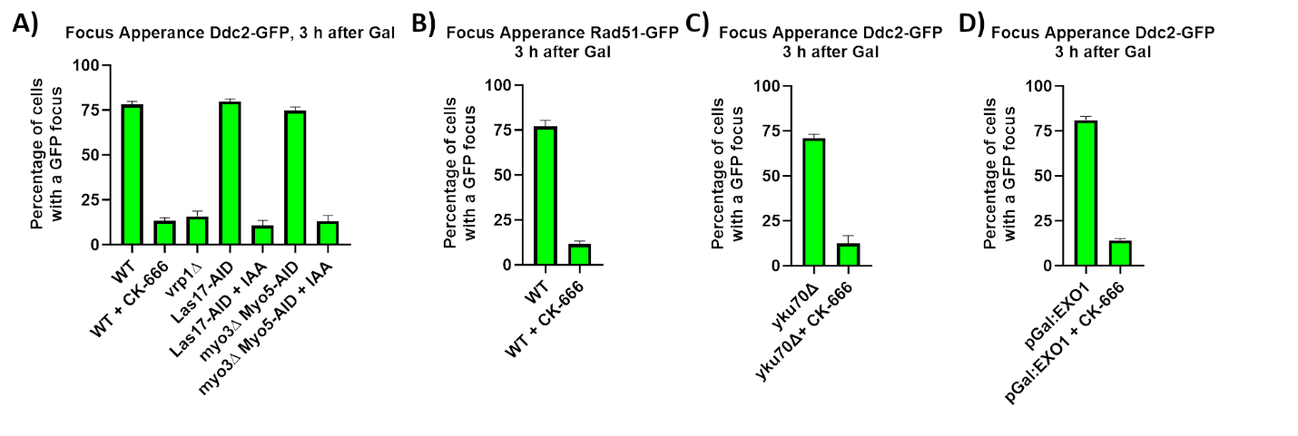
Figure S5 Percentage of cells with a Ddc2-GFP or Rad51-GFP focus 3 h after DSB induction
- Percentage of cells with a Ddc2-GFP focus 3 h after DSB induction in FZ015 (WT), FZ071 (vrp1∆) FZ075 (Las17-AID), and FZ074 (myo3∆ Myo5-AID). CK-666 (10 µM) was added 20 min before galactose to WT and IAA (1 mM) was added to Las17-AID and myo3∆ Myo5-AID 1 h before adding galactose. Cells were collected 3 h after adding galactose. Cells were imaged with a 488 nm laser taking optical stacks of 1.5 µm with step size of 300 nm. Mean ± SEM is shown.
- Percentage of cells with a Rad51-GFP focus 3 h after DSB induction in FZ012. CK-666 (10µM) was added 20 min before galactose. Sample collection and imaging was done as described in (A). Mean ± SEM is shown.
- Percentage of cells with a Ddc2-GFP focus 3 h after DSB induction in FZ028 (yku70∆) ± CK-666. CK-666 was added 20 min before galactose. Sample collection and imaging was done as described in (A). Mean ± SEM is shown.
- Percentage of cells with a Ddc2-GFP focus 3 h after DSB induction in FZ201 (pGal:EXO1). CK-666 (10 µM) was added 20 min before galactose to WT. Cells were collected 3 h after adding galactose. and imaging was done as described in (A). Mean ± SEM is shown.

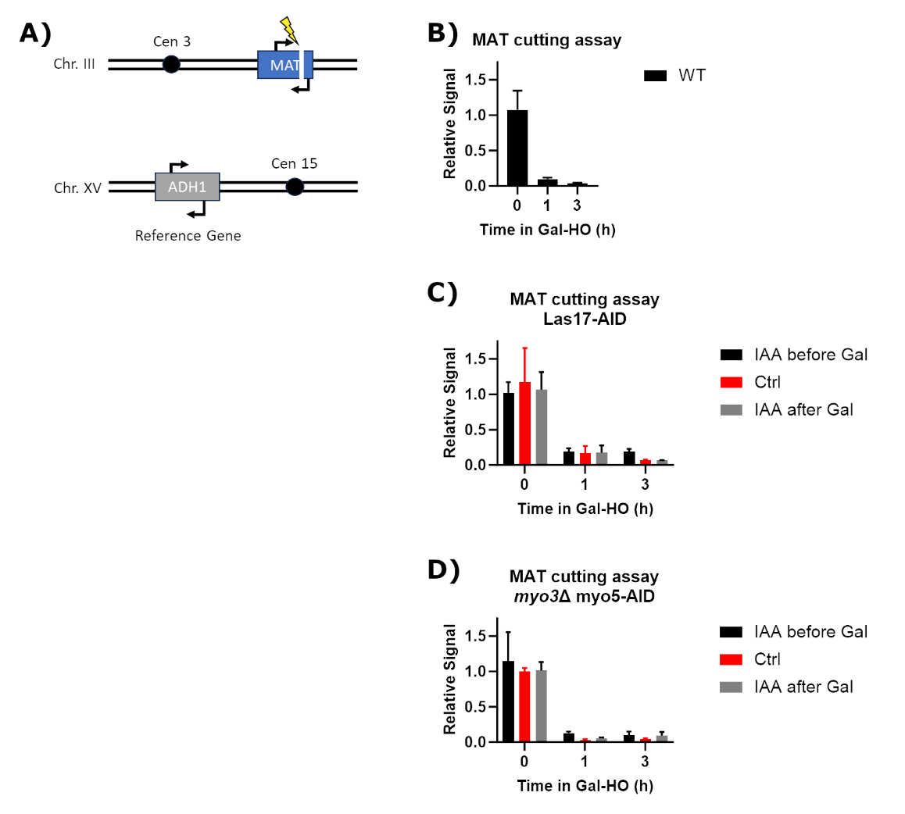
Figure S6. Blocking Arp2/3 activity does not affect cutting by Gal-HO
- Model of MAT cutting assay to determine Gal-HO cutting of the MAT locus on chromosome III. Primers flank the HO-cut site in the MAT locus. A second set of primers in ADH1 on chromosome XV were used as a control.
- Cutting assay of FZ041 (WT) shows that within 1 h after adding galactose. Mean ± SD shown.
- Cutting assay of FZ075 (Las17-AID) shows that within 1 h after adding galactose. IAA was added either 1 h before or 1 h after adding galactose. Mean ± SD shown.
- Cutting assay of FZ074 (myo3Δ Myo5-AID) shows that within 1 h after adding galactose. IAA was added either 1 h before or 1 h after adding galactose. Mean ± SD shown.

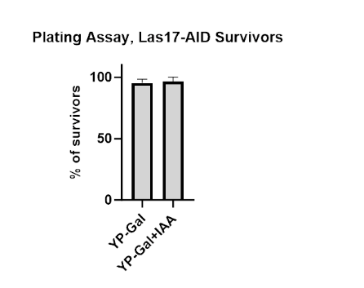
Figure S7. Percentage of MATa-inc Las17-AID survivors regrown on YP-Gal plates
Survival assay of FZ177 Las17-AID survivors from YP-Gal and YP-Gal+IAA plates regrown on YPD and YP-Gal plates. Graph shows the number of colonies on YP-Gal plates divided by the number of colonies on YPD plates. See Methods for more details. Mean ± SEM shown.

