Supplementary Information
Table S1. Frequencies of the different phenotypic classes calculated for the 12 morphological traits by landraces*

Landraces | N | SC | SS | SD | SL | AL | AC | NS | GlC | GC | GSp | GSz | GN
Azizi  (G1/G8) | 42 | 0.00 | 0.00 | 0.67 | 0.00 | 0.00 | 0.00 | 0.00 | 0.00 | 0.00 | 0.00 | 0.00 | 0.00
 |  | 1.00 | 0.00 | 0.33 | 1.00 | 0.02 | 0.02 | 0.48 | 0.98 | 0.00 | 1.00 | 0.98 | 1.00
 |  | 0.00 | 0.00 | 0.00 | 0.00 | 0.98 | 0.33 | 0.52 | 0.02 | 0.02 | 0.00 | 0.02 | 0.00
 |  |  | 1.00 | 0.00 |  |  | 0.64 |  |  | 0.98
 |  |  | 0.00
Jneh Khotifa  (G2) | 12 | 0.00 | 0.00 | 0.00 | 0.00 | 0.00 | 0.00 | 0.00 | 0.00 | 0.00 | 0.00 | 0.00 | 0.00
 |  | 0.00 | 1.00 | 0.00 | 0.00 | 0.00 | 0.00 | 0.00 | 0.00 | 0.00 | 1.00 | 0.00 | 0.00
 |  | 1.00 | 0.00 | 0.00 | 1.00 | 1.00 | 0.00 | 1.00 | 1.00 | 0.00 | 0.00 | 1.00 | 1.00
 |  |  | 0.00 | 1.00 |  |  | 1.00 |  |  | 1.00
 |  |  | 0.00
Taganrog | 27 | 1.00 | 0.00 | 0.00 | 0.15 | 0.00 | 0.00 | 0.00 | 0.04 | 0.37 | 0.00 | 0.00 | 0.00
(G3) |  | 0.00 | 0.00 | 1.00 | 0.85 | 0.00 | 0.00 | 0.00 | 0.00 | 0.00 | 1.00 | 0.81 | 0.00
 |  | 0.00 | 0.00 | 0.00 | 0.00 | 1.00 | 0.00 | 1.00 | 0.96 | 0.63 | 0.00 | 0.19 | 1.00
 |  |  | 1.00 | 0.00 |  |  | 1.00 |  |  | 0.00
 |  |  | 0.00
Mekki | 28 | 0.00 | 0.00 | 0.00 | 1.00 | 0.00 | 0.00 | 0.00 | 0.00 | 0.00 | 0.00 | 1.00 | 0.00
(G4) |  | 1.00 | 1.00 | 0.00 | 0.00 | 0.00 | 0.11 | 0.36 | 1.00 | 0.00 | 1.00 | 0.00 | 1.00
 |  | 0.00 | 0.00 | 0.00 | 0.00 | 1.00 | 0.14 | 0.64 | 0.00 | 1.00 | 0.00 | 0.00 | 0.00
 |  |  | 0.00 | 1.00 |  |  | 0.75 |  |  | 0.00
 |  |  | 0.00
Richi | 11 | 1.00 | 1.00 | 0.00 | 0.00 | 0.00 | 1.00 | 0.00 | 1.00 | 0.18 | 0.00 | 0.00 | 0.00
(G5) |  | 0.00 | 0.00 | 0.00 | 0.18 | 0.82 | 0.00 | 0.18 | 0.00 | 0.00 | 0.00 | 0.18 | 0.18
 |  | 0.00 | 0.00 | 0.09 | 0.82 | 0.18 | 0.00 | 0.82 | 0.00 | 0.82 | 1.00 | 0.82 | 0.82
 |  |  | 0.00 | 0.91 |  |  | 0.00 |  |  | 0.00
 |  |  | 0.00
Souri | 10 | 0.00 | 0.00 | 1.00 | 0.00 | 1.00 | 0.00 | 0.00 | 0.00 | 0.00 | 1.00 | 0.00 | 0.00
(G6) |  | 1.00 | 0.00 | 0.00 | 0.80 | 0.00 | 1.00 | 0.10 | 1.00 | 1.00 | 0.00 | 1.00 | 1.00
 |  | 0.00 | 0.00 | 0.00 | 0.20 | 0.00 | 0.00 | 0.90 | 0.00 | 0.00 | 0.00 | 0.00 | 0.00
 |  |  | 1.00 | 0.00 |  |  | 0.00 |  |  | 0.00
 |  |  | 0.00
Roussia | 7 | 0.00 | 0.00 | 1.00 | 0.00 | 0.00 | 0.00 | 0.14 | 0.00 | 0.00 | 1.00 | 0.00 | 1.00
(G6) |  | 1.00 | 0.00 | 0.00 | 0.29 | 0.00 | 1.00 | 0.14 | 1.00 | 1.00 | 0.00 | 1.00 | 0.00
 |  | 0.00 | 1.00 | 0.00 | 0.71 | 1.00 | 0.00 | 0.71 | 0.00 | 0.00 | 0.00 | 0.00 | 0.00
 |  |  | 0.00 | 0.00 |  |  | 0.00 |  |  | 0.00
 |  |  | 0.00
Badri | 22 | 1.00 | 0.00 | 0.00 | 1.00 | 0.00 | 0.00 | 1.00 | 0.00 | 1.00 | 1.00 | 1.00 | 0.00
(G7) |  | 0.00 | 0.00 | 0.00 | 0.00 | 0.00 | 0.00 | 0.00 | 0.00 | 0.00 | 0.00 | 0.00 | 1.00
 |  | 0.00 | 0.00 | 1.00 | 0.00 | 1.00 | 0.00 | 0.00 | 1.00 | 0.00 | 0.00 | 0.00 | 0.00
 |  |  | 1.00 | 0.00 |  |  | 1.00 |  |  | 0.00
 |  |  | 0.00
Biskri | 46 | 1.00 | 0.00 | 0.00 | 0.00 | 0.00 | 0.00 | 0.00 | 1.00 | 0.00 | 0.00 | 0.00 | 0.00
(G9) |  | 0.00 | 0.24 | 0.24 | 0.00 | 1.00 | 0.00 | 0.00 | 0.00 | 0.00 | 0.80 | 0.07 | 0.22
 |  | 0.00 | 0.00 | 0.76 | 1.00 | 0.00 | 0.02 | 1.00 | 0.00 | 1.00 | 0.20 | 0.93 | 0.78
 |  |  | 0.00 | 0.00 |  |  | 0.98 |  |  | 0.00
 |  |  | 0.76
Biada | 24 | 1.00 | 0.00 | 0.00 | 0.04 | 0.00 | 1.00 | 0.00 | 1.00 | 1.00 | 0.00 | 0.00 | 0.00
(G10) |  | 0.00 | 0.00 | 1.00 | 0.96 | 1.00 | 0.00 | 1.00 | 0.00 | 0.00 | 1.00 | 1.00 | 0.71
 |  | 0.00 | 0.00 | 0.00 | 0.00 | 0.00 | 0.00 | 0.00 | 0.00 | 0.00 | 0.00 | 0.00 | 0.29
 |  |  | 1.00 | 0.00 |  |  | 0.00 |  |  | 0.00
 |  |  | 0.00
Mahmoudi | 74 | 1.00 | 1.00 | 0.00 | 0.28 | 0.00 | 0.18 | 0.00 | 0.86 | 1.00 | 0.00 | 0.00 | 0.00
(G11) |  | 0.00 | 0.00 | 0.23 | 0.72 | 0.00 | 0.00 | 1.00 | 0.00 | 0.00 | 0.00 | 0.16 | 0.58
 |  | 0.00 | 0.00 | 0.77 | 0.00 | 1.00 | 0.00 | 0.00 | 0.14 | 0.00 | 1.00 | 0.84 | 0.42
 |  |  | 0.00 | 0.00 |  |  | 0.82 |  |  | 0.00
 |  |  | 0.00
N: Number of accessions per landrace; SC : spike color ; SS : spike shape ; SD : spike density ; SL : spike length ; AL : awn length ; AC : awn color ; NS : number of spikelets/spike ; GlC : glume color ; GC : grain color ; GSp : grain shape ; GSz : grain size ; GN : number of grains/spikelet ; * Phenotypic classes per trait have the same order as mentioned in Table S11.

Table S2. Main morphological characteristics of 11 landraces identified across 304 Tunisian durum wheat accessions based on IPGRI (1985) [23], UPOV (1988) [24] and Deghais et al. [13].
Landrace | 12 studied Spike characteristics | Additional characteristics
Azizi  (G1/G8)  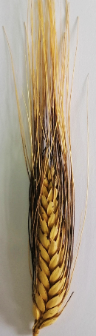 | 1. Spike color : light tan  2. Spike shape : rectangular  3. Spike density : lax to intermediate  4. Spike length : intermediate (6 to 9 cm)  5. Number of spikelets /spike : intermediate (16 to 22)  6. Awn color : Black  7. Awn length : longer than the spike  8. Glume color : tan with black spots  9. Grain color : brown  10. Grain shape : moderately long  11. Grain size : Intermediate (0.3 to 0.5 cm)  12. Number of grains/spikelet :  intermediate (2 to 3) | Glume Form : long and tight  Glume Hairiness : absent  Straw Color : golden blond  Plant Height : intermediate to high (~120 cm)
Jneh Khotifa  (G2)  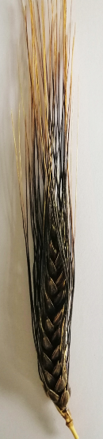 | 1. Spike color : Black to purple  2. Spike shape : elongate with parallel edges  3. Spike density : very dense  4. Spike length : long (>9 cm)  5. Number of spikelets /spike : high (>23)  6. Awn color : Black  7. Awn length : longer than the spike  8. Glume color : Black to purple  9. Grain color : dark brown  10. Grain shape : moderately long  11. Grain size : large (>0.5 cm)  12. Number of grains/spikelet :  high (> 3) | Glume Form : short, sharp, curved inside  Glume Hairiness : high  Straw Color : blond  Plant Height : high (~150 cm)
Taganrog  (G3)  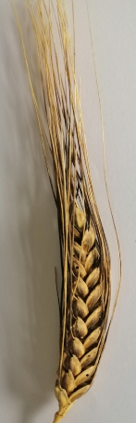 | 1. Spike color : white  2. Spike shape : flattened and half cylindrical  3. Spike density : intermediate  4. Spike length : short to intermediate  5. Number of spikelets /spike : high (>23)  6. Awn color : Black  7. Awn length : longer than the spike  8. Glume color : Black  9. Grain color : light brown  10. Grain shape : moderately long  11. Grain size : Intermediate (0.3 to 0.5 cm)  12. Number of grains/spikelet :  high (> 3) | Glume Form : long and sharp, washed with black  Glume Hairiness : low  Straw Color : white  Plant Height : high (~120 to 140 cm)
Mekki  (G4)  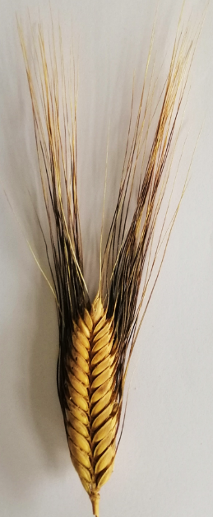 | 1. Spike color : tan to red  2. Spike shape : with parallel edges  3. Spike density : very dense  4. Spike length : short (< 6 cm)  5. Number of spikelets /spike : high (>23)  6. Awn color : Brown  7. Awn length : longer than the spike  8. Glume color : brown to red  9. Grain color : tan  10. Grain shape : moderately long  11. Grain size : small (<0.3 cm)  12. Number of grains/spikelet :  intermediate (2 to 3) | Glume Form : short and curved  Glume Hairiness : absent  Straw Color : white  Plant Height : high (~120 cm)
Richi  (G5)  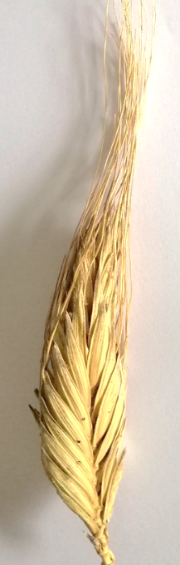 | 1. Spike color : white  2. Spike shape : stretched and pyramidal  3. Spike density : dense  4. Spike length : long (>9 cm)  5. Number of spikelets /spike : high (>23)  6. Awn color : White  7. Awn length : same length as the spike  8. Glume color : white to blond  9. Grain color : tan  10. Grain shape : elongate  11. Grain size : large (>0.5 cm)  12. Number of grains/spikelet :  high (>3) | Glume Form : very long and feathery  Glume Hairiness : Presence of hair on Glume edges  Straw Color : white  Plant Height : high (~130 cm)
Souri  (G6)  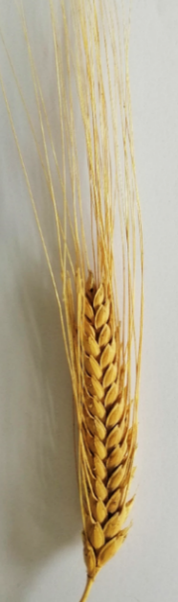 | 1. Spike color : red  2. Spike shape : rectangular, flattened, tight  3. Spike density : intermediate to lax  4. Spike length : intermediate to long (>9 cm)  5. Number of spikelets /spike : high (>23)  6. Awn color : Red  7. Awn length : shorter than the spike  8. Glume color : red  9. Grain color : yellow-orange  10. Grain shape : slightly long  11. Grain size : Intermediate (0.3 - 0.5 cm)  12. Number of grains/spikelet :  intermediate (2 to 3) | Glume Form : moderately long  Glume Hairiness : absent  Straw Color : dark blond  Plant Height : intermediate (~100 to 110 cm)
Roussia  (G6)  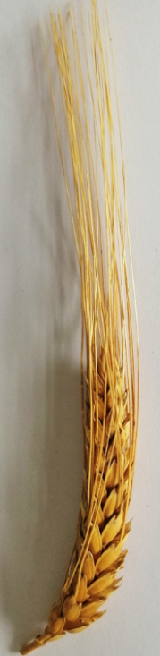 | 1. Spike color : red  2. Spike shape : long, cylindrical, very tight  3. Spike density : lax  4. Spike length : long (>9 cm)  5. Number of spikelets /spike : high (>23)  6. Awn color : Red  7. Awn length : longer than the spike  8. Glume color : red  9. Grain color : orange  10. Grain shape : slightly long  11. Grain size : Intermediate (0.3 to 0.5 cm)  12. Number of grains/spikelet :  low (< 2) | Glume Form : horizontale  Glume Hairiness : absent  Straw Color : dark blond  Plant Height : intermediate (~110 cm)
Badri  (G7)  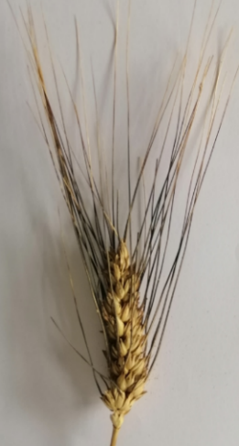 | 1. Spike color : white greyish  2. Spike shape : very short and large  3. Spike density : dense  4. Spike length : short (< 6 cm)  5. Number of spikelets /spike : low (<15)  6. Awn color : Black  7. Awn length : longer than the spike  8. Glume color : white with black bordure  9. Grain color : white  10. Grain shape : slightly long  11. Grain size : small (<0.3 cm)  12. Number of grains/spikelet : intermediate  (2 to 3) | Glume Form : long  Glume Hairiness : absent  Straw Color : golden blond  Plant Height : short (~90 cm)
Biskri  (G9)  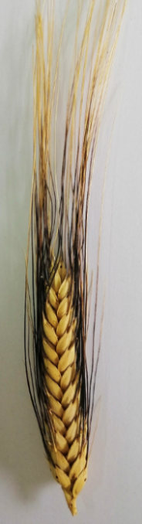 | 1. Spike color : white  2. Spike shape : fusiform and flattened  3. Spike density : intermediate to dense  4. Spike length : long (>9 cm)  5. Number of spikelets /spike : high (>23)  6. Awn color : Black  7. Awn length : longer than the spike  8. Glume color : white with a line on the sup edge  9. Grain color : dark tan  10. Grain shape : moderately long  11. Grain size : large (> 0.5 cm)  12. Number of grains/spikelet :  high (>3) | Glume Form : long and very sharp with a black line on top  Glume Hairiness : low  Straw Color : white  Plant Height : high (~120 to 140 cm)
Biada  (G10)  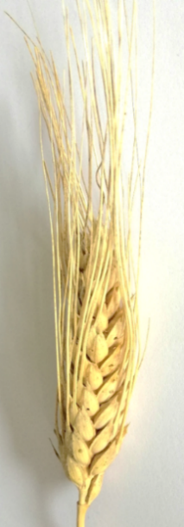 | 1. Spike color : white  2. Spike shape : round to half cylindrical  3. Spike density : intermediate to lax  4. Spike length : intermediate (6 to 9 cm)  5. Number of spikelets /spike : intermediate (16 to 22)  6. Awn color : White  7. Awn length : same length as the spike  8. Glume color : white with some spots  9. Grain color : white  10. Grain shape : moderately long  11. Grain size : Intermediate (0.3 to 0.5 cm)  12. Number of grains/spikelet :  intermediate (2 to 3) | Glume Form : elongate  Glume Hairiness : very low  Straw Color : white  Plant Height : intermediate to short (~90 to 100 cm)
Mahmoudi  (G11)  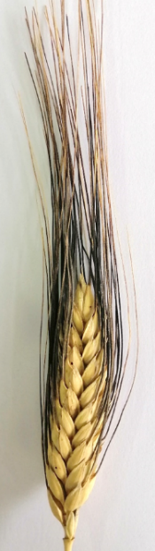 | 1. Spike color : white to blond  2. Spike shape : sub-pyramidal and flattened  3. Spike density : dense  4. Spike length : intermediate (6 to 9 cm)  5. Number of spikelets /spike : intermediate (16-22)  6. Awn color : Black  7. Awn length : longer than the spike  8. Glume color : white with black bordures  9. Grain color : white  10. Grain shape : long  11. Grain size : large (> 0.5 cm)  12. Number of grains/spikelet : high (>3) | Glume Form : short and oblique  Glume Hairiness : absent  Straw Color : blond  Plant Height : high (~120 to 130 cm)

Table S3. Shannon-Weaver index (H’) estimated on the 11 Tunisian durum wheat landraces.

Landraces | SC | SS | SD | SL | AL | AC | NS | GlC | GC | GSp | GSz | GN | Mean H'
Azizi | 0.00 | 0.00 | 0.46 | 0.00 | 0.10 | 0.53 | 0.63 | 0.10 | 0.08 | 0.00 | 0.10 | 0.00 | 0.17
Badri | 0.00 | 0.00 | 0.00 | 0.00 | 0.00 | 0.00 | 0.00 | 0.00 | 0.00 | 0.00 | 0.00 | 0.00 | 0.00
Biada | 0.00 | 0.00 | 0.00 | 0.16 | 0.00 | 0.00 | 0.00 | 0.00 | 0.00 | 0.00 | 0.00 | 0.55 | 0.06
Biskri | 0.00 | 0.34 | 0.40 | 0.00 | 0.00 | 0.08 | 0.00 | 0.00 | 0.00 | 0.45 | 0.22 | 0.48 | 0.16
Jneh Khotifa | 0.00 | 0.00 | 0.00 | 0.00 | 0.00 | 0.00 | 0.00 | 0.00 | 0.00 | 0.00 | 0.00 | 0.00 | 0.00
Mahmoudi | 0.00 | 0.00 | 0.39 | 0.54 | 0.00 | 0.34 | 0.00 | 0.36 | 0.00 | 0.00 | 0.40 | 0.62 | 0.22
Mekki | 0.00 | 0.00 | 0.00 | 0.00 | 0.00 | 0.53 | 0.59 | 0.00 | 0.00 | 0.00 | 0.00 | 0.00 | 0.09
Richi | 0.00 | 0.00 | 0.22 | 0.43 | 0.43 | 0.00 | 0.43 | 0.00 | 0.34 | 0.00 | 0.43 | 0.43 | 0.23
Roussia | 0.00 | 0.00 | 0.00 | 0.54 | 0.00 | 0.00 | 0.72 | 0.00 | 0.00 | 0.00 | 0.00 | 0.00 | 0.11
Souri | 0.00 | 0.00 | 0.00 | 0.46 | 0.00 | 0.00 | 0.30 | 0.00 | 0.00 | 0.00 | 0.00 | 0.00 | 0.06
Taganrog | 0.00 | 0.00 | 0.00 | 0.38 | 0.00 | 0.00 | 0.00 | 0.14 | 0.48 | 0.00 | 0.44 | 0.00 | 0.12
Mean | 0.00 | 0.03 | 0.13 | 0.23 | 0.05 | 0.13 | 0.24 | 0.06 | 0.08 | 0.04 | 0.14 | 0.19 | 0.11
SC : spike color ; SS : spike shape ; SD : spike density ; SL : spike length ; AL : awn length ; AC : awn color ; NS : number of spikelets/spike ; GlC : glume color ; GC : grain color ; GSp : grain shape ; GSz : grain size ; GN : number of grains/spikelet

Table S4. List of Single Sequence Repeat (SSR) markers with their chromosome allocation, forward and reverse primer sequences, size and Dye used.

Locus | Forward Primer | Reverse Primer | Chromosome Arm | Allele Size range (bp¹) | Dye Eurofins
Xgwm413 | TGCTTGTCTAGATTGCTTGGG | GATCGTCTCGTCCTTGGCA | 2B | 90-110 | a
Xgpw7148 | GCACACAACGACACTTGCTT | GCTTAGCTGCTTGCTTTGTG | 3B | 93-100 | a
Xgwm495 | GAGAGCCTCGCGAAATATAGG | TGCTTCTGGTGTTCCTTCG | 4B | 157-191 | b
Xgwm193 | CTTTGTGCACCTCTCTCTCC | AATTGTGTTGATGATTTGGGG | 6BS | 162-192 | b
Xgpw2239 | CAACCATATGCCCAGGAGAC | TGTTGCTGTCTGAAACAGGG | 4AS | 191-193 | b
Xgwm285 | ATGACCCTTCTGCCAAACAC | ATCGACCGGGATCTAGCC | 3B | 209-235 | c
Xgpw4082 | CTTTCTTTCCCCTCCTGTCC | ATCATCACAAATGCAGCGAG | 4B | 213-228 | c
Xgpw4004 | CGCCTCGGATTCTATTCTTG | CTTACTGCGGCCTTGAGTTG | 5A | 224-229 | c
Xgpw2103 | CGTATGCAGCATGGCATC | GCTATGTTGTGTGGCATTGG | 7AL (7B) | 230-238 | c
Xgwm372 | AATAGAGCCCTGGGACTGGG | GAAGGACGACATTCCACCTG | 2A | 312-314 | d
bp : base pairs ; Annealing temperature (TM) = 60°C ; a : multiplex 1 (Ned-Fam) ; b : multiplex 2 (Fam-Ned-Vic) ; c : multiplex 3 (Ned-Fam-Pet-Vic) ; d : multiplex 4 (Fam)

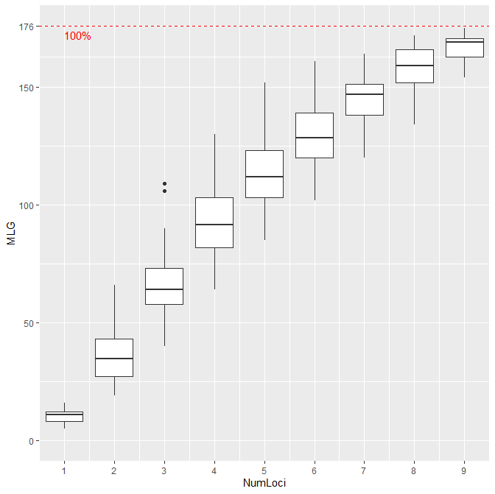
Figure S1. Genotype accumulation curve generated under R 3.3.2 [48], for the Tunisian durum wheat landraces accessions genotyped with 10 SSR markers.

Table S5. Summary of Private Alleles.

 |  | Locus | Allele | Freq
Subpopulations | ADMIX | L1 | 199 | 0.024
Subpopulations | ADMIX | L2 | 194 | 0.049
Subpopulations | ADMIX | L4 | 189 | 0.024
Subpopulations | ADMIX | L6 | 228 | 0.024
Subpopulations | ADMIX | L8 | 234 | 0.111
Subpopulations | ADMIX | L10 | 305 | 0.014
Subpopulations | G1 | L1 | 101 | 0.229
Subpopulations | G1 | L1 | 102 | 0.021
Subpopulations | G1 | L2 | 186 | 0.083
Subpopulations | G10 | L10 | 312 | 0.063
Subpopulations | G11 | L10 | 299 | 0.017
Subpopulations | G3 | L8 | 286 | 0.053
Subpopulations | G4 | L10 | 323 | 0.154
Subpopulations | G5 | L4 | 175 | 0.200
Subpopulations | G5 | L8 | 227 | 0.100
Subpopulations | G6 | L2 | 181 | 0.111
Subpopulations | G6 | L6 | 213 | 0.111
Subpopulations | G6 | L6 | 230 | 0.333
Subpopulations | G6 | L6 | 232 | 0.111
Subpopulations | G6 | L7 | 218 | 0.111
Subpopulations | G6 | L8 | 222 | 0.111
Subpopulations | G6 | L9 | 240 | 0.125
Subpopulations | G8 | L1 | 103 | 0.500
Subpopulations | G8 | L1 | 104 | 0.100
Subpopulations | G8 | L4 | 173 | 0.100
Subpopulations | G8 | L4 | 177 | 0.100
Subpopulations | G9 | L8 | 235 | 0.250
Subpopulations | G9 | L8 | 236 | 0.036
Regions | Gabes | L1 | 102 | 0.013
Regions | Gabes | L1 | 104 | 0.026
Regions | Gabes | L1 | 196 | 0.263
Regions | Gabes | L1 | 199 | 0.026
Regions | Gabes | L2 | 181 | 0.026
Regions | Gabes | L2 | 186 | 0.053
Regions | Gabes | L2 | 194 | 0.026
Regions | Gabes | L4 | 177 | 0.026
Regions | Gabes | L4 | 189 | 0.026
Regions | Gabes | L6 | 213 | 0.026
Regions | Gabes | L6 | 228 | 0.026
Regions | Gabes | L7 | 216 | 0.026
Regions | Gabes | L7 | 218 | 0.026
Regions | Gabes | L8 | 234 | 0.026
Regions | Gabes | L9 | 240 | 0.029
Regions | Gabes | L10 | 305 | 0.014
Regions | Gabes | L10 | 314 | 0.042
Regions | Kairouan | L1 | 192 | 0.060
Regions | Kairouan | L2 | 198 | 0.119
Regions | Mahdia | L1 | 100 | 0.037
Regions | Mahdia | L2 | 192 | 0.037
Regions | Mahdia | L3 | 172 | 0.037
Regions | Mahdia | L3 | 176 | 0.056
Regions | Mahdia | L4 | 173 | 0.037
Regions | Mahdia | L4 | 175 | 0.074
Regions | Mahdia | L4 | 187 | 0.037
Regions | Mahdia | L5 | 191 | 0.037
Regions | Mahdia | L8 | 227 | 0.040
Regions | Mahdia | L8 | 286 | 0.040
Regions | Mahdia | L10 | 299 | 0.045
Regions | Mednine | L8 | 222 | 0.045
Regions | Sousse | L3 | 174 | 0.111
Climatic stages | High-arid | L1 | 192 | 0.060
Climatic stages | High-arid | L2 | 198 | 0.119
Climatic stages | Low semi-arid | L1 | 100 | 0.028
Climatic stages | Low semi-arid | L2 | 192 | 0.028
Climatic stages | Low semi-arid | L3 | 172 | 0.028
Climatic stages | Low semi-arid | L3 | 174 | 0.028
Climatic stages | Low semi-arid | L3 | 176 | 0.042
Climatic stages | Low semi-arid | L4 | 173 | 0.028
Climatic stages | Low semi-arid | L4 | 175 | 0.056
Climatic stages | Low semi-arid | L4 | 187 | 0.028
Climatic stages | Low semi-arid | L5 | 191 | 0.028
Climatic stages | Low semi-arid | L8 | 227 | 0.029
Climatic stages | Low semi-arid | L8 | 286 | 0.029
Climatic stages | Low semi-arid | L10 | 299 | 0.032
Climatic stages | Mid-arid | L1 | 102 | 0.008
Climatic stages | Mid-arid | L1 | 104 | 0.017
Climatic stages | Mid-arid | L1 | 196 | 0.167
Climatic stages | Mid-arid | L1 | 198 | 0.083
Climatic stages | Mid-arid | L1 | 199 | 0.017
Climatic stages | Mid-arid | L2 | 181 | 0.017
Climatic stages | Mid-arid | L2 | 186 | 0.033
Climatic stages | Mid-arid | L2 | 194 | 0.017
Climatic stages | Mid-arid | L4 | 177 | 0.017
Climatic stages | Mid-arid | L4 | 189 | 0.017
Climatic stages | Mid-arid | L6 | 213 | 0.017
Climatic stages | Mid-arid | L6 | 228 | 0.017
Climatic stages | Mid-arid | L7 | 216 | 0.017
Climatic stages | Mid-arid | L7 | 218 | 0.017
Climatic stages | Mid-arid | L8 | 222 | 0.017
Climatic stages | Mid-arid | L8 | 234 | 0.017
Climatic stages | Mid-arid | L9 | 240 | 0.018
Climatic stages | Mid-arid | L10 | 305 | 0.009
Climatic stages | Mid-arid | L10 | 314 | 0.026
L1= Xgwm413 ; L2= Xgpw7148 ; L3= Xgwm495 ; L4= Xgwm193 ; L5= Xgpw2239 ; L6= Xgwm285 ; L7= Xgpw4082 ; L8= Xgpw4004 ; L9= Xgpw2103 ; L10= Xgwm372

Table S6. Pairwise Nei’s genetic distances between the durum wheat subpopulations based on 10 SSR markers.

ADMIX | G1 | G10 | G11 | G2 | G3 | G4 | G5 | G6 | G7 | G8 | G9
0.000 |  |  |  |  |  |  |  |  |  |  |  | ADMIX
0.453 | 0.000 |  |  |  |  |  |  |  |  |  |  | G1
0.673 | 1.365 | 0.000 |  |  |  |  |  |  |  |  |  | G10
0.512 | 1.184 | 1.063 | 0.000 |  |  |  |  |  |  |  |  | G11
0.565 | 1.189 | 1.437 | 0.708 | 0.000 |  |  |  |  |  |  |  | G2
0.653 | 1.606 | 1.560 | 0.630 | 1.019 | 0.000 |  |  |  |  |  |  | G3
0.502 | 0.871 | 0.985 | 0.716 | 0.960 | 0.630 | 0.000 |  |  |  |  |  | G4
0.468 | 0.738 | 2.416 | 0.769 | 0.934 | 1.351 | 0.934 | 0.000 |  |  |  |  | G5
0.261 | 0.852 | 0.922 | 0.624 | 0.983 | 0.726 | 0.662 | 0.717 | 0.000 |  |  |  | G6
0.715 | 1.039 | 2.319 | 0.740 | 1.200 | 0.692 | 1.350 | 0.873 | 0.706 | 0.000 |  |  | G7
0.692 | 0.421 | 2.265 | 1.179 | 0.981 | 1.875 | 1.666 | 1.100 | 1.435 | 1.080 | 0.000 |  | G8
0.423 | 1.432 | 1.857 | 1.337 | 0.993 | 1.271 | 1.667 | 0.805 | 0.902 | 0.923 | 1.132 | 0.000 | G9

Table S7. Shannon-Weaver index (H’) estimated for the genetic clusters C1 and C2 defined by MSN analysis.

 | C1 | C2 | Mean
SC | 0.48 | 0.44 | 0.46
SS | 0.80 | 0.63 | 0.72
SD | 0.94 | 0.75 | 0.84
SL | 0.73 | 0.65 | 0.69
AL | 0.75 | 0.38 | 0.57
AC | 0.60 | 0.52 | 0.56
NS | 0.83 | 0.48 | 0.65
GlC | 0.74 | 0.87 | 0.80
GC | 0.90 | 0.39 | 0.64
GSp | 0.82 | 0.63 | 0.73
GSz | 0.95 | 0.95 | 0.95
GN | 0.74 | 0.62 | 0.68
Mean H’ | 0.77 | 0.61 | 0.69
SC : spike color ; SS : spike shape ; SD : spike density ; SL : spike length ; AL : awn length ; AC : awn color ; NS : number of spikelets/spike ; GlC : glume color ; GC : grain color ; GSp : grain shape ; GSz : grain size ; GN : number of grains/spikelet

Table S8. Diversity indexes of the genetic clusters C1 and C2 defined by MSN analysis.

Cluster | N | Na | Ne | I | Ho | He | Nm | Fst
C1 | 121 | 11 (4.000) | 5.246 (2.713) | 1.722 (0.581) | 0.004 (0.004) | 0.740  (0.135)
C2 | 140 | 6  (4.000) | 2.350 (1.197) | 0.911 (0.654) | 0.004 (0.004) | 0.425  (0.293)
Total | 261 | 8.500 (2.723) | 3.798 (1.471) | 1.316 (0.427) | 0.004 (0.002) | 0.583 (0.160) | 1.889 (1.576) | 0.256
N: number of accessions; Na : Number of different Alleles ; Ne : Number of Effective Alleles ; I : Shannon's Information Index ; Ho : Observed Heterozygosity ; He : Expected Heterozygosity ; Nm : gene flow ; Fst : genetic differenciation

Table S9. Frequencies of the different phenotypic classes calculated for the 12 morphological traits by regions and by climatic stages*

 |  | SC | SS | SD | SL | AL | AC | NS | GlC | GC | GSp | GSz | GN
Entire collection |  | 0.81 | 0.28 | 1.61 | 0.25 | 0.06 | 0.16 | 0.08 | 0.62 | 0.46 | 0.13 | 0.17 | 0.02
Entire collection |  | 0.15 | 0.17 | 0.27 | 0.39 | 0.39 | 0.07 | 0.46 | 0.22 | 0.06 | 0.56 | 0.40 | 0.58
Entire collection |  | 0.04 | 0.03 | 0.30 | 0.36 | 0.55 | 0.06 | 0.46 | 0.16 | 0.31 | 0.31 | 0.43 | 0.40
Entire collection |  |  | 0.40 | 0.28 |  |  | 0.71 |  |  | 0.18
Entire collection |  |  | 0.12
Regions | Gabes | 0.08 | 0.03 | 0.24 | 0.11 | 0.84 | 0.08 | 0.45 | 0.84 | 0.11 | 0.08 | 0.82 | 0.05
Regions |  | 0.92 | 0.05 | 0.63 | 0.05 | 0.08 | 0.05 | 0.55 | 0.08 | 0.08 | 0.82 | 0.18 | 0.79
Regions |  | 0.00 | 0.79 | 0.13 | 0.84 | 0.08 | 0.13 | 0.00 | 0.08 | 0.16 | 0.11 | 0.00 | 0.16
Regions |  |  | 0.13 | 0.00 |  |  | 0.74 |  |  | 0.66
Regions |  |  | 0.00
Regions | Kairouan | 0.81 | 0.19 | 0.01 | 0.34 | 0.01 | 0.01 | 0.32 | 0.44 | 0.54 | 0.34 | 0.32 | 0.44
Regions |  | 0.01 | 0.19 | 0.09 | 0.24 | 0.26 | 0.01 | 0.22 | 0.34 | 0.01 | 0.43 | 0.13 | 0.56
Regions |  | 0.18 | 0.01 | 0.51 | 0.43 | 0.72 | 0.01 | 0.46 | 0.22 | 0.22 | 0.24 | 0.54 | 0.00
Regions |  |  | 0.41 | 0.38 |  |  | 0.96 |  |  | 0.22
Regions |  |  | 0.19
Regions | Mahdia | 1.00 | 0.48 | 0.48 | 0.37 | 0.30 | 0.41 | 0.52 | 0.78 | 0.52 | 0.52 | 0.78 | 0.59
Regions |  | 0.00 | 0.48 | 0.44 | 0.37 | 0.70 | 0.15 | 0.48 | 0.22 | 0.26 | 0.48 | 0.22 | 0.41
Regions |  | 0.00 | 0.04 | 0.07 | 0.26 | 0.00 | 0.44 | 0.00 | 0.00 | 0.22 | 0.00 | 0.00 | 0.00
Regions |  |  | 0.00 | 0.00 |  |  | 0.00 |  |  | 0.00
Regions |  |  | 0.00
Regions | Medenine | 0.73 | 0.59 | 0.36 | 0.14 | 0.27 | 0.18 | 0.64 | 0.73 | 0.64 | 0.27 | 0.55 | 0.05
Regions |  | 0.27 | 0.23 | 0.64 | 0.73 | 0.14 | 0.27 | 0.36 | 0.27 | 0.27 | 0.14 | 0.45 | 0.50
Regions |  | 0.00 | 0.18 | 0.00 | 0.14 | 0.59 | 0.55 | 0.00 | 0.00 | 0.09 | 0.59 | 0.00 | 0.45
Regions |  |  | 0.00 | 0.00 |  |  | 0.00 |  |  | 0.00
Regions |  |  | 0.00
Regions | Sousse | 1.00 | 1.00 | 0.00 | 1.00 | 0.00 | 1.00 | 0.00 | 1.00 | 0.00 | 0.00 | 0.00 | 0.00
Regions |  | 0.00 | 0.00 | 0.00 | 0.00 | 1.00 | 0.00 | 0.00 | 0.00 | 0.00 | 0.00 | 0.00 | 0.00
Regions |  | 0.00 | 0.00 | 0.00 | 0.00 | 0.00 | 0.00 | 1.00 | 0.00 | 1.00 | 1.00 | 1.00 | 1.00
Regions |  |  | 0.00 | 1.00 |  |  | 0.00 |  |  | 0.00
Regions |  |  | 0.00
Climatic stages | Low semi-arid | 0.47 | 0.61 | 0.36 | 1.00 | 0.28 | 0.56 | 0.39 | 0.83 | 0.39 | 0.39 | 0.58 | 0.44
Climatic stages |  | 0.53 | 0.36 | 0.33 | 0.00 | 0.53 | 0.11 | 0.61 | 0.17 | 0.44 | 0.61 | 0.42 | 0.56
Climatic stages |  | 0.00 | 0.03 | 0.31 | 0.00 | 0.19 | 0.33 | 0.00 | 0.00 | 0.17 | 0.00 | 0.00 | 0.00
Climatic stages |  |  | 0.00 | 0.00 |  |  | 0.00 |  |  | 0.00
Climatic stages |  |  | 0.00
Climatic stages | Mid-arid | 0.15 | 0.25 | 0.53 | 0.85 | 0.08 | 0.10 | 0.58 | 0.80 | 0.30 | 0.15 | 0.72 | 0.05
Climatic stages |  | 0.58 | 0.10 | 0.38 | 0.15 | 0.33 | 0.15 | 0.42 | 0.15 | 0.15 | 0.57 | 0.28 | 0.68
Climatic stages |  | 0.27 | 0.57 | 0.08 | 0.00 | 0.58 | 0.08 | 0.00 | 0.05 | 0.10 | 0.28 | 0.00 | 0.27
Climatic stages |  |  | 0.08 | 0.00 |  |  | 0.67 |  |  | 0.45
Climatic stages |  |  | 0.00
Climatic stages | High-arid | 0.01 | 0.19 | 0.01 | 0.81 | 0.34 | 0.01 | 0.33 | 0.45 | 0.55 | 0.34 | 0.33 | 0.45
Climatic stages |  | 0.27 | 0.19 | 0.07 | 0.01 | 0.22 | 0.01 | 0.22 | 0.34 | 0.01 | 0.42 | 0.13 | 0.55
Climatic stages |  | 0.72 | 0.01 | 0.52 | 0.18 | 0.43 | 0.01 | 0.45 | 0.21 | 0.21 | 0.24 | 0.54 | 0.00
Climatic stages |  |  | 0.40 | 0.39 |  |  | 0.96 |  |  | 0.22
Climatic stages |  |  | 0.19
SC : spike color ; SS : spike shape ; SD : spike density ; SL : spike length ; AL : awn length ; AC : awn color ; NS : number of spikelets/spike ; GlC : glume color ; GC : grain color ; GSp : grain shape ; GSz : grain size ; GN : number of grains/spikelet ;
* Phenotypic classes per trait have the same order as mentioned in Table S11.

Table S10. Global Positioning System coordinates, number of durum wheat accessions and regions of the different collecting sites provided by The National Gene Bank (BNG).

Region | Site | Longitude | Latitude | Number of accessions | Accessions NGB code
Kairouan | Sbikha, Kondar | 10° 18′ 0.4″ E | 35° 55′ 57.62″ N | 9
  14773, 14774, 14780, 14783, 14792, 14794, 14797, 14839, 14841
Kairouan | Sbikha, Nadhour | 10° 5′ 33.57″ E | 36° 7′ 18.58″ N | 4 | 14842, 14843, 14844, 14845
Kairouan | Sbikha, Sisseb | 10° 21′ 69.4″ E | 35° 97′ 19.4″ N | 23
  16154, 16155, 16160, 16161, 16168, 16176, 16178, 16179, 16180, 16181, 16182, 16183, 16184, 14748, 14749, 14753, 14759, 14764, 14767, 14769, 14770, 14771, 14772
Kairouan | El Guefaî, Sbikha | 9° 93′ 62.7″ E | 35° 97′ 23.8″ N | 13
  16185, 16186, 16193, 16194, 16206, 16207, 16210, 16211, 16214, 16215, 16216, 16217, 16218
Kairouan | Sbikha | 10° 1′ 12″ E | 35° 55′ 48″ N | 12
  16219, 16220, 16231, 16244, 16245, 16255, 16256, 16267, 16268, 16278, 16288, 16297
Kairouan | Sidi El Heni, direction Kairouan | 10° 18′ 34.93″ E | 35° 40′ 54.56″ N | 7
  16105, 16106, 16113, 16114, 16145, 16146, 16150
Gabes | Menzel Hbib | 9°36'22.3"E | 34°13'34.2"N | 31
  14846, 14849, 14853, 14857, 14860, 14861, 14864, 14868, 14871, 14873, 14956, 14957, 14964, 15087, 15088, 15102, 15107, 15125, 15129, 15130, 15131, 15132, 15133, 15134, 15135, 15136, 15137, 15138, 15139, 15141, 15142
Gabes | Elmzaraa. El Hamma | 9°47'50.3"E | 33°53'13.7"N | 4
  15168, 15169, 15171, 15173
Gabes | Aouledkhout. Ara ouali | 9° 91′ 30″ E | 33° 96′ 44″ N | 3
  16369, 28566, 28569
Medenine | Ejjoref. Djerba | 10°43'56.3"E | 33°41'38.8"N | 1 | 15441
Medenine | Elhnichrate. Zarzis | 11°04'14.0"E | 33°30'19.7"N | 16
  15524, 15525, 15529, 15533, 15534, 15537, 15546, 15555, 15564, 15576, 15584, 15587, 15588, 15590, 15591, 15643
Medenine | Salb. à 10km de Zarzis | 11°01'03.7"E | 33°27'36.7"N | 5
  15729, 15730, 15732, 15733, 15734
Mahdia | Route Bou Merdes | 10° 43′ 48″ E | 35° 27′ 0″ N | 13
  15902, 15903, 15915, 15928, 15929, 15942, 15953, 15954, 15965, 15966, 15971, 15972, 15973
Mahdia | Lahkayma (Ouled Dhaouadi) | 10°45'39.1"E | 35°32'32.6"N | 3
  15974, 16023, 16024
Mahdia | Elmharza (Ouled el Haj Ennaas) | 10° 18′ 57.88″ E | 35° 29′ 28.75″ N | 10
  16057, 16058, 16065, 16066, 16073, 16074, 16078, 16081, 16084, 16085
Mahdia | Elmharza (Ouled Mansour) | 10° 18′ 97.78″ E | 35° 49′ 65.75″ N | 1 | 16086
Sousse | Henchet el Magroun. Msaken | 10° 34′ 42.15″ E | 35° 43′ 49.76″ N | 9 | 16087, 16088, 16091, 16092,  16095, 16096, 16100, 16103,  16104
Unknown | - | - | - | 140 | 28591, 28596, 28599, 28600, 28601, 28606, 28607, 28614, 28615, 28623, 28624, 28657, 28671, 28672, 28681, 28682,  28694, 28695, 28708, 28709,  28720, 28721, 28732, 28733, 28745, 28746, 28747, 28751,  28752, 28759, 28760, 28769, 28772, 28773, 28776, 28777,  28778, 28791, 28792, 28973, 28988, 28989, 28995, 28997, 29005, 29016, 29017, 29025, 29036, 29037, 29040, 29041,  29043, 29139, 29164, 29191,  29208, 29213, 29215, 29221,  29251, 29268, 29356, 29378,  29379, 29400, 29403, 29404,  29442, 29443, 29449, 29450,  29457, 29458, 29466, 29474,  29476, 29478, 29479, 29494,  29502, 29512, 29522, 29531,  29542, 29554, 29561, 29562,  29565, 29566, 29567, 29568,  29571, 29572, 29574, 29575,  29576, 29578, 29580, 29581,  29582, 29583, 29584, 29585,  29586, 29587, 29588, 29589,  29590, 29591, 29599, 29700,  29702, 29703, 29706, 29714,  29715, 29726, 29727, 29735,  29736, 29745, 29756, 49609,  49617, 49624, 49625, 49629, 49630, 49633, 49641, 49649,  49652, 49653, 49654, 49661,  49668, 49675, 49681, 49687
Total | 17 | - | - | 304

Table S11. Descriptors used for estimating spike- and grain-based trait diversity in the durum wheat landraces.

Morphological trait | Observed phenotypic class | Note/code used
Spike color  (SC) | White  Light colored  Dark colored | 1  2  3
Spike shape  (SS) | Pyramidal  With parallel edges  Cylindrical  Half cylindrical-Rectangular  Fusiform | 1  3  5  7  9
Spike density  (SD) | Lax  Intermediate  Dense  Very dense | 3  5  7  9
Spike length  (SL) | Short (< 6 cm)  Medium (6 - 9 cm)  Long (> 9 cm) | 1  3  5
Awn length compared to the spike  (AL) | Shorter han the spike  Same length as the spike  Longer than the spike | 1  3  5
Awn color  (AC) | White/White-yellow  Light tan  Tan  Black | 1  2  3  4
Number of spikelets per spike  (NS) | Low (<15)  Intermediate (16 -22)  High (> 23) | 1  2  3
Glume color  (GlC) | White  Tan-Red  Grey-Black | 1  2  3
Grain color  (GC) | Yellow-white  Yellow-orange  Light brown  Brown | 1  2  3  5
Grain shape  (GSp) | Slightly long  Moderately long  Elongate | 1  2  3
Grain size  (GSz) | Small (< 0.3 cm)  Intermediate (0.3 - 0.5 cm)  Big (> 0.5 cm) | 3  5  7
Number of grains per spikelet  (GN) | Low (< 2)  Medium (2-3)  High (> 3) | 1  2  3

