Supplementary Data
qRT-PCR
RNA was extracted from cultured cells using the Nucleospin RNA II kit (TaKaRa). cDNA was prepared from 0.5 µg of total RNA using the Reverse Ace qPCR RT Master Mix with gDNA Remover (TOYOBO). qRT-PCR was performed using FastStart Universal SYBR Green Mastermix (Roche) and Step One Plus real-time PCR system (Applied Biosystems). The amount of PCR product was normalized to β-actin as an internal control. The primer sequences used are listed in Supplementary Table 1

Induction of bone marrow-derived macrophages and collection of supernatants
BMDMs were prepared according to the Cold Spring Harbor Laboratory protocols ⁽⁴⁸⁾. Equal numbers of 6-8-week-old Ccr2 WT (C57BL/6) and Ccr2 KO (Ccr2^{-/-}) mice were prepared to collect bone marrow cells. The sex ratio of mice in both groups was the same. Collected bone marrow cells were spread onto collagen-coated culture plates (IWAKI) along with culture medium, and the medium was changed every 2-3 days. The culture medium was prepared by mixing M-CSF (Macrophage Colony Stimulating Factor) containing solution and 10% FBS + RPMI at a ratio of 1:9. The M-CSF solution was prepared by culturing L929 cells in 10% FBS + DMEM for 3 weeks and then filtering the suspended culture medium at 0.45 µm filter (SIGMA ALDRICH). The induced BMDMs were used for experiments from day 6 after cell seeding. After culturing BMDM in 5% FBS + RPMI for 24 hours, the collected cell supernatant was used for cancer cell proliferation and invasion experiments.

Cell proliferation assay
Cell proliferation was examined using Cell Counting Kit-8 (Dojin Chemical Laboratory) according to the manufacturer’s instructions. mPDAC cell K375 and mCAF 311f were seeded in 96 well plates and after 24 hours culture with 5% + RPMI and the supernatant of Ccr2 WT BMDM or Ccr2 KO BMDM was started. Culture with 5% FBS + RPMI alone was used as a control. The BMDM supernatant and 5% + RPMI were mixed at a ratio of 1:1. Proliferation was measured at the time point of 0, 24, 48, 72, and 96 hours.

Cell invasion assay
Cell invasion assay was performed using BD BioCoat Matrigel Invasion Chamber (BD Biosciences). The Matrigel-coated upper insert (8 µm pore) was seeded with mPDAC cell K375 (2 x 10⁴/ml) along with 5% + RPMI. In the lower chamber, a 1:1 mixture of 5% FBS + RPMI and the supernatant of BMDM (Ccr2 WT BMDM or Ccr2 KO BMDM). 5% FBS + RPMI alone was used as a control. After the incubation for 48 hours, the number of cells that passed through the matrigel membrane in the upper insert was counted using Diff-Quick staining (Sysmex). The experiments were triplicated and repeated more than three times.
To evaluate the effect of Cxcl2 and Cxcl5 on the invasion of mPDAC cells, 0.4 µM or 4 µM CCR2 inhibitor SB225002 or DMSO (control) was added to the lower chamber containing Ccr2 WT BMDM supernatant.

Cytokine Array
Cytokines in the supernatant of Ccr2 WT BMDM and Ccr2 KO BMDM were compared using RayBio Label-based (L-series) Mouse Antibody Array L-308 Membrane (Ray Biotech) according to the manufacturer’s instruction. Ccr2 WT BMDM and Ccr2 KO BMDM were incubated in 0.02% FBS + RPMI for 48 hours and the supernatants were used as samples. Spot signals were developed using ImmunoStar (Wako) and detected by LAS3000mini (Fujifilm). The density of the detected spots was quantified using Image J (RRID: SCR 003070, Wayne Rasband (NIH)) and corrected by the spot density of the background control. The complete list of cytokines in this array is shown in Supplementary Table 4.
RNA Sequencing
RNA was extracted from Ccr2 WT/KO BMDMs and mPDAC K375 cells were stimulated with supernatants of Ccr2 WT/KO BMDM using a Nucleospin RNA II kit. Two samples each for Ccr2 WT or Ccr2 KO BMDM and 3 samples each for mPDAC cells stimulated with Ccr2 WT or Ccr2 KO BMDM were used, respectively. The extracted RNA samples were quality-checked using NanoDrop one (Thermo Scientific) and were submitted to Macrogen Japan for library preparation and sequencing. Raw data from the libraries were analyzed using the analysis tools RaNA-seq, Metascape, and GSEA ^{(27), (49), (50)}.

Apoptosis assay
Apoptosis assay was examined using the Caspase-Glo® 3/7 Assay System (Promega Corporation) according to the manufacturer’s instructions. mPDAC cells (K375) were seeded in 96 well plates (Greiner Bio-One). After 24 hours of culture with 10% FBS+ RPMI, each medium was changed to 5% FBS + RPMI + IFNα agonist RO8191. 5% FBS + RPMI was used as a control. Three concentrations of IFN-α were used: high (0.01nM), medium (0.005nM), and low (0.001nM), respectively. Similarly, in another plate seeded with mPDAC cells, culture was started with Ccr2 WT BMDM supernatant and Ccr2 KO BMDM supernatant. The BMDM supernatant and 5% FBS + RPMI were mixed at a ratio of 1:1. Apoptosis was measured at the time point of 48 hours.

Western blotting
Lysis buffer (50 mM Tris HCl, 1% Triton-X, 5 mM EDTA, 1 mM Na3VO4, 50 mM NaF, protease inhibitor cocktail [Complete Mini, Roche]) was added to the plate on which cells were cultured, and after 15 minutes on ice, the cell lysate was collected. The collected cell lysate was further centrifuged at 15,000 G × 15 min in a centrifuge and the supernatant was used. The adjusted solution was developed by 10% SDS-PAGE and transferred to a PVDF membrane (Amersham Bioscience). After reacting with the primary antibody overnight at 4℃, the membrane was reacted with horseradish peroxidase (HRP)-conjugated secondary antibody (Amersham Bioscience) for 1 hour at room temperature, then chromogenized with ImmunoStar (Wako) and the signal was detected using LAS3000mini (Fujifilm). Anti-Stat1 and anti-pStat1 antibodies (Cell Signaling Technologies) were used as primary antibodies at dilution 1:1000.

Histology and immunostaining
Pancreatic tumor tissues were fixed with 4% paraformaldehyde (PFA) (WAKO) and embedded in paraffin. Subsequently, 4 µm sections were prepared and analyzed by hematoxylin & eosin (H&E) staining and immunohistochemistry. The sections were deparaffinized and antigen-activated, and endogenous peroxidase was blocked with a 3% hydrogen peroxide solution. The sections were reacted overnight at 4℃ with primary antibodies diluted in 1% bovine serum albumin in buffered phosphate-buffered saline. The next day, the sections were reacted with a secondary antibody for mouse tissues (Nichirei) for 1 hour at room temperature and developed by DAB (3,3'-diaminobenzidine) substrate solution (DAKO Japan). Hematoxylin was used for nuclear staining.
For cell immunohistochemistry, cultured cells were seeded onto glass slides and fixed with 4% PFA. Subsequent manipulations were the same as above.
For double staining of vascular invasion, the tissue was first stained with primary antibody of CD31 or Lyve-1 and developed by DAB, then stained for K19 and developed by HistoGreen/HISTOPRIME® (Linaris-Biologische Produkte).
For fluorescent double staining, after the antigen-activation antigen activation, 10% goat serum was used for blocking. After the incubation simultaneously with two primary antibodies, Alexa fluor® 488 (Invitrogen) and Alexa fluor® 555 (Invitrogen) were used for secondary antibodies. Fluor-KEEPER Antifade Reagent, Non-Hardening Type with DAPI (NACALAI TESQUE, INC) was used for nuclear staining.
Primary antibodies and the condition and dilution used are shown in Supplementary Table 2.

Quantitative evaluation of H&E and immunostaining
For evaluating H&E and immunostaining, sections from 7-week-old PKF (n=6) and PKFC (n=6) mice were used. For tumor/stroma area ratio in H&E, 8 fields of view were randomly taken from each sample at 200x original magnification and compared by measuring the tumor and stroma area using Image J software.
For immunohistochemical staining, the intralobular stroma and interlobular stroma of each sample were randomly photographed in four views at 200x original magnification and compared by counting the number of positive cells in the area. For Ki-67, cleaved Caspase-3, and Stat1, only the number of positive tumor epithelial cells was counted and compared.
For vascular invasion of the tissue, all of the pancreatic tissue of each sample was observed at 200x original magnification and compared as "invasive" if even one cancer cell was found in the vasculature.
For double fluorescent immunostaining, the stroma of each sample was photographed in four fields of view at 400x original magnification, and the number of double-positive cells was counted and compared.
These quantitative evaluations were performed blindly by two researchers.

Evaluation of mouse pancreatic tumor weight
PKF (n=10, median week age 9 weeks) and PKFC (n=11, median week age 11 weeks) mice were sacrificed and the body weight and weight of the excised pancreatic tumors were measured. To eliminate bias due to body size among individuals, pancreatic tumor weight/body weight ratios were compared.

Statistical Analysis
The results obtained are presented as mean ± standard deviation (SD) or median ± standard deviation for each group. For comparison between the two groups, Student’s t-test or Mann-Whitney's U test was used according to the data distribution. The χ2 test was used to evaluate vascular invasion. For comparison of survival rates in Kaplan-Meier analysis, PKF and PKFC mouse littermates were recruited serially and the log-rank test was used for survival analysis. A p-value less than 0.05 was considered statistically significant. JMP statistical software16.0.0 (Statistical Analysis System Institute, Inc. RRID: SCR 008567) was used for statistical calculations. A false discovery rate (FDR) of less than 0.25 and a normalized enrichment score (NES) of more than 1.5 was considered statistically significant in the GSEA of RNA sequence.

Supplementary Figure 1. Induction of macrophages from mouse bone marrow
- Macrophages were induced from the bone marrow of Ccr2 wild type (WT) and Ccr2
knockout (KO) mice (bone marrow-derived macrophages; BMDM). B. Cell immunostaining with F4/80 to confirm that the induced cells were macrophages. C. D. Confirmation of Ccr2 KO in the induced BMDMs by Western blotting (C) and qRT-PCR (D). mCSF: murine Colony Stimulating Factor.

Supplementary Figure 2. Macrophages promote the proliferation of pancreatic cancer cells and cancer-associated fibroblasts, but not Ccr2-dependent
A. Cell proliferation assay of mPDAC cells stimulated by BMDM supernatant. B. Cell proliferation assay of mCAF cells stimulated by BMDM supernatant. Cell counts were measured with or without BMDM supernatant at the indicated time points. Experiments were triplicated and data are presented as mean ± SD. *p < 0.05

Supplementary Figure 3. Analysis of infiltration of neutrophils, CAFs, and MDSCs in the TME of PKF and PKFC mice
Immunostaining for MPO, α-SMA, PDGFR-α, and Gr-1 in the pancreatic tumors in 7wo PKF (n=6) and PKFC (n=6) mice. Positive cell counts in the intralobular stroma and interlobular stroma are shown as median±SD. Scale bars, 50μm. Insets: 200x magnification.

Supplementary Figure 4. Analysis of infiltration of T cells and B cells in the TME of PKF and PKFC mice
Immunostaining for CD3, CD4, CD8, FoxP3, CD45R in the pancreatic tumors in 7wo PKF (n=6) and PKFC (n=6) mice. Positive cell counts in the intralobular stroma and interlobular stroma are shown as median±SD. Scale bars, 50μm. Insets: 200x magnification. *p < 0.05.

Supplementary Figure 5. Gene Set Enrichment Analysis (GSEA) between Ccr2 WT BMDM and Ccr2 KO BMDM. The gene sets that are thought to be involved in M1-type and M2-type macrophages are colored in red and blue, respectively. NES: Normalized Enrichment Score.

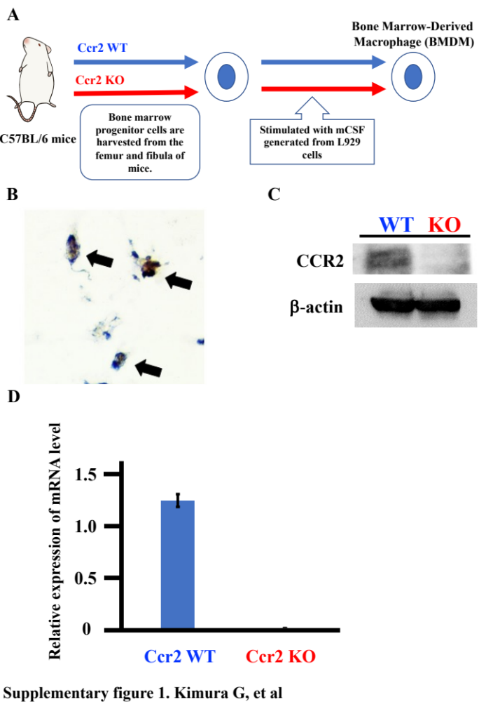

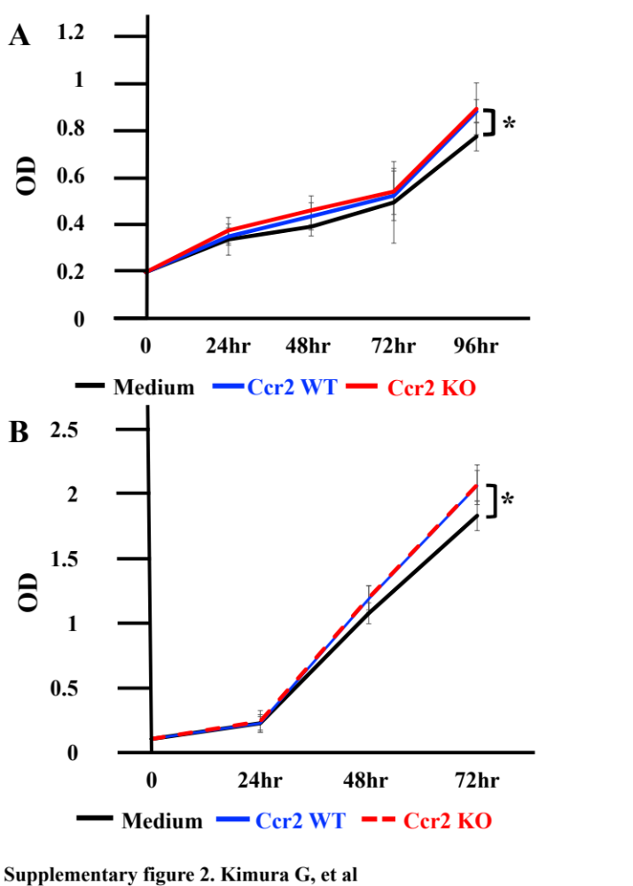

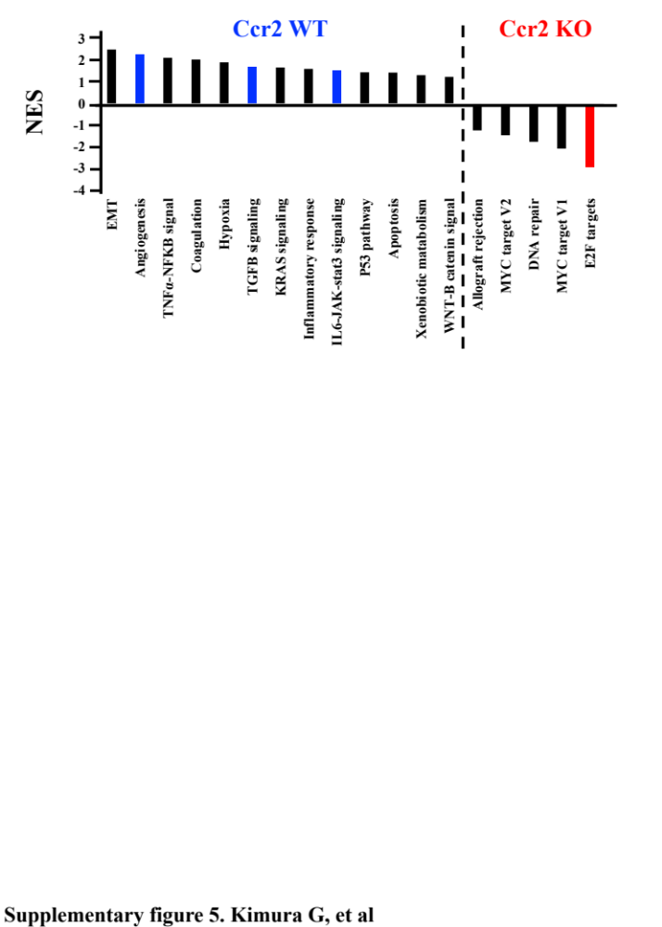

Supplementary Table 1 qRT-PCR primers
mβ-actin | forward | 5’ -CACCATTGGCAATGAGCGGTTC- 3’
 | reverse | 5’ -AGGTCTTTGCGGATGTCCACGT- 3’
mCcl2 | forward | 5’ -TGCCCTAAGGTCTTCAGCAC- 3’
 | reverse | 5’ -AAGGCATCACAGTCCGAGTC- 3’
mCcl3 | forward | 5' -TCTGCGCTGACTCCAAAGAG- 3'
 | reverse | 5' -CTCAAGCCCCTGCTCTACAC- 3'
mCcl6 | Forward | 5' -TTCGCCCTGCCACAATAGAG- 3'
 | Reverse | 5' -ATTTCACCCCAAGAGCCCAG- 3'
mCcl7 | forward | 5' -CCAATGCATCCACATGCTGC- 3'
 | reverse | 5' -CTCGACCCACTTCTGATGGG- 3'
mCcl9 | forward | 5' -TCGGTTTCCCAGCGGATTTT- 3'
 | reverse | 5' -GGCTTACTGATGGAGGGGTG- 3'
mCcl20 | forward | 5' -ATGGCCGATGAAGCTTGTGA- 3'
 | reverse | 5' -CTCCTTGGGCTGTGTCCAAT- 3'
mIl1 α | forward | 5' -ACGTCAAGCAACGGGAAGAT- 3'
 | reverse | 5' -AAGGTGCTGATCTGGGTTGG- 3'
mIl28 | forward | 5' -CTGGGCCAGCCTCTTCATAC- 3'
 | reverse | 5' -CTGTGGCCTGAAGCTGTGTA- 3'
mCxcl5 | forward | 5' -CACTCGCAGTGGAAAGAACG- 3'
 | reverse | 5' -CGTGGGTGGAGAGAATCAGC- 3'
mOsteoactivin | forward | 5' -CAAGGGCCTGAGTGTTCTCC- 3'
 | reverse | 5' -GCTTGTCCTGGAGCAATGGA- 3'
mOsteopontin | forward | 5' -CCTGGCTGAATTCTGAGGGAC- 3'
 | reverse | 5' -CTTCTGAGATGGGTCAGGCA- 3'
mCxcl4 | forward | 5' -CAGTGGCACCCTCTTGACAT- 3'
 | reverse | 5' -ATCGCTTTCTTCGGGACCAG- 3'
mCxcl2 | forward | 5' -CTCCTTGGGCTGTGTCCAAT- 3'
 | reverse | 5' -CAGGTACGATCCAGGCTTCC- 3'
mTgfb2 | forward | 5' -TCCCCTCCGAAAATGCCATC- 3'
 | reverse | 5' -CTCTGGCTTTGGGGTTTTGC- 3'
mUrokinase | forward | 5' -CATCCAGTCCTTGCGTGTCT- 3'
 | reverse | 5' -ACGCATACACCTCCGTTCTG- 3'
mVcam1 | forward | 5' -CTGGGAAGCTGGAACGAAGT- 3'
 | reverse | 5' -GCCAAACACTTGACCGTGAC- 3'
mVE cadherin | forward | 5' -CCTGAGGCAATCAACTGTGC- 3'
 | reverse | 5' -GGAGGAGCTGATCTTGTCCG- 3'
mIfn α1 | forward | 5' -CCTTCTTGATCTGCTGGGCA- 3'
 | reverse | 5' -CCTTCTTGATCTGCTGGGCA- 3'
mIfn α2 | forward | 5' -ATGAGGAGGCTCCCCTTTCT- 3'
 | reverse | 5' -TATCCACCTTCTCCAGGGGG- 3'
mIfn α4 | forward | 5' -GCAATGACCTCCATCAGCAGCT- 3'
 | reverse | 5' -GTGGAAGTATGTCCTCACAGCC- 3'
mIfn α5 | forward | 5' -GGATGTGACCTTCCTCAGACTC- 3'
 | reverse | 5' -CACCTTCTCCTGTGGGAATCCA- 3'
mIfn α6 | forward | 5' -GCAATGACCTCCATCAGCAGCT- 3'
 | reverse | 5' -GTGGAAGTATGTCCTCACAGCC- 3'
mIfn α7/10 | forward | 5' -TCCTGCCTGAAGGACAGAAAGG- 3'
 | reverse | 5' -GGTCAGCTCATGCAGAACACAG- 3'
mIfn α9 | forward | 5' -AGATCCAGGAGGCTCAAGCCAT- 3'
 | reverse | 5' -CCAGTGCAGAATGAGTCTAGGAG- 3'
mIfn α11 | forward | 5' -CGCATCAAAGGACTCATCTGCTG- 3'
 | reverse | 5' -CTGCTGCATCAGACAACCTTGC- 3'
mIfn α12 | forward | 5' -AGGATGTGACCTGCCTCAGACT- 3'
 | reverse | 5' -TGATCTGCTGGGCATCCACCTT- 3'
mIfn α13 | forward | 5' -AGGATGTGACCTGCCTCAGACT- 3'
 | reverse | 5' -CACCTTCTCCTGTGGGAATCCA- 3'
mIfn α14 | forward | 5' -AGGATGTGACCTGCCTCAGACT- 3'
 | reverse | 5' -ACCTTCTCCTGCGGGAATCCAA- 3'
mIfn αΑ | forward | 5' -GCTGGGTCAGCTCTTGTAGG- 3'
 | reverse | 5' -GCTGGGTCAGCTCTTGTAGG- 3'
mIfn αβ | forward | 5' - AGGGTATCCACCTTCTCCTGGG- 3'
 | reverse | 5' -AGGGTATCCACCTTCTCCTGGG- 3'
mIfn β | forward | 5' -CCTGGAGCAGCTGAATGGAA- 3'
 | reverse | 5' -CCACCCAGTGCTGGAGAAAT- 3'

Supplementary Table 2 Antibodies for immunohistochemistory
Antibody | Animal | Company | Clone or Catalog # | Dilution
Ki-67 | Rabbit poly | Abcam | ab66155 | X 500
CD31 | Rabbit poly | Abcam | ab28364 | X 50
LYVE-1 | Rabbit poly | Abcam | ab14917 | X 100
K-19 | Rat mAb | DSHB | TOROMA-III; AB_2133570 | X 200
MPO | Rabbit poly | Thermo Scientific | RB-373-A0 | X 50
F4/80 | Rat mAb | AbD Serotec | A3-1; MCA497GA | X 100
iNOS | Rabbit poly | Abcam | ab15323 | X 50
Arginase-1 | Rabbit mAb | Cell Signaling Technology | D4E3M; #93668 | X 400
CD4 | Rat mAb | eBioscience TM | 4SM95; 14-9766 | X 50
CD8 | Rabbit poly | Abcam | ab203035 | X 500
PON2 | Rabbit poly | Abcam | Ab183710 | X 100
α-SMA | mouse mAb | DAKO | M0851 | X 100
CCR2 | Rabbit mono | Abcam | Ab273050 | X 250
PDGFR-α | Goat poly | R & D systems | AF1062 | X 100
Cleaved Caspase-3 | Rabbit poly | Cell Signaling Technology | Asp175; #9661 | X 400
Interferon-α | Rat mono | PBL assay science | 22100 | X 50

Supplementary Table 3 Antibodies for western blotting
Antibody | Animal | Company | Clone or Catalog # | Dilution
β-actin | Rabbit mono | Cell Signaling Technology | 13E5; #5125 | X500
CCR2 | Rabbit mono | Abcam | Ab273050 | X 500
p-STAT1 | Rabbit mono | Cell Signaling Technology | Tyr701; #9167 | X 500
STAT1 | Rabbit mono | Cell Signaling Technology | D1K9Y; #14994 | X 500

Supplementary Table 4 Antibody Array List
Number | Name | ASI (WT) | ASI (KO) | Fold (WT/KO)
1 | 6Ckine | N.D | N.D | -
2 | Activin A | 78.11 | 82.85 | 0.94
3 | Activin C | N.D | N.D | -
4 | Activin R1B | N.D | N.D | -
5 | Adiponectin | N.D | N.D | -
6 | AgRP | 1647.57 | 1296.19 | 1.27
7 | ALCAM | N.D | N.D | -
8 | ANGPTL2 | 1281.59 | 1115.16 | 1.15
9 | ANGPTL3 | N.D | N.D | -
10 | Amphiregulin | N.D | N.D | -
11 | Artemin | N.D | N.D | -
12 | Axl | N.D | N.D | -
13 | bFGF | N.D | N.D | -
14 | B7-1 | N.D | N.D | -
15 | BAFF R | N.D | N.D | -
16 | BCMA | N.D | N.D | -
17 | β-Catenin | N.D | N.D | -
18 | BLC | N.D | N.D | -
19 | Betacellulin | N.D | N.D | -
20 | Cardiotrophin1 | N.D | N.D | -
21 | CCL1 | 1310.83 | 1020.21 | 1.28
22 | CCL28 | 1394.86 | 1079.44 | 1.29
23 | CCL4 | N.D | N.D | -
24 | CCL7 | 273.04 | 494.38 | 0.55
25 | CCL8 | N.D | N.D | -
26 | CCR10 | N.D | N.D | -
27 | CCR3 | N.D | N.D | -
28 | CCR4 | N.D | N.D | -
29 | CCR6 | N.D | N.D | -
30 | CCR7 | N.D | N.D | -
31 | CCR9 | 748.79 | 344.55 | 2.17
32 | CD11b | N.D | N.D | -
33 | CD14 | N.D | N.D | -
34 | CCR5 | 2464.76 | 1649.02 | 1.49
35 | CD27 | N.D | N.D | -
36 | CD27 Ligand | N.D | N.D | -
37 | CD30 Ligand | N.D | N.D | -
38 | CD30 | N.D | N.D | -
39 | CD40 | N.D | N.D | -
40 | CD40 Ligand | N.D | N.D | -
41 | Cerberus 1 | N.D | N.D | -
42 | Chordin-Like 2 | N.D | N.D | -
43 | F3 | N.D | N.D | -
44 | IL-2 R g | 2134.25 | 1442.7 | 1.47
45 | IP-10 | N.D | N.D | -
46 | Cripto-1 | N.D | N.D | -
47 | Crossveinless-2 | N.D | N.D | -
48 | Cryptic | N.D | N.D | -
49 | CSK | N.D | N.D | -
50 | CCL27 | 1511.06 | 891.24 | 1.69
51 | CTLA-4 | N.D | N.D | -
52 | CXCL14 | 976.63 | 822.07 | 1.18
53 | CXCL16 | 163.42 | 62.14 | 2.62
54 | CXCR2 | N.D | N.D | -
55 | CXCR3 | N.D | N.D | -
56 | CXCR4 | N.D | N.D | -
57 | CXCR6 | 1971.45 | 969.81 | 2.03
58 | EGF | N.D | N.D | -
59 | Decorin | N.D | N.D | -
60 | DKK-1 | N.D | N.D | -
61 | Dkk-3 | N.D | N.D | -
62 | Dkk-4 | N.D | N.D | -
63 | DPPIV | N.D | N.D | -
64 | DR3 | N.D | N.D | -
65 | Dtk | N.D | N.D | -
66 | EDAR | N.D | N.D | -
67 | EGFR | N.D | N.D | -
68 | EG-VEGF | 2102.33 | 1544.95 | 1.36
69 | Endocan | 1502.42 | 1097.45 | 1.36
70 | Endoglin | N.D | N.D | -
71 | Endostatin | 2453.05 | 1822.25 | 1.34
72 | Eotaxin-1 | N.D | N.D | -
73 | Eotaxin-2 | N.D | N.D | -
74 | Epigen | N.D | N.D | -
75 | Epiregulin | N.D | N.D | -
76 | Erythropoietin | N.D | N.D | -
77 | E-seletin | N.D | N.D | -
78 | FADD | N.D | N.D | -
79 | FAM3B | N.D | N.D | -
80 | Fas | 1519.99 | 1068.57 | 1.42
81 | Fas Ligand | N.D | N.D | -
82 | Fc G RIIB | N.D | N.D | -
83 | FGFR3 | N.D | N.D | -
84 | FGFR4 | N.D | N.D | -
85 | FGFR5b | 3281.15 | 1959.76 | 1.67
86 | FGF-21 | N.D | N.D | -
87 | Flt-3 Ligand | N.D | N.D | -
88 | FLRG | N.D | N.D | -
89 | Follostatin-like 1 | 279.51 | 221.4 | 1.26
90 | Fractalkine | N.D | N.D | -
91 | Frizzeled-1 | N.D | N.D | -
92 | Frizzeled-6 | 1618.65 | 1459.61 | 1.11
93 | Frizzeled-7 | N.D | N.D | -
94 | Galectin-3 | 180.24 | 197.43 | 0.91
95 | GCSF | N.D | N.D | -
96 | GDF-1 | N.D | N.D | -
97 | GDF-3 | N.D | N.D | -
98 | GDF-5 | N.D | N.D | -
99 | GDF-8 | 2680.1 | 2011.67 | 1.33
100 | GDF-9 | N.D | N.D | -
101 | GFR a-2 | N.D | N.D | -
102 | GFR a-3 | N.D | N.D | -
103 | GFR a-4 | N.D | N.D | -
104 | GITR | N.D | N.D | -
105 | GITR Ligand | N.D | N.D | -
106 | Glut2 | 1003.25 | 502.63 | 1.99
107 | GM-CSF | N.D | N.D | -
108 | Granzyme B | N.D | N.D | -
109 | Granzyme D | N.D | N.D | -
110 | Granzyme G | N.D | N.D | -
111 | Gremlin-1 | N.D | N.D | -
112 | GHR | N.D | N.D | -
113 | HGFR | N.D | N.D | -
114 | HGF | N.D | N.D | -
115 | HVEM | N.D | N.D | -
116 | ICAM-1 | 2352.68 | 1771.15 | 1.32
117 | ICAM-2 | N.D | N.D | -
118 | ICAM-5 | N.D | N.D | -
119 | ICK | N.D | N.D | -
120 | IFN-α/β R1 | N.D | N.D | -
121 | IFN-α/β R2 | N.D | N.D | -
122 | IFN-β | N.D | N.D | -
123 | IFN-γ | N.D | N.D | -
124 | IFN-γ R1 | 1075.79 | 791.61 | 1.35
125 | IGFBP-1 | 1538.79 | 1111.31 | 1.38
126 | IGFBP-2 | 1509.99 | 985.2 | 1.53
127 | IGFBP-3 | 2310.68 | 1582.95 | 1.46
128 | IGFBP-5 | N.D | N.D | -
129 | IGFBP-6 | N.D | N.D | -
130 | IGFBP-L1 | N.D | N.D | -
131 | IGF-1 | 480.23 | 373.3 | 1.28
132 | IGF-2 | N.D | N.D | -
133 | IL-1 α | 1817.53 | 1163.16 | 1.56
134 | IL-1 β | N.D | N.D | -
135 | IL-1 R4 | 1514.44 | 1135.29 | 1.33
136 | IL-1 R6 | N.D | N.D | -
137 | IL-1 R9 | N.D | N.D | -
138 | IL-1 R1 | 2142.32 | 1966.61 | 1.08
139 | IL-1 R2 | N.D | N.D | -
140 | IL-2 | N.D | N.D | -
141 | IL-2 α | N.D | N.D | -
142 | IL-2 β | N.D | N.D | -
143 | IL-3 | N.D | N.D | -
144 | IL-3 R α | 2390.82 | 1674.9 | 1.42
145 | IL-3 R β | N.D | N.D | -
146 | IL-4 | N.D | N.D | -
147 | IL-4 R | N.D | N.D | -
148 | IL-5 | N.D | N.D | -
149 | IL-5 R α | N.D | N.D | -
150 | IL-6 | N.D | N.D | -
151 | IL-6 R | N.D | N.D | -
152 | IL-7 | N.D | N.D | -
153 | IL-7 R α | N.D | N.D | -
154 | IL-9 | N.D | N.D | -
155 | IL-9 R | N.D | N.D | -
156 | IL-10 | N.D | N.D | -
157 | IL-10 R α | N.D | N.D | -
158 | IL-11 | 2102.93 | 1589.48 | 1.32
159 | IL-12 p40 | N.D | N.D | -
160 | IL-12 p70 | 1421.02 | 1690.23 | 0.84
161 | IL-12 R b 1 | N.D | N.D | -
162 | IL-13 | N.D | N.D | -
163 | IL-13 R α 2 | N.D | N.D | -
164 | IL-15 | N.D | N.D | -
165 | IL-15 R α 2 | 2161.91 | 1306.39 | 1.65
166 | IL-16 | 3100.55 | 2054.84 | 1.51
167 | IL-17A | N.D | N.D | -
168 | IL-17RB | N.D | N.D | -
169 | IL-17C | N.D | N.D | -
170 | IL-17D | N.D | N.D | -
171 | IL-17E | N.D | N.D | -
172 | IL-17F | N.D | N.D | -
173 | IL-17 RA | 2422.95 | 1690.85 | 1.43
174 | IL-17 RC | N.D | N.D | -
175 | IL-17 RD | N.D | N.D | -
176 | IL-18 R α | N.D | N.D | -
177 | IL-20 | N.D | N.D | -
178 | IL-20 R α | N.D | N.D | -
179 | IL-21 | N.D | N.D | -
180 | IL-21 R | N.D | N.D | -
181 | IL-22 | N.D | N.D | -
182 | IL-22 BP | N.D | N.D | -
183 | IL-23 | N.D | N.D | -
184 | IL-23 R | 2471.39 | 1398.94 | 1.76
185 | IL-24 | N.D | N.D | -
186 | IL-27 | 3011.25 | 1787.94 | 1.68
187 | IL-28B | 2770.76 | 1577.21 | 1.75
188 | IL-31 | 1848.681 | 984.93 | 1.87
189 | IL-31 RA | N.D | N.D | -
190 | Insulin | N.D | N.D | -
191 | integrin b-2 | N.D | N.D | -
192 | I-TAC | N.D | N.D | -
193 | GRO a | N.D | N.D | -
194 | Kremen-1 | N.D | N.D | -
195 | Kremen-2 | N.D | N.D | -
196 | Lefty-1 | N.D | N.D | -
197 | Leptin R | N.D | N.D | -
198 | LEPTIN | N.D | N.D | -
199 | LIF | 781.46 | 683.07 | 1.14
200 | LIGHT | N.D | N.D | -
201 | CXCL5 | 2769.45 | 1251.69 | 2.21
202 | LRP-6 | 1135.8 | 761.0 | 1.49
203 | L-selectin | N.D | N.D | -
204 | Lungkine | 1396.87 | 110282 | 1.26
205 | Lymphotactin | N.D | N.D | -
206 | LTBR | 3389.35 | 2554.61 | 1.32
207 | MAdCAM-1 | N.D | N.D | -
208 | MCP-1 | N.D | N.D | -
209 | MCP-5 | 279.3 | 350.75 | 0.79
210 | M-CSF | 3078.99 | 2060.93 | 1.49
211 | MDC | N.D | N.D | -
212 | MFG-E8 | N.D | N.D | -
213 | MFRP | N.D | N.D | -
214 | MIG | N.D | N.D | -
215 | MIP-1 a | N.D | N.D | -
216 | MIP-1 g | N.D | N.D | -
217 | CXCL2 | 2571.51 | 1531.65 | 1.67
218 | MIP-3 a | N.D | N.D | -
219 | MIP-3 b | N.D | N.D | -
220 | MMP-2 | 2569.86 | 1729.08 | 1.48
221 | MMP-3 | N.D | N.D | -
222 | MMP-9 | 260.65 | 720.92 | 0.36
223 | MMP-12 | 1531.58 | 928.4 | 1.64
224 | MMP-14 | N.D | N.D | -
225 | MMP-24 | N.D | N.D | -
226 | NRG3 | N.D | N.D | -
227 | Neurturin | N.D | N.D | -
228 | NGFR | N.D | N.D | -
229 | NOV | N.D | N.D | -
230 | Osteoactivin | 1993.51 | 1222.79 | 1.63
231 | Osteopontin | 1051.36 | 668.07 | 1.57
232 | Osteoprotegerin | N.D | N.D | -
233 | OX40 Ligand | N.D | N.D | -
234 | PDGF-C | N.D | N.D | -
235 | PDGF-R α | N.D | N.D | -
236 | PDGF-R β | N.D | N.D | -
237 | Pentraxin-3 | 683.88 | 472.55 | 1.44
238 | CXCL4 | 3304.63 | 1801.23 | 1.83
239 | PIGF-2 | N.D | N.D | -
240 | Progranulin | 634.76 | 475.7 | 1.33
241 | Prolactin | 3415.41 | 1839.47 | 1.85
242 | P-selectin | 1664.55 | 829.35 | 2.01
243 | RAGE | N.D | N.D | -
244 | RANTES | N.D | N.D | -
245 | RELM b | 127.3 | 95 | 1.34
246 | Resistin | N.D | N.D | -
247 | S100A10 | N.D | N.D | -
248 | SCF | N.D | N.D | -
249 | SCF R | N.D | N.D | -
250 | SDF-1 | N.D | N.D | -
251 | SAA1 | N.D | N.D | -
252 | Shh-N | N.D | N.D | -
253 | SIGIRR | N.D | N.D | -
254 | SLPI | 91.61 | 507.85 | 0.18
255 | Soggy-1 | 1295.13 | 1470.27 | 0.93
256 | SPARC | N.D | N.D | -
257 | Spinesin | N.D | N.D | -
258 | TACI | N.D | N.D | -
259 | TARC | N.D | N.D | -
260 | CCL1 | 2694.68 | 1741.33 | 1.57
261 | IL-27 R α | 1077.88 | 493.09 | 2.18
262 | TECK | N.D | N.D | -
263 | TFPI | N.D | N.D | -
264 | TGF β1 | N.D | N.D | -
265 | TGF β2 | 2702.21 | 1550.29 | 1.74
266 | TGF β3 | 3855.07 | 1875.96 | 2.05
267 | TGF β R1 | 461.65 | 405.81 | 1.13
268 | TGF β R2 | N.D | N.D | -
269 | TSP-1 | N.D | N.D | -
270 | CXCL7 | N.D | N.D | -
271 | Tie-2 | N.D | N.D | -
272 | TIMP-1 | N.D | N.D | -
273 | TIMP-2 | 3102.62 | 2179.73 | 1.42
274 | TIMP-4 | N.D | N.D | -
275 | TL1A | N.D | N.D | -
276 | TLR1 | N.D | N.D | -
277 | TLR2 | 1744.07 | 1627.46 | 1.07
278 | TLR3 | N.D | N.D | -
279 | TLR4 | N.D | N.D | -
280 | TMEFF1 | N.D | N.D | -
281 | TNF R1 | 143.11 | 144.18 | 0.99
282 | TNF R2 | 238.6 | 280.78 | 0.84
283 | TNF α | N.D | N.D | -
284 | TNF β | 1065.57 | 931.03 | 1.14
285 | Thrombopoietin | N.D | N.D | -
286 | TRAIL | N.D | N.D | -
287 | TRAIL R2 | N.D | N.D | -
288 | TRANCE | N.D | N.D | -
289 | TREM-1 | N.D | N.D | -
290 | TROY | N.D | N.D | -
291 | TSLP | N.D | N.D | -
292 | TSLP R | N.D | N.D | -
293 | TWEAK | N.D | N.D | -
294 | TWEAK-R | 1142.78 | 920.64 | 1.24
295 | Ubiquitin1 | N.D | N.D | -
296 | uPAR | N.D | N.D | -
297 | Urokinase | N.D | N.D | -
298 | VCAM-1 | N.D | N.D | -
299 | VE-Cadherin | 392.91 | 211.69 | 1.85
300 | VEGF-A | 355.93 | 378.85 | 0.93
301 | VEGFR1 | N.D | N.D | -
302 | VEGFR2 | N.D | N.D | -
303 | VEGFR3 | N.D | N.D | -
304 | VEGF-B | 2653.55 | 1466.09 | 1.81
305 | VEGF-C | 127 | 83.06 | 1.52
306 | VEGF-D | N.D | N.D | -
307 | WIF-1 | N.D | N.D | -
308 | WISP-1 | 1538.16 | 1247.41 | 1.27

