Additional file 3 - Supplementary results II related to the simulation for ‘Impact of treatment discontinuation definitions on comparative retention studies: a simulation-based case study in spondyloarthritis’.

Plots of estimates data from simulations
Figure S8: Scatter plots of estimates by distribution, sample size per drug, true HR, dosing intervals, and analysis method. Each panel includes 2000 estimates, per row these were derived from the same simulated data. The red reference lines indicate the natural log-transformed HR. The panel-specific yellow reference lines indicate the mean of the 2000 estimates. In case of equal dosing intervals of one day, SM1 and SM3 are identical.
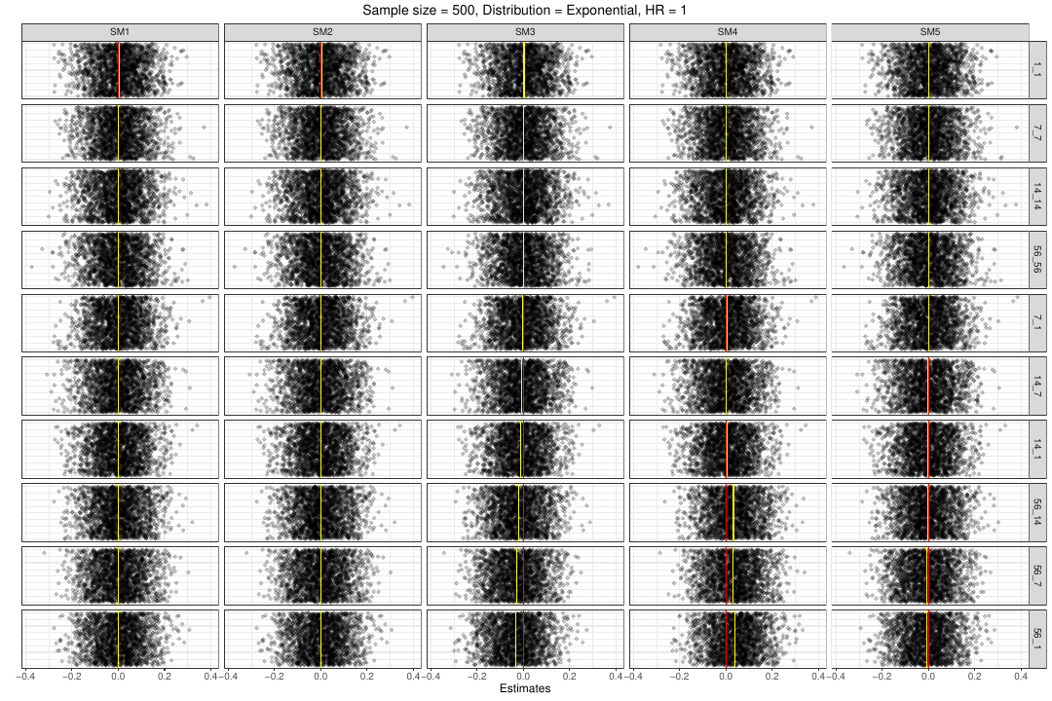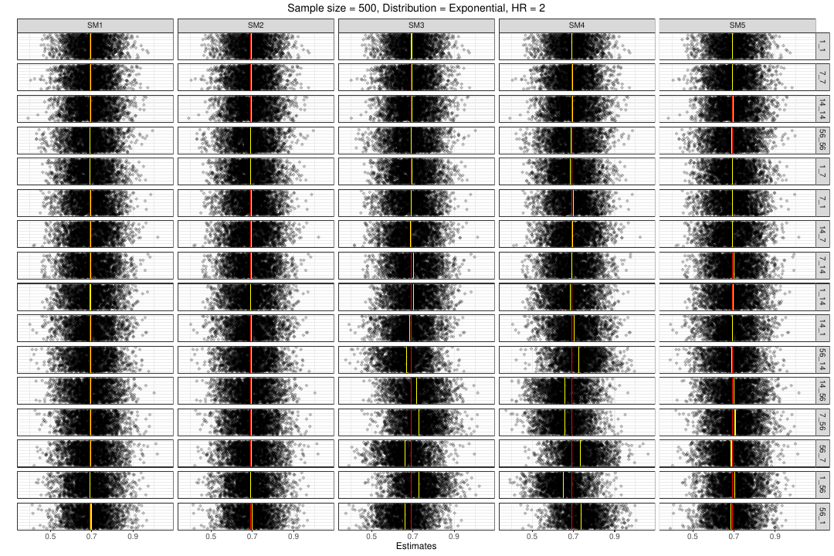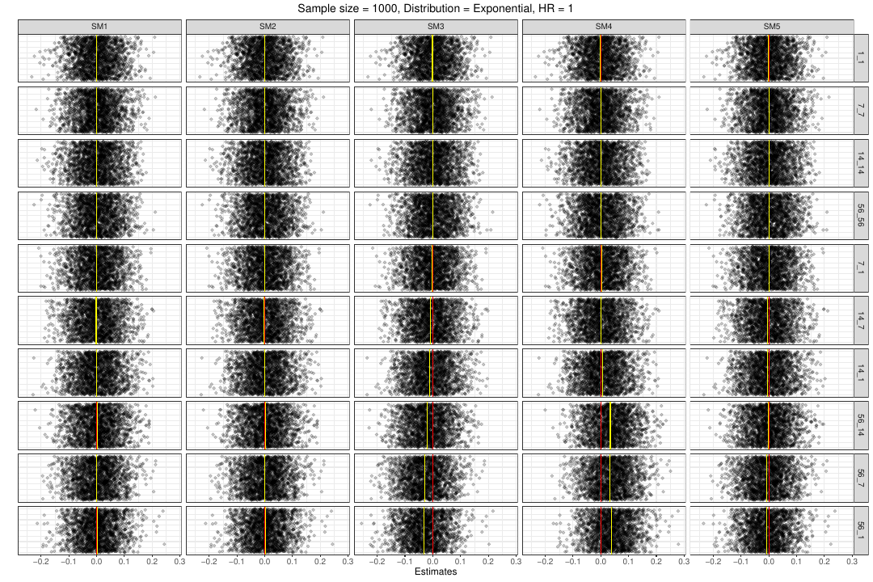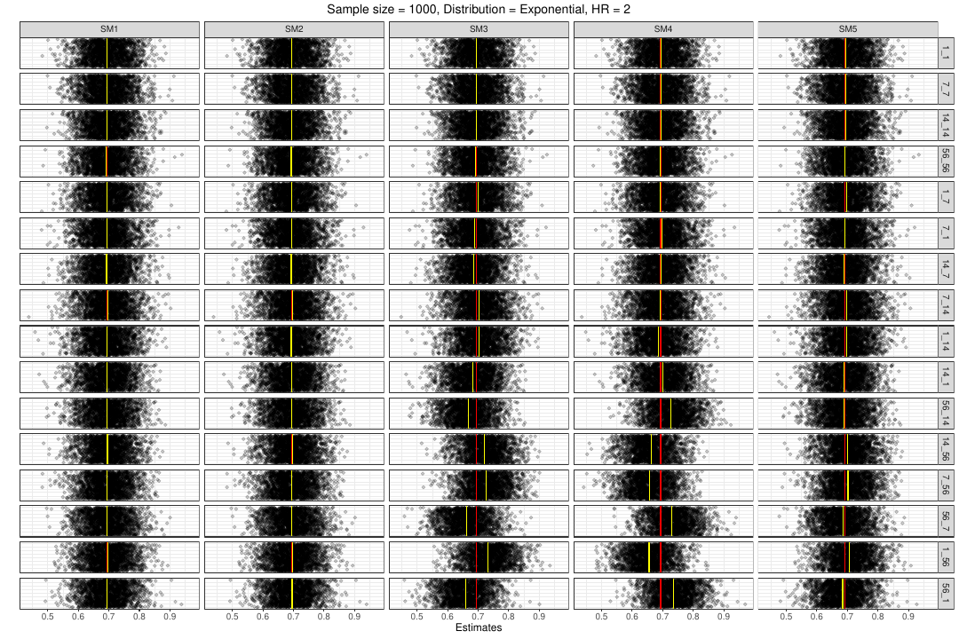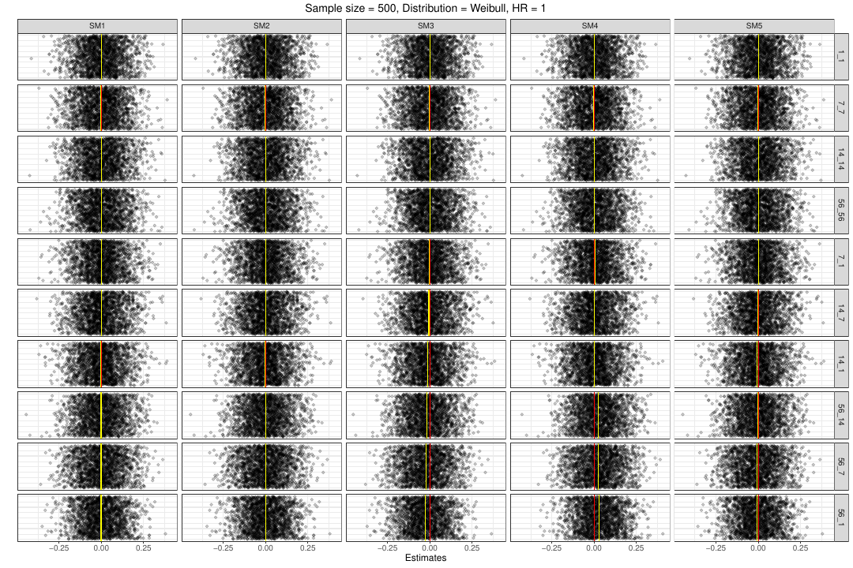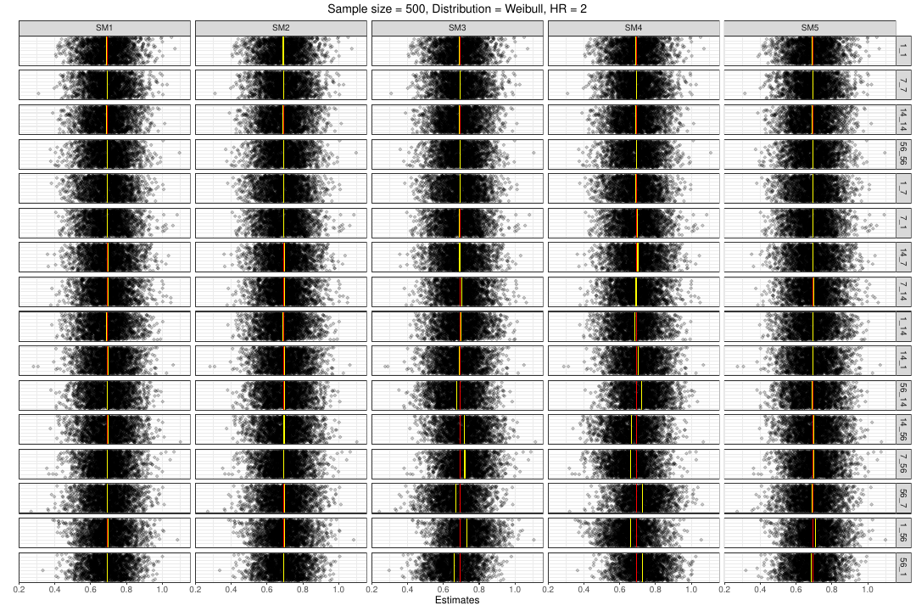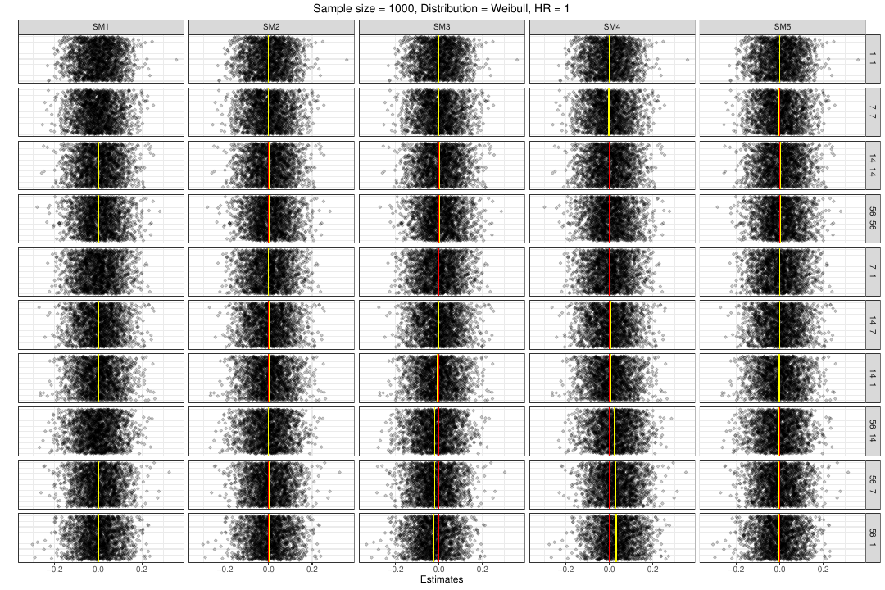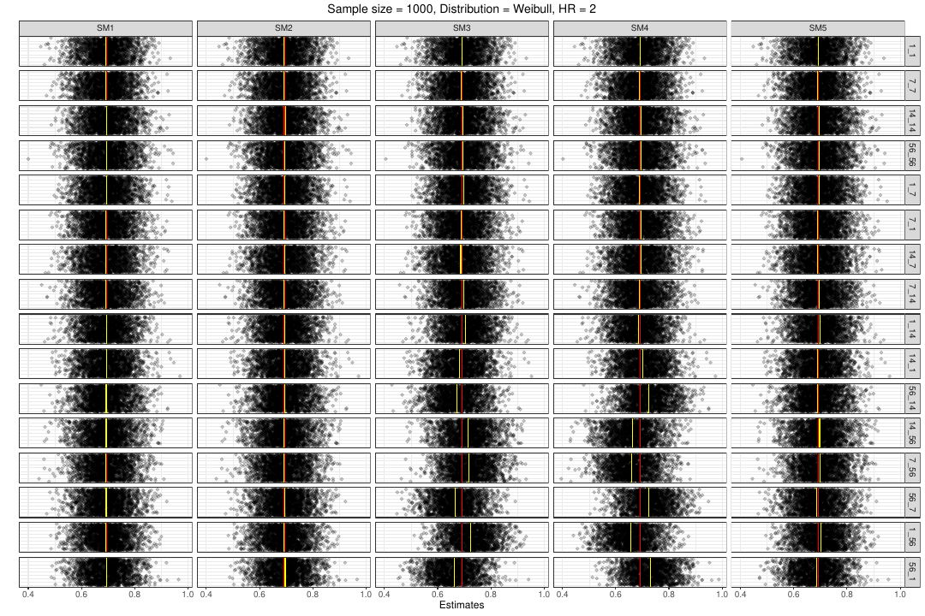

Figure S9: Scatter plots of the square root of model-based variance estimates by distribution, sample size per drug, true HR, dosing intervals, and analysis method. Each panel includes 2000 estimates, per row these were derived from the same simulated data. The panel-specific yellow reference lines indicate the mean of the 2000 estimates. In case of equal dosing intervals of one day, SM1 and SM3 are identical.
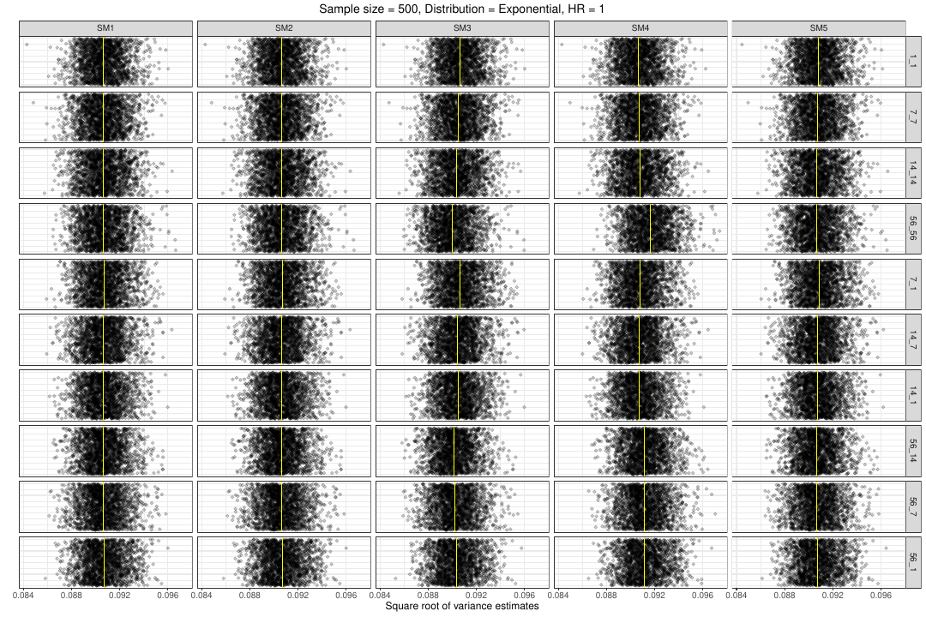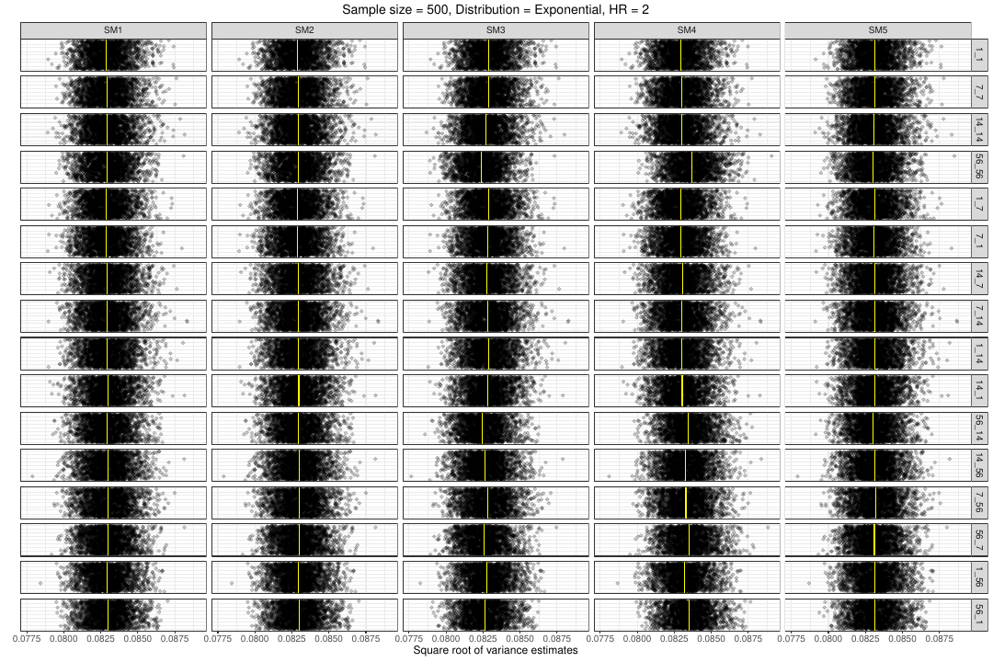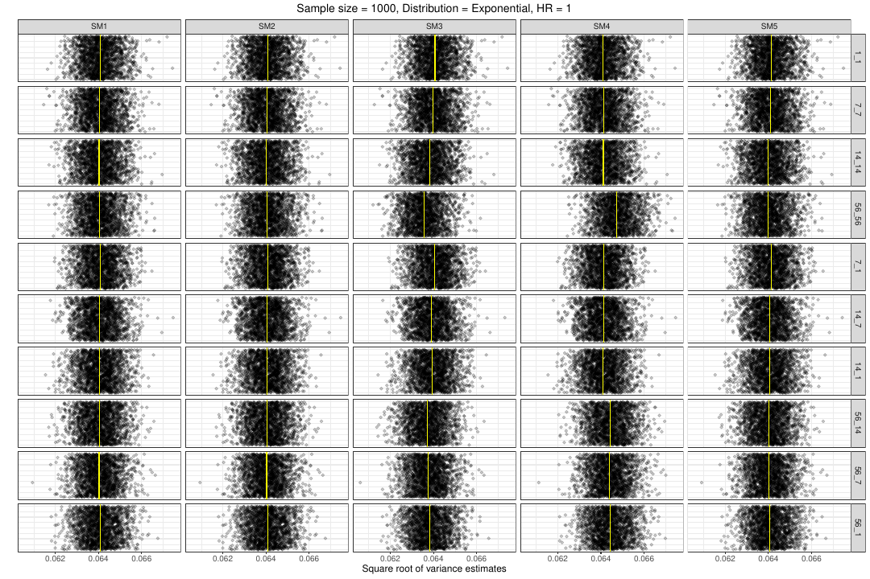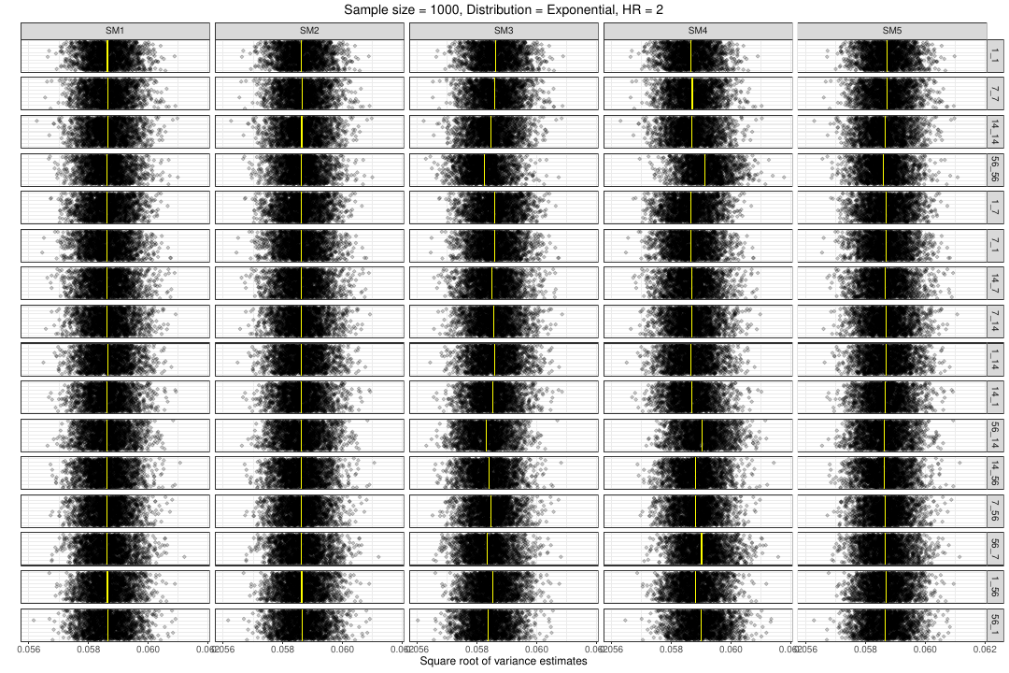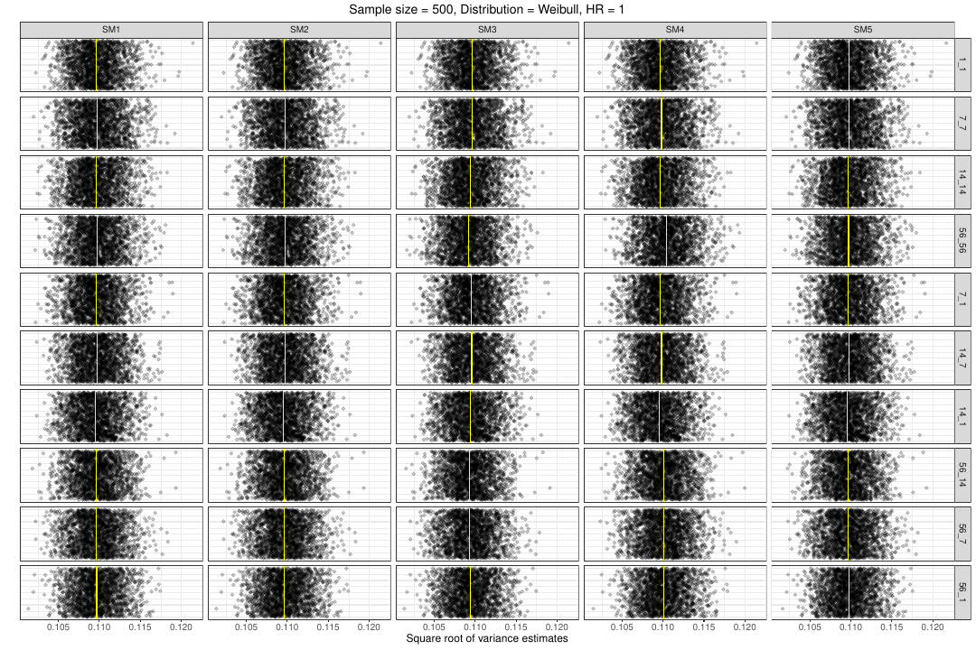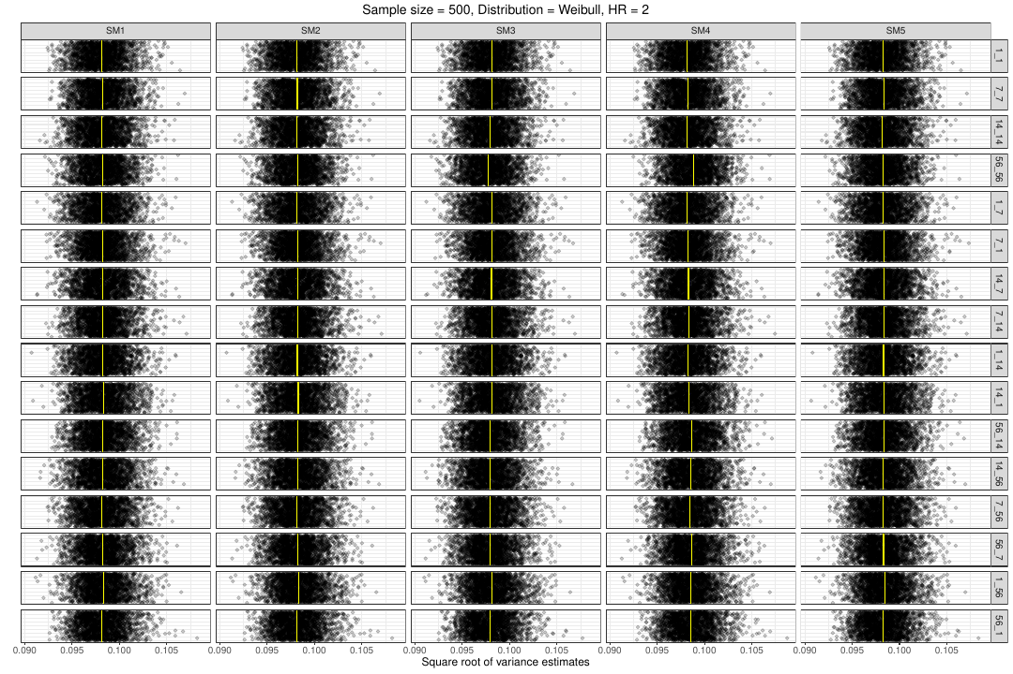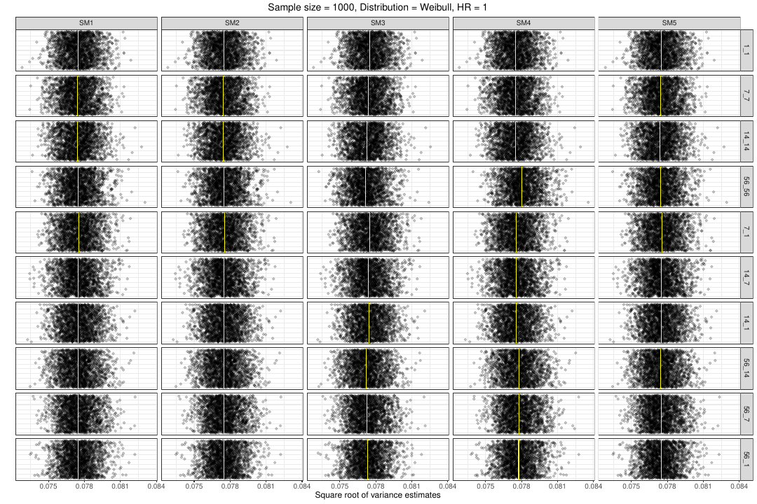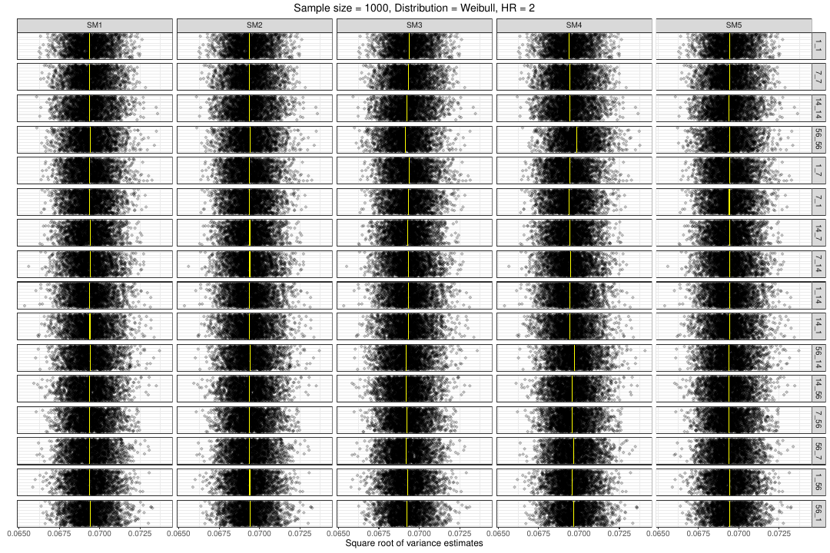

Figure S10: Normal quantile-quantile plots of estimates by distribution, sample size per drug, true HR, dosing intervals, and analysis method. In each panel, 2000 estimates are shown per method. If the observations for a given method lie nicely on the respective straight line, normality seems to hold. In case of equal dosing intervals of one day, SM1 and SM3 are identical.
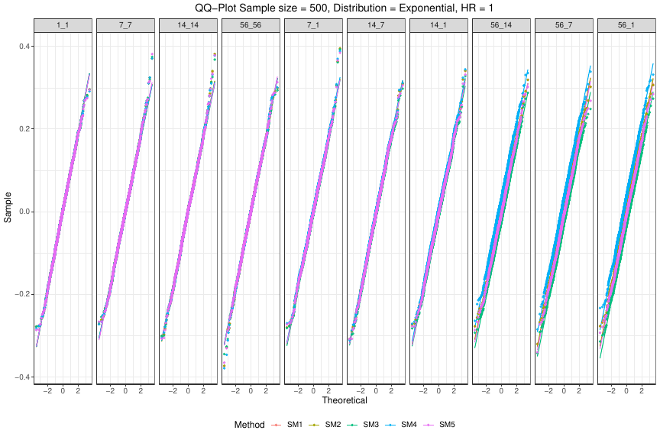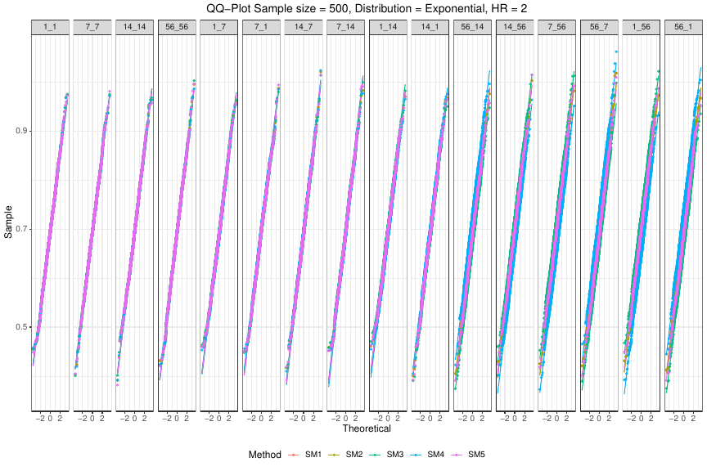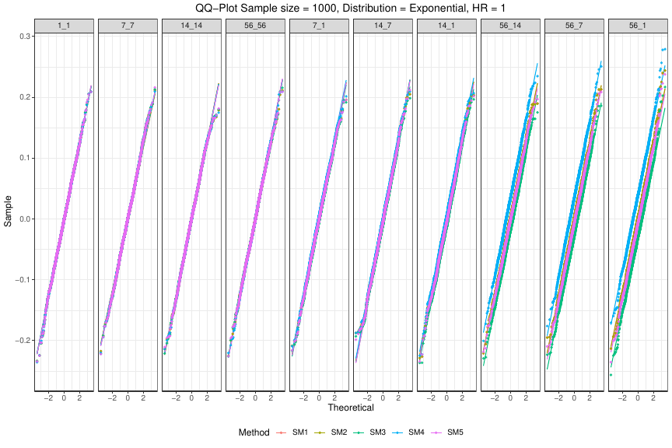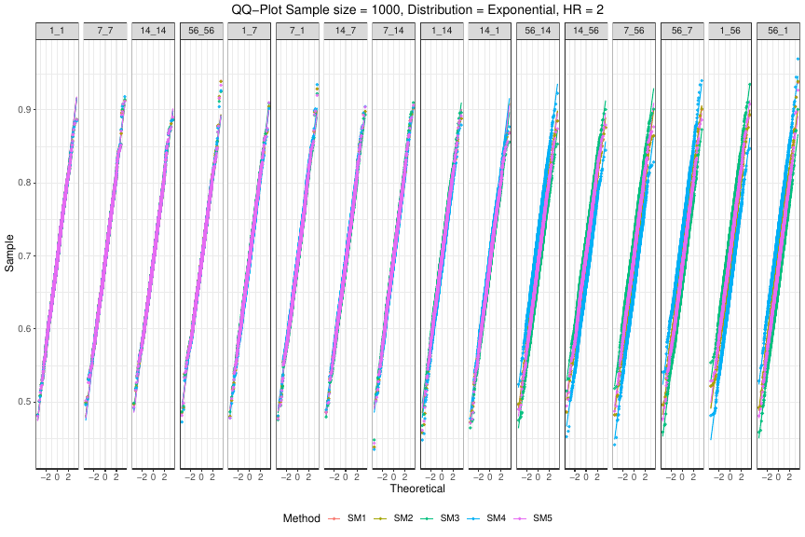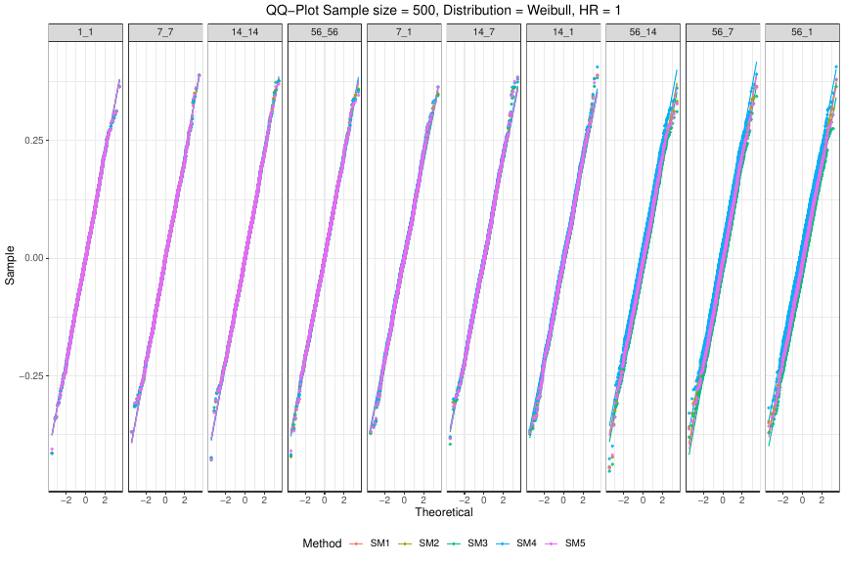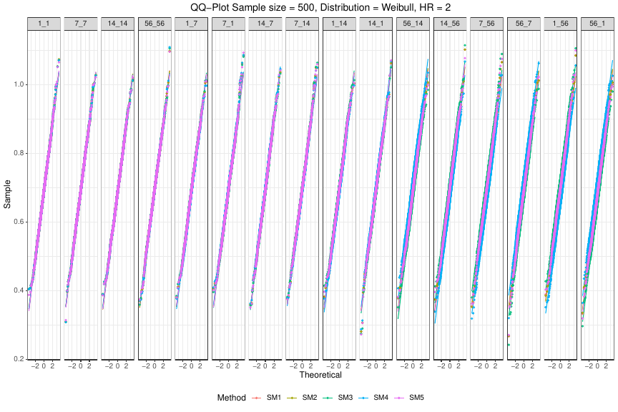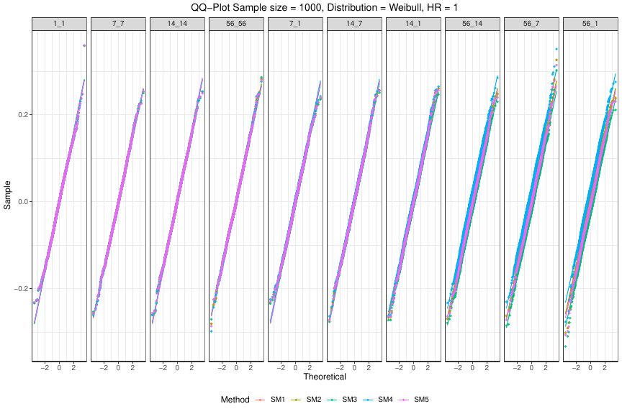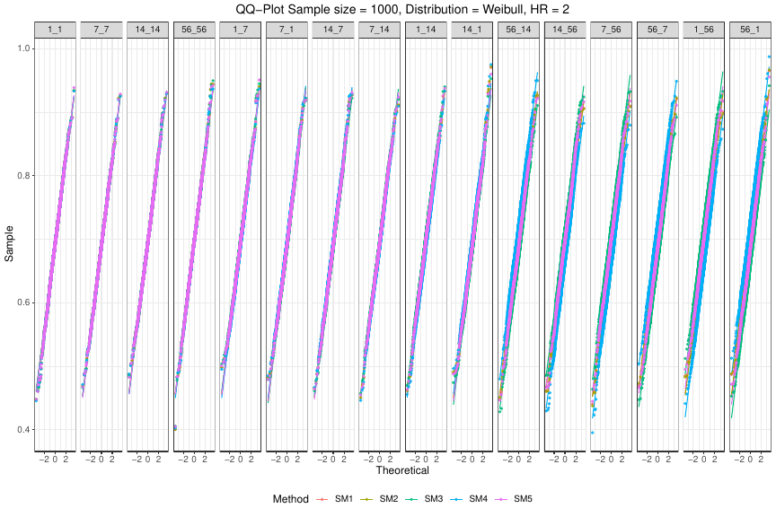

Figure S11: Zip plots by distribution, sample size per drug, analysis method, true HR, and dosing intervals. Per panel the 2000 two-sided 95% Wald-type confidence intervals (CIs) are fractional-centile-ranked according to $\left|z_{i}\right|=\left|\left({\text{estimate}}_{i}–\text{true natural log-transformed HR}\right)/\sqrt{{\text{model-based variance estimate}}_{i}}\right|$, i from 1 to 2000. CIs covering the true natural log-transformed HR are green, those not covering it violet. The vertical reference line in red shows the true natural log-transformed HR. The horizontal reference line in red lies at 95. The switch from green to violet CIs is expected to happen at 95 if the nominal coverage of 95% is met. In case of equal dosing intervals of one day, SM1 and SM3 are identical.
