Supplementary Methods
1. Cell culture and transfection
TNBC cell lines (MDA-MB-231, HCC1806, BT-549, and SUM159PT) were maintained under the following conditions: 10% fetal bovine serum (HyClone) and 1% penicillin/streptomycin were added to Dulbecco’s Modified Eagle Medium (DMEM; Invitrogen) or RPMI-1640 medium (Invitrogen), and cells were incubated with a 5% CO₂ atmosphere at 37°C. For decitabine treatment, cells were plated for 24 h and cultured in daily refreshed medium containing the indicated concentrations of decitabine for 3 days. For docetaxel treatment, cells were plated for 24 h and treated with medium containing the indicated concentrations of docetaxel. Docetaxel-resistant MDA-MB-231 (MDA-MB-231-Doc-R) and HCC1806 (HCC1806-Doc-R) cell lines were established in medium containing docetaxel via a 2-fold increase in concentration (1-64 nM for MDA-MB-231 and 2-128 nM for HCC1806) every 4 weeks.
DAB2IP cDNA (corresponding to ENST00000259371.6) was amplified and cloned into the pEZ-Lv201 vector. psi-LVRU6GP vectors containing short-hairpin RNA (shRNA) were used to knock down the expression of DAB2IP. Cells were infected with lentivirus generated with pEZ-Lv201-puro-DAB2IP/vector or psi-LVRU6GP-shRNAs/control for 72 h and selected with puromycin to establish stable cell lines.
2. Quantitative real-time polymerase chain reaction (qRT-PCR)
qRT-PCR was performed using TB Green Fast qPCR Mix (TaKaRa) and the CFX96 Real Time System C1000 Cycler (Bio-Rad Laboratories, Singapore) according to the manufacturer’s instructions. The specific sequences of the primers are listed in the Supplementary table 2.
3. Protein lysates and Western blotting
After removal of the culture medium, cells were incubated with RIPA lysis buffer (Sigma-Aldrich). The bicinchoninic acid (BCA) assay (Pierce, Rockford, USA) was used to evaluate the protein concentration. Western blotting was performed according to previously published methods. The following antibodies were used in our studies: anti-DAB2IP polyclonal rabbit antibody (1:2,000 dilution; Abcam # ab87811), anti-Erk1/2 polyclonal mouse antibody (1:1,000 dilution; CST # 9102), anti-phosphorylated Erk1/2 (p-Erk1/2, Thr202/Thr204) monoclonal rabbit antibody (1:1,000 dilution; CST # 4370), anti-Akt monoclonal mouse antibody (1:2,000 dilution; CST # 2920), anti-phosphorylated Akt (p-Akt) monoclonal rabbit antibody (1:2,000 dilution; CST # 4060), anti-cyclin B1 polyclonal rabbit antibody (1:1,000 dilution; Proteintech # 55004-1-AP), anti-CDK1 monoclonal mouse antibody (1:1,000 dilution; CST # 9116), anti-phosphorylated CDK1 (p-CDK1 T161) monoclonal rabbit antibody (1:1,000 dilution; Abcam # ab201008), anti-GAPDH monoclonal mouse antibody (1:1,000 dilution; CST # 51332), and goat anti-mouse/rabbit IgG secondary antibody (1:2,000 dilution; ThermoFisher # 31430/31460).
4. Immunohistochemistry (IHC)
Protein expression of DAB2IP in FFPE tissues was evaluated by IHC as previously described. Anti-DAB2IP polyclonal rabbit antibody (1 µg/ml; Abcam#ab87811) was used. Two pathologists separately assessed the immunostaining intensity. Scores comprised the percentage of positively stained cells and the staining intensity. We scored the staining intensity as follows: 1, no staining; 2, weak staining (light yellow); 3, moderate staining (yellow brown); and 4, strong staining. The percentage of positively stained cells was stratified as follows: 0, no positive cells; 1, < 10% positive cells; 2, 10%–35% positive cells; 3, 35%–75% positive cells; and 4, > 75% positive cells. The staining index (SI) was calculated by multiplying the percentage of positively stained cells with the staining intensity score, and the staining index was used to evaluate the protein expression level. SI ≥ 8 and SI < 8 were defined as high expression and low expression, respectively.
5. Cell viability assay
Cells (2,000 cells/well) were seeded in 96-well plates and treated with decitabine or docetaxel. The viability of cells was evaluated using cell counting kit-8 (CCK-8) following the manufacturer’s instructions.
6. Flow cytometry analysis
Before analysis of cell apoptosis or analysis of the CSC population using a flow cytometer (CytoFLEX; Beckman Kurt), 2×10⁴ cells were washed and suspended. For the cell apoptosis assay, the Annexin V/PI Kit (Invitrogen) was used according to the manufacturer's instructions. For the analysis of the CSC population, CD44 (Tonbo Biosciences) and CD24 (Invitrogen) were used to identify the CSC population, while propidium iodide (PI, Sigma-Aldrich) was used to identify live cells.
For the cell cycle analysis, 2×10⁶ cells were seeded and cultured in serum-free medium for 24 h. After trypsinization, cells were fixed in ethanol at 4°C overnight and incubated in bovine pancreatic RNase (Sigma-Aldrich, Saint Louis, MO). Propidium iodide (Sigma-Aldrich) was used to label DNA.
7. Tumor-sphere culture and isolation of CSC-like cells
Cells (1,000 cells/ml) were cultured in ultralow attachment dishes (Corning) in DMEM/F-12 medium with 1% B27 (Invitrogen, Carlsbad, CA), epidermal growth factor (EGF) (20 ng/ml, Invitrogen), basic fibroblast growth factor (bFGF) (10 ng/ml, Invitrogen), and insulin (10 mg/ml, Sigma-Aldrich). Spheres were counted after 7 days or collected for extraction of RNA, DNA or protein. For wnt3a stimulation, tumor spheres were treated with Wnt3a (250 ng/ml, R&D Systems; 0, 15 or 30 min).
Tumor spheres cultured in ultralow attachment dishes for 7 days were fixed in 10% neutral buffered formalin overnight and embedded in 4% agar before paraffin embedding. The embedded spheres were cut into slices for subsequent immunocytochemistry and immunofluorescence analyses.
8. Immunocytochemistry (ICC) and immunofluorescence (IF)
For immunocytochemistry, cells grown in attached culture or tumor spheres were paraffin-embedded, and the paraffin blocks were cut into slices. The slices were deparaffinized, rehydrated and heated in citrate buffer (pH = 6.0) for antigen retrieval. After blocking antigens with normal goat serum for 2 h, the slices were incubated with anti-DAB2IP polyclonal rabbit antibody (1 µg/ml; Abcam # ab87811) at 4°C overnight. The goat anti-rabbit IgG secondary antibody (1:1000) and 10% Mayer's hematoxylin were used to label DAB2IP and the cell nucleus, respectively. Images were taken using a microscope (Olympus BX51).
For immunofluorescence, slices were deparaffinized, rehydrated, antigen-retrieved and antigen-blocked. Then, the antigens were labeled with anti-phosphorylated Erk1/2 (p-Erk1/2, Thr202/Thr204) monoclonal rabbit antibody (1:200 dilution; CST # 4370) and anti-nonphosphorylated (active) β-catenin (Ser45) monoclonal rabbit antibody (1:800 dilution; CST # 19807) at 4°C overnight. A goat anti-mouse/rabbit IgG secondary antibody (Alexa Fluor 488/594; Invitrogen) was used to label p-Erk1/2 or active β-catenin, while DAPI (Sigma-Aldrich) was used to label the cell nuclei. Images were taken using a high-resolution laser confocal microscope (Zeiss).
9. Terminal deoxynucleotidyl transferase dUTP nick end labeling (TUNEL) assay
The TUNEL assay was performed according to the manufacturer’s protocol (Genecopoeia; cat. # A050E). The slices of paraffin-embedded tissue were deparaffinized, rehydrated, and incubated in dilute proteinase K solution and DNase buffer at room temperature for 30 min and 5 min, respectively. Then, the tissue slices were incubated with the TdT reaction mixture at room temperature in the dark. The apoptotic cells and cell nuclei were labeled with Andy Fluor™ 647-Streptavidin staining buffer and DAPI and detected by fluorescence microscopy.

Supplemental Table 1. Clinicopathological characteristics of patients with TNBC
Characteristics |  |  |  | No. of patients (%)
Age (y)
≤35 |  |  |  | 26 (8.5)
35-50 |  |  |  | 145 (47.7)
>50 |  |  |  | 133 (43.8)
T classification
T0 |  |  |  | 2 (0.7)
T1-2 |  |  |  | 264 (86.9)
T3-4 |  |  |  | 32 (10.6)
Unknown |  |  |  | 6 (1.8)
N classification
N0 |  |  |  | 165 (54.3)
N1-2 |  |  |  | 98 (32.3)
N3 |  |  |  | 38 (12.5)
Unknown |  |  |  | 3(0.9)
Menopause status
Premenopausal |  |  |  | 186 (61.2)
Menopausal |  |  |  | 118 (38.8)
Chemotherapy
Docetaxel-based regimen |  |  |  | 104 (34.2)
Other regimen |  |  |  | 166 (54.6)
Non-chemotherapy |  |  |  | 30 (9.9)
Unknown |  |  |  | 4(1.3)
Vital status (at follow-up)
Alive |  |  |  | 223 (73.4)
Dead |  |  |  | 81 (26.6)
Relapse status
Relapse |  |  |  | 86 (28.3)
Relapse-free |  |  |  | 218 (71.7)
Expression of DAB2IP
Low expression |  |  |  | 184 (60.5)
High expression |  |  |  | 120 (39.5)
DNA methylation status
Hyper-methylation |  |  |  | 91(29.9)
Hypo-methylation |  |  |  | 135(44.4)
Unknown |  |  |  | 78(25.7)

Supplemental Table 2. Real-time PCR primers in our study
Gene | Forward primer (5'-3') | Reverse primer (5'-3')
CD44 | CAGCTCATACCAGCCATCCA | TGGGGTGTGAGATTGGGTTG
RASA1 | GCTCCAGGTAGTGAGCAGTT | TTCTTCACCACCCCAGTTCC
RASA2 | ACCACAAACAGCCAGAGTTCA | TGCCTGGACATAGAGTGGTT
RASA3 | CTCCTCCTGCTCGGCCT | CGTGCAGTAGCAATCCCTCA
RASA4 | CTCCAGGCTCCTCACAACAG | AACATCTGGAGGGCTGGGA
RASAL1 | GAGGTTGGAGAGAGGAGCTA | TCCACCACGCGAACATTCA
RASAL2 | GTTCTTCTGCGTCCTCTCCC | ACACCTCTCACCTCCTTCCC
RASAL3 | AACAGAACCGGAGACTGCTG | GCTCCAACCTGGCCTTTTTC
IQGAP1 | CGGCTAGACAGCTCCATCAG | ATGCAACGAGTCCTTCAGCA
IQGAP2 | AGCGAGGGAGGAGAGTTCAC | CGAAGATCTGCGACCCACTC
IQGAP3 | CAAGATGGAGAAGGCAGCCA | CTAGAGCCCCATGGACGTTG
DAB2IP | CGCGCTACCAAACCATCAC | ATCATCAGGTCTGTCAGGAAGT
NF1 | CAACTTGCCACTCCCTACTGA | CTGAGGGAAACGCTGGCTAA
SynGAP1 | TCAGCACAGCTCTGAGGAAC | CTCGAGCCATGAAGGACTGA
Nanog | GGTCTCGTATTTGCTGCATCG | ACACTCGGTGAAATCAGGGT
Sox2 | AACCAGCGCATGGACAGTTA | CGAGCTGGTCATGGAGTTGT
POU5F1 | GGGTTGAGTAGTCCCTTCGC | TAGCCAGGTCCGAGGATCAA
C-myc | CCCTCCACTCGGAAGGACTA | GCTGGTGCATTTTCGGTTGT
GAPDH | GACAGTCAGCCGCATCTTCT | GCGCCCAATACGACCAAATC

Supplemental Table 3. Primers for DNA methylation analysis
Transcript | Promoter region range | CpG island range | Primer range | Left primer | Right primer | CpGs in product
ENST00000259371.6 | Chr9:121566852-121567351 | Chr9:121,566,866-121,566,969 | Chr9:121,566,727-121,566,975 | GGGTATTGGGGGTAAATAGAGTAGA | AAAACATTAAAAAAAACTAAAACAAC | 10
ENST00000408936.7 | Chr9:121649594-121651775 | Chr9:121,651,265-121,651,720 | Chr9:121,651,282-121,651,446 | GGATTTTAATTGAAGGTGAT | AAAATTCTAACTCCCACCCC | 15
ENST00000648444.1 | Chr9:121735151-121737536 | Chr9:121,736,197-121,736,682 | chr9:121,736,135-121,736,382 | TTTTGGTTTTGTTTGGATTTTAGTT | AATCTCTACCTTACAACTCCTTCCC | 16
ENST00000309989.1 | Chr9:121740785-121757022 | NA | Chr9:121742706-121,742,902 | TTGGTTTTTTGTATTTGTTTTTTTT | CACCAAACTTTCAATTTAAACCTC | 4

Supplementary figure legends
Supplementary Figure S1. A low dose of decitabine enhances the docetaxel response without directly inducing cell apoptosis.
- TNBC cells were treated with the indicated dose of DAC or vehicle (veh) for 72 h, and cell viability was evaluated by CCK-8 assay. Data are presented as the mean ± SD. P-values were determined by two-way ANOVA. *P < 0.05, **P < 0.01, ***P < 0.001.
- Tumors of the veh group, DAC group, DOC group or DAC+DOC group were collected when mice were sacrificed on the 28th day, after the tumor volume reached 200 mm³.
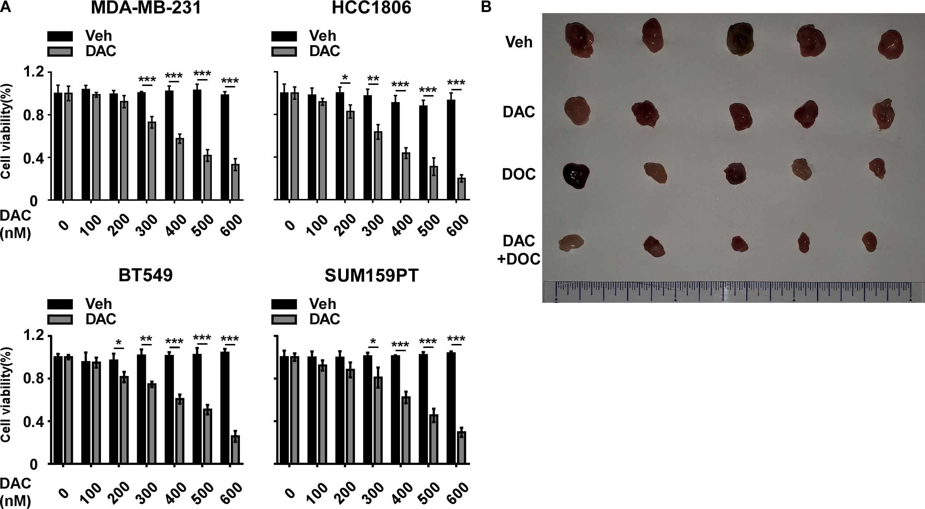

Supplementary Figure S2. CSC enrichment inducing DOC resistance was inhibited by low-dose DAC treatment.
- Flow cytometry for CD44 and CD24 cell surface expression in TNBC cells with the indicated treatment.
- Cell viability was assessed in the indicated cells.
- Cell apoptosis was evaluated by an Annexin V/PI assay using flow cytometry.
- Flow cytometry for CD44 and CD24 cell surface expression in the indicated cells.
- qRT-PCR analysis of IQGAP2 expression in 10 paired normal mammary (normal) tissues and breast cancer (tumor) tissues. GAPDH was used as an internal control.
- qRT-PCR analysis of IQGAP3 expression in 10 paired normal mammary (normal) tissues and breast cancer (tumor) tissues. GAPDH was used as an internal control.
- qRT-PCR analysis of DAB2IP expression in 10 paired normal mammary (normal) tissues and breast cancer (tumor) tissues. GAPDH was used as an internal control.
- IQGAP2, IQGAP3 and DAB2IP mRNA expression in normal mammary (normal; n= 113) and breast cancer (tumor; n= 1080) tissues was assessed by analyzing the TCGA BRCA mRNA dataset.
- Gene set enrichment analysis (GSEA v2.2.0: http://www.broadinstitute.org/gsea/) of DAB2IP expression using the TCGA BRCA mRNA dataset (n = 1080).
- Correlation analysis of mRNA expression and DNA methylation in BC cell lines using the Cancer Cell Line Encyclopedia database (CCLE: https://portals.broadinstitute.org/ccle/about).
- Analysis of DNA methylation level in the indicated cells. DNA methylation level of 4 DAB2IP transcripts were assessed.
- The mRNA expression and DNA methylation level of DAB2IP (ENST00000259371.6) in the indicated cells. Data are presented as the mean ± SD.
- The mRNA expression of DAB2IP in DOC-resistant cells treated with vehicle (veh, 72 h) or DAC (100 nM, 72 h).
In L and M, primers corresponding to the ENST00000259371.6 transcript were used. In B, Data are presented as the mean ± SD, P-values were determined by two-way ANOVA, ***P < 0.001. In, C, E-H, K and M, Data are presented as the mean ± SD, P-values were determined by a two-tailed Student’s t test, *P < 0.05, **P < 0.01, ***P < 0.001.

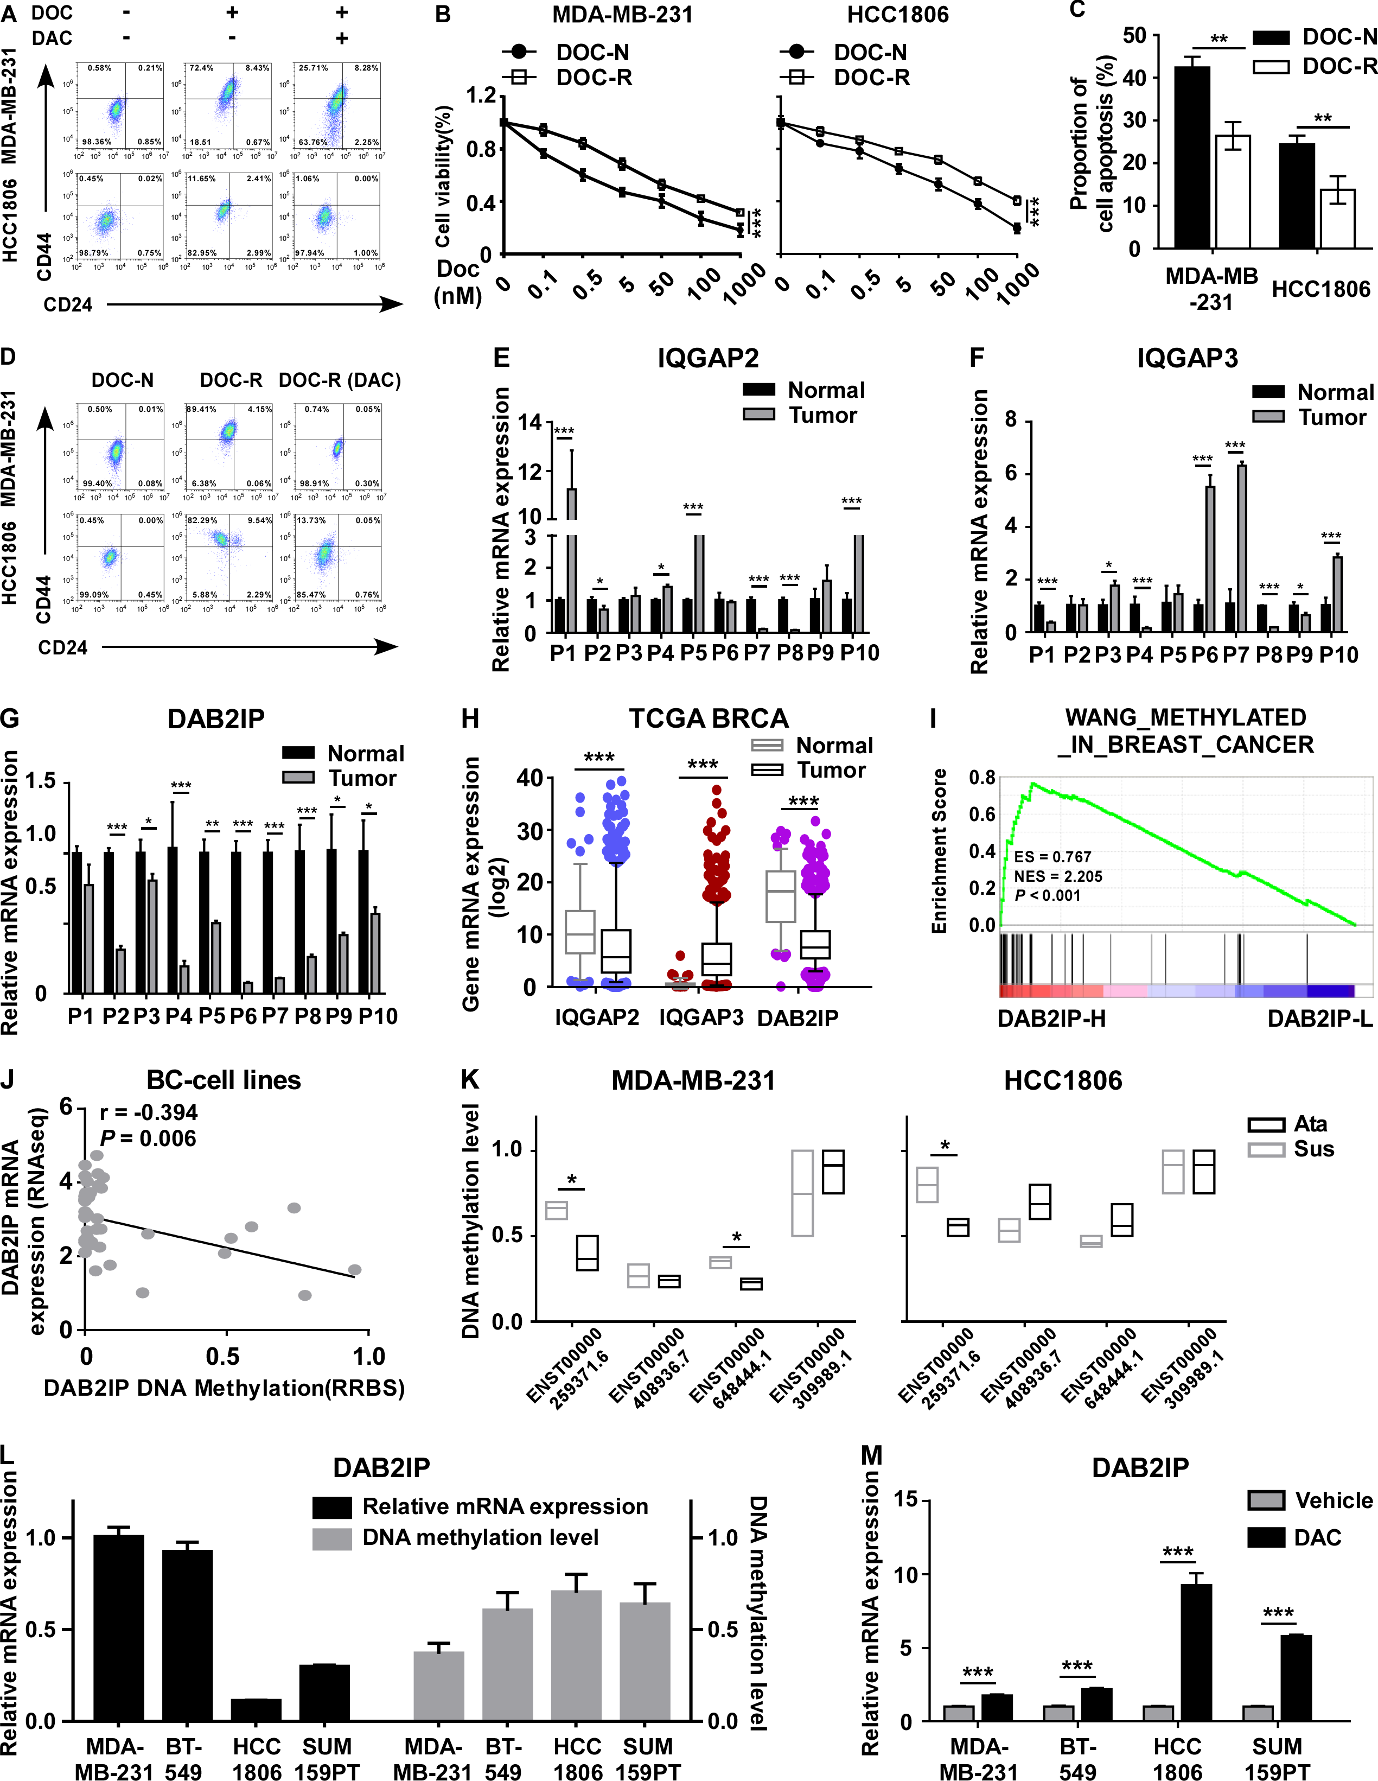

Supplementary Figure S3. DAB2IP suppresses cancer stem cell capacity in TNBC.
- Gene set enrichment analysis (GSEA v2.2.0: http://www.broadinstitute.org/gsea/) of DAB2IP expression using the TCGA BRCA mRNA dataset (n = 1080).
- The protein expression of DAB2IP in stable cell lines overexpressing and silencing DAB2IP. GAPDH was used as an internal control.
- Quantification of tumor spheres formed by the indicated cells. Data are presented as the mean ± SD, and P-values were determined by one-way ANOVA. *P < 0.05.
- Flow cytometry for CD44 and CD24 cell surface expression in the indicated cells.
- qRT-PCR analysis of Nanog, Sox2, Pou5f1 and C-myc in the indicated TNBC cells. Data are presented as the mean ± SD. P-values were determined by a two-tailed Student’s t test. *P < 0.05, **P < 0.01.
- Representative images of p-Erk1/2 (in green) and active β-catenin (in red) stained using IF in tumor spheres formed by the indicated cells. Tumor spheres were stimulated by Wnt3a (0 min, 15 min and 30 min). Cell nuclei were labeled with DAPI (in blue). Images were captured using confocal microscopy. Scale bar: 20 μm.
- A limiting dilution assay was used to evaluate the tumor initiation capacity. The indicated number of MDA-MB-231-vector cells or MDA-MB-231-DAB2IP (overexpressing DAB2IP) cells were mixed with Matrigel and subcutaneously injected into right (MDA-MB-231-vector) and left (MDA-MB-231-DAB2IP) fat pads of female NOD/SCID mice. A schematic diagram of the limiting dilution assay is shown (left panel). The tumor initiation frequency was assessed by luciferase activity (right panel).
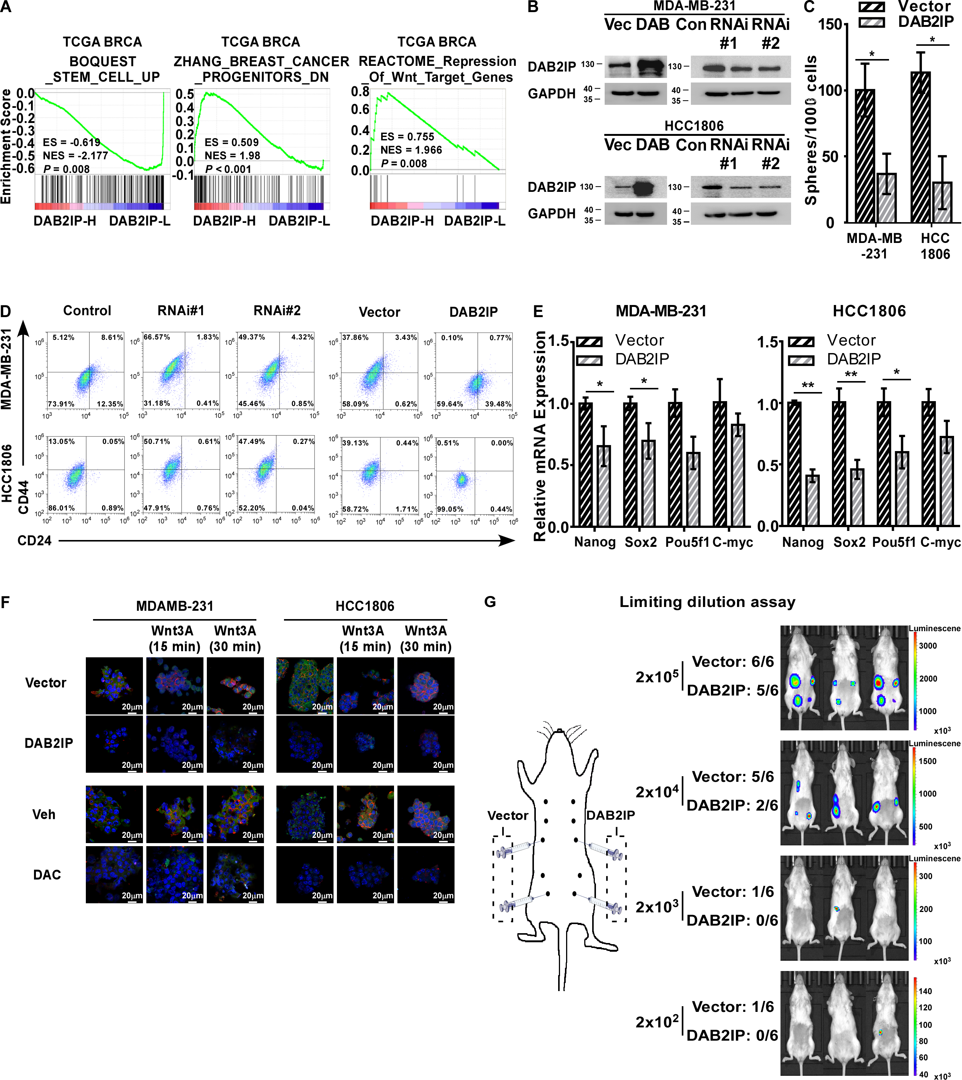
Supplementary Figure S4. DAB2IP improves DOC response in TNBC.
- Cell viability was assessed in the indicated cells treated with DOC. TNBC cells were pretreated with various concentrations of docetaxel, and cell viability was evaluated by CCK-8 assay.
- Cell apoptosis was evaluated by an Annexin V/PI assay using flow cytometry. The indicated cells were treated with DOC.
- Cell cycle analysis of the indicated cells by flow cytometry. Cells were serum starved (24 h) and then cultured in serum-containing medium. A total of 2×10⁴ cells were stained with propidium iodide (PI), and the cell cycle distribution was evaluated.
- The protein expression of p-Erk1/2, Erk1/2, p-Akt, Akt, CCNB1, p-CDK1 and CDK1 in the indicated cells. GAPDH was used as an internal control.
- Tumors of the indicated groups were collected when mice were sacrificed on the 28th day, after the tumor volume reached 200 mm³.
- Volumes of tumors in the indicated groups (n = 5/group). Mice were treated with DOC (15 mg/kg, i.p. weekly) when tumors reached a volume of 200 mm³. Tumor volumes were measured every 4 days and are shown by tumor growth curves.
- Tumor weights of tumors in the indicated groups.
- Representative images of TUNEL staining of apoptotic cells in the indicated tumors treated with DOC. Cell nuclei were labeled with DAPI (in blue), and the apoptotic cell fraction was labeled with TUNEL (in green). Scale bars: 50 μm and 500 μm.
In A and F, Data are presented as the mean ± SD, P-values were determined by two-way ANOVA, **P < 0.01, ***P < 0.001. In B and G, Data are presented as the mean ± SD, P-values were determined by a two-tailed Student’s t test, *P < 0.05, **P < 0.01.
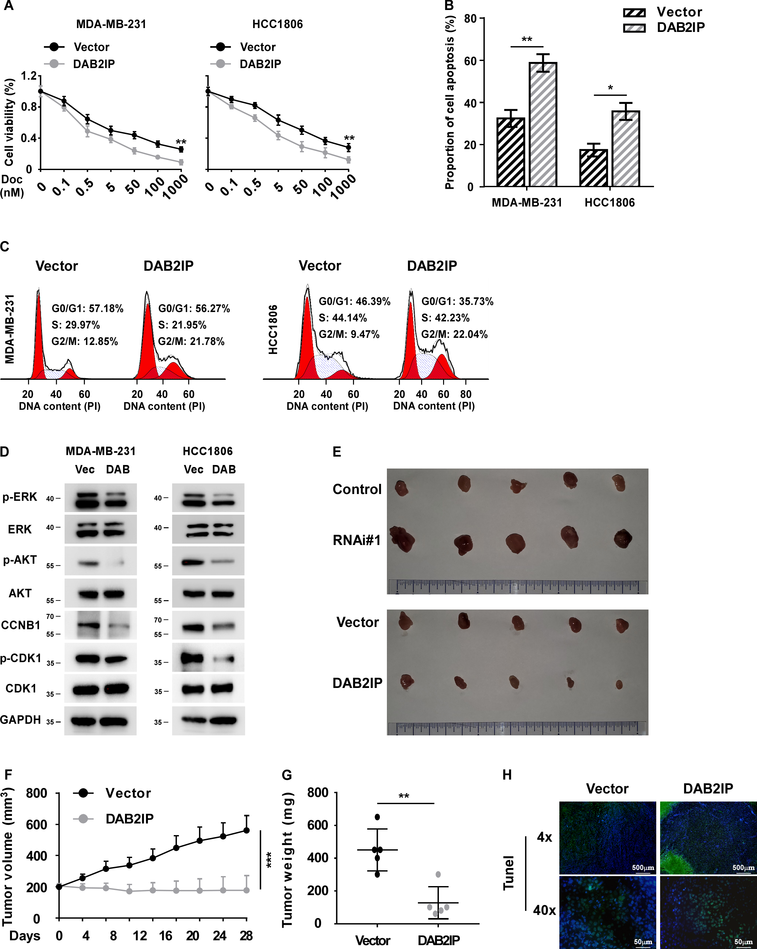

Supplementary Figure S5. A low dose of decitabine inhibits DNA methylation at the DAB2IP promoter in docetaxel-resistant cells.
- DNA methylation analysis of the methylation status of DAB2IP in DOC-N and DOC-R cells.
- DNA methylation analysis of the methylation status of DAB2IP in DOC-R cells with the indicated treatments.
- qRT-PCR analysis of DAB2IP in the indicated TNBC cells.
- Cell apoptosis was evaluated by flow cytometry. The indicated cells pretreated with vehicle or DAC were treated with DOC.
- Tumors of the indicated groups were collected when mice were sacrificed on the 28th day, after the tumor volume reached 200 mm³.
In A and B, primers corresponding to the ENST00000259371.6 transcript were used. In C-D, Data are presented as the mean ± SD, P-values were determined by a two-tailed Student’s t test, **P < 0.01, ***P < 0.001.

