Supplementary materials

Fully automated sample-to-result SIMPLE-RPA microfluidic chip: towards in ovo sexing application
Simão Monteiro Belo dos Santos¹, Celine Wegsteen¹, Dries Vloemans¹, Matthias Corion², Bart De Ketelaere³, Dragana Spasic^{1,*} and Jeroen Lammertyn^{1,*,†}
¹ KU Leuven, Department of Biosystems - Biosensors group, Willem de Croylaan 42, B-3001 Leuven, Belgium
² KU Leuven, Department of Biosystems – A2H Nutrition & Animal EcoSystems (NAMES) Lab, Kasteelpark Arenberg 30, 3001 Leuven, Belgium
³ KU Leuven, Department of Biosystems – MeBioS Biostatistics group, Kasteelpark Arenberg 30, 3001 Leuven, Belgium
* Shared last co-author
† Corresponding author: jeroen.lammertyn@kuleuven.be

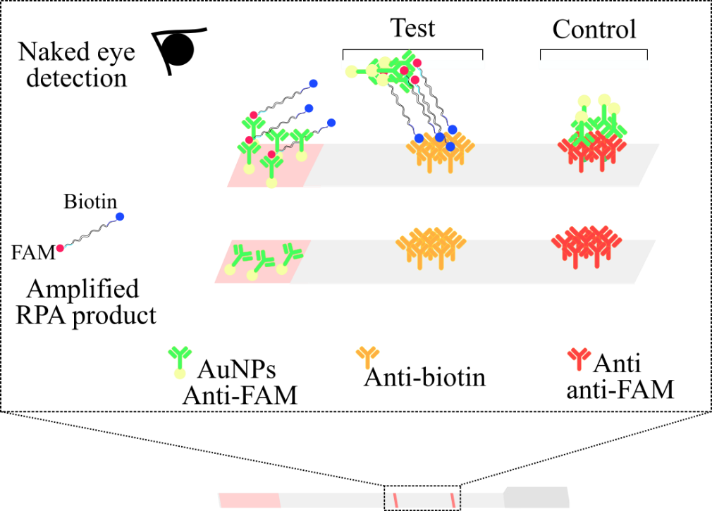S1 – Depiction of the commercial LFS used in this work
Figure S1 - LFS representation with colorimetric read-out. The amplified RPA product has a biotin and FAM label at each end (because of the usage of the forward and reverse primers having biotin and FAM labels, respectively). The RPA amplified product is mixed with the reporter probes (AuNPs FAM antibody) present in the sample pad, which will bind the FAM labels. Afterwards, biotin antibodies capture the biotin in the amplified RPA product. At the control line, anti-FAM antibodies also capture the AuNPs FAM antibodies. The AuNPs on the reporter probes in the control line or the test and control line (in case there is amplification) can be visualized with the naked eye due to their aggregation that results in a reddish color.

S2 - SIMPLE-RPA Inkscape designs

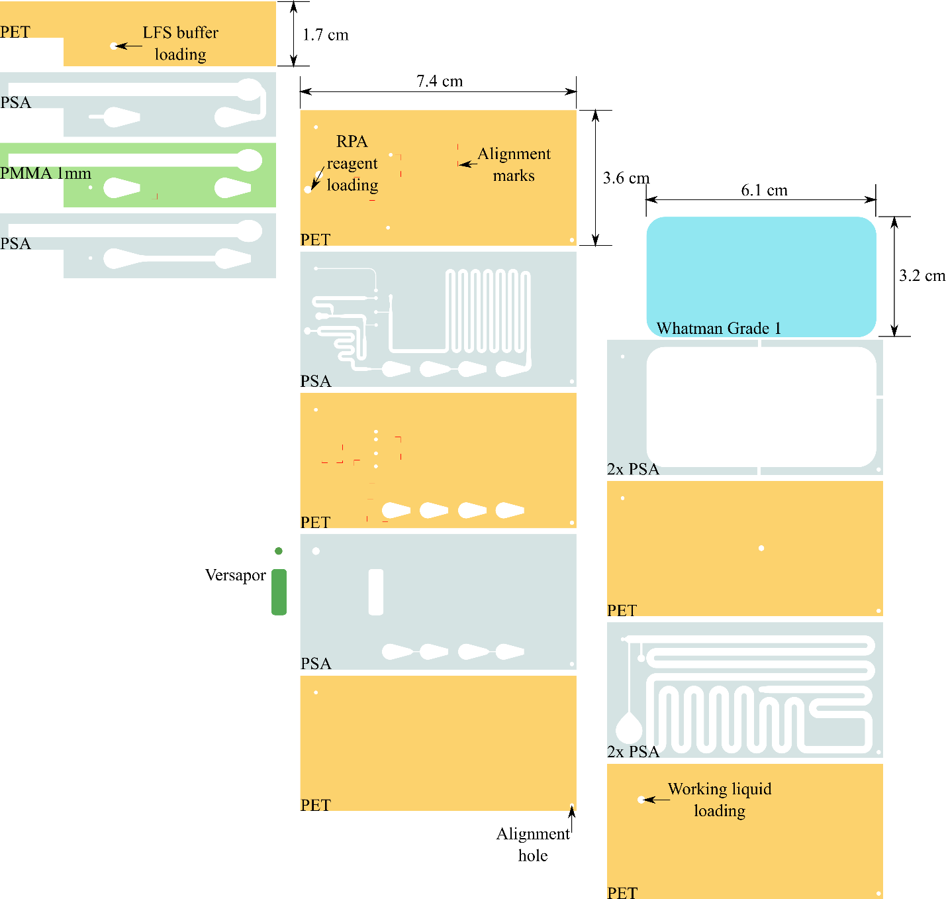
Figure S2 – SIMPLE-RPA chip design in Inkscape. All the materials were cut using an 80-watt Speedy300 Trotec laser cutter (Trotec Lasers, Austria) and fabricated using a previously reported layer-by-layer fabrication method^{1,2}.

S3 – TapeStation results from the off-chip optimization of the RPA bioassay

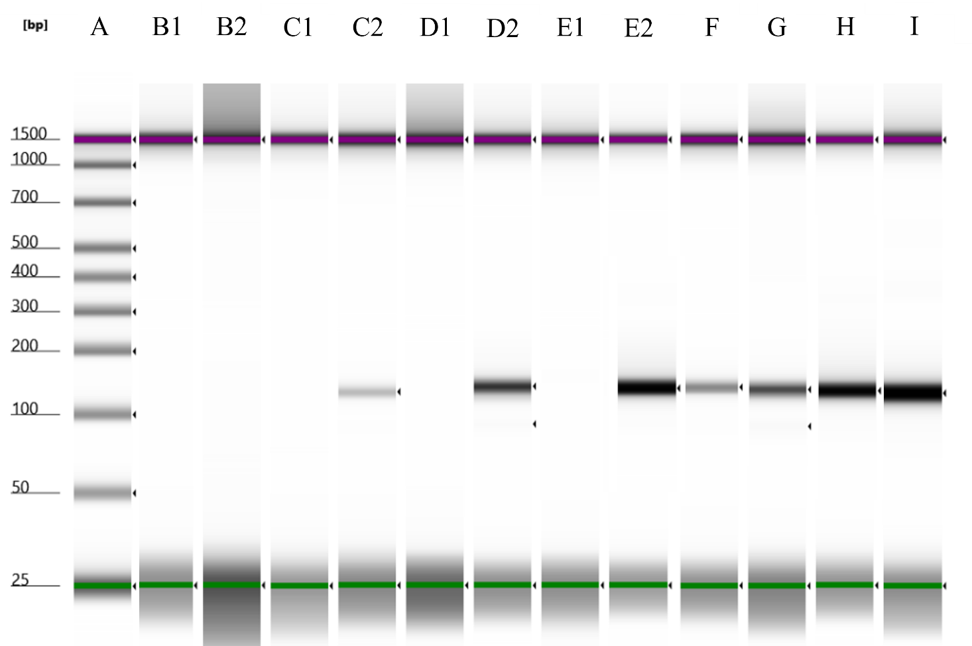
Figure S3 – TapeStation results obtained with 0.01 ng/µL synthetic DNA from the targeted HINTW gene during RPA bioassay optimization. A: Ladder. B2, C2, D2 and E2: primer concentrations of 0.5, 2.5, 5 and 10 µM, respectively, with 20 minutes incubation time. Their respective NTC controls are presented in lanes B1, C1, D1 and E1. F – I: 5, 10, 15 and 20 min of incubation time, respectively, with 2.5 µM primer concentration.

S4 – Examples of the obtained LFSs from off-chip RPA bioassay
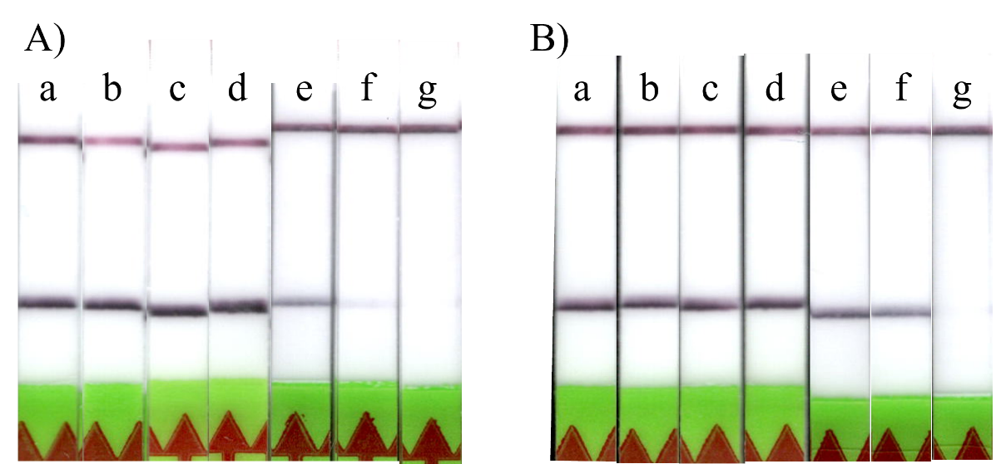
Figure S4 – Examples of obtained LFSs from the RPA performed for 15 minutes with a 2.5 µM primer concentration and synthetic target serial dilutions (a – f: 0.05, 0.01, 2 x 10⁻³, 4 x 10⁻⁴, 8 x 10⁻⁵, 1.6 x 10⁻⁵ ng/µL and g being NTC) when using A) the PCR thermocycler or B) the egg incubator as heating source to achieve 37.7 °C.

S5 – Scanned LFS from determining sensitivity for the off-chip RPA bioassay

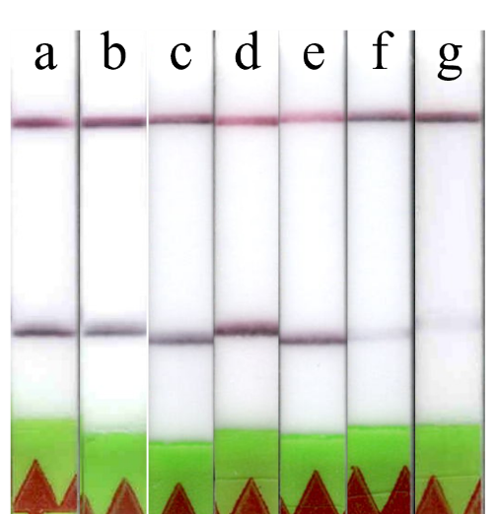
Figure S5 - Examples of the obtained LFS from the on-chip RPA with synthetic HINTW DNA serial dilutions (a – f: 0.05, 0.01, 2 x 10⁻³, 4 x 10⁻⁴, 8 x 10⁻⁵, 1.6 x 10⁻⁵ ng/µL and g being NTC).

S6 – PVA concentration in working liquid and incubation time
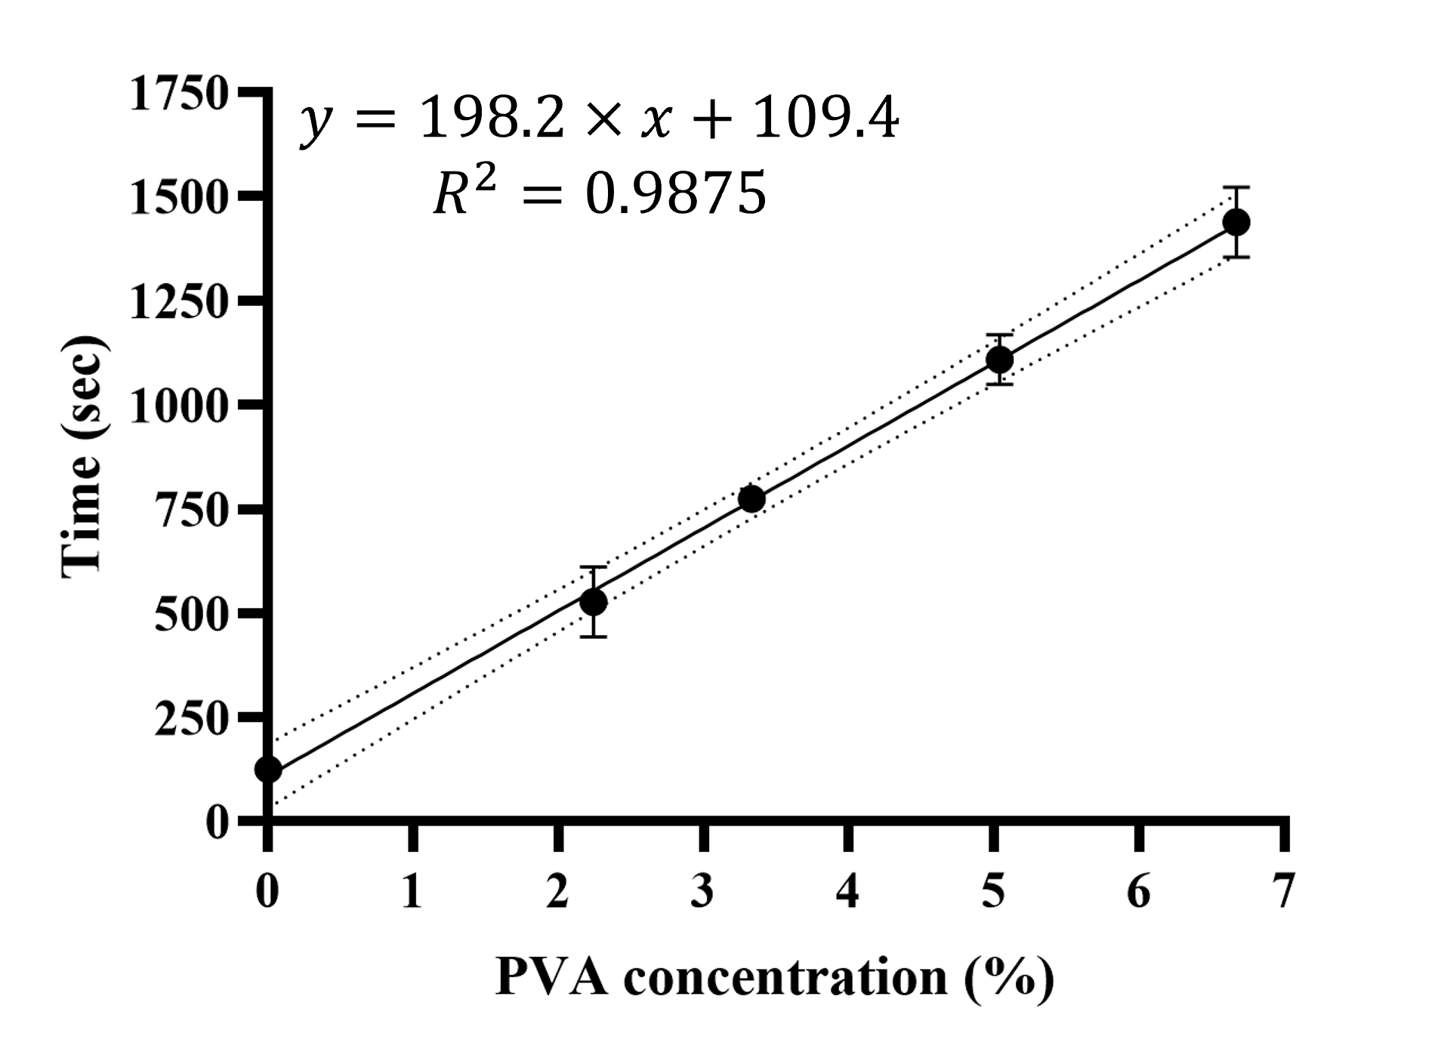
Figure S6 – Obtained linear regression between incubation time of the SIMPLE-RPA chip and the amount of PVA in the working liquid. Dashed lines represent a 95 % confidence interval.

S7 – SIMPLE-RPA platform prefilling video

S8 - SIMPLE-RPA platform video with colored liquids

S9 – Lucas-Washburn equation for liquid adsorption in a porous media
Cohesive (intermolecular attractions at the liquid-air interface, i.e., molecular tension) and adhesive forces (van der Waals forces) of the working liquid in the porous material lead to a passive and continuous liquid absorption and flow and increasing negative pressure at the back of the working liquid and inside of the microfluidic channels, which drives the liquids (sample and reagents) in those³. The Lucas-Washburn equation (Equation 1) shows the inverse correlation between liquid viscosity (µ) and the porous media wetted distance (l) in a porous material over time (t)⁴, which was utilized in this report to control the volumetric flow rate of the liquid samples. By increasing the working liquid viscosity with PVA, it was possible to control the wetting distance over time and, hence, the flow rate of the liquids inside the microfluidic channels. More recent models^{5,6}, requiring higher computational power, can still be used to further describe the SIMPLE pumps' behavior and modify the working liquid, pump geometries and pump materials to modify the fluid flow within the channels.
(S8) | 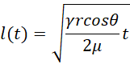

References
1. Kokalj, T., Park, Y., Vencelj, M., Jenko, M. & Lee, L. P. Self-powered imbibing microfluidic pump by liquid encapsulation: SIMPLE. Lab Chip 14, 4329–4333 (2014).
2. Dal Dosso, F., Bondarenko, Y., Kokalj, T. & Lammertyn, J. SIMPLE analytical model for smart microfluidic chip design. Sensors Actuators, A Phys. 287, 131–137 (2019).
3. Chen, T. et al. Multi-dimensional microfluidic paper-based analytical devices (μPADs) for noninvasive testing: A review of structural design and applications. Anal. Chim. Acta 342877 (2024) doi:10.1016/j.aca.2024.342877.
4. Washburn, E. W. The dynamics of capillary flow. Phys. Rev. 18, 206–209 (1921).
5. Channon, R. B. et al. Rapid flow in multilayer microfluidic paper-based analytical devices. Lab Chip 18, 793–802 (2018).
6. Perez-Cruz, A., Stiharu, I. & Dominguez-Gonzalez, A. Two-dimensional model of imbibition into paper-based networks using Richards’ equation. Microfluid. Nanofluidics 21, 1–12 (2017).

