Supplementary material A

Evaluating Cognitive Decline Detection in Aging Populations with Single-Channel EEG Features: Insights from Studies and Meta-Analysis
Lior Molcho^{†1*}, Neta B. Maimon^{†1,2}, Talya Zeimer¹, Ofir Chibotero¹, Sarit Rabinowicz⁴, Vered Armoni⁴, Noa Bar On⁴, Nathan Intrator^{1,3}, Ady Sasson⁴
¹ Neurosteer Inc, NYC, New York, USA
² School of Psychological Sciences, Tel Aviv University, Tel Aviv, Israel
³ Blavatnik School of Computer Science, Tel-Aviv University, Tel-Aviv, Israel; Sagol School of Neuroscience, Tel Aviv University, Tel Aviv, Israel
⁴ Dorot Geriatric Medical Center, Netanya, Israel
*lior@neurosteer.com
†These authors contributed equally to this work.
Group distributions
Figures 1 and 2 depict the distributions of mean A0 activity levels during both resting state and cognitive resource allocation tasks, respectively. During the resting state condition, participants were instructed to relax as much as they could. In the cognitive resource allocation condition, participants performed a high-load detection task, designed to assess attention and inhibition [1].
The figures illustrate the distribution of participants across various A0 values, with the x-axis representing A0 biomarker values—lower values indicating lower activity levels and higher values signifying higher activity levels. The y-axis reflects the frequency of participants, indicating how many individuals correspond to each A0 value based on their average brain activity. Refer to Table 1 for the demographic details and cognitive assessment scores of the four groups represented in the distribution graphs: Healthy Young, Healthy Seniors, MCI-R, and MD.
Measure | MD | MCI-R | Healthy | Healthy Young
Sample size (n) | 32 | 84 | 87 | 67
Age range | 61-94 | 50-101 | 54-92 | 18-65
Mean age (± STD) | 79.09 (7.87) | 74.36 (10.12) | 72.9 (8.2) | 22.5 (7.6)
MMSE Score range | 10-23 | 24-27 | 28-30 | N/A
Mean MMSE score (± STD) | 20.6 (2.13) | 25.4 (1.03) | 28.9 (0.8) | N/A

Table 1. Sample size (n), age range, mean age with standard deviation (± SD), Mini-Mental State Examination (MMSE) score range, and mean MMSE score with standard deviation (± SD) for each group.
The graphs show that the Healthy Young group (blue line) exhibits a concentrated distribution with a high density of individuals at lower A0 levels, contrasting with the broader distributions observed in the Healthy Seniors (orange line), MCI-R (green line), and MD (red line) groups, which extend to higher A0 levels. On average, the Healthy Young group displays the lowest A0 values, while the MCI-R and MD groups show the highest averages.
In the Healthy seniors group, two peaks are evident, one aligning closely with the average of the Healthy Young group, and the other with the MCI-R and MD groups. These results highlight differences between young and elderly individuals, as well as between cognitively healthy and impaired seniors, across both resting and cognitive load conditions. Further research should explore whether A0 activity could serve as a potential predictor of MCI-R within the healthy senior population.
These findings are consistent with previous research showing that individuals with Alzheimer's disease (AD) exhibit increased Theta [2], [3] and Delta [3] power during rest, compared to age-matched controls and individuals with MCI. This trend is also seen in Gamma during cognitive task performance [4], suggesting an over-allocation of cognitive resources in cognitively impaired individuals compared to those with MCI and healthy controls.

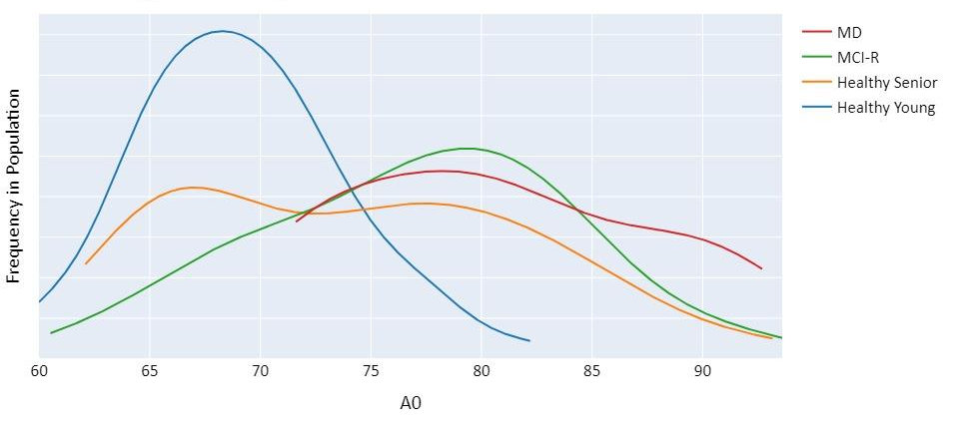Figure 1. Group distributions of A0 activity during resting state tasks.
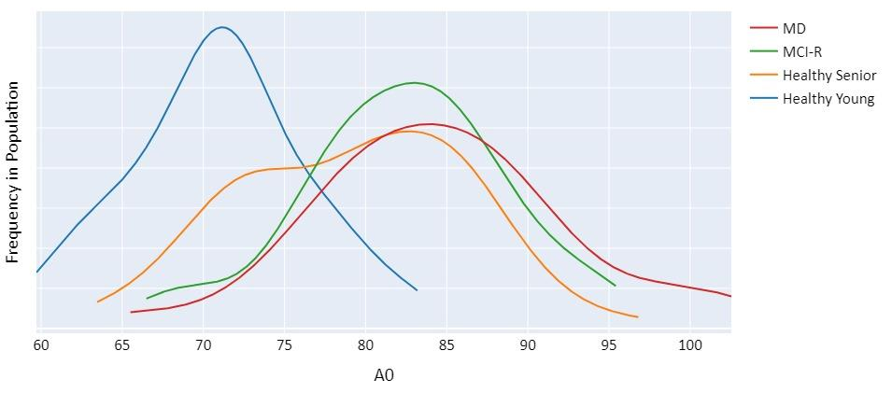
Figure 2. Group distributions of A0 activity during cognitive resource allocation tasks.

References
[1] H. Garavan, T. J. Ross, K. Murphy, R. A. P. Roche, and E. A. Stein, ‘Dissociable executive functions in the dynamic control of behavior: Inhibition, error detection, and correction’, Neuroimage, vol. 17, no. 4, 2002, doi: 10.1006/nimg.2002.1326.
[2] K. van der Hiele et al., ‘EEG correlates in the spectrum of cognitive decline’, Clinical Neurophysiology, vol. 118, no. 9, 2007, doi: 10.1016/j.clinph.2007.05.070.
[3] A. H. Meghdadi et al., ‘Resting state EEG biomarkers of cognitive decline associated with Alzheimer’s disease and mild cognitive impairment’, PLoS One, vol. 16, no. 2 February, 2021, doi: 10.1371/journal.pone.0244180.
[4] J. A. Van Deursen, E. F. P. M. Vuurman, F. R. J. Verhey, V. H. J. M. Van Kranen-Mastenbroek, and W. J. Riedel, ‘Increased EEG gamma band activity in Alzheimer’s disease and mild cognitive impairment’, J Neural Transm, vol. 115, no. 9, 2008, doi: 10.1007/s00702-008-0083-y.

