Physicochemical Characteristics and Inhibition Effect of Curcumin Based Schiff Bases on Industrially Important Mild Steel Corrosion in Acidic Medium

Contents
Materials and Methods
Figure S1A: UV Spectrum of P-Nitro[(Curcumin)]-aniline (PNCA)
Figure S1B: UV Spectrum of P-Bromo[(Curcumin)]-aniline (PBCA)

Figure S2A: FTIR Spectrum of P-Nitro[(Curcumin)]-aniline (PNCA)
Figure S2B: FTIR Spectrum of P-Bromo[(Curcumin)]-aniline (PBCA)

Figure S3A: ¹H NMR Spectrum of P-Nitro[(Curcumin)]-aniline (PNCA)
Figure S3B: ¹H NMR Spectrum of P-Bromo[(Curcumin)]-aniline (PBCA)

Figure S4A: ¹³C NMR Spectrum of P-Nitro[(Curcumin)]-aniline (PNCA)
Figure S4B: ¹³C NMR Spectrum of P-Bromo[(Curcumin)]-aniline (PBCA)

Figure S5A: Mass Spectrum of P-Nitro[(Curcumin)]-aniline (PNCA)
Figure S5B: Mass Spectrum of P-Bromo[(Curcumin)]-aniline (PBCA)

Figure S6A: Weight loss measurement process and fresh crystals of P-Nitro[(Curcumin)]-aniline (PNCA)
Figure S6B: Weight loss measurement process and fresh crystals of P-Bromo[(Curcumin)]-aniline (PBCA)

Figure S1A: UV Spectrum of P-Nitro[(Curcumin)]-aniline (PNCA)
Figure S1B: UV Spectrum of P-Bromo[(Curcumin)]-aniline (PBCA)
Figure S2A: FTIR Spectrum of P-Nitro[(Curcumin)]-aniline (PNCA)

Figure S2B: FTIR Spectrum of P-Bromo[(Curcumin)]-aniline (PBCA
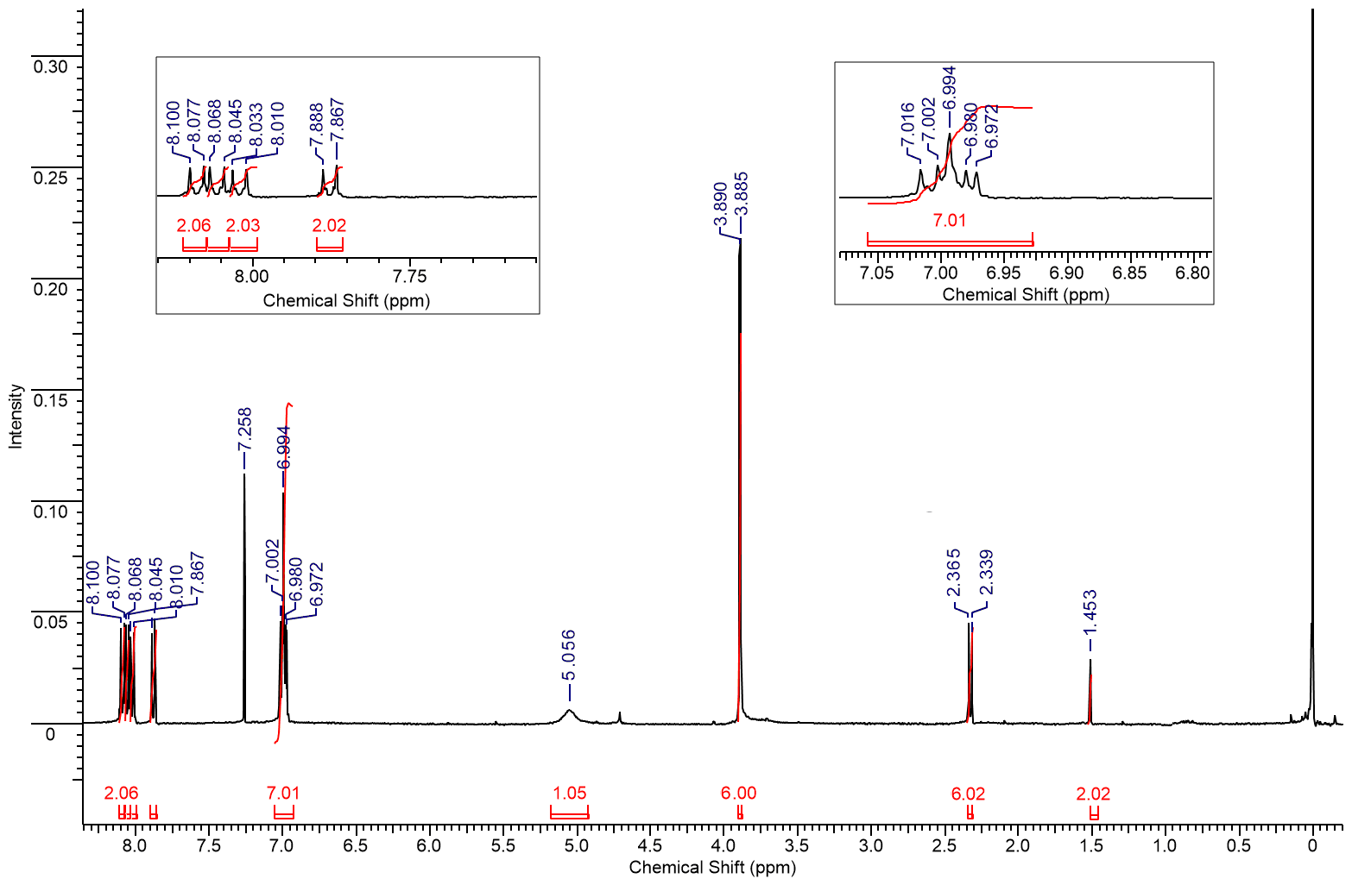
Figure S3A: ¹H NMR Spectrum of P-Nitro[(Curcumin)]-aniline (PNCA)
PNCA

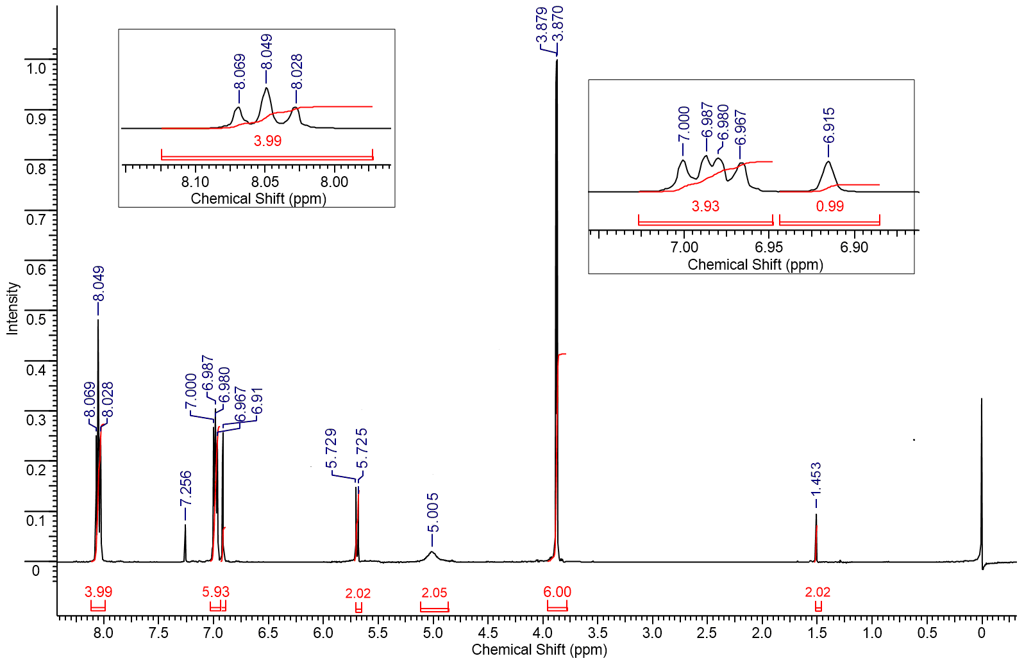
Figure S3B: ¹H NMR Spectrum of P-Bromo[(Curcumin)]-aniline (PBCA)
PBCA

Figure S4A: ¹³C NMR Spectrum of P-Nitro[(Curcumin)]-aniline (PNCA)
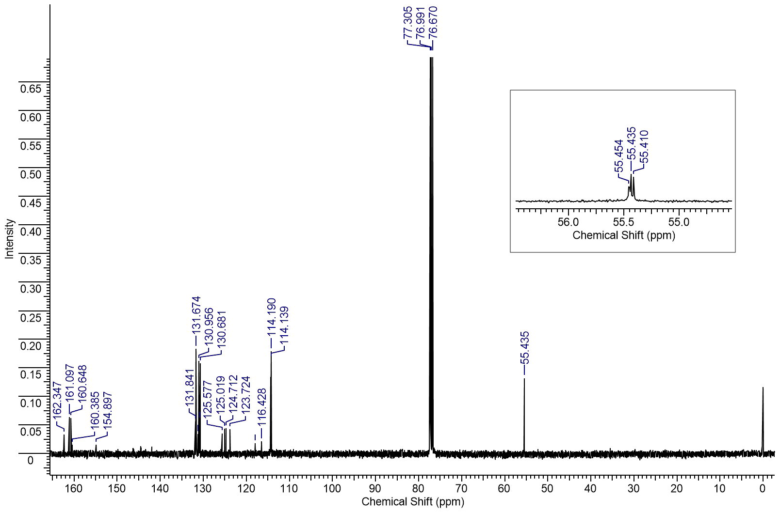
PNCA

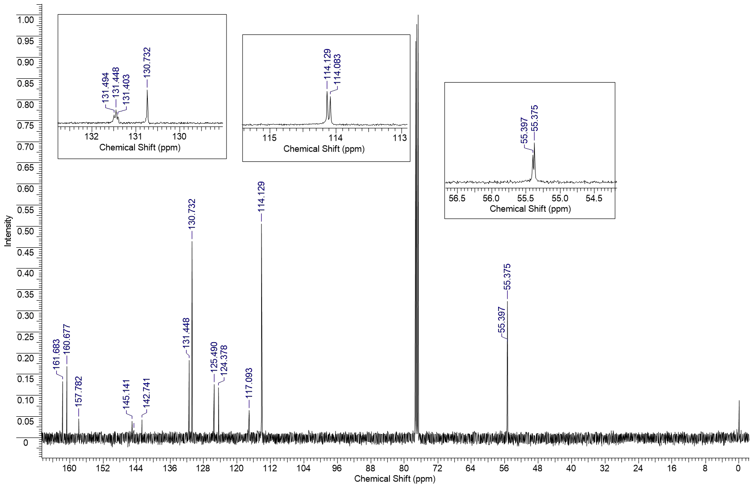
Figure S4B: ¹³C NMR Spectrum of P-Bromo[(Curcumin)]-aniline (PBCA)
PBCA

Figure S5A: Mass Spectrum of P-Nitro[(Curcumin)]-aniline (PNCA)

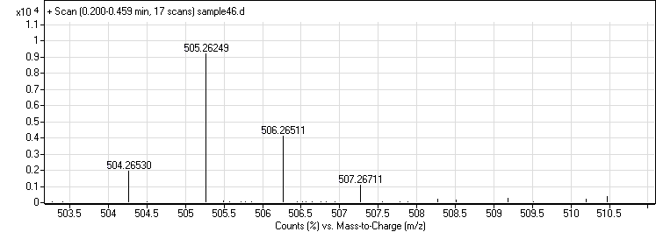
PNCA

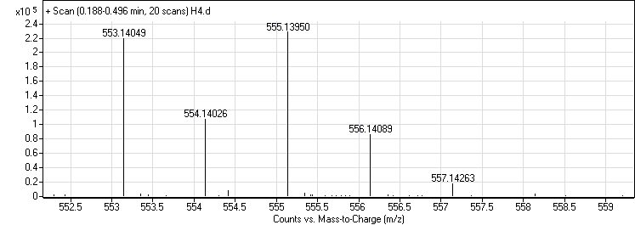
Figure S5B: Mass Spectrum of P-Bromo[(Curcumin)]-aniline (PBCA)
PBCA

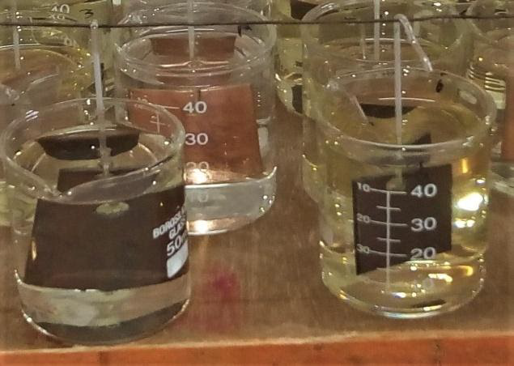
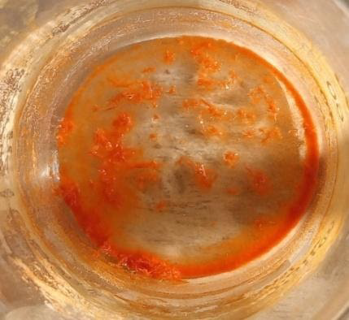
Figure.S6A: Weight loss measurement process and fresh crystals of P-Nitro[(Curcumin)]-aniline (PNCA)

Figure.S6B: Weight loss measurement process and fresh crystals of P-Bromo[(Curcumin)]-aniline (PBCA)
