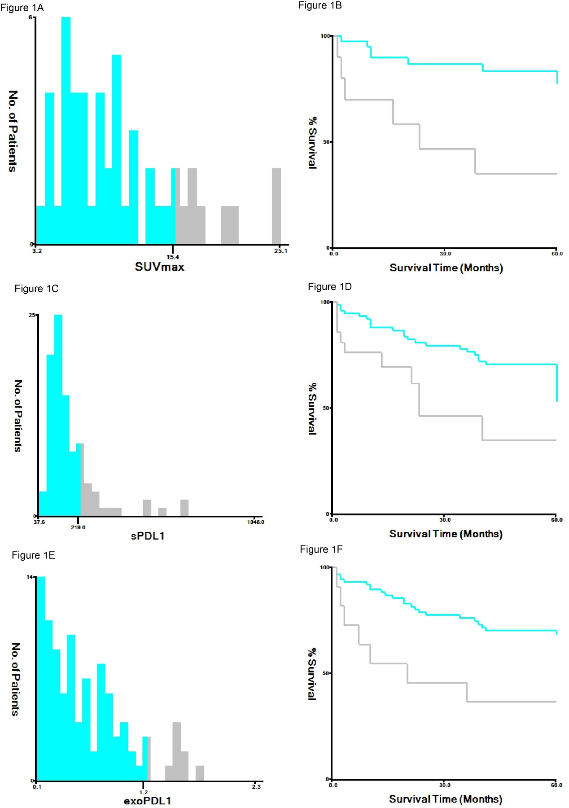
Supplemental Figure 1: X-tile is used to calculate for each possible cutoff that dichotomizes pretreatment SUVmax, exoPD-L1 and sPD-L1 level as low versus high level. The cutoff varies from the minimum to the maximum value of the sPD-L1 levels measured at diagnosis in our cohort. The optimal threshold is determined for the maximum log-rank statistic. The optimal cutoff value of SUVmax, exoPD-L1 and sPD-L1 level are 15.4, 1.2 and 219pg/ml, respectively.

