Supportting information

Efficient charge separation in Z-scheme heterojunctions induced by chemical bonding-enhanced internal electric field for promoting photocatalytic conversion of corn stover to C₁/C₂ gases

Guoyang Gao, Yuxin Dai, Ying Lin, Houjuan Qi, Zhanhua Huang*

Key Laboratory of Bio-based Material Science and Technology, Ministry of Education, Material Science and Engineering College, Northeast Forestry University, Harbin 150040, China
*Corresponding author E-mail address: huangzh1975@163.com

Experimental
Chemicals. Cadmium chloride hemi(pentahydrate) (CdCl₂·2.5H₂O, AR) was purchased from Fuchen (Tianjin) Chemical Reagent Co., Ltd. Cobalt nitrate hexahydrate (Co(NO₃)₂·6H₂O, AR) was purchased from Shanghai Macklin Biochemical Technology Co., Ltd. 2-Methylimidazole (2-MIM, AR), Ethanol anhydrous (CH₃CH₂OH, AR) and Thioacetamide (TAA, AR) were purchased from Tianjin Guangfu Technology Development Co., Ltd. Sodium hydroxide (NaOH, AR) and Methyl alcoholwere (CH₃OH, AR) were purchased from Tianjin Tianli Chemical Reagent Co., Ltd. Dimethyl sulfoxide (DMSO, AR) was obtained from Sinopharm Chemical Reagent Co., Ltd. Deionized water was used throughout the experiment. All the chemicals were obtained from commercial sources without further purification.
Characterization. The powder X-ray diffraction (XRD) pattern was acquired under Cu Kα irradiation (40 kV, 30 mA) with a scan range of 5-80° and a speed of 5° min⁻¹ (XRD-6100, Shimadzu, Japan). The morphologies of the samples were analyzed by transmission electron microscopy (TEM) on an JEOL JEM-F200 with an acceleration voltage of 200 kV. The field emission scanning electron microscopy (SEM) were carried out to acquire the microstructure and morphologies of the samples (regulus 5.0 kV 8.1 mm × 60.0 K SE(UL)). The UV-Vis diffuse reflectance spectra (UV-Vis DRS) of the samples were acquired using Shimadzu UV-3600i Plus spectrophotometer with BaSO4 as a reference. The Fourier-transform infrared (FT-IR) spectra of the samples were recorded with a Nicolet IS10 (Thermofisher, MA, USA). X-ray photoelectron spectroscopy (XPS) utilized non-monochromatic Al X-rays as the primary excitation (PHI5700, Thermo Electron Corporation, USA). The pore size distribution as well as the specific surface area of the catalysts were analyzed using the Brunauer-Emmett-Teller (BET) method on a nitrogen adsorption analyzer (ASAP2020, Micromeritics, USA). Photoluminescence (PL, G9800A, Agilent, USA) spectrograms were measured at 375 nm excitation wavelength. Electron spin/paramagnetic resonance (ESR/EPR) measurements were carried out on a Bruker EMX plus model spectrometer operating at the X-band frequency. The reactive •O²⁻ and •OH species were detected by using 5,5-dimethyl-1-pyrroline N-oxide (DMPO) as a spin trap under light irradiation.
Photoelectrochemical measurement. Photoelectrochemical measurements were performed by using a CHI-760 electrochemical workstation (Chenhua Instrument, Shanghai, China) with a 300W Xe arc lamp as the light source. All measurements were carried out in a traditional three-electrode system. The electrode of fluorine-doped tin oxide (FTO) conductive glass coated with a catalyst film is the working electrode. Pt foil and Ag/AgCl (saturated KCl) were used as the counter electrode and the reference electrode, respectively. A 0.3 M Na₂SO₄ aqueous solution was used as the electrolyte. All the experiments were performed at room temperature (about 25 ºC).
Photocatalytic measurement. The photocatalytic reaction was carried out in a custom-made reactor (made in Pyrex glass with a specification of c.a. 250 mL) connected to a close-loop gas circulation system (Labsolar-6A, Beijing Perfectlight
technology Co, Ltd.). In a typical experiment, 30 mg catalysts, 200 mg raw corn stover powders and 5 g NaOH were dispersed into a mixture of H₂O/DMSO (25 mL/25 mL) and mixed thoroughly. The above mixture was further transferred to the reactor for photocatalytic reaction. Prior to illumination, the mixed solution in the reactor was evacuated to ~0.5 kPa to ensure that the whole photocatalytic reaction was carried out under vacuum. A 300 W Xenon lamp (PLS-SXE 300+, Perfectlight, China) was used as the irradiation source, and gases such as CO, CO₂, CH₄, C₂H₆ and C₂H₄ were automatically quantified every one hour by an online gas chromatograph (8890 GC System, Agilent) equipped with a thermal conductivity detector (TCD) and a flame ionisation detector (FID) with Ar used for the carrier gas. Throughout the process, the reaction system and reactor were maintained at a temperature of 8 °C by water circulation. The liquid products were analyzed by high-performance liquid chromatography (HPLC, Agilent 1290 Infinity Ⅱ) with ZORBAX Eclipse Plus C18 (2.1 mm × 50 mm × 1.8 μm).
Computational Method. First-principles calculations carried out on the basis of periodic DFT using a generalized gradient approximation within the Perdew-Burke-Ernzerh of exchange correction functional. The geometry optimization was conducted with Gamma centered k-point with 3×3×1 mesh. The wave functions were constructed from the expansion of plane waves with an energy cutoff of 450 eV. The consistence tolerances for the geometry optimization were set as 1.0 ×10-5 eV/atom for total energy and 0.05 eV/Å for force, respectively. Work function was calculated by the formular:
Φ = E – Ef
where E and Ef are electrostatic potential and Fermi level.
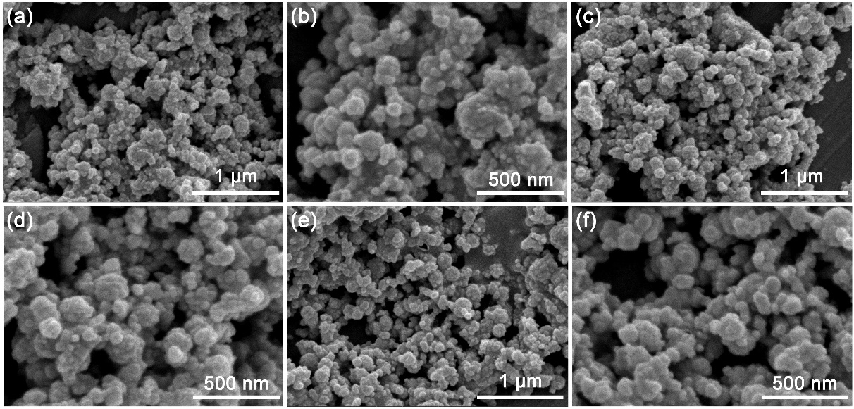
Fig. S1 SEM images of CdS nanoparticles with different CdCl₂ and TAA molar ratios: (a, b) Cd²⁺ : S²⁻ = 1:1, (c,d) Cd²⁺ : S²⁻ = 1:2, and (e,f) Cd²⁺ : S²⁻ = 1:3.

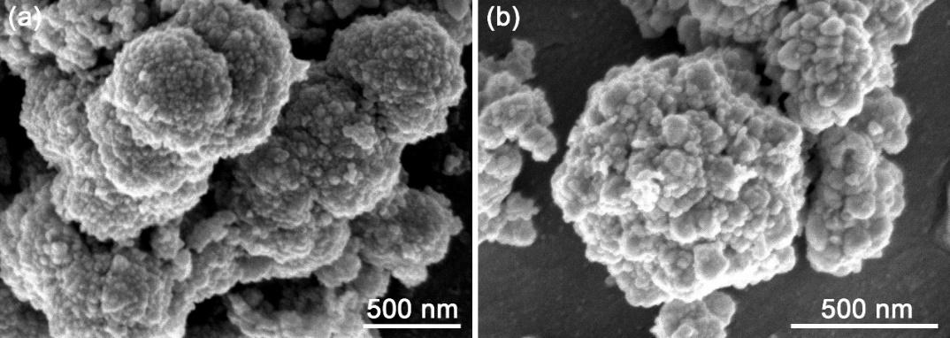
Fig. S2 SEM images of CS/CO-20.

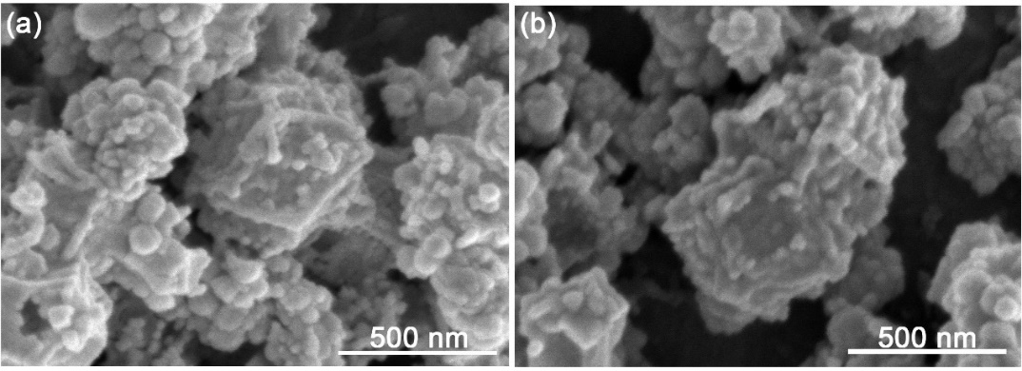
Fig. S3 SEM images of CS/CO-40.

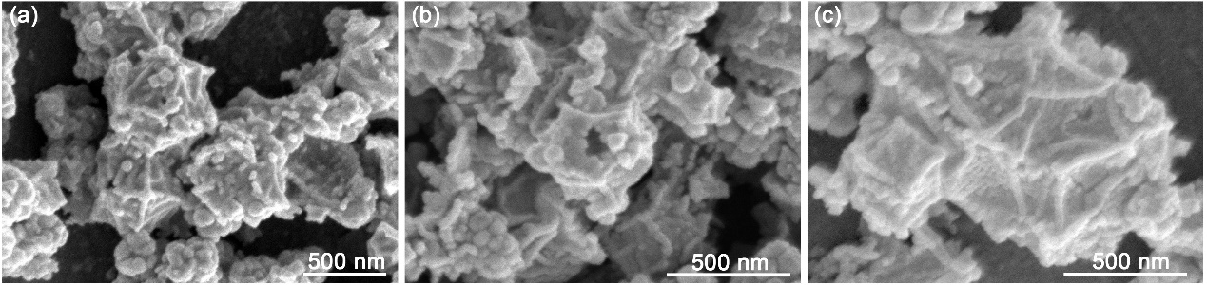
Fig. S4 SEM images of CS/CO-60.

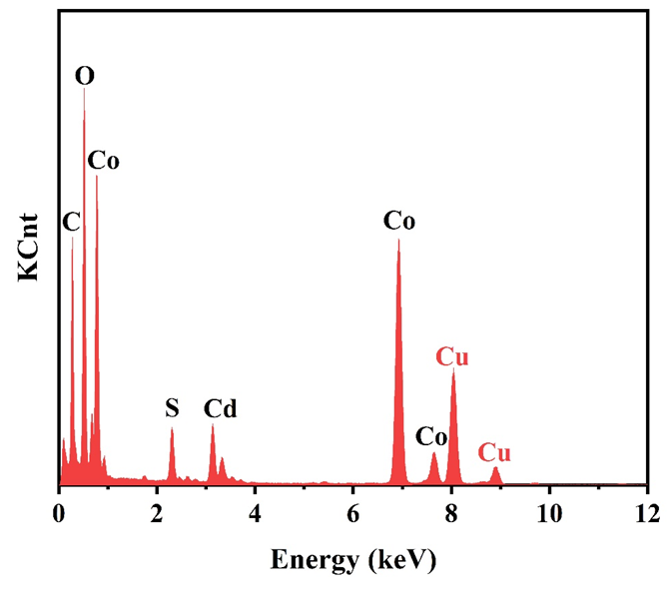
Fig. S5 EDS spectrum of CS/CO-40.

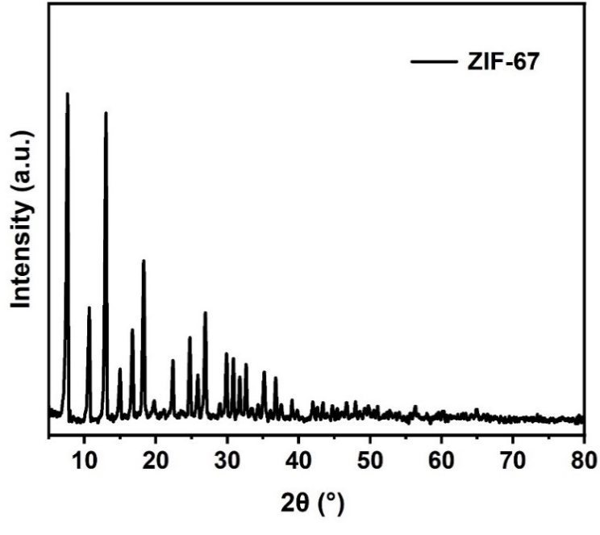
Fig. S6 XRD pattern of ZIF-67.

Fig. S7 XRD patterns of CdS nanoparticles with different CdCl₂ and TAA
molar ratios.

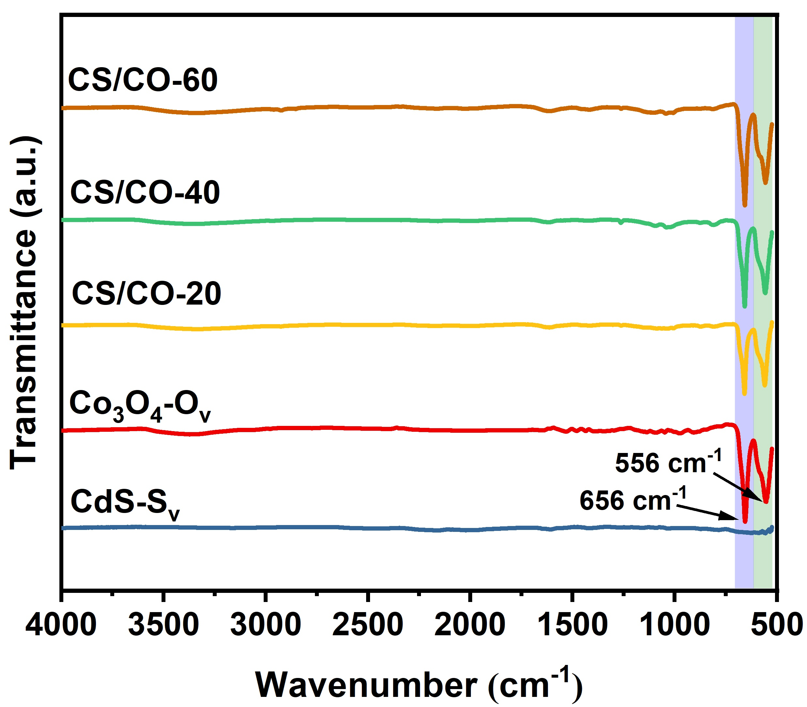
Fig. S8 FT-IR spectra of CdS-S_{v}, Co₃O₄-O_{v}, CS/CO-20, CS/CO-40, and CS/CO-60.

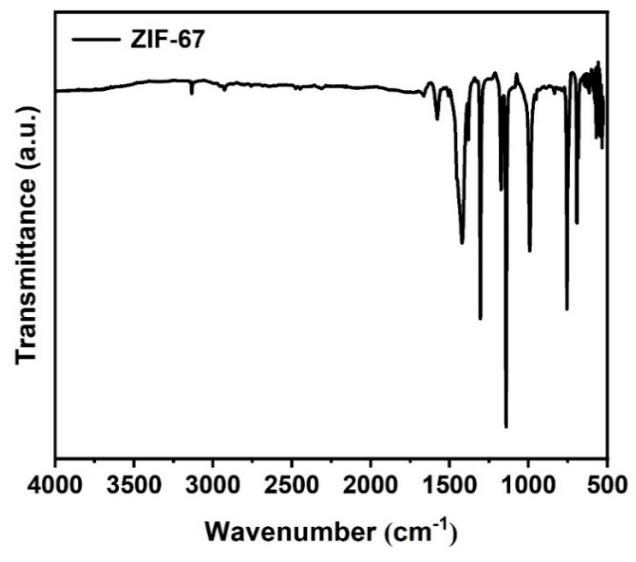
Fig. S9 FT-IR spectrum of ZIF-67.
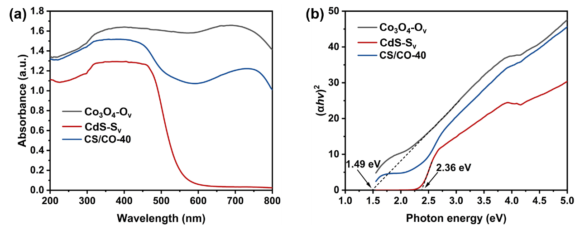
Fig. S10 (a) UV−vis absorption spectra and (b) Kubelka-Munk plots of Co₃O₄-O_{v}, CdS-S_{v}, and CS/CO-40.

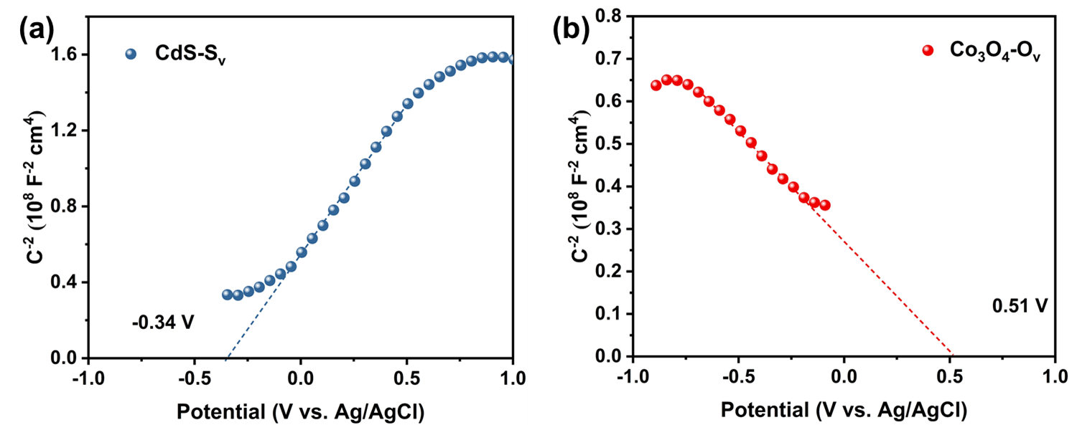
Fig. S11 Mott-Schottky plots of (a) CdS-S_{v} and (b) Co₃O₄-O_{v}.
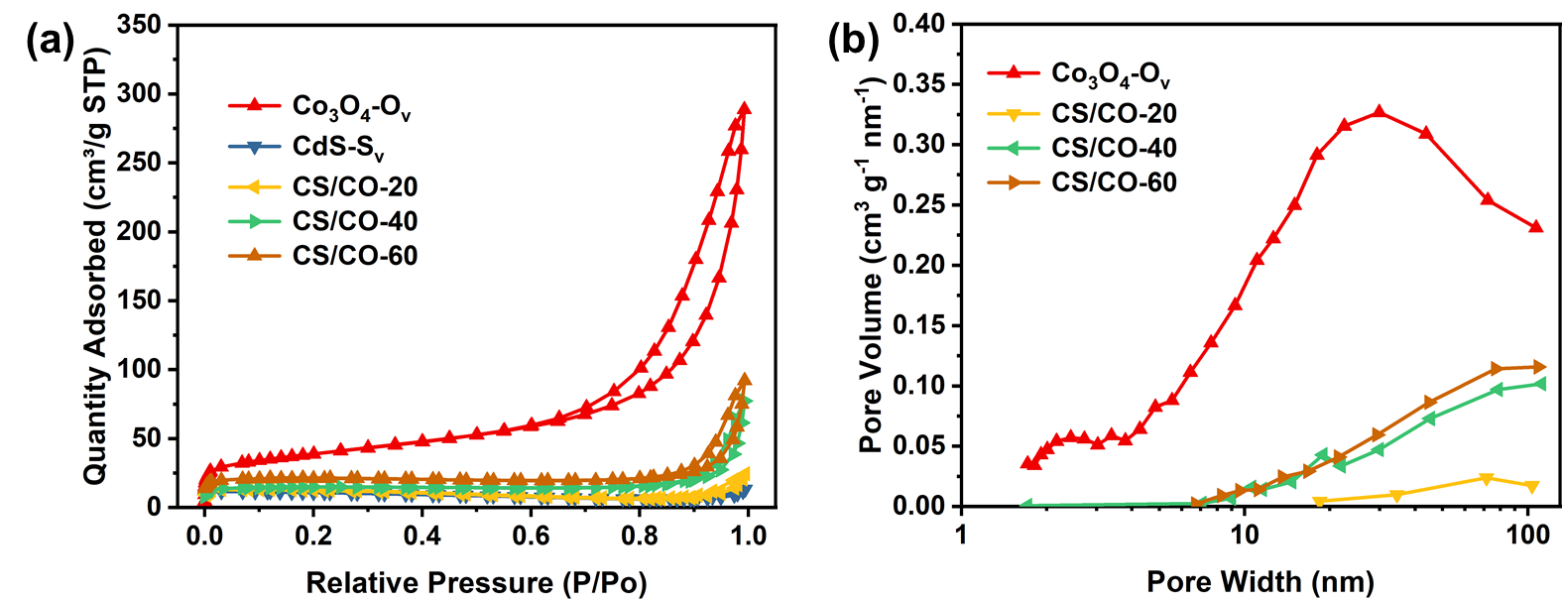
Fig. S12 (a) N₂ adsorption-desorption isotherms and (b) the pore size distributions of Co₃O₄-O_{v}, CS/CO-20, CS/CO-40, and CS/CO-60.

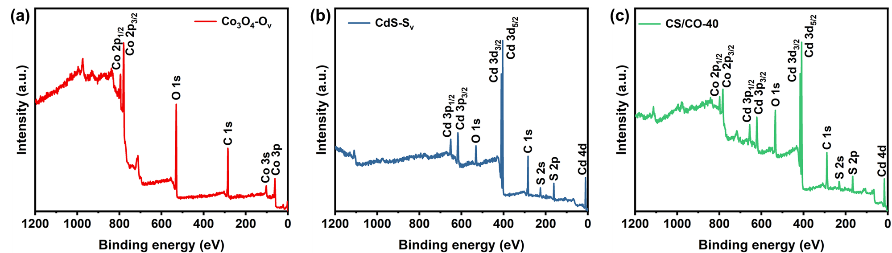
Fig. S13 XPS full spectra of (a) Co₃O₄-O_{v}, (b) CdS-S_{v}, and (c) CS/CO-40.

Fig. S14 Photocatalytic product species.
Fig. S15 Gas-phase product evolution rates of CdS nanoparticles with different CdCl₂ and TAA molar ratios (1:1, 1:2, and 1:3).

Fig. S16 Gas-phase product evolution rates of CdS/Co₃O₄ with different CdCl₂ and TAA molar ratios (1:1, 1:2, and 1:3).
Fig. S17 Time-dependent products evolution rates of CdS-S_{v}.

Fig. S18 Time-dependent products evolution rates of Co₃O₄-O_{v}.

Fig. S19 Time-dependent products evolution rates of CS/CO-20.

Fig. S20 Time-dependent products evolution rates of CS/CO-60.

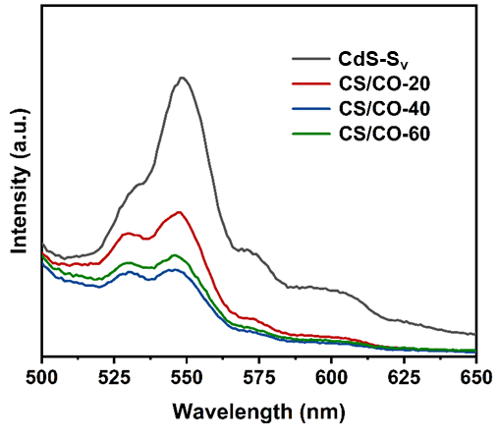
Fig. S21 PL spectra of CdS-Sv, CS/CO-20, CS/CO-40, and CS/CO-60.

Fig. S22 Gas phase results analysis of radical scavenging experiments.

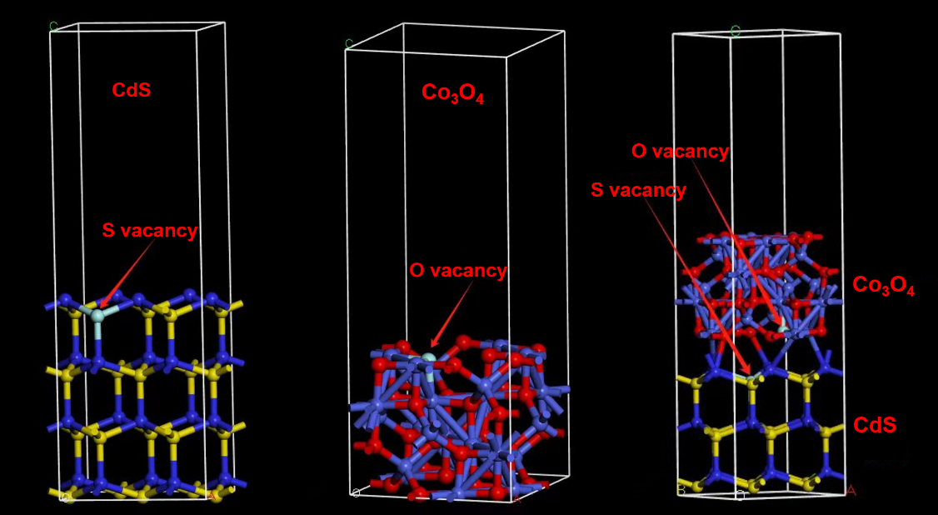
Fig. S23 CdS-S_{v}, Co₃O₄-O_{v}, and CdS-S_{v}/Co₃O₄-O_{v} crystal structure model used for DFT calculations.

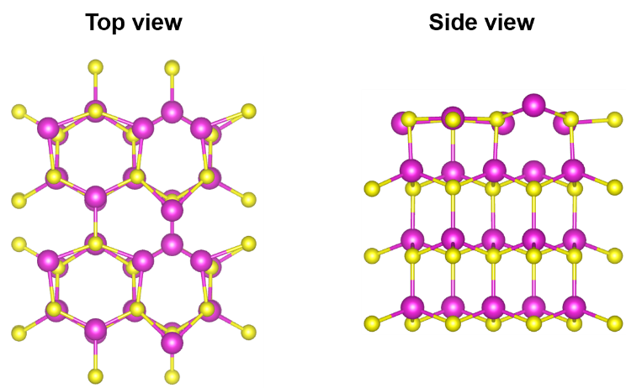
Fig. S24 Top and side views of the optimized CdS-S_{v} crystal structure.

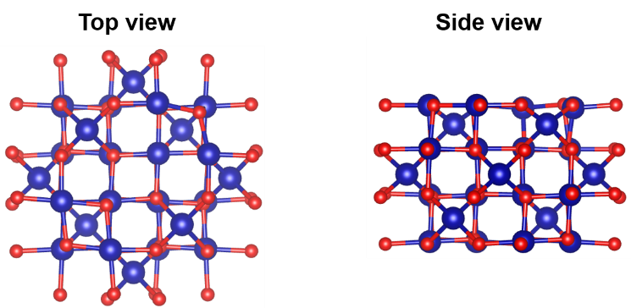
Fig. S25 Top and side views of the optimized Co₃O₄-O_{v} crystal structure.

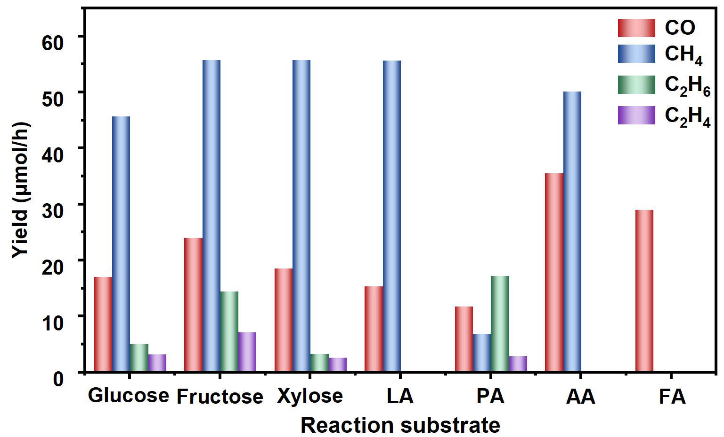
Fig. S26 Gas phase results analysis of experiments with different reaction substrates: Glucose, Fructose, Xylose, Lactic acid (LA), Propionic acid (PA), Acetic acid (AA), and Formic acid (FA).

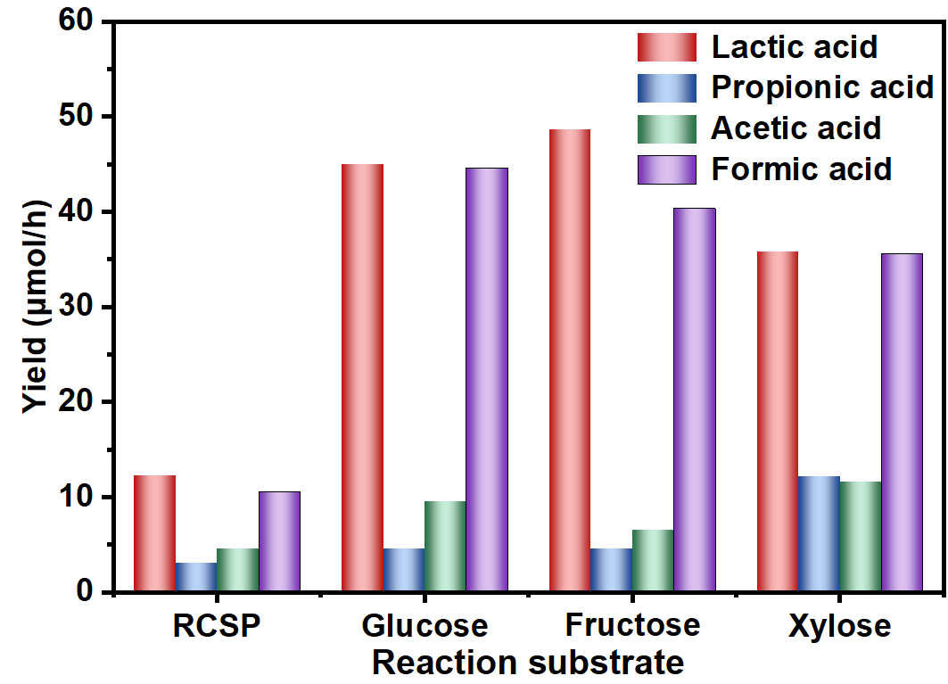
Fig. S27 Liquid phase results analysis of experiments with different reaction substrates.

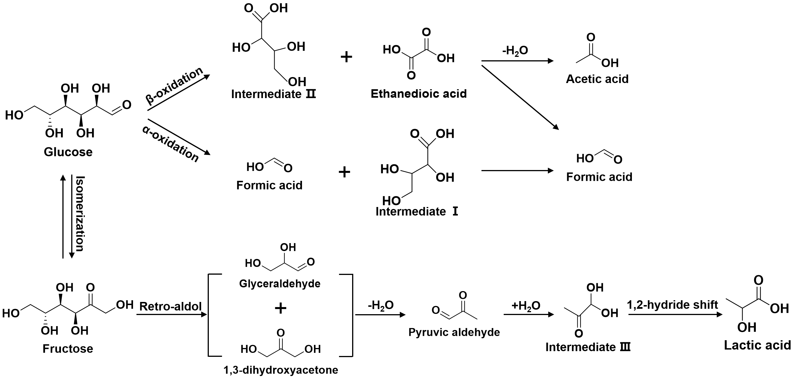
Fig. S28 Proposed pathway for photocatalytic glucose and fructose conversion.

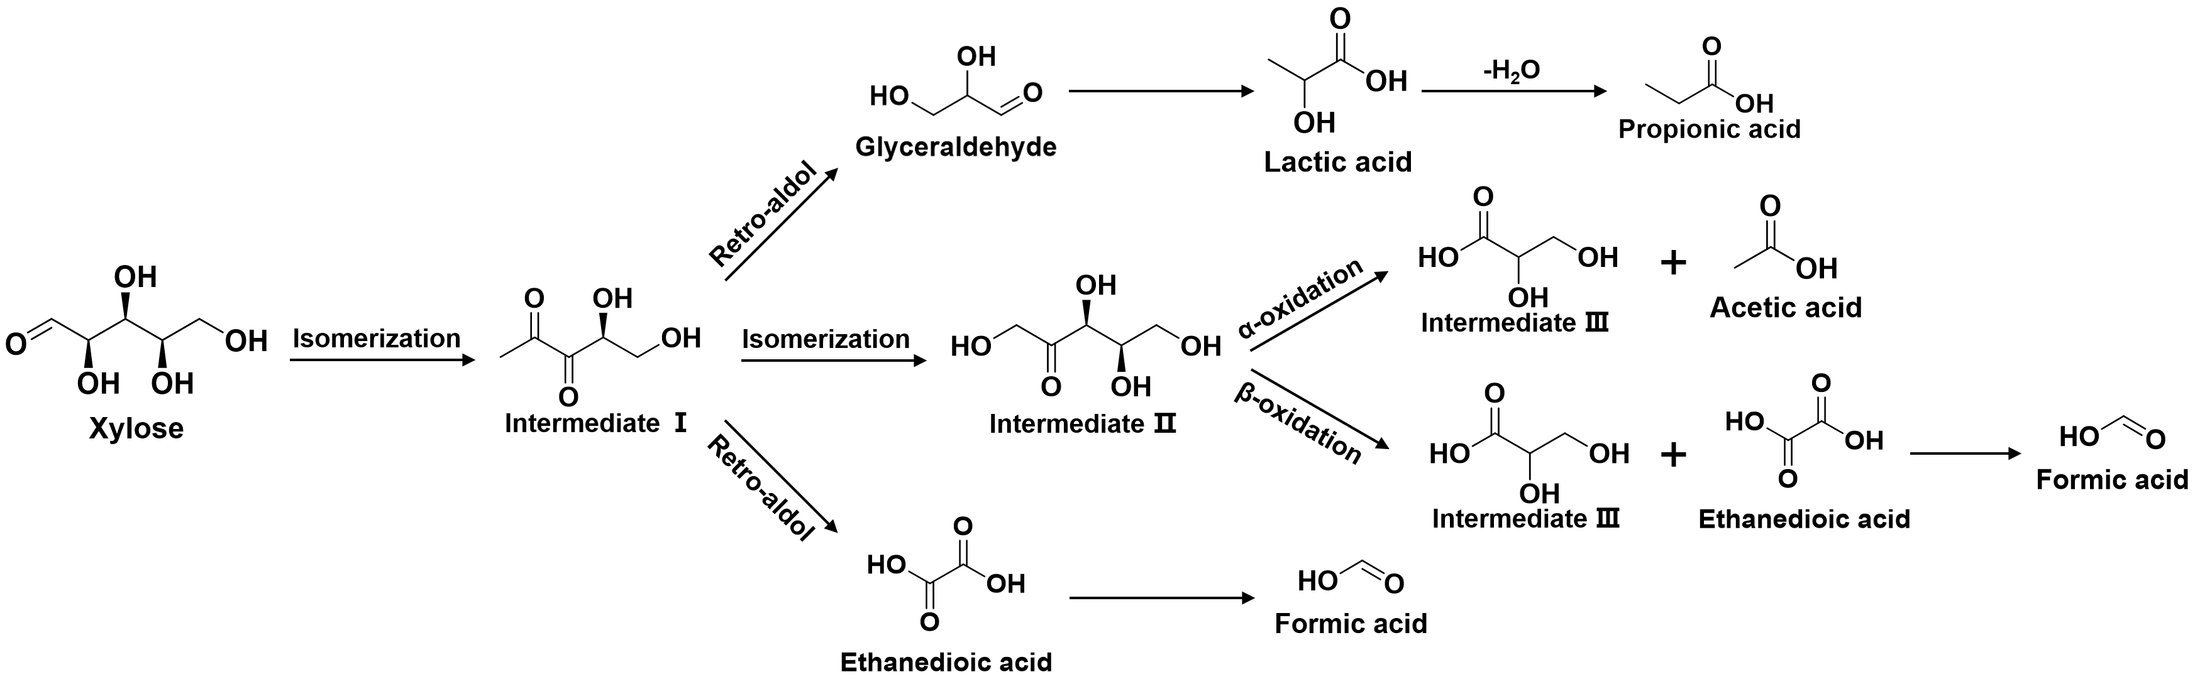
Fig. S29 Proposed pathway for photocatalytic xylose conversion.

Table S1. Photocatalytic gas production of raw biomass and biomass polymers as reaction substrates in the literature
Photocatalysts | Reaction substrate | Light source | Gas Products | References
Pt/TiO₂ | alkali pretreated corn stover | Xe lamp (300 W) | H₂ (212.3 μmol g⁻¹ h⁻¹) | 1
Pt/TiO₂ | alfalfa stems | UV-A (4 × 15 W) | H₂ (100 μmol g⁻¹ h⁻¹) | 2
Pt/TiO₂ | rice plant | Xe lamp (500 W) | H₂ (8 μmol g⁻¹ h⁻¹) | 3
P25-S-Ni | cellulose | Xe lamp (500 W) | H₂ (60.4 μmol g⁻¹ h⁻¹) | 4
CdS/CdO_{x} QDs | wooden branch | AM 1.5G (100 mW cm⁻²) | H₂ (5.3 μmol g⁻¹ h⁻¹) | 5
Activated ^{NCN}CN_{x} | sawdust | AM 1.5G (100 mW cm⁻²) | H₂ (202 μmol g⁻¹ h⁻¹) | 6
TiO₂/NiO_{x}@Cg | cellulose | Xe lamp (500 W) | H₂ (5.4 μmol g⁻¹ h⁻¹) | 7
TiO₂-Au-CdS | cellobiose | Xe lamp (300 W) | H₂ (425 μmol g⁻¹ h⁻¹)  CH₄ (9.5 μmol g⁻¹ h⁻¹)  CO (100 μmol g⁻¹ h⁻¹)  C₂H₄ (0.22 μmol g⁻¹ h⁻¹)  C₂H₆ (0.23 μmol g⁻¹ h⁻¹) | 8
(CdZnCuCoFe)S_{x} | guar gum | Xe lamp (300 W) | CO (1.7 mmol g⁻¹ h⁻¹)  C₂H₄ (15 umol g⁻¹ h⁻¹)  C₂H₆ (2.5 μmol g⁻¹ h⁻¹) | 9
(CdZnCuCoFe)S_{x} | cellulose | Xe lamp (300 W) | CO (1.2 mmol g⁻¹ h⁻¹)  C₂H₄ (7.5 μmol g⁻¹ h⁻¹)  C₂H₆ (1.8 μmol g⁻¹ h⁻¹) | 9
Pt- C₃N₄ | α-cellulose | 40 W blue LED | H₂ (1.11 mmol g^{–1}h^{–1}) | 10
Pt/TiO₂ | poplar wood chip | Xe lamp (300 W) | H₂ (26 μmol g⁻¹ h⁻¹) | 11
h-ZnSe/Pt@TiO₂ | α-cellulose | Xe lamp (300 W) | H₂ (1858 μmol g⁻¹ h⁻¹) | 12
g-C₃N₄–C_{x} | α-cellulose | Xe lamp (300 W) | H₂ (105 μmol g⁻¹ h⁻¹) | 13
CdZnS | waste straw | Xe lamp (300 W) | H₂ (2.25 mmol g⁻¹ h⁻¹) | 14
Ni(OH)₂/Cd_{0.5}Zn_{0.5}S | lignocellulose | Xe lamp (300 W) | H₂ (1.97 mmol g⁻¹ h⁻¹) | 15
g-C₃N₄-Na | α-cellulose | Xe lamp (300 W) | H₂ (37.2 μmol g⁻¹ h⁻¹) | 16
CdS/Co₃O₄ | raw corn stover powders | Xe lamp (300 W) | CH₄ (342.95 μmol g⁻¹ h⁻¹)  CO (115.33 μmol g⁻¹ h⁻¹)  C₂H₄ (31.22 μmol g⁻¹ h⁻¹)  C₂H₆ (33.82 μmol g⁻¹ h⁻¹) | This work
References
[1] Y. Zhou, X. Ye, D. Lin, Enhance photocatalytic hydrogen evolution by using alkaline pretreated corn stover as a sacrificial agent, Int. J. Energy Res. 44 (2020) 4616-4628.
[2] A. Speltini, M. Sturini, D. Dondi, E. Annovazzi, F. Maraschi, V. Caratto, A. Profumo, and A. Buttafava, Sunlight-promoted photocatalytic hydrogen gas evolution from water-suspended cellulose: a systematic study, Photochem. Photobiol. Sci. 13 (2014) 1410-1419.
[3] T. Kawai, T. Sakata. Photocatalytic hydrogen production from water by the decomposition of poly-vinylchloride, protein, algae, dead insects, and excrement, Chem. Lett. 10 (1981) 81-84.
[4] H. Hao, L. Zhang, W. Wang, S. Zeng, Facile Modification of Titania with Nickel Sulfide and Sulfate Species for the Photoreformation of Cellulose into Hydrogen, ChemSusChem 11 (2018) 2810.
[5] D. Wakerley, M. Kuehnel, K. Orchard, Solar-driven reforming of lignocellulose to H₂ with a CdS/CdO_{x} photocatalyst, Nat. Energy 2 (2017) 17021.
[6] K. Hatice, D.S. Achilleos, H. Ailun, Photoreforming of lignocellulose into H₂ using nanoengineered carbon nitride under benign conditions, J. Am. Chem. Soc. 140 (2018) 11604-11607.
[7] L. Zhang, W. Wang, S. Zeng, Y. Su, H. Hao, Enhanced H₂ evolution from photocatalytic cellulose conversion based on graphitic carbon layers on TiO₂/NiO_{x}, Green Chem. 20 (2018) 3008-3013.
[8] H. Zhao, C. Li, X. Yu, N. Zhong, Z. Hu, Y. Li, S. Larter, M.G. Kibria, J. Hu, Mechanistic understanding of cellulose β-1,4-glycosidic cleavage via photocatalysis, Appl. Catal. B 302 (2022) 120872.
[9] Y. Xu, L. Wang, Z. Shi, N. Su, C. Li, Y. Huang, N. Huang, Y. Deng, H. Li, T. Ma, X. Kong, W. Lin, Y. Zhou, and L. Ye, Peroxide-mediated selective conversion of biomass polysaccharides over high entropy sulfides via solar energy catalysis, Energy Environ. Sci. 16 (2023) 1531-1539.
[10] E. Wang, A. Mahmood, S. Chen, W. Sun, T. Muhmood, X. Yang, and Z. Chen, Solar-Driven Photocatalytic Reforming of Lignocellulose into H₂ and Value-Added Biochemicals, ACS Catal. 12 (2022) 11206-11215.
[11] Q. Cheng, Y. Yuan, R. Tang, Q. Liu, L. Bao, P. Wang, J. Zhong, Z. Zhao, Z. Yu, and Z. Zou, Rapid Hydroxyl Radical Generation on (001)-Facet-Exposed Ultrathin Anatase TiO₂ Nanosheets for Enhanced Photocatalytic Lignocellulose-to-H₂ Conversion, ACS Catal. 12 (2022) 2118-2125.
[12] Y. You, S. Chen, J. Zhao, J. Lin, D. Wen, P. Sha, L. Li, D. Bu, S. Huang, Rational Design of S-Scheme Heterojunction toward Efficient Photocatalytic Cellulose Reforming for H₂ and Formic Acid in Pure Water, Adv. Mater. 36 (2024) 2307962.
[13] Z. Xie, Y. Jia, Y. Huang, D. Xu, X. Wu, M. Chen, and W. Shi, Near-infrared light-driven photocatalytic reforming lignocellulose into H₂ and chemicals over heterogeneous carbon nitride, ACS Catal. 13 (2023) 13768-13776.
[14] F. Liu, Y. Fu, K. Lu, S. Wang, B. Wang, J. Huang, X. Yan, Y. Zheng, L. Guo, and M. Liu, Solar reforming lignocellulose into H₂ over pH-triggered hydroxyl-functionalized chalcogenide nanotwins, ACS Catal. 13 (2023), 15591-15602.
[15] Z. Li, F. Liu, X. Yan, Y. Wang, K. Lu, J. Liu, Y. Qiao, M. Liu, Photoreforming lignocellulose to hydrogen over noble-metal-free Ni(OH)₂/Cd_{0.5}Zn_{0.5}S nanotwins, Int. J. Hydrogen Energ., 69 (2024) 234-241.
[16] H. Luo, Y. Jia, Z. Xie, W. Shi, Sodium-doped carbon nitride for visible light-driven photocatalytic reforming lignocellulose into H₂ and chemicals, Chem. Eng. Sci., 299 (2024) 120409.

