SUPPLEMENTARY
Human Vaginal Lactobacillus jensenii -Derived (-)-Terpinen-4-ol restores antibiotic sensitivity by inhibiting efflux pumps in drug resistant E. coli and K. pneumoniae

Veena G Nair ¹, Vineetha K Unnikrishnan¹, Niraimathi Muralidharan¹, Badri Narayanan S V¹, Rene Christena L², Y.B.R.D Rajesh³, Dhiviya Narbhavi⁴, Anupriya A⁵, Prabhusaran N^{6,}, Saisubramanian Nagarajan ^{1*}
* Corresponding Author: Dr Saisubramanian Nagarajan, Antimicrobial Resistance Lab, Centre for Research in Infectious diseases, School of Chemical and Biotechnology, SASTRA Deemed to be University, Thanjavur 613401, Tamil Nadu, India. Phone: +91 4362 2641011
email: sai@scbt.sastra.edu
¹Antimicrobial Resistance Lab, Centre for Research in Infectious diseases, School of Chemical and Biotechnology, SASTRA Deemed to be University, Thanjavur 613401, Tamil Nadu, India.
² Formerly with the Antimicrobial Resistance Lab, Centre for Research in Infectious diseases, School of Chemical and Biotechnology, SASTRA Deemed to be University, Thanjavur 613401, Tamil Nadu, India.
³ Department of Chemistry, School of Chemical and Biotechnology, SASTRA Deemed University, Thanjavur – 613 401, Tamil Nadu, India.
⁴ Assistant Professor, Department of Obstetrics and Gynaecology, TSRMMCH&RC, Tiruchirappalli, Tamil Nadu, India
⁵ Associate Professor, Department of Microbiology, TSRMMCH&RC, Tiruchirappalli, Tamil Nadu, India
⁶ Research Faculty, Institutional Research Board TSRMMCH&RC, Tiruchirappalli, Tamil Nadu, India

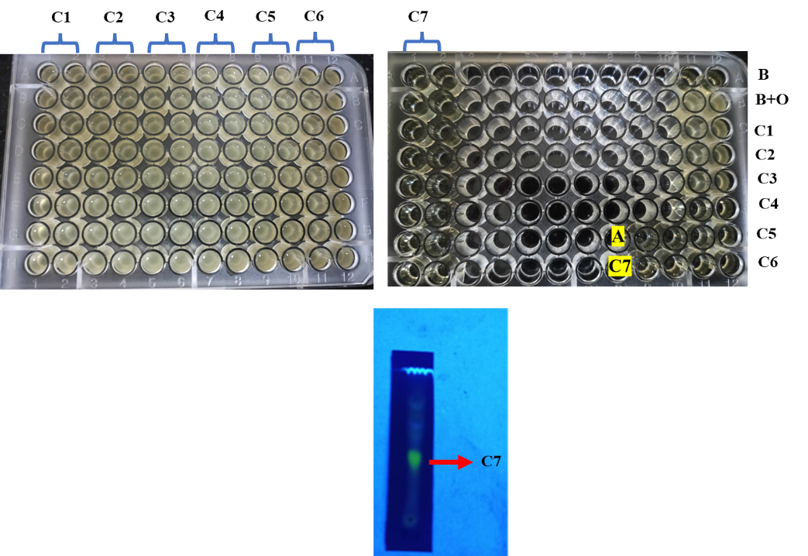
A Screening and Characterization of Cell free supernatant, C1- C7 were Compound 1 to Compound 7 A) TLC plate after Column chromatography
B Screening and Characterization of Cell free supernatant, C1- C7 were Compound 1 to Compound 7 A) TLC plate after Column chromatography
Fig. S1 Screening and Characterization of Cell free supernatant, C1- C7 were Compound 1 to Compound 7 A) Screening of the compounds for efflux activity, where C7 marked in red square shows efflux activity against K. pneumonaie MTCC 432 B) TLC plate after Column chromatography.

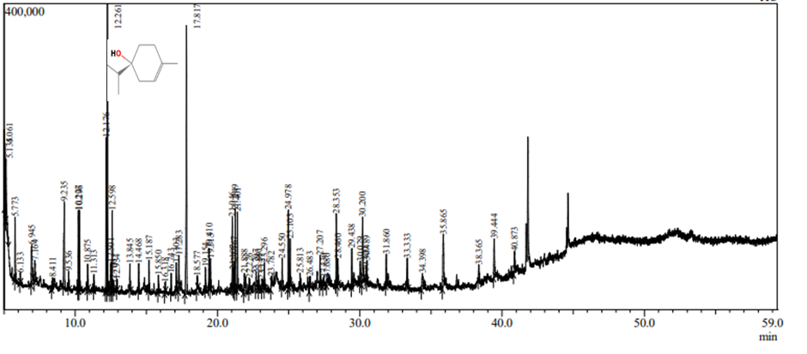
Fig. S2: Gas Chromatography-Mass Spectrometry (GC-MS) of Compound 7(C7). The highest peak with R. time12.261 indicates the compound is Terpinen-4-ol.

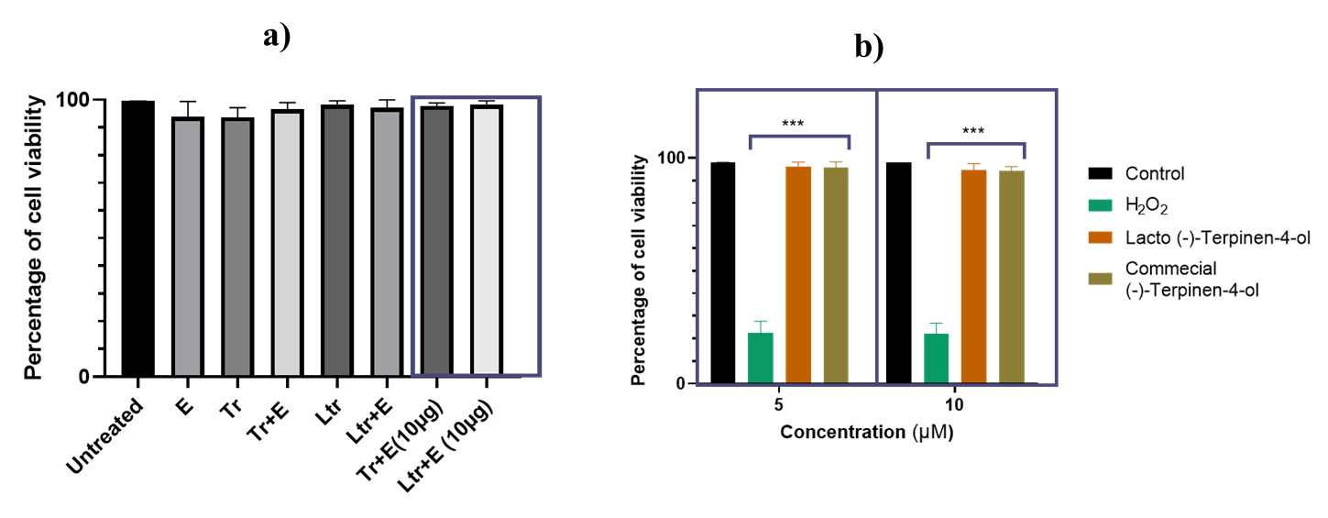
Fig. S3. MTT assay showing survival of human urinary bladder cancer cells T24 and Raw Macrophages upon incubation with (-)-Terpinen-4-ol (Commercial (Tr) and Extracted(Ltr)) and in combination with erythromycin (E) (n=3). The experiment was performed in triplicates and the error bar represents standard error of the mean.

Fig. S4 Effect of Terpinen-4-ol and Erythromycin on biofilm formation. Impact of terpinen-4-ol, both alone and in combination with erythromycin, on the formation of mature biofilms. The y-axis represents the biofilm biomass quantified by crystal violet staining, while the x-axis indicates different treatment groups: untreated control, terpinen-4-ol alone (Ltr-Lactobacillus derived, Tr- Commercial), Ery- erythromycin alone, and the combination of terpinen-4-ol and erythromycin. Unpaired t-test, n= 3, 95% CI, p*** < 0.0001

Minimum Inhibitory Concentration (μg/ml)
Antibiotic | K. p MTCC 432 | K. p BC936 | K. p BC1415 | K. p 1876 | K. p 44350 | K. p 44357 | K. p 15410 | K. p 27736 | E. coli U1007 | E. coli  UTI89 |  | E. coli  CFT073 |  | E. coli  F11
Kanamycin | >256 | >128 | >128 | >256 | >256 | 32 | >256 | <4 | >128 | 16 |  | 32 |  | 32
Ceftriaxone | <1 | >128 | >128 | >256 | >256 | >256 | >256 | <4 | >128 | <4 |  | <4 |  | <4
Tetracycline | >128 | >128 | >128 | <4 | <4 | 128 | <4 | <4 | >128 | <4 |  | <4 |  | <4
Streptomycin | 64 | 32 | 32 | 16 | 128 | 128 | 128 | 16 | 128 | <4 |  | <4 |  | <4
Colistin | 2 | 8 | 32 | 4 | >4 | <4 | 8 | <4 | 4 | <4 |  | <4 |  | <4
Meropenem | 0.5 | 16 | 16 | 8 | 128 | 128 | 256 | >4 | >128 | <4 |  | <4 |  | <4
Levofloxacin | 1 | 32 | 32 | 128 | 128 | 128 | 64 | <4 | 32 | <4 |  | <4 |  | <4
Ciprofloxacin | 4 | 16 | 16 | >256 | >256 | >256 | 128 | <4 | >128 | <4 |  | <2 |  | 4
Erythromycin | 64 | >128 | >128 | >128 | >128 | >128 | >128 | >128 | >128 | 256 |  | 256 |  | 64
Norfloxacin | <2 | >128 | 64 | 32 | >128 | >128 | >128 | 32 | >128 | <4 |  | <2 |  | <4
Amikacin | <2 | >128 | >128 | 16 | >4 | >128 | >128 | 16 | >128 | 8 |  | 16 |  | 16
Gentamicin | <4 | >128 | >128 | >128 | >128 | >128 | >128 | >128 | >128 | <4 |  | 4 |  | <4
Rifampicin | 4 | >128 | >128 | 16 | >128 | >128 | >128 | 16 | 32 | 32 |  | 16 |  | 16

Table S1: Drug resistance profile of clinical isolates of K. pneumoniae and E. coli , where erythromycin showed resistance to all the strains( in red)

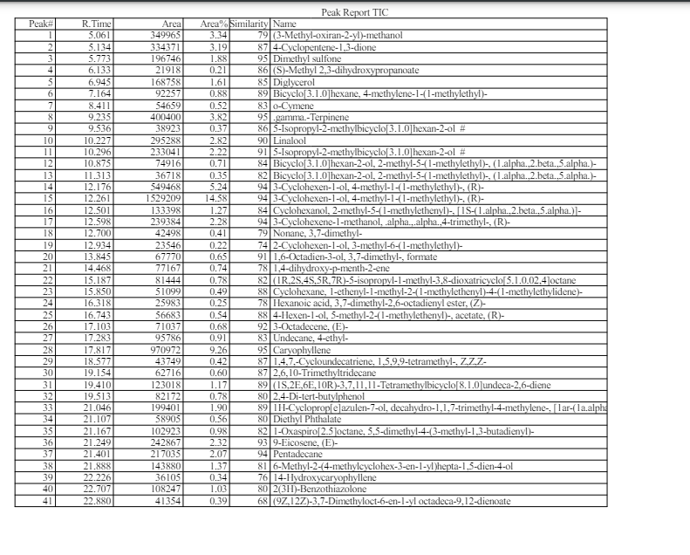
Table S2: Gas Chromatography-Mass Spectrometry (GC-MS) of Compound 7(C7). The peak analysis shows that the compound is (-)-Terpinen-4-ol (Indicated in red box)

Organisms | Antibiotic | MIC (μg/ml) | MIC Reversal (μg/ml) | Fold
Staphylococcus aureus 160018 | Norfloxacin | 128 | 8 | 16
Staphylococcus aureus 160031 | Norfloxacin | >256 | 8 | 32
Staphylococcus aureus 16001 | Norfloxacin | 128 | 4 | 32
MRSA | Vancomycin  Tigecycline | 128  64 | 4  16 | 32  4
E. faecalis | Ampicillin | 256 | 4(done up to) | 64
Acinetobacter baumanii 1467 | Colistin  Ciprofloxacin | >256  >256 | >256 (no reversal)  8 | 32
Klebsiella pneumoniae 474 | Erythromycin  Ciprofloxacin | >256  128 | 8  4 | 32  32
Pseudomonas aeruginosa E355 | Ciprofloxacin  Gentamicin | >256  128 | 8  >128 (no reversal) | 32
Pseudomonas aeruginosa BC934 | Ciprofloxacin  Gentamicin | >256  128 | 16  >128 (no reversal) | 16
Pseudomonas aeruginosa BC1640 | Ciprofloxacin  Gentamicin | >256  128 | 8  8 | 32  16
Table S3. Fold reversal of Minimum Inhibitory Concentration (MIC) of antibiotics in clinically relevant pathogens

Gene | Primers (5`-3`) | Ref
acrA | GTCCTCAGGTCAGTGGCATTA  ATTGCTCTGCTGCGCCGTTG | 69
oqxA | AAGGTGCTGGTGAAGTCGATC  GCGCGATAGGTTCTGTCATC | 69
kexC | TGCCGGTTGAACAGTATCCC  ACATCAGGTTATCGAGGCCG | 69
kexD | ACCGGTTGCGCAATACCCTG  CGTAATTGACGCCATCCCTG | 69
kexE | TTACGCTTCAGGATGATACCG  GGTCCATGTCGTGAACAGC | 69

Table. S4: Primers used in gene expression study

